Electoral Representation Review
Macedon Ranges Shire Council
Final Report
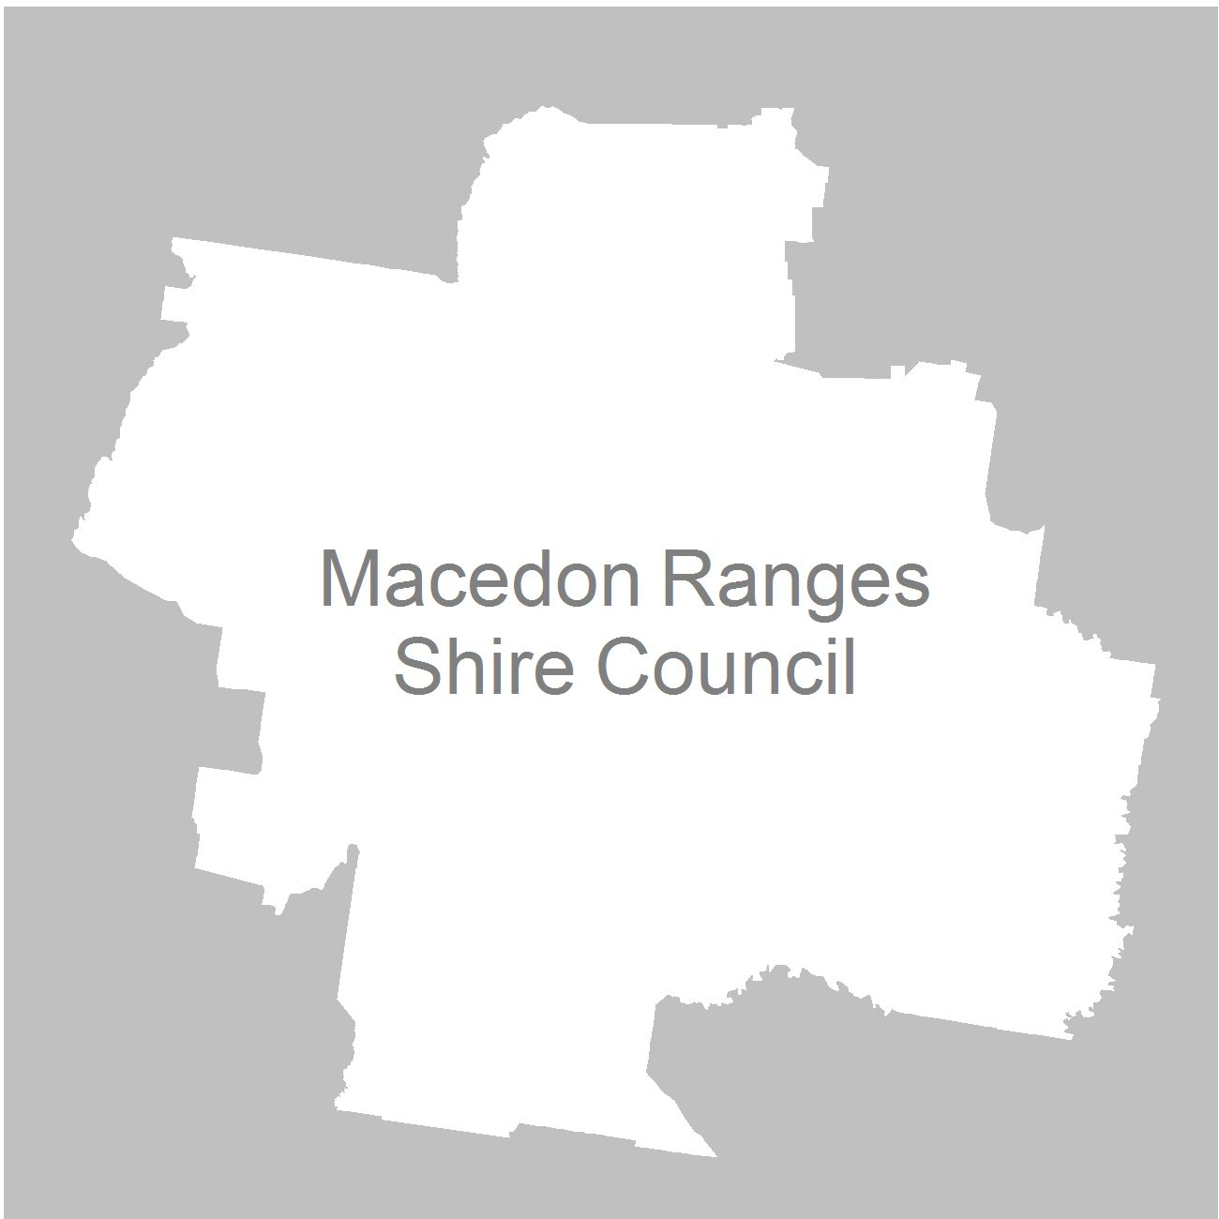

19 October 2011

Contents
Recommendation 3
Background 4
Legislative basis 4
The VEC and Electoral Representation Reviews 4
Profile of Macedon Ranges Shire 5
Current electoral structure 6
The electoral representation review process 7
VEC research 8
Public involvement 9
Preliminary report 11
Preliminary submissions 11
Preliminary options 11
Public response 14
Response submissions 14
Analysis of submissions 14
Public hearing 15
Findings and Recommendation 16
Recommendation 16
Appendix 1: List of submitters 18
Appendix 2: Map 19

Recommendation
The Victorian Electoral Commission (VEC) recommends that
Macedon Ranges Shire Council remain with its current structure of three wards, with three councillors representing each ward, and with unchanged ward boundaries.

Background

Legislative basis
The Local Government Act 1989 (the Act) requires the VEC to conduct an Electoral Representation Review of each municipality in Victoria at least every 12 years. The Act specifies that the purpose of a representation review is to recommend to the Minister for Local Government the number of councillors and the electoral structure for a municipality, which will provide ‘fair and equitable representation for the persons who are entitled to vote at a general election of the Council’.
The Act requires the VEC, as part of an Electoral Representation Review, to consider:
- the number of councillors in a municipality;
- whether a municipality should be unsubdivided or subdivided;
- if it should be subdivided, whether ward boundaries:
  - provide for fair and equitable division of the municipality;
  - ensure equality of representation through the number of voters being represented by each councillor being within 10 per cent of the average number of voters represented by all councillors; and,
- if it should be subdivided, the number of councillors that should be elected for each ward.

The VEC and Electoral Representation Reviews
The VEC has conducted Electoral Representation Reviews since 2004 on appointment by local councils. The Act was changed in 2010 to define the VEC as the only agency authorised to undertake the reviews.
The VEC drew on its experience in mapping and boundary modelling and also engaged consultants with experience in local government to provide advice on specific local representation issues during the review.

Profile of Macedon Ranges Shire
Macedon Ranges Shire is located 85 kilometres north-west of Melbourne, halfway between Melbourne and Bendigo. It comprises 1,714 square kilometres and registered a population of 38,360 at the 2006 census.
The northern part of the Shire (Kyneton, Malmsbury and Lancefield) is characterised by agricultural enterprises including sheep and cattle grazing, and broad acre cropping as well as manufacturing linked to the various wineries and speciality farms.
The southern part of the Shire nearest to Melbourne (Gisborne, Riddells Creek and Romsey) is also rural in character but has a significant commuter population. The Shire is well serviced by transport routes with the Calder Freeway and the Bendigo-Melbourne Railway.
The Shire is recognised for its semi-rural lifestyle, heritage towns and natural landscapes, making tourism a major part of the Shire’s economy.
On average Macedon Ranges Shire Council is projected to grow by 16.32 per cent over the next ten years.

Current electoral structure
Macedon Ranges Shire Council is divided into three wards (West Ward, East Ward, South Ward) with three councillors representing each ward. Prior to the last representation review in 2004, the Council comprised nine single-councillor wards, with each major town divided between two or more wards. The VEC recommended a change to three three-councillor wards considering that the recommended structure better grouped the broad geographic communities of interest in the Shire while encouraging a wider range of candidates and diversity of representation.
As at 6 May 2011 the wards in Macedon Ranges Shire were comprised as shown in Figure 1:

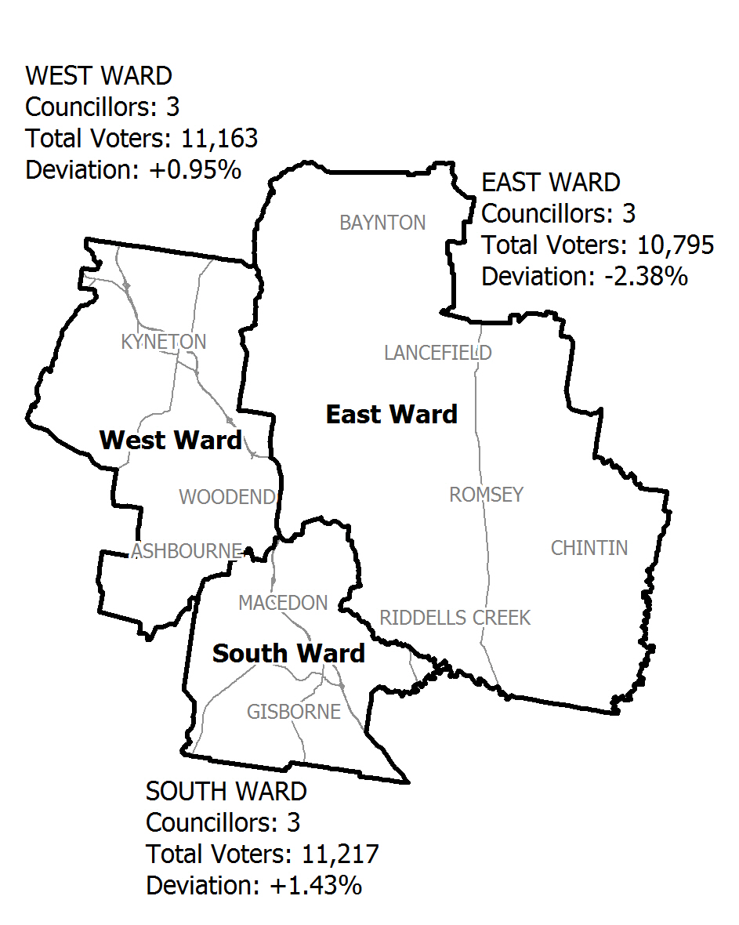
Figure 1

The electoral representation review process
The VEC proceeded on the basis of three main principles:
- Ensuring the number of voters represented by each councillor is within 10 per cent of the average number of voters per councillor for that municipality.
Populations are continually changing. Over time these changes can lead to some wards having larger or smaller numbers of voters. As part of the review, the VEC corrected any imbalances and also took into account likely population changes to ensure these boundaries provide equitable representation until the next review.
- Taking a consistent, State-wide approach to the total number of councillors.
The VEC was guided by its comparisons of municipalities of a similar size and category to the council under review. The VEC also considered any special circumstances that may warrant the municipality to have more or fewer councillors than similar municipalities.
- Ensuring communities of interest are as fairly represented as possible.
Each municipality contains a number of communities of interest and, where practicable, the electoral structure should be designed to take these into account. This allows elected councillors to be more effective representatives of the people in their particular municipality or ward.
The recommendation is based on:
- internal research specifically relating to the municipality under review;
- VEC experience from its work with other municipalities and in similar reviews for State elections;
- VEC expertise in mapping, demography and local government;
- careful consideration of all public input in the form of written and verbal submissions received during the review; and,
- advice received from consultants with wide experience in local government.
Public submissions were an important part of the process, but were not the only consideration during the review. The VEC seeks to combine the information gathered through public submissions with its own research and analysis of other factors, such as the need to give representation to communities of interest. The recommendation is not based on a ‘straw poll’ of the number of submissions supporting a particular option.

VEC research
In addition to the information provided in submissions, the VEC created a profile of the municipality based on population trends, development projections and demographic indicators. The VEC used the Australian Bureau of Statistics 2006 census community profiles, the Department of Planning and Community Development projections and voter statistics from the Victorian electoral roll. The VEC also undertook field work to view current and possible boundaries for each of the options presented in the preliminary report to evaluate their effectiveness.
Public involvement
The VEC values the local knowledge and perspectives presented by the public in written submissions. The public were given two opportunities to provide submissions during the review. Their input was considered by the panel in forming the options in the preliminary report and they were also invited to respond to these options. In addition, a public hearing was held to enable people to speak in support of their submissions and supplement it with further information.
To ensure transparency in the process, all written submissions were published on the VEC website and all verbal submissions were heard at a public hearing.
To raise awareness of the review and encourage the public to engage with the process, a public information campaign was undertaken.

Advertising
In accordance with section 219F (4) of the Act, the VEC ensured public notices were placed in local newspapers. The notices detailed the process for the review and called for public submissions. They appeared in The Telegraph, the Kyneton Midland Express and the Sunbury and Macedon Ranges Leader on Tuesday, 5 July 2011.
A general notice covering several reviews was printed in The Age and the Herald Sun on 5 July 2011.
Notification of the release of the preliminary report appeared in The Telegraph, the Sunbury and Macedon Ranges Leader and the Kyneton Midland Express on Tuesday, 23 August 2011.

Media releases
Two media releases were sent to local media for this review. The first release provided information on the review and the process. The second release detailed the options in the preliminary report and how to make a submission in response to the options outlined in the report.

Public information session
The VEC held a public information session on Wednesday, 20 July 2011 at the Gisborne Administration Centre.

Information brochure and poster
An information brochure and poster were made available as extra publicity tools. Council distributed copies of each across their four locations (Kyneton, Romsey, Gisborne and Woodend).

Helpline
A dedicated helpline was established to assist with public enquiries concerning the review process.

VEC website
The VEC website delivered up to date information to provide transparency during the review process. All preliminary and response submissions were published on the VEC website.

Guide for Submissions
A Guide for Submissions was developed and distributed to those interested in making submissions. Copies of the Guide for Submissions are available on the VEC website and were provided to council and handed out at the information sessions.

Preliminary report
In accordance with the requirements of the Act, the VEC produced a preliminary report outlining its prefered option and an alternative option for Macedon Ranges Shire Council. The report was released on Tuesday, 23 August 2011.

Preliminary submissions
By the close of preliminary submissions at 5.00pm on Tuesday, 2 August 2011, the VEC received seven submissions.
The three submitters that requested fewer wards all favoured an unsubdivided municipality. Each submitter stated that it would ensure that councillors took a more holistic approach to the Shire and would be accountable to everyone in the Shire. They also noted it offered a wider range of councillors for residents to approach.
The Proportional Representation Society supported the current system as it ensures election results are determined by the proportional representation vote counting method. The society also commended the structure for offering ‘adequate representation from each of the three areas making up Macedon Ranges Shire, namely the Kyneton-Woodend area, the Gisborne-Macedon area and the Romsey-Lancefield area’.
Macedon Ranges Shire Council stated that the current system has ‘arguably worked well’ and ‘been accepted by the community’. Council recommended retaining the current structure on the grounds it allows councillors to represent geographic areas and become acquainted with issues and opportunities while working as a team. Council suggested that the wards should only be changed to accommodate the forecast growth within the wards.
Another submitter also believed the Shire should be divided into wards but suggested the current geographical boundaries should better reflect the communities of interest with the boundaries changed to run across the Shire from east to west.
The Macedon Ranges Residents Association requested a range of options be put forward for consideration and urged the VEC to consider all possibilities to reduce ward size, encourage participation and foster a sense of local representation in the face of population growth. Their suggestions included increasing the number of wards, a mix of councillor numbers in wards and they also suggested a ward structure with horizontal boundaries.
None of the submissions argued for a change in councillor numbers.
A list of submitters, by name, is available in Appendix One. Copies of the submissions can be viewed on the VEC website: vec.vic.gov.au.

Preliminary options
The VEC began the process of determining an appropriate electoral structure by conducting an assessment of the existing nine-councillor ward structure. Taking into consideration the potential for population growth, the VEC discovered that the existing structure is robust and would accommodate the projected growth in the municipality over the next 12 years.
The VEC also compared Macedon Ranges Shire Council to other rural municipalities in Victoria to ensure that a State-wide approach was taken into account when deciding the appropriate number of councillors and considered that nine councillors would be able to provide fair and equitable representation to residents until the next review. This view was reinforced by the public submissions. None of the submitters called for an increase in councillor numbers.
Indeed, there was no real call for change from the community leading the VEC to believe the structure had been accepted by the community, as stated in the Council’s submission.
Using the natural boundary of the Great Dividing Range and the transport corridors that already divide the Shire is logical and neatly captures the distinct geographic communities of interest.
When the existing boundaries can withstand future population growth and capture the communities of interest the VEC prefers to make no change or minimal changes. The two options put forward in the report reflect this approach. The preferred option recommended no change to the existing structure and the alternative option recommended only a slight modification to the boundary to incorporate all of Riddells Creek into the current East Ward and all of New Gisborne into the current South Ward.
The VEC also noted that the ward names were not reflective of the historical and cultural heritage of Macedon Ranges Shire and put forward some suggestions for alternative ward names for consideration by the community.
Summary of recommendations:
Option A (Preferred option)
No changes should be made to Macedon Ranges Shire Council. It should remain in three wards with three councillors representing each ward. Suggestions for alternative ward names were put forward for public comment.
Option B (Alternative option)
Minor modifications should be made to the existing ward boundaries.
Public response

Response submissions
Response submissions on the Electoral Representation Review of Macedon Ranges Shire Council opened on Tuesday, 23 August 2011 and closed at 5.00pm on Tuesday, 20 September 2011 at 5.00pm. Three response submissions were received.

Analysis of submissions
Macedon Ranges Shire Council strongly supported Option A – the current structure - as outlined in their preliminary submission. The Council agreed there were some merits in the minor modifications suggested in Option B, including the fact that residents in the northern part of New Gisborne and Barringo would arguably align themselves with Gisborne as it is the main township in the South. However, the Council was less certain that residents in the area south of Riddells Creek would align themselves to Riddlells Creek rather than Gisborne, even though these residents are geographically closer to Riddells Creek. The Council was also concerned that the proposed change of boundary would not be as clear and easily identifiable as the existing one which follows the natural boundary of Riddells Creek.
The Council accepted that the existing ward names are not unique to Macedon Ranges Shire and noted that it is reasonable for names with historic or cultural relevance to be considered. The Council endorsed the name changes put forward in the preliminary report with the caveat that any suggestions made by the community would also be supported by the Council.
A resident of Woodend suggested that Campaspe Ward could be a more suitable name for the current West Ward in preference to the VEC’s proposed name of Black Hill. She pointed to the fact that Black Hill is situated north of Kyneton and is very close to the east and north boundaries of the ward making it irrelevant to the rest of the ward. She suggested Campaspe Ward would be a more appropriate name because the river rises within the ward and flows through no other ward.
The third submission was received from the Proportional Representation Society of Australia in support of either option put forward in the Preliminary Report. Both the options ensured future elections would be counted by the proportional representation counting system.
A list of submitters, by name, is available in Appendix 1. Copies of the submissions can be viewed on the VEC website at vec.vic.gov.au.
Public hearing
A public hearing was held at Gisborne Administration Centre on Monday,
26 September at 6.30pm. Everyone who made a submission in response to the report was invited to speak to their submission. The Macedon Ranges Shire requested to speak in support of its submission and was represented by Councillor Henry McLaughlin, the Mayor of Macedon Ranges Shire Council, and Mr Stephen Mahon, Manager, Council & Customer Services.
Mr Mahon, speaking for the Council, stated its support for the VEC’s preferred option, recapping the points made in the earlier preliminary and response submissions. While he acknowledged the potential advantages of incorporating all of New Gisborne into South Ward, he did point to the fact that Council was not aware of any concerns from residents about the separation of these communities between two wards, leading Council to believe there was no strong desire for this change.
Mr Mahon explained that he had thoroughly researched Option B and noted that the boundary would track a section of Barringo Creek to Shannons Road then follow some property boundaries to join Riddells Creek; it would then follow property boundaries again to join the railway line, Kilmore Road, Campbell Road and Peters Road before it met the municipal boundary. He argued that this boundary is much less clear than the current boundary which follows the natural boundary of Riddells Creek. For these reasons Council argued that Option B is less desirable, would add no real value and be potentially confusing for residents.
The Council’s acceptance of the names recommended in the Preliminary Report was also expressed by Mr Mahon, although he reiterated that other suggestions from the community would also be supported. The Mayor put forward the suggestion of Five Mile Creek Ward in preference to Dryden’s Run and the panel addressed the suggestion (put forward by Ms Duckworth in a response submission) to change West Ward to Campaspe Ward noting that it could cause confusion with Campaspe Shire.
Due to the number of relevant ward names that were proposed in this review, Council requested that the VEC delay the naming of the wards until a dedicated consultation process, initiated by the council, could be conducted.
Findings and Recommendation
Number of councillors
In its preliminary report, the VEC stated that nine councillors was the appropriate number for Macedon Ranges Shire Council. The VEC takes a State-wide approach when determining the number of councillors for a municipality by comparing similar municipalities. As a rural municipality, Macedon Ranges Shire was compared with Wellington Shire, East Gippsland Shire and Baw Baw Shire, all of which are larger municipalities with bigger populations and have nine councillors.
Macedon Ranges Shire Council is projected to grow by 16.32 per cent over the next ten years. The VEC believes that nine councillors could absorb this increase in population and still provide fair and equitable representation to all residents.
The VEC did not receive any submissions to counter this view. None of the submissions mentioned an increase or decrease in councillor numbers.
For these reasons, the VEC confirms its recommendation that nine is the appropriate number of councillors for Macedon Ranges Shire Council.

Electoral Structure
In its Preliminary Report, the VEC observed that the current structure of Macedon Ranges Shire Council is stable and complies with the legislation that no ward can have 10 per cent more or less voters than any other ward. The VEC is confident that this structure would absorb the projected future population growth and therefore endure until the next electoral representation review in 12 years time.
The current structure continues to group the distinct geographic communities of interest in the Shire neatly using the obvious boundaries created by the transport corridors which capture the larger towns of Kyneton and Woodend within the West Ward and group the more rural areas into East Ward.
The current structure also works well with the natural boundary of the Great Dividing Range which groups the lower part of the Shire and its significant commuter population into the South Ward. By maintaining these geographic communities of interest, councillors will be able to offer a continuity of representation to residents who are more likely to share similar concerns.
The VEC accepts the Council’s argument that the slight boundary change recommended in Option B, a portion of which runs along the back of some residential property boundaries, is in parts less clear than the current boundary and that there is no call for this change within the community. None of the submissions received by the VEC favoured this change and the council confirmed that they were not aware of receiving any queries from residents.
For these reasons, the VEC considers that the current structure should be retained with no changes.
The VEC also acknowledges that the change of ward names is an important issue for Council and its community and considers it appropriate for Council to consult with the community about potential ward names and if change is desired, for Council to recommend to the Minister for Local Government to alter the ward names in accordance with 220Q(m) of the Local Government Act 1989.

Recommendation
The Victorian Electoral Commission (VEC) recommends that Macedon Ranges Shire Council remain with its current structure of three wards, with three councillors representing each ward and with unchanged ward boundaries.

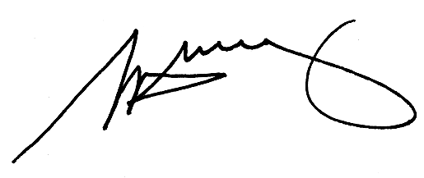
S. H. Tully
Electoral Commissioner

Appendix 1: List of submitters
Preliminary submissions were received from:
Donovan, J.
Harvey, N.
Letchford, J.
Macedon Ranges Residents Association
Macedon Ranges Shire Council
Proportional Representation Society of Australia
Williams J.

Response submissions were received from:
Duckworth, K.
Macedon Ranges Shire Council
Proportional Representation Society of Australia

Appendix 2: Map

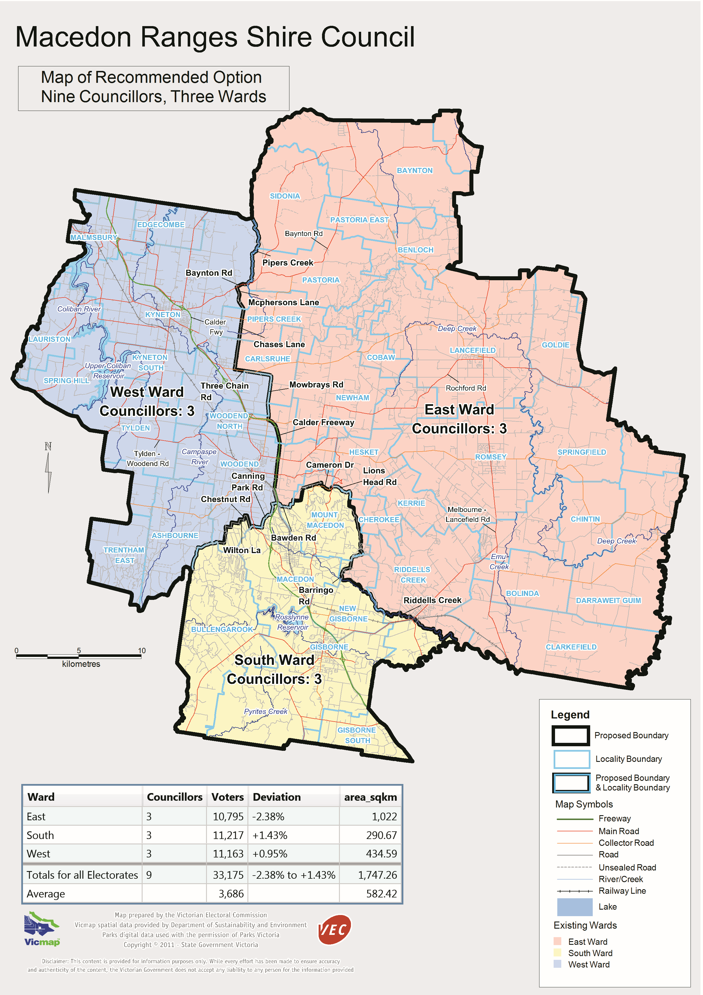

Victorian Electoral Commission
Level 11, 530 Collins Street
Melbourne, Vic 3000

131 VEC (131 832)
macedonranges.review@vec.vic.gov.au
vec.vic.gov.au

Section 219D of the Local Government Act 1989.
Department of Planning and Community Development, Victoria in Future 2008 projections

