**Easy English**

**Disability Access and Inclusion Plan**2019 - 2023

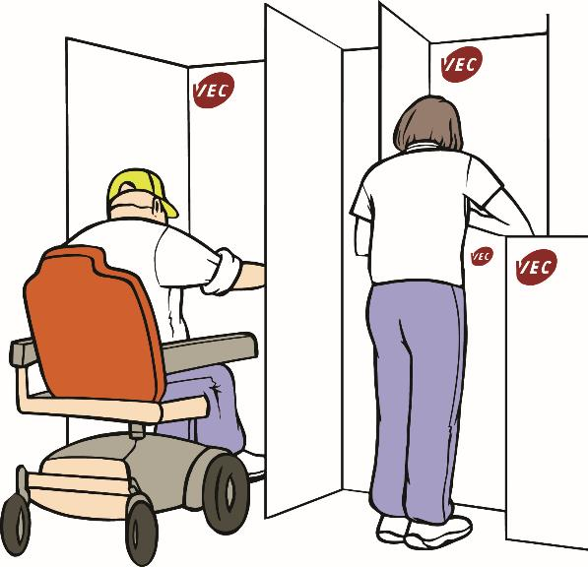

**Cover image:**

Monica Lazzari painted the art on our cover. She named the artwork How Many Triangles Can You See?

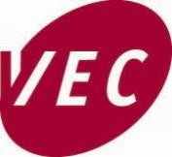

This information is from the

Victorian Electoral Commission.

We will write **V.E.C.** when we talk about us.

 The V.E.C. respect the Aboriginal people

of Victoria.



We have a group to help us do our work.

They

* are people with a disability

**or**

* help people with a disability.

The group is called the Electoral Access and Advisory Group. We will write **Access Group** when we talk about this group.

# The Electoral Commissioner Warwick Gately From the Electoral Commissioner

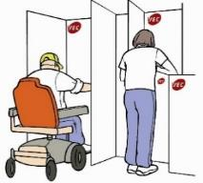The aims of this plan are to make sure every one

* can enrol
* can vote

**and**

* can have a secret vote.

Thank you for the work of the Access Group.

This plan has many ideas from the

* Access Group
* the V.E.C. staff
* other people with disabilities
* other people the V.E.C. work with.

# VEC logoVEC logoAbout the V.E.C.

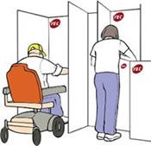The V.E.C. run

* the Victorian State elections
* the local council elections.

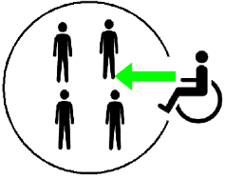

**What we say about access**

At the V.E.C., we include every one. The V.E.C.

* is independent
* is fair
* tell us all what the V.E.C. does
* respects every one in the community
* uses new ideas to make things better.

The V.E.C. are **not** part of the government.

# Cover of NEW planAbout this Plan

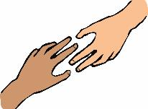

It will help the V.E.C. know what to do.

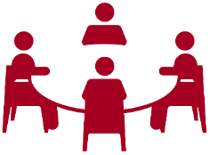We talked about this plan with

* our Access Group
* staff from other organisations
* V.E.C. staff
* other people who work with us.

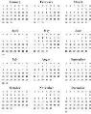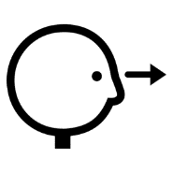

We will do a big review of this plan in 2023.

We want more people to know how to vote. Like

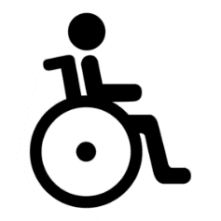

* people with a disability

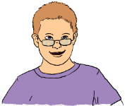

* young people

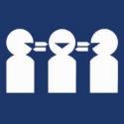

* people who do **not** speak English



* Aboriginal and Torres Strait Islander people



* people who do **not** have a home

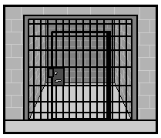

* people in prisons.

# The old planThe old plan

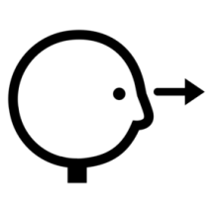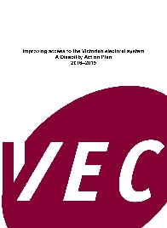

We looked back at what we did.



We did most things from our plan.

# The new planA person looking.T**he new plan**

This plan is for 2019 to 2023.

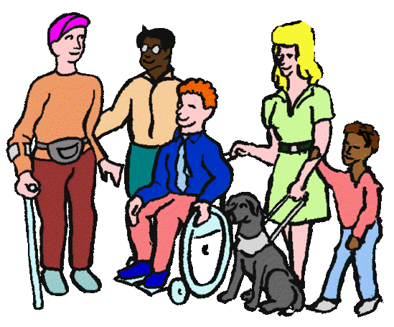This plan is about

1. Access

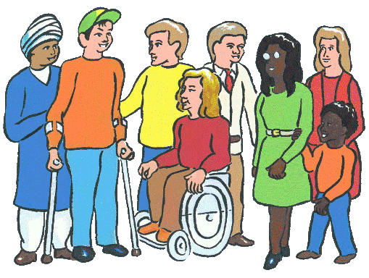

1. The people who work for us



1. Working together



1. Be the best we can be.

# A diverse group of people1. Access

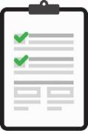

1. The V.E.C. have an Access Checklist now.

We will use the Access Checklist for all

* meetings
* events
* training
* projects.



We will check the right staff have done the checklist training.

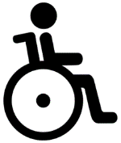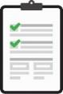We will plan for people with disabilities to do the access checklist at voting centres.

1. We will plan our website to have

good access.

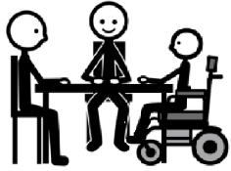

1. The V.E.C. will do user testing with all

new information.

1. Plain language. The V.E.C will plan to put information in

* Plain Language



* Easy English



* so you can listen to it

Large print page of information.

* large print

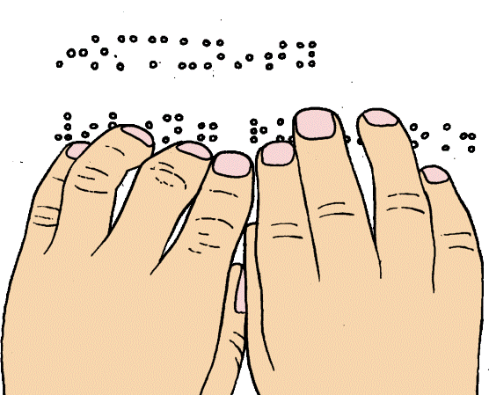

* Braille.

1. 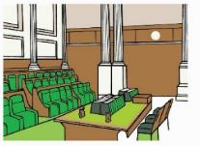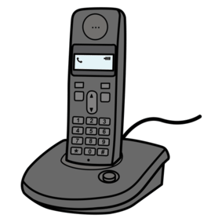We will talk to the Parliament about

telephone voting.



1. We will ask for new ideas for voting places. Like

* buildings at local councils
* voting places that can come to you.

1. 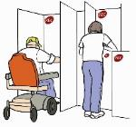We will tell you where voting places

are with

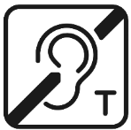

* hearing loops

**and**

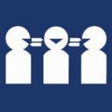

* people who can talk a different language

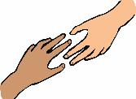

* more help for you



* quiet places in the voting area.

# **Group of diverse people2. People who work for us**

1. The V.E C. will have **more** people with a disability work for us. We will make

sure people have the right things for work.

The V.E.C. will have 1 new job each year for a person with a disability. It will be for a person who is at university. It is a program called 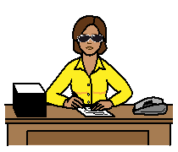

**Stepping into Internship.**

1. 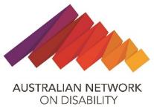The V.E.C. will find out more about access in the workplace.

Like talk to Australian Network on Disability.

1. 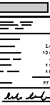The V.E.C will have staff information in

different ways. Like

Plain language icon

* Plain Language



* Easy English



* so you can listen to it

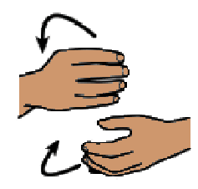

* sign language.

1. 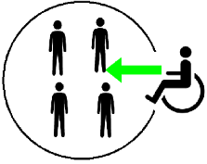All staff will learn how everyone can take part of all our meetings.



1. 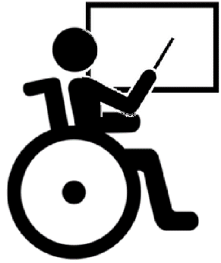All V.E.C. staff will do access training.

People with disability teach at some

of the training.

1. 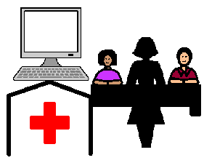Some staff will do

* website access training
* mental health training.

1. The V.E.C will be clear about tasks for

election staff. Like staff will

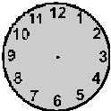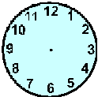

* have long hours. Staff may need to work from 8 am to 6 pm

A person standing

* need to stand for a long time



* need to sit for a long time



* need to count for a long time

**and**



* need to be able to lift boxes.

# a red cahin3. Working together

1. 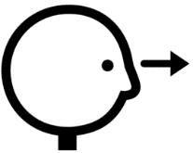The V.E.C. will look back at the rules for the

Access Group.

1.  The V.E.C. will listen to different people. Like

* the Access Group
* other people with lived experience

of disability.

1.  The V.E.C. will have people with disability teach other people about voting.
2. 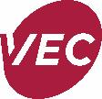The V.E.C. will make a new training program for support staff. It will help these staff teach people with disabilities about voting.
3. The V.E.C. will teach voting in

* disability support worker courses



* Special Schools

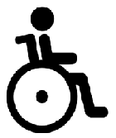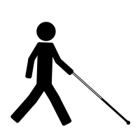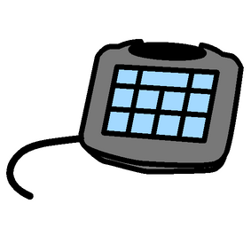

* Special Developmental Schools.



1. The V.E.C. will have more voting places that go to where people live. Like

* nursing homes
* mental health services.

1. The V.E.C. will send letters in

Plain Language. The V.E.C. will also send information in different ways.

Like so you can listen to it.

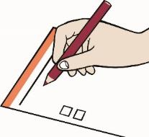

1. We will learn why some people with disability

do **not** vote.

# Thumbs up.4. Be the best we can be



1. The V.E.C. want our staff tell their stories about being part of the V.E.C.

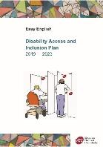



1. The plan will be in the V.E.C. report each year.
2. Staff will hear about this plan at

staff meetings.

1. 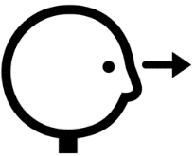We will look back at this plan every year.

We will change things when they do **not** work.

1. 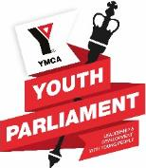There is a Youth Parliament in Victoria.

It is for school students.

The V.E.C. will talk to schools about more students with disability joining it.

# A report.Reports



The V.E.C will tell the Access Group

* what we have done



* what is good
* what is **not** good.

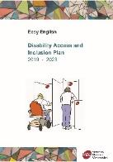



We will write a report about this plan each year.

# Information icon. **More information**



Phone 03 8620 1100



Email info@vec.vic.gov.au

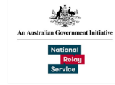

National Relay Service 1800 555 600



V.E.C.

Level 11, 530 Collins St. Melbourne 3000

**Images**

We have used images from

* Inspired Services
* Mayer-Johnson
* Picto-selector
* Pinterest
* The Noun Project.

We can use the

* AND logo
* Youth Parliament logo.

This plan is based on V.E.C. Disability Access and Inclusion Plan 2019 - 2023. August 2019.

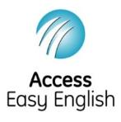Access Easy English wrote the Easy English.

November 2019.

© State of Victoria (Victorian Electoral Commission) November 2019.

This work, Disability Access and Inclusion Plan, is licensed under a Creative Commons Attribution 4.0 licence (http://creativecommons.org/licenses/ by/4.0/). You are free to re-use the work under that licence, on the condition that you credit the State of Victoria (Victorian Electoral Commission) as author, indicate if changes were made and comply with the other licence terms. The licence does not apply to any branding, including government logos.

**

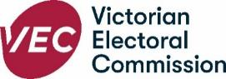

Level 11, 530 Collins Street  
Melbourne Victoria 3000  
T 131 832  
info@vec.vic.gov.au  
vec.vic.gov.au

