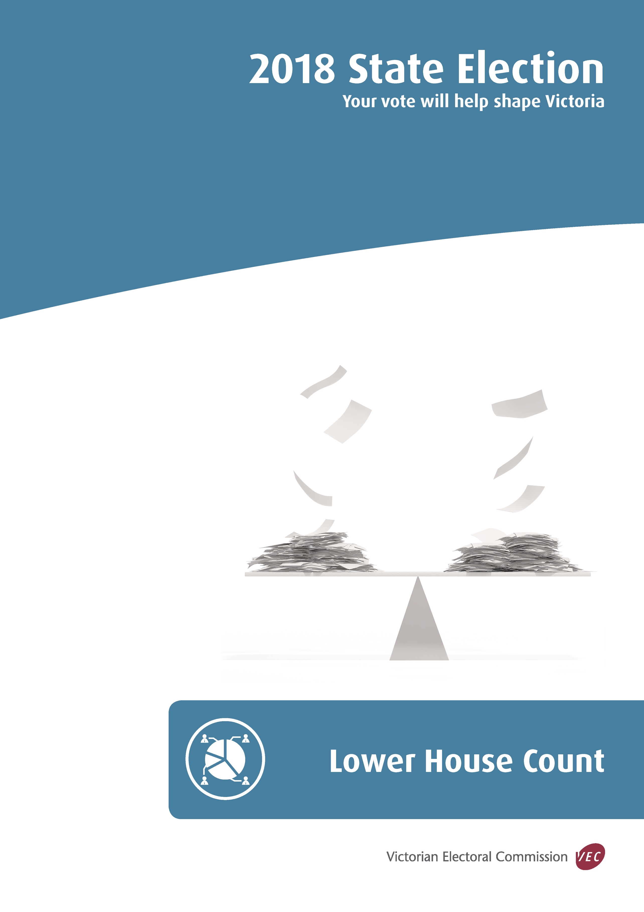

State of Victoria (Victorian Electoral Commission)
October 2018
Version 1.0

This work, Lower House Count, is licensed under a Creative Commons Attribution 4.0 licence [http://creativecommons.org/licenses/by/4.0/]. You are free to share this work under that licence, on the condition that you do not change any content and you credit the State of Victoria (Victorian Electoral Commission) as author and comply with the other licence terms. The licence does not apply to any branding, including Government logos.
Contents
Introduction 1
Count overview 2
Vote types 3
Scrutineers 4
Detailed count process 5
Voting centres – election night 5
Election offices – primary and 2CP counts 5
Postal vote count centre (PVCC) – primary and 2CP counts 6
District rechecks 6
Absolute majority 6
District preference distributions 6
Recounts 8
Declaration of result 9
Two-party-preferred counts 10
Appendix 1: Formality of ballot papers 11
Damaged ballot papers 15
Appendix 2: Lower House count timetable 16
Appendix 3: Sample preference distribution report 17

Introduction
There are 88 members of the Victorian Legislative Assembly (Lower House) and each member represents one electoral District. Full preferential voting applies for the Lower House and electors must number all the boxes on their District ballot paper in the order of their choice. A guide to ballot paper formality for the Lower House is included in Appendix 1.
The Victorian Electoral Commission (VEC) will establish 1,795 voting centres across Victoria to facilitate voting on election day and will establish approximately 150 early voting centres within Victoria, at interstate venues and overseas locations.
The VEC will provide mobile voting services at approximately 1,100 venues in the two weeks before election day to enable those in aged care facilities, hospitals, homeless agencies and prisons the opportunity to vote.
Accordingly, votes for one District could come from up to 3,000 voting locations across Victoria, from interstate and overseas.
In addition, the VEC is expecting to process in excess of 350,000 postal vote applications from electors. Completed postal votes are returned to a central location and marked as returned through the election management system (EMS).
Eighty-eight Election Managers have been appointed to oversee the conduct of elections for each of the Lower House Districts. Election Managers will be responsible for consolidating all votes cast for their electorate and conducting the scrutiny, count and declaration for their District election.
This document outlines the process that the VEC will follow in conducting the count for Victoria’s 88 Lower House Districts at the 2018 Victorian State election.

Count overview
After the close of voting at 6.00 pm on election day, ordinary votes issued in election day voting centres will be counted in voting centres. The primary (first preference) and two-candidate-preferred (2CP) counts for the Lower House will take place first followed by the primary count for the Upper House.
Counting of postal votes for all Districts will commence at 6.00 pm on election night at the centralised Postal Vote Count Centre (PVCC). The District counts will be conducted in the same count order as District counts at voting centres. It is the aim that District ballot papers for all postal votes in the hands of the PVCC at close of voting on Friday 23 November will be counted on election night. Remaining postal votes will continue to be counted at the PVCC from Monday 26 November.
During the week following election day the PVCC will also be responsible for counting postal and early votes cast at interstate and overseas early voting centres, and early votes cast using Telephone Assisted Voting (TAV).
Counting of own District early votes will commence in election offices and some standalone early voting centres on election night, Saturday 24 November. Early vote counts will resume from Monday 26 November, and will continue until all early votes received have been counted. Absent votes will be counted following the completion of the declaration exchange from Tuesday after election day, once these votes are returned to the relevant District office.
Counting of accepted provisional votes will take place during the week following election day.
All primary and 2CP counts for early, absent, provisional and marked as voted votes for the Lower House will take place in District election offices. A full recheck of these ballot papers will take place in each District election office commencing Monday after election day. The rechecking of postal votes will take place at the PVCC.
Where preference distributions are required they will commence Monday 3 December. Postal votes held at the PVCC will be transported to relevant District election offices where preference distributions are required. It is anticipated that if a recount is necessary, this will commence on Tuesday 4 December.

Vote types

Ordinary | A vote issued to an elector who attends an election day voting centre in the District for which they are enrolled.
Absent | A vote issued to an elector who attends a voting centre outside their enrolled District on election day (s 109 EA)
Marked-as-voted | A vote issued to an elector who is found to be marked off the roll as having voted but declares they have not voted in the election (s 110 EA)
Early | A vote cast at an early or mobile voting centre before election day by an elector who is unable to attend a voting centre on election day (s 99 EA)
Postal | A vote cast by an elector who is unable to attend a voting centre on election day, and who has successfully applied for postal ballot paper(s)  (s 101 EA)
Provisional | A vote cast by a person who cannot be found on the roll but declares they are eligible to enrol and provides prescribed proof of identity (s 108 EA)
EA – Electoral Act 2002

Scrutineers
Candidates may appoint scrutineers to observe all counting processes in voting centres and at election offices. Scrutineers must submit to the person in charge at the counting venue a completed Appointment of Scrutineer form which has been signed by the candidate.
Each form must contain the candidate’s original signature; electronic signatures will not be accepted. The Election Manager can provide candidates with copies of these forms, or alternatively, they can be downloaded from the VEC website at vec.vic.gov.au.
Candidates may appoint one scrutineer for every election official involved in the counting of ballot papers. Candidates will be advised of counting times and the number of election officials expected to be involved in the count.
The VEC has published a handbook for scrutineers which outlines their role and responsibilities. Election Managers will have copies of the handbook and they are also available at vec.vic.gov.au

Detailed count process

Voting centres – election night
District ballot papers completed by electors in voting centres on election day will be sorted and counted in each voting centre following the close of voting at 6.00 pm on election night.
These counts will include primary (first preference) results for each candidate and a two-candidate-preferred count (2CP). The 2CP count involves the distribution of preferences to the two candidates considered most likely to be in the lead after a distribution of preferences. The Electoral Commissioner selects two candidates in each District for this purpose. The 2CP count provides an early indication of the result of the election but does not influence the final result.
Voting centre managers will phone primary and 2CP results through to election offices where they will be entered into the VEC’s computerised election management system (EMS) and published on the VEC’s website.
In situations where the two candidates selected do not turn out to be the two leading candidates, the two-candidate-preferred counts will be redone after election day.

Election offices – primary and 2CP counts
All primary and 2CP counts for absent, early, marked-as-voted and provisional votes will be conducted in District election offices commencing on election night and continuing during the week following election day. Primary and 2CP count results will continue to be entered into the VEC’s election management system and published on the VEC’s website.
After the close of voting on election night, own District early vote counts will take place in each election office and some standalone early voting centres. In addition, completed ballot papers from early voting centres and mobile voting teams for other Districts will be sorted according to the District and Region they belong. They will be reconciled and packaged ready for dispatch to their home election office via the declaration exchange.
On Sunday following election day, all absent, marked-as-voted, provisional and early votes will be sorted and packaged ready for collection from each District office on Monday morning. These votes will be taken to the VEC warehouse (declaration exchange) where they will be sorted and dispatched to their home election office.
The acceptance of provisional vote declarations will be determined by the VEC’s enrolment branch who will advise Election Managers of admissibility from Tuesday 27 November.
Primary counts for early votes will continue in District election offices from Tuesday 27 November and will continue during the following week when further early votes are received from other electorates via the declaration exchange. Primary counts for absent and provisional votes will also take place during this period.
The Election Manager is able to provide candidates and scrutineers with consolidated reports for primary and 2CP counts. The results will also be published progressively on the VEC website.
The proposed timetable for the conduct of Lower House counts is included in Appendix 2.

Postal vote count centre (PVCC) – primary and 2CP counts
Primary and 2CP counts for postal votes will be conducted at the Postal Vote Count Centre (PVCC) commencing on election night and continuing during the week following election day. Primary and 2CP count results will continue to be entered into the VEC’s election management system and published on the VEC’s website.

District rechecks
All ballot papers from voting centres and absent, early, marked-as-voted and provisional vote parcels will be rechecked in Election Offices for correct counting and sorting. Rechecking of postal vote parcels will take place at the PVCC. Rechecks will commence from Monday 26 November and will continue until Monday 3 December. Rechecked results will be entered progressively into the VEC’s election management system and will be published on the VEC website.
It is not uncommon for minor variations in sorting and counting to be identified during the rechecking process. The Election Manager can provide candidates and scrutineers with a consolidated report of rechecked results and consolidated recheck results will be published on the VEC website.

Absolute majority
In order to be elected for the Lower House, a candidate must achieve an absolute majority (more than 50%) of the formal vote. If a candidate has achieved an absolute majority after first preferences have been counted, the Election Manager will declare that candidate elected.
If no candidate has achieved an absolute majority or is not likely to achieve an absolute majority after all first preferences have been counted, the Election Manager will arrange for a preference distribution to be conducted.

District preference distributions
If a preference distribution is required, the Election Manager will advise all candidates of the time and place that the preference distribution will take place. It is expected that preference distributions will take place from Monday 3 December. Where a preference distribution is required the VEC will make arrangements for postal votes held at the PVCC to be transported to relevant election offices for inclusion in the preference distribution.
Before the preference distribution commences, the Election Manager will amalgamate all first preference ballot papers for each candidate from the rechecked parcels of votes. The total ballot papers will be confirmed after amalgamation to ensure that it matches the total ballot papers from all rechecked voting centre/ballot paper packages.
There are usually 6-10 election officials involved in a preference distribution who work under the guidance of a Team Leader.
During a preference distribution:
- the candidate with the lowest number of first preference votes is excluded, and that candidate’s votes are distributed to the remaining candidates according to the second preferences on the ballot papers;
- the total votes received by the remaining candidates during the distribution are added to their first preference totals and a further check is conducted to see if any candidate has achieved an absolute majority;
- if no majority is achieved, the candidate with the lowest progressive total is excluded next, and their votes are distributed to the remaining candidates according to the next available preference;
- the process of excluding the lowest candidate and distributing that candidate’s votes to the remaining candidates continues until one candidate has an absolute majority of votes, and is declared elected.
A sample report showing the result of a preference distribution is included in Appendix 3.

Recounts
Following the calculation of the result, but before a candidate has been declared elected, a recount may be conducted at the Election Manager’s discretion, at the request of a candidate, or if directed by the Commission.
A recount involves:
- a complete recheck of each ballot paper for correct formality and sorting;
- a full recount of first preference votes for each candidate and informal; and
- a full preference distribution following the rechecking and recounting of first preference votes (where required).
During a recount the Electoral Commissioner rules on disputed ballot papers.
The VEC aims to achieve an accuracy of 99.98% via its counting and rechecking processes and has a proven track record of achieving at least this. Accordingly as a general guide, a recount will only take place if the margin at a critical exclusion is less than 0.05% of total votes counted.

Declaration of result
Once the result of the election is determined, and it is clear that no outstanding votes can affect the result, the Election Manager will arrange to formally declare the result of the election.
The Election Manager will advise all candidates of the time and location for the declaration.
It is expected that Lower House declaration ceremonies will take place between Friday 30 November and Friday 7 December 2018.

Two-party-preferred counts
The VEC prepares two-party-preferred statistics following each State election. The purpose of the two-party-preferred vote is to show, for each electorate and for the State as a whole, how the vote is divided between the ALP and the Liberal and National Parties, taking into account the preferences of people who vote for minor parties and independents.
In Districts where a preference distribution is conducted to determine the result, where the distribution continues until only two candidates are left in the count, and where the final distribution is between a Labor and a Liberal/National candidate, the final result of the preference distribution will be used for the two-party-preferred vote. In Districts where a preference distribution is not conducted or cannot be used (because there were more than two candidates still in the count when the result was determined, or because the distribution was not between a Labor and a Liberal/National candidate), the two-candidate–preferred count will be used for the two-party-preferred votes as long as the two-party-preferred count was between Labor and Liberal/National. In Districts where neither the preference distribution nor the two-candidate-preferred count is between a Labor and a Liberal/National candidate, a special two-party-preferred count will be conducted. Election Managers will conduct these counts in their offices once all other counting responsibilities have been completed. Candidates will be notified when these counts will be conducted. There were six special two-candidate-preferred counts conducted for the 2014 election.

Appendix 1: Formality of ballot papers
District formality rules are:
- each ballot paper must have a number 1 in, adjacent to, or level with one box’
- all boxes should be numbered using the full sequence of numbers as indicated on the ballot paper. The only exception is where one box is left blank and would logically have contained the last preference, i.e. with six candidates, the number 6 may be omitted’
- more than one box left blank makes the vote informal’
- any duplication or omission of a number from the sequence makes the vote informal’
- numbers next to, or on the other side of the names, are acceptable providing the elector’s intention is clear’
- amendments are acceptable providing the elector’s intention is clear. All other marks are to be ignored’
- the number ‘0’ (zero) makes the vote informal. It is outside the range of numbers indicated in the instructions on the ballot paper’
- poorly formed numbers must be considered in the context of the whole ballot paper and are acceptable if they can reasonably be construed as numbers comprising part of the sequence’
- unconventional but recognisable numbers such as continental 1s and 7s are acceptable. Roman numerals are also acceptable if all numbers are clearly represented in this format. Other ‘non-English’ characters are not acceptable. Numbers may be written one, two, etc., but only in English’
- ticks, crosses, As and Bs, etc. are not acceptable as indicators of preference’
- a ballot paper that has not been initialled by an election official is not excluded for that reason alone, provided it is printed on VEC official security paper.
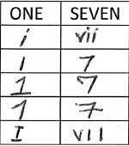
Examples of recognisable numbering

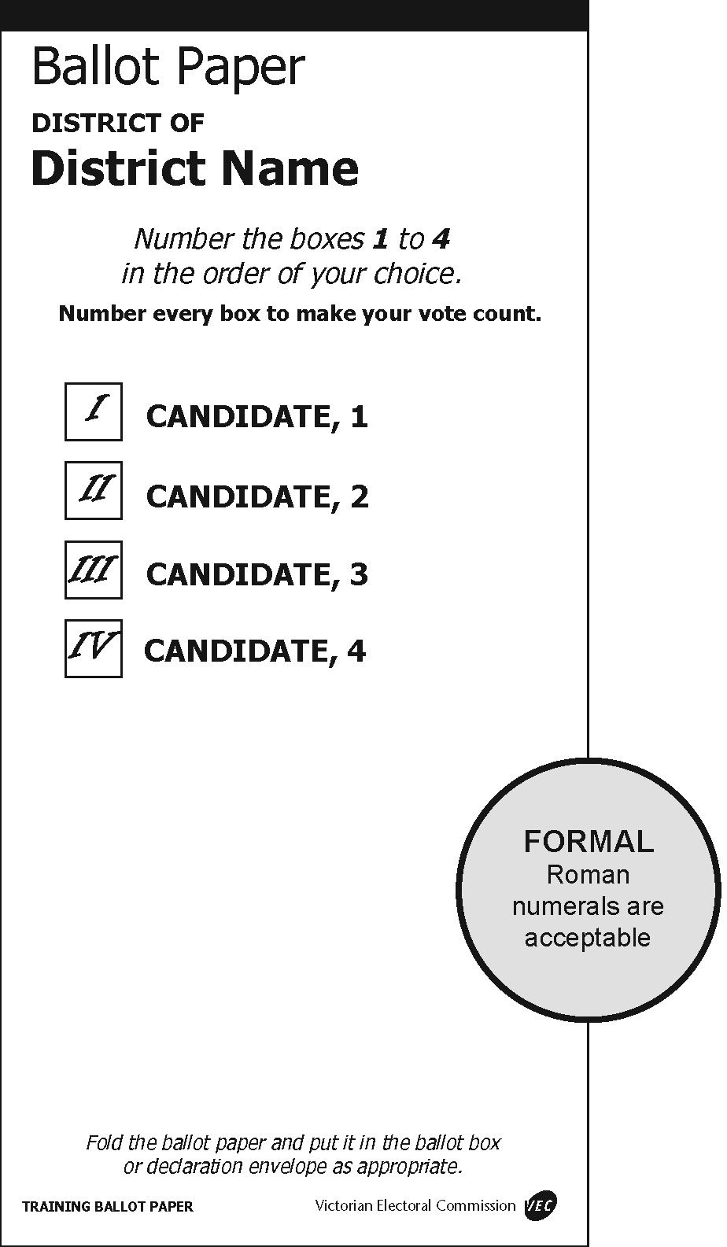 | 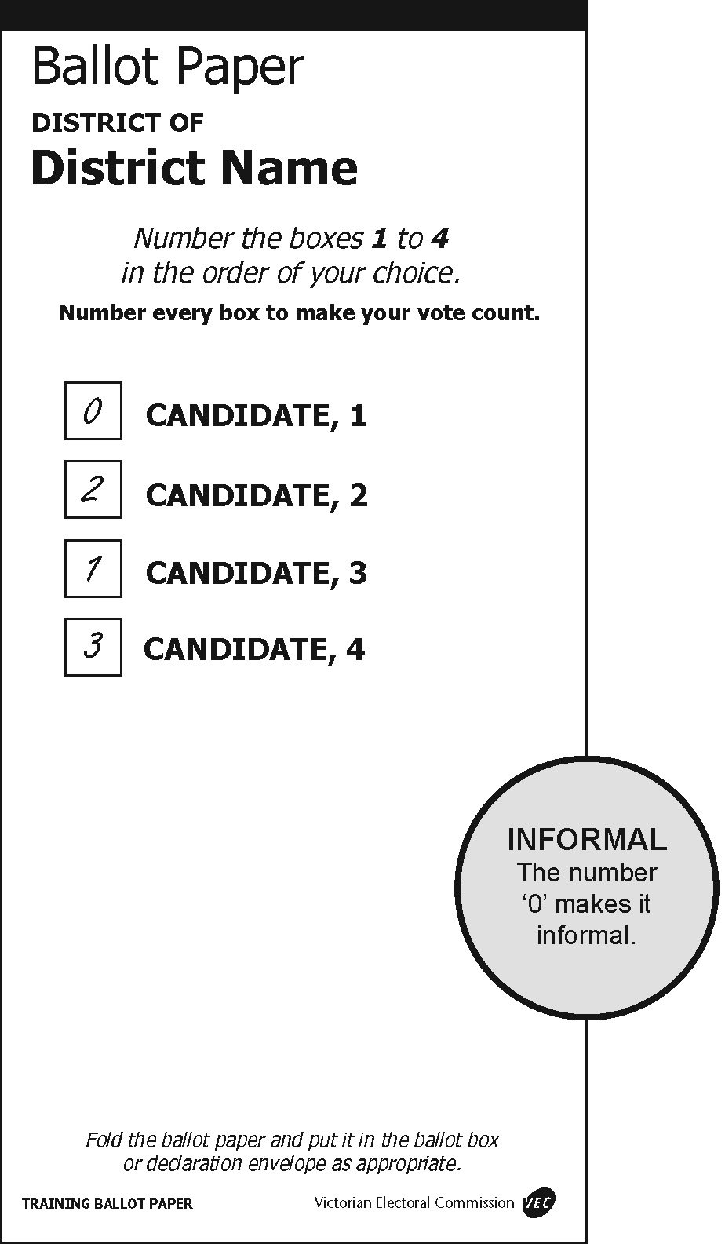
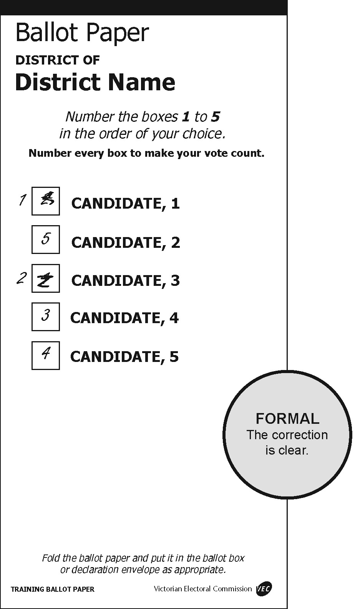 | 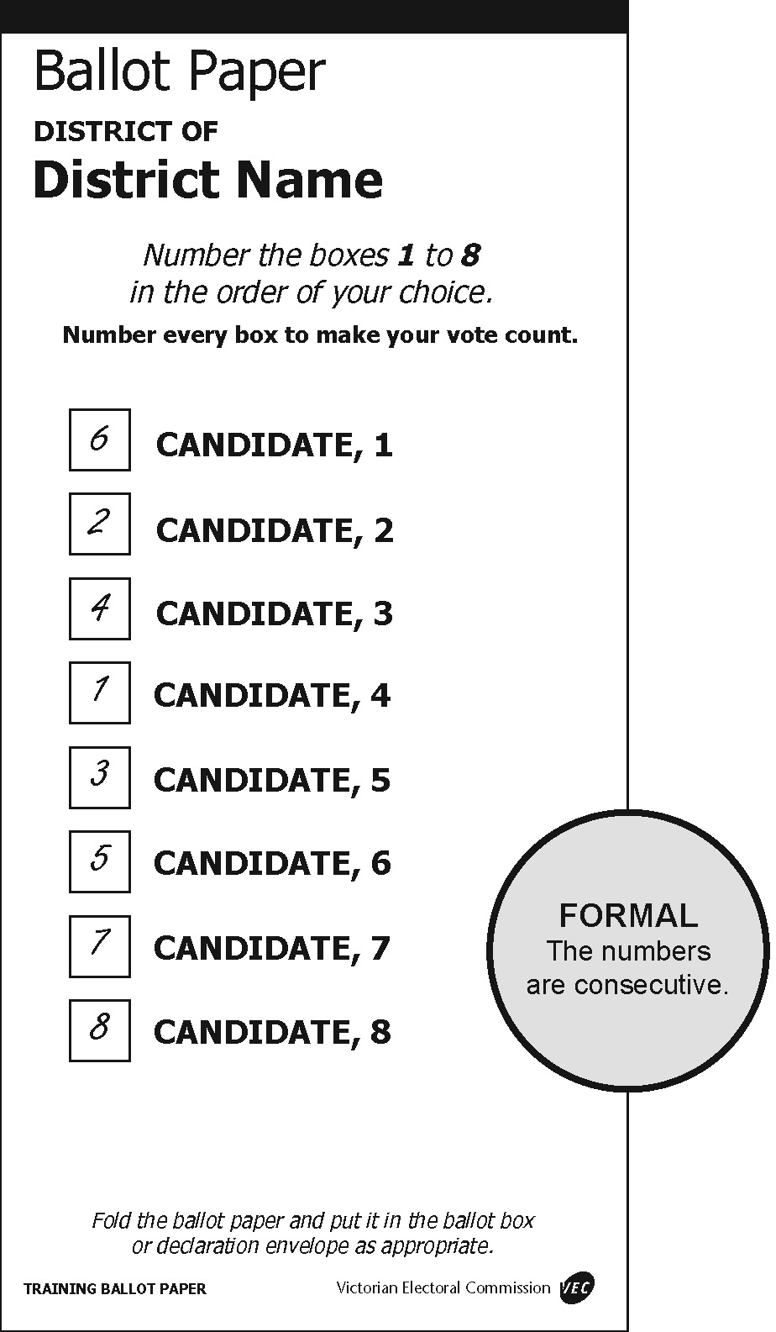

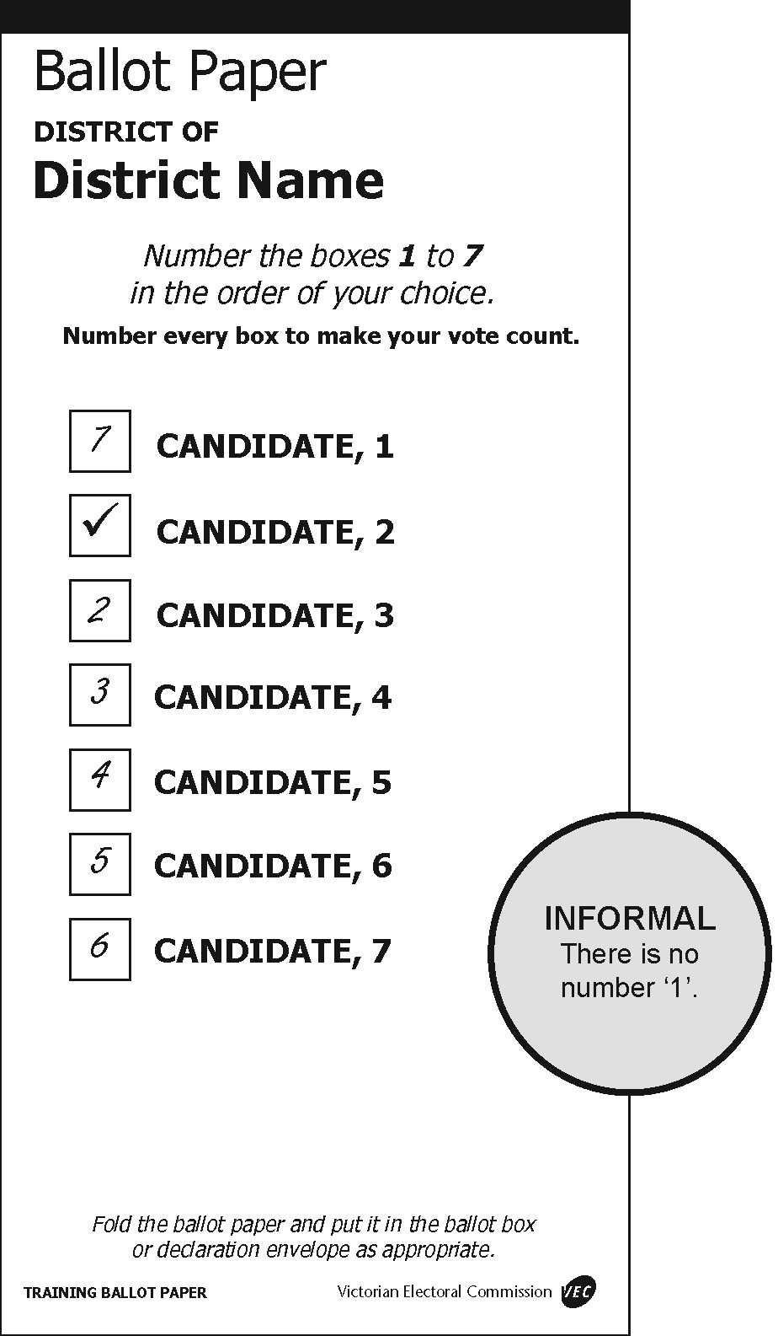 | 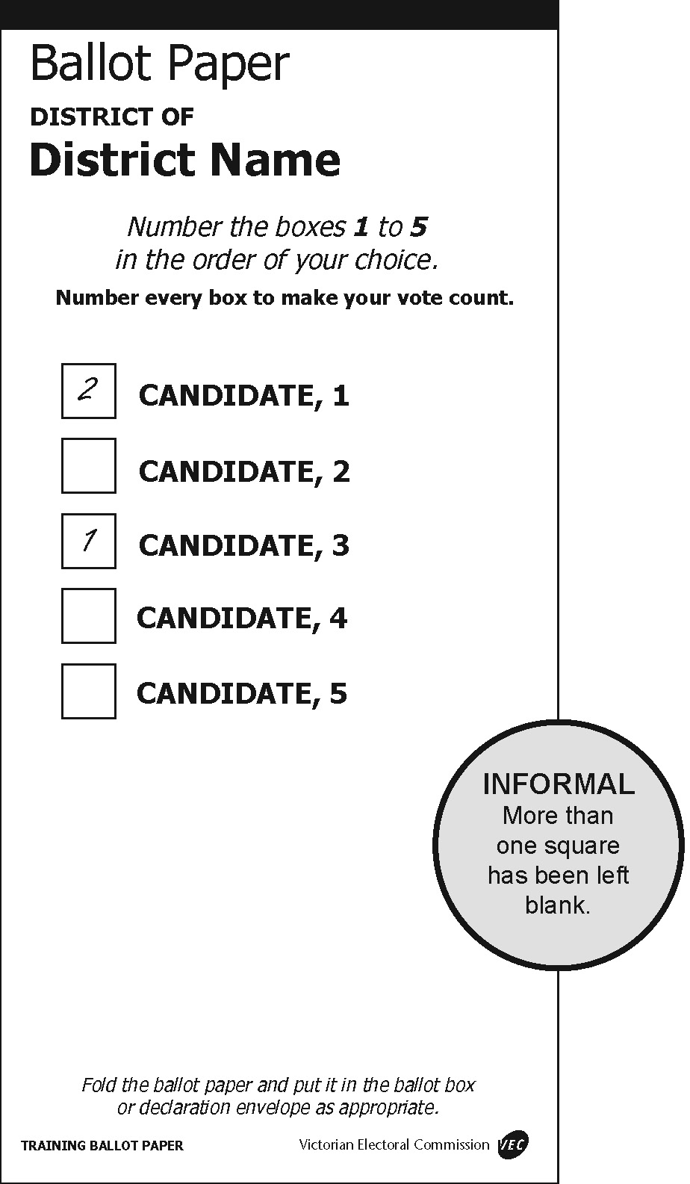
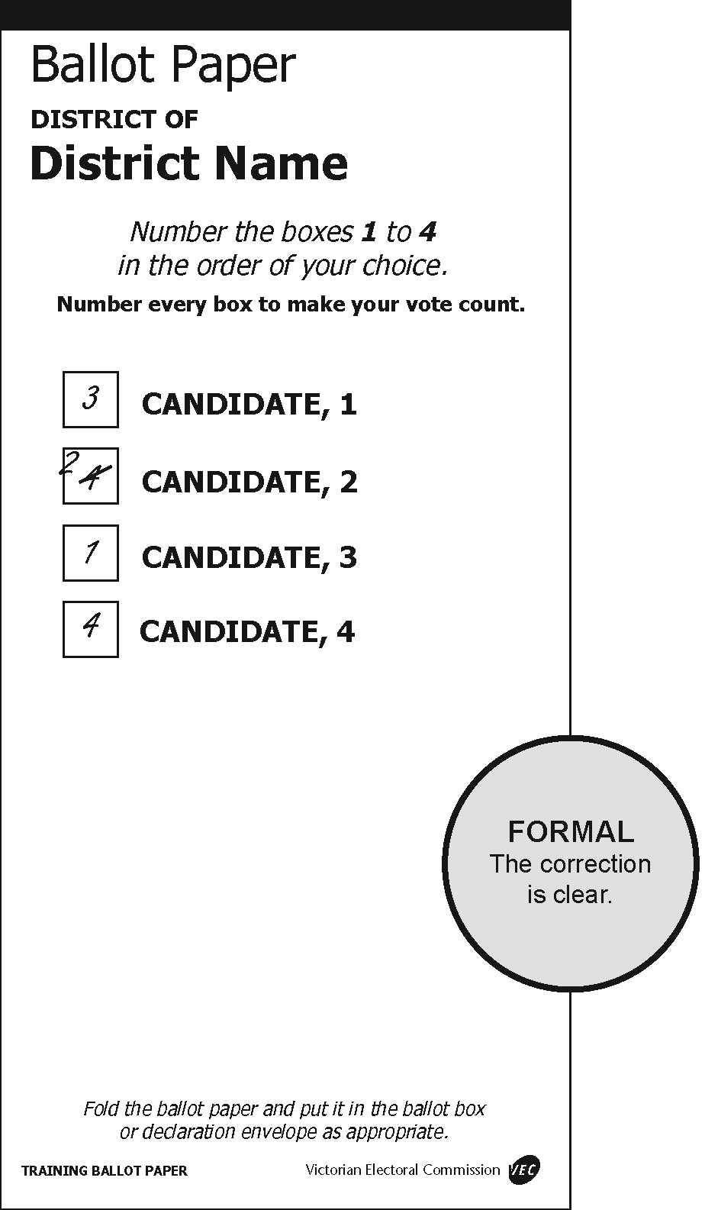 | 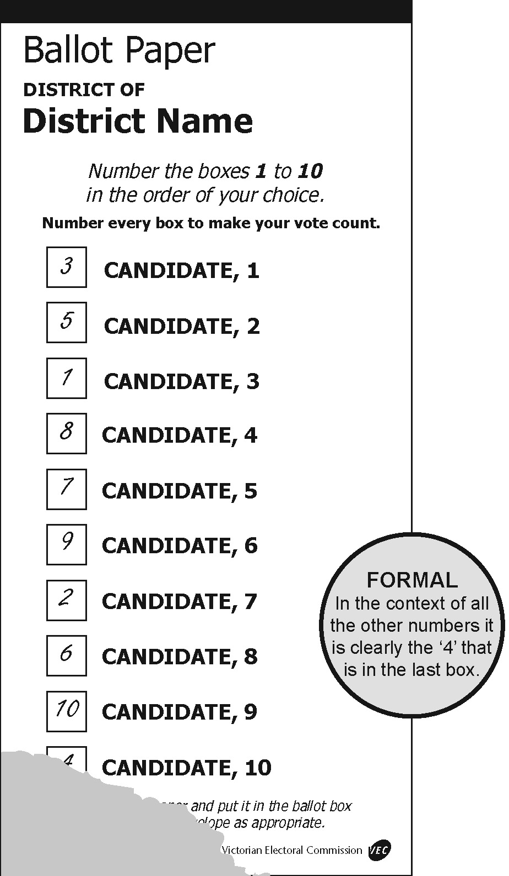
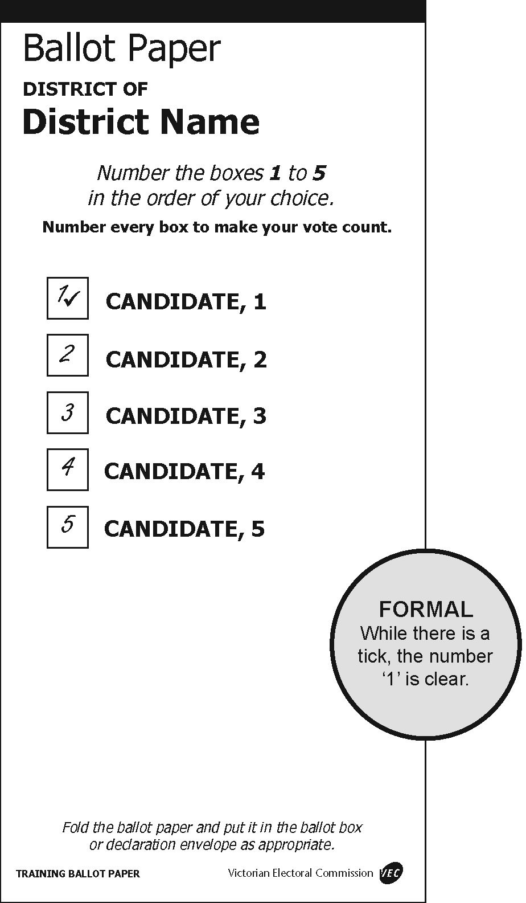 | 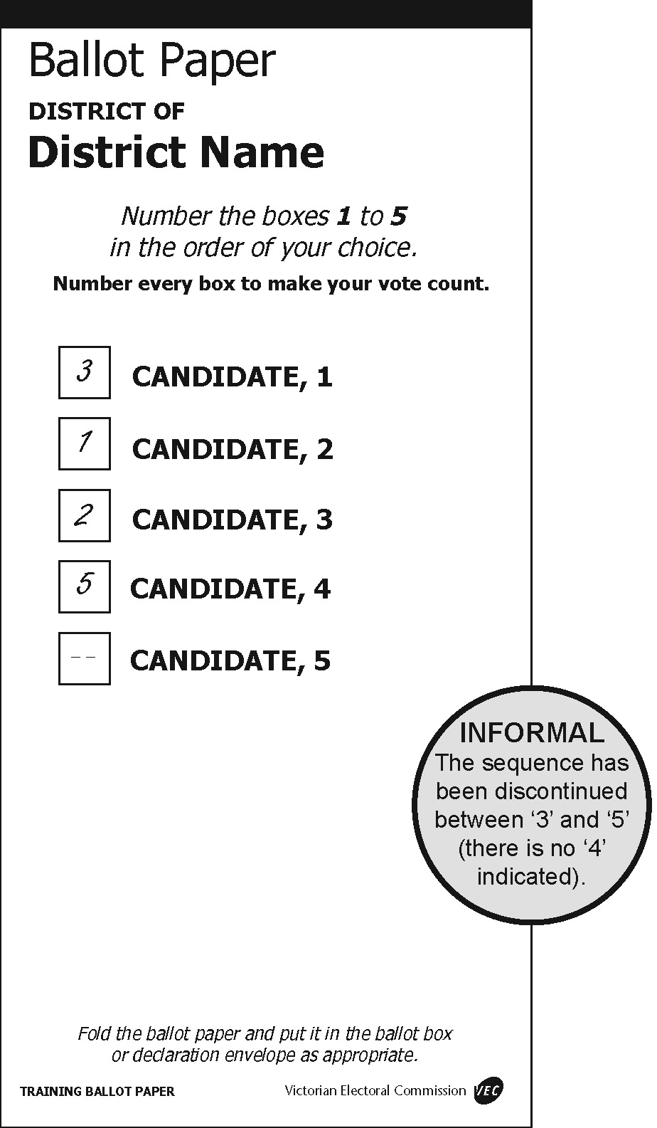
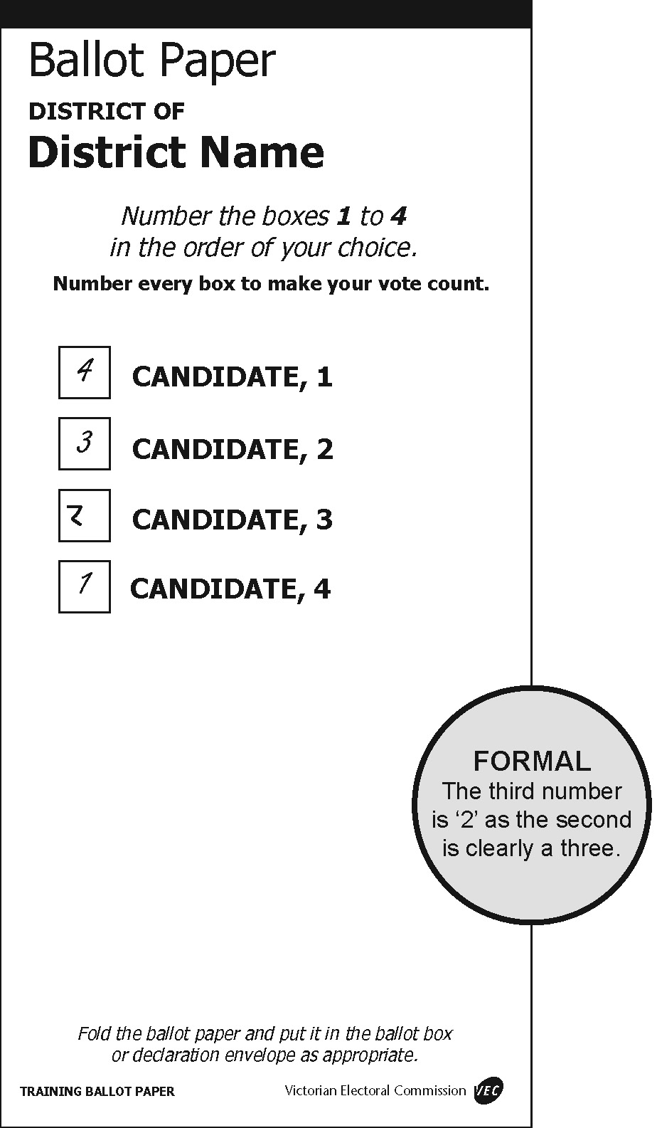 | 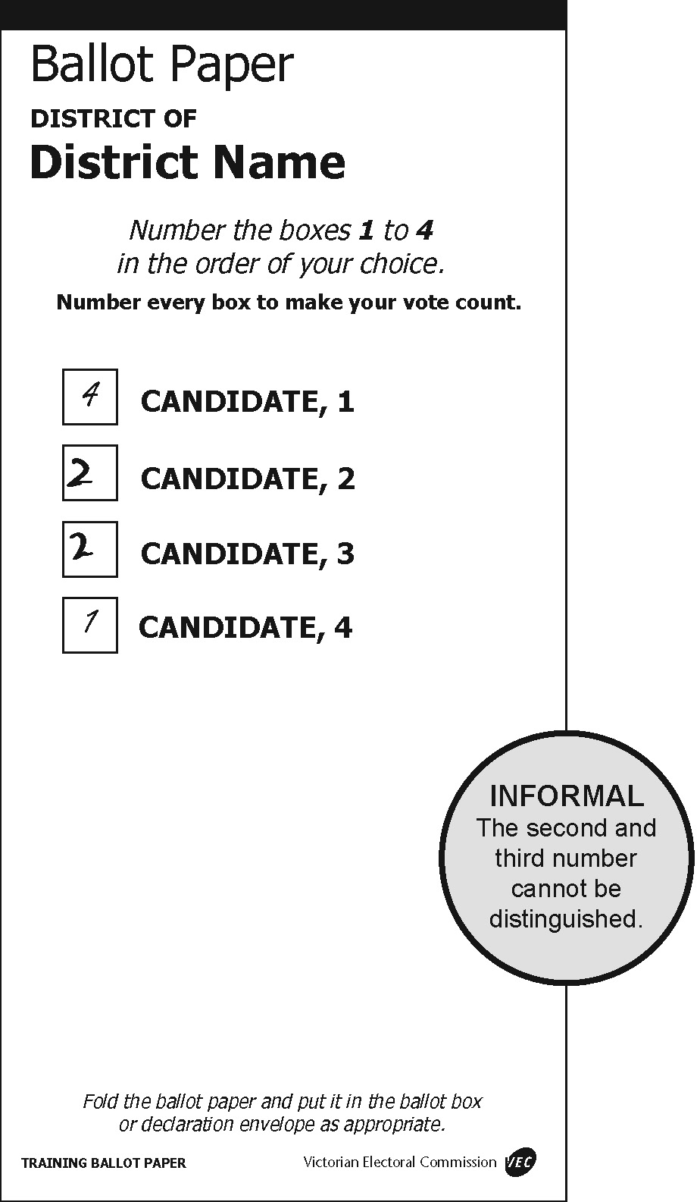

Damaged ballot papers
Election officials from time to time may come across ballot papers that have been torn or cut. Where ballot papers are cut or torn during processing by an election official, and the different parts can be identified beyond doubt as having originated from the same ballot paper, officials will tape the pieces and count as one ballot paper.
Where an official can determine an elector had access to all candidate and party information on the ballot paper when recording their preferences, such a ballot paper can be ruled ‘formal’ if all formality requirements have otherwise been met. If from the intact part the official can determine that the elector had access to the names of all candidates and their affiliations then look at the formality requirements.
In situations where the ballot paper has been torn across one of the boxes for recording preferences, the ballot paper may still be deemed formal if the preference recorded in the box can be determined. See the following examples for illustrations of these principles.
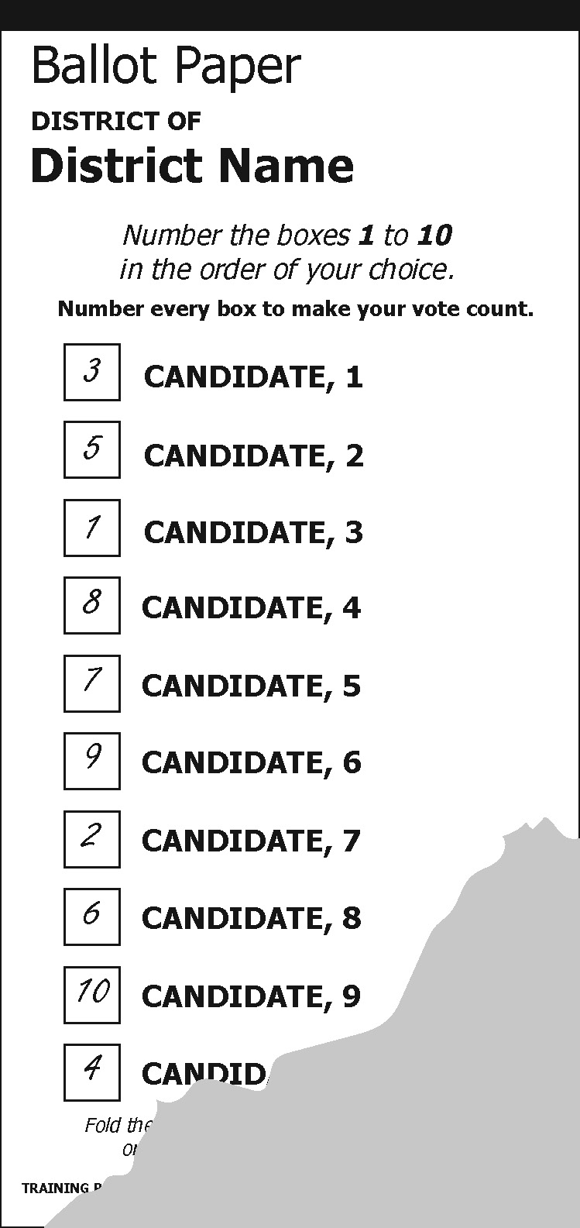 | 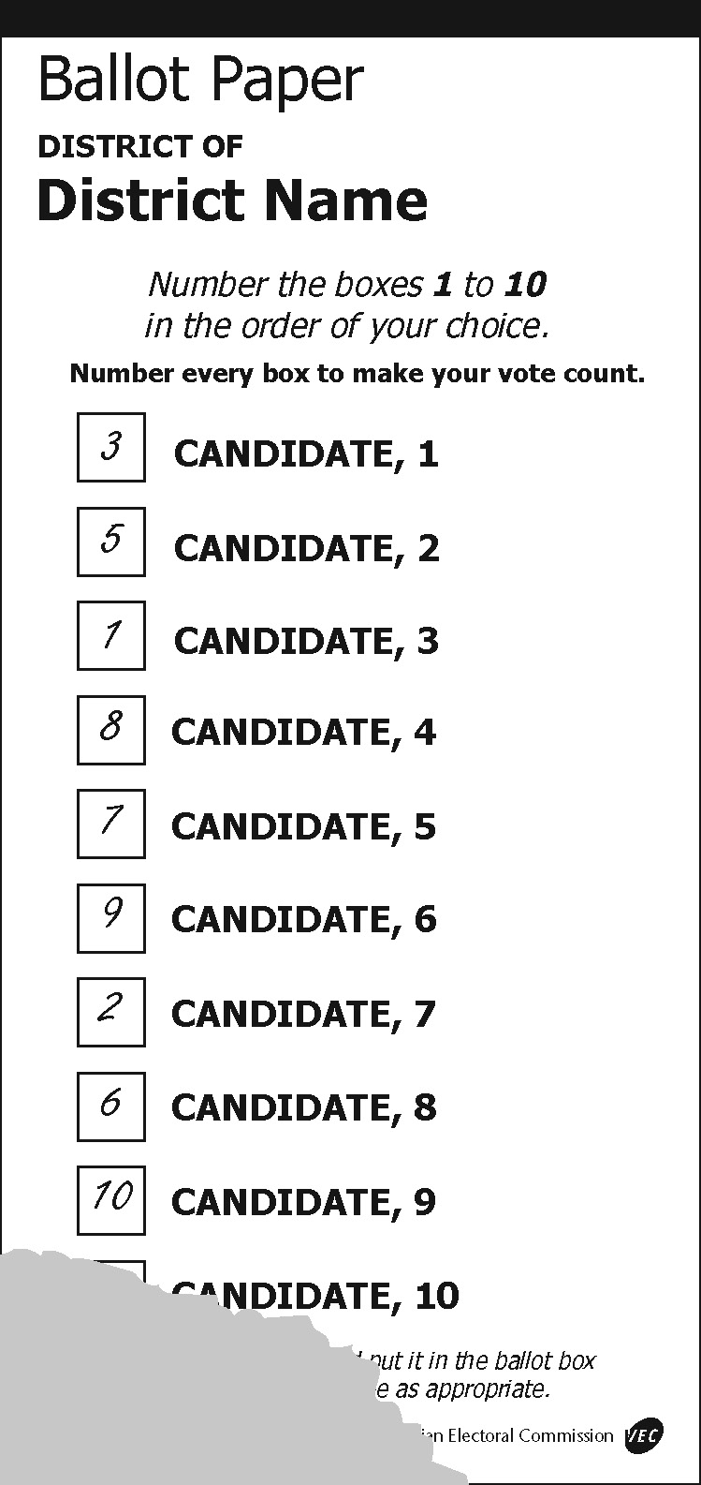 | 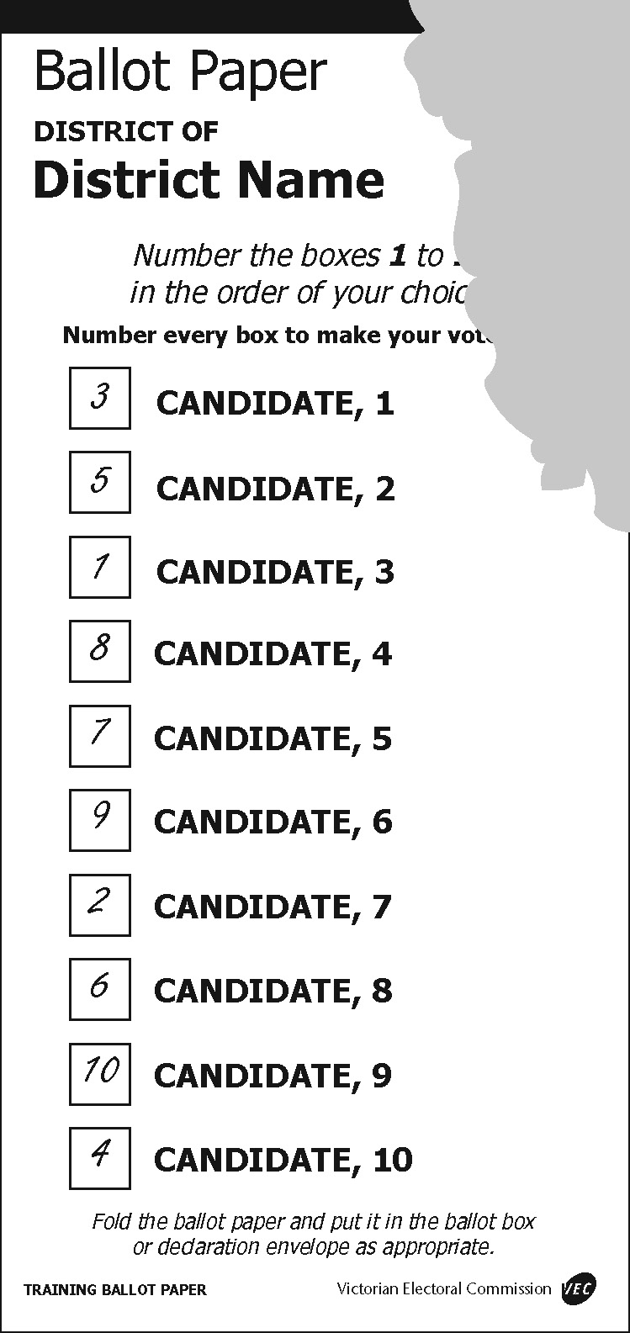
Formal: All the preferences are discernible. | Informal: The number 4 is missing and the official cannot be sure that it existed. | Formal: As long as the paper can be identified as being printed by the VEC the removal of the official’s initials does not make the ballot paper informal.

Appendix 2: Lower House count timetable
Date | Notes | Early Votes  Primary, 2CP and Recheck | Ordinary Votes  Primary, 2CP and Recheck | Absent Votes  Primary, 2CP and Recheck | Postal Votes  Primary, 2CP and Recheck | Marked as Voted (MAV) and Provisional Votes  Primary, 2CP and Recheck | Preference Distributions and Recounts | 2PP where required
Saturday 24 November | Election Day | 4.00 – 6.00 pm: Sort own District votes.  6.00 pm: Primary and 2CP count of own District votes. Sort other Districts. | Primary and 2CP count in voting centres | Commence sort/package of Absent votes for inclusion in dec exchange | 8.00 am: Extract and sort all admitted votes at Postal Vote Count Centre (PVCC).  6.00 pm: Primary and 2CP count. | Commence sort/package of MAV and Provisional votes for inclusion in dec exchange
Sunday 25 November | Preparation for dec exchange | Complete sort/package for dec exchange |  | Complete sort/package for dec exchange | Election offices package postal votes for dispatch to PVCC | Complete sort/package for dec exchange
Monday 26 November | Dec exchange collected | Correct any incorrect 2CPs.  Commence rechecks. | Correct any incorrect 2CPs.  Commence rechecks. |  | Correct any incorrect 2CPs.  Extraction and primary, 2CP and recheck counts for close seats only (at PVCC). | Provisional vote checking commences at VEC (close seats prioritised)
Tuesday 27 November | Dec exchange received | Complete 2CP corrections.  Continue Primary, 2CP and recheck counts. | Complete 2CP corrections.  Continue rechecks. | Commence marking absent votes off election roll | Complete 2CP corrections.  Commence rechecks. Continue counts for close seats only. | Commence primary, 2CP and recheck counts of admitted provisional votes
Wednesday 28 November |  | Continue Primary, 2CP and recheck counts | Complete rechecks | Commence primary, 2CP and recheck counts. | Continue rechecks.  Continue counts for close seats.
Thursday 29 November |  | Complete Primary, 2CP and recheck counts. |  | Complete primary, 2CP and recheck counts | Continue rechecks.  Continue counts for close seats. | Primary, 2CP and recheck all MAV votes.
Friday 30 November | Last day to accept postal votes into count (6.00 pm) |  |  |  | Complete rechecks.  Continue counts for close seats. | Complete checking at VEC.  Complete primary, 2CP and recheck counts of admitted provisional votes.
Saturday 1 December |  | Complete primary, 2CP and recheck counts of votes returned from interstate/ overseas (at PVCC) |  |  | Conduct primary, 2CP and recheck counts of remaining postal votes
Sunday 2 December
Monday 3 December |  | PVCC dispatches early votes to Districts requiring preference distributions |  |  | PVCC dispatches postal votes to Districts requiring preference distributions |  | Commence amalgamation (where preference distribution is required)
Tuesday 4 December |  |  |  |  |  |  | Commence preference distributions.  Commence recounts (where required)
Wednesday 5 December |  |  |  |  |  |  | Complete preference distributions.  Continue recounts (where required). | Commence 2PP counts
Thursday 6 December |  |  |  |  |  |  | Continue recounts (where required)
Friday 7 December |  |  |  |  |  |  | Complete any recounts
Saturday 8 December
Sunday 9 December
Monday 10 December |  |  |  |  |  |  |  | All 2PP counts completed
Tuesday 11 December
Wednesday 12 December
Thursday 13 December
Friday 14 December
Saturday 15 December | Last Day for Return of Writs
Notes:
This is a proposed timeline only. Timings are subject to change and close seats will have their timelines expedited where possible
Activities will occur at the election office unless stated otherwise
All primary counts will be followed by a 2CP distribution, and then a recheck of all ballot papers
2CP results will not be adjusted after rechecks are conducted. Therefore, there may be some minor variations between 2CP and recheck totals
District declarations will commence from Friday 30 November 2018

Appendix 3: Sample preference distribution report
Distribution of Preference Votes
State Election 2006
Kilsyth District
Total valid first preference votes polled for all candidates 34611
Number of votes required to constitute an absolute majority on first count 17306
Number of informal votes 1412
Candidates Names (in ballot-paper order) | SCHWAB, Gillian | BEARD, Dympna | CRAIG, Salore | HILL, Patsy | HODGETT, David | TOTAL
Total first preference votes recorded for each candidate | 2332 | 13458 | 2982 | 742 | 15097 | 34611
Transfer of 742 ballot-papers of HILL, Patsy (1st excluded candidate) | 116 | 150 | 330 |  | 146 | 742
Progressive Total | 2448 | 13608 | 3312 |  | 15243 | 34611
Transfer of 2448 ballot-papers of SCHWAB, Gillian (2nd excluded candidate) |  | 714 | 444 |  | 1290 | 2448
Progressive Total |  | 14322 | 3756 |  | 16533 | 34611
Transfer of 3756 ballot-papers of CRAIG, Salore (3rd excluded candidate) |  | 2861 |  |  | 895 | 3756
FINAL TOTAL |  | 17183 |  |  | 17428 | 34611
Name of ELECTED candidate: HODGETT, David



