ELECTORAL REPRESENTATION REVIEW
Hobsons Bay City Council
Final Report
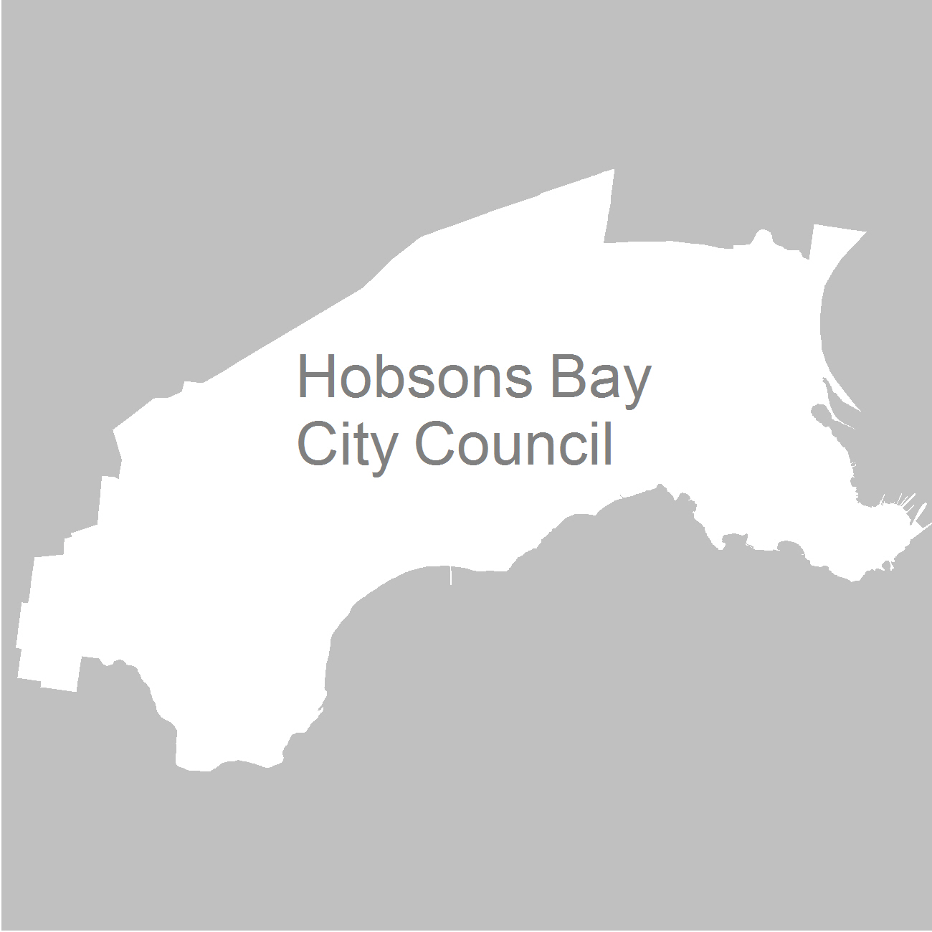

11 April 2012

Contents
Recommendation 4
Background 5
Legislative basis 5
The VEC and electoral representation reviews 5
Profile of the City of Hobsons Bay 6
Current electoral structure 6
The electoral representation review process 6
VEC research 7
Public involvement 7
Advertising 8
Media releases 8
Public information session 8
Information brochure and poster 8
Helpline 9
VEC website 9
Guide for Submissions 9
Preliminary report 10
Preliminary submissions 10
Preliminary options 10
Public response 21
Response submissions 21
Analysis of submissions 21
Public hearing 22
Findings and Recommendation 23
Recommendation 27
Appendix 1: List of submitters 28
Appendix 2: Map 30

Recommendation
The Victorian Electoral Commission (VEC) recommends that Hobsons Bay City Council consists of seven councillors, to be elected from a three-councillor Strand Ward, a two-councillor Cherry Lake Ward and a two-councillor Wetlands Ward.

Background

Legislative basis
The Local Government Act 1989 (the Act) requires the VEC to conduct an Electoral Representation Review of each municipality in Victoria at least every 12 years. The Act specifies that the purpose of a representation review is to recommend to the Minister for Local Government the number of councillors and the electoral structure for a municipality, which will provide ‘fair and equitable representation for the persons who are entitled to vote at a general election of the Council’.
The Act requires the VEC, as part of an Electoral Representation Review, to consider:
- the number of councillors in a municipality;
- whether a municipality should be unsubdivided or subdivided;
- if it should be subdivided, whether ward boundaries:
  - provide for fair and equitable division of the municipality;
  - ensure equality of representation through the number of voters being represented by each councillor being within 10 per cent of the average number of voters represented by all councillors; and,
- if it should be subdivided, the number of councillors that should be elected for each ward.

The VEC and electoral representation reviews
The VEC has conducted electoral representation reviews since 2004 on appointment by local councils. The Act was changed in 2010 to define the VEC as the only agency authorised to undertake the reviews.
The VEC drew on its experience in mapping and boundary modelling and also engaged consultants with experience in local government to provide advice on specific local representation issues during the review.

Profile of the City of Hobsons Bay
The City of Hobsons Bay was formed in 1994 by the amalgamation of the Cities of Altona and Williamstown, the Laverton area of the City of Werribee and the Kingsville South district and the Francis Street wharf area of the City of Footscray. The city is located to the south-west of metropolitan Melbourne. Localities within the City include Altona, Altona East, Altona Meadows, Altona North, Brooklyn, Laverton, Newport, Spotswood, Williamstown and Williamston North.
At the 2006 census, the City recorded a population of 81,459. Over the next ten years, the population is projected to grow by 7.2 per cent. The highest projected growth rate is in the Williamstown area with a population growth of 12.9 per cent. Altona is forecast a lower rate of growth at 3.7 per cent.

Current electoral structure
The last electoral representation review for the Hobsons Bay City Council took place in 2004. Following the review, the Minister for Local Government determined that the structure of Hobsons Bay City Council would consist of seven councillors to be elected from seven single-councillor wards.
Before the 2004 representation review, the Council comprised four wards with two councillors elected for each ward. The VEC recommended that Hobsons Bay should consist of seven councillors to be elected from seven single-councillor wards. The recommendation for an odd number of councillors stemmed from the need to overcome the many deadlocks that had occurred at Hobson Bay City Council meetings. Votes were frequently tied and the mayor often had to use a casting vote. An odd number of councillors would facilitate clear policy direction on a majority decision basis. The VEC recommended seven, rather than nine, councillors for the City of Hobsons Bay because seven councillors would bring the voter/councillor ratio closer to the metropolitan average of 10,872 (at 9,028). The VEC recommended single-councillor wards because it considered that these fitted the communities of interest within the City.

The electoral representation review process
The VEC proceeded on the basis of three main principles:
- Ensuring the number of voters represented by each councillor is within 10 per cent of the average number of voters per councillor for that municipality.
Populations are continually changing. Over time these changes can lead to some wards having larger or smaller numbers of voters. As part of the review, the VEC corrected any imbalances and also took into account likely population changes to ensure these boundaries provide equitable representation until the next review.
- Taking a consistent, State-wide approach to the total number of councillors.
The VEC was guided by its comparisons of municipalities of a similar size and category to the council under review. The VEC also considered any special circumstances that may warrant the municipality to have more or fewer councillors than similar municipalities.
- Ensuring communities of interest are as fairly represented as possible.
Each municipality contains a number of communities of interest and, where practicable, the electoral structure should be designed to take these into account. This allows elected councillors to be more effective representatives of the people in their particular municipality or ward.
The recommendation is based on:
- internal research specifically relating to the municipality under review;
- VEC experience from its work with other municipalities and in similar reviews for State elections;
- VEC expertise in mapping, demography and local government;
- careful consideration of all public input in the form of written and verbal submissions received during the review; and,
- advice received from consultants with wide experience in local government.
Public submissions were an important part of the process, but were not the only consideration during the review. The VEC seeks to combine the information gathered through public submissions with its own research and analysis of other factors, such as the need to give representation to communities of interest. The recommendation is not based on a ‘straw poll’ of the number of submissions supporting a particular option.

VEC research
In addition to the information provided in submissions, the VEC created a profile of the municipality based on population trends, development projections and demographic indicators. The VEC used the Australian Bureau of Statistics 2006 census community profiles, the Department of Planning and Community Development projections and voter statistics from the Victorian electoral roll. The VEC also undertook field work to view current and possible boundaries for each of the options presented in the preliminary report to evaluate their effectiveness.

Public involvement
The VEC values the local knowledge and perspectives presented by the public in written submissions. The public were given two opportunities to provide submissions during the review. Their input was considered by the panel in forming the options in the preliminary report and they were also invited to respond to these options. In addition, a public hearing was held to enable people to speak in support of their submissions and supplement it with information.
To ensure transparency in the process, all written submissions were published on the VEC website and all verbal submissions were heard at a public hearing.
To raise awareness of the review and encourage the public to engage with the process, a full public information campaign was undertaken.

Advertising
In accordance with sections 219F(4) and 219F(7) of the Act, the VEC ensured public notices were placed in local newspapers.
Notification of the review appeared in the Hobsons Bay Leader and the Williamstown Altona Laverton Star on Tuesday, 15 November 2011 and the Hobsons Bay Weekly on Wednesday, 16 November. The notice detailed the process for the review and called for public submissions. A general notice covering several reviews was printed in The Age and the Herald Sun on Saturday,
22 October 2011.
Notification of the release of the preliminary report appeared in the Hobsons Bay Leader and the Williamstown Altona Laverton Star on Tuesday, 14 February 2012 and the Hobsons Bay Weekly on Wednesday, 15 February. The notice detailed the options contained in the preliminary report, including a map of each option, instructions on how to access a copy of the preliminary report and how to make a submission in response to the report.

Media releases
The VEC distributed two media releases for this review to supplement the advertising. The first release provided information on the review and overall process. A second release detailed the options in the preliminary report and how to make a submission in response to the report.

Public information session
The VEC held a public information session for people interested in the review process on 1 December 2011 at the Hobsons Bay Civic Centre, 115 Civic Parade, Altona.

Information brochure and poster
An information brochure was provided to the Council to be distributed to residents through the Council’s network, such as in libraries and service centres. A poster was provided to the Council to be displayed in public spaces.

Helpline
A dedicated helpline was established to assist with public enquiries concerning the review process.

VEC website
The VEC website delivered up-to-date information to provide transparency during the preliminary and response stages of the review process. All submissions were posted on the website and an online submission tool was created to facilitate the submission process. The preliminary report was available for electronic download on the website.

Guide for Submissions
A Guide for Submissions was developed and distributed to those interested in making submissions. Copies of the Guide for Submissions were available on the VEC website, in hard copy on request, and were provided to the Council.

Preliminary report
In accordance with the Act, the VEC produced a preliminary report outlining its proposed options for Hobsons Bay City Council. The report was released on
14 February 2012.

Preliminary submissions
By the close of preliminary submissions at 5.00pm on Wednesday, 14 December 2011, the VEC received eight submissions.
Opinion was divided on the appropriate number of councillors for Hobsons Bay. Three submissions (including the Council’s) did not even mention the matter. Three submitters argued that the number should be increased to nine, to provide better service to residents and allow for Hobsons Bay’s ethnic diversity and rapid growth. In contrast, two other submissions considered that the municipality’s relatively small size and low population growth did not warrant an increase in councillors.
All submissions, including the Council’s, advocated a change from the current structure of single-councillor wards to multi-councillor wards or an unsubdivided structure. Perceived advantages of a multi-councillor ward structure were that it would encourage diversity of representation, would give residents a choice of councillors to approach, and would better fit communities of interest. Three submissions favoured multi-councillor wards without specifying a model; three supported a “3 x 3” structure; and two wanted one three-councillor ward and two two-councillor wards, though differing about the configuration of these wards. The Proportional Representation Society’s alternative model was for an unsubdivided municipality with seven councillors.
A list of submitters, by name, is available in Appendix One. Copies of the submissions can be viewed on the VEC website vec.vic.gov.au.

Preliminary options
The VEC considers that similar types of municipality of a similar size should have the same number of councillors, unless special circumstances justify a variation. In terms of numbers of voters, Hobsons Bay is the second smallest metropolitan municipality. It fits well within the seven-councillor band of small metropolitan councils.
Several submitters argued that Hobsons Bay’s circumstances meant that it needed more councillors. Although the submission by Mr John Power and Ms Ann Morrow claimed that “our Municipality continues to grow more quickly than the Metropolitan average”, in fact Hobsons Bay is growing comparatively slowly. The Department of Planning and Community Development has forecast a population increase of 7.2 per cent by 2021, compared with a metropolitan median of 16.78 per cent. Development is taking place, especially in Williamstown, Spotswood and South Kingsville, but not on the same scale as in metropolitan/rural fringe municipalities. Thus neither the increased numbers of constituents nor development decisions are likely to impose an unacceptable additional workload on councillors.
Cultural diversity and the challenges of representing voters who are not fluent in English are other factors that the VEC takes into account. Hobsons Bay’s inhabitants come from a wide variety of national backgrounds, and there are concentrations of people who speak a language other than English in Altona North and Brooklyn. For the City as a whole, though, 28.3 per cent of the population speak a language other than English at home – only slightly more than the metropolitan area’s 26.5 per cent. People who are not proficient in English comprise 14.9 per cent of Hobsons Bay’s population – again only just above the metropolitan area’s 13.9 per cent. Relatively few of the immigrant population have arrived in Australia recently. Hobsons Bay is a multicultural community, but the magnitude of diversity and language issues is not sufficient to justify an increase in the number of councillors.
The SEIFA Index of Relative Socio-Economic Disadvantage is another indicator of the challenges of representing the people of Hobsons Bay. The Index is derived from attributes such as low income, low educational attainment, high unemployment, jobs in relatively unskilled occupations and other variables that reflect disadvantage. Hobsons Bay’s index score is 997.8, making it the ninth-most disadvantaged metropolitan municipality. Laverton, Brooklyn and Altona North have low SEIFA scores, indicating significant disadvantage. However, Hobsons Bay’s overall score is close to the Australian average. The difficulty of representing disadvantaged constituents should not be discounted, but in general, social disadvantage does not appear to be on a large enough scale to justify additional councillors.
The submission by Barry and Jenni Mitchell contended that:
It is clear that 7 councillors are too few to adequately represent the area. It is our considered opinion that residents would be better served by 9 councillors...
We acknowledge that this reduces the ratio of voters to councillors to less than the state average, but we question the rationale which holds 10,000:1 as the optimum. Is there an empirical study which supports this figure?
There has been no empirical study along the lines suggested by the Mitchells. The quality of representation can depend on many things other than the voter/councillor ratio. However, it should be noted that the Local Government Commission’s 1986 report, The Restructure of Local Government in Victoria: Principles and Programme, recommended a voter/councillor ratio for metropolitan municipalities of 10,000:1. Since it began conducting electoral representation reviews in 2004, the VEC has taken a statewide approach to the number of councillors for municipalities, as this is the only approach that makes logical sense. Under this approach, the number of councillors is broadly related to the number of voters, while allowing for different types of municipality and for any special circumstances in the municipality under review. Feedback since 2004 suggests that this approach is generally accepted. An increase to nine councillors would reduce the number of voters per councillor to 7,040 – lower than any other metropolitan municipality.
The VEC did not receive direct evidence from submissions that seven councillors are not enough to represent the voters of Hobsons Bay. When Hobsons Bay is compared to other metropolitan municipalities, seven councillors appears to be the correct number. It is acknowledged that special circumstances exist, but their effect is not considered strong enough to justify an increase in the number of councillors. Therefore, all of the options that the VEC put forward in the Preliminary Report were based on seven councillors.
The social geography of a municipality shapes the possible electoral structures. There are 12 suburbs in the City of Hobsons Bay, each of which has its own characteristics. The Council website includes detailed profiles of 12 small areas (shown below), which generally coincide with the suburbs.
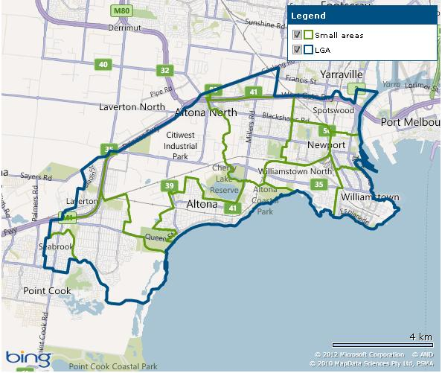
Diagram 1: Hobsons Bay small areas
Broadly, the City of Hobsons Bay falls into four main zones:
- along the eastern shoreline are the old “working class” suburbs of Williamstown, Newport and Spotswood. These suburbs are gentrifying, and are characterised by relatively high incomes and levels of education, skilled occupations, low unemployment, relatively low proportions of residents who are not proficient in English and some medium density housing;
- to the west is the old suburb of Altona. On most indicators, Altona is close to the Hobsons Bay average, though it does have an older age profile. Altona is somewhat isolated from the rest of the City by Kororoit Creek, Cherry Lake, the industrial area and the parklands and wetlands at the mouth of Laverton Creek;
- at the western end of the municipality are Altona Meadows and Seabrook. These suburbs, developed in the 1980s and 1990s, still have some of the features of a new suburb, including a young age profile, high proportions of families with children and of residents purchasing their homes, and substantial numbers of tradesmen;
- in the north is the Altona industrial area, one of the largest in the State, including a petrochemical complex, and flanked by the industrial suburbs of Altona North, Brooklyn and Laverton.
One of the VEC’s main principles in conducting representation reviews is ensuring communities of interest are as fairly represented as possible. The VEC took these areas into account in preparing possible ward boundaries, subject to the legislative requirement of enrolment numbers per councillor being approximately equal.
The simplest possible structure is an unsubdivided municipality, under which there are no wards and all the voters choose among all the candidates. This was one of the alternatives recommended by the Proportional Representation Society. However, this structure is considered impractical for the City of Hobsons Bay. At the 2008 Council elections, a total of 37 candidates contested seven positions, with an overall informal voting rate of 7.57 per cent. In an unsubdivided election, all the candidates would be on one ballot paper, and voters would have to number all the squares correctly for their vote to count. In 2008 there was a strong positive correlation of .946306 between the number of candidates for a ward and the informal vote, meaning that the more candidates there were, the higher the informal vote. With more than 30 candidates on one ballot paper, the informal vote could be expected to rise dramatically, with the result that a high proportion of voters would not be represented because of numbering mistakes. In addition, it may be more difficult for candidates to canvass voters across the entire municipality. For these reasons, the VEC did not include an unsubdivided municipality as an option.
At present Hobsons Bay City Council comprises seven single-councillor wards. In 2004 the VEC recommended this structure because it best reflected the diverse and distinct communities within the City.
Enrolments for all the wards currently comply with the equality requirements of the Act, and are expected to continue to do so until 2020 with the possible exception of Altona Meadows Ward. The ward boundaries are clear, following main roads, railways and creeks. The wards are named after the main suburb within the ward, and as much as possible fit communities of interest (though in some cases ward boundaries inevitably cut through suburbs). For example, the Altona Ward comprises effectively the whole of Altona and Seaholme. The Williamstown Ward is the older part of Williamstown. The Williamstown North Ward is based on the suburb of Williamstown North and includes surrounding areas. The Altona North Ward groups Altona North, Brooklyn and Laverton, which are demographically similar and are linked by the Princes Freeway and Melbourne-Geelong railway.
For these reasons the VEC recommended the current structure as its preferred option for the Preliminary Report. Several multi-councillor ward options were also provided.
The Hobsons Bay City Council on 13 November 2011 resolved to support “Multimember wards using proportional representation”. In the VEC’s experience, it is rare for a Council to propose a change to its current electoral structure. Most submissions supported a change to multi-councillor wards, including John Power and Ann Morrow, who favoured single-councillor wards at the last review. Submitters saw multi-councillor wards elected by proportional representation as promoting diversity of representation, making the Council more democratic and accountable to the voters. Moreover, multi-councillor wards would give voters a choice of councillors to contact, whereas currently a single ward councillor might be unavailable or unsympathetic. The VEC acknowledges the strength of these arguments.
Several submissions pointed out that the current ward boundaries split suburbs. Newport is divided between Spotswood, Williamstown and Williamstown North Wards; Williamstown is divided between Williamstown and Williamstown North Wards; Altona North is divided between Altona North, Spotswood and Williamstown North Wards; Altona Meadows is divided between Altona Meadows and Seabrook Wards; and Laverton is divided between Altona North and Seabrook Wards. Multi-councillor wards offer scope to reduce the number of split suburbs, and so fit communities of interest better than the current structure.
Two submissions put forward specific ward boundaries, and the VEC modelled these proposals. The Hobsons Bay Branch of the Australian Greens proposed three wards: a three-councillor east ward comprising the current Williamstown, Williamstown North and Spotswood Wards; a two-councillor central ward comprising the current Altona and Altona North Wards; and a two-councillor west ward comprising the current Altona Meadows and Seabrook Wards. The Greens also suggested shifting the part of Altona North currently in the Spotswood Ward to the central ward, which would reduce voter confusion and allow for Williamstown’s faster growth. The VEC saw merit in this proposed structure, which formed the basis of Option B.
Ms Linden Salter-Duke proposed a different configuration, with a two-councillor North Ward stretching from Spotswood to Laverton and including the industrial area, a three-councillor Coastal Ward including Williamstown and Altona, and a two-councillor West Ward covering Altona Meadows and Seabrook. Ms Salter-Duke suggested including Newport in the North Ward as its industrial-residential mix made it more compatible with that ward, and joining the northern part of Laverton to the West Ward. As enrolments for all three wards were outside the 10 per cent tolerance, this model could not be accepted. The VEC modified the model to follow the current ward boundaries, as shown in Diagram 2. Under the modified boundaries, enrolments for the wards were well within the 10 per cent threshold (though at the price of Newport and Laverton being split). The key question was whether this configuration best suits the broad communities of interest in Hobsons Bay. It is true that Williamstown and Altona, in the proposed Coastal Ward, share coastal issues. It is also the case that there are good transport links between Newport/South Kingsville and Altona North. The demographic profiles of Newport West and Spotswood-South Kingsville on the Council website show some similarities with Altona North.

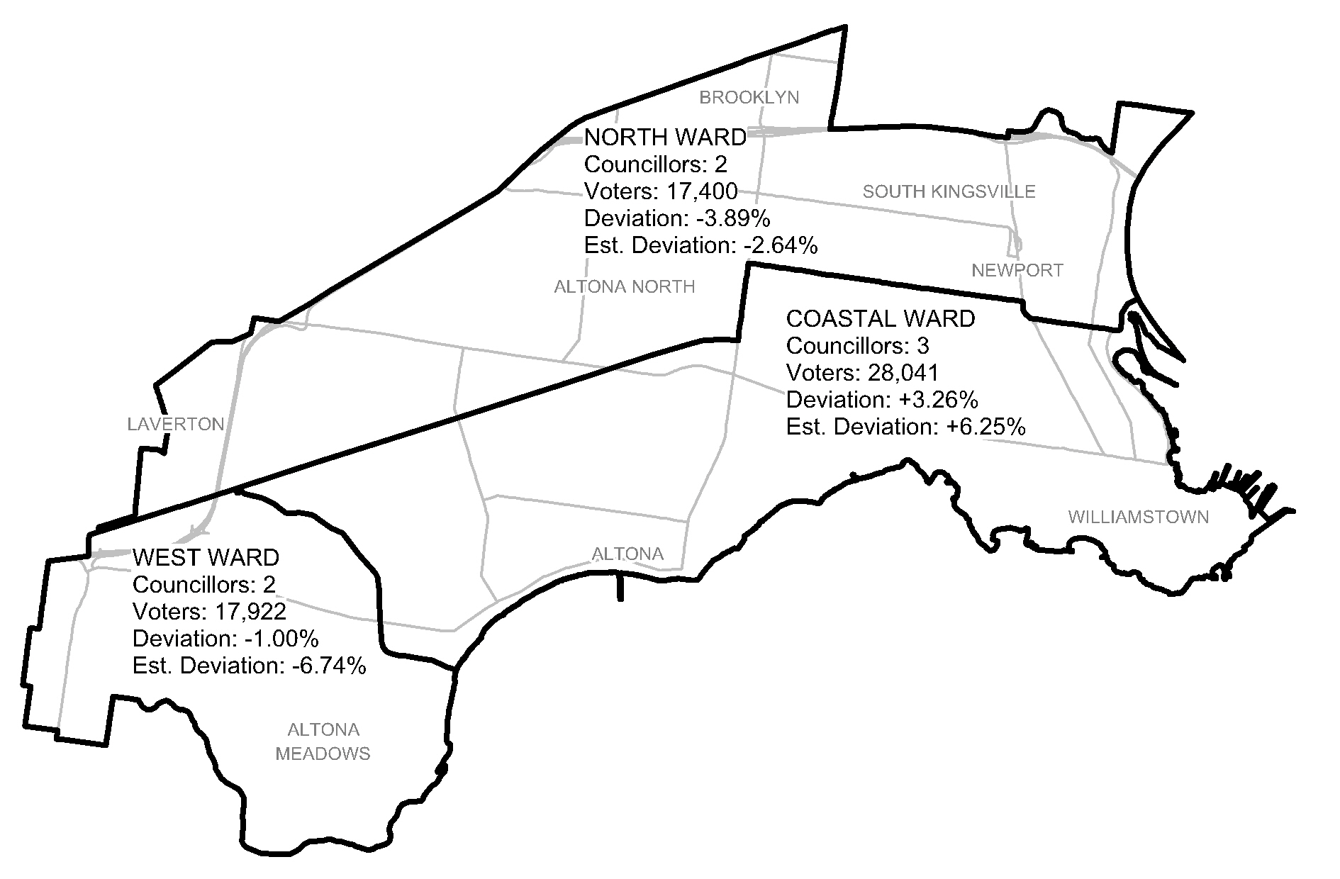
Diagram 2: Salter-Duke proposal - modified
Nevertheless, the VEC believes that there are stronger connections and similarities between Williamstown, Newport and Spotswood than there are between Spotswood and points west. Williamstown, Newport and Spotswood are linked by Melbourne Road and Douglas Parade, and share similar demographic profiles. For these reasons, the VEC considered a north-south division of the City to be more appropriate than the horizontal division proposed by Ms Salter-Duke.
The VEC put forward the following four options in the Preliminary Report:

Option A (Preferred Option): That Hobsons Bay City Council consist of seven councillors elected from seven single-councillor wards
The VEC’s preferred option was the status quo model, with the current seven single-councillor wards and no change to ward boundaries.
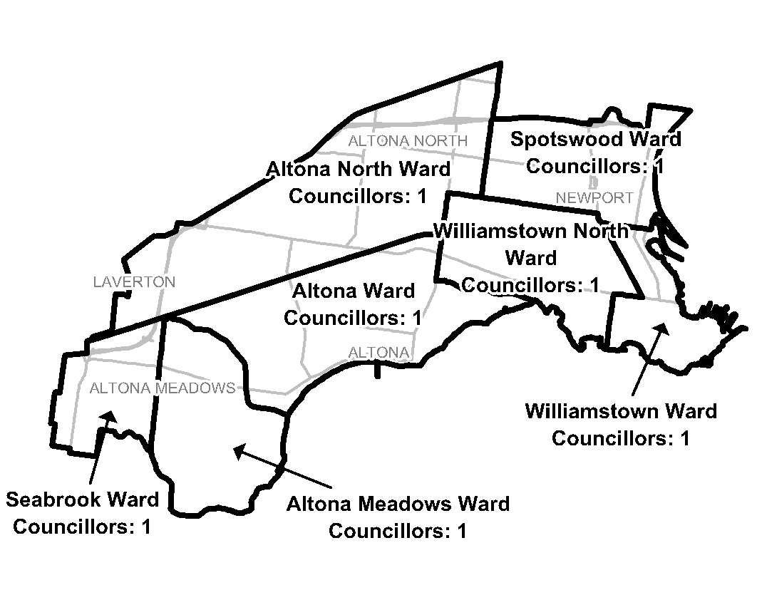
Diagram 3: Option A

Option B (Alternative Option): That Hobsons Bay City Council consist of seven councillors elected from one three-councillor ward and two two-councillor wards
The VEC considered that Option B, dividing Hobsons Bay into East, Central and West Wards, best fits the broad communities in the municipality. The option is a development of the model put forward by the Greens.
The model unites Laverton in the proposed West Ward. Laverton is the most disadvantaged suburb in the municipality. Currently it is divided between Altona North and Seabrook Wards, which means that Laverton residents make up only a small proportion of the voters of both wards. Uniting Laverton in one ward gives its people a larger voice. Laverton’s socio-economic profile is similar to those of Brooklyn and Altona North, but it is physically separated from those suburbs by the Altona industrial area. As Laverton has closer transport links with the suburbs immediately to its south, this option includes all of Laverton in the West Ward. To keep enrolment for the West Ward within tolerance, a wedge of Altona Meadows bounded by Queen Street, Victoria Street and Laverton Creek is transferred to the Central Ward.
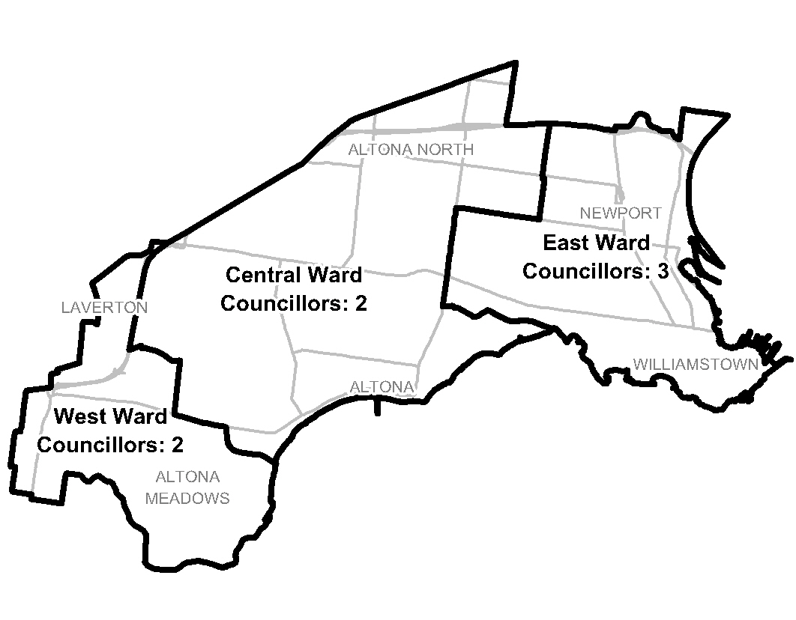 Diagram 4: Option B

Option C (Alternative Option): That Hobsons Bay City Council consist of seven councillors elected from one three-councillor ward and two two-councillor wards with different ward boundaries from Option B
Option C is essentially the same as Option B, except for the position of Altona Meadows and Laverton. All of Altona Meadows is included in the western ward, while the northern part of Laverton is in the central ward. The issue is which option better fits communities of interest.
The ward names in this option derive from features in each ward. The VEC welcomed public feedback on the names.
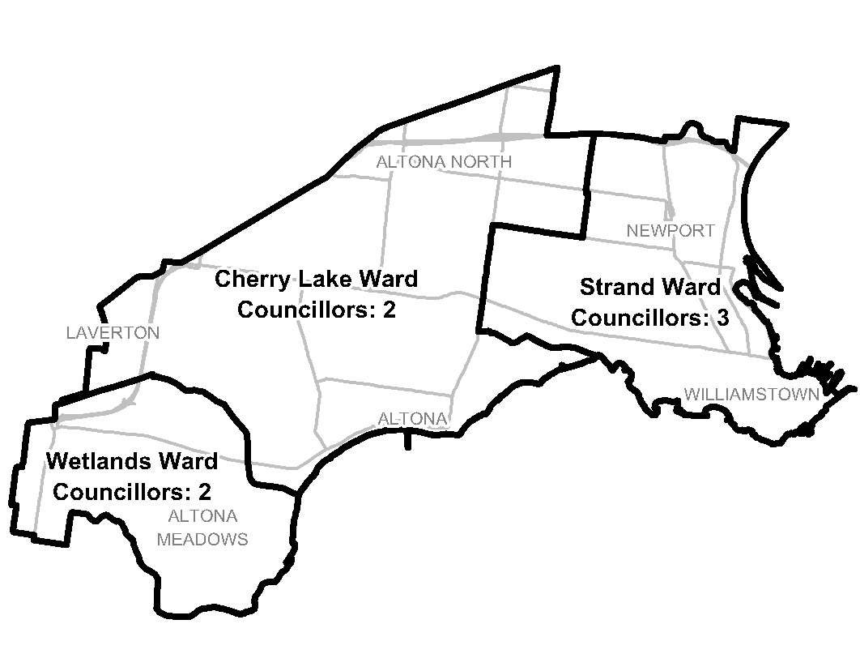 Diagram 5: Option C

Option D (Alternative Option): That Hobsons Bay City Council consists of seven councillors elected from one three-councillor ward, one two-councillor ward and two single-councillor wards
Option D is essentially the same as Option C except that the two-councillor Cherry Lake Ward has been split into the single-councillor Cherry Lake and Altona North Wards. The reason for this division is that there are substantial differences between Altona and Altona North, despite their physical proximity. The demographic profiles of the two suburbs show wide variations on a range of indicators. The suburbs are separated by the industrial belt and the railway, with only two roads connecting them (Millers Road and Maidstone Street).
A potential difficulty with this option is the variation in the size of wards, from three councillors and 27,000 voters to one councillor and 8,500 voters. This might lead to a perception of inequality.
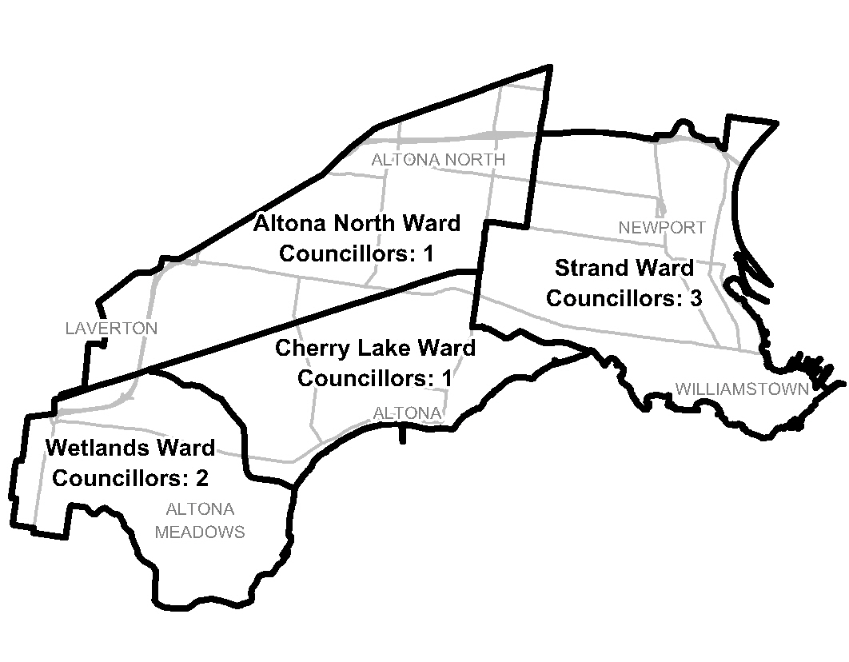 Diagram 6: Option D

Public response

Response submissions
Response submissions on the electoral representation review of Hobsons Bay City Council opened on 14 February 2012 and closed at 5.00pm on Wednesday,
14 March 2012. Eleven response submissions were received. Table 1 shows the levels of support for each option based on the preferences expressed in each response submission.
Table 1: Preferences expressed in response submissions for each option

A | B | B or C | C | D | N/A
2* | 5⁺ | 3 | - | - | 1
* One submission proposed a modified Option A.
⁺ One submission proposed a modified Option B.

Analysis of submissions
All but one submission accepted the current number of councillors. Mr Assaf thought that the total number of councillors should increase to nine, in three three-councillor wards, to cater for the growing population.
Eight of the eleven submissions supported either Option B or Option C (which both provided for one three-councillor ward and two two-councillor wards on similar boundaries). Submitters stressed the advantages of proportional representation as the fairest method of electing councillors. Some submitters considered that Option B’s boundaries best reflected communities of interest, particularly because they placed all of Laverton in one ward.
Only Mr Taliana’s submission made a case for Option A, arguing that multi-councillor wards can be prohibitively expensive to campaign in, that single-member wards have worked well, and that all councillors can be approached on local issues.
The Council’s submission was silent on the options, confining itself to the statement that suburb names should only be applied to wards where the ward and suburb boundaries are aligned.
A list of submitters, by name, is available in Appendix 1. Copies of the submissions can be viewed on the VEC website at vec.vic.gov.au.

Public hearing
A public hearing was held at 6.30 pm on Thursday, 22 March 2012 in Meeting Rooms 1 and 2, Hobsons Bay Civic Centre, 115 Civic Parade, Altona. Everyone who made a submission in response to the report was invited to speak to their submission and four individuals spoke. Members of the public were invited to attend and seven people, including the speakers, were present.
Speakers expressed a variety of views. They generally expanded on their submission, and also provided valuable information about communities and issues in the City of Hobsons Bay.

Findings and Recommendation
Mr Wajde Assaf urged that the number of councillors be increased to nine, pointing to the residential developments around the City. The VEC undertook to model the “3 x 3” structure proposed by Mr Assaf. As shown in Diagram 7, the numbers of voters enrolled for each ward are well within the 10 per cent allowance. The ward boundaries follow suburban boundaries, though the inclusion of South Kingsville in the Central Ward creates a noticeable indentation in the East Ward. The main flaw of this model is not the structure itself nor the boundaries, but the total number of councillors. As Mr Assaf stated, development is taking place, and Hobsons Bay is growing - but not at the same rate as other metropolitan councils. As one of the smallest metropolitan municipalities, it is appropriate that Hobsons Bay should have seven councillors.
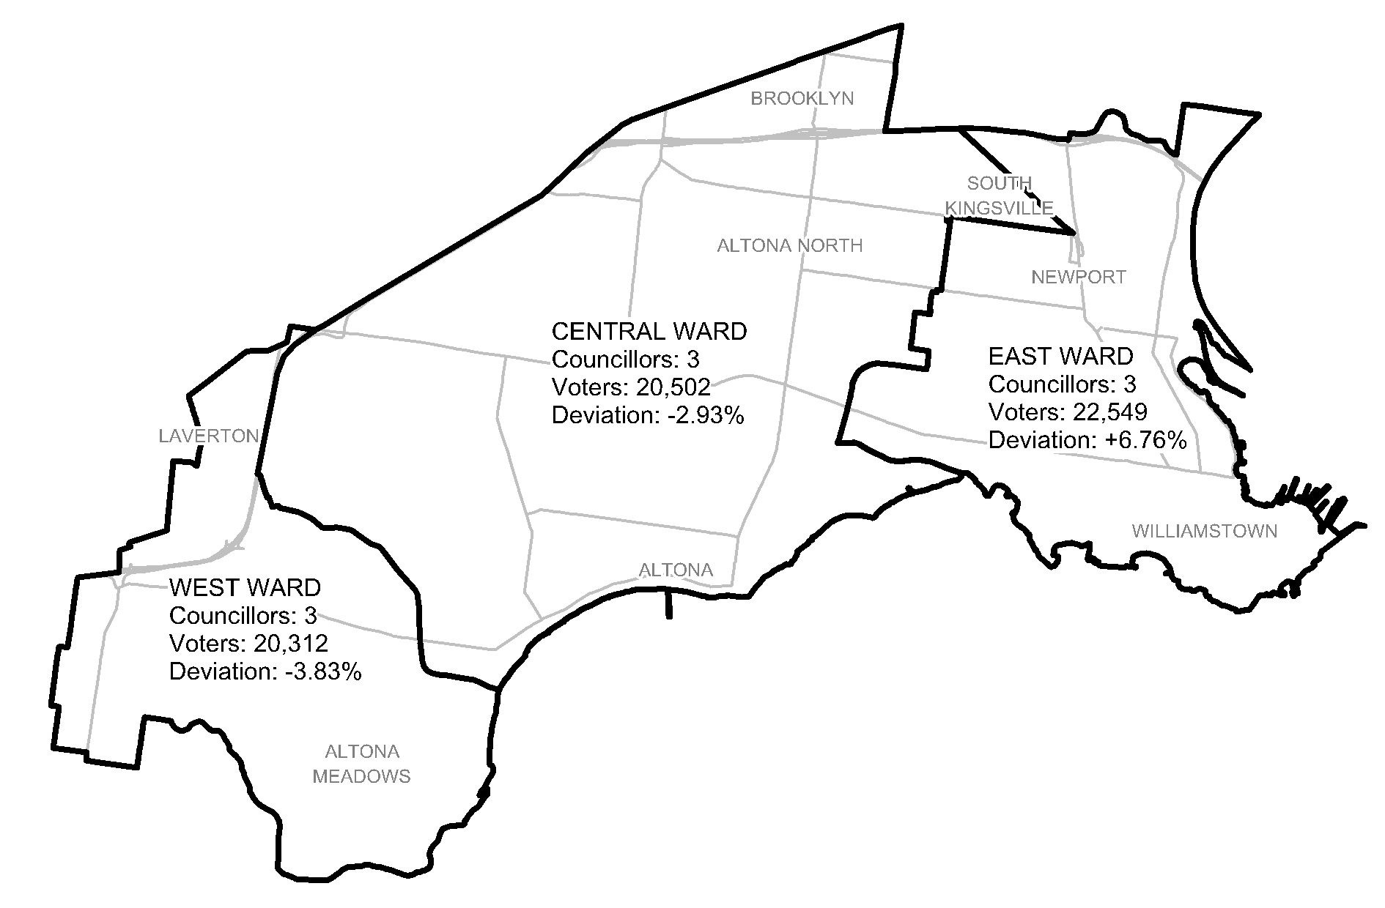
Diagram 7: 3 x 3 model
Another modification to the VEC’s options was proposed by Mr Shaun Taliana. Mr Taliana supported Option A, but stated that, on community of interest grounds, all of Laverton should be included in the Seabrook Ward. To compensate for this change, part of Altona North should be transferred from the Williamstown North Ward to the Altona North Ward, and part of Altona Meadows should be transferred from the Seabrook Ward to the Altona Meadows Ward. Mr Taliana’s proposal fits communities of interest marginally better than the VEC’s Option A, but, as Diagram 8 shows, in three of the wards enrolment is well outside the 10 per cent tolerance. Consequently, this model cannot be considered.
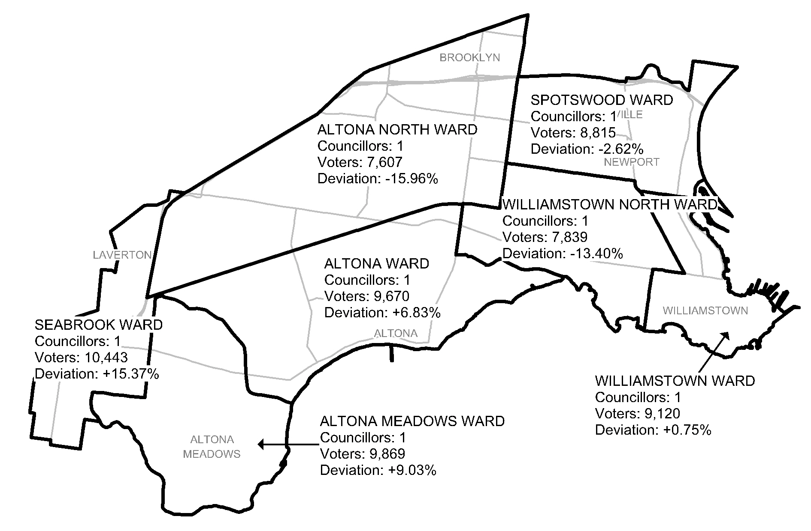
Diagram 8: Taliana proposal
Each of the options put forward by the VEC complies with the numbers requirements of the Act, both currently and in future. Each option has readily identifiable ward boundaries. The options conform to geographical communities of interest to varying extents. The key issue for this review is whether to continue with the current single-councillor ward structure or to change to multi-councillor wards.
In 2004 the VEC opted for single-councillor wards because it considered that these best fitted the distinct and diverse communities within the City of Hobsons Bay, and because smaller wards were easier to represent. In that review, there was strong support for single-councillor wards. In the current review, nearly all submissions, including people who preferred singles in the past, have favoured multi-councillor wards; the Council itself resolved to support “Multimember wards utilising proportional representation”. The VEC does not base its recommendations on straw polls, but it needs to recognise this significant change of opinion.
Mr Taliana’s submission argued that, with multi-councillor wards, “A geographically larger ward with more voters means that election campaigning could become prohibitively expensive for potential candidates who do not have the support of political parties or other substantial campaign assistance”. However, the proposed wards under Options B and C are only slightly larger than the two-councillor wards of the period before the 2004 review. The size of the multi-councillor wards in Hobsons Bay would probably not be an impossible obstacle for independent candidates. As many submitters contended, multi-councillor wards would encourage diversity of representation, and would give residents a choice of councillors.
One of the VEC’s main principles in representation reviews is to ensure that communities of interest are as fairly represented as possible. Although the VEC’s 2004 recommendation was based on communities of interest, in fact the current ward boundaries cut through suburbs at many points. Newport and Altona North are split among three wards, and three other suburbs are divided between two wards. In contrast, under the multi-councillor wards Options B and C, only two suburbs are significantly split. The ward boundaries under these options broadly follow the main geographical zones described on pages 13-14. Evidence from the Greens speakers (one from Spotswood and the other from Altona) at the public hearing about attendance at local community events, the distribution of community organisations, and a subjective sense of place suggest that the proposed boundaries in Options B and C fit communities of interest.
Having considered communities of interest and the likely representational effects of multi-councillor wards, the VEC believes that a multi-councillor ward structure would best suit the City of Hobsons Bay.
Option D has a mixed structure, with two single-councillor wards in the centre covering Altona and Altona North respectively, flanked by two multi-councillor wards to east and west. This option recognises the differences between Altona and Altona North but is otherwise unsatisfactory; it infringes communities of interest at several points, and it could produce a sense of inequality between the single- and multi-councillor wards.
Thus the choice is between Options B and C. The main difference between them is that under Option B all of Laverton is in the West Ward and part of Altona Meadows is in the Central Ward, while under Option C all of Altona Meadows is in the western (Wetlands) ward and the part of Laverton north of the railway is in the central (Cherry Lake) ward.
Five response submissions (including three from residents of Laverton) requested that all of Laverton be placed in one ward to improve its representation. Mr Taliana stated that Laverton has closer links with Seabrook to its immediate south than with Altona North, and should be in the same ward as Seabrook. The VEC considers that, as a disadvantaged suburb, Laverton needs the strongest representation possible, and it makes sense for all of it to be included in the ward with which it has the closest connections.
The consequence is that part of Altona Meadows east of Victoria Street and north of Queen Street would be placed in the Central Ward. This is not ideal on community of interest grounds, but it should be noted that only 547 of the 13,888 Altona Meadows voters (3.9 per cent) would be placed in this position, compared to the 5,258 Altona Meadows voters (37.9 per cent of the total) who are currently outside the Altona Meadows Ward.
On the names of wards, the Council resolved that “suburb names should only be applied to wards where the ward and suburb boundaries are aligned”. This is not an issue for Option B, under which the ward names are directional – accurate but perhaps colourless. For Option C, the VEC put forward the names of prominent features: Strand for the eastern ward; Cherry Lake for the central ward; and Wetlands for the western ward. One submitter suggested using these names, and speakers at the public hearing said that they were acceptable. The VEC proposes to use these names for the Option B wards.
The VEC has made minor changes to Option B’s ward boundaries. The northern part of the boundary between the Strand and Cherry Lake Wards now follows New and Watson Streets instead of the South Kingsville/Altona North locality boundary, which cuts through several properties. The change affects a total of five voters. In the west, the boundary between Cherry Lake and Wetlands Wards now follows Laverton Creek to its junction with the Princes Freeway, instead of tracing a dogleg along the railway. No voters are affected.

Recommendation
The Victorian Electoral Commission (VEC) recommends that Hobsons Bay City Council consists of seven councillors, to be elected from a three-councillor Strand Ward, a two-councillor Cherry Lake Ward and a two-councillor Wetlands Ward.
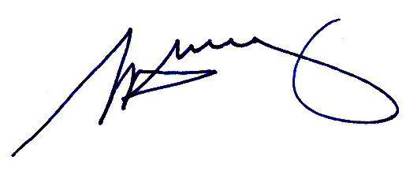
S. H. Tully
Electoral Commissioner

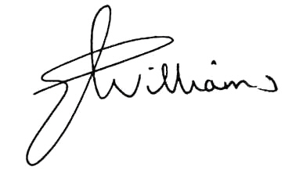
Liz Williams
Deputy Electoral Commissioner

Appendix 1: List of submitters
Preliminary submissions were received from:
Name
Australian Greens (Vic) Hobsons Bay Branch
Davies, Aaron
Hobsons Bay City Council
Mitchell, Barry and Jenni
Proportional Representation Society of Australia (Victoria-Tasmania) Inc.
Salter-Duke, Linden
Transition Hobsons Bay (Kate Leslie)
Williamstown, Newport and Spotswood Residents Association (John Power and Ann Morrow)

Response submissions were received from:
Name
Assaf, Wajde*
Australian Greens (Vic) Hobsons Bay Branch*
Davis, John Wesley
Davis, Valerie Ina
Hobsons Bay City Council
Laverton Community Integrated Services Inc. (Michael Pernar)
Leslie, Kate
Murdoch, Graeme
Proportional Representation Society of Australia (Victoria-Tasmania) Inc.
Symons, Ainsley
Taliana, Shaun*

* indicates those submitters who spoke in support of their submission at the public hearing.

Appendix 2: Map

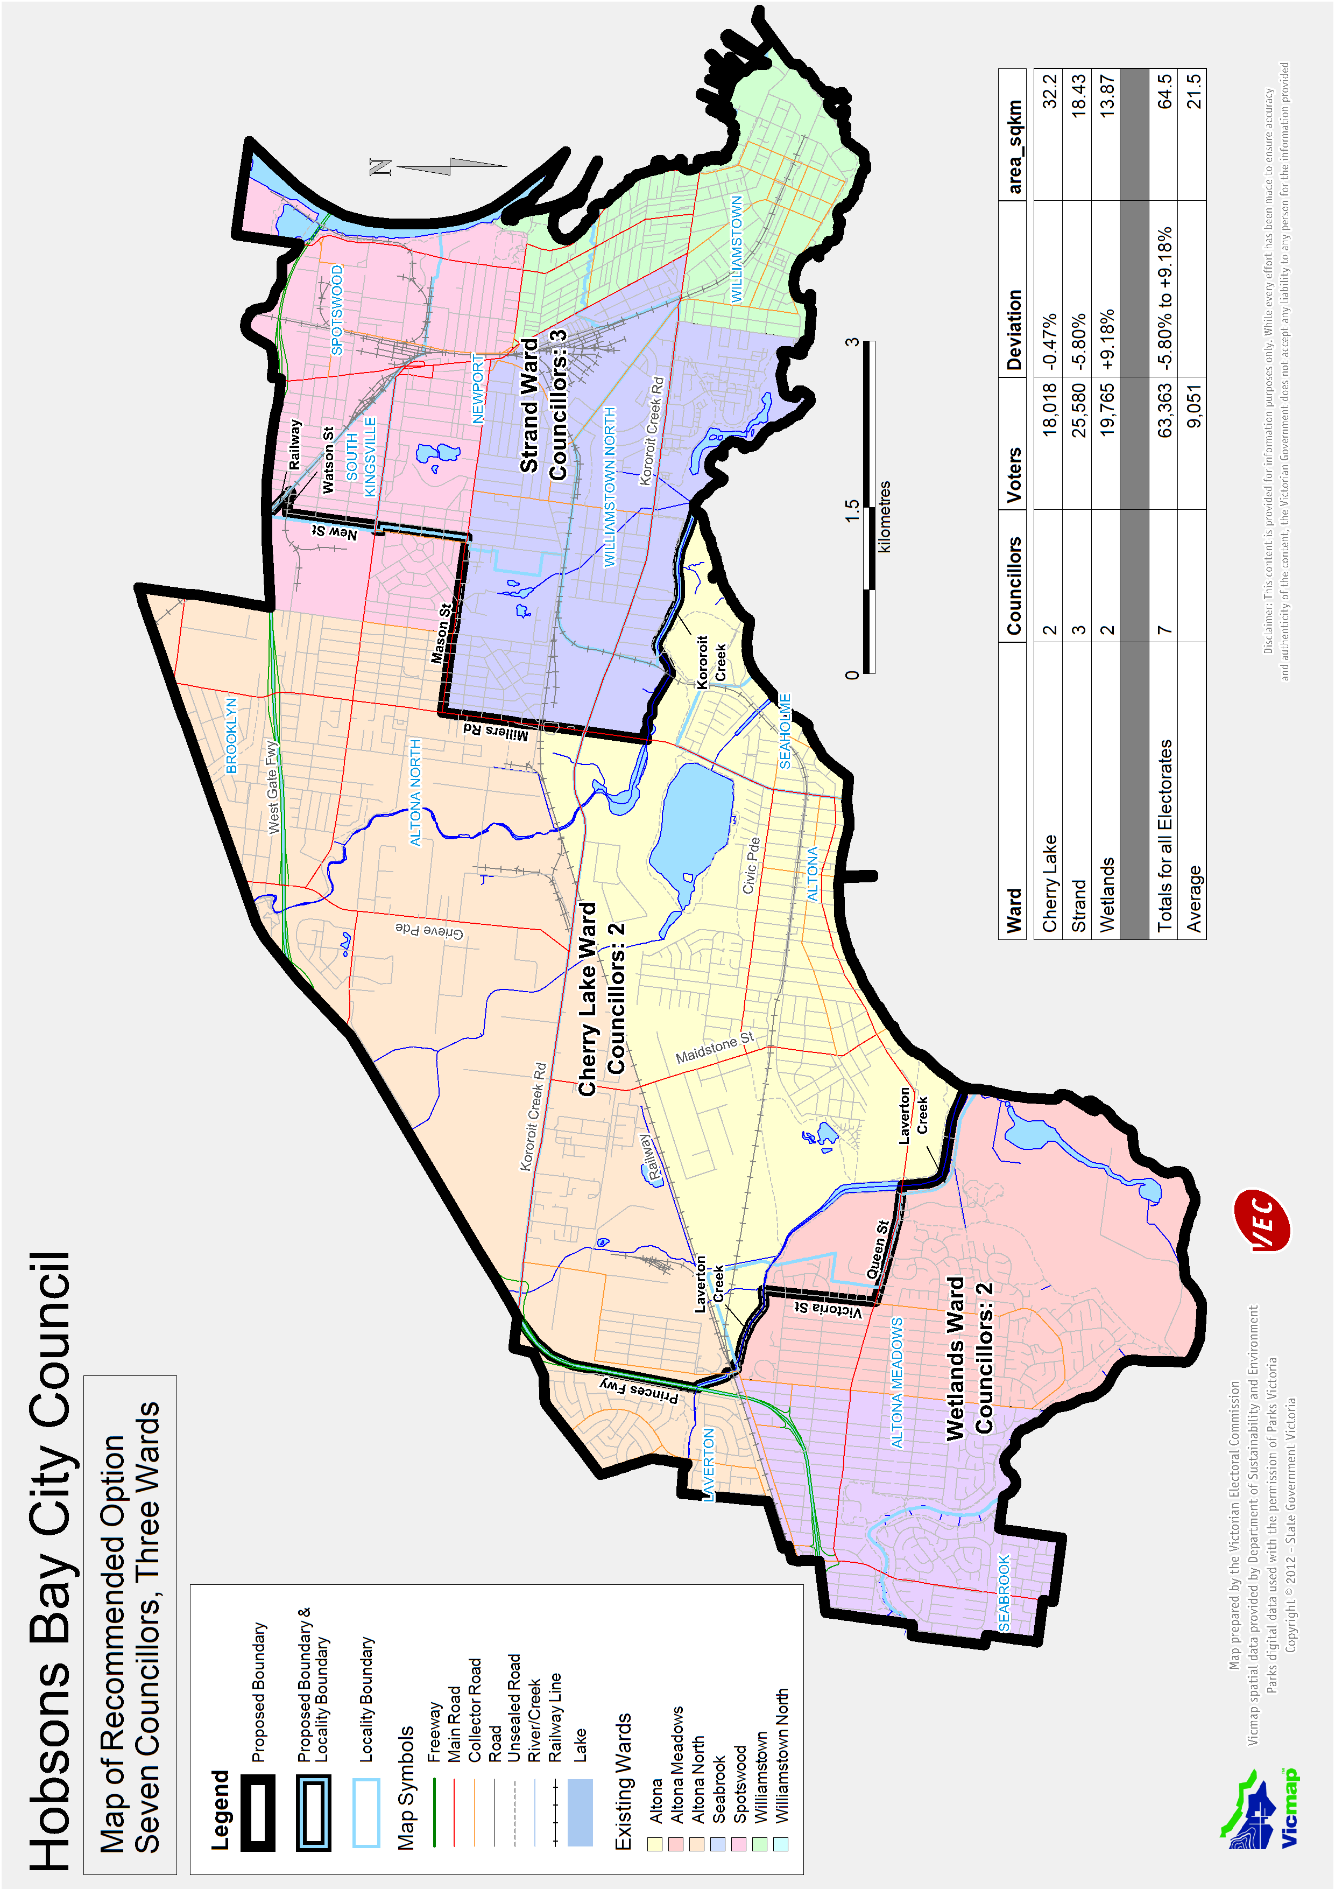

Victorian Electoral Commission
Level 11, 530 Collins Street
Melbourne, Vic 3000

131 VEC (131 832)
hobsonsbay.review@vec.vic.gov.au
vec.vic.gov.au

Section 219D of the Local Government Act 1989.
http://profile.id.com.au/Default.aspx?id=112&pg=244&gid=10&type=enum
See Victorian Electoral Commission: Report of local government electoral activity 2008-09, Part III, Report of local government electoral representation reviews conducted by the VEC between 2004 and 2008, pp 16-22.
See http://profile.id.com.au/Default.aspx?id=112&pg=11&gid=10&type=enum
Another difference from Options B and C is that the part of Altona North currently in Spotswood Ward is included in the proposed Strand Ward.

