ELECTORAL REPRESENTATION REVIEW
Pyrenees Shire Council
Final Report
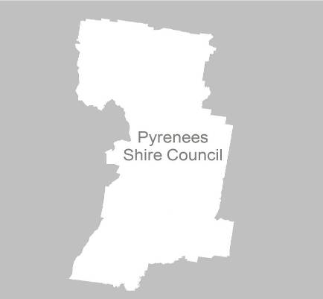

31 May 2011

Contents
Recommendation 4
Background 5
Legislative basis 5
The VEC and Electoral Representation Reviews 5
Profile of Pyrenees Shire Council 6
Current electoral structure 6
VEC research 9
Public involvement 9
Preliminary report 11
Preliminary submissions 11
Analysis of submissions 11
Preliminary options 12
Public response 13
Response submissions 13
Analysis of submissions 13
Public hearing 13
Findings and Recommendation 15
Recommendation 16
Appendix 1: List of submitters 17
Appendix 2: Map 18

Recommendation
The Victorian Electoral Commission (VEC) recommends that Pyrenees Shire Council should remain with five councillors and five wards with one councillor representing each ward.
Minor adjustments should be made to the existing ward boundaries and the Council’s preferred ward names should be adopted.

Background

Legislative basis
The Local Government Act 1989 (the Act) requires the VEC to conduct an Electoral Representation Review of each municipality in Victoria at least every 12 years. The Act specifies that the purpose of a representation review is to recommend to the Minister for Local Government the number of councillors and the electoral structure for a municipality, which will provide ‘fair and equitable representation for the persons who are entitled to vote at a general election of the Council’.
The Act requires the VEC, as part of an Electoral Representation Review, to consider:
- the number of councillors in a municipality;
- whether a municipality should be unsubdivided or subdivided;
- if it should be subdivided, whether ward boundaries:
  - provide for fair and equitable division of the municipality;
  - ensure equality of representation through the number of voters being represented by each councillor being within 10 per cent of the average number of voters represented by all councillors; and,
- if it should be subdivided, the number of councillors that should be elected for each ward.

The VEC and Electoral Representation Reviews
The VEC has conducted Electoral Representation Reviews since 2004 on appointment by local councils. The Act was changed in 2010 to define the VEC as the only agency authorised to undertake the reviews.
The VEC drew on its experience in mapping and boundary modelling and also engaged consultants with experience in local government to provide advice on specific local representation issues during the review.

Profile of Pyrenees Shire Council
Pyrenees Shire Council was formed in 1995 by the amalgamation of the Shire of Lexton and parts of the Shires of Avoca and Ripon.
The Shire is geographically diverse with a climate that varies between the north and south of the region. The wetter, cooler weather in the south benefits the broad acre farming of hay and cereal crops while the warmer, drier weather in the north attracts tourists to the wineries.
The Shire covers 3,433 square kilometres and recorded a population of 6,558 in the 2006 census.

Current electoral structure
The last representation review for Pyrenees Shire council took place in 2004. Following the review, the Minister for Local Government determined the structure of Pyrenees Shire Council would be:
- five councillors;
- divided into five wards — Avoca Ward, Beaufort Ward, Goldsmith Ward, Mitchell Ward and Warrenmang Ward; with
- one councillor from each ward.
The VEC recommended this structure on the basis of the right for residents for Pyrenees Shire Council to receive fair and equitable representation during the ensuing terms of the council. The VEC noted there was slight population decline in the Shire, and forecasts, at the time, were for the population to continue to decline. The VEC recommended the number of councillors be reduced from seven to five, considering that five was an appropriate number for one of the smallest municipalities in the State.

The map below illustrates the current structure of Pyrenees Shire Council.
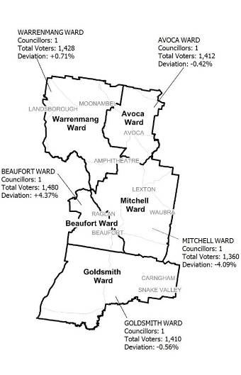

The electoral representation review process
The VEC proceeded on the basis of three main principles:
- Ensuring the number of voters represented by each councillor is within 10 per cent of the average number of voters per councillor for that municipality.
Populations are continually changing. Over time these changes can lead to some wards having larger or smaller numbers of voters. As part of the review, the VEC corrected any imbalances and also took into account likely population changes to ensure these boundaries provide equitable representation until the next review.
- Taking a consistent, State-wide approach to the total number of councillors.
The VEC was guided by its comparisons of municipalities of a similar size and category to the council under review. The VEC also considered any special circumstances that may warrant the municipality to have more or fewer councillors than similar municipalities.
- Ensuring communities of interest are as fairly represented as possible.
Each municipality contains a number of communities of interest and, where practicable, the electoral structure should be designed to take these into account. This allows elected councillors to be more effective representatives of the people in their particular municipality or ward.
The recommendation is based on:
- internal research specifically relating to the municipality under review;
- VEC experience from its work with other municipalities and in similar reviews for State elections;
- VEC expertise in mapping, demography and local government;
- careful consideration of all public input in the form of written and verbal submissions received during the review; and,
- advice received from consultants with wide experience in local government.
Public submissions were an important part of the process, but were not the only consideration during the review. The VEC seeks to combine the information gathered through public submissions with its own research and analysis of other factors, such as the need to give representation to communities of interest. The recommendation is not based on a ‘straw poll’ of the number of submissions supporting a particular option.

VEC research
In addition to the information provided in submissions, the VEC created a profile of the municipality based on population trends, development projections and demographic indicators. The VEC used the Australian Bureau of Statistics 2006 census community profiles, the Department of Planning and Community Development projections and voter statistics from the Victorian electoral roll. The VEC also undertook field work to view current and possible boundaries for each of the options presented in the preliminary report to evaluate their effectiveness.

Public involvement
The VEC values the local knowledge and perspectives presented by the public in written submissions. The public were given two opportunities to provide submissions during the review. Their input was considered by the panel in forming the options in the preliminary report and they were also invited to respond to these options. In addition, a public hearing was held to enable people to speak in support of their submissions and supplement it with information.
To ensure transparency in the process, all written submissions were published on the VEC website and all verbal submissions were heard in a public environment.
To raise awareness of the review and encourage the public to engage with the process, a full public information campaign was undertaken.

Advertising
In accordance with sections 219F(4) and 219F(7) of the Act, the VEC ensured public notices were placed in local newspapers. Notification of the review appeared in Beaufort Pyrenees Advocate and Maryborough Advertiser on Friday,
11 February 2011 and the Ballarat Courier and Stawell Times News/Ararat Advertiser on Tuesday, 15 February 2011.The notice detailed the process for the review and called for public submissions. A general notice covering several reviews was printed in The Age and Herald Sun on Tuesday, 1 February 2011.
Notification of the release of the preliminary report appeared in Ballarat Courier, Stawell Times News/Ararat Advertiser and Maryborough Advertiser on Tuesday,
5 April and in Beaufort Pyrenees Advocate on Friday, 8 April. The notice detailed the options contained in the preliminary report, including a map of each option, instructions on how to access a copy of the preliminary report and how to make a submission in response to the report.

Media releases
The VEC produced two media releases for this review. The first release, distributed to local media through the Council, provided information on the review and overall process. A second release, distributed to local media by the VEC, detailed the options in the preliminary report and how to make a submission in response to the report.

Public information session
The VEC held a public information session for people interested in the review process on Wednesday, 2 March 2011 at Lexton Public Hall.

Guide for Submissions
A guide for submissions was developed and distributed to those interested in making submissions. Copies of the guide for submissions were available on the VEC website, in hardcopy on request, and were provided to the Council.

Information brochure and poster
An information brochure was provided to the Council to be distributed to residents through the Council’s network, such as in libraries and service centres. A poster was provided to the Council as an extra publicity tool.

Helpline
A dedicated helpline was established to assist with public enquiries concerning the review process.

Pyrenees Shire Council website
Information about the review was highlighted in the news section of the Pyrenees Shire website (pyrenees.vic.gov.au) with a copy of the Guide for Submissions and a direct link to the VEC website.

VEC website
The VEC website delivered up-to-date information to provide transparency during the preliminary and response stages of the review process. All submissions were posted on the website and an online submission tool was created to facilitate the submission process. The preliminary report was available for electronic download on the website.

Preliminary report
In accordance with the Act, the VEC produced a preliminary report outlining its proposed options for Pyrenees Shire Council. The report was released on Tuesday, 5 April 2011.

Preliminary submissions
By the close of preliminary submissions at 5.00pm on Tuesday, 15 March the VEC received three submissions.
 | Submitter wanted fewer wards | Submitter wanted the number of wards to remain unchanged | Submitter wanted more wards | Submitter did not comment on the number of wards
Submitter wanted fewer councillors | — | — | — | —
Submitter wanted the number of councillors to remain unchanged | 2 | 1 | — | —
Submitter wanted more councillors | — | — | — | —
Submitter did not comment on the number of councillors | — | — | — | —

Analysis of submissions
Two of the submissions argued in favour of an unsubdivided municipality to ensure elections would be conducted by the proportional representation vote counting method.
The third submission came from Pyrenees Shire Council and favoured retaining the current ward structure, stating it has provided ‘a stable, cohesive council’ that recognises the ‘geographically diverse communities of interest.’
A list of submitters, by name, is available in Appendix One. Copies of the submissions can be viewed on the VEC website at vec.vic.gov.au.

Preliminary options
After careful consideration of the preliminary submissions, the VEC put forward two options:

Option A (Preferred Option)
Pyrenees Shire Council should remain with five councillors and five wards with one councillor representing each ward. Minimal changes should be made to the ward boundaries.

Option B (Alternative Option)
Pyrenees Shire Council should become an unsubdivided municipality with five councillors representing the entire Shire.

Public response

Response submissions
Response submissions on the Electoral Representation Review of Pyrenees Shire Council opened on Tuesday, 5 April and closed at 5.00pm on Friday, 6 May. Three response submissions were received. Table 1 shows the levels of support for each option based on the preferences expressed in each response submission.
Table 1:
Option A  (Preferred Option) | Option B  (Alternative Option)
2 | 1

Analysis of submissions
Two of the submissions favoured Option A, and stated that that the current structure is working well and should be retained.
The Proportional Representation Society of Australia preferred Option B on the grounds that it ensures candidates are elected via proportional representation. They also argued that single councillor wards can lead to unopposed returns and a decreased involvement by the community and cited the 2008 general election in Pyrenees Shire as an example (when the Shire endured Victoria’s only failed election and across the municipality only eight candidates nominated).
A list of submitters, by name, is available in Appendix 1. Copies of the submissions can be viewed on the VEC website at vec.vic.gov.au.

Public hearing
A public hearing was held at Lexton Public Hall on Wednesday, 11 May at 6.30pm. Everyone who made a submission in response to the report was invited to speak to their submissions and two individuals accepted. Members of the public were also invited to attend and some did.
The first speaker, Mr Scott, stressed the importance of retaining the current ward structure, stating the wards had been in place for a long time and worked well. He also argued that without a ward structure, there is a possibility that all councillors could be elected from one area within the municipality. When asked by the panel about the advantage of all electors being able to vote for all councillors, Mr Scott explained that each ward had a unique community and a different identity.
The second speaker, Councillor O’Connor (Mayor of the municipality), expressed the Council’s preference for seven councillors but acknowledged he accepted the VEC’s reasoning for five councillors. Councillor O’Connor also spoke in favour of Option A, highlighting the diverse geography of the municipality and stating that the current structure had produced a ‘stable and cohesive Council’.
As part of his presentation, he put forward the case for changing the ward names in line with early pastoral runs within the Shire, as tabled below:

Current Ward name | Proposed Ward name
Warrenmang | De Cameron
Avoca | Avoca
Mitchell | Ercildoune
Beaufort | Beaufort
Goldsmith | Mt Emu

When questioned by the panel, Councillor O’Connor agreed that the current boundaries represented the communities of interest and stated that the introduction of four-year terms for councillors, or the extensive workload for five councillors, may have deterred candidates from nominating at the last election. Councillor O’Connor also questioned why the proposed boundary in the Beaufort-Raglan area did not follow the roads. The Electoral Commissioner agreed to look into the matter further.

Findings and Recommendation
The VEC always prefers to make minimal changes to ward structures when they are working well and they are able to sustain population fluctuations. There would have to be very clear evidence that the structure does not work to warrant the potential disruption caused by major change. Although the recent history of Pyrenees Shire Council in general elections is a concern, with Victoria’s only failed election, an unopposed election and only two or three candidates standing in the other wards, the VEC accepts that this could be due to community satisfaction or the introduction of four-year terms. The VEC recommended an unsubdivided municipality at the last electoral representation review in 2004 and acknowledges that the arguments against this structure still stand, especially the lack of Shire-wide media which would make it difficult for candidates to campaign across the entire municipality and could further deter candidates from nominating.
The VEC also accepts the evidence presented by submitters that Pyrenees Shire is made up of different communities of interest with five main communities that are neatly encapsulated in each of the wards. These wards also look outwards in three different directions for their main services, with Avoca Ward looking towards Maryborough, the north-western ward looking toward Stawell and the southern wards looking towards Ballarat.
The geographic diversity of the Shire is a further consideration with broad-acre farming in the south and wineries attracting a growing tourist industry in the north.
The VEC acknowledges that single-councillor wards will continue to ensure that the diversity and communities of interest across the Shire are fairly represented.
Option A incorporates very minimal changes to the Beaufort Ward boundary. The current boundary is at the edge of a built up area and the VEC now recommends that Beaufort Ward be extended to the Beaufort locality boundary, using Listons Road as the northwest boundary. To compensate, the entire locality of Raglan would be included in the current Mitchell Ward.
As agreed at the public hearing, the VEC reviewed the suitability of the proposed boundary in the Beaufort-Raglan area, as raised by Councillor O’Connor. The boundary in this area was aligned mainly to locality boundaries and the VEC prefers to use clear boundaries wherever possible, using main roads, rivers and significant landmarks while keeping together communities of interest. Shifting the boundary to Musical Gully Road was considered; however, this would have divided the community of Waterloo. On balance it was decided to adhere to the locality boundary, as determined by Pyrenees Shire Council in 2003, and the VEC confirmed with the Council there were no pending changes to these locality boundaries.
While reviewing the suitability of the boundary, the VEC mapping team identified that a small section of the boundary actually veered away from the locality boundaries and cut through two properties. A very small, cosmetic change to more closely follow the locality boundary has now been applied and is illustrated in Appendix 2.
The VEC acknowledges the Council’s wish to change the ward names to more relevant names and has adopted all the Council’s suggestions.

Recommendation
The Victorian Electoral Commission (VEC) recommends that Pyrenees Shire Council consist of five single wards with one councillor representing each ward. Minor changes should be made to the existing boundaries and the Council’s preferred names should be adopted.

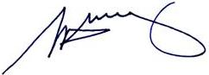

S. H. Tully
Electoral Commissioner

Appendix 1: List of submitters
Preliminary submissions were received from:
Name
Allan, L
Proportional Representation Society of Australia
Pyrenees Shire Council

Response submissions were received from:
Name
Proportional Representation Society of Australia
*Pyrenees Shire Council
*Scott, K
*Spoke at the public hearing.

Appendix 2: Map

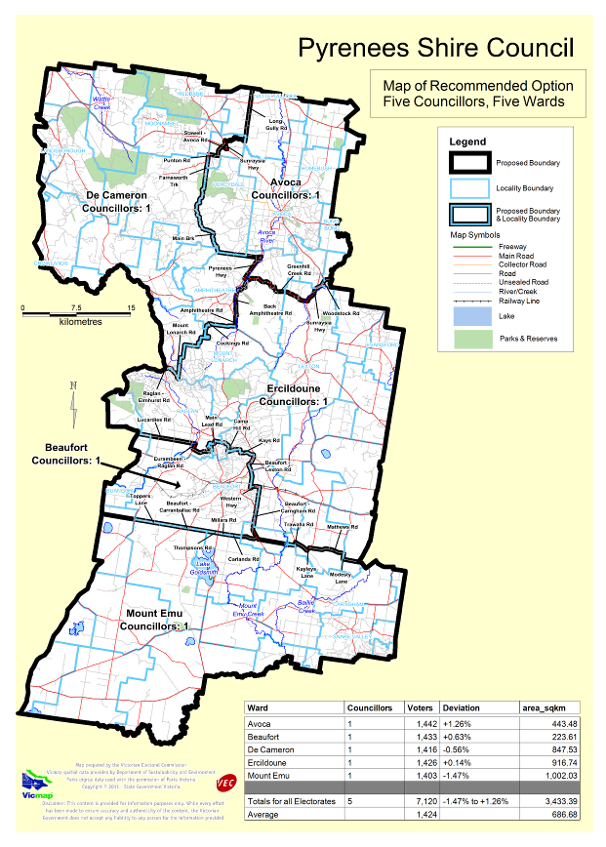

Victorian Electoral Commission
Level 11, 530 Collins Street
Melbourne, Vic 3000

131 VEC (131 832)
info@vec.vic.gov.au
vec.vic.gov.au

Section 219D of the Local Government Act 1989.
Statistics are subject to variation and are regularly updated. Latest statistics are used during the review.

