Victorian Electoral Commission

Disability Access and
Inclusion Plan 2019-2023

Cover image:
How Many Triangles Can You See, Monica Lazzari. Lazzari employs a vast colour palette with meticulous application of media. Her works are active spaces, resonating with energy. Monica Lazzari has been a regular studio artist at Arts Project Australia since 2006.
Foreword
I am pleased to present the Victorian Electoral Commission’s Disability Access and Inclusion Plan for 2019-2023.
Electoral accessibility is about removing barriers to enrolling and voting for people with disability. These barriers may be physical, sensory, or communicative in nature. The establishment of almost 1,800 State election voting centres is just such an example. An ongoing challenge moving forward is finding enough fully accessible premises for use as voting centres.
Another accessibility opportunity is reviewing the way the VEC employs people. It is important that the diversity of the community is reflected in the people the VEC engages, regardless of whether it is an ongoing core role or a short-term role in a voting centre or election office. All roles advertised at the VEC are sent to members of its Electoral Access Advisory Group (EAAG). The aim is to encourage applications from people associated with the disability support agencies represented. The application process itself must be accessible, the culture encouraging and the necessary support available to assist transition into the workplace.
This next VEC Disability Access and Inclusion Plan incorporates, wherever possible, the actions and focus areas from the Victorian State Government’s Getting to work: Victorian public sector disability employment action plan 2018-2025.
Incorporated within this plan are many more initiatives resulting from significant consultation with staff, people with disability, and of course, the VEC’s EAAG. The assistance of our EAAG members has been invaluable over the last 13 years. Members have challenged and supported the Commission to do more and do better. My sincere thanks goes to every member for the progress made in recent years and in anticipation of achieving the commitments in this plan.
I look forward to the next four years in the context of the delivery of this plan, which is designed to take Victorian electoral access to the next level in partnership with our key stakeholders and community. The aim is to ensure that everyone is equal at the ballot box and can cast an independent and secret vote.

Acknowledgement of Aboriginal Victoria
The Victorian Electoral Commission (VEC) acknowledges the Aboriginal and Torres Strait Islander people of this nation, as the traditional custodians of the lands on which the VEC works and where we conduct our business. We pay our respects to ancestors and Elders, past, present and emerging. The Commission is committed to honouring Aboriginal and Torres Strait Islander peoples’ unique cultural and spiritual relationships to the land, waters and seas and their rich contribution to society.

Contents
About the Victorian Electoral Commission 6
Introduction 7
Purpose 7
The working environment 7
VEC Diversity and Inclusion Statement 8
Strategy 2023 8
Review of the VEC’s Disability Action Plan 2016-19 9
Key priority areas and actions 10
Access 10
Employment 10
Community 11
Changing attitudes 11
Reporting and Governance 12
Feedback 12

About the Victorian Electoral Commission
The purpose of the Victorian Electoral Commission (VEC) is to deliver high quality, accessible electoral services with innovation, integrity and independence. The VEC is an independent and impartial statutory authority established under Victoria’s Electoral Act 2002. It operates under the auspices of the Department of Premier and Cabinet, within the portfolio of the Special Minister of State. However, the VEC is not subject to the direction or control of the Minister in respect to the performance of its responsibilities and functions and the exercise of its power.
VEC representative handing out VEC promotional items at Southern Cross Station, Melbourne.

Our primary responsibilities include:
• conducting State, local government and certain statutory elections
• maintaining the register of Victorian electors
• implementing electoral representation reviews of local councils
• promoting public awareness and understanding of electoral issues.
Our vision – all Victorians actively participating in their democracy.
Our values are:
- Independence - acting with impartiality and integrity
- Accountability - transparent reporting and effective stewardship of resources
- Innovation - shaping our future through creativity and leadership
- Respect - consideration of self, others and the environment
- Collaboration - working as a team with partners and communities.
The VEC has three active community advisory groups: Electoral Access Advisory Group (EAAG); Culturally and Linguistically Diverse (CALD) Advisory Group; and Homelessness Advisory Group.
The EAAG consists of 20 community members with professional and lived experience of disability. The EAAG supports the VEC with advice, suggestions, feedback, and ideas to achieve better outcomes against actions within the terms of our Disability Access and Inclusion Plan.
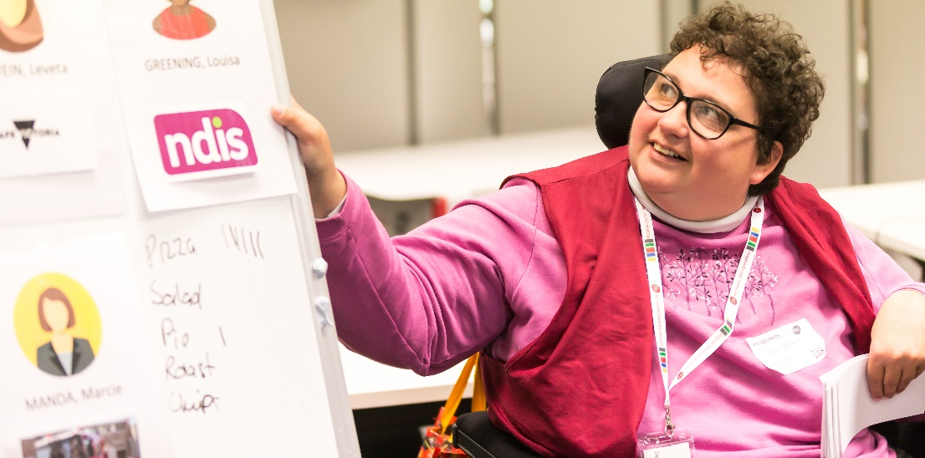
Our Democracy Ambassador Simone co-facilitating an education session.

Introduction
The VEC Disability Access and Inclusion Plan 2019-2023 (the Plan) incorporates the lessons learned from previous Action Plans and focuses on diversity, access and inclusion. We commit to engaging with people with disability from various communities that are traditionally underrepresented in Victoria’s democracy, including young people, Aboriginal and Torres Strait Islanders, and those who are culturally and linguistically diverse, experiencing homelessness, or within prisons. The Plan has been developed in consultation with VEC staff and contractors, all VEC Advisory groups, and external Victorian Public Service staff from the Enablers Network. The Plan has been aligned with the VEC’s overarching Strategy 2023. The intention is that the Disability Access and Inclusion Plan will be a living document and may evolve as reviews are conducted. Additional actions and changes will be reported annually within the VEC’s Annual Report.

Purpose
The Plan lays out the priority areas for improvement across the document’s life cycle. The Plan also takes into consideration the variable workload within the VEC across election and non-election years (the VEC conducts a major electoral event every second year).

The working environment
The VEC is responsible for the conduct of elections and referendums for the Parliament of Victoria and conducts local council elections and other elections and polls on a fee for service basis in Victoria. The VEC has a Melbourne-based core staff that expands to approximately 15,000 staff on election day for State elections as well as an ongoing team at the VEC warehouse at Tullamarine. Federal elections are the responsibility of the Australian Electoral Commission.

VEC Diversity and Inclusion Statement
Launched in 2017, the VEC Diversity and Inclusion Statement assists the VEC to build confidence and trust in recognising and celebrating diversity—both within the VEC and the communities we serve.
We are committed to:
- recognising and celebrating diversity as a strength and corporate asset
- creating a workplace culture that is inclusive, equitable and safe for all
- increasing our awareness and understanding of barriers to inclusion and addressing these barriers in our practices
- providing a workplace that enables employees to bring their full selves to work, and where their diversity is celebrated and appreciated.

Strategy 2023
The VEC works to remove all possible barriers to participation and strives to ensure all eligible Victorians are engaged with the democratic process. To achieve this, the VEC released Strategy 2023 (Strategy). The Strategy provides an overarching five-year goal for the VEC to be change ready and ensure there are people, systems and relationships in place to make the most of opportunities.
The Strategy has four focus areas for overall implementation including: people; technology; decision making; and relationships. Extensive internal consultation on the Plan ensures strategic alignment with Strategy 2023. Our aim is to learn from others outside the VEC about opportunities and challenges. By seeking advice and knowledge from all our networks when planning how to improve our services, we continually change with the times.
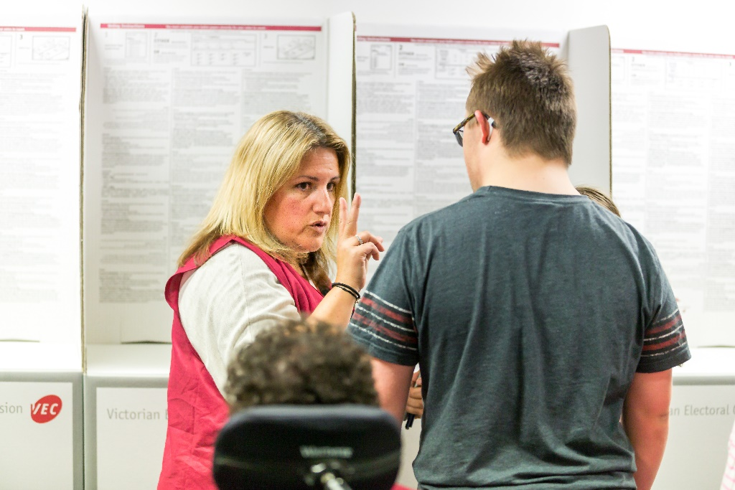
Alex, our Democracy Ambassador explaining how a voting centre works.

Review of the VEC’s Disability Action Plan 2016-19
As the VEC Disability Action Plan 2016-2019 concludes, the VEC has been able to evaluate its work against the strategies and actions committed to in 2016.
The VEC has completed 39 of the 43 actions (91%) of the Disability Action Plan 2016-2019. Through successful implementation, the VEC has been able to convert many successful initiatives into ongoing business-as-usual activity. Based on feedback from staff, the community and its Advisory Groups, the VEC has developed four key priority areas for this new Disability Access and Inclusion Plan:
• access – to premises, information and services
• employment – staff recruitment, training and retention
• community – engagement and consultation
• changing attitudes – lead by example.

Key priority areas and actions
Access - to premises, information and services
We commit to continually improving access to voting centres, to services we offer both in person and online, and to information provided to all Victorians.
To achieve this, we will:
- continue to source voting centre options that are accessible
- continually review and improve our building access tools and how we train our election staff to complete building audits
- communicate the accessibility features of all voting centres to the public for all electoral events
- develop and implement an event access checklist for all VEC events, meetings and training, and incorporate this into our project management framework
- embed codesign, end user testing and accessibility auditing in all assisted voting options and public facing websites
- incorporate plain English and easy English practices into both internal and external communications at the VEC.
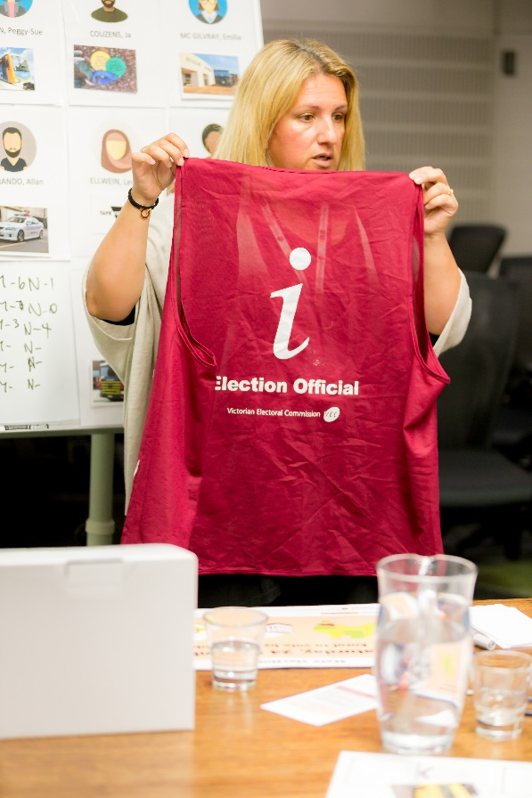
Alex, our Democracy Ambassador running an education session.
Employment – staff recruitment, training and retention
The VEC comprises core Victorian Public Service (VPS’ staff and a casual workforce that can reach 15,000 people across Victoria during State elections. We aim to employ and retain a diverse workforce that is representative of the community we serve.
To achieve this, we will:
- employ more people with disability and work on our processes to support their success
- ensure our recruitment practices are fully inclusive
- provide at least one intern opportunity each year through the Australian Network on Disability - Stepping into Internship program
- ensure that staff increase their knowledge and skills by participating in training, including disability access and awareness and web accessibility guideline training
- outline roles in detail on our job descriptions, to ensure the physical requirements of roles are clearly stated.

Community – engagement and consultation
The VEC plays a vital role in ensuring that Victorians understand voting and can participate in their democracy.
To achieve this, we will:
- evaluate the Terms of Reference and membership responsibilities of the Electoral Access Advisory Group, to ensure that new members reflect the changing needs of people with disability
- listen to our Electoral Access Advisory Group members and key stakeholders to ensure feedback is obtained regarding resources, education and research programs
- have people with disability teach other people about enrolling and voting
- co-design an education resource for supports, carers, mental health workers, and disability support workers, so they can learn how people with disability can be supported to vote
- pilot a school based electoral education resource (based on the existing curriculum aligned Passport to Democracy program) that is available for use by specialist and special development schools for students with a disability
- continue to support mobile voting and specialist mobile voting across Victoria, including services that support people with mental illness
- work to ensure that enrolment and compulsory voting notices are in plain (and provide alternative supplementary information where this is not possible for legal reasons).

Changing attitudes - leading by example
We aim to be a leader in demonstrating inclusive practices and attitudes towards people with disability.
To achieve this, we will:
- celebrate success by sharing stories about our achievements and supporting staff to talk about their own personal journeys working at the VEC
- review this Plan annually and make amendments to ensure actions match business needs
- collaborate with schools and TAFE colleges to include students with disability in the sponsored Youth Parliament teams.

Reporting and Governance
The Electoral Commissioner and the VEC Executive Management Group are responsible for ensuring the actions of the Disability Access and Inclusion Plan 2019-2023 are achieved.
The VEC will maintain a progress report for the Disability Access and Inclusion Plan and invite feedback twice a year at the Electoral Access Advisory Group.
An annual progress summary will be reported in the VEC Annual Report.

Feedback
If you have any feedback or suggestions about this Plan, you can:
Email us at info@vec.vic.gov.au
Call us on (03) 8620 1100
If you are deaf, hard of hearing or need communication support, you can contact us on 133 677 or through National Relay Service 1800 555 600
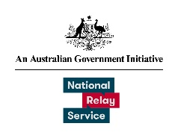

Write to us at:
Victorian Electoral Commission
Level 11
530 Collins Street
Melbourne VIC 3000.

