ELECTORAL REPRESENTATION REVIEW
South Gippsland
Shire Council
Final Report
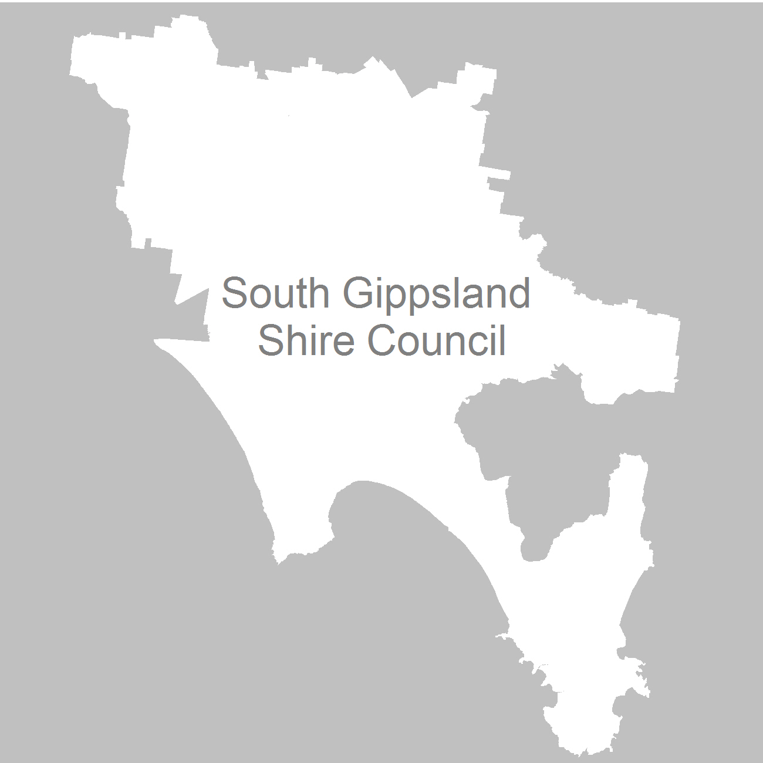

11 April 2012

Contents

Recommendation 4
Background 5
Legislative basis 5
The VEC and electoral representation reviews 5
Profile of South Gippsland Shire Council 6
Current electoral structure 6
The electoral representation review process 6
VEC research 7
Public involvement 7
Advertising 8
Media releases 8
Public information session 8
Information brochure and poster 8
Helpline 8
VEC website 9
Guide for submissions 9
Preliminary report 10
Preliminary submissions 10
Preliminary options 10
Public response 14
Response submissions 14
Public hearing 15
Findings and Recommendation 16
Number of councillors 16
Electoral structure 16
Recommendation 20
Appendix 1: List of submitters 21
Appendix 2: Map 22

Recommendation
The Victorian Electoral Commission (VEC) recommends that South Gippsland Shire Council consist of nine councillors from three three-councillor wards, with minor changes to current ward boundaries.

Background

Legislative basis
The Local Government Act 1989 (the Act) requires the VEC to conduct an electoral representation review of each municipality in Victoria at least every 12 years. The Act specifies that the purpose of a representation review is to recommend to the Minister for Local Government the number of councillors and the electoral structure for a municipality, which will provide ‘fair and equitable representation for the persons who are entitled to vote at a general election of the Council’.
The Act requires the VEC, as part of an Electoral Representation Review, to consider:
- the number of councillors in a municipality;
- whether a municipality should be unsubdivided or subdivided;
- if it should be subdivided, whether ward boundaries:
  - provide for fair and equitable division of the municipality;
  - ensure equality of representation through the number of voters being represented by each councillor being within 10 per cent of the average number of voters represented by all councillors; and,
- if it should be subdivided, the number of councillors that should be elected for each ward.

The VEC and electoral representation reviews
The VEC has conducted electoral representation reviews since 2004 on appointment by local councils. The Act was changed in 2010 to define the VEC as the only agency authorised to undertake the reviews.
The VEC drew on its experience in mapping and boundary modelling and also engaged consultants with experience in local government to provide advice on specific local representation issues during the review.

Profile of South Gippsland Shire Council
South Gippsland Shire Council was formed in 1994 by the amalgamation of the Shires of Mirboo and South Gippsland and parts of the Shires of Korumburra and Woorayl. The Shire encompasses a total land area of about 3,300 square kilometres, including substantial coastal areas. Major towns include Leongatha, Korumburra, Mirboo North and Foster.
At the 2006 census, the South Gippsland Shire recorded a population of 25,735. Population is expected to increase by 8.3 per cent in the next 10 years. The highest projected rate is in the west of the Shire, with a projected population growth of
10.8 per cent. The east of the Shire is forecast to experience a lower rate of growth
at 2.2 per cent.

Current electoral structure
The last electoral representation review for South Gippsland Shire Council took place in 2004. Following the review, the Minister for Local Government determined that the structure of South Gippsland Shire Council would be:
- nine councillors;
- divided into three wards: Coastal-Promontory Ward, Strzelecki Ward and Tarwin Valley Ward; and,
- with three three-councillor wards.

The electoral representation review process
The VEC proceeded on the basis of three main principles:
- Ensuring the number of voters represented by each councillor is within 10 per cent of the average number of voters per councillor for that municipality.
Populations are continually changing. Over time these changes can lead to some wards having larger or smaller numbers of voters. As part of the review, the VEC corrected any imbalances and also took into account likely population changes to ensure these boundaries provide equitable representation until the next review.
- Taking a consistent, State-wide approach to the total number of councillors.
The VEC was guided by its comparisons of municipalities of a similar size and category to the council under review. The VEC also considered any special circumstances that may warrant the municipality to have more or fewer councillors than similar municipalities.

- Ensuring communities of interest are as fairly represented as possible.
Each municipality contains a number of communities of interest and, where practicable, the electoral structure should be designed to take these into account. This allows elected councillors to be more effective representatives of the people in their particular municipality or ward.
The recommendation is based on:
- internal research specifically relating to the municipality under review;
- VEC experience from its work with other municipalities and in similar reviews for State elections;
- VEC expertise in mapping, demography and local government;
- careful consideration of all public input in the form of written and verbal submissions received during the review; and,
- advice received from consultants with wide experience in local government.
Public submissions were an important part of the process, but were not the only consideration during the review. The VEC seeks to combine the information gathered through public submissions with its own research and analysis of other factors, such as the need to give representation to communities of interest. The recommendation is not based on a ‘straw poll’ of the number of submissions supporting a particular option.

VEC research
In addition to the information provided in submissions, the VEC created a profile of the municipality based on population trends, development projections and demographic indicators. The VEC used the Australian Bureau of Statistics 2006 census community profiles, the Department of Planning and Community Development projections and voter statistics from the Victorian electoral roll. The VEC also undertook field work to view current and possible boundaries for each of the options presented in the preliminary report to evaluate their effectiveness.

Public involvement
The VEC values the local knowledge and perspectives presented by the public in written submissions. The public were given two opportunities to provide submissions during the review. Their input was considered by the panel in forming the options in the preliminary report and they were also invited to respond to these options. In addition, a public hearing was held to enable people to speak in support of their submissions and supplement it with information.
To ensure transparency in the process, all written submissions were published on the VEC website and all verbal submissions were heard at a public hearing.
To raise awareness of the review and encourage the public to engage with the process, a full public information campaign was undertaken.

Advertising
In accordance with sections 219F(4) and 219F(7) of the Act, the VEC ensured public notices were placed in local newspapers.
Notification of the review appeared in local newspapers: Great Southern Star and South Gippsland Sentinel on Tuesday, 15 November 2011 and Foster Mirror and Mirboo North Times on Wednesday, 16 November 2011. The notice detailed the process for the review and called for public submissions. A general notice covering several reviews was printed in The Age and Herald Sun on Saturday, 22 October 2011.
Notification of the release of the preliminary report appeared in local newspapers: Great Southern Star and South Gippsland Sentinel on Tuesday, 14 February 2012 and Foster Mirror and Mirboo North Times on Wednesday, 15 February 2012. The notice detailed the options contained in the preliminary report, including a map of each option, instructions on how to access a copy of the preliminary report and how to make a submission in response to the report.

Media releases
The VEC produced two media releases for this review and distributed these to the
local media. These releases corresponded with the notice of review on Tuesday,
15 November 2011 and with the notice of release of the preliminary report on Tuesday,
14 February 2012.

Public information session
The VEC held two public information sessions for people interested in the review process on Monday, 28 November 2011 — in Foster and Korumburra.

Information brochure and poster
An information brochure was provided to the Council to be distributed to residents through the Council’s network, such as in libraries and service centres. A poster was provided to the Council to be displayed in public spaces.

Helpline
A dedicated helpline was established to assist with public enquiries concerning the review process.

VEC website
The VEC website delivered up-to-date information to provide transparency during the preliminary and response stages of the review process. All submissions were posted on the website and an online submission tool was created to facilitate the submission process. The preliminary report was available for electronic download on the website.

Guide for submissions
A guide for submissions was developed and distributed to those interested in making submissions. Copies of the guide for submissions were available on the VEC website, in hardcopy on request, and were provided to the Council.

Preliminary report
In accordance with the requirement of the Act, the VEC produced a preliminary report outlining its preferred option and an alternative option proposed for South Gippsland Shire Council. The report was released on Tuesday, 14 February 2012.

Preliminary submissions
The VEC received a total of six submissions, with four from individuals and two made on behalf of organisations, including one from the Proportional Representation Society of Australia (Victoria–Tasmania) Inc.
Four submissions suggested a change was needed to shift the areas of Mount Best and Toora North from Tarwin Valley Ward into Coastal-Promontory Ward. The submitters argued that the Strzelecki Ranges disconnect these areas from the remainder of Tarwin Valley Ward, and suggested that these communities had closer ties with the localities of Foster and Toora and had a stronger relationship with the councillors of Coastal-Promontory Ward. All four submitters suggested that shifting the boundary between Tarwin Valley and Coastal-Promontory Wards to run along Grand Ridge Road would be a more suitable boundary that reflects geographic communities of interest.
The Proportional Representation Society supported the retention of the current structure of three three-councillor wards, suggesting that this electoral structure would provide equity and parity to voters throughout the Shire.
Finally, the submission from another local resident suggested there is a lack of rural representation on the Council and an apparent concentration on town matters, because residents of the town make up a majority of the voter base of the wards. Under proportional representation a candidate needs 25 per cent of the vote to be elected. As rural residents make up a significant proportion of each ward, there is an opportunity for rural based candidates to be elected.
A list of submitters, by name, is available in Appendix One. Copies of the submissions can be viewed on the VEC website at vec.vic.gov.au.

Preliminary options
The VEC assessed a range of electoral representation models that may suit South Gippsland Shire Council. The VEC considered the projected population change, the desire to maintain communities of interest, and the number of voters and number of councillors compared with other municipalities. The VEC developed a preferred option and an alternative option for consideration.
The VEC compares the municipality under review with Councils of a similar size and category to determine the appropriate number of councillors for a council. With approximately 27,654 voters, South Gippsland Shire sits in the lower quartile of rural municipalities with nine councillors. In addition, the Department of Planning and Community Development’s Victoria in Future projections show that the municipality’s population growth, at 8.3 per cent, will be less than the median for non-metropolitan municipalities over the next 10 years. With only a moderate population growth projected, and no arguments raised in submissions to support an increase in the number of councillors, the VEC has only considered nine-councillor electoral structures.
In considering a suitable electoral structure for the Shire, the VEC took into account the effect of geographic factors on the diversity of the population in the municipality. South Gippsland has a total land area of about 3,300 square kilometres, including substantial coastal regions, and is considered a rural, residential and holiday area. Almost a quarter (23.6 per cent) of the Shire’s workforce is employed in the agriculture, fishing and forestry sector. Much of the Shire’s rural area is used for timber getting and agriculture, while tourism is an important industry in the coastal areas.
Prior to the Council’s last review in 2004, the electoral structure comprised seven single-councillor wards and one two-councillor ward. A change to three three-councillor wards was recommended to reflect the Shire’s broad geographic communities of interest, grouping the coastal regions in Coastal-Promontory Ward and dividing the remainder of the Shire, consisting of rural districts, into the Strzelecki and Tarwin Valley Wards. These rural wards were based around the major population centres — Korumburra in Strzelecki Ward and Leongatha in Tarwin Valley Ward. The VEC also recommended a change from single-councillor wards to the current structure, as larger multi-councillor wards are less vulnerable to population change.
Since the Council’s last review, technological advancements in mapping software and an increase in the number of data sources have led to improvements in mapping, enabling the VEC to determine population distribution beyond the geographic parameters of Census Collection District data. The VEC modelled a structure comprising of seven single-councillor wards and one two-councillor ward using the current voter numbers to determine whether it could be a viable structure for the municipality. Although the structure was successful in retaining voter numbers within the tolerance in the short term, anticipated population change would result in Drumdlemara Ward, at + 15.56 per cent, exceeding tolerance by 2016. In addition, the VEC considered this structure to be problematic in that it uses boundaries that run to the edge of Leongatha, isolating the locality from its hinterland.
The Council’s existing structure of three three-councillor wards currently meets the tolerance requirement of the Act, and provides a sustainable structure until the Council’s next scheduled review in 2023. The VEC, however, received a number of submissions that raised concerns regarding communities of interest. Several submitters suggested the physical terrain of the Strzelecki Ranges disconnects Mount Best and Toora North from the remainder of Tarwin Valley Ward, indentifying communities of interest through their relationship with the number of commercial and retail hubs located in Foster and Toora in Coastal-Promontory Ward. These submitters all recommended moving the boundary between Tarwin Valley and Coastal-Promontory Wards further up to Grand Ridge Road, on the eastern border of the municipality, in order to shift Mount Best and Toora North into Coastal-Promontory Ward. Moreover, one submitter suggested the boundary could be further adjusted to also include Foster North, Wonga and Woorarra West in Coastal-Promontory Ward. The VEC found that although the submitter’s suggested change could satisfy the numbers requirement of the Act, the transfer of all these localities resulted in an arbitrary splitting of the ward. Where possible, the VEC prefers to use clearly identifiable boundaries, using main roads, rivers and significant landmarks while keeping together communities of interest. The VEC considered a boundary that follows Boolarra-Foster Road to Grand Ridge Road provided a clear and logical boundary and has the capacity to maintain voter numbers within tolerance. The VEC, therefore, recommended this structure as its preferred option (Option A).
The VEC also modelled a three-ward structure using the locality boundaries. Ward boundaries that apply locality boundaries are also considered to provide clear boundaries, and have the advantage of generally defining broad communities of interest. However, with Coastal-Promontory Ward exceeding the 10 per cent threshold, this structure did not satisfy legislative requirements of the Act.
The VEC, however, found that with some further minor changes, locality boundaries that generally follow the existing ward boundaries could be applied effectively. The VEC put forward this electoral structure as its alternative option (Option B) for public consideration. The VEC considered that both Option A and Option B recognised the existing communities of interest that are represented under the current ward make-up and were likely to meet the VEC’s main electoral representation review principles.
The options were:
- Option A (Preferred Option) that South Gippsland Shire Council consist of nine councillors from three three-councillor wards, with minor changes to current ward boundaries.
Option A is based on the existing boundaries, with only a minor adjustment made to the boundary shared by Tarwin Valley and Coastal-Promontory Wards to reflect the functional ties of the Mount Best and Toora North communities with the north-eastern areas of Coastal-Promontory Ward. The boundary between Tarwin Valley and Coastal-Promontory Wards was shifted to follow Boolarra-Foster Road, north to Grand Ridge Road. As a result, a significant part of the localities of Boolarong, Gunyah, Mount Best, Toora North and Wonga were transferred to Coastal-Promontory Ward.
- Option B (Alternative Option) that South Gippsland Shire Council consist of nine councillors from three three-councillor wards, with modified boundaries from the existing structure.
Under this option, ward boundaries have been aligned with locality boundaries where possible. As a result the localities of Foster, Mount Best, Toora North and Wonga are now part of Coastal-Promontory Ward; Buffalo, Koonwarra, Meeniyan and most of Fish Creek are part of Strzelecki Ward; and Fairbank, Ruby, Stony Creek and Wild Dog Valley are part of Tarwin Valley Ward.
While this structure requires more significant changes to the current ward boundaries, the structure applies communities of interest in the broader functional dimension of localities and has the advantage of providing clearly identifiable boundaries.

Public response

Response submissions
Response submissions on the electoral representation review of South Gippsland
Shire Council opened on Tuesday, 14 February 2012 and closed at 5.00pm on Wednesday, 14 March 2012. Four response submissions were received. Table 1 shows the levels of support for each option based on the preferences expressed in each response submission.
Table 1: Preferences expressed in response submissions for each option
Option A  (Preferred Option) | Option B  (Alternative Option) | Other
4 | 1 | —

* The Proportion Representation Society (Vic-Tas) Inc. indicated its support for both options.
All submitters supported Option A (Preferred Option), proposing nine councillors from three three-councillor wards, with minor changes to current ward boundaries. The Proportional Representation Society supported both options equally. The submission suggested that the electoral structure of three three-councillor wards has served the Shire well and, through the system of proportional representation, offers wide representation to the whole community.
Three submitters, in favour of Option A, noted their support for the proposed boundary changes to bring in Mount Best and Toora North into Coastal-Promontory Ward to better reflect the functional ties of these areas with the neighbouring localities. The South Gippsland Shire Council’s submission suggested this option could be further improved by uniting the entire locality of Fish Creek in one ward. Further, the submission also highlighted a concern with the length of the Strzelecki Ward, and suggested that communities in the south of the ward had little to do with those in the north. The submission, however, did not detail a specific ward to which Fish Creek would be best suited.
Finally, one submitter in favour of Option A recommended that Coastal-Promontory Ward be renamed simply Promontory Ward. The submitter suggested that this name would recognise the hinterland and still reflect the importance of Wilsons Promontory to the Ward.
A list of submitters, by name, is available in Appendix One. Copies of the submissions can be viewed on the VEC website at vec.vic.gov.au.

Public hearing
A public hearing was held at 6.30pm on Monday, 19 March 2012 at the South Gippsland Shire Council Chambers in Leongatha and three speakers presented.
The Council’s Manager Governance, Mr Luke Anthony and Councillor Mohya Davies spoke on behalf of the Council, and expressed their support for the proposed changes that shift the Mount Best and Toora North areas into the Coastal-Promontory Ward, under both options. Councillor Davies also provided further clarification on the Council’s recommendation to unite the locality of Fish Creek in one ward, under the proposed boundaries of Option A. Councillor Davies submitted that Fish Creek has strong community ties with Foster and other coastal communities of Coastal-Promontory Ward. Councillor Davies also described the historical link between Fish Creek and the nearby Corner Inlet community prior to Council amalgamations in 1994, and also discussed the geographic similarities of these areas.
Councillor Davies further supported her arguments by sharing that she had worked in the Fish Creek area as a kindergarten teacher in the past, and suggested that having the ward split between three three-councillor wards resulted in resident confusion over their ward and respective councillors. It is for this reason, Councillor Davies suggested that keeping these areas together under one ward would be beneficial. Mr Anthony supported Councillor Davies’ arguments and described his own family history links to these areas, and suggested these changes would receive strong community support. Both Councillor Davies and Mr Anthony also suggested that similar arguments could be made in support of also bringing in the Tarwin Lower and Buffalo localities into the Coastal-Promontory.
Councillor Davies argued against one submitter’s suggestion to rename Coastal-Promontory Ward as Promontory Ward to represent the hinterland communities of the ward. She contended that the ward largely consisted of coastal areas, and that the current ward name would adequately reflect this characteristic.
Jeetho resident, David Wanless did not support any option put forward by the VEC, but took the opportunity to discuss the inadequate level of representation of rural communities. Mr Wanless explained that while these communities represented almost 40 pent of the Shire, and provide a significant proportion the Shire’s income, this was not reflected in the composition of council and the level of consideration given to rural issues. Mr Wanless described the average farmer as being in his/her late-50s, and questioned the permanence of this community in light of its depleting representation. Mr Wanless acknowledged that there was some farming knowledge on council, but considered that this did not go far enough in providing adequate rural representation.

Findings and Recommendation
This report has summarised the process the VEC completed to gather information and to develop and consult on the options under consideration. The VEC now provides its findings for recommendation to the Minister for Local Government.

Number of councillors
The Act requires the VEC to recommend the appropriate number of councillors for the council under review, with the provision that this remain between five and 12 councillors. To determine the most suitable number of councillors, the VEC compares the Council under review with other municipalities of similar size and category in Victoria. However, special circumstances may justify a change to the standard.
As discussed earlier in this report, when comparing its voter numbers with other rural municipalities in the State, South Gippsland Shire Council sits at the lower end in the band of nine-councillor municipalities. In addition, the Council’s moderate population growth anticipated for the next 10 years is below the median for non-metropolitan municipalities, which further affirms that an increase in the number of councillors is not justified to compensate for significant growth in the Shire. Further, none of the submissions made throughout the review process highlighted an issue with the current number of councillors.
The VEC is confident that a structure with nine councillors would continue to provide fair and equitable representation for the residents of South Gippsland Shire until the next scheduled representation review in 2023.

Electoral structure
The Act also requires the VEC to recommend an appropriate electoral structure for the municipality. The VEC considers whether the municipality should be unsubdivided or subdivided into wards and, if subdivided, the positioning of ward boundaries and the number of councillors to be elected for each ward to provide a fair and equitable division and ensure equity of representation.
In determining a suitable electoral structure for South Gippsland Shire, the VEC firstly assessed whether the current structure met the tolerance requirement of the Act. The Act requires all wards in a ward structure to deviate from the average number of voters per councillor by no more than +/- 10 per cent of the average number of voters per councillor across the municipality. With the largest deviation in voter numbers at only
-2.52 per cent, in Coastal-Promontory Ward, the Council’s electoral structure is well within the tolerance requirement of the Act. Further, when applying Department of Planning and Community Development projections, the VEC found that these ward boundaries were able to absorb anticipated population growth and provide sustainable boundaries until the next scheduled review.
As part of the review process, the VEC also considered the extent to which the existing electoral structure complies with communities of interest. The Council’s current electoral structure consists of three wards, with three councillors elected from each ward. The VEC recommended this structure at the Shire’s last review in 2004, as it was considered to be in accord with the municipality’s broad geographic communities of interest: Coastal-Promontory Ward encompasses the Shire’s sizeable coastal regions; Strzelecki Ward groups the northern and western rural district and is based around the major population centre of Korumburra; and, Tarwin Valley Ward consists of the eastern rural districts and has the major population centre of Leongatha.
Public submissions received during the preliminary stages provided further insight into communities of interest within the municipality. Submitters drew attention to the separation that exists between the Mount Best and Toora North communities and the remainder of the Tarwin Valley Ward, which is divided by the Strzelecki Ranges. The VEC acknowledged the strength of the arguments made in the submissions, and modelled the recommended changes. Accordingly, minor adjustments were made to existing boundary shared by Tarwin Valley and Coastal-Promontory Wards, shifting the localities of Boolarong, Gunyah, Mount Best, Toora North and Wonga into Coastal-Promontory Ward. The VEC considered the minor modification made as an improvement that reinforces the functional ties of the areas with north-eastern parts of Coastal-Promontory Ward. The VEC presented this structure as its preferred model (Option A) in the preliminary report.
The VEC also put forward a model with a similar composition of wards as Option A, but which aligned ward boundaries with locality boundaries where possible. The use of locality boundaries shifted some towns into the adjoining ward: Foster, Mount Best, Toora North and Wonga to Coastal-Promontory Ward; Buffalo, Koonwarra, Meeniyan and a significant segment of Fish Creek to Strzelecki Ward; and Fairbank, Ruby, Stony Creek and Wild Dog Valley to Tarwin Valley Ward. The VEC put forward this structure as its alternative option (Option B) for public consideration. The VEC considered that both options put forward in the preliminary report recognised the Shire’s existing communities of interest and were likely to meet the VEC’s main electoral representation review principles.
The VEC received four submissions in response to the preliminary report, and all supported the VEC’s preferred model (Option A). The Proportional Representation Society’s submission also supported Option B, as it also offered a ‘3x3’ structure. The Proportional Representation Society considers the election of councillors by proportional representation from three three-councillor wards provides a structure consistent with sound electoral arrangements. The Council’s submission recommended that the boundaries be further modified to unite Fish Creek in its entirety in one ward. Further, the submission also highlighted a concern regarding the length of the Strzelecki Ward, and suggested that communities in the south had little to do with those in the north of the ward. Those who spoke on behalf of the Council at the public hearing provided further clarification on the suggested changes. Councillor Davies suggested that both Fish Creek and Tarwin Lower would be best placed in the Coastal-Promontory Ward because of the close community ties of these areas with adjoining localities in the Ward. Councillor Davies provided similar reasoning in recommending that Middle Tarwin and Buffalo be also shifted to the Coastal-Promontory Ward.
In considering whether this would be a suitable change for the Shire, the VEC reviewed and, where possible, modelled the suggestions made to test the viability of such structure in meeting the tolerance requirement of the Act. The VEC modelled a structure that includes Fish Creek and Tarwin Lower in Coastal-Promontory Ward and found that the ward boundaries were able to meet the +/- 10 per cent tolerance, and would be capable of absorbing anticipated population growth until at least 2020 (Figure 1). However, the structure was closer to the maximum allowable tolerance, with wards reaching as high as +8.71 per cent in the short term, compared to a moderate deviation of only -1.95 per cent, in Tarwin Valley Ward, under Option A. The VEC’s concerns, however, were not about this point alone.
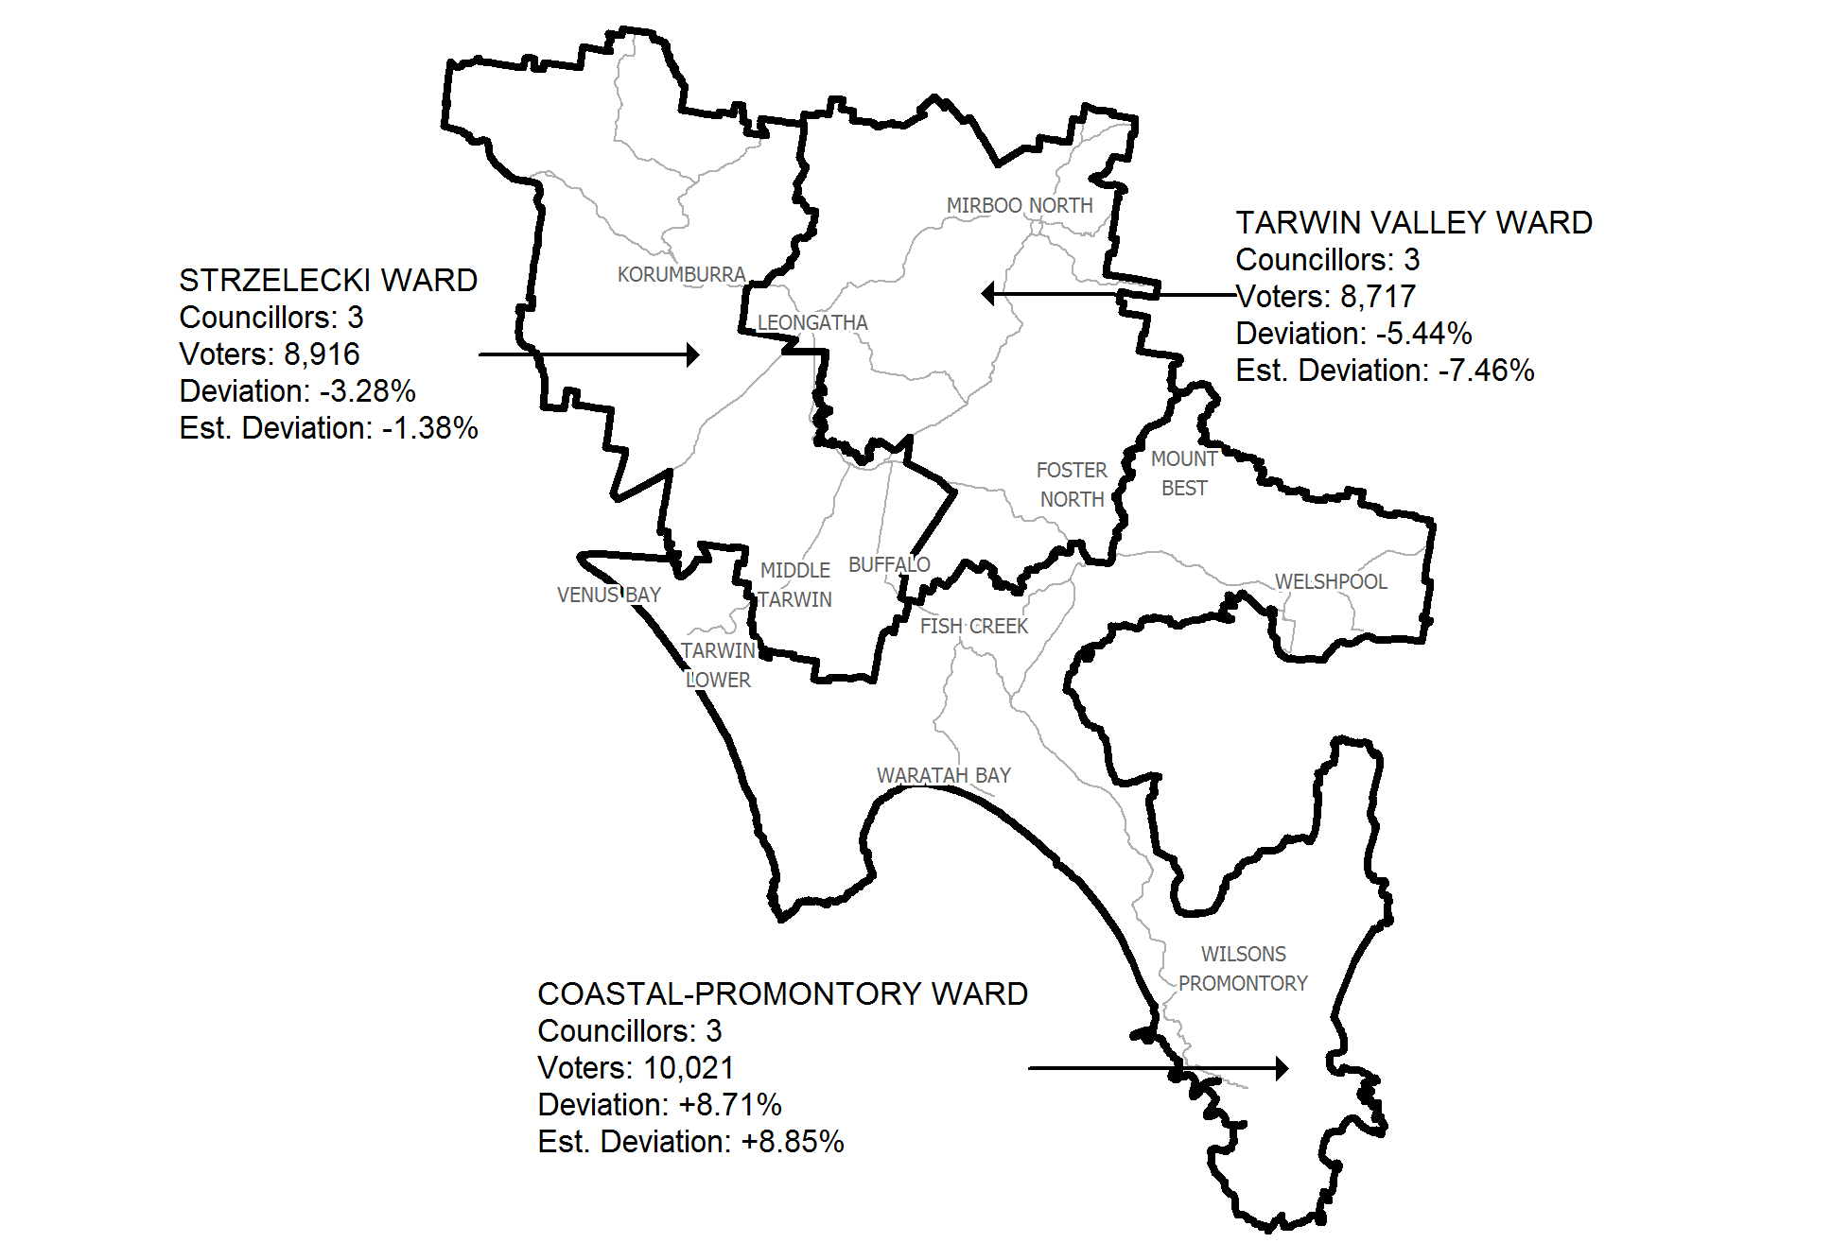
Figure 1: Model suggested by South Gippsland Shire Council proposing that Fish Creek and Tarwin Lower be shifted to Coastal-Promontory Ward, with estimated deviations for 2020.
The VEC makes the preliminary report publicly available for scrutiny and comment before its final report is released to ensure consistent and open consideration of all issues. The VEC also considers submissions provide an invaluable source of local knowledge and perspectives. Without public input on the Council’s suggestions, an indication of views was sought from the Shire’s last review. The VEC found a degree of variation in public opinion on where Fish Creek was most closely aligned to in term of communities of interest. While one group suggested Fish Creek had the strongest ties with Coastal-Promontory Ward, another submitter argued that the locality was more closely connected to the farming traditions of the Tarwin Valley Ward than to the coastal themes associated with the Coastal-Promontory Ward. Indeed, at the most recent hearing Mr Wanless, when asked by the Panel where he felt the Fish Creek most related, stated that he believed this to be the rural community within the Tarwin Valley Ward. The VEC acknowledges the other arguments put forward about Fish Creek at the public hearing. However, in the light of varying opinions about Fish Creek during the last review, and in absence of any opportunity for public feedback to the Council’s views, the VEC is reluctant to make the major change of transferring Fish Creek and neighbouring areas to a different ward.
The VEC believes that Option A (Preferred Option), with nine councillors from three three-councillor wards and with minor changes to current ward boundaries provides the most effective electoral structure for the residents of South Gippsland Shire. When comparing this option to Option B, this structure puts forward the least disruption to residents by using a similar electoral structure and boundaries to the existing structure. This structure also provides sustainable boundaries until at least the next scheduled electoral representation review.
In addition, the VEC considers that Option A recognises the existing broad communities of interest that are represented under the current structure and makes minor boundary changes to refine this structure by placing the Mount Best, Toora North and surrounding communities into Coastal-Promontory Ward. This structure also has the advantage of providing boundaries that are closest to the mathematical equality. The VEC considers structures with ward boundaries close to maintaining an equal number of voters represented by each councillor across the municipality are strongest in upholding the democratic principles of ‘one vote, one value’.

Recommendation
The Victorian Electoral Commission (VEC) recommends that South Gippsland Shire Council consist of nine councillors from three three-councillor wards, with minor changes to current ward boundaries.

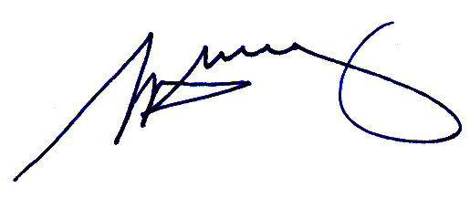
S. H. Tully
Electoral Commissioner

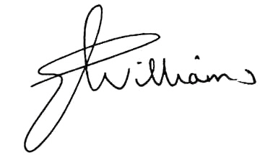
Liz Williams
Deputy Electoral Commissioner

Appendix 1: List of submitters
Preliminary submissions were received from:
Name
Allen, J
Ford, H
Lidstone, V
Mt Best Community Hall
Proportional Representation Society of Australia (Victoria–Tasmania) Inc.
Wanless, D*

Response submissions were received from:
Name
Agars, M
Lidstone, V
Proportional Representation Society of Australia (Victoria–Tasmania) Inc.
South Gippsland Shire Council*

* indicates those submitters who spoke in support of their submission at the public hearing on Monday, 19 March.

Appendix 2: Map
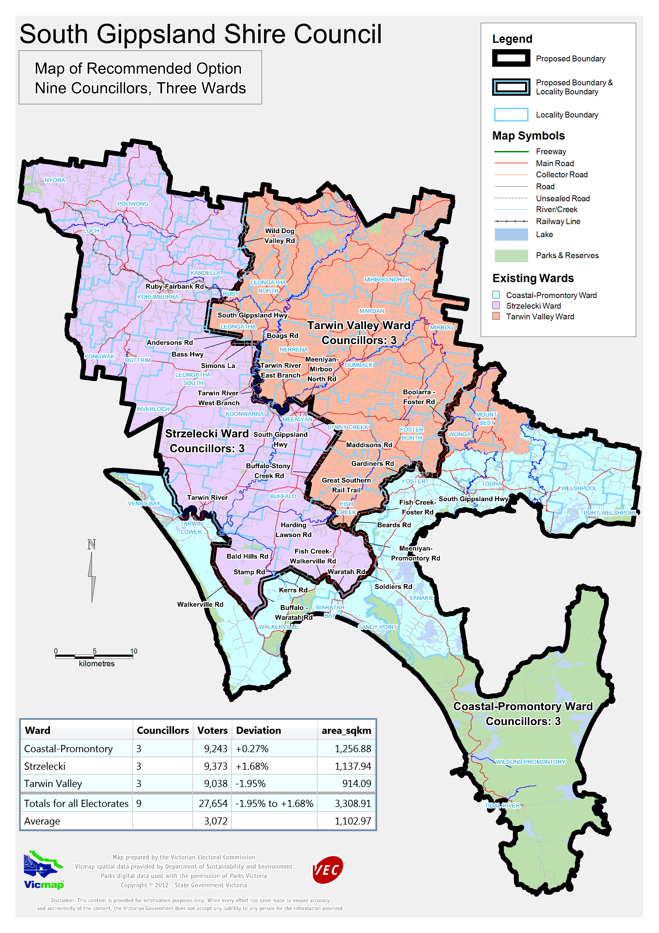

Victorian Electoral Commission
Level 11, 530 Collins Street
Melbourne, Vic 3000

131 VEC (131 832)
southgippsland.review@vec.vic.gov.au
vec.vic.gov.au

Section 219D of the Local Government Act 1989.
Department of Planning and Community Development, Victoria in Future 2008.
The VEC calculates voter numbers by merging the resident electoral roll and most recently provided non-resident electoral roll.

