Introduction
Our regulatory approach
October 2022
The Electoral Act 2002 (Vic) (Electoral Act) establishes the Victorian Electoral Commission (VEC) and the regulatory scheme administered by the VEC.
The Electoral Act requires the VEC to facilitate democratic and transparent electoral processes for all Victorians. The Electoral Act also places obligations on those participating in State elections.
The VEC is required to regulate electoral participants, including:
- electors
- candidates in elections and elected members
- registered political parties, their officeholders and their members
- those who give or receive political donations
- those who campaign or fundraise, and
- those who publish or distribute electoral campaign material.
The VEC has adopted a constructive compliance approach for its regulatory activities, which focuses on providing electoral participants with resources to understand and comply with their obligations. Where a person or organisation fails to comply with their obligations, compliance action is taken proportionate to the VEC’s assessment of harm. The constructive compliance approach is consistent with the VEC’s vision and purpose:
Our vision All Victorians actively participating in their democracy.

Our purpose To deliver high quality, accessible electoral services with innovation, integrity and independence.

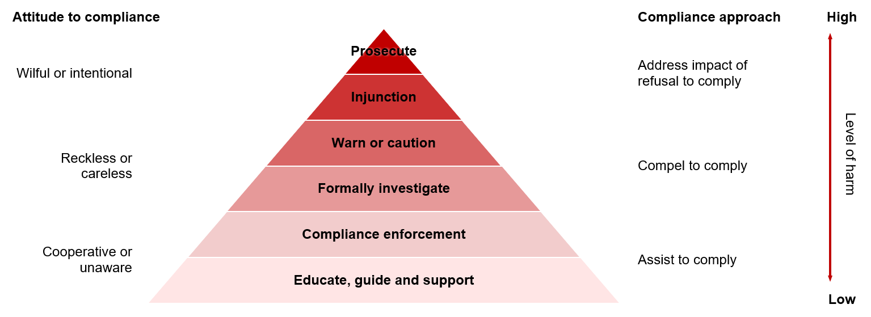

Figure 1. The VEC’s constructive compliance approach (Source: Adapted from Ayres and Braithwaite, 1992).

What is constructive compliance?
A constructive compliance approach is focused on escalating compliance action proportionate to the level of non-compliance.
Most Victorians require minimal support to comply with their obligations under the Electoral Act. The VEC’s first priority is to educate, guide and support electoral participants to comply with their obligations. Where this fails to address non-compliance with the Electoral Act, the VEC will take action proportionate to the level of harm.
The peak of the constructive compliance approach is criminal prosecution, which is only used when no other compliance action is appropriate or other appropriate steps have already been exhausted.
Educate, guide and support
The VEC offers education and guidance by making relevant information available for all participants in Victoria’s democracy. The VEC engages directly with more targeted audiences where tailored education, guidance and support is needed.
Support is available through contact with subject matter experts and access to systems like VEC Disclosures, a portal for those who give or receive political donations to meet their legal disclosure obligations.
Education and guidance may be provided in writing where it is necessary to caution a participant that their behaviour or conduct may be placing them at risk of further compliance action. Where possible, the VEC will try to identify solutions to help them rectify the issue so that no further compliance action is needed.
Compliance enforcement
The Electoral Act sets out clear obligations for those who participate in Victoria’s electoral processes. These obligations range from the requirement for all enrolled Victorians to vote in State elections, all the way to regular reporting requirements for registered political parties and others to detail certain financial transactions.
Where the VEC identifies unintentional non-compliance, the VEC will seek to resolve the matter in a supportive manner. The participant may be contacted by phone or email to remind them of their obligations. If this resolves the issue, and no significant harm has occurred, the VEC will likely decide that no further action is necessary.
The VEC also has powers under the Electoral Act to require certain people and organisations to provide documents, materials and other things, or to answer questions. These powers are used in accordance with the VEC’s values: independence, accountability, innovation, respect and collaboration.
Where appropriate, the VEC may partner with or refer matters to State and federal enforcement or integrity agencies.
Formally investigate
Where efforts to address non-compliance are unsuccessful or there is a breach of the Electoral Act associated with a greater level of harm, the VEC may commence an investigation. Matters involving careless, reckless or intentional non-compliance may progress directly to investigation.
The VEC will always be cautious in its communications about investigations, including with the media. The VEC won’t make public comment on investigations that may compromise fairness or prejudice any further action. The VEC understands that being involved in an investigation can be stressful and will consider support that may be needed.
Warn or caution
If an investigation finds an offence against the Electoral Act, the VEC may issue a formal warning. Formal warnings are appropriate when the offence identified is less harmful. The warning is restorative and seeks to prevent future offending.
Injunction
An injunction is a court order requiring a person to do, not to do, or to stop doing something. Failing to comply with the requirements of an injunction has serious consequences.
The VEC may apply for an injunction when a person or organisation’s behaviour or conduct poses a significant risk to the electoral process, and the behaviour or conduct needs to be stopped immediately. An injunction may also be sought where the VEC needs to stop someone from causing harm to an election. During an election, the Electoral Act also allows other participants in the election to seek an injunction in certain circumstances.
Where the VEC seeks an injunction, it may do this alongside other compliance actions. The VEC will communicate the reason for seeking the injunction to those involved, and may also make a public statement regarding why it has applied for the injunction.
Prosecute
Prosecuting a person for an offence against the Electoral Act is the final option for non-compliance. Before deciding to prosecute an offence, the VEC considers any other appropriate compliance action and the success of actions already taken.
The VEC also acknowledges the important role the justice system has in regulating democracy, and the independence of the courts in making decisions.
The VEC maintains its own policies to inform its decision to prosecute and also refers to other policies, including those of the Director of Public Prosecutions.
Our values
Accountability, transparency and integrity are central to VEC’s regulatory approach. The VEC will always provide as much information about its actions as possible, but not to the extent that it may compromise any particular compliance action in doing so.
The VEC reports annually in relation to its regulatory activity, including its use of any powers provided by the Electoral Act.

Feedback on our regulatory approach
The VEC is committed to continuous improvement and welcomes feedback on its regulatory approach.
If you have feedback on the VEC’s regulatory approach, contact us through the feedback and complaints forms available at vec.vic.gov.au.

