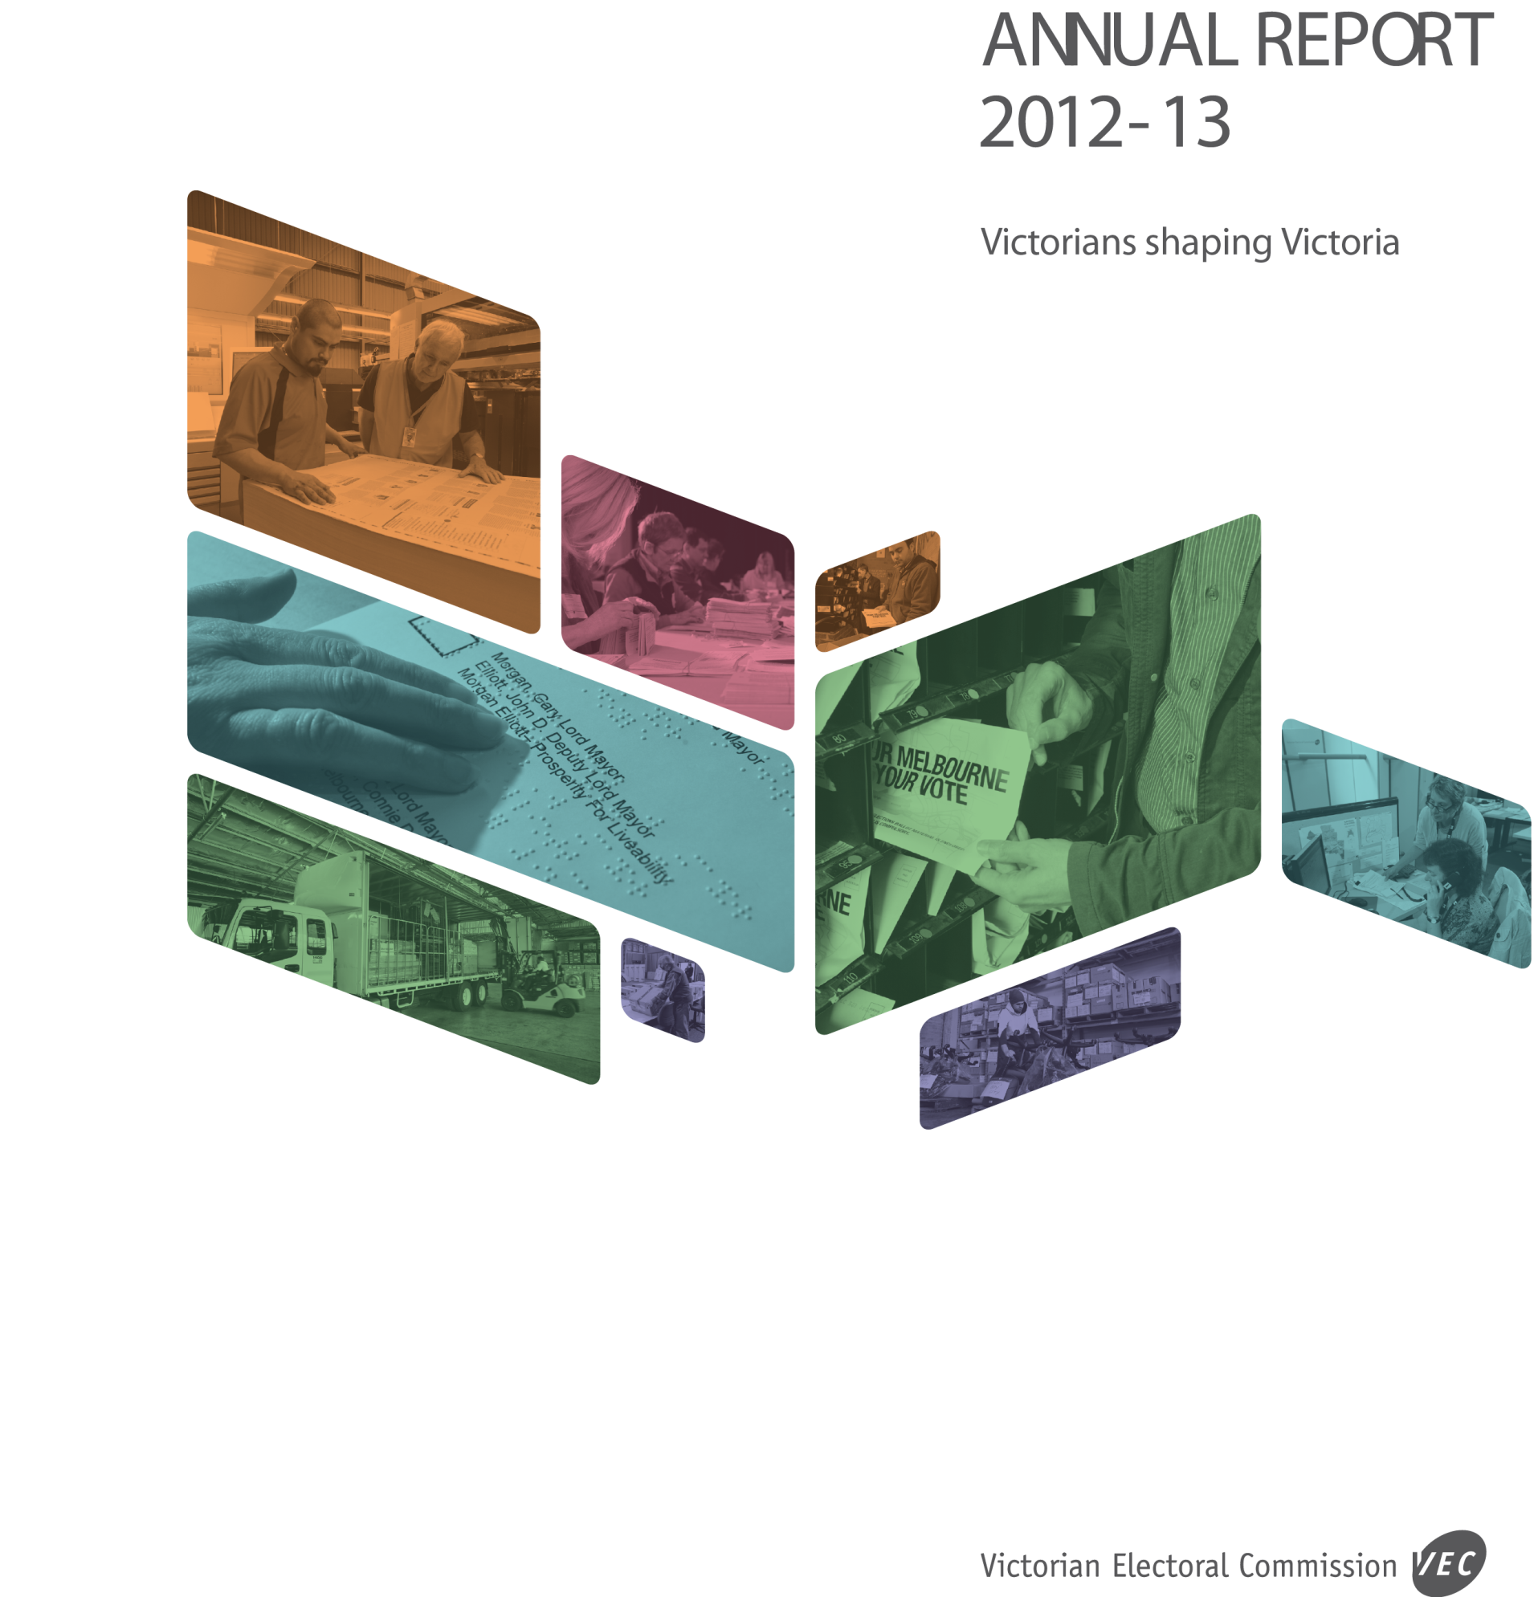

LETTER OF TRANSMITTAL
The Hon. Robert Clark, MP

Attorney-General
L26, 121 Exhibition St
Melbourne Vic 3000

Dear Attorney
In accordance with the requirements of the Financial Management Act 1994, I am pleased to submit the Annual Report of the Victorian Electoral Commission for the year ending 30 June 2013
for presentation to Parliament. Also included is the Report of the Electoral Boundaries Commission for the year ending 30 June 2013.
Yours sincerely
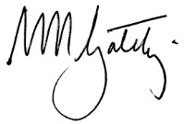
Warwick Gately AM
Electoral Commissioner

Fast facts | 2011–12 | 2012-13
Enrolled electors at 30 June | 3,623,594 | 3,662,957 | g
Voting-eligible population enrolled (estimated) | 91.87% | 92.68 | g
Staff (FTE) at 30 June | 77.9 | 75 | h
Training days per FTE | 2.38 | 1.1 | h
Lost time days | 0 | 13.8 | g
State elections (88 District, 8 Region) | 0 | 0 | –
State by-elections | 1 | 2 | g
Local government elections | 0 | 78 | g
Local government by-elections and countbacks | 9 | 8 | h
Other statutory and fee-for-service elections | 9 | 15 | g
Local government representation and subdivision reviews | 31 | 0 | h

Financial fast facts | 2011–12*  ($,000) | 2012-13  ($,000)
Special appropriation | 21,685 | 40,245 | g
Total expenses from transactions | 22,519 | 41,663 | g
Net result from transactions | (834) | (1,418) | h
Net result for the period | (896) | (1,411) | h
Net cash flow from/(used in) operating activities | (2) | 4 | g
Total assets | 9,017 | 10,471 | g
Total liabilities | 2,394 | 3,020 | g

OUR HIGHLIGHTS
- NEW ELECTORAL COMMISSIONER APPOINTED APRIL 2013 (PAGE 14)
- THREE NEW MANAGERS APPOINTED TO VACATED POSITIONS (PAGE 15)
- STRATEGIC PLAN 2013-14 TO 2017-18 LAUNCHED, PROVIDING DIRECTION AND A STRONG PLANNING FRAMEWORK TO SUPPORT THE ACHIEVEMENT OF THE VEC’S STRATEGIC INTENT (PAGE 129)
- 103 ELECTORAL EVENTS CONDUCTED ON TIME, WITHIN BUDGET AND IN ACCORDANCE
WITH LEGISLATION, RULES AND REGULATIONS (PAGE 30)
- LOCAL GOVERNMENT ELECTION SERVICES PROVIDED TO 4,098,007 ENROLLED VOTERS
IN 78 VICTORIAN COUNCILS (PAGE 33)
- LOCAL GOVERNMENT ELECTION SUPPORT SERVICES PROVIDED TO 2004 CANDIDATES
FOR 631 POSITIONS (PAGE 33)
- VEC WAREHOUSE RELOCATION PROVIDES SAFER, FIT-FOR-PURPOSE WAREHOUSING FACILITY (PAGE 55)
- PROPORTION OF ENROLMENT TRANSACTIONS FROM DIRECT ENROLMENT PROGRAM: 58.46% (UP FROM 26.97% IN 2011-12) (PAGE 43)
- COMMUNICATION ACCESS ACCREDITATION ACHIEVED, INDICATING HIGH CAPACITY FOR SERVICE PROVISION TO PEOPLE WITH COMMUNICATION DIFFICULTIES (PAGE 49)
- REVIEW OF ALL VEC POSITION DESCRIPTIONS, PROVIDING ROLE CLARITY AND DEFINING RESPONSIBILITIES AND RELATIONSHIPS WITHIN AND BETWEEN WORK GROUPS, AND ENABLING EFFECTIVE MANAGEMENT AND FORECASTING OF RESOURCE REQUIREMENTS (PAGE 58)
- APPOINTMENT AND TRAINING OF 6,500 CASUAL STAFF, AND OVER 2,000 VOTING CENTRE OFFICIALS TO ASSIST WITH THE CONDUCT OF LOCAL GOVERNMENT ELECTIONS (PAGE 34)
- ANNUAL REPORT 2011-12 ACHIEVES GOLD AUSTRALASIAN REPORTING AWARD (PAGE 22)

ABOUT THE VEC
Our challenge
To stimulate leading thinking and deliver excellence in all electoral endeavours.
Our vision
All Victorians actively participating in our democracy.
Our values
- Independence: acting with impartiality and integrity
- Accountability: transparent reporting and effective stewardship of resources
- Innovation: shaping our future through creativity and leadership
- Respect: consideration of self, others and the environment
- Collaboration: working as a team with partners and communities
Our history and functions
Elections for the Victorian Parliament began when Victoria achieved independence from New South Wales in 1851. In 1910, Victoria’s first Chief Electoral Inspector was appointed to head the new State Electoral Office.
The State Electoral Office existed as part of a public service department for 70 years. However, it became increasingly clear that it was inappropriate for the conduct of elections to be subject to ministerial direction. On 1 January 1989, legislation established the independent statutory office of Electoral Commissioner who was to report to Parliament instead of a Minister. In 1995, the State Electoral Office was renamed the Victorian Electoral Commission (VEC).
The VEC’s operations are governed by six main pieces of legislation:
Electoral Act 2002: establishes the VEC as an independent statutory authority, and sets out the processes for State elections
- Constitution Act 1975: sets out who is entitled to enrol as an elector, who is entitled to be elected to Parliament, and the size and term of Parliament
- Financial Management Act 1994: governs the way the VEC manages finances and financial reporting
- Electoral Boundaries Commission Act 1982: governs the determination of State electoral boundaries.
- Under this legislation, the Victorian Electoral Commissioner is nominated as a member
of the Electoral Boundaries Commission
- Local Government Act 1989: provides for local government elections and electoral representation reviews
- Infringements Act 2006: provides for stages 2 and 3 of compulsory voting enforcement.
Subject to these acts, the VEC maintains the electoral enrolment register, conducts State elections, local government elections, statutory elections, commercial and community elections, and boundary reviews. Electoral research and the provision of communication and education services that inform Victorians and engage them in the democratic process also form part of the VEC’s operations. A full list of legislation and regulations governing the VEC is included as Appendix B.

Our people and partners
The VEC has a core staff of dedicated and highly skilled people whose specialised knowledge ensures the success of its operations. The VEC also draws on the experience and expertise of a number of associated personnel, such as election officials and contractors, to complement the work of its core staff at times of peak activity. Valued partnerships with suppliers also contribute greatly to the VEC’s achievements.
The VEC also works closely with a range of advisory groups and community groups that provide information about ways to increase participation in the electoral system. These groups include youth, people experiencing homelessness, people with disabilities, culturally and linguistically diverse communities and Traditional Owners.
The VEC thanks all these people and organisations for their contributions to its work during 2012–13.
The VEC pays respect to Victorian Aboriginal communities and their elders past and present who have been custodians of this country for many thousands of years. We acknowledge their living culture and their role in the life of Victoria.
Operational and budgetary objectives and performance against objectives
The VEC has a number of performance measures that relate specifically to the Budget Paper Number 3 Service Delivery (BP3). In accordance with the Department of Treasury and Finance, Financial Reporting Directions (FRD), the following table provides details of the output report provided by the VEC to the Government, including performance measures and targets for agreed outputs, and the actual performance results for the VEC over the full year ending 30 June 2013 (see Figure 1).

Figure 1 – Performance against budgetary objectives
 | Unit | 2012–13  BP3 Target | June YTD Actual | % variance
State elections, municipal and statutory elections, by-elections, countbacks and polls | number | 110 | 103 | (6.36%)*
Challenges to VEC conduct upheld in Court | number | 0 | 0 | 0.00%
Elector enrolment changes and new enrolments processed within set timeframes | per cent | 98% | 100% | 2.00%
Figure 1 – Performance against budgetary objectives
*Note: The number of by elections, countbacks and polls is fewer than was estimated. The Brimbank Council general election was postponed by legislation. A number of pre-election vacancies were not filled in the six months prior to the general elections in accordance with Council decisions, as allowed under legislation.

ABOUT THIS REPORT
This report provides a summary of programs and initiatives implemented to meet the key objectives set out in an interim corporate plan developed prior to the departure of the previous Electoral Commissioner, Mr Steve Tully. In place from April 2012 to June 2013, the interim plan set out a number of key directions for the VEC to continue in the period between the departure of the previous Commissioner and the appointment and commencement of the new Electoral Commissioner. The interim plan provided continuity and certainty to staff, the Parliament and Victorians, and enabled key projects to continue and important events to be conducted without disruption.
As part of the VEC’s environmental sustainability activity, only the necessary number of copies of this report was printed, and once again environmentally friendly paper and printing were used. The report can be read and downloaded at vec.vic.gov.au.
Contents
6 | 10 | 28
Our year  In this section, Mr Warwick Gately AM is introduced. Mr Gately was appointed as Victoria’s Electoral Commissioner in April, 2013.  Mr Gately and Deputy Electoral Commissioner, Ms Liz Williams, who was Acting Electoral Commissioner for most of 2012-13, provide a summary of key activities and achievements for 2012–13, and the outlook for 2013-14.  Also included in this section is a summary of the VEC’s financial performance during 2012-13, which indicates that the VEC once again received an unqualified report from the Auditor General. | Our Commission  Good corporate governance and transparent reporting help ensure continued public confidence in the VEC and its processes.  Effective corporate systems enabled the VEC to deliver its core business and operate effectively and efficiently on a day-to-day basis.  The VEC prides itself on its accountability to the Victorian public and the Parliament. Good corporate citizenship is evidenced by its performance in areas such as diversity, sustainability, information management and reporting.  The 2013-14 year commences with a new five-year strategic plan that directs attention to consistent and cohesive organisational planning.  Governance and organisational structures, as well as internal and external advisory groups, are detailed in this section. Along with the new Electoral Commissioner, three new managers are introduced and departing managers farewelled. | Our core business  The VEC’s core business includes the conduct of elections, maintenance of the enrolment register and ensuring fair and equitable representation for electors at State and local government levels.  With all elections conducted in accordance with legislation, the  VEC maintained its record of no elections being overturned as a result of VEC error.  This section details the VEC’s electoral activity including highlights of the 2012 local government elections, comprising 78 general elections, and the provision of electoral services to nearly four million voters and over 2000 candidates. A full report of those elections has been forwarded to the Minister for Local Government.  The strengthening of operational planning structures during 2013-14 will ensure the VEC is ready to commence the successful implementation of its next major cyclical event – the 2014 State election.

40 | 56 | 65
Our voters  One of the VEC’s key strategic intents is the continued accuracy, integrity and security of the enrolment register.  The VEC’s automatic enrolment program was expanded and 112,499 electors were enrolled under this legislation during 2012-13. The VEC once again exceeded its target of processing 98% of all updates within one business day of receipt.  The 2012 local government elections provided a platform from which to launch information and engagement activities relating to council electoral matters. The VEC implemented programs designed  to engage people as candidates and voters in their local government elections.  While reflective of a national and international phenomenon, the decreases in average enrolment, turnout and formality figures at the local government elections is of great concern to the VEC. Considerable effort goes into communication campaigns, electoral education and engagement and stakeholder surveys conducted after those elections will assist with service improvement.  This section includes details of the VEC’s efforts to inform and engage electors as voters and candidates, and to assist them to vote and do so correctly. | Our people  The VEC aims to provide staff with the environment and opportunity to learn and thrive on a personal and professional level. The Human Resources area assisted the VEC to continue its focus on the realignment of organisational culture.  Staff involved in the strategic planning process provided their views in three main areas:  - challenges, trends and influences  - opportunities, and  - future aspirations.  Their valuable contributions helped shaped the five-year Strategic Plan.  Aurion, a new payroll, performance planning and professional development program has been developed to help ensure the VEC supports and retains a diverse, well-qualified, motivated and engaged staff. This program will be implemented during 2013-14.  Occupational health and safety statistics are also included in this section. | Audited financial statements  The VEC is pleased to provide value for money electoral services to the Victorian public. Once again, the VEC’s sound financial management is evidenced by another unqualified report from the Auditor-General. This section provides the VEC’s audited financial statements for 2012-13.
 |  | 108
Appendices
Glossary
Index

© Copyright State of Victoria 2013
This publication is copyright. No part may be reproduced by any process except in accordance with the provisions of the Copyright Act 1968.

OUR YEAR

“Having observed the VEC from a distance over many years, I have confirmed my earlier view that the Commission is a well regarded, progressive and professional agency delivering services to the highest standard.”
Warwick Gately AM
Electoral Commissioner

In the two months since my appointment as the Electoral Commissioner for Victoria, I have spent the time getting to know the organisation and activities of the Victorian Electoral Commission and importantly, its people. Having observed the VEC from a distance over many years, I have confirmed my earlier view that the Commission is a well regarded, progressive and professional agency delivering services to the highest standard.
In the next reporting period, the Commission will focus on preparations for the November 2014 State election, with particular emphasis on staff recruitment and training, the identification of election offices and voting centres, the structured improvement of election management systems, and applications and the format and media for communicating public messages and education services.
In assuming responsibility from the Acting Electoral Commissioner, Ms Liz Williams, I acknowledge her significant work over the past 12 months and remain grateful for her support and advice during this transition. This Annual Report is essentially Ms Williams’ report on the Victorian Electoral Commission.
Good governance and sound financial management
The VEC governance structure and four-year budget planning process enables it to proceed with long and short-term projects that relate to the two by two-year (parliamentary and local government) election event cycle, as well as the ongoing activity related to fair and equitable representation, electoral education and engagement and organisational management. Careful budget forecasting and financial management resulted once again in an unqualified report from the Auditor-General, and a budget result in line with performance outputs.
Plans and strategy for the future
In the first half of 2013, the VEC completed an intensive strategic planning project. The resulting plan is based on deep reflection and consultation and will provide direction, focus and strength to the organisation as a whole, and to teams and individuals as they proceed with special projects and day-to-day work. Developing the consistency of organisational planning processes has commenced and will remain a priority in 2013-14.
The VEC is determined to ensure that business processes, policies and guidelines are effective, able to withstand scrutiny and perhaps more importantly, serve VEC staff and the Victorian public well.

Elections and legislation provide opportunity for innovation
In October 2012, under the catchphrase Your community – Your opportunity, the VEC conducted elections for 78 Victorian councils involving over four million voters to elect council representatives for the next four-year term.
Legislative change and new technologies provide impetus for innovation. Every election brings opportunities for the VEC to introduce new ways of doing things or refine existing methods. At the Melbourne District by-election in
July 2012, and again at the Lyndhurst District by-election in April 2013, the VEC implemented electronic roll mark-off at all voting centres. The same technology will be a feature of the 2014 State election, significantly reducing the need for electronic roll scanning and greatly reducing paper-use.
The VEC has taken a careful approach to the expansion of its automatic enrolment program by introducing new data sets progressively. To date, the VEC has directly enrolled or updated details for 155,391 Victorians under this program, with 112,499 of these transactions carried out in 2012-13.
Advanced technology helps ensure fair and equitable representation
This year the VEC provided technical and administrative support to the Electoral Boundaries Commission (EBC) for the State re-division, which commenced in November 2012 and will conclude later in 2013. Advanced mapping and geo-spatial technology, which the VEC has developed and used since the last State boundary review, has greatly assisted the EBC in assessing submissions and determining suitable boundaries for State Districts and Regions. A report containing proposed boundaries was released for public comment in June.
New premises enable safer, streamlined warehouse services
Early in 2013, after a long search and significant negotiations, the VEC’s warehousing operations officially moved into a new, larger, modern facility in Tullamarine. The new facility addresses storage and occupational health and safety deficiencies, and will help remedy logistical inefficiencies inherent at the old premises.
Organisational culture
Along with a focus on business and operations, in 2012-13 the VEC continued its program focussing on organisational culture. A combination of broad-based and targeted consultation, evaluation, responsive training and a strong commitment by personnel has resulted in a refreshed organisation with a clear direction to meet the challenges inherent in a modern workplace.
Farewells and new recruits bring significant changes to management group
The VEC farewelled a number of key staff members during 2012-13, including Mr Paul Strickland, who managed the Electoral Enrolment Branch for nine years. Paul retired after thirty-seven years in the Victorian Public Service, most of which was with the State Electoral Office and the VEC. The Finance and Budget Manager, Mr David Clarke, retired after almost ten years with the VEC, and Ms Gill Kelly moved on to another organisation after managing Human Resources at the VEC for six years. We thank Paul, David, Gill and others who have retired or left the VEC during the year for their service and contributions, and wish them all the best in their various ventures.
The VEC appointed new people into three management roles, welcoming Ms Melanie Davidson, Mr Matthew Beattie and Ms Bernadette Lamaro to the VEC. See page 15 for details of the VEC Management Group
Outlook for 2013-14 includes both short and long-term preparation and planning
Along with the implementation of the 2014 State election plan, the finalisation of top level strategic planning provides a focus for the coming months, as the VEC moves into the next phase - developing depth and detail to its operational planning. The resulting strong and considered operational plans will enable the VEC to capitalise on the opportunities and respond to the challenges the next five years will present.

Appreciation and anticipation of continued success
The value of highly-skilled staff, effective operational planning and strong partnerships with suppliers must not be underestimated. Together with the new Electoral Commissioner, I take this opportunity to formally express my appreciation for the support and contributions of the VEC Management Group, our committed and accomplished staff, and the VEC’s responsive and reliable supply partners. These organisations, people and groups collaborate effectively to provide every Victorian with the opportunity to participate in their democracy.

Warwick Gately AM
Electoral Commissioner

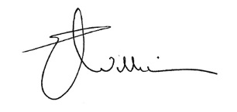
Liz Williams
Deputy Electoral Commissioner

OUR FINANCIAL YEAR
Overview
The VEC has once again received an unqualified report from the Auditor-General, who states that, “The financial report presents fairly, in all material respects, the financial position of the Victorian Electoral Commission as at 30 June 2013 and of its financial performance and its cash flows for the year, in accordance with applicable Australian Accounting Standards, and the financial reporting requirements of the Financial Management Act 1994.”
A five-year summary of the VEC’s financial performance is set out in Figure 2. Full financial details for 2012-13 are outlined in the Financial Statements.
A major electoral event, either Parliamentary (State) or local government (council), elections occur every two years, with other events conducted throughout the four-year cycle. The amount of Special Appropriation and expenses from transactions fluctuates in direct correlation with the cyclical nature of electoral activity.
Major activity 2012–13
Internally, the VEC monitors its expenditure, fees and charges based on core services and electoral activity outputs. Five components comprise the major electoral activity for 2012–13:
- the conduct of elections for 78 local government councils
- the conduct of the Melbourne and Lyndhurst State by-elections
- support to the Electoral Boundaries Commission for the State redivision
- preparations for the 2014 State election
- redevelopment of the Election Management System.
Revenue
The VEC’s appropriation increased in 2012-13 due to the costs involved in conducting 78 local government elections. A substantial decrease follows in 2013-14, as there is no major electoral activity scheduled.
The VEC collects revenue from charges for the conduct of local government elections and by-elections, fee for service elections, representation reviews, State and local government election fines, and all other fees and charges, which are not included in the VEC Comprehensive Operating Statement and Balance Sheet. This revenue is included as a note to the accounts, Note 3 ‘Administered (non-controlled) items’.
Revenue collected by the VEC on behalf of the State is forwarded to the Department of Treasury and Finance as consolidated revenue. Receipts from local government election fines and forfeited candidate deposits are collected by the VEC on behalf of councils, and remitted to the appropriate council.
Assets
The current assets of the VEC include receivables, prepayments of expenditure, and inventory. Sufficient inventory is kept to enable minor elections to occur, with purchases substantially increasing during a major election. Inventory has increased due to the preparation for the 2014 State election.
The non-current assets of the VEC include plant and equipment, leasehold improvements and computer software developed for the Register of Electors and conducting elections. The VEC is conducting a re-development of its Election Management System, and this development is reflected in the increase in intangible assets.

Liabilities
Except for the provisions for employee annual leave and long service leave, the liabilities of the VEC are small. They include payables for goods and services, motor vehicle finance leases, and bank balance.
Equity
The equity of the VEC is split into contributed capital and accumulated loss. The contributed capital represents the amount of funding contributed by the Government of Victoria for the purchase and development of VEC non-current assets. The accumulated loss represents the accumulated result from continuing operations of the VEC.
Cash flows
The Commission does not hold a cash reserve in its bank accounts. The funding arrangements often result in the Commission having a notional shortfall in the cash at bank required for payment of unpresented cheques at the reporting date.
Outlook 2013–14
Major activity scheduled for 2013–14 includes the continuing redevelopment of the Election Management System along with preparation of the 2014 State election, and support to the Electoral Boundaries Commission in its redivision of State electoral boundaries.


Matthew Beattie
Manager, Finance and Budget Branch

Figure 2 – Five year financial summary
 | 2008–09 ($,000) | 2009–10 ($,000) | 2010–11 ($,000) | *2011–12 ($,000) | 2012-13 ($,000)
Special appropriation | 29,984 | 19,250 | 51,415 | 21,685 | 40,245
Total expenses from transactions | 31,310 | 19,897 | 54,592 | 22,519 | 41,663
Net result from transactions | (1,326) | (647) | (3,177) | (834) | (1,418)
Net result for the period | (1,326) | (647) | (3,177) | (896) | (1,411)
Net cash flow from/(used in) operating activities | - | 2 | 2 | (2) | 4
Total assets | 8,293 | 7,752 | 8,323 | 9,017 | 10,471
Total liabilities | 2,062 | 1,842 | 2,416 | 2,394 | 3,020

*Restated

OUR COMMISSION
Aim
Responsible, transparent and accountable corporate citizenship
Strategies
- Conduct governance activities in accordance with legislation and corporate planning, striving for industry best practice
- Record and report reliable corporate data and information related to the operations of the VEC
Result
- All governance activities and risk management conducted diligently
- All reports delivered on schedule and in accordance with legislation
- Strategic Plan 2013-14 to 2017-18 launched
- VEC policies review on schedule
- WasteWise Gold accreditation achieved
Outlook 2013–14
- Implementation of Strategic Plan 2013-14 to 2017-18 will commence
- Implementation of the VEC’s internal audit schedule and policy reviews will continue
- Focus on information and records management awareness, training and procedural compliance will continue in response to audit findings
Priority initiatives: Strategic Plan 2013-14 to 2017-18
Enabler | Strategic initiative | Success indicator
Quality business systems | Map, document and regularly review key organisational business processes | - VEC systems are fit for purpose  - Consistent business methodologies are applied
Effective management  of resources | Review and implement a consistent budgeting process | - Activities are conducted on schedule and within budget  - Resource management targets are achieved

Inside this section
Governance | 11
Organisational structure | 12
Staff profile | 13
The Electoral Commissioner | 14
The VEC Management Group | 15
Committees and groups | 18
Accountability and transparency | 21
Disclosures | 23

Governance
The VEC is the administrative agency through which the Electoral Commissioner’s legislative obligations are exercised. The VEC is committed to ensuring that its policies and practices reflect good governance as well as complying with all relevant legislation. Adherence to the VEC’s governance framework demonstrates accountability to stakeholders and ensures the vitality and impartiality of the electoral system, now and into the future. Staffing and work practices are determined by the Public Administration Act 2004 and guided by the State Services Authority.
The VEC is an independent agency, operating under the auspices of the Department of Justice, within the portfolio of the Attorney-General, the Honourable Robert Clark, MP. The VEC is not subject to the direction or control of the Minister in respect of the performance of its responsibilities and functions and the exercise of its powers.
The Secretary of the Department of Justice is responsible for providing support to Cabinet on matters relating to the VEC. In its last report, the VEC farewelled previous Secretary, Ms Penny Armytage, and the VEC looks forward to a similarly productive relationship with Mr Greg Wilson, who was appointed to the role in mid-
April 2013.
Figure 3 – Governance and consultation structure of the VEC (FRD 22C)
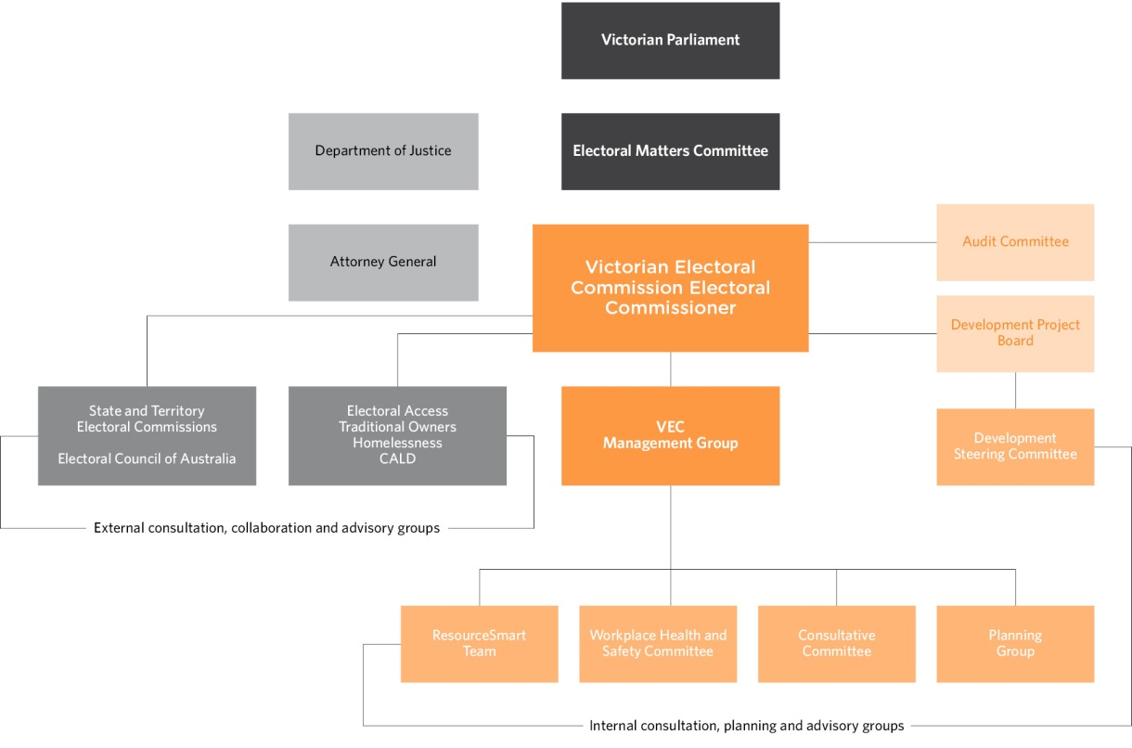

Organisational structure
The VEC’s organisational structure reflects the main activity areas of the VEC.
The VEC Management Group works closely with the Electoral Commissioner and Deputy Commissioner to develop and implement strategic and operational plans.
Three members of the VEC Management Group were farewelled during 2012-13. The VEC acknowledges Mr Paul Strickland (Electoral Enrolment Branch), Mr David Clarke (Finance and Budget Branch) and Ms Gill Kelly (Human Resources) whose wide-ranging contributions helped shape the organisation and played a part in its successes.
Three new managers have been appointed and are introduced on page 15 and 16.
Figure 4 – VEC Organisational Structure (FRD 22C)

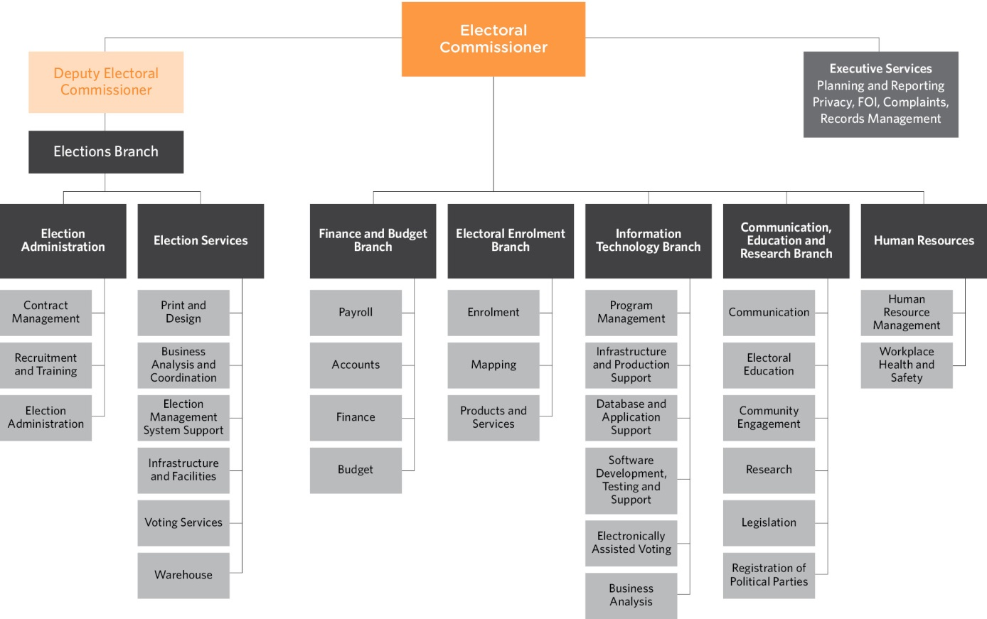

STAFF PROFILE
Comparative workforce data
Figure 5: Full time equivalent (FTE) staffing trends, 30 June 2009 to 2013 (FRD 22C)
 | Ongoing Employees |  |  |  | Fixed Term  & Casual
 | Number  (Headcount) | Full Time (Headcount) | Part Time (Headcount) | FTE | FTE
2013 | 62 | 52 | 10 | 58.4 | 16.6
2012 | 60 | 49 | 11 | 56.7 | 21.8
2011 | 59 | 52 | 5 | 53 | 19.6
2010 | 59 | 47 | 12 | 54.9 | 21.6
2009 | 58 | 50 | 8 | 54.5 | 17.6

Figure 6: VEC staff profile, 30 June 2012 and 2013 (Not including statutory appointees) (FRD 29)
 | 2013 |  |  |  | 2012
 | Ongoing |  | Fixed term & Casual |  | Ongoing |  | Fixed term & Casual
 | Headcount | FTE | Headcount | FTE | Headcount | FTE | Headcount | FTE
Gender
Male | 25 | 25 | 8 | 6.80 | 25 | 25 | 8 | 7
Female | 37 | 33.4 | 12 | 9.80 | 35 | 31.7 | 16 | 13.2
Total | 62 | 58.4 | 20 | 16.6 | 60 | 56.7 | 24 | 20.2
Age
Under 25 | 1 | 1 | 0 | 0.00 | 3 | 3 | 1 | 1
25-34 | 12 | 12 | 7 | 5.80 | 7 | 7 | 8 | 7.4
35-44 | 14 | 13.7 | 9 | 7.70 | 14 | 13.7 | 9 | 8
45-54 | 9 | 8.9 | 2 | 2.00 | 10 | 9 | 3 | 1.7
55-64 | 23 | 20.4 | 2 | 1.10 | 23 | 21.6 | 3 | 2.1
Over 64 | 3 | 2.4 | 0 | 0.00 | 3 | 2.4 | 0 | 0
Total | 62 | 58.4 | 20 | 16.6 | 60 | 56.7 | 24 | 20.2
Classification
STS | 2 | 2 | 0 | 0.00 | 2 | 1.6 | 0 | 0
VPS Grade1 | 0 | 0 | 3 | 1.10 | 1 | 1 | 2 | 0.8
VPS Grade2 | 13 | 11 | 2 | 1.40 | 12 | 9.8 | 3 | 2.6
VPS Grade3 | 15 | 14.8 | 4 | 4.00 | 14 | 14 | 12 | 11.2
VPS Grade4 | 11 | 10.6 | 6 | 5.10 | 8 | 7.8 | 4 | 2.6
VPS Grade5 | 18 | 17 | 2 | 2.00 | 18 | 17.5 | 3 | 3
VPS Grade6 | 3 | 3 | 3 | 1.10 | 5 | 5 | 0 | 0
Total  (non-exec) | 62 | 58.4 | 20 | 14.7 | 60 | 56.7 | 24 | 20.2

The Electoral Commissioner

Electoral Commissioner (appointed April 2013) – Warwick Gately AM

The Electoral Commissioner is appointed by the Governor in Council for a period of 10 years, and is responsible for the administration of the enrolment process and the conduct of parliamentary elections and referendums in Victoria.
Mr Warwick Gately AM was appointed as the Electoral Commissioner for Victoria on 29 April 2013. Mr Gately’s early career was with the Royal Australian Navy where he was a Principal Warfare Officer and Navigation specialist. He commanded the Destroyer, HMAS TORRENS in 1994 and the Guided Missile Frigate, HMAS ADELAIDE, the latter during operations off East Timor in 1999 for which he was awarded a Defence Force Commendation. He was appointed as a Member (AM) in the Military Division of the Order of Australia in June 1999, for exceptional service to the Australian Defence Force in a number of key operational appointments.
In 2003, Warwick joined the Western Australian Electoral Commission as the Deputy Electoral Commissioner. He was appointed as the Electoral Commissioner for Western Australia in August 2006, and reappointed in 2009 for a further five-year term.
As Western Australian Electoral Commissioner, Mr Gately was responsible for the conduct of the 2005, 2008 and 2013 State general elections, and State-wide referendums on retail trading hours and daylight saving. He oversaw the State electoral boundary redivision, and conducted local government elections every two years. Continuing his long-standing career in public service, now as Victorian Electoral Commissioner, Mr Gately is committed to the provision of effective electoral services to the Victorian community.
The Electoral Commissioner is assisted by the Deputy Commissioner and the Executive Services team, which has responsibilities including:
- planning and reporting
- records management
- freedom of information
- information privacy awareness.


Deputy Electoral Commissioner – Liz Williams

(Acting Electoral Commissioner: May 2012 – April 2013)
Elections Branch Manager (Election Administration)
Liz Williams was Acting Electoral Commissioner from May 2012 until the appointment of the new Electoral Commissioner in April 2013. As Deputy Electoral Commissioner, Liz works closely with the Electoral Commissioner in the management and administration of the VEC.
Liz also oversees the Elections Branch, which is divided into two areas: Election Administration, managed by Liz, and Election Services, managed by Glenda Frazer (see below).
Elections Branch:
- oversees the planning and conduct of State, local government and commercial elections
- promotes local government election services and tendering to conduct local government elections
- recruits, trains and assesses election managers and election officials
- develops election manuals and handbooks
- procures and manages resources including election offices, early voting centres and voting centres
- develops and implements election management systems.
The Election Administration area undertakes large-scale recruitment and training projects, providing information and support for Election Managers, Returning Officers and their staff. The team also manages substantial election contracts with councils, statutory and fee-for-service clients.
Liz has significant electoral experience gained in various roles held during the numerous State, local government and non-government elections that have been conducted since starting with the VEC.
Commencing as a Returning Officer in 1992, Liz moved to an ongoing full-time appointment in 1996 and was appointed Deputy Electoral Commissioner in 2005.
Liz believes fostering a working environment that promotes learning and collaboration, drives innovation and excellence in election administration; and efficient and inclusive electoral processes are integral to full democratic participation.

The VEC MANAGEMENT GROUP

Electoral Enrolment Branch Manager – Melanie Davidson

Melanie joined the VEC in January 2013, having migrated to Melbourne from Wellington, New Zealand. Melanie was in the New Zealand Public Service for more than 12 years, in a range of operational and management roles, with a particular focus on operational accountability and business improvement. As the Manager of the Enrolment Branch, Melanie is responsible for the preparation and provision
of accurate electoral rolls and mapping data.
In addition to maintaining an up-to-date and accurate Register of Electors, the Electoral Enrolment Branch provides the following services:
- implementation of electoral enrolment programs
- conduct of electoral representation reviews for councils and supports electoral boundary work by the Electoral Boundaries Commission
- production of electoral rolls and other roll products
- provision of advice on electoral enrolment matters.
As the VEC has moved towards a direct enrolment approach for managing enrolment, the focus is on the continued integrity of the Register of Electors, while also offering more customer-focussed means of updating and keeping elector enrolment details current. The Branch is also involved in managing electoral representation reviews and supporting the work of the Electoral Boundaries Commission. Melanie’s team employ a variety of administrative, technological, mapping and geo-spatial knowledge and skills to help ensure that Victorian electors have fair and equitable representation.


Finance and Budget Branch Manager – Matthew Beattie
Matthew joined the VEC in February 2013. Prior to joining the VEC, Matthew worked for WorkSafe Victoria for 10 years in various senior finance roles, and prior to that a mix of private sector finance roles.
The Finance and Budget Branch maintains the VEC financial management systems, manages the VEC’s budget and expenditure, and provides VEC payroll services.
Matthew views sound budgeting and accounting as crucial to the success of the operations of the VEC. Matthew and his team ensure that the VEC complies with all financial and auditing requirements. The Finance and Budget Branch also manages payroll services for core VEC staff and up to 17,000 casual appointees over election periods.

The VEC Management Group

Human Resources Manager – Bernadette Lamaro
Bernadette is new to the VEC and new to the public sector having worked in private industry for the last 13 years, predominately for global consulting organisations, as a human resources professional.
Bernadette has worked in several core human resource disciplines throughout her career across the following areas; Learning and Professional Development, Workforce and Talent Management, Recruitment, Performance Management and Remuneration, with roles incorporating transition management, program and project management, learning facilitation, consulting, people management and program leadership.
As Human Resources Manager, Bernadette believes strongly in the ongoing investment of reviewing current work place practices and policies, assessing and evaluating the impact of existing programs and identifying opportunities for improvement with a focus on integrated solutions for improving organisational climate and employee engagement.

Elections Branch Election Services Manager – Glenda Frazer
Working closely with the Deputy Commissioner and the Elections Administration area, the Election Services area aims to provide accessible and well-equipped voting centres and election offices, and to ensure that voting materials are accurate, easily understood and available on time.
Glenda Frazer commenced with the VEC in 1988 and has been a Returning Officer at three State elections and one council election. She moved to a full-time position in 1995. Glenda has extensive knowledge of the conduct of elections with significant experience in the application of information technology to elections.
Glenda is responsible for major large scale operations for the VEC and is the State election program manager. She believes thorough planning and preparation enables voters to experience trouble-free elections. Glenda and her team are focused on the efficient and effective delivery of election services.
Between May 2012 and April 2013, Glenda took on a number of responsibilities, usually held by the Deputy Electoral Commissioner.

Communication, Education and Research Branch Manager – Sue Lang
Sue joined the VEC in 2006 after spending much of her career in senior communication roles within the metropolitan water industry, local government, statutory authorities and State Government. She has particular experience in major public awareness programs.
The Communication, Education & Research Branch comprises three distinct teams and provides a number of communication and education services to various audiences, including:
- internal communication services for the VEC
- development and implementation of communication strategies for electoral events
- delivery of information services to key stakeholders
- development of strategies to promote and encourage electoral enrolment and involvement
- provision of electoral education and outreach services
- provision of advice on electoral legislation and strategic matters
- provision of research services and information.
Sue and her team aim to effectively communicate electoral information and education to the many diverse groups throughout Victoria. An area of increasing interest to Sue is the use of social media to inform, engage and provide services to the community.


Information Technology Branch Manager – Simon Hancock
Simon commenced at the VEC in 2000 and has managed the Information Technology (IT) Branch since 2003. Prior to working at the VEC, Simon worked for a number of information technology companies providing project management and technical consultancy over a range of industry settings.
Providing information technology expertise and support across the VEC, both at head office and throughout the State, the Information Technology Branch:
- provides a stable and reliable technology environment for the VEC
- plans, sets up and supports the technology used during the conduct of all elections
- maintains and enhances the VEC’s enterprise software
- maintains and administers the VEC’s corporate databases
- manages the VEC technology environment.
Simon considers that the provision of excellent IT services is vital for the success of all VEC operations. Simon’s team provides hardware and software support for everyday VEC activities, providing extremely high volume support during election periods.

Internal committees and groups
A number of consultation groups and committees assist the Electoral Commissioner and Management Group with the development and implementation of strategies and policies, providing expertise and promoting staff consultation. As part of an organisation-wide review of teams and their purpose within the VEC, a number of teams have undergone changes to structure and roles.
Planning Group
The Election Planning Group (EPG), was the major cross-organisational work group at the VEC. Operating continuously, the Group plans, tracks and monitors the implementation of elections and other activity across the VEC. During 2012-13 the EPG membership was redefined and its charter updated to define the scope of its work and guide future activity. Renamed the Planning Group, it is now able to comprise a changing complement of key team-leaders across the organisation to reflect its broad-ranging role across all operations.
Consultative Committee
The Consultative Committee (CC) provides a mechanism for communication flow between management and employees on major people management and organisational policy issues. Meeting monthly, the group is comprised of a representative from each area of the VEC.
During 2012–13, the CC charter and the roles of the CC members were reviewed and revised. This is an ongoing project as the CC re-establishes its membership and purpose. As part of that review, the 0ccupational Health and Safety Committee, which was under the umbrella of the CC, was established as a separate committee.
Occupational Health and Safety Committee
The Occupational Health and Safety Committee (OHSC) commenced working under its own charter, which defines its scope and purpose. Staff representatives were elected in accordance with the legislation and a regular meeting schedule is in place. Under the new OHSC Charter, staff will continue to be well-represented and the VEC believes its strong record of OHS management will be maintained.
Development Steering Committee
The Development Steering Committee (DSC) meets monthly and provides strategic oversight to the VEC’s Information Technology (IT) development program.
The DSC is responsible for ensuring the program is consistent with the VEC’s business strategy and that appropriate controls are in place. DSC members include Branch Managers and the IT Program Manager. The DSC is chaired by the Deputy Electoral Commissioner or delegate.
ResourceSmart Committee
The ResourceSmart Committee (RSC) oversees the implementation of the VEC’s Environmental Management Plan with the purpose of raising awareness of environmentally sound work practices and reducing the negative environmental impact of the organisation. The RSC charter was redeveloped, as was the Environmental Management Plan (formerly the Environmental Management Strategy).

External advisory groups
The VEC has established a number of advisory groups to provide advice and assistance with service provision, employment and electoral education for specific groups in the community.
Electoral Access Advisory Group
The Electoral Access Advisory Group (EAAG) provides advice and knowledge to the VEC in relation to accessibility, continually challenging and assisting the VEC in its aim to provide universal access across all organisational functions.
The VEC’s EAAG met in February 2013 to review the VEC’s accessibility performance with regard to the 2012 local government elections, to have an update on the progress of the VEC’s input to the Victorian State Disability Plan and to seek volunteers for the VEC’s electronic voting trial.
Feedback from the Group was that excellent efforts had been made with regard to resources and outreach services. It was suggested that a focus should be placed in future on those living with a disability in culturally and linguistically diverse communities; that the VEC should explore a partnership with community radio station 3CR and consider providing more communication around voting responsibilities for electors over the age of 70.
Homelessness Advisory Group
The VEC’s Homelessness Advisory Group provides advice and assistance in relation to working with homelessness agencies. The aim is to ensure that everyone has access to the electoral process, regardless of their current living situation. During 2012–13 the Group considered ways to raise awareness of the availability and importance of voting in the local government elections among people experiencing homelessness. Particular consideration has been given to women and those in rural and regional areas, two groups where homelessness is more likely to be hidden. Following these elections, the Group reconvened to evaluate the programs and explore opportunities for the VEC to offer employment to people experiencing homelessness.
The VEC also began a relationship with the Council to Homeless Persons’ Peer Education Support Program, which saw consumers of homelessness organisations joining the Advisory Group and providing a valuable insight into the problems and potential solutions for engaging those experiencing homelessness in elections.
Aboriginal Advisory Group
The VEC’s Aboriginal Advisory Group (AAG) includes Traditional Owners, the Victorian Electoral Commissioner and VEC staff. The Group advises and assists the VEC in its aim to develop effective resources and materials, and deliver education, seminars and workshops.
The Aboriginal Advisory Group did not meet during the year as a result of the sudden departure of the Indigenous Engagement Officer and the relatively long search to replace that role.
Culturally and Linguistically Diverse Advisory Group
The VEC also works with representatives from agencies working with culturally and linguistically diverse (CALD) communities to develop resources in response to community specific needs. The CALD Advisory Group met this year to discuss the additional barriers to voting experienced by those from new and emerging communities and provide feedback on the VEC’s proposed ‘Democracy Ambassador’ program outline. With the subsequent approval of the ‘Democracy Ambassador’ Pilot, the VEC will meet regularly with the Group in the year ahead to seek guidance from partner agencies and to develop a responsive electoral education program, which meets the needs of Victoria’s CALD communities.

Governing legislation and tribunals
The two pieces of legislation that set out the VEC’s primary responsibilities are the Constitution Act 1975 and the Electoral Act 2002.
In accordance with this legislation, the VEC conducts State and local government elections and by-elections, and certain statutory and fee-for-service elections. The VEC also provides advice to the Attorney-General and Parliament on electoral issues. 0ther legislation and regulations imposing certain duties on the Electoral Commissioner are listed in Appendix B.
Legislative and regulatory amendments
The Justice Legislation Amendment Act 2013, which came into operation on 5 June 2013, made a small but important change to the Electoral Act 2002, enabling the VEC to use information obtained from the Australian Electoral Commission (AEC) to directly enrol Victorian electors.
This amendment streamlines the enrolment process for electors and electoral commissions, and contributes to a more complete and accurate electoral roll.
The Electoral Regulations 2012 came into operation on 31 August 2012, replacing the Electoral Regulations 2002. The most significant differences from the 2002 regulations are:
- the forms of identification prescribed for the purposes of provisional enrolment and voting have been extended to include a current Victorian identification, defined as a current identification that is issued to a person by the State or a statutory authority and that includes the person’s name, residential address, date of birth and photograph. The list of service providers to enable identification of a voter has been extended to include any entity that issues Victorian identifications. These changes assist, for example, a young person who might have a proof of age card (issued by the Victorian Commission for Gambling and Liquor Regulation) but not a driver licence
- the nomination form for a State election has been amended to enable more than one party candidate to be nominated at a time
- electronic transmission to the VEC of Antarctic ballot papers and of provisional enrolment/declaration vote forms
- provision for electronic voting at an interstate or overseas early voting centre
- the preliminary scrutiny can start no earlier than 8.00 am on the Monday before election day, to allow time for postal votes to be processed so that, as soon as voting closes on election day, the envelopes can be opened and postal votes counted. The previous starting point was 8.00 am on election day.
In the local government election field, the Local Government Legislation Amendment (Miscellaneous) Act 2012 provides that councils must place a summary of each candidate’s election donation return on the council website within 14 days after the deadline for such returns. Previously, those interested had to visit each council office to inspect the physical returns. The Act also removed from the Local Government Act 1989 the offence of making a false or defamatory statement about the personal character or conduct of a candidate.
Court of Disputed Returns
Parliament alone has the authority and jurisdiction to determine who and how a person can be elected to Parliament, and to determine whether a person has been validly elected. To ensure disputes are settled in a bi-partisan manner, Parliament creates an independent, neutral body (Court of Disputed Returns) to make these determinations. Under the Electoral Act 2002, the Supreme Court of Victoria is the Court of Disputed Returns.
No petitions were brought before the Court during 2012–13.
Municipal Electoral Tribunal
Section 45 of the Local Government Act 1989 (LG ACT) provides for a candidate or a group of ten voters at a local government election who dispute the validity of the election, to apply for an inquiry into the election by a Municipal Electoral Tribunal (MET). Applications must be lodged within 14 days of the declaration of the result of the election in dispute. Following the local government elections in October 2012, five applications were lodged with the MET (compared to 12 at the previous general elections in November 2008). See Appendix G for details of these applications.There were no applications to the MET in relation to local government by-elections or countbacks during 2012-13.
Victorian Civil and Administrative Tribunal
Section 48(2) of the LG ACT allows a person whose interests are affected by a MET decision to apply to the Victorian Civil and Administrative Tribunal (VCAT) for a review of that decision. No applications were lodged with VCAT in relation to local government election matters during 2012–13.
A matter appealing the Electoral Registrar’s rejection of an application to change an elector’s surname on the Register of Electors was dismissed by VCAT on 14 March 2013 and is detailed on page 44.

Accountability and transparency
The VEC has legislated and organisational processes in place to ensure transparency and accountability to the Victorian public. These include internal and external auditing, regular reporting to stakeholders including Parliament, Government and the public, and tabling of audited financial statements as part of this report.
Financial Management Compliance Framework
The Financial Management Compliance Framework has been developed to provide the Minister for Finance an assurance that Victorian Government entities have implemented the appropriate systems to ensure compliance with the framework directions to provide for effective, efficient and responsible financial management of public resources.
The directions include:
- includes financial code of conduct, financial governance including the establishment of an Audit Committee, financial risk management, authorisations, and internal and external audits
- financial management structure, systems, policies and procedures – which includes roles and responsibilities of the financial management team, policies and procedures, managing outsourced services, information technology management, operations, development and change, education and training
- financial management reporting – which includes internal and external reporting; reporting requirements for Financial Statements and Report of Operations in accordance with part 7 of the Financial Management Act 1994, performance management and evaluation, financial management compliance obligations, tax compliance, purchasing cards and thefts and losses compliance
- the Financial Management Framework is audited by the internal auditor, and reviewed by the Audit Committee. The VEC is fully compliant with the framework directions.
Development Project Board
The Development Project Board (DPB) provides governance oversight to the VEC’s Development Steering Committee. The DPB takes responsibility for ensuring the program of works and projects are consistent with the VEC’s business strategy and that the correct project controls are being applied. The following are the members of the DPB:
- Warwick Gately AM, Electoral Commissioner – Chair
- Michael Cornelius, Director Major Procurement Program, Department of Justice
- David Fahey, VEC Audit Committee.
In addition, the following provide ex-officio support to the DPB:
- Liz Williams, Deputy Electoral Commissioner – Chair of Development Steering Committee
- Simon Hancock, VEC IT Manager – Secretary.
The VEC continued with the program of works to redevelop the systems used by the VEC to support electoral events. During the 2012-13 financial year the program delivered the Nominations and Results modules, as well as the Computer Count application used in the conduct of the 2012 local government elections. The program objectives for the
2013–14 financial year will be to develop the functionality used by the VEC’s Election Managers in readiness for the 2014 State election, as the completion of the procurement process for an application to support the VEC’s personnel, payroll and human resource management functions, and the completion of the VEC’s electronically assisted voting product. The Computer Count application will be further enhanced to support the calculation of the Victorian Upper House results.
The system redevelopment plan was developed after a strategic assessment of the current systems and the VEC’s ability to meet future requirements and expectations.
A major part of the program involves the redevelopment of the VEC’s Election Management System (EMS), which has served the VEC well since its introduction in 1999. The redevelopment addresses identified process inefficiencies and data management overheads that have grown over the life of the existing application. Objectives include improved integration between systems, enhanced reporting capability, increased on-line ‘self-service’ access to data, and improved processes to minimize the negative impact of VEC functions on the environment.
Audit Committee
The primary objective of the Audit Committee is to assist the Electoral Commissioner in fulfilling the VEC’s responsibilities and to add value to the accounting, operational practices, controls and risk strategies of the Commission. This involves overseeing:
- financial performance and reporting including the financial statements
- the scope of work, performance and independence of the internal and external audit
- monitoring VEC compliance with the Financial Management Compliance Framework, including financial policies and procedures, and the Victorian Government Risk Management Framework including the attestation by the Electoral Commissioner in the Annual Report
- matters of accountability and internal control.
In 2012–13 the Committee comprised:
- Mr Robert Yeo (Chairman), consultant
- Ms Elizabeth Reeves, accountant senior election official
- Mr David Fahey, accountant.
The Committee held four formal meetings during the year, with other informal meetings and discussions between members and the Electoral Commissioner and Manager of Finance and Budget on various issues and outcomes. The internal and external auditors attended meetings as required.
During the year, the internal audit function was performed by HLB Mann Judd. The Auditor General also advised that DFK Collins Pty Ltd replaced LDAssurance as his agent.
At its meetings, the Audit Committee considered and discussed the following:
- Financial report
- review of the financial statements and audit management letter, and follow-up action taken in relation to outcomes raised
- receipt and review the Auditor General’s audit program
- Internal audit program and a review of outcomes of audits conducted for:
- VicRoads – statement of compliance of confidentiality of data
- accounts payable and probity management
- Fringe Benefits Tax
- taxation compliance
- Financial Management Compliance and Risk Management Framework
- local government election processes
- payroll and human resources
- risk framework

Corporate planning
The VEC Corporate Plan provides the strategic basis for operations. The VEC reports against the Plan in its annual report, and the Plan is central to staff performance planning and review. Staff training is linked to corporate objectives and strategies as well as to organisational and professional needs.
Prior to the appointment of the new Electoral Commissioner, an interim plan was developed to provide strategic direction, certainty of purpose and goal congruence to the VEC staff and suppliers, and assurance to the many stakeholders, including Parliament.
In the first half of 2013, the VEC Management Group commenced the strategic planning project, involving wide staff consultation and intensive planning workshops.
The resulting plan, developed under the authority of the new Electoral Commissioner, Mr Warwick Gately AM, outlines the VEC’s strategic intent for the period 2013-14 to 2017-18, and will shape operational planning. The new strategic plan sets out three major strategic intents.
Enablers (characterised as conditions that need to be in place in order for the VEC to achieve its strategic intent) have been identified along with strategic initiatives, success indicators and key activities. Operational plans at branch and project levels across all areas are essential in pursuing the VEC’s strategic intent.
The re-invigorated planning structure, strategic content and associated workforce planning framework, performance planning and professional learning will help ensure that the VEC continues to deliver its statutory mandate in a fair, transparent, effective and accountable manner. The strategic initiatives have been prioritised and work will commence on those considered to be the highest priority in 2013-14. Priority initiatives for relevant business areas have been included throughout the report. See Appendix P for content of the Strategic Plan 2013-14 to 2017-18.
Corporate reporting
The VEC has a comprehensive program of reporting to stakeholders that supports its goals of accountability and transparency. Internal reporting is aligned with lines of authority and cross-organisational channels to meet organisational needs.
External reporting is based on legislative and governance obligations, transparency objectives and commitments to stakeholders. The standard of reporting is high, with the VEC Annual Report 2011-12 achieving a gold award at the 2013 Australasian Reporting Awards.
During 2012–13 the VEC tabled two reports before Parliament: the VEC Annual Report 2011–12 and the Report of the conduct of the Melbourne District by-election.
Three reports were provided to the Minister for Local Government:
- Report of Local Government activity for 2011-12
- Report of the conduct of electoral representation reviews and sub-division reviews 2011- 2012
- Report of the 2012 Local Government elections
The VEC Annual Report 2011–12 was provided to the Attorney-General and delivered to Parliament in accordance with the tabling schedule. Annual reports are available on vec.vic.gov.au and from the VEC. Other reports to external stakeholders are made available on vec.vic.gov.au if appropriate.

Disclosures
Public administration values and employment principles
The VEC maintains and implements a suite of policies and guidelines with respect to upholding public sector conduct, managing and valuing diversity, employment, managing underperformance, reviewing personal grievances, and selecting on merit.
Human resource management
The goal of the VEC’s Occupational Health and Safety (OHS) strategy is to ensure all staff remain safe and healthy at work. An OHS management system has been put in place and branches within the VEC have implemented OHS local action plans aimed at enhancing safety performance and ensuring safe systems of work. In 2012-13, there was one lost time injury resulting in 13.8 days lost. For more on human resource management at the VEC, including performance against OHS management measures, see the Our People section of this report.
Executive officer data (FRD 15B)
The Electoral Commissioner and Deputy Electoral Commissioner are appointed by the Governor in Council as statutory office holders. These appointments do not fall within the definition of executive officer under the Public Administration Act 2004.
Implementation of the Victorian Industry Participation Policy (FRD 25A)
The Victorian Industry Participation Policy Act 2003 requires public bodies and departments to report on the implementation of the Victorian Industry Participation Policy (VIPP). Departments and public bodies are required to apply VIPP in all tenders over $3 million in metropolitan Melbourne and $1 million in regional Victoria. No contracts to which the VIPP applies were commenced or completed by the VEC during 2012–13.
Disclosure of grants and transfer payments (other than contributions by owners)
Included in the ‘Total expenses from transactions’ are payments of grants and assistance to certain companies and organisations. During 2012–13, the VEC provided grants to three organisations (see Figure 7).
Figure 7: Grants to external bodies, 2012–13
Organisation | Purpose of grant | Amount
Tigers in the Community Foundation Ltd – Richmond Emerging Aboriginal Leadership (REAL) Camps | Support of Richmond Emerging Aboriginal Leaders camps (at Korin-Gamadji-Institute) for Indigenous youth to build their leadership skills through active citizenship and position them as role models within their community | $100,000  (ex GST)
Education sponsorship | Africa Media Australia for the production of a DVD of their community event ‘Engaging African-Australians: Voting, civic engagement and political leadership’ | $2,000  (ex GST)
Electoral Regulation Research Network | Ongoing support of the Electoral Regulation Research Network to foster exchange and discussion on research relating to electoral regulation | $25,000

Consultancies and contracts (FRD 22C)
Consultancies over $10,000
In 2012–13, the total for the consultancies engaged during the year (where the total fees payable to the consultants was more than $10,000) was $49,591 excluding GST (see Figure 8).
Consultancies under $10,000
In 2012-13, the total amount for the consultancies engaged during the year (where the total fees payable to the consultants was less than $10,000) was $2,278 excluding GST.
Accredited Purchasing Unit
One contract that was before the Accredited Purchasing Unit (APU) in 2011-12, was approved in 2012-13. No other contracts have been put before the APU during this reporting period (see Figure 9).
Disclosure of major contracts
In accordance with the requirements of Financial Reporting Directive 12A, the VEC discloses all contracts greater than $10 million in value which it entered into during the year ended 30 June 2012.
No contracts greater than $10 million in value were entered into by the VEC during 2012–13.
Advertising disclosure
Financial Reporting Direction 22D requires Victorian government agencies to disclose advertising expenditure on campaigns with a media spend of $150,000 or greater. Figure 10 provides details of this expenditure for 2012-13.

Figure 8: Consultancies over $10,000, 2012-13
Consultant | Purpose of consultancy | Start date | End date | Total approved project fee (ex GST) | Expenditure  2012-13  (ex GST) | Future expenditure  (ex GST)
CGI Technologies and Solutions Australia Pty Ltd | Electoral Roll Management Gap Analysis | 8/04/2013 | 27/06/2013 | $20,441 | $20,441 | nil
The Training Link | Development of VEC Strategic Plan | 12/04/2013 | 31/08/2013 | $30,250 | $29,150 | $1,100
Figure 9: Contracts approved by the Accredited Purchasing Unit, 2012-13
Title of contract (as named in APU document) | Period of contract | Contractor details | Contractor ABN | Contract value approved | APU reference number
Title of Contract: Contract for the Provision of the Personnel Management System | 4 years  (from 10 Dec 2012) | Aurion Corporation  Pty Ltd | 63 050 431 868 | $661,412.13 | 242/11-12
Figure 10: Advertising disclosure under FRD 22D, 2012-13
Name of campaign | Campaign summary | Start / End date | Advertising (media) Expenditure 2012-13
Local government elections, statutory campaign | To meet legislative requirements relating to the promotion of local government elections, to engage people in individual municipalities with the election, to encourage enrolment, nominations and active participation in the local government electoral process | 8 August to  18 November 2012 | $603,599
Local government elections, State-wide campaign | To engage people with the local government elections, encourage enrolment, nominations and active participation in the local government electoral process | 13 to 22  October 2012 | $311,938
Local government elections, optional print collateral | To engage voters and provide extra information for non-English speakers, those participating in attendance elections and those in non-contested elections | 13 to 22  October 2012 | $199,692

Compliance with the Building Act 1993
The VEC does not own or control any Government buildings and consequently is exempt from notifying its compliance with the building and maintenance provisions of the Building Act 1993.
National Competition Policy
Competitive neutrality requires government businesses to ensure where services compete, or potentially compete with the private sector, any advantage arising solely from their government ownership be removed if they are not in the public interest. Government businesses are required to cost and price these services as if they were privately owned and thus be fully cost reflective. Competitive neutrality policy provides government businesses with a tool to enhance decisions on resource allocation. This policy does not override other policy objectives of government and focuses on efficiency in the provision of service.
The VEC continues to comply with the requirements of the National Competition Policy.
Freedom of information
The Freedom of Information Act 1982 (FOI Act) gives Victorians the right to access certain classes of documents held by Government agencies. Staff are regularly reminded of their obligations under the FOI Act and staff memorandums relating to registration, retention and storage of documents were regularly issued. One Freedom of Information application was received by the VEC in 2012–13. The request was from a member of the general public and was acceded to in full. For information about how to lodge an application under the FOI Act see Appendix E.
Information privacy
The VEC collects and handles personal information in relation to both the Victorian public and VEC staff in order to fulfil its functions under the Electoral Act 2002. The VEC’s policies regarding management of personal information comply with the Information Privacy Act 2000 and are set out in its Privacy Policy, which is available at vec.vic.gov.au or at the VEC.
During 2012–13, the VEC Privacy Awareness 0fficer attended privacy network meetings on a regular basis and relevant information was disseminated to staff. Privacy awareness activity continued during 2012–13 to help ensure that VEC staff continue to implement information privacy procedures.
No complaints in relation to breaches of information privacy were received by the VEC during 2012–13. Each year, the VEC receives a number of inquiries relating to the release of information to certain people and organisations in accordance with legislation. The VEC responds to these queries explaining the conditions of release and advising that while correspondents may object to the release of their information, it does not constitute a breach of privacy.
Information and records management
The VEC has responsibility for election materials and other documents that must be stored and kept for the future. The VEC has directed considerable effort to training staff in records management, and updating and maintaining its document control, filing and archiving.
During 2012–13, the systematic upgrade of document filing, archiving, retention and destruction continued. The VEC upgraded its records management system in order to expand its capacity to comply with the Victorian Electronic Records Strategy (VERS compliance) in the future.
An external audit of records management processes and support was carried out in 2012-13, with the final audit report due early in 2013-14.
Disclosure index
The Annual Report of the VEC is prepared in accordance with all relevant Victorian legislation and pronouncements. A disclosure index has been prepared to facilitate identification of the VEC’s compliance with statutory disclosure requirements. The disclosure index is included as Appendix A.
Whistleblowers Protection Act 2001 Protected Disclosure Act 2012
The Protected Disclosure Act 2012 (PDA) came into force in February 2013. The purpose of the PDA is to encourage and facilitate the making of disclosures of improper conduct by public bodies or public sector employees, and to protect persons who make those disclosures. The PDA also made related amendments to other Acts, and repealed the Whistleblowers Protection Act 2001.
The VEC is committed to the aims and objectives of the PDA. Improper conduct by its employees, officers or members is not tolerated, nor is the taking of reprisals against those who come forward to disclose such conduct.
The VEC recognises the value of transparency and accountability in its administrative and management practices, and supports the making of disclosures that reveal corrupt conduct, conduct involving a substantial mismanagement of public resources, or conduct involving a substantial risk to public health and safety or the environment. The VEC will take all reasonable steps to protect people who make such disclosures from any detrimental action in reprisal for making the disclosure. It will also afford natural justice to the person who is the subject of the disclosure to the extent it is legally possible. There were no disclosures under these acts during 2012–13. For details about reporting procedures under the Protected Disclosure Act 2012 see
Appendix D.
Pecuniary interest declarations
The Electoral Commissioner and Deputy Electoral Commissioner completed declarations of pecuniary interests as required.
Attestation to Public Sector Standards Commissioner
The Electoral Commissioner and Deputy Electoral Commissioner completed the annual attestation of hospitality and gifts as required.
Compliance with the Disability Act 2006
The Disability Act 2006 requires that all public sector bodies prepare a disability action plan and that departments report on the implementation of their disability action plan in their annual report. See page 120 for information on the VEC Disability Action Plan.
Environmental performance
The VEC has continued its commitment to reducing the negative impact of its operations on the environment with ongoing communication and information programs to encourage continued positive behavioural changes.
In 2012-13, the VEC achieved WasteWise gold accreditation, which recognises the VEC’s efforts and achievements in reducing waste to landfill and increasing recycling of recyclable materials.
The Environmental Management Plan was refreshed with new goals and the VEC plans even greater sustainability changes.
The work of the VEC in support of environmental sustainability was highlighted by the Metropolitan Waste Management Group in a case study published on its website (mwmg.vic.gov.au) in February 2013. The VEC has continued its organisational, management and staff commitment to environmental sustainability by including environmental sustainability objectives in its Strategic Plan 2013-14 to 2017-2018. The VEC Environmental Sustainability Report for 2012-13 is included as Appendix N.
Compliance with other legislation
The VEC is subject to, and complies with a range of legislation as listed in Appendix B, and detailed in this report as applicable.
Additional information available on request
Information relating to the 2012–13 reporting period is made available to Ministers, Members of Parliament and the public on request (subject to the Freedom of Information Act 1982) and is listed in Appendix C.
Identifying and managing risk
The Victorian Government Risk Management Framework provides for a minimum risk management standard across public sector entities. The Electoral Commissioner is responsible for the development and implementation of the framework and processes to ensure that risks are being managed in a consistent manner.
Risk management is built into the planning and reporting processes. The risk package is audited and reviewed by the Audit Committee. The VEC conducts assessments to identify other organisational risks, evaluates risk controls in place and develops new controls where required.
Risks are rated according to their hazard potential across operational and non-operational activities. Risk ratings are presented to the Audit Committee in accordance with its charter. This Committee determines whether adequate controls are in place, and whether a periodic review of those controls is required.
At an operational level, the VEC has comprehensive risk management plans for all electoral events. These are developed, discussed and analysed at branch level during the planning phase and cover election management, infrastructure, communication, recruitment and information technology. Risk management is addressed at senior management level and in staff meetings.
Legal and compliance issues associated with occupational health and safety are managed through the VEC’s OH&S Committee, which meets every month.
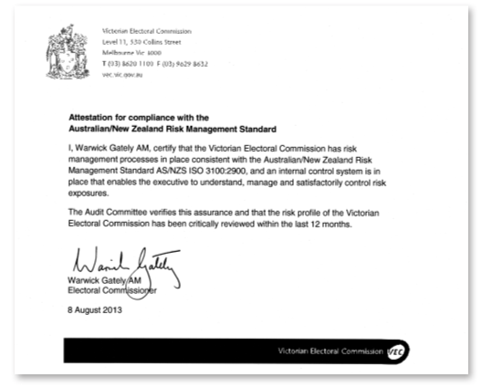
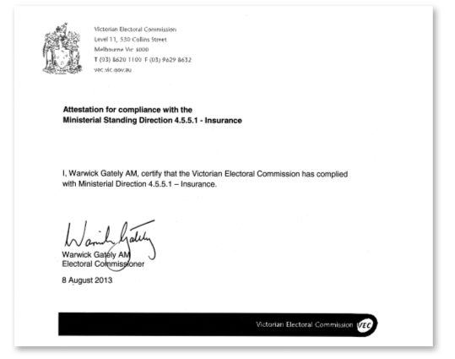

OUR CORE BUSINESS
Aim
- High quality election services, in accordance with legislation
Strategies
- Collaborate across all business areas to ensure effective delivery of increasingly accessible election services so that all elections, by-elections and polls are conducted within budget and in accordance with legislation, rules and guidelines
- Use information technology and specialised electoral expertise to support and enhance the delivery of electoral services
- Collaborate with other electoral bodies to continually improve electoral service capacity and staff knowledge and skills
Result
- The VEC conducted all elections, by-elections and polls on schedule, within budget and in accordance with legislation, rules and guidelines
- Five applications to Municipal Elections Tribunal, four resulting in no election failed or overturned, one decision pending
- Interstate secondments (5 staff, 79 days) to assist at Western Australian State election
- Voting services provided to six electoral bodies for nine electoral events
Aim
- Fair and equitable representation at State and local government levels
Strategies
- Assist the Electoral Boundaries Commission with the conduct of the 2012-2013 State boundary redivision, using geospatial mapping technology, cross-organisational collaboration and public consultation to ensure accurate research and well-informed decision-making
Result
- The State redivision project, due to finish in October 2013, is currently on schedule, within budget and in accordance with legislation
- Proposed Boundaries Report published on schedule and within budget
Highlights
- Conduct of general elections for 78 of Victoria’s 79 councils; on time, within budget and in accordance with legislation, rules and regulations
- Local government election services provided to 4,098,007 enrolled voters and 2004 candidates in 273 wards and unsubdivided municipalities across Victoria
- VEC warehouse relocation provides a safer, fit-for-purpose warehousing facility
Outlook 2013–14
- Finalise 2014 State election plan and commence implementation
- Review of all electoral events plans (Strategic initiative)
- Provide support to Electoral Boundaries Commission to complete the State boundary redivision
Priority initiative: Strategic Plan 2013-14 to 2017-18
Enabler | Strategic initiative | Success indicator
Comprehensive electoral event programs | Maintain an effective set of electoral  event plans | - Electoral events delivered within legislative and organisational requirements  - VEC project management framework applied consistently in managing electoral event  - Event plans are ready for immediate implementation as required

Inside this section
Electoral activity | 30
State government electoral activity | 31
Local Government electoral activity | 33
Other elections and polls | 35
Interaction with electoral bodies | 36
Research and development | 39

Our core business
The VEC is an independent election services provider, with a recognised reputation for excellence and electoral innovation. Although the VEC’s workload fluctuates with election cycles, with work peaking in a major election event every two years, minor elections, by-elections and polls are conducted throughout each year, and electoral representation reviews of councils take place within each four-year cycle.
Core business development
The VEC is undergoing a program of works to redevelop the systems it uses to support electoral events ensuring the VEC’s ability to meet future requirements and expectations.
A major part of the program involves the redevelopment of the VEC’s Election Management System (EMS), which has served the VEC well since its introduction in 1999. The redevelopment addresses identified process inefficiencies and data management overheads that have grown over the life of the existing application. Objectives include improved integration between systems, enhanced reporting capability, increased on-line ‘self-service’ access to data, and improved processes to minimize the negative impact of VEC functions on the environment.
During 2012-2013, three modules were successfully deployed for the 2012 local government elections: Nominations, Results and Computer Count. A prototype for electronic voting at the 2014 State election was also developed and the contract arrangements for an application to support the VEC’s personnel, payroll and human resource management functions were finalised.
The program objectives for the next financial year include the completion of functionality required for election offices supporting the 2014 State election. The governance model for the program includes a Development Project Board (see Our Commission).
Electoral activity
The VEC conducted 103 electoral events during 2012–13, more than double the number conducted in 2011-12 (see Figure 11). These included two State by-elections and 101 fee-for-service elections, countbacks and polls (see Appendix F for details). All events were conducted on schedule and within budget, with none failed or overturned. The State election which comprises elections in 88 Districts and eight Regions has previously been counted as one event.
Figure 11: Electoral activity, 2008-09 to 2012-13
Type of activity | 2008–09 | 2009–10 | 2010–11 | 2011–12 | 2012-13
State elections | 0 | 0 | 1 (88 + 8) | 0 | 0
State by-elections | 0 | 1 | 1 | 1 | 2
Local government elections | 1 | 0 | 0 | 0 | 78
Local government by-elections | 2 | 4 | 6 | 3 | 1
Local government countbacks | 0 | 8 | 15 | 6 | 7
Liquor licencing polls | 4 | 5 | 10 | 2 | 5
Commercial elections, by-elections and polls | 12 | 5 | 4 | 7 | 10
Representation reviews | 0 | 0 | 9 | 28 | 0
Subdivision reviews | 0 | 0 | 0 | 3 | 0
Total | 19 | 23 | 46 (141) | 50 | 103

State Government electoral activity
State elections
On 29 November 2014, the VEC will conduct the State election, in which over 3.6 million eligible Victorians will cast their votes to elect the 58th Victorian Parliament. Representatives will be elected to 88 Legislative Assembly districts and eight Legislative Council regions.
A State election consumes significant financial, logistical, human and administrative resources. The Victorian Electoral Commission must exercise fiscal responsibility without compromising integrity or service delivery standards.
An event this size requires considerable planning, extensive preparation and co-ordination, details of which will be made available on vec.vic.gov.au in the 2014 State Election Service Plan.
The VEC’s intention is that every eligible Victorian will vote at an election that is fully compliant with State law, transparent, fair and accurate, and delivered to the highest standards with efficiency and enthusiasm.
Key performance indicators have been developed to assess the performance of the Victorian Electoral Commission and identify where future performance improvement initiatives are required. The following key performance indicators have been adopted for the 2014 State election. This intention, while event specific, is closely aligned to the VEC’s vision and purpose as stated in its Strategic Plan for the next five-year period. To achieve this intent, the following major operational objectives have been identified:
- complete all election projects on schedule and within budget
- ensure that as many eligible Victorians as possible, are enrolled, prior to the close of roll
- increase public awareness and knowledge of the election process and the alternatives offered by which they can participate
- assist the nearly 30% of electors affected by the recent re-division understand their electoral district changes and participate without hindrance
- provide every eligible elector with a voting experience that is:
- convenient and easy to access
- timely to their requirements
- easy to understand
- respectful and courteous
- confidential
- assist candidates, registered political parties and other participants to meet nomination and other compliance requirements and participate effectively in the election.
- provide electoral information, including results to all stakeholders in a format that is easy to use, easy to find, rapid and deliverable through muliple channels
- ensure all votes cast are accounted for and counted accurately and efficiently and that the results are available in a timely manner
- maintain stakeholder confidence and trust in the Commission’s capacity to deliver impartial, accurate and efficient electoral outcomes.
State by-elections
A State by-election occurs if a Member of Parliament resigns or can no longer hold office. The VEC maintains the capability and capacity to conduct State by-elections as required, within minimum prescribed timeframes.
Two State by-elections were conducted during 2012-13 after the resignations of the Hon. Bronwyn Pike MP, the member for Melbourne District, and the Hon. Tim Holding MP, the member for Lyndhurst District.

State electoral boundaries
State boundary redivisions are conducted periodically to help ensure fair and equitable representation for Victorian electors. During 2012-13, the VEC provided administrative and technical assistance to the Electoral Boundaries Commission for the redivision of State electoral boundaries. The proposed boundaries have been published and are available at the VEC, online at vec.vic.gov.au and at council offices throughout the state. The release of the final boundaries is scheduled for October 2013. See page 37 for more. The Report of the Electoral Boundaries Commission 2012-13 is included as Appendix O.
Melbourne District by-election
Following the resignation of the member for Melbourne District, a writ was issued on 28 May, for a by-election to be held on 21 July 2012. The roll closed on 4 June 2012, with 44,889 electors enrolled.
The election-ready positioning of the Victorian Electoral Commission (VEC), its planning, processes and systems and the strong capabilities of VEC staff meant that the VEC was able to conduct the Melbourne by-election at short notice without critical disruption to the preparations for the 2012 local government elections in October.
Sixteen candidates nominated for the Melbourne District by-election, ten of whom were independent candidates. The Australian Labor Party, the Democratic Labor Party, the Australian Greens, the Australian Christians, Family First and the Australian Sex Party each endorsed a candidate.
The turnout rate of 68.62% for the by-election was lower than the turnout rate of 86.93% for Melbourne District at the 2010 State election. The turnout rate for the Melbourne by-election was lower than the average turnout of 81.35% for the six most recent State by-elections (excluding Melbourne).
The informality rate of 9.34%, with 16 candidates, was an increase on the informality rate of 3.69% for the Melbourne District with seven candidates at the 2010 State election. The informality rate was also higher than the average informality rate of 7.75% for the six most recent State by-elections (excluding Melbourne). The full Report of the Melbourne District by-election was tabled in Parliament in October 2012.
Lyndhurst District by-election
Following the resignation of the member for Lyndhurst District, a writ was issued on 5 March, for a by-election to be held on 27 April 2013. The roll closed on 12 March 2103, with 43,441 electors enrolled.
Eight candidates, of whom three were independent candidates, nominated for the by-election held on 27 April 2013. The Sex Party, Family First, The Greens, the Australian Labor Party and the Democratic Labor Party each endorsed a candidate. The turnout rate of 80.07% for the by-election was lower than the turnout rate of 92.47% for Lyndhurst District at the 2010 State election. The turnout rate for the Lyndhurst by-election was slightly higher than the average turnout of 80.05% for the five most recent State by-elections (excluding Lyndhurst).
The informality rate of 9.45%, with eight candidates, was an increase on the informality rate of 7.06% for the Lyndhurst District with seven candidates at the 2010 State election. The informality rate was also higher than the average informality rate of 8.32% for the five most recent State by-elections (excluding Lyndhurst).
A report of the Lyndhurst District by-election will be tabled within 12 months of the date of the by-election as required by legislation. Copies of all reports tabled by the VEC are available at vec.vic.gov.au and from the VEC.
Solid partnerships with our efficient and reliable suppliers and contractors also feature as a key component of the successful conduct of the by-elections.
Communication campaigns that included a householder letter and a range of newspaper advertisements helped ensure that electors were aware of details of the by-elections, their voting options and the result. Information was available in a range of languages and through an interpreter telephone service. Key statistics from the two by-elections held in 2012-13 are presented in Figure 12.

Figure 12: Key statistics, State By-elections, 2012-13
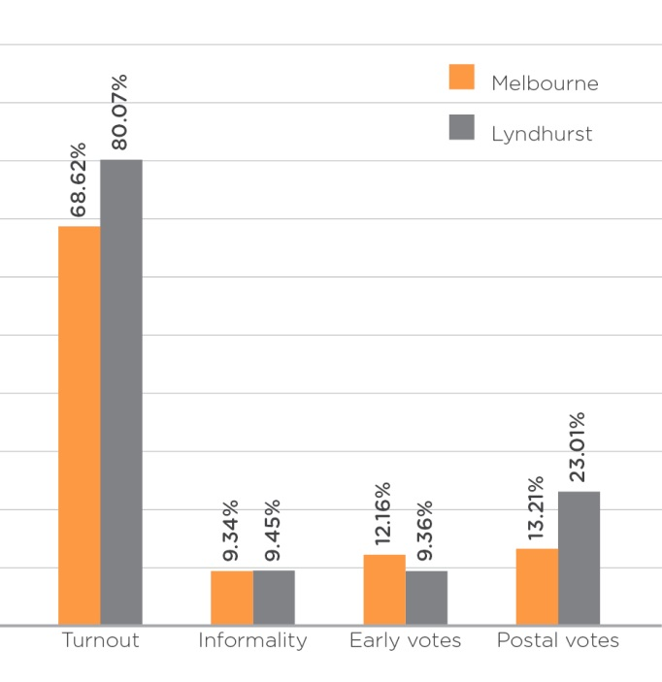

Local government electoral activity
Local government elections
Local government elections are conducted within a legislative and regulatory framework. Section 74A(1) of the Constitution Act 1975 provides that local government is a distinct and essential tier of government, consisting of democratically elected councils.
The Local Government Act 1989 (LG Act) is the principal legislation governing the conduct of local government elections in Victoria. Detailed provisions for the elections are contained in the Local Government (Electoral) Regulations 2005 (LGR). The City of Melbourne Act 2001 (CoM Act) and City of Melbourne (Electoral) Regulations 2012 make provisions for the conduct of elections for the Melbourne City Council.
The City of Greater Geelong Act 1993 (CGG Act) made provision for the direct election of Mayor for the Greater Geelong City Council.
A number of legislative amendments that affected the 2012 local government elections were made between the 2008 and 2012 local government elections. Some of these amendments reflected recommendations from the VEC’s report following its conduct of the 2008 local government elections, and were listed in previous reports.
2012 local government elections
In October 2012, the VEC conducted elections for 78 of Victoria’s 79 councils under the provisions of the LG Act, CGG act and the CoM Act. There were no elections for Brimbank City Council, which currently has a Panel of Administrators and is scheduled to hold a general election in March 2015.
Seventy councils chose to conduct their elections entirely by postal voting; the remaining eight councils used the attendance method of voting. There were contested elections in 245 electorates and uncontested elections (where the number of candidates was equal to the number of vacancies) in 28 electorates. This includes Ararat Rural City Council, an unsubdivided municipality, which was entirely uncontested and no voting was required.
Ballot papers in 146 multi-councillor wards and unsubdivided councils were counted using proportional representation (six were uncontested). Ballot papers in 126 single-councillor wards were counted using the preferential method (21 were uncontested). Sixteen councils had a combination of single and multi-councillor wards and counting included both preferential and proportional representation counts for the respective wards.
A total of 173 voting centres and 22 early voting centres were established for the eight attendance elections held on Saturday, 27 October. Across the State, 64 computer counting venues and 26 manual counting venues were established.
The results for 77 councils were declared on or by Wednesday, 31 October, with all elections declared by Friday, 2 November. The VEC was appointed by 73 councils to follow up apparent non-voters, and a total of 505,582 Apparent Failure to Vote Notices were sent.
In accordance with the LG Act, a report on each council’s election was delivered to the respective council in January 2013 (within three months of the election).
Figure 13: 2012 local government elections snapshot
 | 2012 | 2008
People enrolled as voters at the entitlement date | 4,098,007 | 3,987,726
Positions vacant | 631 | 629
Candidates nominated | 2,004 | 1,953
How-to-vote cards registered | 506 | 625
Participation rate - all elections | 70.89% | 74.68%
Participation rate - postal elections | 72.32% | 75.96%
Participation rate - attendance elections | 63.62% | 70.03%
Informal voting rate - all elections | 5.39% | 4.99%
Informal voting rate - postal elections | 4.58% | 3.75%
Informal voting rate - attendance elections | 10.09% | 9.90%
Applications lodged with the Municipal Election Tribunal | 5 | 12

Planning and preparation
Planning for the 2012 local government elections began in early 2011, approximately 18 months in advance of election day. The VEC developed a draft service plan that was distributed throughout the Victorian local government sector for comment and was presented to councils through eight council information sessions held across the State in October 2011. The plan was reviewed with feedback from the sector and the final plan was provided to each council in December 2011 with an estimated cost for their elections. Invitations to tender, requests for quotes and contract negotiations were conducted in the second half of the 2011-12 year.
At the start of 2012-13, the VEC worked closely with those councils, whose contract negotiations had been delayed to finalise these contracts. Once the contract arrangements were understood and in place, the VEC was able to proceed with leasing accommodation, where required, and collating the municipal voters’ rolls for each election. The planning for the elections included the preparation of 78 voters’ rolls (within the legislative timelines and without compromising the quality of the rolls) to allow the roll to be certified by each council’s Chief Executive Officer on the day nominations opened. The VEC prepared and dispatched over three million ballot packs for up to 238 postal elections and approximately 690,000 EasyVote letters for 36 attendance elections.
Staffing for 2012 local government elections
The VEC appointed 78 Returning Officers to be responsible for the local government elections conducted in October 2012. Returning Officers were supported by the appointment of 62 Deputy Returning Officers, including 15 that had responsibility for more than one election. To reflect the additional workload of larger and more complex elections, more than one Deputy Returning Officer was appointed for each of six larger elections. All Returning Officers and Deputy Returning Officers completed at least 4 days training prior to the election period. In addition, almost 6,500 casual staff and just over 2,000 voting centre officials were appointed to assist with the conduct of these elections. A diverse range of people were appointed to roles in election offices and voting centres at these elections. Among our staff, 624 people noted fluency in a foreign language, 46 people identified themselves as having an Indigenous heritage and 80 people identified themselves as either having a disability or having special needs in the workplace.
The VEC provided a team of five contract managers to supervise the contracts with the 78 councils. During the election period, each Returning Officer was supported by one of 10 Election Support Officers (ESOs), operating from the VEC’s head office. The ESOs had considerable experience in successfully managing elections and were responsible for providing guidance and procedural advice to Returning Officers.
Cost recovery for local government elections
The VEC recovers marginal costs associated with the delivery of local government elections from each council. The contract established with each council includes a principal cost for the preparation of the voters’ roll and conduct of the elections and, for those councils who require it, a separate cost for compulsory voting enforcement. The contract amounts are subject to a prescribed list of variations that provides for the adjustments at invoicing based on specified variables. An uncontested election, for example, cannot be predicted during contract negotiations and requires a significant reduction to the service requirements.
The VEC invoiced councils in two stages:
- In February and March 2013, the VEC invoiced all 78 councils for the preparation of the voters’ roll and conduct of the elections. The invoices included a consolidated net deduction of nearly $500,000 from the consolidated principal amounts quoted through the contracts with these councils.
- In May and June 2013, the VEC invoiced 72 of the 73 councils that required compulsory voting services for the cost of this service. The invoices included a consolidated net increase of nearly $350,000 from the consolidated principal amounts quoted through contracts with these councils.
A further invoice was issued for three of the five councils that required contingency services in relation to the VEC’s participation in Municipal Electoral Tribunal inquiries. The two remaining councils, and the last council for compulsory voting services, will be invoiced in the next financial year.
Information on the election costs was included with the VEC’s Report on the Conduct of the 2012 Local Government Elections, published in April 2013. The final costs for the 2012 local government elections will be reported in the VEC’s Report on Local Government Electoral Activity for 2013-14.
Extraordinary vacancies
An extraordinary vacancy arises in a council when a councillor resigns or can no longer hold office as a councillor. The LG Act provides for a countback to be conducted when an extraordinary vacancy arises in a multi-councillor ward or unsubdivided council. A by-election is necessary when an extraordinary vacancy arises in a single-councillor ward or when the vacancy cannot be filled by a countback because of a failed countback or because there are no eligible candidates for election.
Local government by-elections and countbacks
During 2012–13, the VEC conducted one council by-election and seven countbacks to fill six extraordinary vacancies that occurred leading into or during the year. Details of the by-election and countbacks conducted during the year are included in Appendix F. A report on each by-election and countback was prepared and provided to the relevant council within the legislated three month period.
The number of extraordinary vacancies was significantly greater than 2008-09, the previous reporting year that included local government general elections, which saw two by-elections and no countbacks.
The cost per voter for the local government by-election was $6.53. The election was conducted using postal voting. This cost does not include compulsory voting enforcement services, which councils may engage the VEC to undertake.
The VEC’s countback application can be accessed remotely to allow countbacks to be conducted locally. In previous years, it was more expensive to conduct a countback within the municipality than to conduct it at the VEC’s office in Melbourne because of the essential computer infrastructure requirements. The new countback application reduces the cost for holding countbacks locally. In 2012-13, all countbacks were held locally within the municipality. The average cost of the seven countbacks held in 2012-13 was $2,117.49. The cost of a countback includes public notices, configuration of the countback application, and staff time.
A modified countback procedure is necessary when there is only one remaining eligible candidate for election but public notice of the countback is still necessary. There was one countback that required a modified countback procedure during 2012–13. The countback was held within the municipality and cost $828.26.
A further countback is where a countback has already occurred and the successful candidate at the countback has failed to declare that they are eligible to be elected within the prescribed time in the LG Act (48 hours). Although this is counted as a separate countback, there is no additional advertising for the second countback and they are invoiced to councils as a single event. There was one further countback during 2012-13.
Early in 2012-13, the VEC provided the Minister for Local Government with a Report on Local Government Electoral Activity for 2011-12. The report provides details, statistics, analysis and results of local government by-elections and countbacks, and is available from the VEC and on the VEC website in electronic format.
All by-elections and countbacks were conducted in compliance with legislative requirements, with no elections failed or overturned. The VEC achieved its aim of providing value for money local government election services.
Review of council structures
Conducted by the VEC under the LG ACT, an electoral representation review helps ensure fairness and equity for council voters. An electoral representation review considers the number of councillors and the internal electoral structure of a council. A council must be reviewed before every third general election.
An electoral subdivision review may be conducted between electoral representation reviews to adjust ward boundaries within a municipality. A subdivision review may be requested by the Minister if any ward within a municipality is deemed unlikely to meet the legislative requirement that the ratio of voters to councillors is within 10% of the ratio in any other ward in that municipality.
No electoral representation reviews or subdivision reviews were scheduled to be conducted during 2012-13. The next reviews will commence early in 2015.
Other elections and polls
Under Victorian legislation, the VEC is required to conduct certain elections and polls. Depending on the legislation, these elections and polls may be partly or wholly funded by the VEC. The VEC also conducts fee-for-service and non-statutory elections that meet certain criteria, including the number of voters, the existence of formal election rules and election timing.
The VEC conducted five liquor licencing polls, and ten commercial elections, by-election and polls during
2012-13. All were conducted in accordance with legislation, regulations or rules, on time and within budget.

Interaction with electoral bodies
Remaining a leader in the Australian electoral industry, the VEC will continue to introduce innovations to increase efficiency, transparency and participation in elections, by developing and maintaining relationships with a range of organisations in the electoral industry. The VEC is also committed to recommending and advising on relevant legislative change.
During 2012–13, the VEC worked with various electoral bodies to help advance the industry practically and legislatively in an effort to increase innovation and electoral harmonisation across Australia.
Electoral Council of Australia and New Zealand (ECANZ)
During 2012–13, Elections New Zealand accepted invitations to join the two major collaborative groups, the Electoral Council of Australia and the State and Territories Electoral Commissions. This recognises the strong association and commonality existing between these organisations. The Electoral Council of Australia and New Zealand (ECANZ) is a consultative forum with membership comprising Commonwealth, New Zealand, State and Territory Electoral Commissioners. It met three times in 2012–13.
ECANZ considers best practice and innovation in activities such as the maintenance of electoral rolls, the operation of new electoral legislation and the management of elections. During 2012–13, the ECANZ undertook projects and consulted on a range of issues including:
- the activity of the continuous roll update program, and the move to Federal direct enrolment and update
- the use of new technology to assist in electoral processes such as electronic voting and electronic certified lists
- electoral education and electoral research
- participation trends in enrolment and voting.
These themes will continue to be a focus for the ECANZ in 2013–14.
State and Territory Electoral Commissions
State and Territory Electoral Commissions (STEC) is a forum established by State and Territory Electoral Commissioners to consider electoral policy, research and operational matters of mutual interest. STEC consists of the Electoral Commissioner from each State and Territory and since October 2012, New Zealand. The Australian Electoral Commission also participates in STEC activities other
than those related to the conduct of council elections.
STEC also provides the opportunity for personnel within each commission to collaborate on projects with similar objectives and to share resources across jurisdictions.
STEC studies and projects during 2012–13 included:
- finalisation of work on performance measurement and common reporting definitions
- identifying strategies to better inform and engage Culturally and Linguistically Diverse persons
- continuation of the Electoral Educators’ Network
- advancing common understandings of the place for and use of technology in elections
Proposed projects for 2013–14 include:
- refining the use of mobile devices in elections
- examining commonality in online training of election officials
Electoral Boundaries Commission
The VEC is required by legislation to provide administrative and technical services to the Electoral Boundaries Commission. The Report of the Electoral Boundaries Commission 2012-13 is included in this Report
(Appendix O).
A redivision of the State was commenced in November 2012, the first for both Houses of Parliament since 2001. The VEC, as required by legislation, provided administrative and technical services to the Electoral Boundaries Commission, which comprised the Chief Judge of the County Court, the Surveyor General and the Electoral Commissioner. Following a call for public submissions and after conducting public hearings, proposed electoral boundaries were published on 27 June 2013. This will be followed by a period of further public consultation with the final boundaries to be published early October 2013. The final boundaries will apply at the next State election in November 2014.
Electoral Matters Committee
The VEC has an interest in the work of the Electoral Matters Committee (EMC), a Joint Investigatory Committee of the Parliament of Victoria. The EMC comprises five Members of Parliament drawn from both Houses. Its powers and responsibilities are determined by the Parliamentary Committees Act 2003.
The EMC is currently conducting an Inquiry into the Future of Victoria’s Electoral Administration. The VEC made a submission and spoke at the public hearing. The report of this inquiry must be tabled by March 2014.
Arrangements with other electoral agencies
In a reciprocal arrangement, the VEC provides election services such as voting services and information provision for other Australian electoral agencies. The VEC also provides staff secondment to other electoral agencies in Australia (and occasionally overseas) for short periods to provide assistance and expertise at electoral events. During Victorian election periods, reciprocal services are provided to Victorian voters by these agencies. Figure 14 and Figure 15 indicate the services and staff provided in these areas by the VEC during 2012–13.
International electoral bodies
The VEC hosted two international delegations during 2012-13, the first from East Timor and the second, from Vietnam. On both occasions, the Acting Electoral Commissioner and representatives from key areas of the VEC presented information about the VEC and the Victorian electoral system.

Figure 14: Election services provided by the VEC to electoral agencies in other jurisdictions, 2012–13
Election date | Jurisdiction | Election | Total votes
25/8/2012 | Northern Territory | Legislative Assembly Election | 33
25/8/2012 | New South Wales | Heffron State District By-election | 0
20/10/2012 | Australian Capital Territory | Legislative Assembly Election | 153
16/02/2013 | Northern Territory | Legislative Assembly Wanguri By-election | 0
9/03/2013 | Western Australia | State Election | 740
9/03/2013 | Queensland | De-amalgamation Polls: Douglas/Livingstone/Noosa/Mareeba | 0
4/05/2013 | Tasmania | Legislative Council Election - Nelson | 1
 |  | Legislative Council Election - Montgomery | 0
 |  | Legislative Council Election - Pembroke | 0
Figure 15: Staff seconded to other agencies, 2012-13
Election date | Jurisdiction | Election | Total Staff | Total days
9 Mar 2013 | Western Australia | 2013 State Election | 5 | 79 days

Register of political parties
The Electoral Act 2002 (the Act) requires the VEC to establish and maintain a register of political parties.
In order to qualify for registration, a political party must have a written constitution and at least 500 members who are Victorian electors, party members in accordance with the party’s rules, and not members of another registered political party or of a party applying for registration.
It is not compulsory for political parties to be registered to contest an election, but registration gives a party a number of important entitlements. These include:
- the right to have the party’s name on ballot papers
- access to enrolment and voter information on a periodic basis
- public funding for parties that attain a specified level of first preference votes.

Re-registration of political parties
Section 58A of the Act provides that, to retain their registration, registered political parties must apply for re-registration in the period 27 to 25 months before the next scheduled State election. This period was from 29 August to 29 October 2012. On 8 August 2012, the VEC wrote to the 11 registered political parties, reminding them of the re-registration requirements. On 9 August 2012, the Citizens Electoral Council applied for voluntary de-registration, and was de-registered on 20 August under section 53 of the Act. The other ten registered parties applied for re-registration within the time limit.
A party applying for re-registration must provide the same materials as for an initial application for registration. These materials include a list of at least 500 party members who are Victorian electors, are members according to the party’s rules, and are not members of another registered party or party applying for registration. The VEC writes to the people on the list provided by the party, asking them to confirm whether they are members of the party who can be counted for registration purposes.
The VEC wrote to a total of 11,936 people on the lists provided by the parties. The VEC relied on responses to the mail-outs as a primary indicator of whether a party had sufficient eligible members to retain its registration. As is its customary practice, the VEC allowed parties to send supplementary lists of additional members if the parties had not reached 500 confirmed “Yes” responses but appeared likely to do so. The VEC satisfied itself that all ten parties had at least 500 eligible members, and re-registered the parties, starting with the Country Alliance on 22 October 2012 and finishing with Family First on 30 April 2013.
Several issues arose during the re-registration process. One party member criticised the cost of the process and questioned its necessity. The VEC replied that the process was required by law. The total direct cost of re-registration was some $8,000. A member of another party argued that re-registration was unconstitutional and was an intrusion into personal privacy. The VEC assured the writer that re-registration was in accordance with the law and the Constitution, and that the VEC did not provide anyone with individuals’ responses to its mail-outs. In relation to the Australian Sex Party, the VEC received 234 responses from members who had not paid membership fees, which appeared contrary to the Party’s rules. When contacted about this matter, the Party’s registered officer replied that on special occasions the executive waived the membership fee. As the Party leadership had been forthcoming throughout the process and as the Party administers its own rules, the VEC accepted this explanation and the membership of the 234 individuals.
Changes to the Register of Political Parties
The VEC received applications from most of the registered parties for changes to such matters as the name of the registered officer, deputy registered officers, and the address of the party. These applications were all processed without delay.
Research policy
The VEC updated its research policy, incorporating planned research projects for the coming two years.
Attitudes to electronic voting
During 2011-12, the VEC’s major research project covered attitudes to electronically assisted voting among Victorians who are blind or have low vision. In 2012-13, to assist the VEC to obtain further information about the needs of this group, the Victorian Taxi directorate enabled the VEC to write to the Directorate’s 6,000 clients who are blind or have low vision, inviting them to call a market research company, the Social Research Centre, to participate in a survey. A total of 489 interviews were completed – a number that was substantially more than the VEC’s target of 350 interviews, and that enables a fair degree of confidence in the outcomes of the survey.
Electors who are blind or have low vision are entitled to vote electronically, but take-up in the past two elections has been limited. The goals of the survey were to understand the experiences of these voters in the election process, their perceptions of electronic voting, and their preferred channels for obtaining and receiving information. The survey revealed that about a third of respondents were aware of electronic voting before being interviewed. Over half of the respondents stated that they were likely or planned to use electronic voting in the future. This group tended to be younger than the average (with a mean age of 60), more likely to live alone and to have always been blind, and to be more proficient with technology. The reasons they gave for trying electronic voting centred on independence and ease of use. These respondents would have liked to vote online; in the absence of online voting, they divided evenly between voting electronically at early voting centres, or at voting centres on election day. Conversely, respondents who were not disposed to try electronic voting preferred current voting practices and were uncomfortable with technology. Respondents preferred to receive general election information through mainstream radio and TV, though they would also like to receive election information through the mail or via email. The survey provides valuable information for the VEC’s planning for the 2014 State election.
Electoral Regulation Research Network
The VEC joined with the New South Wales Electoral Commission and the University of Melbourne in March 2012 to establish the Electoral Regulation Research Network. The purpose of the Network is to foster exchange and discussion among academics, electoral commissions and other interested groups on research relating to electoral regulation. The Network continued to host seminars on a range of matters, including “Drawing the lines without drawing blood: redistricting institutions and criteria in America and Australia”. The network has also sponsored a collaborative research project on “Enhancing local government democracy”, that will examine the nature of local government democracy in the City of Melbourne.
Development of Personnel Management System
In 2011-12, the VEC ran an open tender process for the provision of a Personnel Management System. Aurion Corporation was engaged in December 2012. Work has proceeded through 2012-13 and in 2013-14 the VEC will work with Aurion to implement a fully integrated human resource (HR) management and payroll system. The system will enable the VEC to manage and pay its staff in a consistent, centralised manner, regardless of employment category. The Aurion system will also provide ongoing payroll and HR support to the VEC’s permanent staff, and will have the capacity to support the VEC’s vastly expanded payroll and HR function during major electoral events.
Development of electronic voting
The electronically assisted voting project began in November 2011 with the aim to provide independent, secret and verifiable voting to people with a print disability and those who are culturally or linguistically diverse.
The system is a touch-screen tablet that features a fully guided audio facility for people who are totally blind, as well as a large print and multi-lingual option for people who have low vision or speak a language other than English.
As well as the survey through the Victorian Taxi Directorate to reach blind and vision impaired voters to better understand trends, needs and requirements within that community, other studies were conducted, in which target users tested the system. These testers provided feedback to assist the development process. The system will be ready for production by June 2014, in time for the Victorian State election.

rESEARCH AND DEVELOPMENT
Research policy
The VEC updated its research policy, incorporating planned research projects for the coming two years.
Attitudes to electronic voting
During 2011-12, the VEC’s major research project covered attitudes to electronically assisted voting among Victorians who are blind or have low vision. In 2012-13, to assist the VEC to obtain further information about the needs of this group, the Victorian Taxi directorate enabled the VEC to write to the Directorate’s 6,000 clients who are blind or have low vision, inviting them to call a market research company, the Social Research Centre, to participate in a survey. A total of 489 interviews were completed
– a number that was substantially more than the VEC’s target of 350 interviews, and that enables a fair degree
of confidence in the outcomes of the survey.
Electors who are blind or have low vision are entitled to vote electronically, but take-up in the past two elections has been limited. The goals of the survey were to understand the experiences of these voters in the election process, their perceptions of electronic voting, and their preferred channels for obtaining and receiving information. The survey revealed that about a third of respondents were aware of electronic voting before being interviewed. Over half of the respondents stated that they were likely or planned to use electronic voting in the future. This group tended to be younger than the average (with a mean age of 60), more likely to live alone and to have always been blind, and to be more proficient with technology. The reasons they gave for trying electronic voting centred on independence and ease of use. These respondents would have liked to vote online; in the absence of online voting, they divided evenly between voting electronically at early voting centres, or at voting centres on election day. Conversely, respondents who were not disposed to try electronic voting preferred current voting practices and were uncomfortable with technology. Respondents preferred to receive general election information through mainstream radio and TV, though they would also like to receive election information through the mail or via email. The survey provides valuable information for the VEC’s planning for the 2014 State election.
Electoral Regulation Research Network
The VEC joined with the New South Wales Electoral Commission and the University of Melbourne in March 2012 to establish the Electoral Regulation Research Network. The purpose of the Network is to foster exchange and discussion among academics, electoral commissions and other interested groups on research relating to electoral regulation. The Network continued to host seminars on a range of matters, including “Drawing the lines without drawing blood: redistricting institutions and criteria in America and Australia”. The network has also sponsored a collaborative research project on “Enhancing local government democracy”,that will examine the nature of local government democracy in the City of Melbourne.
Development of Personnel Management System
In 2011-12, the VEC ran an open tender process for the provision of a Personnel Management System. Aurion Corporation was engaged in December 2012. Work has proceeded through 2012-13 and in 2013-14 the VEC will work with Aurion to implement a fully integrated human resource (HR) management and payroll system. The system will enable the VEC to manage and pay its staff in a consistent, centralised manner, regardless of employment category. The Aurion system will also provide ongoing payroll and HR support to the VEC’s permanent staff, and will have the capacity to support the VEC’s vastly expanded payroll and HR function during major electoral events.

Development of electronic voting
The electronically assisted voting project began in November 2011 with the aim to provide independent, secret and verifiable voting to people with a print disability and those who are culturally or linguistically diverse.
The system is a touch-screen tablet that features a fully guided audio facility for people who are totally blind, as well as a large print and multi-lingual option for people who have low vision or speak a language other than English.
As well as the survey through the Victorian Taxi Directorate to reach blind and vision impaired voters to better understand trends, needs and requirements within that community, other studies were conducted, in which target users tested the system. These testers provided feedback to assist the development process. The system will be ready for production by June 2014, in time for the Victorian State election.

OUR VOTERS
Aim
- An accurate, complete and secure register of electors
Strategies
- Develop and implement the 2011–14 Enrolment Strategy
- Identify and evaluate opportunities to improve the effectiveness and efficiency of the enrolment process, incorporating these into the continuous roll update process
- Observe information privacy principles in the collection, use and storage of elector data
Result
- 100% of enrolment transactions processed within the target timeframe (above target)
- 92.68% of voting eligible population enrolled (above target)
- 79.25% youth enrolment (above target)
- Direct enrolment reaches 58.5% of total enrolments
Aim
- • Increased ease of access to, and participation in the electoral system
Strategies
- Conduct, analyse and respond to research to better understand industry and community issues and implement activities that engage and educate the Victorian community
- Develop and deliver communication products that improve accessibility and clarity of electoral information
- Maintain a responsive Disability Action Plan
Result
- Communication and Community Education Programs developed in response to research findings and delivered in accordance with plans
- Programs received positive feedback from key stakeholders

Highlights 2012–13
- Provision of electoral enrolment, roll and mapping products and services for almost 4.1 million electors in 78 councils for the 2012 local government elections
- Successful expansion of the VEC’s direct enrolment program
- Communication Access accreditation with SCOPE achieved

Outlook 2013–14
- Preparation for 2014 State election will include electoral education, engagement and outreach activities with groups identified as at risk of low participation
- The VEC website will be refreshed with the delivery of new information architecture in response to feedback
- Preparations for the conduct of the election will commence including the securing of election offices and voting centres with a key focus being accessibility for voters
Priority initiatives: Strategic Plan 2013-14 to 2017-18
ENABLER | Strategic initiative | Success indicator
An engaged and informed community | Design and implement responsive electoral education and awareness programs | Increased community awareness of electoral matters  Electoral engagement program targets are met  Participation rates in accordance with targets (enrolment, turnout, informality)
A complete, secure and accurate register of electors | Review and improve enrolment programs | Enrolment program targets achieved
A complete, secure and accurate register of electors | Review and improve enrolment systems | Enrolment transactions captured effectively  Enrolment systems are elector-centric  Successful security audit outcomes

Inside this section
Enrolment | 42
Turnout | 45
Enforcement of compulsory voting | 46
Informality of voting | 47
Services for voters with  special needs | 48
Community education and engagement | 50
Geographic Information Systems | 53
Roll products and services | 54
Warehouse | 55

Enrolment
Facilitation of participation in the democratic process by all Victorians is a central aim of the work of the VEC. Activities undertaken in the electoral enrolment, communication, electoral education and electoral engagement areas throughout 2012-13 supported this aim.
Key objectives for the VEC are to maintain the accuracy and security of the Register of Electors; to annually increase the proportion of eligible electors enrolled; and to maintain this measure at a level higher than the national average. The VEC undertakes a range of activities to keep the Register of Electors current and complete, and to ensure electors vote and do so correctly.
Register of Electors
The VEC processed 100% of elector enrolment changes and new enrolments within set timeframes, exceeding its target of 98%, and helping ensure that the Register of Electors is as accurate as possible.
The number of Victorians enrolled to vote increased by 39,363 to 3,662,957 in 2012–13. Using available data, it is estimated that 92.68% of eligible electors are enrolled. This is slightly more than the national figure of 91.40% and just over the VEC’s target of at least 1% higher than the national average. The VEC enrolment rate increased by 0.81% on the previous year (see Figure 16).

Figure 16: Proportion of voter eligible population enrolled at 30 June 2009-2013
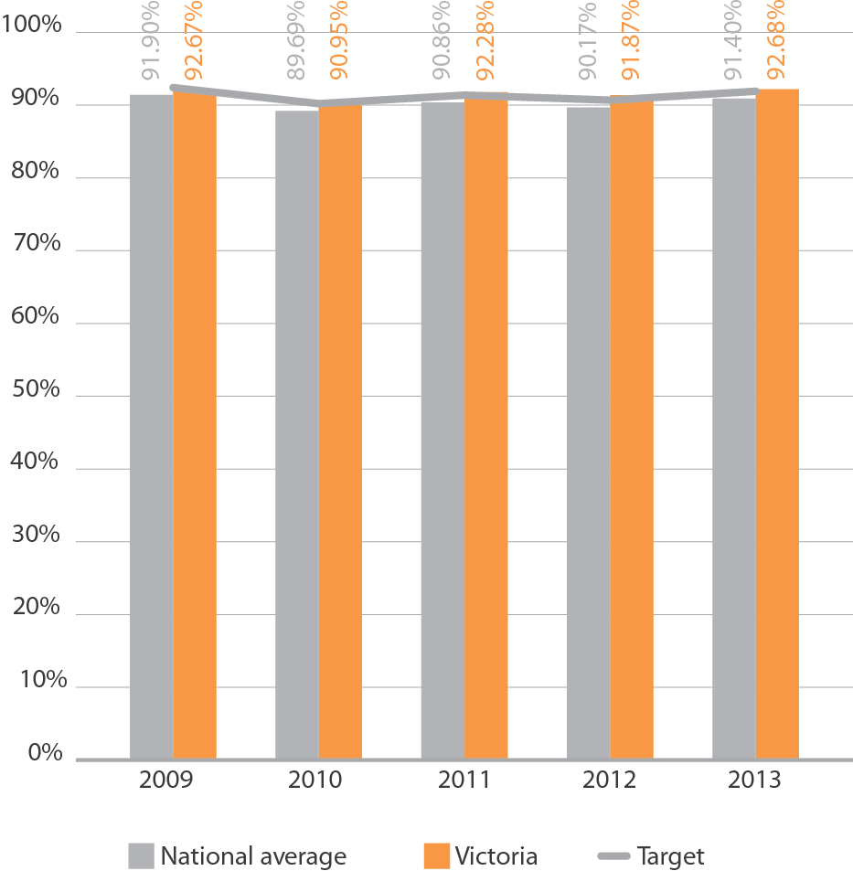
Enrolment Programs
The VEC undertakes a number of Continuous Enrolment Update (CRU) programs. In the past these programs solely assisted electors to enrol and to keep their enrolment details up-to-date. Mail-out activities targeted potential electors using data provided by the Residential Tenancies Bond Authority, the Victorian Tertiary Admissions Centre and VicRoads. People who registered or updated their address details with one of these agencies were sent an enrolment form if they were not already enrolled.
Following the introduction of direct enrolment in 2011-12, the VEC’s CRU programs were modified to enable the VEC to directly enrol members of the voting-eligible population using its external data sources instead of sending them an enrolment form. These people are sent a letter advising them of the VEC’s intention to directly enrol them, and asking them to advise the VEC if they are not eligible to be enrolled. Where eligibility cannot be confirmed, an enrolment form is sent.
During 2012-13 the VEC continued to improve and increase its direct enrolment program, utilising additional data sources, including the Victorian Curriculum and Assessment Authority (VCAA) for young electors and VicRoads data more generally. As expected, this has resulted in a significantly greater number of enrolments being achieved through direct enrolment, growing from 26.97% of total VEC enrolment transactions in 2011-12 to 58.47% of total enrolments in 2012-13. See Figure 17 for the different sources of VEC enrolment transactions.
The VEC’s enrolment programs generated 192,414 enrolment applications in 2012-13 amounting to 30.68% of total Victorian applications received by both the VEC and the Australian Electoral Commission (Figure 18). This is an excellent result against a target of 25%.
Figure 17: Enrolments from VEC programs, 2008–09 to 2012–13
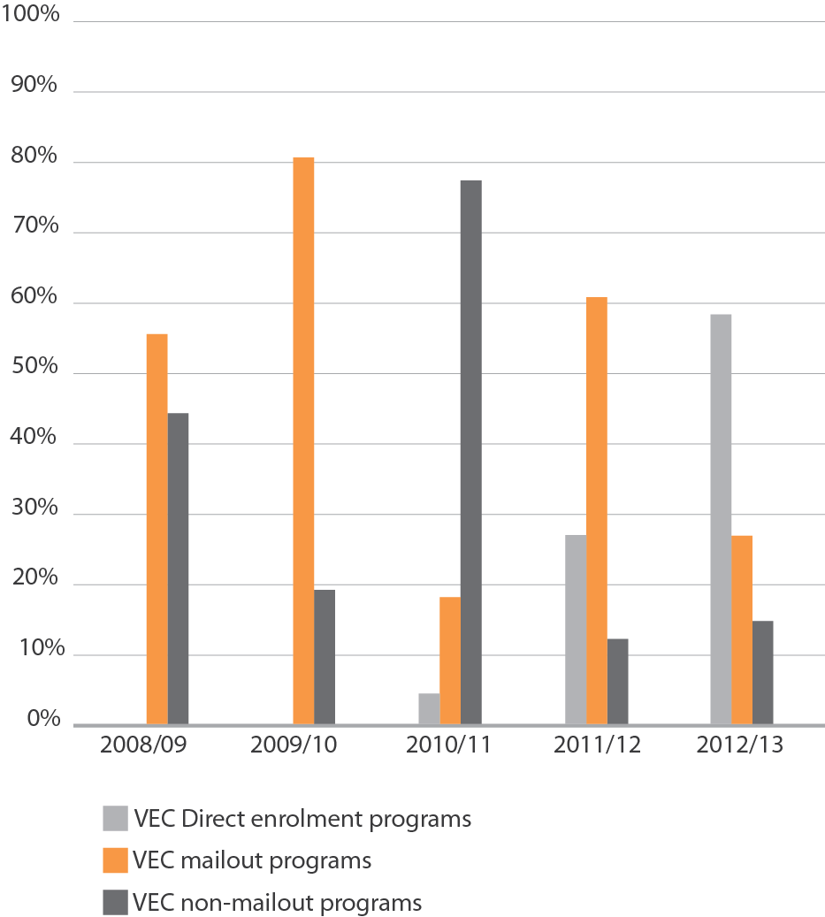

Figure 18: Proportion of enrolment updates sourced from VEC programs, 2008-09 to 2012-13
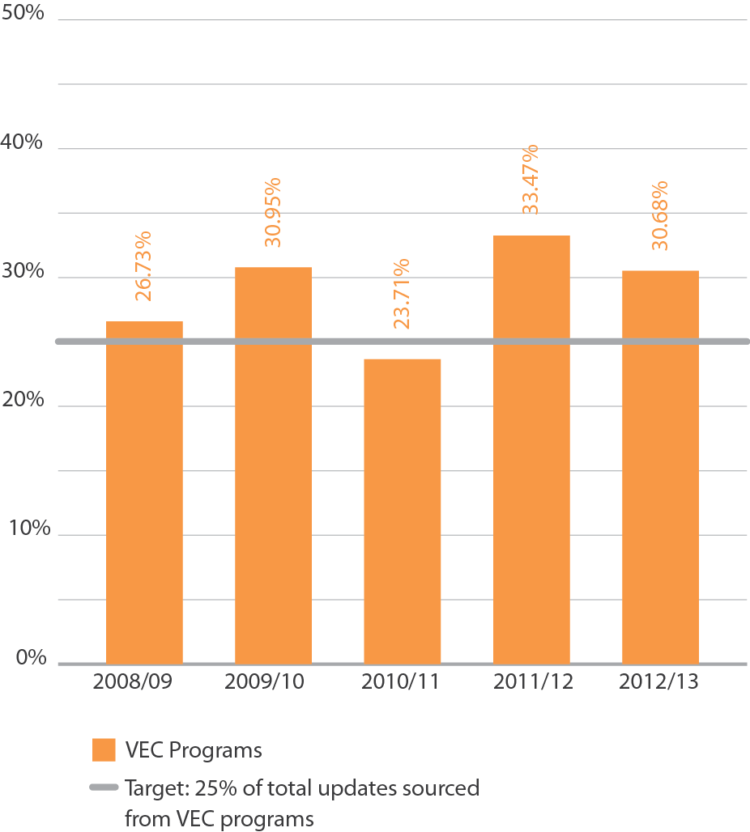

Youth enrolment
Eligible Victorians may enrol at 17 years of age, but cannot vote until they turn 18. Data is provided by the Victorian Curriculum and Assessment Authority (VCAA) to enable the VEC to send a birthday card and enrolment form to Victorians in the education system after they turn 17 years of age. According to VEC tracking of enrolments, 21% of 17-year-olds who received a birthday card in 2012–13 enrolled as a result of this program.
The estimated percentage of eligible 17-year-olds provisionally enrolled on the Register of Electors at 30 June 2013 was 20.29%. Passport to Democracy, a school education program, is an effective way of encouraging interest in and knowledge about the democratic process in upper secondary students. A VEC presence at events involving young people and teachers is also part of the strategy.
The number of young Victorians enrolled is around 13% below that of the general eligible population. Figure 19 shows the extent to which Victorian young people (18 to 25 years) are represented on the electoral roll. Since 2008-09, Victorian figures have been consistently higher than the national average, and youth enrolment in 2012-13 is higher than the VEC’s target of at least two percentage points above the national average (76.3% at 30 June.2013).

Figure 19: Youth enrolment, 2008-09 to 2012-13
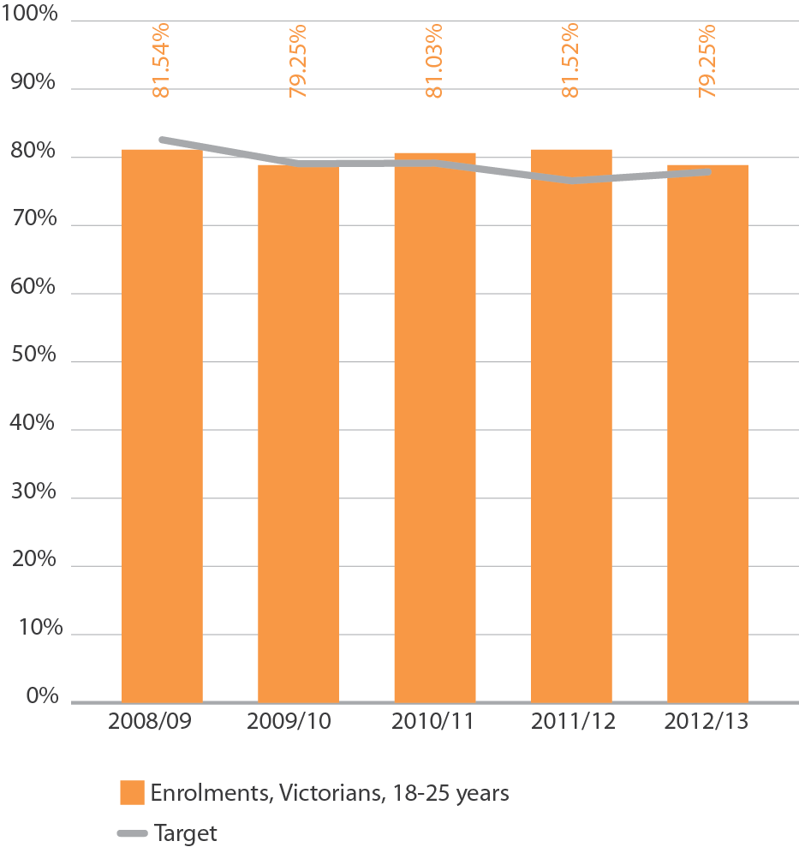
Victorian Civil and Administrative Tribunal
The Victorian Electoral Registrar refused an application by an elector who sought to be registered with the last name “Xxxx-Liberal”. The name was deemed by the VEC to have the potential to mislead electors should this person nominate as a candidate for an election. The application was refused under section 25(1)(b)(v) of the Electoral Act 2002. The applicant subsequently applied to VCAT for review of the decision. The matter was heard on 30 October 2012.
The Electoral Registrar’s decision was affirmed. The reasoning focused on the likely outcome for voters and the potential for voters to be misled and concluded that inclusion of the last name “Xxxx-Liberal” on the register of electors would be contrary to the public interest.
Compulsory enrolment
Compulsory enrolment has been a feature of Victoria’s electoral legislation since 1923. By law, eligible electors who do not enrol or keep their enrolment details current can be prosecuted and fined one penalty unit. A conviction may also be recorded.
The VEC has traditionally taken the position of encouraging eligible electors to enrol and maintain their enrolment to protect their right to vote should an election (local government, State or Federal) be called. With the introduction and success of direct enrolment, compulsory enrolment becomes less problematic for the majority of electors, and the VEC will investigate ways of targeting the voting-eligible population that is not captured by automatic enrolment activities. With a focus on automatic enrolment and other continuous roll update activities, no follow-up of compulsory enrolment provisions was undertaken in 2012–13.

Turnout
Turnout is measured as the number of formal and informal votes received by the close of voting in an election as a proportion of enrolment. The VEC provides an increasing number of services to electors to help ensure that all enrolled electors turn out to cast their vote. These include information services prior to, and on election day, as well as a variety of voting options and aids.
Turnout at State by-elections
The average turnout at the two State District by-elections held in 2012-13 was 74.35% with a low 68.62% being recorded at the Melbourne District by-election and 80.07% at the Lyndhurst District by-election (Figure 20).
Figure 20: Turnout, State by-elections, 2008 to 2012-13
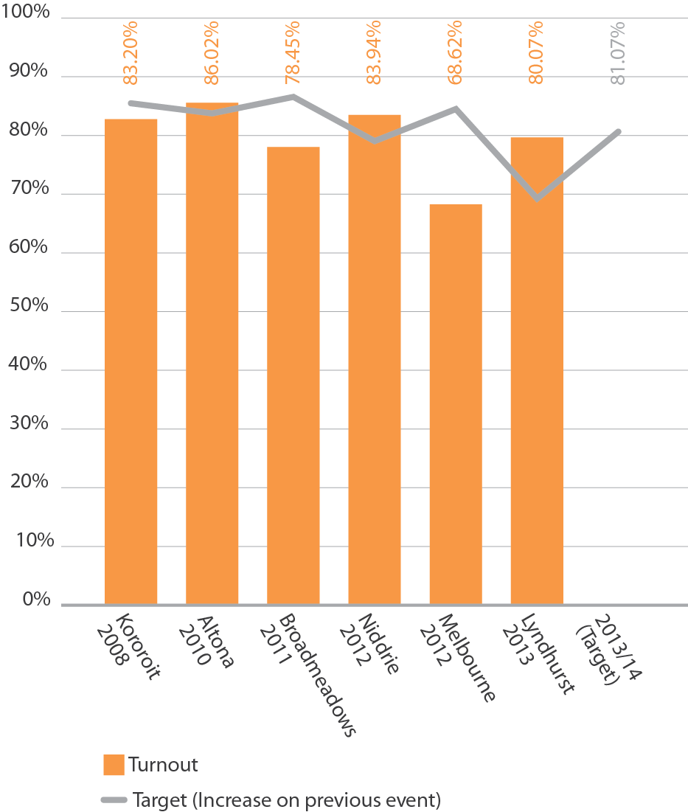
Turnout at local government by-elections
Only one local government by-election was conducted during 2012–13. The turnout rate was 75.92%, meeting the VEC’s target of an increase year to year (see Figure 21), and higher than the average turnout during 2011-12 (73.76%). It is an increase on the average turnout for the last five-year period (73.11%), and slightly more favourable than the average turnout rate for the local government general elections held in October 2012 (70.96%).
Local government by-election turnout rates are generally lower than the turnout at State by-elections. The main reason is that voting at local government by-elections is not compulsory for non-residents. 0ther factors include lower awareness of the election due to less media attention and (generally) less candidate activity, the perception that only property owners (as opposed to tenants) are required to vote in local government by-elections, and the fact that people over 70 years of age are automatically excused if they do not vote.

Figure 21: Average turnout, local government by-elections, 2007–08 to 2011–12
Enforcement of compulsory voting
After the conduct of elections, by-elections and polls in which voting is compulsory, the VEC carries out compulsory voting enforcement where legislated and when a council contracts the VEC to do so. In order to conduct compulsory voting follow-up for councils, the Chief Executive 0fficer must appoint a VEC staff member as the prosecution officer.
Three stages of enforcement (or non-voter follow-up) are managed by the VEC.
- Dispatch of Apparent Failure to Vote Notices to those electors who appear not to have voted in an election. Apparent non-voters have 28 days from the date of the notice to provide a valid excuse for failing to vote.
- Follow-up (by Infringement Notice) of electors who did not respond, or who provided an invalid response to the Apparent Failure to Vote Notice. A penalty amount is applied (currently set at $70.00). Non-voters have 42 days to respond to the Infringement Notice by making the penalty payment or seeking a review of the penalty. Consideration is also given to written correspondence detailing reasons for failing to vote.
- A Penalty Reminder Notice is sent to those who do not pay the infringement penalty. An amount for prescribed costs is added to the original penalty amount.
Where the VEC conducts non-voter follow-up for State elections, by-elections or liquor licensing polls, a final non-voter file is lodged with the Infringements Court for further action. In 2012–13, the VEC continued enforcement of compulsory voting for two by-elections, one liquor licensing poll and the 2010 State election. Enforcement of compulsory voting commenced for the Melbourne and Lyndhurst District by-elections, three liquor licensing polls and on behalf of 73 municipal councils following the 2012 local government elections.
Where non-voter follow-up is conducted on behalf of a council, the VEC provides the council with a final non-voter list and an Infringements Court file. The council makes a decision about further follow-up. The VEC concluded non-voter follow-up for one State by-election, three liquor licensing polls and one local government by-election. Penalties collected are transferred to the council twice during the enforcement process, the first at the end of the infringements stage and the second at the conclusion of the penalty reminder stage. Appendix H provides details of all apparent non-voter follow-up and compulsory voting enforcement conducted during 2012–13.

Informal voting
A vote is declared informal when an elector does not complete their ballot paper according to the instructions, or their voting intention is not clear. Ballot papers that do not comply with the formality rules are not admitted to the count.
Informality rate at State by-elections
The average informality rate for the State District by-elections held in 2012-13 was 9.40%. This is higher than the average informality rate for State by-elections conducted between 2007 and 2012 (9.24%) (see Figure 22).
The VEC aims to increase electors’ understanding of how to cast a formal vote. The VEC conducts an analysis of informal voting after each State by-election to assist with developing strategies to help reduce informal voting. Details of individual analyses are included in the VEC’s report on each State by-election.
Informality rate at local government by-elections
The informality rate for the Ararat Rural City Council by-election conducted in 2012-13 was 2.57%, which is lower than the average of 3.12%) for by-elections conducted in the past five years (see Figure 23). The by-election was conducted by post. Informality rates are generally lower at elections conducted by post than those conducted by attendance voting.
Advertising and communication campaigns are designed to help ensure that Victorians are provided with voting information in accessible formats. Information is available in languages other than English, and telephone interpreter services are provided all year round. VEC electoral education and engagement programs aim to provide Victorians with the motivation and knowledge to cast a valid vote.
Figure 22: Proportion of informal votes, State by-elections, 2007-08 to 2012-13
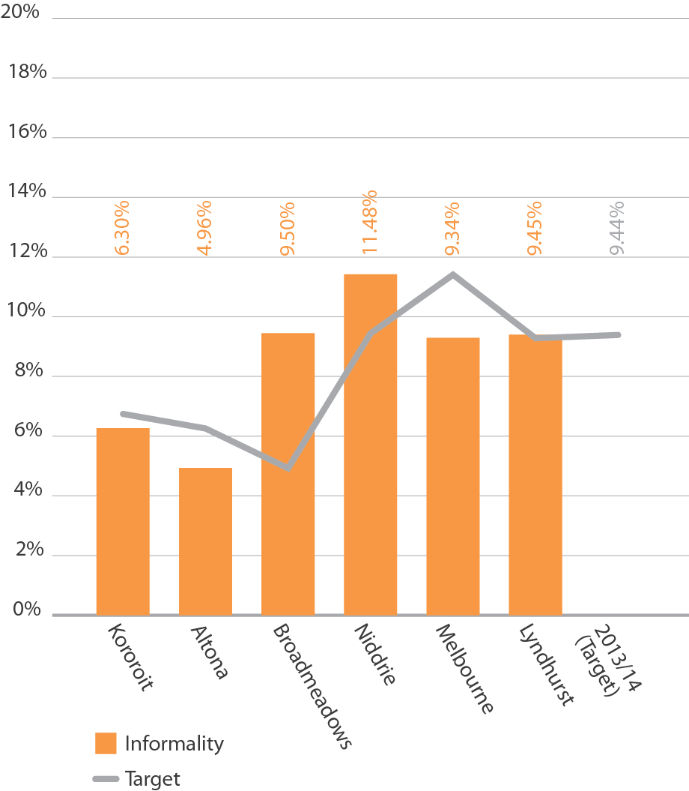

Figure 23: Average informality rate, local government by-elections, 2008-09 to 2012-13
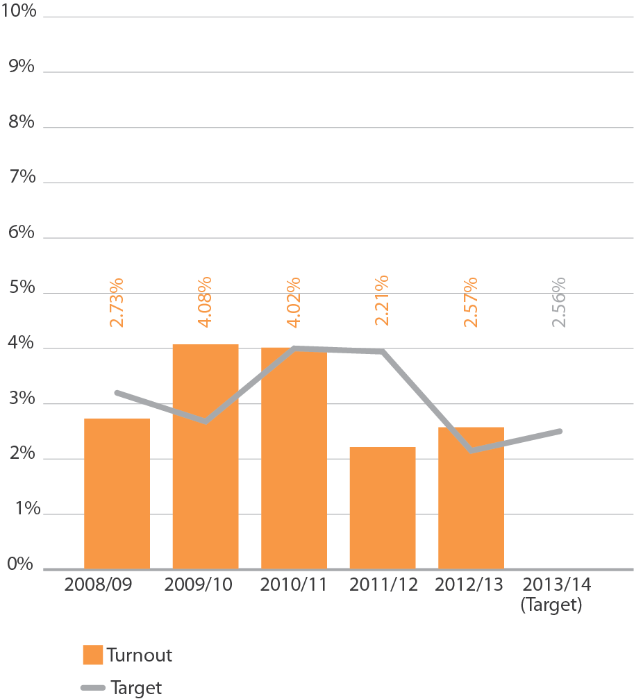

Services for voters with specific needs
The VEC provides a wide range of information, resources and education outreach services to help voters participate in the electoral process. Whilst available to all Victorians, there is a special focus on communities typically under-represented, such as Indigenous Victorians, young people, those experiencing homelessness, those from culturally and linguistically diverse communities, electors with disabilities and those who are unable to attend a voting centre on election day.
One braille ballot paper was provided upon request for an elector at the Melbourne District by-election (there were no requests for the Lyndhurst District by-election). Assistive aides were provided in voting centres, and voting instructions in multiple languages were printed on voting screens and included in ballot packs sent to electors. Internet services such as voting centre look-up tools, online enrolment forms, recruitment and nomination services were also provided at vec.vic.gov.au. The VEC also used Facebook and Twitter to aid the distribution of election information.
The VEC will continue to provide early and postal voting services for electors who are unable to vote on election day, or who will be away during the voting period. This will include a special postal voting service for armed services personnel stationed overseas.
Disability Action Plan
The VEC has a Disability Action Plan to address the way it provides services to people with disabilities. The Plan is informed by various legislation, regulations and guidelines, and by the Electoral Access Advisory Group (see p 19).
Easy English Guides
Easy English Guides have proven to be one of the most frequently requested publications the VEC produces. They are particularly suitable for people for whom English is not their first language or who have a low level of literacy. In preparation for the 2012 local government elections, the VEC updated its existing postal and attendance guides and produced new guides for Melbourne and Greater Geelong City Council elections. The full list of
Easy English Guides available from the VEC includes:
- Voting in Local Council Postal Elections
- Voting in Local Council Attendance Elections
- Voting in the Melbourne City Council Postal Elections
- Voting in the Greater Geelong City Council Postal Elections
- Voting in the 2010 Victorian State Election
- Running Your Own Election – First-Past-the-Post
Voting is for Everyone DVD
A revised form of the VEC’s Voting is for Everyone DVD was produced and 1,260 copies were distributed to key disability agencies and carers. This resource focuses on the importance of inclusion of people with a disability or multiple disabilities in the electoral process, and the practicalities for family members and carers. It has been an invaluable resource in the 18 education sessions run with disability advocacy groups across the year.
Partnership with VALID
A partnership with the Victorian Advocacy League for Individuals with a Disability (VALID) has seen an additional nine disability sessions run with over 300 VALID member participants. At the commencement of the sessions, many believed that they were not entitled to vote after having been told for many years that their intellectual disability or inability to read and write would preclude them. However, after exploring the importance of voting and assistance available to those living with a disability - including the availability of ‘talking boards’ at early voting centres for those with communication difficulties - many left the meeting feeling empowered to enrol and vote at the next election. The importance of this partnership is reflected in the feedback from one participant: “The government makes decisions that affect my life and my mum’s life. I’m happy to find out that I am allowed to vote. I didn’t think that was possible.”
Website accessibility
The VEC website is being included in a case study, conducted by the Office of Multicultural Affairs and Citizenship, aimed at defining a best practice approach to how State Government websites provide information in languages other than English.
While the VEC website conforms to WC3 guidelines, the website design is being reviewed to further enhance how information in languages other than English is presented and made accessible. One immediate change was to convert all 20 language translations into more easily accessible formats. As a result, the in-language information that is provided on the VEC website is now searchable and the font size can be adjusted in the same way as English language text.
The VEC will continue to work with the Office of Multicultural Affairs and Citizenship to implement recommendations and stay at the forefront of this challenging area of communication.
SCOPE
During the year the VEC became the first Victorian State Government organisation to receive communication access accreditation from SCOPE. This accreditation is evidence that there are trained and tested personnel available and able to assist people with complex communication difficulties, either in person or over the phone. Training, including the use of ‘talking boards’, will be provided to a proportion of staff in every election office and early voting centre for the 2014 State election.
Accessibility of voting centres
The lack of fully accessible voting centres continues to be of deep concern to the VEC. Every effort is made to lease buildings and facilities that are accessible to people with disabilities.
Every early voting and election day voting centre is rated according to its wheelchair accessibility. The audit complies with relevant Australian Standards and assesses building access, as well as the availability of accessible parking. The VEC has been working with the Australian Electoral Commission to ensure that standardised ratings are applied.
For the Melbourne District by-election in July 2012, both early voting centres were rated as ‘Assisted Wheelchair Access’. Of the 14 election day voting centres in Melbourne District, two were ‘Fully Wheelchair Accessible’ and the remaining 12 were rated ‘Assisted Wheelchair Access’.
For the Lyndhurst District by-election, both early voting centres were rated as ‘Assisted Wheelchair Access’. Of the 15 election day voting centres in Lyndhurst District, six were ‘Fully Wheelchair Accessible’, eight were rated ‘Assisted Wheelchair Access’ and one was rated ‘No Wheelchair Access’.
Voting centres for the 2012 local government elections were booked early in 2012. Returning Officers completed accessibility audits at all venues in advance of the election period and all ratings were well-publicised. The VEC made efforts to locate at least one venue with full wheelchair access in each ward. However, the absence of suitable venues severely limited those opportunities. The VEC was able to provide at least one fully wheelchair-accessible venue in each municipality, and there was a total of 30 (17%) fully wheelchair-accessible venues across the eight attendance elections. Of the remaining venues, 107 (62%) were classified as ‘Assisted Wheelchair Access’ and 36 (21%) had no wheelchair access, a reduction on the proportion with no wheelchair access for the 2008 local government elections (25%). Figure 24 shows wheelchair accessibility ratings for voting centres for the last five major events.
During 2012-13, the VEC made efforts to ensure that voting centre accessibility was included in the Victorian State Disability Implementation Plan 2013-2014, which contains a specific action for the Department of Justice to collaborate with the Victorian Electoral Commission and relevant agencies to develop an approach that will increase access to voting centres in electorates with no fully wheelchair accessible voting centres.
Before the end of 2012-2013, the VEC met with Department of Justice and the Department of Education and Early Childhood Development (DEECD) representatives to discuss mechanisms to match electorates with no fully wheelchair accessible centres with the list of schools prioritised for attention under the DEECD’s Accessible Buildings Program.
Figure 24: Wheelchair accessibility ratings, voting centres, State elections and by-elections and local government general elections, 2010-11 to 2012-13
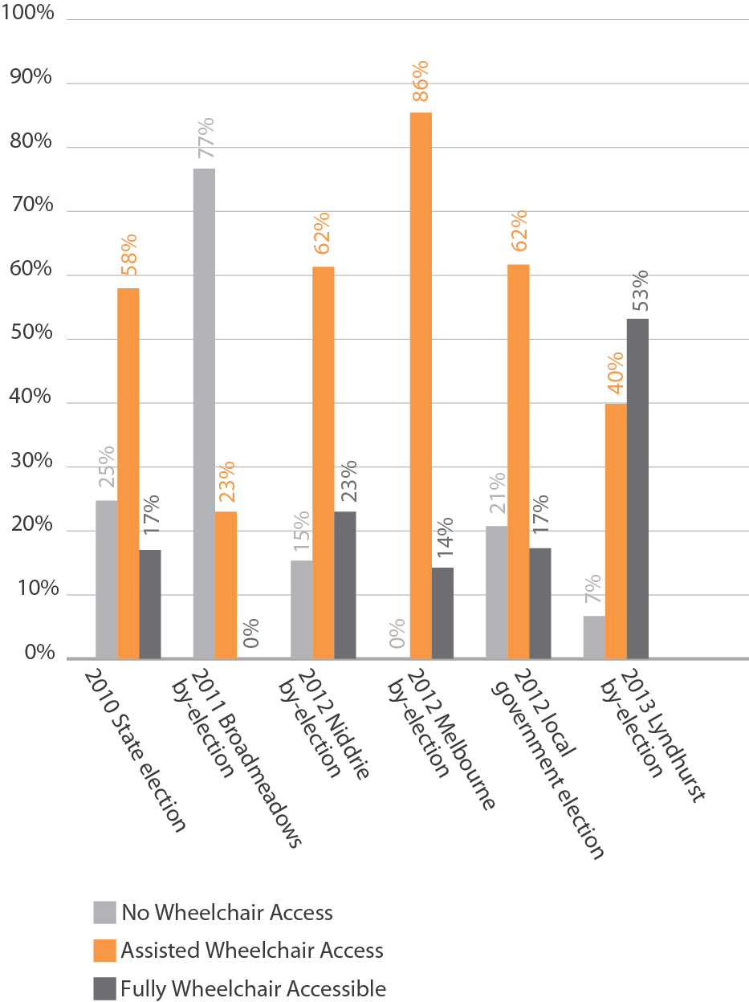

Community education and engagement
The VEC has continued to strengthen relationships with community organisations and education institutions, offering a range of outreach services and education materials. The VEC aims to assist people to develop a broader understanding of the relevance of democracy to their lives, and to support positive experiences of engagement with electoral processes.
Research and project evaluation has guided the focus of this year’s work largely towards Indigenous communities, schools and new and emerging communities. The VEC offered specialised and tailored support presenting 81 activities to 2,559 participants across Victoria.
A breakdown of these events can be seen in Figure 25.
For the 2012 local government elections, community information kits were collated and distributed to 3,000 migrant community support agencies and organisations. The kits included:
- Easy English guides to voting in local government elections (Attendance, Postal, City of Melbourne,
City of Greater Geelong)
- enrolment forms
- poster ‘Your Community, Your Opportunity. Local Council Elections 2012’
- Every Vote Will Shape Victoria publication
Figure 25: Education and engagement activities, 2013-13
Target Audience | Sessions Held | Participant numbers | Key public events
People living with a disability | 17 | 447 | National Disability Youth Conference
Indigenous communities | 5 | 207 | The Long Walk Dreamtime Career Expo
People experiencing homelessness | - 23 Direct outreach  - 24 Staff / Advocacy meetings | - 1090 people experiencing homelessness  - 239 staff | Home is Where the Heart is Festival
CALD communities | 12 | 576 | Ethnic Communities  Council of Victoria Conference

Passport to Democracy
The VEC continued to build on its very successful Passport to Democracy program, which focuses on civics and electoral education in secondary schools.
The program receives strong support from teachers and students, whose feedback validates and enriches the program.
Engagement with Indigenous communities
Research on the electoral engagement of Indigenous Victorians has been instrumental to the VEC’s work with Indigenous communities, and in particular is guiding work with young Aboriginal people participating in the Korin Gamadgi REAL camps. A focus has been the expansion of networks through working closely with local Indigenous networks, to raise awareness and levels of electoral engagement.
Launching its new slogan for the Indigenous program ‘My Vote, Your Vote, Our Vote’, the VEC attended the Dreamtime Career Expo – encouraging Indigenous community members to consider working in upcoming elections.
The Long Walk, a key feature of the Indigenous calendar, also provided a valuable opportunity for the VEC to further promote its new message. With exposure to over 10,000 people, the new Indigenous program slogan was screened on the big screens at Federation Square and supported by a stall encouraging community members to check that their enrolment details were current.
Democracy Ambassadors – relationships with CALD communities
New and emerging communities may experience a range of barriers to electoral engagement that can result in low levels of enrolment and higher than average levels of voting informality. The VEC is finalising a ‘Democracy Ambassadors’ pilot program, an engagement model targeting CALD communities. The program aims to provide information about enrolment and voting processes, and to foster greater community engagement in Victoria’s democratic processes by employing community leaders who will advocate electoral engagement within their communities.
The model is being developed for piloting with African communities. The VEC is working closely with community organisations and community leaders in implementing the pilot.
While planning for this new development, the VEC has been ensuring that all CALD communities are equipped with the knowledge and skills to engage in elections and has been continuing to deliver education sessions on request to CALD community groups. This has included presentation to, and sponsorship of, Africa Media Australia’s ‘Democratic Participation Community Forum’.
Homeless not Voteless
The ‘Homeless not Voteless’ program continues its commitment to ensuring that those experiencing homelessness in Victoria are empowered to vote.
Through presentations at staff network grounds, including Homeground’s Advocacy Committee and across regional staff homelessness networks in Central and East Gippsland and North West Victoria, the VEC has engaged with over 200 homelessness workers - sharing information about upcoming elections and strategies to empower service users.
The VEC’s mobile and assisted voting service targeting those experiencing homelessness is now in its sixth year of program delivery and in 2012-2013 targeted the local government elections and the Melbourne & Lyndhurst by-elections. In the lead up to the local government elections, enrolment outreach and worker information sessions were conducted at homelessness staff meetings. Following this, enrolment outreach and assisted voting sessions were organised at homelessness organisations, resulting in 130 new enrolments. Just under a third of these newly enrolled electors went on to vote in the local government elections. The strength of the partnership with St Mary’s House of Welcome in Fitzroy saw 45% of those new to the roll vote in the City of Yarra Council election.
In addition, many service users voted at early voting centres as a result of the raised profile of the importance of voting among the community. The VEC will continue to closely monitor the effectiveness of the homelessness initiative and hopes to build on this work for the 2014 State election.
The VEC also found that, despite women representing 44% of those experiencing homelessness on any single night, only 15 % of new enrolments of itinerant voters are women. Acknowledging this anomaly, the VEC is committed to making sure the voice of women experiencing homelessness is represented in elections. A new partnership has been developed with The Big Issue focusing on providing employment opportunities for women in elections. This resulted in a successful pilot program during the Melbourne by-election, during which four women from the service were employed as election officials. Further opportunities will be explored as part of the VEC’s ongoing education strategy.
SELECTIONS magazine
The annual stakeholder magazine, SELECTIONS was distributed to MPs, local councils and other stakeholders in July 2012. The edition focussed on the fiftieth anniversary of the Indigenous right to vote in Federal elections (and the VEC’s ongoing work with young Indigenous leaders). Other items covered the local government representation reviews completed in 2011-12, and provided information for the (then upcoming) 2012 local government elections.
Social media
Building on a successful trial during the 2010 State election, the VEC refreshed its Facebook page and created a Twitter account in mid-2012.
With the 2012 local government elections in mind, the VEC aimed to use these channels to help maximise voter participation in the elections, raise awareness of enrolment and when to vote, inform voters of their rights and responsibilities, and explain how to vote correctly.
As Facebook and Twitter are highly popular, but relatively new media channels, the VEC also used them to engage voters who may not encounter or respond to advertising on traditional media channels.
Over the year the VEC’s Facebook following grew from around 750 to almost 3,000 and the organisation’s Twitter following grew from zero to more than 1,500.
The VEC made extensive use of social media platforms Facebook and in particular Twitter, during the 2012 local government elections, and the Melbourne and Lyndhurst District by-elections.
Twitter was utilised to seed conversations, provide notification of results and effectively manage election-related issues in real time.
Facebook provides opportunities for more in-depth conversations, or follow-up on questions or issues posed. The VEC used this medium to achieve positive resolutions to issues raised.
Website
The VEC’s website is the first point of contact for many stakeholders, with an average of 750 visitors per day outside of election periods. During the 2012 local government elections, daily use peaked at more than 75,000 visits.
The site contains detailed information for each current election, as well as tools for candidates and prospective employees, information about the VEC’s education and research initiatives, and a comprehensive account of Parliamentary and local government election results from 1999 to the present.
The current site was launched in early 2010 and in May 2013 the VEC began a program to review site use and feedback with a view to launching an updated site prior to the 2014 Victorian State election.

Geographic Information Systems
As part of the process of ensuring the integrity of the Victorian register of electors, the VEC conducts validation checks using spatial information to determine the accuracy of the coding assigned by the Australian Electoral Commission (AEC) to new addresses. A total of 73,444 records were checked in 2012–13, and 532 inconsistencies were identified and reported to the AEC.
In 2012–13, a number of significant projects were undertaken for the 2012 local government elections, including the production of 391 maps to reflect boundary and ward structure changes as a result of the Municipal Boundary Reviews, and an online voting centre look-up facility. Candidate maps, advertisement maps and voting centre maps were provided for State and local government by-elections.
Boundary Maker, the VEC’s internally developed boundary-modelling software was further developed. Previously, this had only been used for modelling boundaries and structures for municipal electoral representation reviews. Boundary Maker was introduced to the NSW Electoral Commission, which used it to assist with the conduct of a State redivision. The NSW Electoral Commission was also provided with ongoing software support. The relationship was mutually beneficial, as software enhancements and increased functionality were developed as a result of feedback provided.
The VEC provided administrative support to the Electoral Boundaries Commission (EBC) for the 2012-13 State redivision. Boundary Maker was used for the drawing and analysis of boundaries, elector data and projected elector data. The software allowed for more streamlined work enabling modelling and analysis of all submissions sent to the EBC. The printed report, released in June 2013 and available for viewing at the VEC head office and in every municipality in Victoria, contained 114 detailed maps of proposed districts and regions. The final report is scheduled for release in October 2013.
As part of the State redivision, an online interactive mapping application was developed, allowing users to view both existing and proposed boundaries simultaneously. Based on Google Maps, the interactive map allows users to zoom in to street or property level to view proposed boundaries in detail.

Roll products and services
The compilation of electoral rolls and the production of roll products for elections, by-elections and polls is conducted by the VEC. Extracts of data are prepared for the provision of electoral information access granted under s.34 of the Electoral Act 2002.
After the resignation of the member for Lyndhurst District, the roll of electors was prepared for the by-election in March 2013.
Boundaries for the five liquor licensing polls conducted in 2012–13 were determined in conjunction with the Victorian Commission for Gambling and Liquor Regulation. Details pertaining to the relevant properties and electors were then extracted from the State roll database to compile the rolls for these polls.
Voters rolls for local government elections are compiled from a State roll extract for the municipality (around 85% of voters), combined with a ratepayer extract from the municipality (around 15% of voters). The process of combining the two datasets involves complex checking processes to try to ensure that voters in the State roll extract are not duplicated in the council data.
Entitlement day for the 2012 local government elections was on 31 August 2012, and the VEC had all 78 rolls, with almost 4.1 million voters details, ready for the council certification process within 14 days. In order to meet this very tight timeline, the VEC worked with councils during 2011 and 2012 to help them add dates of birth to their rate records to avoid duplicate voters on the certification roll.
The VEC also worked through a preliminary roll production process, feeding data issues and duplicates to councils for correction before the process started in earnest on 19 July 2012.
Voters rolls were also produced for the local government by-election for Ararat Rural City Council held in June 2013 and for Central Goldfields Shire Council (Flynn ward) for the by-election to be held on 24 August 2013.
Rolls for commercial elections conducted in 2012–13 were prepared from the particular organisation’s member-lists using a computer program (roll creation applet) developed by the VEC.

Provision of enrolment information
The register of electors contains personal enrolment information, including name, address, date of birth and gender. Protecting the privacy of electors’ personal enrolment information is of fundamental importance to the VEC, and information is only disclosed according to legislation.
Mandatory provision of enrolment information
The Electoral Act 2002 stipulates the following electoral information to be made available:
- The list of Victorian electors (names and addresses only) excluding silent electors, must be made available for public inspection at the offices of the VEC and updated every six months. Information can only be searched by name.
- The latest print of any electoral roll produced for an election (which contains name and address details only) must be made available for public inspection, free of charge, at locations and during times determined by the VEC.
- Enrolment information, excluding silent electors, must be provided a number of times each year (and at the time of an election) to registered political parties, Members of Parliament and election candidates for permitted purposes.
Enrolment information is also provided under other legislation.
- Under section 19 of the Juries Act 2000, to enable people to be called for jury duty, jury rolls are prepared as requested by the Juries Commission for any of the 14 jury districts (silent electors are included in this process). A total of 47 jury rolls were provided under this legislation during 2012–13.
- Under section 21 of the Local Government Act 1989, enrolment information is provided to municipal councils for elections.
Discretionary provision of enrolment information
Under section 34 of the Electoral Act 2002, (the Act) the VEC has the discretion to release enrolment information to other individuals or organisations under certain circumstances. Strict conditions apply to the provision of information and severe penalties apply to non-compliance or misuse of enrolment information.
During 2012–13, the VEC received eleven requests for access to enrolment information from individuals or organisations. Three requests were approved (including one received in 2011–12) and eight were declined. At the Electoral Commissioner’s discretion, letters were sent to four electors whose information was sought, advising them that a person or organisation was seeking to make contact with them and providing the contact details of the applicant.
One application is still in progress at the time of this report. A number of other queries were received, and either did not result in an application, or the information requested was not held by the VEC.
See Appendix I for a list of organisations and individuals to which the VEC has provided enrolment information, under section 34 of the Act.

Warehouse
Warehousing and distribution facilities play a major role in the core business of the VEC. With the lease acquisition and occupation of a modern warehousing facility during 2012-13, the VEC has increased the capacity and efficiency of operational activities, addressed storage and occupational health and safety deficiencies, and increased logistical efficiencies.
The additional floor space at the new facility and being on a single level allows for:
- the capacity to expand operations in the lead up to, conduct of and after election activity for major electoral events
- a safer and more efficient layout for storage of equipment and election resources
- safer traffic management
- more efficient and safer preparation and compilation of outward consignments for the setting up of election offices and support locations throughout the State
- safer and more efficient allocation of space for storage of official records prior to archiving
- a dedicated external hardstand for the loading and unloading of multiple, larger vehicles and a recessed dock to enable unloading of shipping containers.

OUR PEOPLE
Aim
- A safe, supportive and professional workplace
Strategies
- Implement preventative measures and respond to incidents, reports and evaluation in order to minimise risk and maximise workplace health and safety
Result
- Four claims
- 13.8 lost time days from one injury
Highlights 2012–13
- Health and well-being activities that included skin and health checks were enthusiastically attended by staff
Outlook 2013–14
- The performance management and professional development program will be reviewed and redeveloped to provide staff with a more user-friendly process that continues to address both personal and organisational objectives
- The VEC will continue working on collaborative cultural realignment
- Review of VEC policies, guidelines and procedures having regard to Australian and international best practice and experience will be completed
- The Aurion Human Resources System will be introduced into service

Priority initiative: Strategic Plan 2013-14 to 2017-18
ENABLER | STRATEGIC INITIATIVE | SUCCESS INDICATOR
Robust performance management and professional development | Enhance performance and development program, processes and systems | Performance is recognised and acknowledged  Succession is informed by performance and development  All performance expectations are understood, agreed and monitored on a regular basis  Staff skills are appropriate to organisational needs  Performance and development is aligned with corporate planning

Inside this section
Human resource management
Knowledge capital
Occupational health and safety

Human resource management
The VEC strives to foster an engaging, stimulating and safe work environment. One area that contributes to this commitment is having the appropriate work practices in place to support its people.
During 2012–13 Human Resource (HR) management focused on the establishment of a comprehensive set of internal policies that are aligned with best practice. This involved a review and update of existing policies and the development of new policies to meet organisational and staff needs. The policies are grouped under parent policies such as Conduct and Compliance, Privacy, Leave, Learning and Development, and Remuneration to create a user-friendly experience that enables employees to access the relevant information on demand.
Another key initiative was the organisation-wide review of all VEC position descriptions to provide job role clarity including role responsibilities and role relationships within defined work groups. The review looked at the current tasks, knowledge, skills and accountabilities that form each position. The VEC now has a position description catalogue which will assist Management Group to effectively manage and forecast resource requirements as part of the 2013-14 business planning process.
The VEC has also made headway with the cultural re-alignment project, which commenced in 2011-12. Utilising the 2012 People Matter Survey results in addition to the previous 2011 results, the VEC Management Group, partnering with Insight SRC, is focused on building a culture that is integrity based and progressive. The program looks at the role of the “Leader”, establishing an evidence based understanding of the key leader and cultural behaviours that contribute to organisational success. It incorporates a blended approach with theoretical classroom-based training and practical action-based learning activities.
Figure 26: Active staff in last pay period June 2009-13
 | Ongoing |  |  | Fixed Term |  | Casual
 | Headcount | FTE |  | Headcount | FTE | Headcount |  | FTE
2013 | 62 | 58.4 |  | 16 | 16 | 6 |  | 2.6
2012 | 60 | 56.7 |  | 16 | 16 | 9 |  | 5.2
2011 | 59 | 55.0 |  | 14 | 13.5 | 9 |  | 6.1
2010 | 59 | 54.9 |  | 17 | 16.3 | 10 |  | 5.3
 | Ongoing |  |  |  | Fixed Term and Casual
 | Headcount |  | FTE |  | Headcount |  | FTE
2009 | 60 |  | 54.5 |  | NR |  | 17.6

Notes:
NR = Not reported. Reporting format changed at the 2009–10 period
FTE = Full time equivalent
Excluded are those on leave without pay, or absent on secondment, external contractors and temporary staff employed by employment agencies.
Included are appointees to statutory offices as defined in the Public Administration Act 2004.

Figure 27: Recruitment, departures and turnover, 2008–09 to 2012–13
 | Headcount | FTE | Headcount | FTE | Headcount | FTE
2012-13 | 84 | 75 | 12.9 | 7.8 | 9.6%
2011–12 | 85 | 77.9 | 12.0 | 15.0 | 19.26%
2010–11 | 81 | 74.6 | 6.0 | 9.0 | 12.06%
2009–10 | 86 | 76.5 | 11.5 | 5.0 | 6.54%
2008–09 | NR | 72.1 | 9.0 | 7.2 | 9.99%

Recruitment and turnover
Individual differences are recognised and valued at the VEC, and organisational functions are delivered fairly, without discrimination or harassment. Employment decisions relating to appointment, promotion and career development are based on the competency and skill of the person selected.
The recruitment process is carried out with the highest regard to merit and equity, with specific key selection criteria forming a critical component of the selection decision. Other areas that are considered are; specialised knowledge, technical skills, and experience working with people with cultural and linguistically diverse backgrounds. For elections, the VEC actively recruits through Traditional Owner groups and organisations providing employment assistance to people with disabilities and those with cultural and linguistic diversity.
Figure 28 shows staff (FTE) recruited to and departing from ongoing and fixed term positions from 2008–9 to 2012–13. Recruitment requirements vary according to electoral activity and staff movement. Peaks are generally reflective of the VEC’s electoral activity cycle.
Employment exemptions
The VEC was granted an exemption from provisions of the Equal Opportunity Act 2010 to enable it to employ Aboriginal-identifying applicants for the role of Aboriginal Outreach 0fficer. A copy of the VCAT decision is available from the VEC and on the VEC website. The VEC welcomed a new staff member into this role in May 2013.
Employment diversity
The VEC’s aim is to recruit and support personnel who represent the diversity of the Victorian community and recognise the value individual differences make within the workplace.
Along with the head office and election day workforce being reflective of the diversity of the Victorian community, the appointment of up to 118 election casuals per day for the enforcement of compulsory voting provisions, was carried out with full regard to employment diversity principles.
The VEC has an inclusive employment policy, and where practicable, the VEC makes more than the minimum required adjustments for staff with specific needs. The VEC recognises cultural diversity in employment practices and policies where appropriate and, in an informal manner, with staff-initiated celebrations arranged and supported usually in conjunction with staff meetings or special morning teas.

Figure 28: Recruitment (FTE) 2008-09 to 2012–13
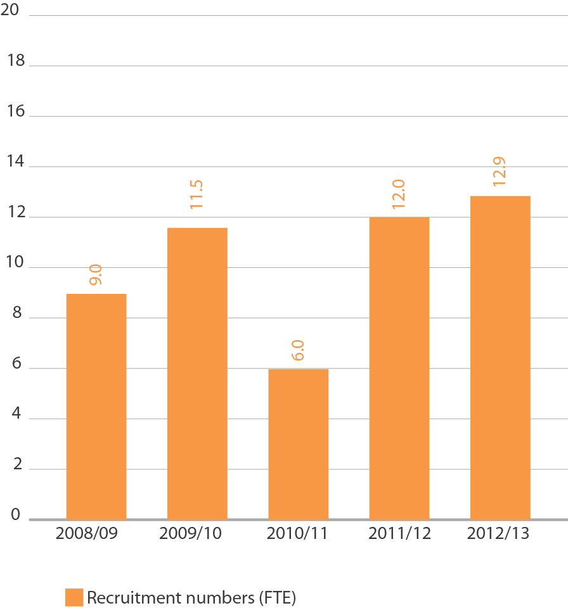

Figure 29: VEC staff by gender, 30 June 2008–13
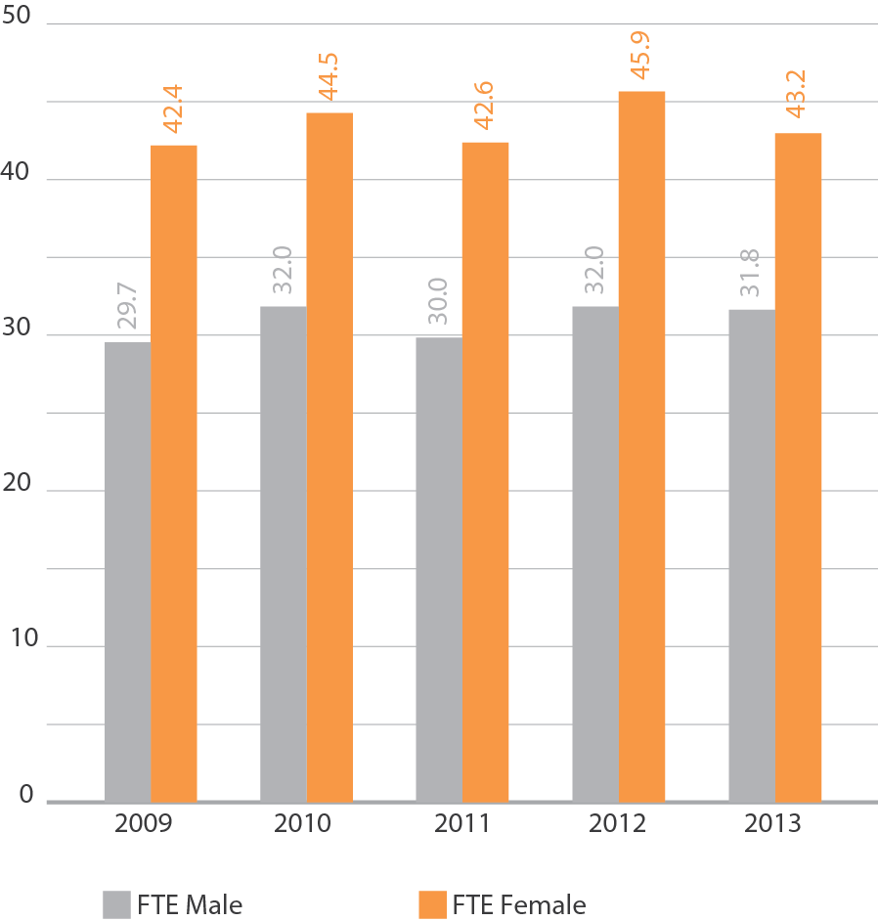

Knowledge capital
Along with formal and informal qualifications, VEC staff have a wide range of experience and high level knowledge and skills relating to electoral activity.
This “knowledge capital” is highly valued by the VEC not only because it helps ensure the achievement of corporate objectives, but because it is passed between staff to ensure continual professional growth and capacity in this specialised field.
The VEC ensures that staff have a variety of ‘on the job’ opportunities to gain election experience at other electoral agencies whenever possible. In 2012-13 five staff members were seconded to the Western Australian Electoral Commission to assist with the Western Australian State Election, all reporting it to be a rewarding and fulfilling experience, professionally and personally.
Performance management
The VEC adheres to the VPS Workplace Determination 2012, maintaining a performance management and progression system that aligns individual performance commitments with the VEC’s strategic direction. Each employee’s performance is assessed annually and reviewed half-yearly against individual and corporate objectives and outcomes.
The VEC believes that employee engagement is supported through a culture that fosters learning and professional development and provides clarity on organisation goals and business priorities, which guides and encourages performance discussions.
As a response to staff feedback, the VEC undertook a review of the performance management program. This review involved assessing the effectiveness of the current Performance Management Tool (LYNX). Also considered was the performance management phases including the setting of personal performance goals and commitments, monitoring performance against these commitments and the ongoing focus on professional development.
The VEC will cease using LYNX as a result of the review and develop a performance management system that is user-friendly and efficient. There will be a new performance management framework that incorporates behaviours within employee plans. The plans will provide clarity on individual contribution expectations and will incorporate organisational and branch priorities for the 12 month review period.
Training
As part of the performance management process, employees (in collaboration with their managers) create a development plan that ensures growth in skills and knowledge. This process also informs succession planning.
The VEC identifies opportunities for training and professional development on both an individual and organisation-wide basis. 0rganisation-wide training addresses areas of identified need, contributing to the achievement of organisational objectives and supporting staff in their personal and professional development.
During 2012–13, training focused on leadership, privacy, occupational health and safety, information technology and electoral administration. 0ther training made available during 2012–13 covered diversity and inclusion.
Staff were again offered the opportunity to participate in fire warden, first aid and defibrillator training, with 32 staff completing the training. During 2012–13, the VEC provided an average of 1.1 days of formal training per full-time equivalent (FTE) (see Figure 30). VEC staff also undertook informal unrecorded learning opportunities, including attending IPAA conferences, Public Administration workshops and a variety of networking sessions.

Figure 30: Training days per FTE, 2008–09 to 2012–13
Note: Figures are for core staff, excludes training for election officials.
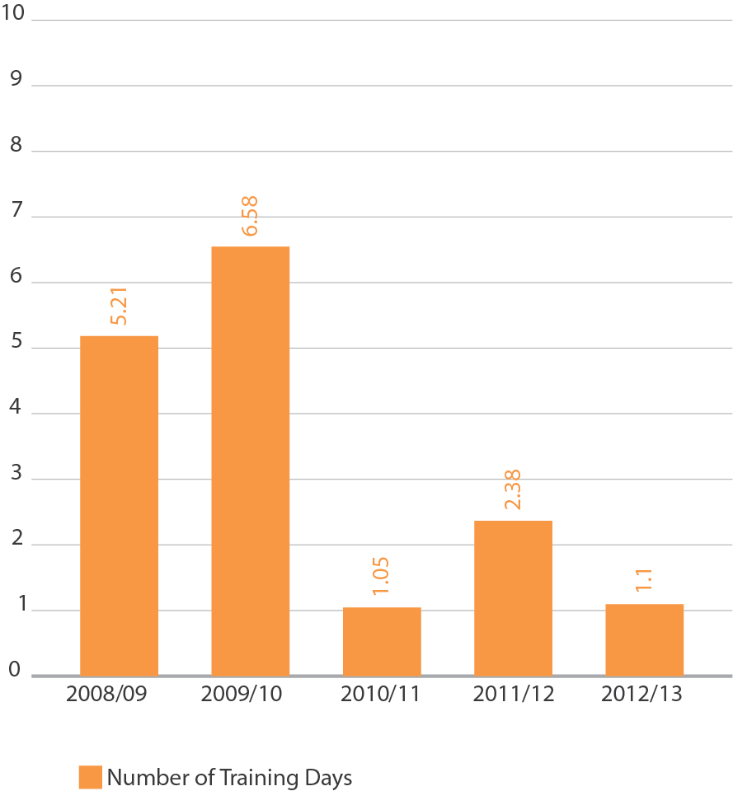

Occupational health and safety
The VEC continued its commitment to Occupational Health and Safety (0HS) compliance as well as general staff health and well being during 2012–13. Quarterly workplace inspections by VEC health and safety representatives continued with the aim of identifying and eliminating hazards, thereby preventing and reducing injuries. Regular clearing and tidying of work areas was organised and available staff were encouraged to participate. 0HS policies, procedures and action plans are subject to ongoing review by the Consultative Committee and Management Group.
Figure 31: The VEC’s performance against OHS management measures, 2008-09 to 2012-13
KPI | 2008-09 | 2009-10 | 2010-11 | 2011-12 | 2012-13
 | 72.1 | 76.5 | 72.6 | 77.9 | 75
No. of incidents | 2 | 8 | 12 | 6 | 17
Rate per 100 FTE | 2.77 | 10.46 | 16.53 | 7.70 | 22.67
No. of standard claims | 2 | 2 | 5 | 0 | 1
Rate per 100 FTE | 2.77 | 2.61 | 6.89 | 0.00 | 5.33
No of lost time claims | 0 | 27 | 4.25 | 0 | 14.8
Rate per 100 FTE | 0.00 | 35.29 | 5.85 | 0.00 | 18.40
No of claims exceeding 13 weeks | 0 | 0 | 0 | 0 | 0
Rate per 100 FTE | 0.00 | 0.00 | 0.00 | 0.00 | 0.00
Fatality claims | 0 | 0 | 0 | 0 | 0
Average cost per standard claim. | $6,408 | $5,723 | $14,095 | NA | NA
Percentage of claims with RTW plan <30 days.
Evidence of OHS policy statement, OHS objectives, regular reporting to senior management of OHS, and OHS plans (signed by CEO or equivalent). | completed | completed | completed | completed | Under review
Evidence of OHS criteria in purchasing guidelines (including goods, services and personnel). | completed | completed | completed | completed | completed
Evidence of agreed structure of designated workgroups (DWGs), health and safety representatives (HSRs), and issue resolution procedures (IRPs). | completed | completed | completed | completed | completed
Compliance with agreed structure on DWGs, HSRs, and IRPs. | completed | completed | completed | completed | Completed
Percentage of internal audits/inspections conducted as planned. | NR | NR | NR | 71% | 60%
Percentage of issues identified/actioned arising from:
- internal audits | NR | NR | NR | 100% | 100%
- HSR provisional improvement notices (PINs) | NA | NA | NA | NA | NA
- WorkSafe notices | NA | NA | NA | NA | NA
Percentage of managers and staff that have received OHS training:
- induction | 0% | 100% | 0% | 100% | 100%
- management training | 0% | 100% | 0% | 100% | Scheduled
- contractors, temps, and visitors. | NA | NA | NA | NA | NA
- Percentage of HSRs trained:
- acceptance of role | 100% | 100% | 100% | 100% | 100%
- re training (refresher) | 100% | 100% | 100% | 100% | 100%
- reporting of incidents and injuries | 100% | 100% | 100% | 100% | 100%
NR: not reported

Figure 32: Claims for WorkCover or workers compensation, 2008–09 to 2012–13
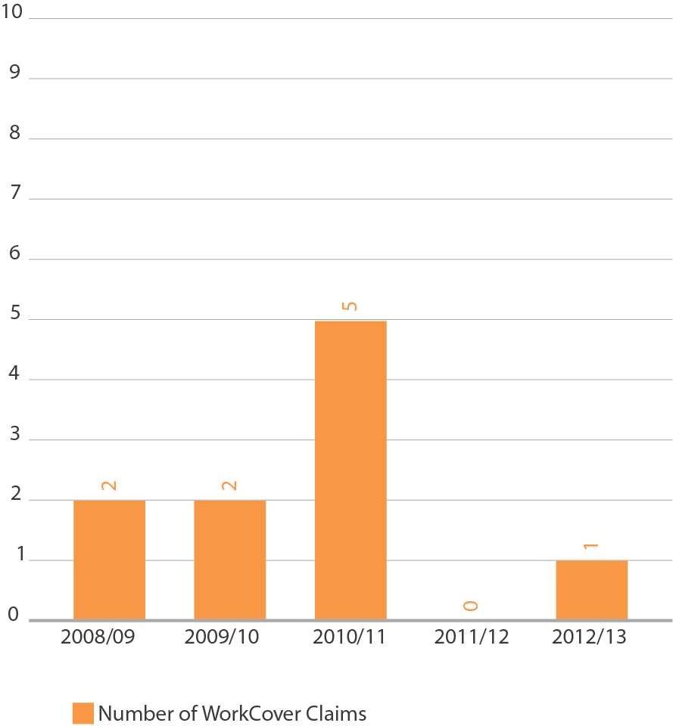

Figure 33: Days lost as a result of workplace-related injury, 2008–09 to 2012–13
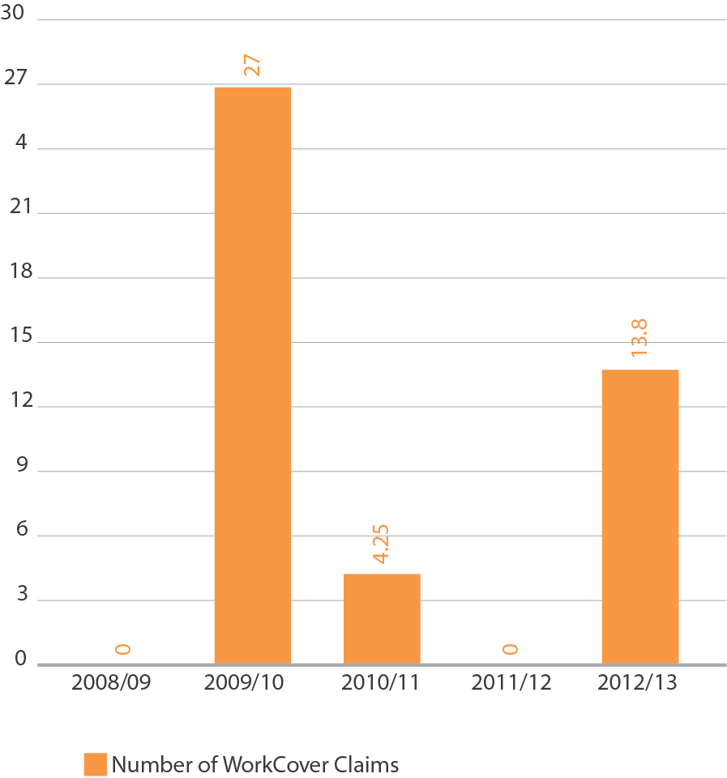
Hazards, incidents and injuries
During 2012–13, the VEC received 17 incident notifications, four hazard notifications, and six claims for compensation. The VEC has an ongoing focus on occupational health and safety training and practices, and a focus on responsiveness to incidents and injuries. One workplace injury resulted in 13.8 lost days (see Figure 8). The management team will continue to promote hazard reporting so that we respond promptly by introducing control measures to remove and mitigate risk of injury. Manual handling training is scheduled for the first quarter of 2013–14.
Staff services and employment conditions
The Consultative Committee contributes to the VEC’s culture and working environment by acting as a conduit for communication and decision-making. The Committee also actively supports the well-being of all employees by promoting staff initiatives such as staff social events, fund-raising and sustainability.

Flexible work arrangements
The VEC believes that flexibility in the workplace contributes to a supportive environment. VEC staff are able to access a variety of options available under the VEC’s Flexible Work Arrangements Policy. This Policy provides strategies to manage fluctuating work requirements, while providing a supportive environment especially during the busiest times.
During election time and at other busy times, staff at Victorian Public Service Grades 1–4 who work outside of normal hours accrue flexi-time (see Figure 34). A regularly reviewed and updated policy framework places limits on the number of hours that may be accrued. This helps ensure that the health of staff remains a priority during the VEC’s most demanding periods.
While staff may accrue additional flexi-time during major electoral events, these hours are managed to ensure staff are able to reduce accrued hours once the work demands reduce.

Figure 34: Accrued hours of flexi-time per FTE, VPS grades 1–4, 2008–09 to 2012–13
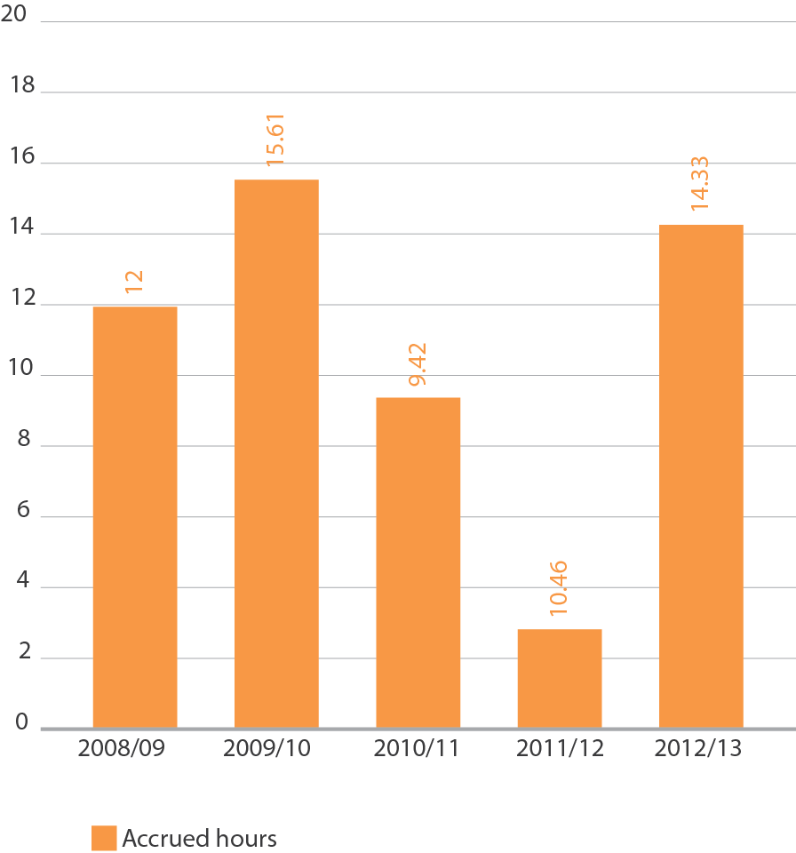

Review of action - raising issues
Issue resolution processes relate to the maintenance of healthy and productive working relationships. The VEC is committed to ensuring that principles of merit and equity are applied throughout the VEC, and work-related complaints are resolved quickly, confidentially and without prejudice.
Code of Conduct
Employees of the VEC are bound by the guidelines outlined in the Code of Conduct for Victorian Public Sector Employees of Special Bodies. The code provides guidance to staff and is a measure by which the VEC expects employees to carry out their duties as a VEC employee. Staff are provided with a copy of the Code and these values are included in the performance review documents and addressed as part of the review process.
Women’s affairs
The VEC supports staff attendance at International Women’s Day events. In 2012–13, the VEC sponsored a number of staff to attend the Institute of Public Administration Australia International Women’s Day event.
Staff well-being services
The VEC supports staff to maintain well-being using preventative and responsive measures. The VEC also makes it a priority to support individual staff experiencing ongoing personal or health issues in a formal and informal manner as appropriate.
A range of services was offered during 2012-13 including staff health checks, skin checks and individual ergonomic assessments. In addition, all VEC staff have access to a counselling service through the Department of Justice Employee Assistance Program (EAP).

AUDITED FINANCIAL STATEMENTS
Inside this section
Comprehensive operating statement | xx
Balance sheet | xx
Statement of changes in equity | xx
Cash flow statement | xx
Notes to the financial statements | xx
Electoral Commissioner and accountable officer’s declaration | xx
Auditor-General’s Report | xx

Comprehensive operating statement

COMPREHENSIVE OPERATING STATEMENT FOR THE FINANCIAL YEAR ENDED 30 JUNE

 | Notes | 2013  $’000 | 2012  $’000  Restated*
Continuing operations
Income from transactions
Special appropriations | 4,22 | 40,245 | 21,685
Total income from transactions |  | 40,245 | 21,685
Expenses from transactions
Employee expenses | 5(a) | 16,719 | 8,429
Supplies and services | 5(d) | 20,464 | 10,888
Depreciation and amortisation | 5(b) | 1,370 | 1,345
Interest expense | 5(c) | 5 | 5
Capital asset charge |  | 129 | 129
Operating lease rental expense |  | 2,976 | 1,723
Total expenses from transactions |  | 41,663 | 22,519
Net result from transactions (net operating balance) |  | (1,418) | (834)
Other economic flows included in net result
Other gains / (losses) from other economic flows | 6 | 7 | (62)
Total other economic flows included in net result |  | 7 | (62)
Net result | 21(b) | (1,411) | (896)
Comprehensive result |  | (1,411) | (896)

The comprehensive operating statement should be read in conjunction with the notes to the financial statements.
* Refer to Note 29 for details regarding the restatement

Balance sheet

As at 30 June 2013

 | Notes | 2013  $’000 | 2012  $’000  Restated*
Assets
Financial assets
Cash and deposits | 21 | 3 | 2
Receivables | 7 | 741 | 483
Total financial assets |  | 744 | 485
Non-financial assets
Inventories | 8 | 1,423 | 848
Property, plant and equipment | 9 | 3,613 | 3,330
Intangible assets | 10 | 4,234 | 3,667
Other non financial assets | 11 | 457 | 687
Total non-financial assets |  | 9,727 | 8,532
Total assets |  | 10,471 | 9,017
Liabilities
Payables | 12 | 380 | 279
Borrowings | 13, 17 | 79 | 84
Provisions | 14 | 1,674 | 1,626
Other liabilities | 15 | 887 | 405
Total liabilities |  | 3,020 | 2,394
Net assets |  | 7,451 | 6,623
Equity
Accumulated (deficit) / surplus |  | (20,695) | (19,284)
Contributed capital |  | 28,146 | 25,907
Net worth |  | 7,451 | 6,623
Commitments for expenditure | 17, 18
Contingent assets and contingent liabilities | 19

Statement of changes in equity

For the financial year ended 30 June 2013

 | Notes | Accumulated Surplus  $’000  Restated* | Contributions by Owners  $’000 | Total  $’000  Restated*
Balance at 1 July 2011 |  | (18,388) | 24,194 | 5,806
Net result for the year |  | (896) | - | (896)
Other comprehensive income for the year |  | - | - | -
Transfer to accumulated surplus |  | - | - | -
Capital appropriations |  | - | 1,713 | 1,713
Balance at 30 June 2012 |  | (19,284) | 25,907 | 6,623
Net result for the year | 21(b) | (1,411) | - | (1,411)
Other comprehensive income for the year |  | - | - | -
Capital appropriations | 22 | - | 2,239 | 2,239
Balance at 30 June 2013 |  | (20,695) | 28,146 | 7,451

The statement of changes in equity should be read in conjunction with the notes to the financial statements.
* Refer to Note 29 for details regarding the restatement

cash flow statement

For the financial year ended 30 June 2013
 | Notes | 2013  $’000  Restated* | 2012  $’000
Cash flows from operating activities
Receipts
Receipts from Government |  | 40,789 | 23,016
Total receipts |  | 40,789 | 23,016
Payments
Payments to suppliers and employees |  | (40,107) | (21,553)
Goods and Services Tax paid to the ATO | (i) | (544) | (1,331)
Capital asset charge payments |  | (129) | (129)
Interest and other costs of finance paid |  | (5) | (5)
Total payments |  | (40,785) | (23,018)
Net cash flows from / (used in) operating activities | 21(b) | 4 | (2)
Cash flows from investing activities
Purchases of non-financial assets | 22 | (2,239) | (1,713)
Sales of non-financial assets |  | - | -
Net cash flows (used in) / from investing activities |  | (2,239) | (1,713)
Cash flows from financing activities
Owner contributions by State Government |  | 2,239 | 1,713
Net cash flows from / (used in) financing activities |  | 2,239 | 1,713
Net increase / (decrease) in cash and cash equivalents |  | 4 | (2)
Cash and cash equivalents at the beginning of the financial year |  | (1) | 1
Cash and cash equivalents at the end of the financial year | 21(a) | 3 | (1)

The above cash flow statement should be read in conjunction with the notes to the financial statements.
Notes: (i) Goods and Services Tax paid to the ATO is presented on a net basis

Notes to the financial statements

For the financial year ended 30 June 2013
Page
Note 1 | Summary of significant accounting policies | 70
Note 2 | Departmental (controlled) outputs | 81
Note 3 | Administered (non-controlled) items | 81
Note 4 | Income from transactions | 82
Note 5 | Expenses from transactions | 82
Note 6 | Other economic flows included in net result | 83
Note 7 | Receivables | 83
Note 8 | Inventories | 84
Note 9 | Property, plant and equipment | 84
Note 10 | Intangible assets | 86
Note 11 | Other non-financial assets | 86
Note 12 | Payables | 87
Note 13 | Borrowings | 87
Note 14 | Provisions | 88
Note 15 | Other liabilities | 89
Note 16 | Superannuation | 90
Note 17 | Leases | 91
Note 18 | Commitments for expenditure | 92
Note 19 | Contingent assets and contingent liabilities | 92
Note 20 | Financial instruments | 93
Note 21 | Cash flow information | 98
Note 22 | Summary of compliance with annual special appropriations | 99
Note 23 | Ex-gratia payments | 99
Note 24 | Trust account balances | 99
Note 25 | Responsible persons | 100
Note 26 | Remuneration of executives and payments to other personnel (i.e. contractors with significant management responsibilities) | 100
Note 27 | Remuneration of auditors | 100
Note 28 | Subsequent events | 100
Note 29 | Correction of prior period error | 101
Note 30 | Glossary of terms and style conventions | 102

- Summary of significant accounting policies
The annual financial statements represent the audited general purpose financial statements for the Victorian Electoral Commission for the period ending 30 June 2013.
The purpose of the report is to provide users with information about the Commission’s stewardship of resources entrusted to it.
- Statement of compliance
These general purpose financial statements have been prepared in accordance with the Financial Management Act 1994 and applicable Australian Accounting Standards (AAS) which include Interpretations, issued by the Australian Accounting Standards Board (AASB). In particular, they are presented in a manner consistent with the requirements of the AASB 1049 Whole of Government and General Government Sector Financial reporting.
Where appropriate, those AAS paragraphs applicable to not-for-profit entities have been applied.
Accounting policies are selected in a manner which ensures that the resulting financial information satisfies the concepts of relevance and reliability, thereby ensuring that the substance of the underlying transactions or other events is reported.
To gain a better understanding of the terminology used in this report, a glossary of terms and style conventions can be found in Note 30.
The annual financial statements were authorised for issue by the Electoral Commissioner of the Victorian Electoral Commission on 15 August 2013.
- Basis of accounting preparation and measurement
The accrual basis of accounting has been applied in the preparation of these financial statements whereby assets, liabilities, equity, income and expenses are recognised in the reporting period to which they relate, regardless of when cash is received or paid.
Judgements, estimates and assumptions are required to be made about the carrying values of assets and liabilities that are not readily apparent from other sources. The estimates and associated assumptions are based on professional judgements derived from historical experience and various other factors that are believed to be reasonable under the circumstances. Actual results may differ from these estimates.
Revisions to accounting estimates are recognised in the period in which the estimate is revised and also in future periods that are affected by the revision. Judgements and assumptions made by management in the application of AASs that have significant effects on the financial statements and estimates, are disclosed throughout the notes to the financial statements.
These financial statements are presented in Australian dollars, and prepared in accordance with the historical cost convention.
- Reporting entity
The financial statements cover the Victorian Electoral Commission as an individual reporting entity. The Commission is an independent body of the State of Victoria, established pursuant to an order made by the Premier under the Electoral Act 2002.
Its principal address is:
Victorian Electoral Commission
Level 11, 530 Collins Street
Melbourne VIC 3000
The Commission is an administrative agency acting on behalf of the Crown.
The financial statements include all the controlled activities of the Victorian Electoral Commission.
A description of the nature of the Commission’s operations and its principal activities is included in the report of operations which does not form part of these financial statements.

Objectives and funding
The Commission’s overall objective is to provide election services to State and Local Government, as well as conducting various fee for service elections.
The Commission is funded by accrual-based parliamentary appropriations for the provision of outputs. It provides on a fee for service basis election services for Local Government and Commercial elections. The fees charges for these services are determined by prevailing market forces.

Outputs of the Commission
Information about the Commission’s output activities, and the expenses, income, assets and liabilities which are reliably attributable to those output activities, is set out in the output activities schedule (Note 2). Information about expenses, income, assets and liabilities administered by the Commission are given in the schedule of administered expenses and income and the schedule of administered assets and liabilities (see Note 3).
- Basis of consolidation
There were no bodies consolidated into the Commission’s reporting entity during the reporting period.

Administered items
Certain resources are administered by the Commission on behalf of the State. While the Commission is accountable for the transactions involving administered items, it does not have the discretion to deploy the resources for its own benefit or the achievement of its objectives. Accordingly, transactions and balances related to administered items are not recognised as Commission income, expenses, assets or liabilities within the body of the financial statements.
Administered income includes taxes, fees and fines. Administered assets include government income earned but yet to be collected. Administered liabilities include government expenses incurred but yet to be paid.
Except as otherwise disclosed, administered resources are accounted for on an accrual basis using the same accounting policies adopted for recognition of the Commission items in the financial statements. Both controlled and administered items of the Commission are consolidated into the financial statements of the State.
Disclosures related to administered items can be found in Note 3.
Funds held in trust

Other trust activities on behalf of parties external to the Victorian Government
The Commission has responsibility for transactions and balances relating to trust funds on behalf of third parties external to the Victorian Government. Income, expenses, assets and liabilities managed on behalf of third parties are not recognised in these financial statements as they are managed on a fiduciary and custodial basis, and therefore are not controlled by the Commission or the Victorian Government. Funds under management are reported in the Note 3.
- Scope and presentation of financial statements

Comprehensive operating statement
Income and expenses in the comprehensive operating statement are classified according to whether or not they arise from ‘transactions’ or ‘other economic flows’. This classification is consistent with the whole of government reporting format and is allowed under AASB 101 Presentation of Financial Statements.
Transactions’ and ‘other economic flows’ are defined by the Australian System of Government Finance Statistics: Concepts, Sources and Methods 2005 and Amendments to Australian System of Government Finance Statistics, 2005 (ABS Catalogue No 5514.0) (the GFS Manual, refer to Note 30).
Transactions’ are those economic flows that are considered to arise as a result of policy decisions, usually interactions between two entities by mutual agreement. Transactions also include flows within an entity, such as depreciation where the owner is simultaneously acting as the owner of the depreciating asset and as the consumer of the service provided by the asset. Taxation is regarded as mutually agreed interactions between the Government and taxpayers. Transactions can be in kind (e.g. assets provided/given free of charge or for nominal consideration) or where the final consideration is cash.
Other economic flows are changes arising from market remeasurements. They include
- gains and losses from disposals,
- revaluations and impairments of non-financial physical and intangible assets,
- actuarial gains and losses arising from defined benefit superannuation plans,
- fair value changes of financial instruments and agricultural assets; and
- depletion of natural assets (non-produced) from their use or removal.
The net result is equivalent to profit or loss derived in accordance with AASs.

Balance sheet
Assets and liabilities are presented in liquidity order with assets aggregated into financial assets and non-financial assets.
Current and non-current assets and liabilities (non-current being those assets or liabilities expected to be recovered or settled more than 12 months after the reporting period) are disclosed in the notes, where relevant.

Cash flow statement
Cash flows are classified according to whether or not they arise from operating, investing, or financing activities.
This classification is consistent with requirements under AASB 107 Statement of Cash Flows.

Statement of changes in equity
The statement of changes in equity presents reconciliation of non-owner and owner changes in equity from opening balance at the beginning of the reporting period to the closing balance at the end of the reporting period. It also shows separately changes due to amounts recognised in the Comprehensive result’ and amounts recognised in ‘Other economic flows - other movements in equity’ related to ‘Transactions with owner in its capacity as owner’.

Rounding
Amounts in the financial statements have been rounded to the nearest thousand dollars, unless otherwise stated. Figures in the financial statements may not equate due to rounding. Please refer to the end of Note 30 for a style convention explaining that minor discrepancies in totals of tables are due to rounding.
- Income from transactions
Income is recognised to the extent that it is probable that the economic benefits will flow to the entity and the income can be reliably measured at fair value.

Special appropriations
Appropriation income becomes controlled and is recognised by the Commission when it is appropriated from the Consolidated Fund by the Victorian Parliament via the Department of Justice, and applied to the purposes defined under the Electoral Act 2002.
All amounts of income over which the Commission does not have control are disclosed as administered income in the schedule of administered income and expenses (see Note 3).
- Expenses from transactions
Expenses are recognised as they are incurred and reported in the financial year to which they relate.

Employee expenses
Refer to the section in Note 1 (M) regarding employee benefits.
These expenses include all costs related to employment (other than superannuation which is accounted for separately) including wages and salaries, fringe benefits tax, leave entitlements, redundancy payments and WorkCover premiums.
Superannuation
The amount recognised in the comprehensive operating statement in relation to employer contributions for members of both defined benefit and defined contribution superannuation plans that are paid or payable during the reporting period.
The Department of Treasury and Finance (DTF) in their Annual Financial Statements, disclose on behalf of the State as the sponsoring employer, the net defined benefit cost related to the members of these plans as an administered liability. Refer to DTF’s Annual Financial Statements for more detailed disclosures in relation to these plans.

Depreciation and amortisation
All property, plant and equipment and other non-financial physical assets (excluding items under operating leases) that have finite useful lives are depreciated. Depreciation is generally calculated on a straight-line basis, at rates that allocate the asset’s value, less any estimated residual value, over its estimated useful life. Refer to Note 1 (L) for the depreciation and amortisation policy for leasehold improvements.
The estimated useful lives, residual values and depreciation method are reviewed at the end of each annual reporting period, and adjustments made where appropriate.
The following are typical estimated useful lives for the different asset classes for current and prior years.
Asset class | Useful life
Leasehold Improvements | 10 - 12 years
Leased motor vehicles | 3 years
Plant & equipment | 2 - 10 years
Furniture & fittings | 5 - 14 years
Computer equipment | 2 - 3 years
Intangible produced assets - software development | 3 election periods (12 years)

Intangible produced assets with finite useful lives are amortised as an expense from transactions on a systematic (typically straight-line) basis over the asset’s useful life. Depreciation begins when the asset is available for use, that is, when it is in the location and condition necessary for it to be capable of operating in the manner intended by management.
Intangible assets with indefinite useful lives are not depreciated or amortised, but are tested annually for impairment.

Interest expense
Interest expense is recognised in the period in which it is incurred.
Refer to Glossary of terms and style conventions in Note 30 for an explanation of interest expense items.

Capital asset charge
The capital asset charge is calculated on the budgeted carrying amount of applicable non-financial physical assets.

Other operating expenses
Other operating expenses generally represent the day to day running costs incurred in normal operations.
Supplies and services
Supplies and services costs are recognised as an expense in the reporting period in which they are incurred. The carrying amounts of any inventories held for distribution are expensed when distributed.
Bad and doubtful debts
Refer to Note 1 (K) Impairment of financial assets.
- Other economic flows included in the net result
Other economic flows measure the change in volume or value of assets or liabilities that do not result from transactions.

Net gain/(loss) on non-financial assets
Net gain/(loss) on non-financial assets and liabilities includes realised and unrealised gains and losses as follows:

Disposal of non-financial assets
Any gain or loss on the disposal of non-financial assets is recognised at the date of disposal and is determined after deducting from the proceeds the carrying value of the asset at that time.
Impairment of non-financial assets
Intangible assets with indefinite useful lives (and intangible assets not yet available for use) are tested annually for impairment (as described below) and whenever there is an indication that the asset may be impaired.
All other assets are assessed annually for indications of impairment, except for inventories (refer Note 1(L)).
If there is an indication of impairment, the assets concerned are tested as to whether their carrying value exceeds their recoverable amount. Where an asset’s carrying value exceeds its recoverable amount, the difference is written off as another economic flow, except to the extent that the write-down can be debited to an asset revaluation surplus amount applicable to that class of asset.
If there is an indication that there has been a change in the estimate of an asset’s recoverable amount since the last impairment loss was recognised, the carrying amount shall be increased to its recoverable amount. This reversal of the impairment loss occurs only to the extent that the asset’s carrying amount does not exceed the carrying amount that would have been determined, net of depreciation or amortisation, if no impairment loss had been recognised in prior years.
It is deemed that, in the event of the loss or destruction of an asset, the future economic benefits arising from the use of the asset will be replaced unless a specific decision to the contrary has been made. The recoverable amount for most assets is measured at the higher of depreciated replacement cost and fair value less costs to sell. Recoverable amount for assets held primarily to generate net cash inflows is measured at the higher of the present value of future cash flows expected to be obtained from the asset and fair value less costs to sell.
Refer to Note 1 (L) in relation to the recognition and measurement of non-financial assets.
- Administered income

Taxes, fines and regulatory fees
The Commission does not gain control over assets arising from taxes, fines and regulatory fees, consequently no income is recognised in the Commission’s financial statements.
The Commission collects these amounts on behalf of the State. Accordingly, the amounts are disclosed as income in the schedule of Administered Items (see Note 3).
- Financial instruments
Financial instruments arise out of contractual agreements that give rise to a financial asset of one entity and a financial liability or equity instrument of another entity. Due to the nature of the Commission’s activities, certain financial assets and financial liabilities arise under statute rather than a contract. Such financial assets and financial liabilities do not meet the definition of financial instruments in AASB 132 Financial Instruments: Presentation. For example, statutory receivables arising from taxes, fines and penalties do not meet the definition of financial instruments as they do not arise under contract. However, guarantees issued by the Treasurer on behalf of the Commission are financial instruments because, although authorised under statute, the terms and conditions for each financial guarantee may vary and are subject to an agreement.
Where relevant, for note disclosure purposes, a distinction is made between those financial assets and financial liabilities that meet the definition of financial instruments in accordance with AASB 132 and those that do not.
The following refers to financial instruments unless otherwise stated.

Categories of non-derivative financial instruments
Loans and Receivables
Loans and receivables are financial instrument assets with fixed and determinable payments that are not quoted on an active market. These assets are initially recognised at fair value plus any directly attributable transaction costs. Subsequent to initial measurement, receivables are measured at amortised cost using the effective interest method, less any impairment. Receivables category includes trade receivables and other receivables, but not statutory receivables.

Available-for-sale financial assets
Available-for-sale financial instrument assets are those designated as available-for-sale or not classified in any other category of financial instrument asset.
Such assets are initially recognised at fair value. Subsequent to initial recognition, they are measured at fair value with gains and losses arising from changes in fair value, recognised in “Other economic flows - other comprehensive income” until the investments are disposed.
Fair value is determined in the manner described inNote 20(c) Financial Instruments.
Financial assets and liabilities at fair value through profit and loss
Financial assets are categorised as fair value through profit or loss at trade date if they are classified as held for trading or designated as such upon initial recognition. Financial instrument assets are designated at fair value through profit or loss on the basis that the financial assets form part of a group of financial assets that are managed by the entity concerned based on their fair values, and have their performance evaluated in accordance with documented risk management and investment strategies.
Financial instruments at fair value through profit or loss are initially measured at fair value and attributable transaction costs are expensed as incurred. Subsequently, any changes in fair value are recognised in the net result as other economic flows.
Financial liabilities at amortised cost
Financial instrument liabilities are initially recognised on the date they are originated. They are initially measured at fair value plus any directly attributable transaction costs. Subsequent to initial recognition, these financial instruments are measured at amortised cost with any difference between the initial recognised amount and the redemption value being recognised in profit and loss over the period of the interest-bearing liability, using the effective interest rate method (refer to Note 20).
Financial instrument liabilities measured at amortised cost include all of the Commissions contract payables, deposits held and advances received, and interest-bearing arrangements other than those designated at fair value through profit or loss.
- Financial assets

Cash and deposits
Cash and deposits, including cash equivalents, comprise cash on hand and cash at bank.

Receivables
Receivables consist of:
- contractual receivables, which include mainly debtors in relation to goods and services.
- statutory receivables, which include predominantly amounts owing from the Victorian
Government and GST input tax credits recoverable.
Contractual receivables are classified as financial instruments and categorised as receivables (refer to Note 20.1 for recognition and measurement). Statutory receivables, are recognised and measured similarly to contractual receivables (except for impairment), but are not classified as financial instruments because they do not arise from a contract.
Receivables are subject to impairment testing as described below. A provision for doubtful receivables is recognised when there is objective evidence that the debts may not be collected, and bad debts are written off when identified.
For the measurement principle of receivables, refer to Note 1 (J)

Impairment of financial assets
At the end of each reporting period, the Commission assesses whether there is objective evidence that a financial asset or group of financial assets is impaired. All financial instrument assets, except those measured at fair value through profit or loss, are subject to annual review for impairment.
Receivables are assessed for bad and doubtful debts on a regular basis. Those bad debts considered as written off by mutual consent are classified as a transaction expense. Bad debts not written off by mutual consent and the allowance for doubtful receivables are classified as other economic flows in the net result.
The amount of the allowance is the difference between the financial asset’s carrying amount and the present value of estimated future cash flows, discounted at the effective interest rate.
In assessing impairment of statutory (non-contractual) financial assets, which are not financial instruments, professional judgement is applied in assessing materiality using estimates, averages and other computational methods in accordance with AASB 136 Impairment of assets.
- Non-Financial assets

Inventories
Inventories include goods and other property for distribution at zero or nominal cost, or for consumption in the ordinary course of business operations.
Inventories held for distribution are measured at cost, adjusted for any loss of service potential.
Bases used in assessing loss of service potential for inventories held for distribution include current replacement cost and technical or functional obsolescence. Technical obsolescence occurs when an item still functions for some or all of the tasks it was originally acquired to do, but no longer matches existing technologies. Functional obsolescence occurs when an item no longer functions the way it did when it was first acquired.

Property, plant and equipment
All non-financial physical assets are measured initially at cost and subsequently revalued at fair value less accumulated depreciation and impairment.
The initial cost for non-financial physical assets under a finance lease (refer to Note 1 (N)) is measured at amounts equal to the fair value of the leased asset or, if lower, the present value of the minimum lease payments, each determined at the inception of the lease.
The fair value of plant, equipment and vehicles, is normally determined by reference to the asset’s depreciated replacement cost. For plant, equipment and vehicles, existing depreciated historical cost is generally a reasonable proxy for depreciated replacement cost because of the short lives of the asset concerned.
For the accounting policy on impairment of non-financial physical assets, refer to impairment of non-financial assets under Note 1(H) Impairment of non-financial assets.

Leasehold improvements
The cost of leasehold improvements is capitalised as an asset and amortised over the shorter of the remaining term of the lease or the estimated useful life of the improvements.

Revaluations of non-current physical assets
Non-financial physical assets are measured at fair value on a cyclical basis, in accordance with Financial Reporting Directions (FRDs) issued by the Minister for Finance.
The Commission controls plant and equipment, furniture and fittings, motor vehicles, and leasehold improvements which are measured at fair value, and are not subject to revaluation.

Intangible assets
Purchased intangible assets are initially recognised at cost. Subsequently, intangible assets with finite useful lives are carried at cost less accumulated depreciation / amortisation and accumulated impairment losses. Costs incurred subsequent to initial acquisition are capitalised when it is expected that additional future economic benefits will flow to the Commission.
When the recognition criteria in AASB 138 Intangible Assets are met, internally generated intangible assets are recognised and measured at cost less accumulated depreciation / amortisation and impairment.
Refer to Note 1(G) Depreciation and amortisation of non-produced intangible assets and Note 1 (H) Impairment of non-financial assets.
An internally-generated intangible asset arising from development (or from the development phase of an internal project) is recognised if, and only if, all of the following are demonstrated:
- the technical feasibility of completing the intangible asset so that it will be available for use or sale;
- an intention to complete the intangible asset and use or sell it;
- the ability to use or sell the intangible asset;
- the intangible asset will generate probable future economic benefits;
- the availability of adequate technical, financial and other resources to complete the development and to use or sell the intangible asset; and
- the ability to measure reliably the expenditure attributable to the intangible asset during its development.
Costs associated with the development of computer software relating to the Election Management and Roll Management system totalling $0.5 million or more are capitalised and amortised on a straight line basis over a twelve year (three State election periods) being the period in which the related benefits are expected to be realised. Costs associated with the acquisition or development of computer software which are less than $0.5 million are charged as expenses in the period as incurred.

Other non-financial assets
Prepayments
Other non-financial assets include prepayments which represent payments in advance of receipt of goods or services or that part of expenditure made in one accounting period covering a term extending beyond that period.
- Liabilities

Payables
Payables consist of:
- contractual payables, such as accounts payable. Accounts payable represent liabilities for goods and services provided to the Commission prior to the end of the financial year that are unpaid, and arise when the Commission becomes obliged to make future payments in respect of the purchase of those goods and services; and
- statutory payables such as goods and services tax and fringe benefits tax payable.
Contractual payables are classified as financial instruments and categorised as financial liabilities at amortised cost (refer to Note 1 (J). Statutory payables are recognised and measured similarly to contractual payables, but are not classified as financial instruments and not included in the category of financial liabilities at amortised cost, because they do not arise from a contract.

Borrowings
All interest bearing liabilities are initially recognised at fair value of the consideration received, less directly attributable transaction costs ( refer also to Note 1(N) Leases). The measurement basis subsequent to initial recognition depends on whether the Commission has categorised its interest-bearing liabilities as either financial liabilities designated at fair value through profit or loss, or financial liabilities at amortised cost. Any difference between the initial recognised amount and the redemption value is recognised in net result over the period of the borrowing using the effective interest method.

Provisions
Provisions are recognised when the Commission has a present obligation, the future sacrifice of economic benefits is probable, and the amount of the provision can be measured reliably.
The amount recognised as a provision is the best estimate of the consideration required to settle the present obligation at reporting date, taking into account the risks and uncertainties surrounding the obligation. Where a provision is measured using the cash flows estimated to settle the present obligation, its carrying amount is the present value of those cash flows, using discount rate that reflects the time value of money and risks specific to the provision.

Employee benefits
Provision is made for benefits accruing to employees in respect of wages and salaries, annual leave and long service leave for services rendered to the reporting date.
- Wages and salaries, annual leave
Liabilities for wages and salaries, including non-monetary benefits annual leave are recognised in the provision for employee benefits, classified as current liabilities. Those liabilities which are expected to be settled within 12 months of the reporting period, are measured at their nominal values.
Those liabilities that are not expected to be settled within 12 months are also recognised in the provision for employee benefits as current liabilities, but are measured at present value of the amounts expected to be paid when the liabilities are settled using the remuneration rate expected to apply at the time of settlement.
- Long service leave
Liability for long service leave (LSL) is recognised in the provision for employee benefits.
Unconditional LSL is disclosed in the notes to the financial statements as a current liability, even where the Commission does not expect to settle the liability within 12 months because it will not have the unconditional right to defer the settlement of the entitlement should an employee take leave within 12 months:
The components of this current LSL are measured at:
- nominal value - component that the Commission expects to settle within 12 months: and
- present value - component that the Commission does not expect to settle within 12 months.
Conditional LSL is disclosed as a non - current liability. There is an unconditional right to defer the settlement of the entitlement until the employee has completed the requisite years of service. This non-current LSL liability is measured at present value.
Any gain or loss following revaluation of the present value of non-current LSL liability is recognised as a transaction, except to the extent that a gain or loss arises due to changes in bond interest rates for which it is then recognised as an other economic flow (refer to Note 1 (H)).
- Termination benefits
Termination benefits are payable when employment is terminated before the normal retirement date, or when an employee accepts voluntary redundancy in exchange for these benefits. The Commission recognises termination benefits when it is demonstrably committed to either terminating the employment of current employees according to a detailed formal plan without possibility of withdrawal or providing termination benefits as a result of an offer made to encourage voluntary redundancy. Benefits falling due more than 12 months after the end of the reporting period are discounted to present value.

Employee benefits on-costs
Employee benefits on-costs such as payroll tax, workers compensation and superannuation are recognised separately from the provision for employee benefits.
- Leases
A lease is a right to use an asset for an agreed period of time in exchange for payment.
Leases are classified at their inception as either operating or finance leases based on the economic substance of the agreement so as to reflect the risks and rewards incidental to ownership. Leases of property, plant and equipment are classified as finance infrastructure leases whenever the terms of the lease transfer substantially all the risks and rewards of ownership from the lessor to the lessee.
All other leases are classified as operating leases.

Finance leases
Commission as lessee
At the commencement of the lease term, finance leases are initially recognised as assets and liabilities at amounts equal to the fair value of the lease property or, if lower, the present value of the minimum lease payment, each determined at the inception of the lease. The lease asset is depreciated over the shorter of the estimated useful life of the asset or the term of the lease.
Minimum finance lease payments are apportioned between reduction of the outstanding lease liability, and periodic finance expense which is calculated using the interest rate implicit in the lease and charged directly to the comprehensive operating statement. Contingent rentals associated with finance leases are recognised as an expense in the period in which they are incurred.

Operating leases
Commission as lessee
Operating lease payments, including any contingent rentals, are recognised as an expense in the comprehensive operating statement on a straight-line basis over the lease term, except where another systematic basis is more representative of the time pattern of the benefits derived from the use of the leased asset. The leased asset is not recognised in the balance sheet.
All incentives for the agreement of a new or renewed operating lease are recognised as an integral part of the net consideration agreed for the use of the leased asset, irrespective of the incentive’s nature or form or the timing of payments.
In the event that lease incentives are received to enter into operating leases, the aggregate cost of incentives are recognised as a reduction of rental expense over the lease term on a straight-line basis, unless another systematic basis is more representative of the time pattern in which economic benefits from the leased asset are consumed.
- Equity
Contributions by owners
Additions to net assets which have been designated as contributions by owners are recognised as contributed capital. Other transfers that are in the nature of contributions or distributions have also been designated as contributions by owners.
- Commitments
Commitments for future expenditure include operating and capital commitments arising from contracts. These commitments are disclosed by way of a note (refer to Note 18) at their nominal value and inclusive of the goods and services tax (GST) payable. In addition, where it is considered appropriate and provides additional relevant information to users, the net present values of significant individual projects are stated. These future expenditures cease to be disclosed as commitments once the related liabilities are recognised in the balance sheet.
- Contingent assets and contingent liabilities
Contingent assets and contingent liabilities are not recognised in the balance sheet, but are disclosed by way of a note (refer to Note 19) and, if quantifiable, are measured at nominal value. Contingent assets and liabilities are presented inclusive of GST receivable or payable respectively.
- Accounting for the Goods and Services Tax (GST)
Income, expenses and assets are recognised net of the amount of associated GST, except where GST incurred is not recoverable from the taxation authority. In this case, the GST payable is recognised as part of the cost of acquisition of the asset or as part of the expense.
Receivables and payables are stated inclusive of the amount of GST receivable or payable. The net amount of GST recoverable from, or payable to, the taxation authority is included with other receivables or payables in the balance sheet.
Cash flows are presented on a gross basis. The GST components of cash flows arising from investing or financing activities which are recoverable from, or payable to the taxation authority, are presented as operating cash flows.
Commitments and contingent assets and liabilities are also stated inclusive of GST.
- Events after reporting date
Assets, liabilities, income or expenses arise from past transactions or other past events. Where the transactions result from an agreement between the Commission and other parties, the transactions are only recognised when the agreement is irrevocable at or before the end of the reporting period. Adjustments are made to amounts recognised in the financial statements for events which occur after the reporting period and before the date the financial statements are authorised for issue, where those events provide information about conditions which existed in the reporting period. Note disclosure is made about events between the end of the reporting period and the date the financial statements are authorised for issue where the events relate to condition which arose after the end of the reporting period and which may have a material impact on the results of subsequent years.
- AASs issued that are not yet effective
Certain new AASs have been published that are not mandatory for the 30 June 2013 reporting period. DTF assesses the impact of these new standards and advises the Commission of their applicability and early adoption where applicable.
As at 30 June 2013, the following AASs have been issued by the AASB but not yet effective. They become effective for the first financial statements for reporting periods commencing after the stated operative dates as follows:
Standard / Interpretation | Summary | Applicable for annual reporting periods beginning on | Impact on VEC financial statements
AASB 9 Financial instruments | This standard simplifies requirements for the classification and measurement of financial assets resulting from Phase 1 of the IASB’s project to replace IAS 39 Financial Instruments: Recognition and Measurement (AASB 139 Financial Instruments: Recognition and Measurement). | 1 Jan 2015 | Subject to AASB’s further modifications to AASB 9, together with the anticipated changes resulting from the staged projects on impairments and hedge accounting, details of impacts will be assessed.
AASB 13 Fair Value Measurement | This Standard outlines the requirements for measuring the fair value of assets and liabilities and replaces the existing fair value definition and guidance in other Australian accounting standards. AASB 13 includes a ‘fair value hierarchy’ which ranks the valuation technique inputs into three levels using unadjusted quoted prices in active markets for identical assets or liabilities; other observable inputs; and unobservable inputs. | 1 Jan 2013 | Disclosure for fair value measurements using unobservable inputs are relatively detailed compared to disclosure for fair value measurements using observable inputs. Consequently, the Standard may increase the disclosures required assets measured using depreciated replacement cost.
AASB 119 Employee Benefits | In this revised Standard for defined benefit superannuation plans, there is a change to the methodology in the calculation of superannuation expenses, in particular there is now a change in the split between superannuation interest expense (classified as transactions) and actuarial gains and losses (classified as ‘Other economic flows – other movements in equity’) reported on the comprehensive operating statement. | 1 Jan 2013 | Not-for-profit entities are not permitted to apply this Standard prior to the mandatory application date. While the total superannuation expense is unchanged, the revised methodology is expected to have a negative impact on the net result from transactions a few Victorian public sector entities that report superannuation defined benefit plans.
AASB 1053 Application of Tiers of Australian Accounting Standards | This Standard establishes a differential financial reporting framework consisting of two tiers of reporting requirements for preparing general purpose financial statements. | 1 Jul 2013 | The Victorian Government is currently considering the impacts of Reduced Disclosure Requirements (RDRs) for certain public sector entities, and has not decided if RDRs will be implemented in the Victorian public sector.

- Departmental (controlled) outputs
A description of Departmental outputs performed during the year ended 30 June 2013, and the objectives of these outputs, are summarised below.
Election Services

Description of output
Maintaining the electoral enrolment register, conducting State elections, local government elections, statutory elections, commercial and community elections, and boundary reviews. Provision of electoral research and communication and education services.

Objectives
Inform Victorians and engage them in actively participating in the democratic process.
Refer to “Comprehensive operating statement” and “Balance sheet” for the controlled income and expenses for the year ended 30 June 2013.
- Administered (non-controlled) items
In addition to the specific Commission operations which are included in the financial statements (comprehensive operating statement, balance sheet, statement of changes in equity and cash flow statement), the Commission administers or manages other activities and resources on behalf of the State and Local Government.
The transactions relating to these activities are reported as administered items (refer to Note 1 (D) and (I)).

 | State |  | Local Government
 | 2013  $’000 | 2012  $’000 | 2013  $’000 | 2012  $’000
Administered income from transactions
Sales of goods and services | 20,093 | 1,332 | - | -
Fines | 628 | 2,519 | 8,551 | 101
Candidates deposits | 3 | 9 | 504 | 4
Electoral entitlements | 78 | 41 | - | -
Total administered income from transactions | 20,802 | 3,901 | 9,055 | 105
Administered expenses from transactions
Payments into the Consolidated Fund | 20,947 | 4,175 | - | -
Payments to Local Government | - | - | 6,617 | 136
Payments made on behalf of the State | 83 | 44 | - | -
Payments made on behalf of Local Government | - | - | 373 | 4
Total administered expenses from transactions | 21,030 | 4,219 | 6,990 | 140
Total administered net result from transactions (net operating balance) | (228) | (318) | 2,065 | (35)
Administered financial assets
Bank | 5 | 18 | 2,068 | 3
Receivables | 1,180 | 140 | - | -
Total administered financial assets | 1,185 | 158 | 2,068 | 3
Administered liabilities
Bank Overdraft | 1,048 | - | - | -
Candidates deposits | - | 6 | - | -
Compulsory voting fines | 5 | 12 | 2,068 | 3
Creditors and accruals | 288 | 68 | - | -
Total administered liabilities | 1,341 | 86 | 2,068 | 3
Total administered net assets | (156) | 72 | - | -

- Income from transactions
 | 2013  $’000 | 2012  $’000
- Revenue from government
Special appropriations | 40,245 | 21,685
Total revenue from government | 40,245 | 21,685

- Expenses from transactions
 | 2013  $’000 | 2012  $’000
(a) Employee expenses
Post employment benefits
Defined benefit and contribution superannuation expense | 1,172 | 647
Salaries, wages and long service leave | 15,547 | 7,782
Total employee expenses | 16,719 | 8,429
(b) Depreciation and amortisation
Plant, equipment and vehicles | 573 | 560
Intangible produced assets | 797 | 785
Total depreciation and amortisation | 1,370 | 1,345
(c) Interest expense
Interest on finance leases | 5 | 5
Total interest expense | 5 | 5
(d) Other operating expenses
Supplies and services
Purchase of supplies and consumables | 5,978 | 3,119
Purchase of services | 14,041 | 7,396
Maintenance | 363 | 249
Other | 82 | 124
Total operating expenses | 20,464 | 10,888

- Other economic flows included in net result
 | 2013  $’000 | 2012  $’000
Net gain/(loss) on non-financial assets
Net gain/(loss) on disposal of property plant and equipment | - | (31)
Total net gain/(loss) on non-financial assets | - | (31)
Other gain/(loss) from other economic flows
Net gain/(loss) arising from revaluation of long service liability (i) | 7 | (31)
Total net gain/(loss) from other economic flows | 7 | (31)
Total Other economic flows included in net result | 7 | (62)
Notes: (i) Revaluation gain/(loss) due to changes in bond rates

- Receivables
 | 2013  $’000 | 2012  $’000
Current receivables
Statutory
Amount owing from Victorian Government (i) | 288 | 68
GST input tax credit recoverable | 445 | 366
 | 733 | 434
Contractual
Other receivables | 8 | 49
Total current receivables | 741 | 483
Total receivables | 741 | 483
Notes: (i) Plant and equipment are classified primarily by the ‘purpose’ for which the assets are used, according to one of six purpose groups based upon government purpose classifications. All assets within a purpose group are further sub categorised according to the asset’s ‘nature’, with each sub category being classified as a separate class of asset for financial reporting purposes.

Notes to the financial statements

for the financial year ended 30 June 2013
- Inventories
 | 2013  $’000 | 2012  $’000
Current inventories
Supplies and consumables
At cost | 1,423 | 848
Total inventories | 1,423 | 848

- Property, plant and equipment
Table 9.1: Classification by 'Purpose Group' - carrying amounts (i)
 | Public Administration
 | 2013  $’000 | 2012  $’000
Nature-based classification
Plant, equipment and vehicles at fair value | 856 | 758
Leasehold Improvements | 2,757 | 2,572
Assets under construction at cost | - | -
Net carrying amount of PPE | 3,613 | 3,330
Notes: (i) Plant and equipment are classified primarily by the 'purpose' for which the assets are used, according to one of six purpose groups based upon government purpose classifications. All assets within a purpose group are further sub categorised according to the asset's 'nature', with each sub category being classified as a separate class of asset for financial reporting purposes.

Table 9.2: Gross carrying amounts and accumulated depreciations
 | Gross carrying amount |  | Accumulated depreciation |  | Net carrying amount
 | 2013  $’000 | 2012  $’000 | 2013  $’000 | 2012  $’000 | 2013  $’000 | 2012  $’000
Plant, equipment and vehicles at fair value | 3,245 | 3,338 | (2,389) | (2,580) | 856 | 758
Leasehold Improvements | 3,292 | 2,949 | (535) | (377) | 2,757 | 2,572
Assets under construction at cost | - | - | - | - | - | -
Net carrying amount of PPE | 6,537 | 6,287 | (2,924) | (2,957) | 3,613 | 3,330

Table 9.3: Classification by ‘Public Administration’ Purpose Group - Movements in carrying amounts
Plant, equipment and vehicles at fair value Leasehold improvements Assets under construction at cost Total
 | 2013 $’000 | 2012 $’000 | 2013 $’000 | 2012 $’000 | 2013 $’000 | 2012 $’000 | 2013 $’000 | 2012 $’000
Opening balance | 758 | 795 | 2,572 | 2,723 | - | 191 | 3,330 | 3,709
Additions | 423 | 373 | 444 | 86 | - | - | 867 | 459
Disposals | (11) | (87) | - | - | - | (191) | (11) | (278)
Depreciation | (314) | (323) | (259) | (237) | - | - | (573) | (560)
Closing balance | 856 | 758 | 2,757 | 2,572 | - | - | 3,613 | 3,330
Note: (i) Fair value assessments have been performed for all classes of assets within this purpose group and the decision was made that movements were not material (less than or equal to 10 per cent ) for a full revaluation. The next scheduled full revaluation for this purpose group will be conducted in 2014.

Table 9.4: Aggregate depreciation and amortisation recognised as an expense during the year
 | 2013  $’000 | 2012  $’000
Leasehold Improvements | 259 | 237
Plant, equipment and vehicles at fair value | 314 | 323
 | 573 | 560
Note: (i) The useful lives of assets as stated in Policy Note 1 are used in the calculation of depreciation and amortisation.

- Intangible assets
 | 2013  $’000 | 2012  $’000
Gross carrying amount
Opening balance | 14,993 | 13,684
Addition from internal development | 1,364 | 1,309
Closing balance | 16,357 | 14,993
Accumulated depreciation, amortisation and impairment
Opening balance | (11,326) | (10,541)
Amortisation expense (i) | (797) | (785)
Impairment losses charged to net result | - | -
Closing balance | (12,123) | (11,326)
Net book value at the end of the financial year | 4,234 | 3,667
Note: (i) The consumption of intangible produced assets is included in ‘depreciation and amortisation’ line item.

Significant intangible assets
The Commission has capitalised software development expenditure for the development of its election management and electoral rolls development.
The carrying amount of the capitalised software development expenditure of $4.2 million (2012: $3.6 million) includes existing developed software and software under development. The existing election management software was fully amortised in 2011 and the electoral roll software development will be fully amortised in 2015.

- Other non-financial assets
 | 2013  $’000 | 2012  $’000
Current other non-financial assets
Prepayments | 457 | 687
Total current other non-financial assets | 457 | 687

- Payables
 | 2013  $’000 | 2012  $’000
Current payables
Contractual
Supplies and services (i) | 278 | 198
Other payables | 102 | 81
Total current payables | 380 | 279
Total payables | 380 | 279
Note: (i) Secured by the assets leased. Finance leases are effectively secured as the rights to the leased assets revert to the lessor in the event of default.

(a) Maturity analysis of borrowings
Please refer to table 20.2 in Note 20 for the maturity analysis of borrowings.

(b) Nature and extent of risk arising from borrowings
Please refer to Note 20 for the nature and extent of risks arising from borrowings

(c) Defaults and breaches
During the current and prior year, there were no defaults and breaches of any of the loans.
- Borrowings
 | 2013  $’000 | 2012  $’000
Current borrowings
Lease liabilities (i) (Note 17) | 26 | 34
Bank overdraft | - | 3
Total current borrowings | 26 | 37
Non-current borrowings
Lease liabilities (i) (Note 17) | 53 | 47
Total non-current borrowings | 53 | 47
Total borrowings | 79 | 84
Note: (i) Secured by the assets leased. Finance leases are effectively secured as the rights to the leased assets revert to the lessor in the event of default.

(a) Maturity analysis of borrowings
Please refer to table 20.2 in Note 20 for the maturity analysis of borrowings.

(b) Nature and extent of risk arising from borrowings
Please refer to Note 20 for the nature and extent of risks arising from borrowings

(c) Defaults and breaches
During the current and prior year, there were no defaults and breaches of any of the loans.

- Provisions
 | 2013  $’000 | 2012  $’000
Current provisions
(i) Employee benefits (Note 14 (a)) - annual leave
(ii) Unconditional and expected to be settled within 12 months | 522 | 488
(iii) Unconditional and expected to be settled after 12 months | 58 | 54
(i) Employee benefits (Note 14 (a)) - long service leave
(ii) Unconditional and expected to be settled within 12 months | 663 | 659
(iii) Unconditional and expected to be settled after 12 months | 74 | 81
 | 1,317 | 1,282
Provisions related to employee benefit on-costs (Note 14(a) and Note 14(b))
(ii) Unconditional and expected to be settled within 12 months | 190 | 180
(iii) Unconditional and expected to be settled after 12 months | 21 | 20
 | 211 | 200
Total current provisions | 1,528 | 1,482
Non-current provisions
(i) Employee benefits (Note 14 (a) and Note 14(b)) | 126 | 125
Employee benefit on-costs (Note 14(a)) | 20 | 19
Total non-current provisions | 146 | 144
Total provisions | 1,674 | 1,626
(a) Employee benefits and related on-costs (i)
Current employee benefits
Annual leave entitlements | 580 | 542
Long service leave entitlements | 737 | 740
Non-current employee benefits
Long service leave entitlements | 126 | 125
Total employee benefits | 1,443 | 1,407
Current on-costs | 211 | 200
Non-current on-costs | 20 | 19
Total on-costs | 231 | 219
Total employee benefits and related on-costs | 1,674 | 1,626

Note: (i)
Provisions for employee benefits consist of amounts for annual leave and long service leave accrued by employees, not including on-costs.
(ii) The amounts disclosed are nominal amounts.
(iii) The amounts disclosed are discounted to present values.

 | Employee Benefits
 | 2013  $’000 | 2012  $’000
(b) Movement in provisions
Opening balance | 1,407 | 1,366
Additional provisions recognised | 585 | 728
Additions due to transfer in | 18 | -
Reductions arising from payments / other sacrifices of future economic benefits | (567) | (654)
Reductions due to transfer out | - | (33)
Closing balance | 1,443 | 1,407
Current | 1,317 | 1,282
Non-current | 126 | 125
Total employee benefits | 1,443 | 1,407

- Other liabilities
 | 2013  $’000 | 2012  $’000  Restated*
Current other liabilities
Lease incentive | 293 | 217
Total current other liabilities | 293 | 217
Non-current other liabilities
Lease incentive | 594 | 188
Total non-current other liabilities | 594 | 188
Total other liabilities | 887 | 405
* Refer to Note 29 for details regarding the restatement

- Superannuation
Employees of the Commission are entitled to receive superannuation benefits and the Commission contributes to both defined benefit and defined contribution plans. The defined benefit plan(s) provides benefits based on years of service and final average salary.
The Commission does not recognise any defined benefit liability in respect of the plan(s) because the entity has no legal or constructive obligation to pay future benefits relating to its employees; its only obligation is to pay superannuation contributions as they fall due. The Department of Treasury and Finance discloses the State’s defined benefit liabilities in its disclosure for administered items.
However, superannuation contributions paid or payable for the reporting period are included as part of employee benefits in the comprehensive operating statement of the Commission.
The name, details and amounts expensed in relation to the major employee superannuation funds and contributions made by the Commission are as follows:

 | Paid Contribution for the Year |  | Contribution Outstanding  at year End
 | 2013  $’000 | 2012  $’000 | 2013  $’000 | 2012  $’000
Defined benefit plans:
- State Superannuation Fund -  revised and new | 69 | 67 | 2 | -
Defined contribution plans:
Vicsuper | 671 | 373 | 20 | 14
Other | 432 | 207 | 11 | 9
Total | 1,172 | 647 | 33 | 23
Notes: (i) The bases for determining the level of contributions is determined by the various actuaries of the defined benefit superannuation plans

- Leases
Disclosures for lessees - finance lease

Leasing arrangements
Finance leases relate to motor vehicles leased through the Department of Justice. The Commission has options to purchase the vehicles for a nominal amount at the conclusion of the lease agreements.
 | Minimum future lease payments (i) |  | Present value of minimum future lease payments
 | 2013  $’000 | 2012  $’000 | 2013  $’000 | 2012  $’000
Other finance lease liabilities payable
Not longer than one year | 30 | 38 | 26 | 34
Longer than one year and not longer than five years | 55 | 50 | 53 | 47
Longer than five years | - | - | - | -
Minimum future lease payments | 85 | 88 | 79 | 81
Less future finance charges | 6 | 7 | - | -
Present value of minimum lease payments | 79 | 81 | 79 | 81
Included in the financial statements as:
Current borrowings lease liabilities (Note 13) |  |  | 26 | 34
Non-current borrowings lease liabilities (Note 13) |  |  | 53 | 47
 |  |  | 79 | 81
Note: (i) Minimum future lease payments include the aggregate of all lease payments and any guaranteed residual.

Disclosure for lessees-operating leases

Leasing arrangements
Operating leases relate to office and warehouse facilities with lease terms between one to twelve years. All operating lease contracts contain market review clauses in the event that the Commission exercises its option to renew. The Commission does not have an option to purchase the leased asset at the expiry of the lease period.

 | 2013  $’000 | 2012  $’000
Other non-cancellable operating lease payables
Not longer than one year | 2,026 | 1,142
Longer than one year and not longer than five years | 10,356 | 4,750
Longer than five years | 15,052 | 11,476
 | 27,434 | 17,368

Maturity analysis of finance lease liabilities and the nature and extent of risk arising from finance lease liabilities are disclosed in Note 20.

- Commitments for expenditure
The following commitments have not been recognised as liabilities in the financial statements:
(a) Commitments payable
 | 2013  $’000 | 2012  $’000
- Other expenditure commitments
Outsourcing commitments (i)
Payable:
Not longer than one year | 2,397 | 2,369
Total commitments for expenditure (inclusive of GST) | 2,397 | 2,369
Less GST recoverable from the Australian Taxation Office | (218) | (215)
Total commitments for expenditure (exclusive of GST) | 2,179 | 2,154
Notes: (i) Commitments under outsourcing contracts are for joint electoral roll procedure at the end of the reporting period.
(ii) All amounts shown in the commitments note are nominal amounts inclusive of GST.

- Contingent assets and contingent liabilities
There are no contingent assets and contingent liabilities as at 30 June 2013 (2012 - nil)

- Financial instruments

(a) Financial risk management objectives and policies
The Commission’s principal financial instruments comprise of:
- cash assets
- receivables (excluding statutory receivables)
- payables (excluding statutory payables)
- finance lease payables
Details of the significant accounting policies and methods adopted, including the criteria for recognition, the basis of measurement, and the basis on which income and expenses are recognised, with respect to each class of financial asset, financial liability and equity instrument above are disclosed in Note 1 to the financial statements.
The main purpose in holding financial instruments is to prudentially manage the Commission’s financial risks within the Government policy parameters.
The Commission’s main financial risks include credit risk, liquidity risk and interest rate risk. The Commission manages these financial risks in accordance with its financial risk management policy.
The Commission uses different methods to measure and manage the different risks to which it is exposed. Primary responsibility for the identification and management of financial risks rests with the Electoral Commissioner in consultation with the Audit Committee.
The carrying amounts of the Commission’s contractual financial assets and financial liabilities by category are in Table 20.1 below.
Table 20.1 Categorisation of financial instruments
 |  | Note | 2013  $’000 | 2012  $’000
Financial assets | Category
Cash and deposits | Cash and bank balances | 21 | 3 | 2
Other receivables | Loans and receivables | 7 | 8 | 49
Total contractual financial assets |  |  | 11 | 51
Financial liabilities
Bank overdraft | Loans and receivables | 21 | - | 3
Trade and other payables | Amortised cost | 12 | 380 | 279
Lease liabilities | Amortised cost | 13 | 79 | 81
Total contractual financial liabilities |  |  | 459 | 363

(b) Financial risks

(i) Liquidity risk
Liquidity risk is the risk that the Commission would be unable to meet its financial obligations as and when they fall due. The Commission operates under the Government fair payments policy of settling financial obligations within 30 days and in the event of a dispute, making payments within 30 days from the date of resolution.
The Commission’s maximum exposure to liquidity risk is the carrying amounts of financial liabilities as disclosed in the face of the balance sheet. The Commission’s exposure to liquidity risk is deemed insignificant based on prior periods’ data and current assessment of risk. The following table discloses the contractual maturity analysis for the Commission’s contractual financial liabilities:
Table 20.2 Maturity analysis of contractual financial liabilities (i)
($ thousand)
Maturity dates
 | Carrying amount | Nominal Amount | less than  1 month | 1-3  months | 3 months  -1 year | 1-5  years | 5+  yearS
2013
(ii) Payables
Trade and other payables | 380 | 380 | 380 | - | - | - | -
Borrowings
Bank overdrafts | - | - | - | - | - | - | -
Lease liabilities | 79 | 85 | 2 | 5 | 23 | 55 | -
Total | 459 | 465 | 382 | 5 | 23 | 55 | -
2012
(ii) Payables
Trade and other payables | 279 | 279 | 279 | - | - | - | -
Borrowings
Bank overdrafts | 3 | 3 | 3 | - | - | - | -
Lease liabilities | 81 | 88 | 5 | 9 | 17 | 57 | -
Total | 363 | 370 | 287 | 9 | 17 | 57 | -
Note:
(i) Maturity analysis is presented using the contractual undiscounted cash flows.
- The carrying amounts disclosed exclude statutory amounts (e.g. GST payables).

(ii) Credit risk
Credit risk arises from the contractual financial assets of the Commission, which comprise cash and deposits, non-statutory receivables and available for sale contractual financial assets. The Commission’s exposure to credit risk arises from the potential default of a counter party on their contractual obligations resulting in financial loss to the Commission. Credit risk is measured at fair value and is monitored on a regular basis.
In addition, the Commission does not engage in hedging for its contractual financial assets and mainly obtains contractual financial assets that are on fixed interest, except for cash assets, which are mainly cash at bank. As with the policy for debtors, the Commission’s policy is to only deal with banks with high credit ratings.
Provision of impairment for contractual financial assets is recognised when there is objective evidence that the Commission will not be able to collect a receivable. Objective evidence includes financial difficulties of the debtor, default payments, debts which are more than 60 days overdue, and changes in debtor credit ratings.
The carrying amount of contractual financial assets recorded in the financial statements, net of any allowances for losses, represents the Commission’s maximum exposure to credit risk without taking account of the value of any collateral obtained. The Commission is not exposed to any material credit risk at balance date.

(iii) Market risk
The Commission’s exposures to market risk are primarily through foreign currency risk and interest rate risk. Objectives, policies and processes used to manage each of these risks are disclosed below.

Foreign currency risk
The Commission is exposed to foreign currency risk mainly through its payables relating to purchases of supplies and consumables from overseas. This is because of a limited amount of transactions denominated in foreign currencies and a relatively short timeframe between commitment and settlement.
Based on past and current assessment of economic outlook, it is deemed unnecessary for the Commission to enter into any hedging arrangements to manage the risk.
The Commission is not exposed to any material foreign currency risk.

Interest rate risk
Fair value interest rate risk is the risk that the fair value of a financial instrument will fluctuate because of changes in market interest rates. The Commission does not hold any interest bearing financial instruments that are measured at fair value, therefore has no exposure to fair value interest rate risk.
Cash flow interest rate risk is the risk that the future cash flows of a financial instrument will fluctuate because of changes in market interest rates. The Commission has minimal exposure to cash flow interest rate risks through its cash and bank overdrafts that are at a floating rate.
The Commission manages this risk by mainly undertaking fixed rate or non-interest bearing financial instruments with relatively even maturity profiles, with only insignificant amounts of financial instruments at floating rate. The Commission’s exposure to interest rate risk is limited to finance leases.
The carrying amounts of financial assets and financial liabilities that are exposed to interest rates are set out in Table 20.3. As all interest rates are fixed at balance date, the Commission is not exposed to any material interest rate risk.
Table 20.3: Interest rate exposure of financial instruments
 |  | ($ thousand)
 | Weighted average interest rate % | Carrying amount | Interest rate exposure
 | Weighted average interest rate % | Carrying amount | Fixed interest rate | Variable interest rate | Non-interest bearing
2013
Financial assets
Cash and deposits | - | 3 | - | - | 3
(i) Receivables
Other receivables | - | 8 | - | - | 8
Total financial assets |  | 11 | - | - | 11
Financial liabilities
(i) Payables
Trade and other payables |  | 380 | - | - | 380
Borrowings
Lease liabilities | 6.58 | 79 | 79 | - | -
Bank overdraft | - | -
Total financial liabilities |  | 459 | 79 | - | 380
2012
Financial assets
Cash and deposits | - | 2 | - | - | 2
(i) Receivables
Other receivables | - | 49 | - | - | 49
Total financial assets |  | 51 | - | - | 51
Financial liabilities
(i) Payables
Trade and other payables | - | 279 | - | - | 279
Borrowings
Lease liabilities | 6.58 | 81 | 81 | - | -
Bank overdraft | - | 3 | - | - | 3
Total financial liabilities |  | 363 | 81 | - | 282
Note: (1) The carrying amounts disclosed here exclude statutory amounts (e.g. Amounts owing from Victorian Government, GST input tax credit recoverable, and GST payables).

(c) Fair value
The Commission considers that the carrying amount of financial instrument assets and liabilities recorded in the financial statements to be a fair approximation of their fair values, because of the short-term nature of the financial instruments and the expectation that they will be paid in full.
The following table shows that the fair values of most of the contractual financial assets and liabilities are the same as their carrying amounts:
Table 20.4: Comparison between carrying amount and fair value
 | ($ thousand)
 | Carrying amount | Fair value | Carrying amount | Fair value
 | 2013 | 2013 | 2012 | 2012
Contractual financial assets
Cash and deposits | 3 | 3 | 2 | 2
(i) Receivables
Other receivables | 8 | 8 | 49 | 49
Total contractual financial assets | 11 | 11 | 51 | 51
Contractual financial liabilities
(i) Payables
Trade and other payables | 380 | 380 | 279 | 279
Borrowings
Bank overdrafts | - | - | 3 | 3
Lease liabilities | 79 | 79 | 81 | 81
Total contractual financial liabilities | 459 | 459 | 363 | 363
Note: (i) The carrying amounts disclosed here exclude statutory amounts (e.g. Amounts owing from Victorian Government, GST input tax credit recoverable, and GST payables).

- Cash flow information

(a) Reconciliation of cash and cash equivalents
 | 2013  $’000 | 2012  $’000
(i) Total cash and deposits disclosed in the balance sheet | 3 | 2
Bank overdraft | - | (3)
Balance as per cash flow statement | 3 | (1)
Note:(i) Due to the State of Victoria’s investment policy and government funding arrangements, the Commission does not hold a large cash reserve in its bank accounts. Cash received by the Commission from the generation of income is generally paid into the State’s bank account, known as the public account. Similarly, any Commission expenditure, including those in the form of cheques drawn by the Commission for the payment of goods and services to its suppliers and creditors are made via the Public Account. The process is such that, the public account would remit to the Commission the cash required for the amount drawn on the cheques. This remittance by the public account occurs upon the presentation of the cheques by the Commission’s suppliers or creditors.

The above funding arrangements often result in the Commission having a notional shortfall in the cash at bank required for payment of unpresented cheques at the reporting date.
At 30 June 2013, cash at bank included the amount of a notional shortfall for the payment of unpresented cheques of $103 (2012 - $3,000)

(b) Reconciliation of net result for the period
 | 2013  $’000 | 2012  $’000  Restated*
Net result for the period | (1,411) | (896)
Non-cash movements:
(Gain)/loss on sale or disposal of non-current assets | - | 31
Depreciation and amortisation of non current assets | 1,370 | 1,345
Movements in assets and liabilities
(Increase) / decrease in receivables | (258) | (55)
(Increase) / decrease in inventories | (575) | (237)
Decrease / (increase) in other non-financial assets | 252 | (65)
Increase / (decrease) in payables | 101 | (483)
Increase / (decrease) in provisions | 48 | 33
Increase / (decrease) in other liabilities | 477 | 326
Net cash from/(used in) operating activities | 4 | (2)
* Refer to Note 29 for details regarding the restatement

(c) Financing facilities
 | 2013  $’000 | 2012  $’000
Unsecured loan facilities with various maturity dates through to
2013 and which may be extended by mutual agreement
Amount used | - | -
Amount unused | - | 3
 | - | 3

- Summary of compliance with annual special appropriations
The following table discloses the details of the annual Parliamentary appropriations received by the Commission via the Department of Justice for the year. In accordance with accrual output-based management procedures provisions of outputs’ and ‘additions to net assets’ are disclosed as ‘controlled’ activities of the Commission. Administered transactions are those that are undertaken on behalf of the State over which the Commission has no control or discretion.
 | Revenue from government
 | 2013  $’000 | 2012  $’000
Controlled
Provision for outputs | 40,245 | 21,685
Additions to net assets | 2,239 | 1,713
Administered
Payments made on behalf of the State (Note 3) | 78 | 41
Total | 42,562 | 23,439

- Ex-gratia payments
The Commission made no ex-gratia payments during the reporting period. (2012 - Nil)

- Trust account balances
(a) Trust account balances relating to trust accounts or administered by the Commission
 | 2013  $’000 |  |  |  | 2012  $’000
 | Opening balance as at 1 July 2012 | Total receipts | Total payments | Closing balance as at 30 June 2013 | Opening balance as at 1 July 2011 | Total receipts | Total payments | Closing balance as at 30 June 2012
Cash and cash equivalents
Administered trusts
Candidates deposits State and Local Governments | 6 | 507 | 513 | - | - | 14 | 8 | 6
Fines State and Local Governments | 15 | 9,179 | 7,121 | 2,073 | 51 | 2,615 | 2,651 | 15
Bank overdraft | - | 21,839 | 22,887 | (1,048) | - | 4,372 | 4,372 | -
Total administered trusts | 21 | 31,525 | 30,521 | 1,025 | 51 | 7,001 | 7,031 | 21

Under the Electoral Act 2002 and Local Government Act 1989, the Commission has responsibility for transactions and balances relating to trust funds on behalf of the State and Local Government. Income, expenses, assets and liabilities managed on behalf of third parties are not recognised in these financial statements as they are managed on a fiduciary and custodial basis, and therefore are not controlled by the Commission.

- Responsible persons
In accordance with the Ministerial Directions issued by the Minister for Finance under the Financial Management Act 1994, the following disclosures are made regarding responsible persons for the reporting period.
Section 7 of the Electoral Act 2002 states that the ‘Commission consists of one member being the person who is appointed as the Electoral Commissioner’. Section 10 of the Electoral Act 2002 also states that the ‘Commission is not subject to the direction or control of the Minister in respect of the performance of its responsibilities and functions and the exercise of its powers’, therefore the accountable officers of the Commission are as listed below.

Names
The persons who held the positions of accountable officers in the Commission are as follows:
Electoral Commissioner
Mr Warwick Gately AM
29 April 2013 to 30 June 2013

Acting Electoral Commissioner
Ms Liz Williams
1 July 2012 to 28 April 2013
Deputy Electoral Commissioner
Ms Liz Williams
29 April 2013 to 30 June 2013

Remuneration
Remuneration received or receivable by the accountable officers in connection with the management of the Commission during the reporting period was in the range:
$50,000 - $50,999 ($210,000 - $219,999 in 2012)
$250,000 - $250,999 ($250,000 - $259,999 in 2012)

Related party transactions
There were no related party transactions during 2013.
(2012 - Nil)
- Remuneration of executives and payments to other personnel (i.e. contractors with significant management responsibilites)
There were no executive officers, other than accountable officers shown in Note 25, during the reporting period.
- Remuneration of auditors
 | 2013  $’000 | 2012  $’000
Victorian Auditor General’s Office
Audit of the financial statements | 23 | 18
 | 23 | 18

- Subsequent events
The Victorian Electoral Commission has no material or significant events occurring after the reporting date.
- Correction of prior period error
Effective 1 March 2011, the Commission entered into an operating lease agreement for the office premises at 530 Collins Street. The initial lease term of twelve years includes an incentive offered by the lessor to the leasee as an abatement of rent of $2,605,772 over the first five years of the lease. From the commencement of the lease term, the rent expense had been recognised at its net payment value rather than recognising the lease incentive over a straight line basis across the lease term in accordance with AASB117 Leases and Interpretation 115 Operating Leases - Incentives. As this error was made in a financial year prior to the comparative year, the Balance Sheet opening balances as at 1 July 2011 were restated as follows:
- Other liabilities increased by $101,336 to recognise the lease incentive not previously recognised; and
- Accumulated surplus decreased by $101,336.
In addition, this error resulted in restatement of the following line items for the year ending 30 June 2012:
- Operating lease rental expense increased by $304,007;
- Other liabilities increased by $304,007 to recognise the lease incentive not recognised in the 2012 financial year; and
- Accumulated surplus decreased by $304,007.
The error has been corrected by restating each of the affected financial statement line items for the prior year
as described in the following table.
Financial report line item / balance affected | Note | Actual 2012 $’000 | Correction $’000 | Corrected Actual 2012 $’000
Comprehensive operating statement extract
Expenses from transactions
Operating lease rental expense |  | 1,419 | 304 | 1,723
Total expenses from transactions |  | 22,246 | 304 | 22,550
Net result from transactions (net operating balance) |  | (592) | (304) | (896)
Balance sheet extract
Liabilities
Other liabilities | 15 | 101 | 304 | 405
Total liabilities |  | 2,090 | 304 | 2,394
Net assets |  | 6,927 | (304) | 6,623
Equity
Accumulated (deficit) / surplus |  | (18,980) | (304) | (19,284)
Total equity |  | 6,927 | (304) | 6,623
Statement of changes in equity extract
Accumulated (deficit) / surplus
Balance at 1 July 2011 |  | (18,388) | - | (18,388)
Net result for the year |  | (592) | (304) | (896)
Balance at 30 June 2012 |  | (18,980) | (304) | (19,284)
Total equity
Balance at 1 July 2011 |  | 5,806 | - | 5,806
Net result for the year |  | (592) | (304) | (896)
Capital appropriations |  | 1,713 | - | 1,713
Closing balance at 30 June 2012 |  | 6,927 | (304) | 6,623

- Glossary of Terms and style conventions

Amortisation
Amortisation is the expense which results from the consumption, extraction or use over time of a non-produced physical or intangible asset. This expense is classified as another economic flow.

Borrowings
Borrowings refers to finance leases.

Comprehensive result
The net result of all items of income and expense recognised for the period. It is the aggregate of operating result and other non-owner movements in equity.

Capital asset charge
The capital asset charge represents the opportunity cost of capital invested in the non-financial physical assets used in the provision of outputs.

Commitments
Commitments include those operating, capital and other outsourcing commitments arising from non-cancellable contractual or statutory sources.

Depreciation
Depreciation is an expense that arises from the consumption through wear or time of a produced physical or intangible asset. This expense is classified as a ‘transaction’ and so reduces the ‘net result from transaction’.

Employee benefits expenses
Employee benefits expenses include all costs related to employment including wages and salaries, fringe benefits tax, leave entitlements, redundancy payments, defined benefit superannuation plans and defined contribution superannuation plans.

Ex gratia payments
Ex gratia payment is the gratuitous payment of money where no legal obligation exists.

Financial asset
A financial asset is any asset that is:
- cash;
- an equity instrument of another entity;
- a contractual or statutory right:
- to receive cash or another financial asset from another entity; or
- to exchange financial assets or financial liabilities with another entity under conditions that are potentially favourable to the entity; or
- a contract that will or may be settled in the entity’s own equity instruments and is:
- a non-derivative for which the entity is or may be obliged to receive a variable number of the entity’s own equity instruments; or
- a derivative that will or may be settled other than by the exchange of a fixed amount of cash or another financial asset for a fixed number of the entity’s own equity instruments.

Financial instrument
A financial instrument is any contract that gives rise to a financial asset of one entity and a financial liability or equity instrument of another entity. Financial assets or liabilities that are non contractual (such as statutory receivables or payables that arise as a result of statutory requirements imposed by governments) are not financial instruments.

Financial liability
A financial liability is any liability that is:
- A contractual obligation:
- To deliver cash or another financial asset to another entity; or
- To exchange financial assets or financial liabilities with another entity under conditions that are potentially unfavourable to the entity; or
- A contract that will or may be settled in the entity’s own equity instruments and is:
- A non-derivative for which the entity is or may be obliged to deliver a variable number of the entity’s own equity instruments; or
- A derivative that will or may be settled other than by the exchange of a fixed amount of cash or another financial asset for a fixed number of the entity’s own equity instruments. For this purpose the entity’s own equity instruments do not include instruments that are themselves contracts for the future receipt or delivery of the entity’s own equity instruments.

Financial statements
Depending on the context of the sentence where the term ‘financial statements’ is used, it may include only the main financial statements (i.e. comprehensive operating statement, balance sheet, cash flow statements, and statements of changes in equity); or it may also be used to replace the old term ‘financial report’ under the revised AASB 101 (Sept 2007), which means it may include the main financial statements and the notes.

General government sector
The general government sector comprises all government departments, offices and other bodies engaged in providing services free of charge or at prices significantly below their cost of production. General government services include those which are mainly non-market in nature those which are largely for collective consumption by the community and those which involve the transfer or redistribution of income. These services are financed mainly through taxes, or other compulsory levies and user charges.

Intangible produced assets
Refer to produced asset in this glossary.

Interest expense
Costs incurred in connection with the borrowing of funds includes the interest component, of finance lease repayments.

Net result
Net result is a measure of financial performance of the operations for the period. It is the net result of items of income, gains and expenses (including losses) recognised for the period, excluding those that are classified as ‘other non-owner changes in equity’.

Net worth
Assets less liabilities, which is an economic measure of wealth.

Non-financial assets
Non-financial assets are all assets that are not ‘financial assets’. It includes inventories, plant and equipment and intangible assets.

Non-profit institution
A legal or social entity that is created for the purpose
of producing or distributing goods and services but is not permitted to be a source of income, profit or other financial gain for the units that establish, control or finance it.

Other economic flows
Other economic flows are changes in the volume or value of an asset or liability that do not result from transactions. It includes gains and losses from disposals, revaluations and impairments of non-financial physical and intangible assets and fair value changes of financial instruments. In simple terms, other economic flows are changes arising from market re-measurements.

Payables
Includes short and long term trade debt and accounts payable, grants, taxes and interest payable.

Produced assets
Produced assets include plant and equipment, inventories and certain intangible assets. Intangible produced assets may include computer software.

Receivables
Includes amounts owing from government through appropriation receivable, short and long term trade credit and accounts receivable.

Sales of goods and services
Refers to income from the direct provision of goods and services and includes fees and charges for services rendered, sales of goods and services, fees from regulatory services and work done as an agent for private enterprises. It also includes rental income under operating leases and on produced assets such as buildings and entertainment, but excludes rent income from the use of non-produced assets such as land. User charges includes sale of goods and services income.

Supplies and services
Supplies and services generally represent cost of goods sold and the day-to-day running costs, including maintenance costs, incurred in the normal operations of the Commission.

Transactions
Transactions are those economic flows that are considered to arise as a result of policy decisions, usually an interaction between two entities by mutual agreement. They also include flows within an entity such as depreciation where the owner is simultaneously acting as the owner of the depreciating asset and as the consumer of the service provided by the asset. Taxation is regarded as mutually agreed interactions between the government and taxpayers. Transactions can be in kind (e.g. assets provided/given free of charge or for nominal consideration) or where the final consideration is cash. In simple terms, transactions arise from the policy decisions of the government.

Style conventions
Figures in the tables and in the text have been rounded. Discrepancies in tables between totals and sums of components reflect rounding. Percentage variations in all tables are based on the underlying unrounded amounts.
The notation used in the tables is as follows:
.. zero, or rounded to zero
(xxx.x) negative numbers
200x year period
200x-0x year period
The financial statements and notes are presented based on the illustration for a government department in the 2012-13 Model Report for Victorian Government departments.
The presentation of other disclosures is generally consistent with the other disclosures made in earlier publications of the Commission’s annual reports.

Electoral Commissioner and Accountable officer’s declaration


Auditor-General’s Report
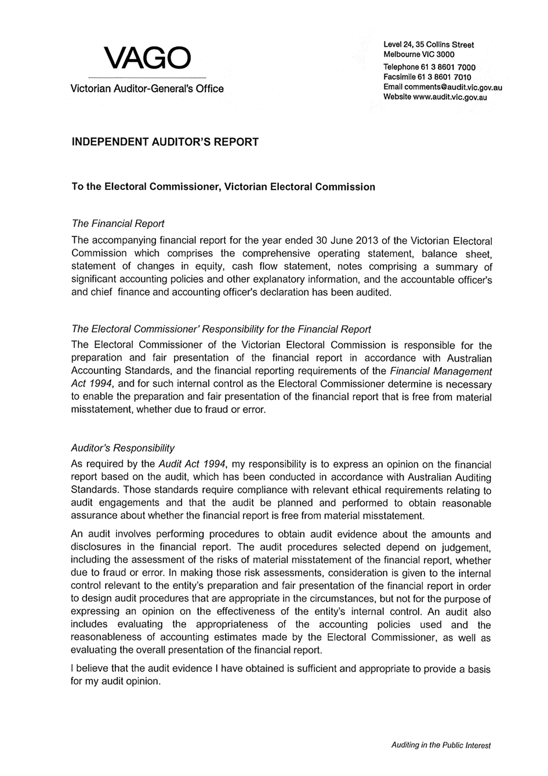

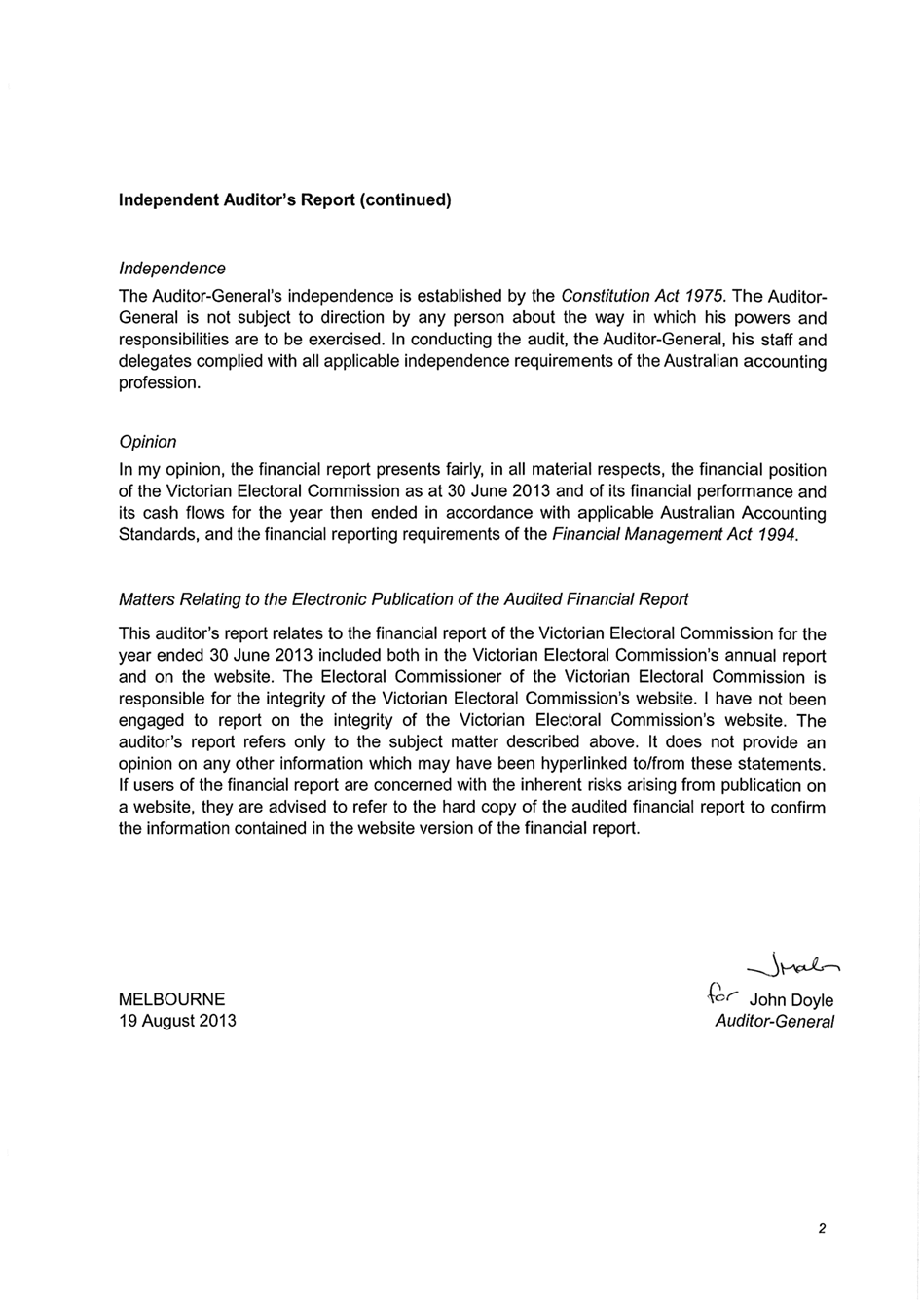

APPENDICES
List of appendices | Page
Appendix A  Disclosure index | 109
Appendix B  Governing legislation and regulations | 111
Appendix C  Additional information available on request | 112
Appendix D  Reporting procedures under the Protected Disclosures Act 2012 | 113
Appendix E  Making a request under the Freedom of Information Act 1982 | 114
Appendix F  Elections, by-elections, countbacks and polls, 2012–13 | 115
Appendix G  Municipal Electoral Tribunal inquiries related to the 2012 local government elections | 116
Appendix H  Enforcement of compulsory voting, 2012-13 | 117
Appendix I  Information provided under section 34 of the Electoral Act 2002 | 118
Appendix J  Registered political parties, 30 June 2013 | 119
Appendix K  Elector statistics by Region, 30 June 2012 | 120
Appendix L  Elector statistics by District, 30 June 2012 | 121
Appendix M  Enrolment transactions, 2008–09 to 2012–13 | 124
Appendix N  Environmental sustainability report | 126
Appendix O  Report of the Electoral Boundaries Commission 2012–13 | 128
Appendix P  Strategic Plan 2013-14 to 2017-18 | 129
Appendix A

DISCLOSURE INDEX
Ministerial Directions
Report of operations – FRD Guidance |  | Page
Charter and purpose
FRD 22B | Manner of establishment and the relevant Ministers | 2, 11
FRD 22B | Objectives, functions, powers and duties | 2
FRD 22B | Nature and range of services provided | 2
Management and structure
FRD 22B | Organisational structure | 12
Financial and other information
FRD 8B | Budget portfolio outcomes | 3
FRD 10 | Disclosure index | 109
FRD 12A | Disclosure of major contracts | 24
FRD 15B | Executive officer disclosures | 26
FRD 22B, SD 4.2(k) | Operational and budgetary objectives and performance against objectives | 3
FRD 22B | Employment and conduct principles | 23
FRD 22B | Occupational health and safety policy | 61
FRD 22B | Summary of the financial results for the year | 8
FRD 22B | Significant changes in financial position during the year | 66
FRD 22B | Major changes or factors affecting performance | 8
FRD 22B | Subsequent events | 106
FRD 22B | Application and operation of Freedom of Information Act 1982 | 25
FRD 22B | Compliance with building and maintenance provisions of Building Act 1993 | 25
FRD 22B | Statement on National Competition Policy | 23
FRD 22B | Application and operation of the Whistleblowers Protection Act 2001  Protected Disclosures Act 2012 | 25
FRD 22B | Details of consultancies over $10,000 | 24
FRD 22B | Details of consultancies under $10,000 | 24
FRD 22B | Statement of availability of other information | 112
FRD 24C | Reporting of office-based environmental impacts | 126
FRD 25A | Victorian Industry Participation Policy disclosures | 25
FRD 29 | Workforce Data disclosures | 13
SD 4.5.5 | Risk management compliance attestation | 27
SD 4.2(g) | Specific information requirements | Inside front cover
SD 4.2(j) | Sign-off requirements | 105

Legislation Requirement
Financial Report |  | Page
Financial statements required under Part 7 of the FMA
SD4.2(a) | Statement of changes in equity | 68
SD4.2(b) | Operating statement | 66
SD4.2(b) | Balance sheet | 67
SD4.2(b) | Cash flow statement | 69
SD4.2(c) | Compliance with Australian accounting standards and other authoritative pronouncements | 105
SD4.2(c) | Compliance with Ministerial Directions | 105
SD4.2(d) | Rounding of amounts | 72
SD4.2(c) | Accountable officer’s declaration | 105
SD4.2(f) | Compliance with Model Financial Report | 105
FRD 9A | Departmental disclosure of administered assets and liabilities | 81
FRD 11 | Disclosure of ex gratia payments | 99
FRD 13 | Disclosure of parliamentary appropriations | 99
FRD 21A | Responsible person and executive officer disclosures | 101
FRD 102 | Inventories | 84
FRD 103D | Non-current physical assets | 72
FRD 104 | Foreign currency | 94
FRD 106 | Impairment of assets | 94, 103
FRD 109 | Intangible assets | 103
FRD 107 | Investment properties | 84
FRD 110 | Cash flow statements | 69
FRD 112C | Defined benefit superannuation obligations | 77
FRD 113 | Investments in subsidiaries, jointly controlled entities and associates | NA
FRD 114A | Financial Instruments – General Government Entities and public non-financial corporations | 93
FRD 119 | Contributions by owners | 68

Appendix b
GOVERNING LEGISLATION AND REGULATIONS

Legislation
- Agricultural Industry Development Act 1990
- Building Act 1993
- Charter of Human Rights and Responsibilities Act 2006
- City of Greater Geelong Act 1993
- City of Melbourne Act 2001
- Constitution Act 1975
- Education and Training Reform Act 2006
- Electoral Act 2002
- Electoral Boundaries Commission Act 1982
- Equal Opportunity Act 2010
- Essential Services Act 1958
- Financial Management Act 1994
- Freedom of Information Act 1982
- Information Privacy Act 2000
- Infringements Act 2006
- Juries Act 2000
- Legal Profession Act 2004
- Liquor Control Reform Act 1998
- Local Government Act 1989
- Monetary Units Act 2004
- Protected Disclosure Act 2012
- Public Records Act 1973
- Shop Trading Reform Act 1996
- Vital State Projects Act 1976

Regulations
- Agricultural Industry Development (Polls) Regulations 2011
- City of Melbourne (Electoral) Regulations 2012
- Education and Training Reform Regulations 2007
- Electoral Regulations 2012
- Infringements (General) Regulations 2006
- Infringements (Reporting and Prescribed Details and Forms) Regulations 2006
- Legal Profession (Board Election) Regulations 2006
- Liquor Control Reform Regulations 2009
- Local Government (Electoral) Regulations 2005
Appendix C
ADDITIONAL INFORMATION AVAILABLE ON REQUEST
- Details of shares held by a senior officer as nominee or held beneficially in a statutory authority or subsidiary
- Details of publications produced by the VEC about itself, and where these can be obtained
- The VEC Environmental Management Plan
- Details of changes in prices, fees, charges, rates and levies charged by the VEC
- Details of any major external reviews carried out in respect of the operation of the VEC
- Details of major research and development activities undertaken by the VEC that are not otherwise covered in this report
- Details of overseas visits undertaken, including a summary of the objectives and outcomes of each visit
- Details of assessments and measures undertaken to improve the occupational health and safety of employees not otherwise detailed in this report
- A general statement on industrial relations within the VEC and details of time lost through industrial accidents and disputes

aPPENDIX D
Reporting procedures under the Protected Disclosure Act 2012
Disclosures of improper conduct or detrimental action by the Victorian Electoral Commissioner must be made to the Independent Broad-based Anti-corruption Commission.
IBAC
GPO Box 24234
Melbourne VIC 3001
Disclosures of improper conduct or detrimental action by an officer of the VEC may be made to the Protected Disclosures Officer or the directly to the Ombudsman.
Protected Disclosures Officer
Victorian Electoral Commission
Level 11, 530 Collins Street
Melbourne
Phone 03 8620 1100
The Ombudsman Victoria
Level 9, 459 Collins Street (North Tower)
Melbourne VIC 3000
Telephone: (03) 9613 6222
Toll free: 1800 806 314
Internet: www.ombudsman.vic.gov.au
Email: ombudvic@ombudsman.vic.gov.au
Further information
Written guidelines outlining the system for reporting disclosures of improper conduct or detrimental action by the VEC or its employees are available from the VEC.

APPENDIX E
Making a request under the Freedom of Information Act 1982
Access to documents may be obtained through written request to the Freedom of Information (FOI) Officer, as detailed in s17 of the Freedom of Information Act 1982.
In summary, the requirements for making a request are:
- it should be in writing
- it should identify as clearly as possible which document is being requested
- it should be accompanied by the appropriate application fee (the fee may be waived in certain circumstances).
Requests for documents in the possession of the VEC should be lodged by email to foi@vec.vic.gov.au or by mail addressed to:
Freedom of Information Officer
Victorian Electoral Commission
Level 11, 530 Collins Street
Melbourne VIC 3000
Access charges may also apply once documents have been processed and a decision on access is made; for example photocopying and search and retrieval charges.
Further information regarding Freedom of Information can be found at www.foi.vic.gov.au.

APPENDIX F
Elections, by-elections, countbacks and polls, 2012–13
Election Name | Type | Election Date | Voting Method | Location | Voters
Melbourne State District | State By-election | 21/07/12 | Attendance
Lyndhurst State District | State By-election | 27/04/13 | Attendance
Casey City Council Springfield Ward | Municipal Countback | 3/12/2012 | N/A | Narre Warren | N/A
Benalla Rural City Council | Municipal Countback | 17/01/2013 | N/A | Benalla | N/A
Benalla Rural City Council | Municipal Countback | 5/06/2013 | N/A | Benalla | N/A
Mitchell Shire Council Central Ward | Municipal Countback | 13/05/2013 | N/A | Broadford | N/A
Monash City Council Mount Waverley Ward | Municipal Countback | 12/06/2013 | N/A | Glen Waverley | N/A
Wangaratta Rural City Council | Municipal Countback | 4/06/2013 | N/A | Wangaratta | N/A
Wangaratta Rural City Council | Municipal Countback | 11/06/2013 | N/A | Wangaratta | N/A
Ararat Rural City Council | Municipal By-election | 22/06/2013 | Postal | Ararat | 9,122
He Says She Says | Liquor Licensing Poll | 30/07/2012 | Postal | VEC | 1,760
Epoca | Liquor Licensing Poll | 13/08/2012 | Postal | VEC | 1,515
Snow Pony | Liquor Licensing Poll | 26/11/2012 | Postal | VEC | 1,539
Hoi’s Kitchen | Liquor Licensing Poll | 17/12/2012 | Postal | VEC | 860
Sakura Inn | Liquor Licensing Poll | 4/02/2013 | Postal | VEC | 1,883
Emergency Services Superannuation  Casual Vacancy 2012 | Commercial Election | 2/08/2012 | N/A - uncontested | VEC | 27,354
Northern Victorian Fresh Tomatoes  Industry Poll 2012 | Statutory Poll | 16/07/2012 | Postal | VEC | 11
Maroondah City Council EA Re-Vote 2012 | Commercial Election | 5/10/2012 | Postal | VEC | 866
Graduate Student Association 2012 | Commercial Election | 5/10/2012 | Postal | VEC | 18,992
Emergency Services Superannuation | Commercial Election | 17/09/2012 | Postal | VEC | 18,016
Murray Valley Wine Grape Growers  Industry Poll 2012 | Statutory Poll | 12/10/2012 | Postal | VEC | 546
Victorian Canine Association  - Management Committee | Commercial Election | 1/03/2013 | Postal | VEC | 7,939
MAV Board Elections | Commercial Election | 1/03/2013 | Postal | VEC | 79
Public Transport Victoria EA 2012 | Commercial Election | 18/01/2013 | Postal | VEC | 449
Legal Services Board | Commercial Election | 19/05/2013 | N/A - uncontested | VEC | 14,000
Local Government (78 Council elections) | General Election | 27/10/12 | See Report of 2012 local government elections at vec.vic.gov.au

APPENDIX G
Municipal Electoral Tribunal inquiries related to the 2012 local government elections
The VEC responded to five applications to the Municipal Electoral Tribunal (MET) following the 2012 local government elections. The applications were lodged within 14 days of the Returning Officers declaring the results for the respective elections and preliminary hearings commenced on 28 November 2012. The MET dismissed four inquiries and struck out the fifth. The five applications are detailed below.

Macedon Ranges Shire Council (South Ward)
The application by an unsuccessful candidate expressed concerns about the procedures and locations used by the VEC during the original count of ballot papers and the subsequent recount.
In response to the application, the VEC closely examined the procedures that were used for the election and confirmed that all procedures were compliant with legislation and regulations. The VEC conducted a review of formal ballot papers before the applicant, and 36 ballot papers were referred to the MET for a determination.
The MET ruled that six of the 36 ballot papers should be treated as informal and a recalculation of the result was carried out. The recalculation resulted in no change to the result and the MET dismissed the application.

Manningham City Council (Mullum Mullum Ward)
The application by an unsuccessful candidate related to another candidate, whom it was alleged was disqualified from being a councillor. It was argued that the candidate should not have been permitted to remain as a candidate once the reasons for disqualification had been disclosed (by a third party or parties) to the Returning Officer.
The VEC did not contest the allegation that the candidate was disqualified from being a councillor and, therefore, that the candidate was ineligible to stand as a candidate in the election. The VEC confirmed that it had been advised of concerns relating to the candidate’s eligibility and had taken appropriate steps. The VEC notified the Local Government Investigations and Compliance Inspectorate and wrote to the candidate requesting that they consider their eligibility, and take the required steps to withdraw their candidacy or retire if they found or considered they were not eligible.
The MET found that the VEC did not have the power to compel a candidate to retire from a local government election and that as the candidate did not retire, there was no opportunity to treat the candidate as retired for the purpose of a recount. The MET ordered a recalculation of the result excluding all formal ballot papers that had directed a first preference to the allegedly disqualified candidate. The recalculation did not change the result and the MET dismissed the application, referring the matter to the Minister for Local Government as a possible offence under the Local Government Act 1989(LG ACT).

Moreland City Council (North-East Ward)
The application by an unsuccessful candidate contained allegations of fraudulent postal voting applications by another candidate.
The application was struck out in June 2013 as the applicant had failed to file documents ordered by the MET.

Port Phillip City Council (Albert Park Ward)
The application by an unsuccessful candidate related to the content of a how-to-vote card allegedly distributed by (or for) another candidate.
The VEC provided the MET with information about the registration process for how-to-vote cards and filed affidavit material from the Returning Officer, stating that the how-to-vote card in question had not been lodged for registration. The applicant subsequently abandoned aspects of his application to pursue issues associated with the registration status of the how-to-vote card. The VEC could not respond to these issues and the other candidate was joined as a respondent.
The MET dismissed the application, referring the matter to the Minister for Local Government as a possible offence under the LG ACT.

Swan Hill Rural City Council (Robinvale Ward)
The application by an unsuccessful candidate related to the behaviour and conduct of another candidate. Secondary to the application, the applicant also raised issues relating to the distance voters in the ward were compelled to travel should they choose to hand-deliver their completed postal ballot packs to Swan Hill; the enrolment status of non-resident property owners; and the response by the Council’s administration to a code of conduct issue raised by the applicant during the election period.
The VEC could not respond to all the claims made in the application. The other candidate and Swan Hill Rural City Council were invited to participate in the proceeding in relation to particular issues raised by the applicant.
The MET dismissed the application, referring the matter to the Minister for Local Government as a possible offence under the LG ACT.

appendix h
Enforcement of compulsory voting, 2012-13
Election Type/Date | Notice  Type* | Mailout Date | Records | Penalties collected  to 30 June 2013 | Infringements Court Lodgement Date | No. of records lodged
Lyndhurst | 1 | 21-Jun | 6,919 | N/A
District By-election | 2 |  | N/A | N/A | due to be lodged
27-Apr-13 | 3 |  |  |  | 02-Feb-14
Camberwell LLP | 1 | 14-Mar | 250 | N/A
(Sakura Inn) | 2 | 1-May | 148 | $3,570.00 | due to be lodged
4-Feb-13 | 3 |  | N/A |  | 01-Nov-13
Local Government Elections 2012 | 1 | 15,17,21,23,25, 29,31 Jan | 505,582 | N/A
(73 Councils) | 2 | 5,7,12,14,19,21 Mar | 333,413 | $5,751,056.42 | Not lodged with Court forwarded to council
27-Oct-12 | 3 | 7,9,14,16,21,23 May. 5 Jun | 225,893 | $2,744,138.76 | 5,7,12,15,19,21 Sep. 3 Oct
Camberwell LLP | 1 | 10-Jan | 119 | N/A
(Hoi’s Kitchen) | 2 | 20-Feb | 72 | $2,170.00 | due to be lodged
17-Dec-12 | 3 | 1-May | 32 | $370.40 | 17-Jul-13
Deepdene LLP | 1 | 19-Dec | 266 | N/A
(Snow Pony) | 2 | 20-Feb | 169 | $3,570.00 | due to be lodged
26-Nov-12 | 3 | 1-May | 91 | $2,177.20 | 17-Jul-13
Balwyn North LLP | 1 | 7-Sep | 296 | N/A
(Epoca Restaurant) | 2 | 26-Oct | 151 | $3,220.00
13-Aug-12 | 3 | 19-Dec | 71 | $1,599.00 | 19-Feb-13 | 47
Camberwell LLP | 1 | 16-Aug | 360 | N/A
(He Says She Says) | 2 | 19-Sep | 216 | $5,390.00
30-Jul-12 | 3 | 9-Nov | 96 | $1,321.20 | 22-Jan-13 | 68
Melbourne | 1 | 7-Aug | 11,866 | N/A
District By-election | 2 | 19-Sep | 7,885 | $112,090.00
21-Jul-12 | 3 | 9-Nov | 5,550 | $54,923.40 | 22-Jan-13 | 4550
Niddrie | 1 | 17-Apr | 4,239 | N/A
District By-election | 2 | 23-May | 2,746 | $14,157.00
24-Mar-12 | 3 | 19-Jul | 1,852 | $20,477.60 | 20-Sep-12 | 1425
Ashburton LLP | 1 | 10-Apr | 192 | N/A
(E’Latte 204) | 2 | 18-May | 166 | $732.00
19-Mar-12 | 3 | 13-Jul | 89 | $1,163.60 | 20-Sep-12 | 59
Mount Alexander Calder |  | 16-Mar | 192 | N/A
By-election |  | 27-Apr | 121 | N/A
25-Feb-12 |  | 29-Jun | 56 | $476.00 | 30-Aug-12 | 43
* 1 - Apparent Failure to Vote 2 - Infringement 3 - Penalty Reminder

Appendix i
Information provided under section 34 of the Electoral Act 2002
During 2012–13, the VEC provided electoral enrolment information to the following organisations under section 34 of the Electoral Act 2002 or other legislation.

BreastScreen Victoria
The Cancer Council Victoria, Cancer Epidemiology Centre – Prostate Cancer Program and Melbourne Collaborative Cohort Study.

State Revenue Office
The VEC provides electoral information to the State Revenue Office for the purpose of law enforcement.

Victoria Police
The Ethical Standards, Records Services, Licensing Services, State Intelligence and Major Fraud Investigation Service divisions of Victoria Police registered 241 logons to the VEC’s dedicated, secure facility of which 114 made 1,797 searches for information during 2012–13.

Country Fire Authority (CFA)
The VEC will facilitate the use of name and postal address information of all electors (excluding silent electors, overseas electors and those electors who have requested to be omitted from such lists) in the areas designated by the CFA as “high risk of bushfire” in 2011–12, 2012–13 and 2013–14 so that community safety information related to fire preparedness can be mailed to those electors by the CFA.

Melbourne IVF
The VEC has agreed to perform up to 20 individual data matching searches per year, and to contact the person
on behalf of Melbourne IVF. At the time of this report, four searches had been requested.

Wellington Shire Council
The Victorian Electoral Commission will conduct verification of certain addresses as provided by the Wellington Shire Council (WSC), and in certain instances provide the current address held by the VEC, so that WSC may serve documents pursuant to section 84 of the Criminal Procedures Act 2009. The details of silent electors will not be used or transmitted. No other use is permitted.

The University of Melbourne
Cross matching and verification of addresses of participants from the Australian Breast Cancer Family Study; the Australasian Colorectal Cancer Family Study; and the Australian Twin Registry.
The Victorian Electoral Commission conducted data-matching and verification to ensure the accuracy of the personal address details of participants from three major research programs conducted under the auspices of the University of Melbourne. The resulting verified data will be used for the purposes of these studies: the Australian Breast Cancer Family Study, the Australasian Colorectal Cancer Family Study and the Australian Twin Registry. No other use is permitted. The details of silent electors, overseas electors and those electors who have requested to be omitted from such lists were not used or transmitted.

appendix j
REGISTERED POLITICAL PARTIES, 30 JUNE 2013
Political party | Registered Officer
Australian Christians | Mr Spero Katos  Registered Officer  PO Box 99  Sandown Village Vic. 3171
Australian Labor Party – Victorian Branch | Mr Noah Carroll  State Secretary  438 Docklands Drive  Docklands Vic. 3008
Australian Sex Party – Victoria | Ms Ange Hopkins  Registered Officer  64 Hamilton Street  Gisborne Vic. 3437
Country Alliance | Mr Russell William Bate  Registered Officer  PO Box 24415  Melbourne Vic. 3001
Democratic Labor Party (DLP) of Australia | Mr Michael Murphy  Secretary  GPO Box 1402  Melbourne Vic. 3001
Family First Party Victoria Inc. | Mr Darren Buller  Secretary  PO Box 83  Canterbury Vic. 3126
Liberal Party of Australia – Victorian Division | Mr Damian Mantach  State Director  104 Exhibition Street  Melbourne Vic. 3000
National Party of Australia – Victoria | Mrs Jenny Hammett  State Director  Level 5, 30 Collins Street  Melbourne Vic. 3000
Socialist Alliance – Victoria | Ms Susanne Bolton  Registered Officer  PO Box 12427  A’Beckett Street Vic. 8006
The Australian Greens – Victoria | Mr Gurmeet Sekhon  Registered Officer  GPO Box 4589  Melbourne Vic. 3001

appendix k
Elector statistics by Region, 30 June 2012
Area No | Area Name | Elector Count | Variance to Average (%)
1 | Eastern Metropolitan | 425,427 | -6.08
2 | Eastern Victoria | 463,253 | 2.27
3 | Northern Metropolitan | 458,570 | 1.24
4 | Northern Victoria | 433,183 | -4.36
5 | South Eastern Metropolitan | 449,238 | -0.82
6 | Southern Metropolitan | 429,695 | -5.13
7 | Western Metropolitan | 491,046 | 8.41
8 | Western Victoria | 473,185 | 4.47

Total number of electorates: | 8
Total number of electors: | 3,623,597
Average number of electors: | 452,949

appendix l
ELECTOR STATISTICS BY DISTRICT, 30 JUNE 2012
Area No | Area Name | Elector Count | Variance to Average (%)
1 | Albert Park | 47,102 | 14.39
2 | Altona | 54,294 | 31.86
3 | Ballarat East | 41,187 | 0.02
4 | Ballarat West | 44,614 | 8.35
5 | Bass | 51,793 | 25.78
6 | Bayswater | 36,717 | -10.83
7 | Bellarine | 45,321 | 10.06
8 | Benalla | 36,964 | -10.23
9 | Benambra | 37,742 | -8.34
10 | Bendigo East | 41,301 | 0.30
11 | Bendigo West | 42,011 | 2.03
12 | Bentleigh | 39,219 | -4.76
13 | Box Hill | 38,921 | -5.48
14 | Brighton | 38,670 | -6.09
15 | Broadmeadows | 37,118 | -9.86
16 | Brunswick | 42,714 | 3.73
17 | Bulleen | 35,315 | -14.24
18 | Bundoora | 36,213 | -12.06
19 | Burwood | 39,194 | -4.82
20 | Carrum | 42,651 | 3.58
21 | Caulfield | 37,495 | -8.94
22 | Clayton | 33,886 | -17.71
23 | Cranbourne | 50,307 | 22.17
24 | Dandenong | 35,214 | -14.48
25 | Derrimut | 41,762 | 1.42
26 | Doncaster | 36,415 | -11.56
27 | Eltham | 39,219 | -4.76
28 | Essendon | 40,057 | -2.72
29 | Evelyn | 40,424 | -1.83
30 | Ferntree Gully | 44,551 | 8.19
31 | Footscray | 40,860 | -0.77
32 | Forest Hill | 35,886 | -12.85
33 | Frankston | 36,286 | -11.88
34 | Geelong | 40,010 | -2.83
35 | Gembrook | 44,037 | 6.95
36 | Gippsland East | 41,792 | 1.49
37 | Gippsland South | 39,466 | -4.16
38 | Hastings | 45,815 | 11.26
39 | Hawthorn | 38,867 | -5.61
40 | Ivanhoe | 38,500 | -6.50
41 | Keilor | 53,751 | 30.54
42 | Kew | 37,007 | -10.13
43 | Kilsyth | 41,085 | -0.22
44 | Kororoit | 43,552 | 5.77
45 | Lara | 45,144 | 9.63
46 | Lowan | 38,305 | -6.97
47 | Lyndhurst | 42,660 | 3.60
48 | Macedon | 48,602 | 18.03
49 | Malvern | 38,268 | -7.06
50 | Melbourne | 44,931 | 9.12
51 | Melton | 45,462 | 10.41
52 | Mildura | 37,924 | -7.90
53 | Mill Park | 41,547 | 0.90
54 | Mitcham | 36,932 | -10.31
55 | Monbulk | 37,899 | -7.96
56 | Mordialloc | 42,130 | 2.31
57 | Mornington | 40,870 | -0.75
58 | Morwell | 38,837 | -5.68
59 | Mount Waverley | 36,824 | -10.57
60 | Mulgrave | 34,848 | -15.37
61 | Murray Valley | 38,852 | -5.65
62 | Narracan | 43,390 | 5.37
63 | Narre Warren North | 40,448 | -1.77
64 | Narre Warren South | 53,984 | 31.10
65 | Nepean | 38,929 | -5.46
66 | Niddrie | 36,603 | -11.11
67 | Northcote | 40,902 | -0.67
68 | Oakleigh | 35,822 | -13.00
69 | Pascoe Vale | 40,924 | -0.61
70 | Polwarth | 42,352 | 2.85
71 | Prahran | 39,813 | -3.31
72 | Preston | 38,957 | -5.39
73 | Richmond | 41,826 | 1.58
74 | Ripon | 37,670 | -8.52
75 | Rodney | 36,738 | -10.78
76 | Sandringham | 38,238 | -7.14
77 | Scoresby | 38,893 | -5.55
78 | Seymour | 41,515 | 0.82
79 | Shepparton | 38,566 | -6.34
80 | South Barwon | 49,523 | 20.27
81 | South-West Coast | 43,597 | 5.88
82 | Swan Hill | 32,968 | -19.94
83 | Tarneit | 49,232 | 19.56
84 | Thomastown | 36,545 | -11.25
85 | Warrandyte | 41,491 | 0.76
86 | Williamstown | 39,328 | -4.49
87 | Yan Yean | 59,317 | 44.05
88 | Yuroke | 50,683 | 23.09

Total number of electorates: | 88
Total number of electors: | 3,623,594
Average number of electors: | 41,17

appendix m
Enrolment transactions, 2008–09 to 2012–13
Enrolment application transactions  - direct enrolments | 2008–09 | 2009–10 | 2010–11* | 2011–12* | 2012–13
Vic Roads |  |  |  | 25,493 | 84,762
VCAA |  |  | 5,904 | 11,495 | 7,668
Local Government Post Election Follow Up |  |  |  | - | 20,069
 |  |  | 5,904 | 36,988 | 112,499
Enrolment application transactions - forms
VEC mailout programs
Current
Victorian Curriculum and Assessment Authority (VCAA) | 13,372 | 13,598 | 10,639 | 15,043 | 16,112
VCAA Over 18 years 2010 State election mail-out | - | - | 603 | - | -
Residential Tenancies Bond Authority | 5,179 | 36,347 | 6,706 | 38,623 | 20,860
VicRoads | 17,351 | 57,653 | 5,754 | 27,252 | 8,422
Victorian Tertiary Admissions Centre | 3,356 | 1,771 | 935 | 2,624 | 168
Local government post-election follow-up | 10,323 | 898 | 112 | - | 6,100
Non-current
TRU Energy | 1 | - | - | - | -
Yarra Valley Water | - | - | - | - | -
2000–01 redivision mailout | 12 | 2 | - | - | -
VEC mailout programs - total | 49,594 | 110,269 | 24,749 | 83,542 | 51,662
VEC non-mailout programs
VEC general enrolment form | 21,185 | 9,628 | 31,355 | 7,288 | 9,568
On-the-day enrolment/Provisional votes | NA | NA | 33,593 | 289 | 1,027
Joint AEC/VEC enrolment form | 2,829 | 5,824 | 2,971 | 2,396 | 2,358
Liquor Licencing Victoria | 1,411 | 1,418 | 1,398 | 1,790 | 1,437
VEC website | 11,295 | 7,787 | 35,838 | 3,687 | 810
VEC municipal enrolment form (M) | 1,449 | 1,054 | 981 | 1,155 | 12,446
Community programs | NA | NA | 77 | 15 | 607
Supermarkets | 1,351 | 350 | - | - | -
VEC non-mailout programs - total | 39,520 | 26,061 | 106,213 | 16,620 | 28,253
Total collected through VEC’s enrolment programs | 89,114 | 136,330 | 136,866 | 137,150 | 192,414

 | 2008–09 | 2009–10 | 2010–11* | 2011–12* | 2012–13
Enrolment application transactions provided by the AEC and imported into Victorian register of electors
Additions
New to roll | 85,758 | 104,174 | 116,395 | 101,759 | 115,729
Reinstatements | 18,580 | 41,343 | 76,331 | 24,071 | 79,416
Subtotal | 104,338 | 145,517 | 192,726 | 125,830 | 195,145
Changes
Change of address | 229,094 | 294,938 | 378,685 | 260,883 | 409,062
Total AEC Import Transactions | 333,432 | 440,455 | 571,411 | 386,713 | 604,207
Less
VEC mailout programs | 49,594 | 110,269 | 24,749 | 83,542 | 51,662
VEC non-mailout programs | 39,520 | 26,061 | 106,213 | 16,620 | 28,253
State direct enrolments in additions and changes |  |  |  | 13,915 | 89,528
Subtotal | 89,114 | 136,330 | 130,962 | 114,077 | 169,443
Total collected through AEC’s enrolment programs | 244,318 | 304,125 | 440,449 | 272,636 | 434,764
VEC sourced enrolments as a percentage of the total | 26.73% | 30.95% | 23.71% | 33.47% | 30.68%

Other enrolment transactions | 2008–09 | 2009–10 | 2010–11* | 2011–12* | 2012–13
Non-application changes
Amendments to elector details | 9,176 | 5,560 | 7,605 | 4,856 | 5,841
Return to sender mail
Subtotal | 80,004 | 8,020 | 50,234 | 18,762 | 100,507
Special category applications
GPV applications | 371 | 367 | 1,801 | 379 | 662
Overseas elector applications | 721 | 758 | 2,371 | 853 | 2,424
Itinerant elector applications | 64 | 55 | 77 | 54 | 115
Silent elector applications | 149 | 301 | 102 | 248 | 228
Subtotal | 1,305 | 1,481 | 4,351 | 1,534 | 3,429
Combined subtotal | 90,485 | 15,061 | 62,190 | 25,152 | 109,777
Total VEC enrolment transactions | 179,599 | 151,391 | 199,056 | 162,302 | 302,191
* restated

appendix n
Environmental sustainability report
The VEC has continued its commitment to reducing the negative impact of its operations on the environment with ongoing communication and information programs to encourage continued positive behavioural changes. In 2012-13, the VEC achieved WasteWise gold accreditation. The Environmental Management Plan was refreshed with new goals and the VEC plans even greater sustainability changes. The VEC has continued its organisational, management and staff commitment to environmental sustainability by including environmental sustainability objectives in its Strategic Plan 2013-14 to 2017-2018.
The ResourceSmart Committee uses a GreenFlash logo to promote ideas to the organisation via email, as well as regularly changed “tips & tricks” signage around the organisation and short humorous presentations at staff meetings. Staff are also encouraged to record improvements centrally so that these are readily available and visible to all.
For some time the VEC has been making environmentally sustainable changes across all operations. These have reflected and affected operations in other jurisdictions. Examples of collaborative environmentally sustainable strategies which deliver efficiency and cost savings include:
- use of unbleached cardboard furniture and equipment for temporary election offices (up to 23,000 units of which are reused for up to eight years and then recycled)
- electronic device sharing arrangements with other states and territories in the conduct of elections (up to 1000 laptops and other devices)
- careful consideration and planning of a more environmentally sustainable use of transportation for election materials across the state to reduce 12 million logistic kilogram kilometres
- paper reduction strategies (such as reducing the amount of paper sent to elections offices for use during elections, moving instruction manuals to an on-line format instead of printed copies and providing electronic copies of reports where possible).
Some of the initiatives underway at the VEC include:
- an electronic personnel management system is being developed to remove the need for paper documents in tracking and authorising all forms of staff leave and timesheets and allowing for electronic distribution of payslips
- a trial of an e-filing system that will also remove the need to print and physically file all documents in important projects. Instead, emails and many other reports will be kept centrally and will become electronically searchable
- electronic roll mark-off deployed and used at Election Day voting centres at the 2012 local government attendance elections. The electronic roll mark-off has also been used at the last four State District by-elections. If this can be fully implemented at a State election, the production of over 9,500 printed voters rolls (approximately 20,000 reams of paper) will be eliminated.
As an organisation with a focus on openness to innovative ideas, the VEC continues to seek ways to achieve environmental sustainability and drive efficiency.
The move to a new 5-star rated building with co-generation of power has led to some difficulties with managing data collection in this area. The ResourceSmart Committee is working with the building management and the VEC Finance and Budget Branch to develop a reliable and accurate method of data collection. Because of this, energy consumption figures have not been included in this report.

Project | Action | Result
Local Government Activity Report | Making an accompanying CD to carry 9 booklets, list of candidates and copy of whole report. | Saves around 150 pages of printing for each copy.
Annual Report | Electronic book version | Halved print run, enable single page printing and reduce need to print when accessing online.
Election official training | 1. Encouraging participants to view forms and other documents on-screen during training, rather than printing them, whenever practicable.  2.Re-use plastic name tag holders MANY times, rather than people taking them home after their seminar. | Reduces paper per person per seminar.
Management Minutes | Electronic send to Management Team for Minutes and Agenda | Very little use of paper, both the  Minutes and Agenda can be screened during the Meetings.
Payroll | Electronic payslips and leave forms | Saves using ATO forms (with 5 pages per form) for 16,000 officials. Total of 80,000 sheets of paper
Resource recovery | Recycling of all copier and printing supplies | 41.26 kg of copier/printer waste certified as recycled/diverted from landfill

appendix o
REPORT OF THE ELECTORAL BOUNDARIES COMMISSION 2012–13
The Electoral Boundaries Commission (EBC) is constituted under the Electoral Boundaries Commission Act 1982 (the Act). The EBC must establish and maintain electorates of approximately equal enrolment (that is, not varying by more than 10% from the average for each House of Parliament) for the conduct of parliamentary elections.
The members of the EBC during 2013–13 were:
- His Honour, Chief Judge Michael Rozenes AO,
Chief Judge of the County Court (Chairman);
- Ms Liz Williams, Acting Electoral Commissioner
(June 2012 – April 2013)
- Mr Warwick Gately AM, Electoral Commissioner
(April 2013 – onwards)
- Mr John Tulloch, Surveyor-General.
The VEC provides administrative and technical support to the EBC, and Dr Paul Thornton-Smith of the VEC is the secretary to the EBC.
The Act provides that the EBC must conduct a redivision of electoral boundaries if certain conditions apply in the period 24 to 18 months before the next scheduled State election. These conditions are that enrolments for a certain number of electorates are more than 10 per cent outside the State average, that there have been more than two general elections (elections for all the members of both Houses of Parliament) since the previous redivision, or that the number of electorates has changed. On 29 November 2012 the “general elections” trigger took effect, as there had been two general elections (in 2006 and 2010) since the last redivision. As well, enrolments for 34 of the 88 electoral districts were more than 10 per cent outside the average, and nine districts were more than 20 per cent outside the average. The redivision began in December 2012.
At a public hearing at the County Court on 14 December 2012, the EBC set out the procedures for the redivision and heard evidence from expert witnesses. The EBC invited submissions from the public, and received 17 submissions by the deadline of 1 March 2013. A public hearing on 8 April 2013 was another opportunity for public input.
On 27 June 2013, the EBC released proposed electoral boundaries. Under the proposals, 12 existing districts would be abolished and 12 new districts created. Only two districts (Gippsland East and South-West Coast) would be unchanged. The EBC invited public feedback on the proposed boundaries.
Written suggestions or objections about the proposed boundaries will be received until 29 July 2013. The EBC expects that boundaries will be finalised in October 2013.
EBC files are maintained at the VEC’s head office at Level 11, 530 Collins Street, Melbourne, separate from the VEC registry.


Appendix P
STRATEGIC PLAN 2013-14 TO 2017-18
OUR VISION
All Victorians actively participating in their democracy

OUR PURPOSE
To deliver high quality, accessible electoral services with innovation, integrity and independence

OUR STRATEGIC INTENTS
- The VEC will provide high quality and innovative opportunities for Victorians to participate in the democratic process
- The VEC will have transparent and accountable governance and business support systems that reinforce and sustain organisational capacity
- The VEC will have a culture that fosters professional growth and development, ensures a safe, inclusive and engaging work environment and leads to high quality staff performance

Enablers
What we need to have in place to achieve our Strategic Intent

Strategic Initiatives
What we will do to achieve the enablers

Success Indicators
How we will know the Strategic Initiative has been achieved

First Strategic Intent
The VEC will provide high quality and innovative opportunities for all Victorians to participate in the democratic process
ENABLER: Comprehensive electoral event programs
Strategic initiatives | Success indicators
Maintain an effective set of electoral event plans | - Electoral events delivered within legislative and organisational requirements  - VEC project management framework applied consistently in managing electoral events  - Event plans are ready for immediate implementation as required
Maintain and enhance support structures for electoral representation activities | - Electoral Boundaries Commission has the necessary information to make decisions  - Local Government Minister has the necessary information and recommendations to make decisions

ENABLER: A complete, secure and accurate register of electors
Strategic initiatives | Success indicators
Review and improve enrolment programs | - Enrolment program targets achieved
Review and improve enrolment systems | - Enrolment transactions captured effectively  - Enrolment systems are elector centric  - Successful security audit

ENABLER: An engaged and informed community
Strategic initiatives | Success indicators
Identify enrolment and voting barriers and emerging trends | - Research conducted and utilised to inform service  design and delivery
Design and implement responsive electoral education  and awareness programs | - Increased community awareness of electoral matters  - Electoral engagement program targets are met *enrolment, turnout, informality rates inform success

ENABLER: Strong and effective partnerships
Strategic initiatives | Success indicators
Identify and engage key partners | - Partnerships contribute to the achievement of VEC objectives
Establish robust and resilient partnering arrangements

ENABLER: Contemporary innovative services delivered effectively
Strategic initiatives | Success indicators
Identify, encourage and facilitate service and product improvements | - VEC services represent best practice  - VEC services respond to community requirements  and expectations
Inform and influence stakeholder opinion | - VEC views are represented at appropriate forums

Second Strategic Intent
The VEC will have transparent and accountable governance and business support systems that reinforce and sustain organisational capacity

ENABLER: Quality business systems
Strategic initiatives | Success indicators
Map, document and regularly review key organisational business processes | - VEC systems are fit for purpose  - Consistent business methodologies are applied  - VEC internal and external reporting framework meets legislative and organisational requirement  - Project management and corporate reporting processes are consistent across VEC  - Corporate knowledge is accessible
Review business systems to ensure they support business processes
Develop and implement a VEC project management framework
Develop and implement a VEC corporate reporting framework
Investigate the feasibility of VEC becoming an accredited quality organisation.

ENABLER: Effective management of resources
Strategic initiatives | Success indicators
Review all corporate wide assets and complete a development plan for them | - Asset plan is in place and implemented  - Assets are optimised
Develop and implement a consistent workforce and succession planning process | - Staff levels are appropriate and flexible to needs
Review and implement a consistent budgeting process | - Activities are conducted on schedule and within budget  - Resource management targets are achieved
Minimise the negative environmental impact of VEC activities | - Environmental management targets are achieved

Third Strategic Intent
The VEC will have a culture that fosters professional growth and development, ensures a safe, inclusive and engaging work environment and leads to high quality staff performance

ENABLER: Robust performance management and professional development
Strategic initiatives | Success indicators
Enhance performance and development program, processes and systems | - Performance is recognised and acknowledged  - Succession is informed by performance and development  - All performance expectations are understood, agreed and monitored on a regular basis  - Staff skills are appropriate to organisational needs  - Performance and development is aligned with corporate planning  - Core competency training delivered to staff where there is an identified need  - Staff satisfaction targets are met
Effectively engage staff in the performance and development program

ENABLER: A safe and inclusive working environment
Strategic initiatives | Success indicators
Build and foster an effective health & safety and wellbeing framework | Compliance with OH&S and Equal Opportunity requirements  Staff satisfaction targets are met

ENABLER: Effective skill, information and knowledge transfer
Strategic initiatives | Success indicators
Create ways to share and store information | - Key learning’s from external programs are shared within the organisation  - New ways of sharing and storing information are identified and implemented  - Skill and knowledge capabilities are enhanced
Identify opportunities for individuals to work across and within branches and across organisations to increase skills and knowledge

ENABLER: VEC operating model is fit for business
Strategic initiatives | Success indicators
Review current operating model and respond accordingly | - VEC operating model is fit for purpose

glossary

Attendance election
In an attendance election most voting is conducted at voting centres on election day, although voters may vote at early voting centres or by pre-poll postal votes.

Accredited Purchasing Unit
Accredited Purchasing Units approve procurement processes up to each department’s level of accreditation under delegated authority from the Victorian Government Purchasing Board.

Ballot
A method of secret voting.

By-election
A by-election is an election in a single-member electorate to fill a casual vacancy caused by the departure of a sitting Member of Parliament or local government councillor before the term expires.

Candidate
A candidate is an eligible elector who nominates for election.

Coding
Coding is the process of classifying information. In communications and computer systems, this involves implementing rules that are used to map the elements of one set onto the elements of another set, usually on a one-to-one basis.

Community of interest
The VEC defines a community of interest as a group of people who share a range of common concerns or aspirations. A community of interest may occur where people are linked with each other geographically (e.g. a town or valley) or economically, such as where people work in similar industries (e.g. tourism) or where people work in mutually-dependant industries (e.g. fruit growers, transporters and canners).
A community of interest may also appear where people share a number of special needs because of similar circumstances (such as new immigrants who may have little English, require assistance with housing or need help finding employment).

Compulsory enrolment
All Australian citizens 18 years and over are required by law to enrol.

Compulsory voting
All enrolled electors must vote at State elections. With some exceptions, enrolled voters must vote at local government elections.

Contested election
A contested election is an election where more candidates than the number of vacancies for the election have nominated by the close of nominations.

Continuous roll update (CRU)
The CRU process consists of a range of strategies to ensure that the electoral roll is continuously kept up-to-date by using internal and external data to direct roll review activities to targeted people and residences.

Councillor
An elected representative on a local government council.

Countback
Method of filling extraordinary vacancies in multi-member wards and unsubdivided municipalities in electorates where general election results were obtained using the proportional representation method. The votes of the vacating councillor are transferred to the previously unelected candidates to fill the vacancy.

District
One of the 88 Legislative Assembly electorates in Victoria. Each District elects one member and comprises approximately 41,000 electors.

Election
The choosing of representatives by the voters.

Election date
The date electors cast their votes.

Election Manager
A person appointed by the Electoral Commissioner to conduct an election for an electoral District or Region.

Elector
A person whose name appears on the register of electors and who is entitled to vote in elections.

Electoral Commissioner
The statutory officer appointed by the Governor-in-Council with responsibility for the proper conduct of parliamentary, local government and statutory elections.

Electoral Matters Committee (EMC)
The EMC comprises five Members of Parliament drawn from both Houses and is a Joint Investigatory Committee of the Parliament of Victoria. Its powers and responsibilities are determined by the Parliamentary Committees Act 2003. The EMC inquires into, considers and reports to the Parliament on any proposal, matter or thing concerned with the conduct of parliamentary elections and referendums in Victoria, the conduct of elections of councillors under the Local Government Act 1989 and the administration of, or practices associated with, the Electoral Act 2002 and any other law relating to electoral matters.

Electoral roll
A list of names of all the people who are entitled to vote in an election under relevant legislation.

Electronically Assisted Voting
A method of casting a vote under legislation by electors who are blind or have low vision, are not literate in English, have a motor impairment or are located interstate or overseas.

Enrolment
The placement of a person’s name and address on the Register of Electors. A person cannot vote at an election unless they are enrolled.

Enrolment information
The information about electors that is held by the VEC.

Entitlement date
To be eligible to vote at a local government election, people must be on the State or local government voters roll 57 days before election day. This is called the “entitlement date”.

Environmental Management Plan
The VEC’s Environmental Management Plan is used to identify, manage and reduce the organisation’s impact on the environment and guides the generation of reports on environmental performance progress. It provides a systematic and methodical approach to planning, implementing and reviewing the VEC’s response to those impacts.

Extensible Markup Language (XML)
XML is a data format for structured document exchange.

General Postal Voter (GPV)
A voter who always has difficulty getting to a voting centre on election day can register as a GPV. GPVs include people who are infirm, prisoners, those in remote communities and people who are 70 or over. After the close of nominations for an election, GPVs are automatically sent postal ballot papers and certificate envelopes.

Geo-coding
Geo-coding is the process of assigning geographic identifiers (e.g. codes or geographic coordinates expressed as latitude-longitude) to map features and other data records, such as street addresses.

How-to-vote cards
Cards handed out to voters by a candidate or party supporters at voting centres showing how a party or candidate would like voters to fill in their ballot papers.
In Victoria, how-to-vote cards handed out within 400 metres of a voting centre on election day for State and local government attendance elections must be registered with the VEC.

Informal voting
A ballot paper that is either left blank or is incorrectly marked. These ballot papers do not contribute to the election of a candidate.

Legislative Assembly (Lower House)
One of the two Houses in the Victorian State Parliament. There are 88 Members of the Legislative Assembly (MLAs), one from each electoral district. The party or coalition of parties that wins majority support in this House forms the Government.

Legislative Council (Upper House)
One of the two Houses in the Victorian State Parliament. There are 40 Members of the Legislative Council (MLCs), five from each region. The Legislative Council is often referred to as the “House of review”.

Lost Time Injury (LTI)
An LTI is an occupational injury or illness that results in days away from work on any rostered shift subsequent to that on which the injury occurred. A fatality is also recorded as an LTI.

Marginal costs
Marginal costs include direct labour and associated on-costs, materials, equipment, mail processing, postage, advertising, printing, rent, utilities, insurance, IT equipment and software licences purchased especially for the specific activity.

Postal election
In an all-postal election, voting papers are posted to voters by the Returning Officer and a vote is made by completing a ballot paper and returning it to the Returning Officer in the reply-paid envelope provided.

Preferential voting
A vote for all candidates in order of preference. If no candidate has an absolute majority of first preference votes, preferences are distributed until one candidate has an absolute majority.

Proportional representation
A system of voting designed to elect representatives in proportion to the amount of support each has in the electorate.

Redivision
The redrawing of electoral boundaries to ensure that there are, as near as possible, equal numbers of voters
in each electorate within Victoria.

Region
One of the eight Legislative Council electorates. Each Region comprises approximately 453,000 electors and elects five Members.

Register of Electors
The VEC’s database of all Victorian electors.

Registered political party (RPP)
A political party that is registered under the Electoral Act 2002. A registered party must have at least 500 members who are Victorian electors and not members of another registered political party.

ResourceSmart Committee
Comprising a representative from each branch of the VEC and a member of the VEC Management Group, the ResourceSmart Committee oversees the implementation of the VEC’s Environmental Management Plan.

Senior Election Official
A trained election official who may be appointed to act as an Election Manager for a parliamentary election. Senior Election Officials may be also be appointed to act as Returning Officers or Deputy Returning Officers for a local government election.

Victorian Electoral Commission (VEC)
The VEC is the independent statutory body that conducts State elections and certain statutory elections. The VEC may also conduct local government elections, commercial and community elections. The VEC also conducts boundary reviews, maintains the Victorian electoral enrolment register, conducts electoral research and provides education services.

Voter
A person whose name appears on the register of electors and who is entitled to vote in elections.

Voting centre
A place at which electors can vote in an election. The three types of voting centres that operate in State elections are early voting centres, mobile voting centres and election day voting centres.

index
2008-09 to 2012-13, statistics Inside back cover
2012 local government elections 33
A
Aboriginal Advisory Group 19
About the VEC 2
About This Report 4
Accessibility, voting centres 49
Accessibility, website 48
Accountability and transparency 21
Accredited Purchasing Unit 24
Additional information 26, 112
Additional information available on request, list 112
Advertising disclosure 24
Advisory groups, external 19
Appendices 106
Attestation to Public Sector Standards Commissioner 26
Attestation, insurance compliance 27
Attestation, risk management compliance 27
Attitudes to electronic voting, research 39
Audit Committee 21
Audited financial statements 65
Auditor-General’s report 105
B
Budgetry objectives and performance 3
Building Act 1993, compliance 25
By-election, Lyndhurst District 32
By-election, Melbourne District 32
By-elections, local government 35
By-elections, State District 31
C
CALD communities, Democracy Ambassadors 50
Challenge, VEC 2
Code of conduct 64
Community education and engagement 50
Compulsory enrolment 44
Compulsory voting enforcement 46
Compulsory voting enforcement, details 117
Consultancies 24
Consultancies over $10,000 24
Consultative Committee 18
Contact details 136
Contents 4
Contracts 24
Contracts and consultancies 24
Core business development 30
Core business, VEC 28
Corporate planning 22
Corporate reporting 22
Cost recovery, local government elections 35
Council by-elections, turnout 45
Council elections 33
Council structures, review 35
Counsultancies 24
Counsultancies under $10,000 24
Countbacks, local government 35
Court of Disputed Returns 20
Culturally and Linguistically Diverse
Communities Advisory Group 19
D
Declaration, Electoral Commissioner
and accountable officer 104
Democracy Ambassadors, CALD communities 50
Deputy Electoral Commisisoner, profile 14
Development Project Board 21
Development Steering Committee 18
Development, electronic voting 39
Diclosures 23
Disability Act 2006, Compliance 26
Disability Action Plan 48
Disclosure index 109
Disclosure, advertising 24
Disclosure, Grants 23
Disclosure, major contracts 24
Discretionary provision of enrolment information 54
Diversity, employment 59
E
Easy English guides 48
EBC, Electoral Boundaries Commission 37
ECANZ, Electoral Council of Australia and New Zealand 36
Elections, summary of 115
Elector statistics, District 121
Elector statistics, Region 120
Electoral Access Advisory Group 19
Electoral activity 30
Electoral activity, Local government 33
Electoral activity, State 30
Electoral Boundaries Commission 37
Electoral Boundaries Commission, Report 2012-13 128
Electoral Commissioner, foreword 6
Electoral Commissioner, Our year 6
Electoral Commissioner, profile 14
Electoral Council of Australia and New Zealand 36
Electoral Matters Committee 37
Electoral Regulation Research network 39
Electronic voting, attitudes to 39
Electronic voting, development 39
EMC, Electoral Matters Committee 37
Employment diversity 59
Employment exemption 59
Enforcement of compulsory voting 46
Enrolment information, discretionary provision 54
Enrolment information, mandatory provision 54
Enrolment information, organisations receiving 118
Enrolment information, privacy 54
Enrolment information, provision 54
Enrolment programs 43
Enrolment transactions, summary 124
Enrolment, compulsory 44
Enrolment, register of electors 42
Enrolment, youth 44
Environmental performance 26
ERRN, Electoral Regulation Research network 39
Executive officer data 23
External advisory groups 19
Extraordinary vacancies, local government 34
F
Fast facts (two-year) Inside front cover
Fast facts (two-year) Inside front cover
Financial management compliance framework 21
Financial statements, audited 65
Financial summary (two-year) Inside front cover
Financial summary, five-year 8
Financial year in review 7
Five year workforce data 13
Five-year financial summary 8
Five-year statistics Inside back cover
Flexible work arrangements 63
Freedom of information 25
Functions, VEC 2
G
Geographic Information systems 53
Glossary 133
Governance 11
Governance structure 11
Governing legislation 20
Governing legislation and regulations, list 111
Grants, disclosure 23
Grievances (Review of action) 64
H
Hazards, incidents and injuries 63
Highlights 1
History, VEC 2
Homeless not Voteless 51
Homelessness Advisory Group 19
Human resource management 23, 58
Human resource management 58
I
Identifying and managing risk 26
Index 135
Index of Notes to the financial statements 70
Indigenous communities 51
Industry particpation policy 23
Informal voting, council by-elections 47
Informal voting, council elections 47
Informal voting, local government elections 47
Informal voting, State by-election 47
Information and records management 25
Information and records management 25
Information privacy 25
Information, additional on request 26
Interaction with electoral bodies 36
Internal committees and groups 18
International electoral bodies 37
Interstate electoral agencies, arrangements with 37
J
K
Knowledge capital 60
L
Legislation, governing 20
Legislative and regulatory amendments 20
Letter of transmittal Inside front cover
Local government by-elections and countbacks 35
Local government elections, 2012 33
Local government elections, cost recovery 35
Local government electoral activity 33
Lyndhurst District by-election 32
M
Magazine, SELECTIONS 52
Major contracts, disclosure 24
Management Group 15
Mandatory provision of enrolment information 54
Melbourne District by-election 32
Municipal Electoral Tribunal 20
N
National Competition Policy 25
New legislation 20
Notes to the financial statements, index 70
O
Occupational health and safety 61
OHS 61
Operational and budgetry objectives and performance 3
Organisational structure 12
Other elections and polls 35
Our Commission 10
Our Core Business 28
Our Financial Year 7
Our People 56
Our Voters 40
Our Year, message from the Electoral Commissioner 6
P
Passport to Democracy 50
Pecuniary interest declaration 26
People and partners, VEC 3
People, VEC personnel 56
Performance against OHS measures 61
Performance management 60
Personnel management system, development 39
Planning Group 18
Political parties, details 119
Political parties, register of 38
Privacy , information 25
Protected Disclosures 25
Provision of enrolment information 54
Public administration and employment principles 23
Public administration values and employment principles 23
Public Sector Standards Commissioner, Attestation to 26
Q
R
Records management 25
Recruitment 59
Register of electors 42
Register of political parties 38
Registered political parties, details 119
Report of the Electoral Boundaries Commission 128
Report, information about 4
Research 39
Research and development 39
ResourceSmart Committee 18
Review of action - raising issues 64
Review of council structures 35
Risk Management 26
Risk, identifying and managing 26
Roll products and services 54
S
Schools program, Passport to Democracy 50
SCOPE, accreditation 49
SELECTIONS, VEC magazine 52
Services for voters with specific needs 48
Staff profile, 30 June 2013 13
Staff services and employment conditions 63
Staff turnover 59
Staff well-being services 64
Staffing, 2012 Council elections 34
State and Territory Electoral Commissions 36
State by-elections 31
State by-elections, turnout 45
State elections 31
State electoral boundaries 31
Statistics 2008-09 to 2012-13 Inside back cover
STEC, State and Territory Electoral Commissions 36
Structure, governance 11
Structure, organisational 12
Summary of elections, by-election and polls 115
T
Traditional Owners, engagement with 51
Training 60
Turnout 45
Turnout, Council by-elections 45
Turnout, State by-elections 45
U
V
VALID, partnership 48
Values, VEC 2
VCAT matter - enrolment 44
VEC newsletter, SELECTIONS 52
VEC, about 2
Victorian Civil and Administrative Tribunal 20
Vision, VEC 2
Voters 40
Voting centres, accessibility 49
Voting is for everyone, DVD 48
W
Warehouse relocation 55
Website accessibility 48
Whistleblowers protection 25
Women’s affairs 64
Workforce data, five-year 13
XYZ
Youth enrolment 44

Feedback on this report is welcome
Please mark to the attention of:
Executive Services
Victorian Electoral Commission
Level 11, 530 Collins Street
Melbourne Vic 3000
Phone: (03) 8620 1100
Email: info@vec.vic.gov.au

Statistics 2008–09 to 2012–13
 | 2008–09 | 2009–10 | 2010–11 | *2011–12 | 2012-13 | Performance against KPI
Enrolled electors at 30 June | 3,488,434 | 3,518,080 | 3,579,383 | 3,623,594 | 3,662,957 |  | 1.09% increase
Eligible electors enrolled | 92.67% | 90.95% | 92.28% | 91.87% | 92.68% |  | 1.28 percentage points above target
Enrolment updates – total | 333,432 | 440,455 | 571,411 | 386,712 | 604,207 |  | 100% of enrolment updates processed within timeframe (target 98%)
Enrolment updates – from VEC initiatives | 89,118 | 136,330 | 136,866 | 137,150 | 192,414 |  | 30.68% of total updates  5.68 percentage points above target (25%)
Direct enrolments | NA | NA | 5,904 | 36,988 | 112,499 |  | On target
State elections | 0 | 0 | 1 | 0 | 0 |  | NA
State by-elections | 0 | 1 | 1 | 1 | 2 |  | Conducted within budget and in accordance with legislation.
Local government elections | 79 | 0 | 0 | 0 | 78 |  | Conducted within budget and in accordance with legislation. No MET applications upheld due to VEC error (1 decision pending)
Local government by-elections and countbacks | 2 | 12 | 21 | 9 | 8 |  | Conducted within budget and in accordance with legislation. No MET applications lodged.
Statutory and fee-for-service elections | 16 | 10 | 14 | 9 | 15 |  | Conducted within budget and in accordance with legislation or rules.
Electoral representation reviews | 0 | 0 | 9 | 28 | 0 |  | NA
Electoral subdivision reviews | 0 | 0 | 0 | 3 | 0 |  | NA
Total expenditure | $29.98m | $19.25m | $54.59m | $22.52m | $41.66m | 
*Restated

Victorian Electoral Commission
Level 11, 530 Collins Street
Melbourne Vic 3000
Telephone: (03) 8620 1100
Fax: (03) 9629 8632
Website: vec.vic.gov.au
Email: info@vec.vic.gov.au
Office hours: 8.30am – 5.00pm
Monday – Friday

Australasian Reporting Awards
2011–12 Gold
2010–11 Silver
2009–10 Gold
2008–09 Silver
2007–08 Silver

Designed by Fluid

