

Annual Report
2011–12

Your community, Your opportunity
Letter of transmittal
The Hon. Robert Clark, MP Attorney-General
L26, 121 Exhibition St
Melbourne Vic 3000

October 2012
Dear Attorney
In accordance with the requirements of the Financial Management Act 1994, I am pleased to submit the Annual Report of the Victorian Electoral Commission for the year ending 30 June 2012 for presentation to Parliament.
Also included is the Report of the Electoral Boundaries Commission for the year ending 30 June 2012.
Yours sincerely

Liz Williams
Acting Electoral Commissioner

Fast facts | 2010–11 | 2011–12
Enrolled electors at 30 June | 3,579,383 | 3,623,594 | ⬆
Voting-eligible population enrolled (estimated) | 92.28% | 91.87% | ⬇
Staff (FTE) at 30 June | 72.6 | 77.9 | ⬆
Training days per FTE | 1.05 | 2.38 | ⬆
Lost time days | 4.25 | 0 | ⬇
State elections | 1 | 0 | ⬇
(88 District
8 Region)
State by-elections | 1 | 1 | –
Council elections | 0 | 0 | –
Council by-elections and countbacks | 21 | 9 | ⬇
Statutory and fee-for-service elections | 14 | 9 | ⬇
Council representation and subdivision reviews | 9 | 31 | ⬆

Financial summary | 2010–11 | 2011–12
Operating revenue (appropriation) | $51.42m | $21.69m | ⬇
Operating expenses | $54.59m | $22.25m | ⬇
Total assets | $8.32m | $9.02m | ⬆
Total liabilities | $2.41m | $1.99m | ⬇
Surplus | ($3.18m) | ($0.59m) | ⬆
Net equity | $5.91m | $51.42m | ⬆
Note: These figures should be read in conjunction with the report of operations and the notes accompanying the audited financial statements.
Our Highlights
“I’ve been reviewing and updating the VEC records management system and processes. It might sound boring, but it is satisfying to know that the VEC is looking after public records for future generations.”
Glenda Brown, Records Management Officer
“It’s been great being able to come back part-time after family leave to coordinate an important organisation- wide project. The support provided by the VEC has enabled me to work flexibly. I was able to contribute valuably at work, while keeping my other meaningful project growing successfully at home!”
Miria Kostiuk, Representation
Review Coordinator
“I’ve been working on the redevelopment of the Election Management System. The redeveloped system uses technologies that will make it more intuitive and simpler for users. The VEC will be able to deploy systems for elections more efficiently with fewer support requirements.”
Elisa Dunstan, Business Analyst
“It is refreshing to join an organisation that is supportive and encourages professional development. The Mapping Team has produced around 475 maps for the Council elections. It has been a privilege to provide useful products for staff and external stakeholders.”
Nhung Vu, Boundaries and Mapping
Project Officer
“One thing I love about working at the VEC is being engaged with the public during elections. We do outreach work with prisoners, homelessness organisations, Traditional Owner groups and CALD community groups. I get a lot of satisfaction from working with people who feel disenfranchised and from helping them participate in the democratic process.”
Kelly Thong, Election Administration Officer
“I am legally blind (low vision) and have been working for the VEC since January 2012. I am working with the print disability community to gather requirements, and develop an accessible voting system for the 2014 Victorian State election. I find the work environment here empowering and dignifying – culturally it is a great environment to work in.”
Glen Morrow, Project Officer, Electronic Voting
“I’ve come back from a secondment, and moved into a different area of the VEC. I’m applying my existing skills to entirely new types of work. I have plenty of opportunities to expand my knowledge in different areas and am enjoying the variety of tasks, and interacting with other VEC teams.”
S. Sim, Project Officer, Privacy
“Meeting the challenge of implementing direct enrolment provisions, and seeing the resulting increase in the number of people being put on the roll, has been very pleasing. Direct enrolment ensures that electors who have changed their address are able to participate in elections.”
Paul Strickland, Electoral Enrolment
Branch Manager
“Some of my work has been on the cultural realignment program. The commitment by the VEC to ensuring that the workplace is a safe and enjoyable one means complex work in the short-term, but I can see that long-term gains will result.”
Aileen Duke, Executive Services Team Leader
About the VEC
Our challenge
To stimulate leading thinking and deliver excellence in all electoral endeavours.
Our vision
All Victorians actively participating in our democracy.
Our values
- Independence: acting with impartiality and integrity
- Accountability: transparent reporting and effective stewardship of resources
- Innovation: shaping our future through creativity and leadership
- Respect: consideration of self, others and the environment
- Collaboration: working as a team with partners and communities
Our history and functions
Elections for the Victorian Parliament began when Victoria achieved independence from New South Wales in 1851. In 1910, Victoria’s first Chief Electoral Inspector was appointed to head the new State Electoral Office.
The State Electoral Office existed as part of a public service department for 70 years. However, it became increasingly clear that it was inappropriate for the conduct of elections to be subject to ministerial direction. On 1 January
1989, legislation established the independent statutory office of Electoral Commissioner who was to report to Parliament instead of a Minister. In 1995, the State Electoral Office was renamed the Victorian Electoral Commission (VEC).
The VEC’s operations are governed by six main pieces of legislation:
- Electoral Act 2002: establishes the VEC as an independent statutory authority, and sets out the processes for State elections
- Constitution Act 1975: sets out who is entitled to enrol as an elector, who is entitled to be elected to Parliament, and the size and term of Parliament
- Financial Management Act 1994: governs the way the VEC manages finances and financial reporting
- Electoral Boundaries Commission Act 1982: governs the determination of State electoral boundaries. Under this legislation, the Victorian Electoral Commissioner is nominated as a member of the Electoral Boundaries Commission
- Local Government Act 1989: provides for local government elections and electoral representation reviews
- Infringements Act 2006: provides for stages 2 and 3 of compulsory voting enforcement
Subject to these acts, the VEC maintains the electoral enrolment register, conducts State elections, local government elections, statutory elections, commercial and community elections, and boundary reviews. Electoral research and the provision of communication and education services that inform Victorians and engage them in the democratic process also form part of the VEC’s operations. A full list of legislation and regulations governing the VEC is included as Appendix B.
Our people and partners
The VEC has a core staff of dedicated and highly skilled people whose specialised knowledge ensures the success of its operations. The VEC also draws on the experience and expertise of a number of associated personnel such as election officials and contractors to complement the work of its core staff at times of peak activity. Our valued partnerships with suppliers also contribute greatly to our achievements.
The VEC also works closely with a range of advisory groups and community groups that advise on ways to increase participation in the electoral system. These groups include youth, people experiencing homelessness, people with disabilities, culturally and linguistically diverse communities and Traditional Owners.
The VEC thanks all these people for their contributions to its work during 2011–12.
The VEC pays respect to Victorian Aboriginal communities and their elders past and present who have been custodians of this country for many thousands of years. We acknowledge their living culture and their role in the life of Victoria.
Operational and budgetary objectives and performance against objectives
The VEC has a number of performance measures that relate specifically to the Budget Paper Number 3 Service Delivery (BP3). In accordance with the Department of Treasury and Finance, Financial Reporting Direction (FRD) 22B, the following table provides details of the output report provided by the VEC to the Government, including performance measures and targets for agreed outputs, and the actual performance results for the VEC over the full year ending 30 June 2012 (see Figure 1).
Figure 1 – Performance against budgetary objectives
State Electoral Roll and Elections | Unit | 2011–12  BP3 Target | June YTD Actual | % variance
State elections, municipal and statutory elections, by-elections and polls | number | 48 | 19 | (60.4%)*
Challenges to VEC conduct upheld in Court | number | 0 | 0 | 0.0%
Elector enrolment changes and new enrolments processed within set timeframes | per cent | 98.0 | 99.5 | 1.5%

*Note: The number of State elections, municipal and statutory elections, by-elections and polls was fewer than expected. Based on a number of unquantifiable variables such as councillor retirements and resignations, and Liquor Licencing referrals, the estimate is based on past years and provides a basis for work planning and budget projections. Fewer vacancies than was anticipated arose in councils during 2011–12. This could be due to the forthcoming general council elections in October 2012. Fewer referrals were received than was anticipated.
About this Report
This report provides a summary of programs and initiatives implemented to meet the key objectives set out in the VEC’s Corporate Plan 2007–12 (revised 2009). As part of our environmental sustainability activity, we print only the necessary number of copies, and once again used environmentally friendly paper and printing. The report can be read and downloaded at vec.vic.gov.au.
Contents
9 | 15 | 44
Our year  The Electoral Commissioner, Steve Tully, farewells the VEC. Acting Electoral Commissioner Liz Williams provides a summary of key activities and achievements for 2011–12, and the outlook for 2012–13. Also included in this section is a review of the VEC’s financial performance during 2011–12. | Our Commission  Good corporate governance and transparent reporting help ensure public confidence in the VEC and its processes.  Effective corporate systems enabled the VEC to deliver its core business and operate effectively and efficiently on a day-to-day basis. The VEC prides itself on its accountability to the Victorian public and the Parliament. Good corporate citizenship is evidenced by our performance in areas such as diversity, sustainability, information management and reporting. Governance and organisational structures as well as internal and external advisory groups are detailed in this section. | Our core business  The VEC’s core business includes the conduct of elections, maintenance of the enrolment register and ensuring fair and equitable representation for electors at State and local government levels. A major project for the VEC, council electoral representation reviews, has been completed and all recommendations have been approved by the Minister. Any changes to council structures as a result of the reviews will take effect from October 2012.  With all elections conducted in accordance with legislation, we maintained our record of no elections being overturned as a result of VEC error. This section also details our electoral activity including our preparations for the 2012 Council elections, which also dominated our work during 2011–12. We move into 2012–13 well-placed to conduct elections for 78 councils involving around 4.1 million voters and an anticipated 1,900 candidates.

62 | 81 | 98
Our voters  A key objective requiring constant diligence is the continued accuracy, integrity and security of the enrolment register. Automatic enrolment legislation enabled an extensive enrolment program to be developed and commenced. The VEC exceeded its target of processing 98% of all updates within one business day of receipt.  The electoral representation reviews and the upcoming council elections provided a platform from which to launch information and engagement activities relating to council electoral matters. The VEC has implemented programs designed to engage people as candidates and voters in their local council elections. Enrolment, turnout and formality figures continue to be of concern to the VEC. This section includes details of the VEC’s efforts to inform and engage electors and assist them to vote correctly. | Our people  We aim to provide staff with the environment and opportunity to enable them to learn and to thrive on a personal and professional level. Human resource management included a focus on a realignment of organisational culture, recruitment, training and preparation of staff to equip them to respond to challenges, and adapt to changes in their operating environment and outside of work. Occupational health and safety statistics are also included in this section. | Audited financial statements  Our sound financial management resulted in value for money electoral services. This section provides the VEC’s audited financial statements for 2011–12.
 |  | 152
Appendices
Glossary

© Copyright State of Victoria 2012
This publication is copyright. No part may be reproduced by any process except in accordance with the provisions of the Copyright Act 1968.
Look for this logo for highlights of our preparations for the 2012 Council elections.

Our Year
“In October 2012, under the catchphrase Your community – Your opportunity, the VEC will encourage, motivate and support Victorians to cast around 4.1 million votes to elect their Council representatives for the next four-year term.”
Liz Williams
Acting Electoral Commissioner
In April 2012, the VEC farewelled Steve Tully, Electoral Commissioner for Victoria since 2005. With his focus on accessible services, Steve made a significant contribution to the electoral industry, championing and introducing innovations including Braille ballot papers, electronically assisted voting, electronic roll mark-off and ballot paper scanning. Steve has returned to his home State of South Australia to take up another appointment. I thank him for his service to Victoria, and wish him all the best on behalf of everyone at the VEC.
The close working relationships, excellent planning and the strength of the VEC team have enabled me to assume the role of Acting Electoral Commissioner with no discernible disruption to work in progress, and with a clear plan for the future. A new Electoral Commissioner will be appointed in due course.

Good governance and sound financial management
The VEC has a clear and effective governance structure and four-year budget planning processes. This enables the organisation to proceed with long and short-term projects that relate to our two by two-year (parliamentary and council) election event cycle, as well as the ongoing activity related to fair and equitable representation, electoral education and engagement and organisational management. Careful budget forecasting and financial management resulted once again in an unqualified report from the Auditor-General, and a budget result in line with performance outputs.

Election Management System for the future
An important project, the redevelopment of the VEC’s Election Management System has involved deep analysis of current systems and business needs, and the development of computer applications that will provide advanced or new automated processes. This is an ongoing, staged project with a projected completion date in time for the 2014 State election.

Elections provide opportunity for innovation
Legislative change and new technologies provide impetus for innovation. Every election brings opportunities for the VEC to pilot or introduce new ways of doing things. At the Niddrie District by-election in March 2012, the VEC implemented electronic roll mark-off at all voting centres, with great success. The same technology will be a feature of the Melbourne District by-election in July and the eight council attendance elections in October. This eliminates the need for electronic roll scanning and significantly reduces paper use.
The VEC has taken a careful approach to the expansion of its automatic enrolment program by introducing new data sets progressively. To date, the VEC has directly enrolled or updated details for almost 37,000 Victorians via this program.

All review recommendations approved by the Minister
During 2011–12, the VEC completed a further 28 electoral representation reviews and three subdivision reviews of Victorian councils. A major task for the VEC over the past 24 months, the reviews are undertaken by a cross- organisational team that includes officers working in council liaison, communication, mapping, enrolment, research and policy as well as local government consultants. All VEC recommendations have been approved by the Minister for Local Government and any changes will take affect at the council elections in October.

Accessibility of electoral services
The VEC engages in ongoing review of materials and strategies to ensure access to electoral services for all. With collaboration from the Electoral Access Advisory Group, the Disability Access Plan was reviewed and redeveloped during 2011–12, with a range of actions to be implemented that will help ensure electoral access for all. The new plan is available at vec.vic.gov.au or from the VEC.

Organisation culture
During 2011–12, the VEC focused on exploring and evaluating its organisational culture, and has embarked on a journey of cultural realignment. This work will continue into 2012–13 with the aim of developing agreed guidelines for workplace interactions, along with a tailored support and training program that will help ensure workplace health and safety at the VEC.

The outlook for 2012–13 includes both short and long-term preparation and planning
In October 2012, under the catchphrase Your community – Your opportunity the VEC will encourage, motivate and support Victorians to cast around 4.1 million votes to elect their Council representatives for the next four-year term. Preparations for the October 2012 Council elections are well underway. Tenders and requests for quote have been responded to, and our extensive training program has commenced, as has the preparation and procurement of election products and consignments for the 78 election offices to be established around the State.
The VEC is also making necessary preparations to provide technical and administrative support to the Electoral Boundaries Commission for the next State re-division, which is due to commence in November 2012.
After moving into its new head office premises in May 2011, the VEC has settled in and has now commenced implementing a much-needed warehouse relocation, which is anticipated to be completed in 2012–13.
The VEC’s corporate planning process also provides a focus for the coming months, as we think strategically and operationally, to provide the detail to our planning. This will enable the VEC to capitalise on the opportunities and respond to the challenges the next five years will present.

Appreciation and anticipation of continued success
The value of highly-skilled staff, effective operational planning and strong partnerships with suppliers should not be underestimated. I take this opportunity to formally express my appreciation for the support and contributions of the VEC Management Group, our committed and accomplished staff, and the VEC’s responsive and reliable supply partners. These people and groups collaborate effectively to provide every Victorian with the opportunity to participate in our democracy.

Liz Williams
Acting Electoral Commissioner
Victorian Electoral Commission

“I leave the VEC, confident that Victorians will continue to be provided with ever- increasing and innovative opportunities to participate in their democracy.”

As Victorian Electoral Commissioner, my focus has been on accessibility for all electors no matter what their circumstances, and I am proud to have been involved with the introduction of some very important innovations aimed at increasing participation for all electors.
My time at the VEC spanned two State elections, six State by-elections, over 130 Council elections, an Upper House redivision, 84 electoral representation reviews and many fee-for-service elections. I have been constantly impressed by the dedication and expertise of the people of the VEC, who carry out our organisational plans with increasingly high level knowledge and skills, a strong commitment to our statutory mandate and organisational values, and with continuous improvement in the delivery of electoral services as a key objective. I thank them for their support during my time as Electoral Commissioner. I would also like to extend my appreciation to all those I have dealt with, including suppliers and contractors, agency heads and Government officials, candidates and registered political parties. I leave the VEC confident that Victorians will continue to be provided with ever-increasing and innovative opportunities to participate in their democracy.

Steve Tully
Electoral Commissioner
2005 – April 2012
Our Financial Year
Figure 2 – Five year financial summary
 | 2011–12  ($,000) | 2010–11  ($,000) | 2009–10  ($,000) | 2008–09  ($,000) | 2007–08  ($,000)
Special appropriation | 21,685 | 51,415 | 19,250 | 29,984 | 15,604
Total expenses from transactions | 22,246 | 54,592 | 19,897 | 31,310 | 17,342
Net result from transactions | (561) | (3,177) | (647) | (1,326) | (1,738)
Net result for the period | (592) | (3,177) | (647) | (1,326) | (1,738)
Net cash flow from/(used in) operating activities | (2) | 2 | 2 | - | 2
Total assets | 9,017 | 8,323 | 7,752 | 8,293 | 9,253
Total liabilities | 1,989 | 2,416 | 1,842 | 2,062 | 1,898

Overview
The VEC has once again received an unqualified report from the Auditor-General, who states that the financial report presents fairly, in all material respects, the financial position of the Victorian Electoral Commission as at 30 June 2012 and of its financial performance and its cash flows for the year, in accordance with applicable Australian Accounting Standards, and the financial reporting requirements of the Financial Management Act 1994. See page 65 for the audited financial statements.
A major electoral event, either Parliamentary (State) or Local Government (Council), elections occurs every two years, with other events conducted throughout the four-year cycle. The amount of Special Appropriation and expenses from transactions fluctuates in direct correlation with the cyclical nature of electoral activity.

Major activity 2011–12
Internally, the VEC monitors its expenditure, fees and charges based on core services and electoral activity outputs.
Four components comprise the major electoral activity for 2011–12:
- the conduct of the Niddrie State by-election, the major proportion of the conduct of the Melbourne State by-election (election day 21 July 2012)
- the conduct of 28 electoral representation reviews and three subdivision reviews
- preparations for the 2012 Council elections
- a project to redevelop the election management systems.

Revenue
The VEC collects revenue from charges for council elections and by-elections, fee for service elections, representation reviews, State election fines, and all other fees and charges, which are not included in the VEC Comprehensive Operating Statement and Balance Sheet. This revenue is included as a note to the accounts, Note 3 ‘Administered (non controlled) items’.
Revenue collected by the VEC on behalf of the State is forwarded to the Department of Treasury and Finance as consolidated revenue. Receipts from local government election fines and forfeited candidate deposits are collected by the VEC on behalf of local government, and remitted to the appropriate council.

Assets
The current assets of the VEC include receivables, prepayments of expenditure, and inventory. Sufficient inventory is kept to enable minor elections to occur, with purchases substantially increasing during a major election. Inventory has increased due to the preparation for the October 2012 Council elections.
The non-current assets of the VEC include plant and equipment, leasehold improvements and computer software developed for the Register of Electors and conducting elections. The VEC is conducting a re-development of its election management systems, and the first stage of this development is reflected in the increase in intangible assets.

Liabilities
Except for the provisions for employee annual leave and long service leave, the liabilities of the VEC are small. They include payables for goods and services, motor vehicle finance leases, and bank balance.

Equity
The equity of the VEC is split into contributed capital and accumulated loss. The contributed capital represents the amount of funding contributed by the Government of Victoria for the purchase and development of VEC non-current assets. The accumulated loss represents the accumulated result from continuing operations of the VEC.

Cash flows
The Commission does not hold a cash reserve in its bank accounts. The funding arrangements often result in the Commission having a notional shortfall in the cash at bank required for payment of unpresented cheques at the reporting date.

Outlook 2012–13
Major activity scheduled for 2012–13 includes the conduct of the 2012 Council elections, continuing redevelopment of the election management software in preparation for the 2014
State election, and the State boundary re-division. The VEC also remains election-ready for State by-elections, council by-elections and countbacks, which may occur at any time. Our strong financial management and budgeting processes mean that the VEC remains in an excellent position to continue to provide value for money electoral services to the Victorian public.
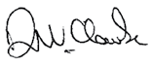
David Clarke CPA
Manager, Finance and Budget Branch

VEC Warehouse

VEC warehouse activity is an integral component of the VEC’s preparations for the council elections. A stock-take was completed early in 2011-12 to ensure that sufficient stock will be available to resource the election offices and voting centres for all 78 council elections. New equipment and supplies arriving at the warehouse were added to inventory and stored.
Over 100 inventory items have been compiled into consignments for each location and are ready for a staged roll-out from August to September 2012. Equipment such as note counters, letter openers, fax machines, photo copiers, first aid kits and multi-function devices were tested, serviced and prepared for delivery.
The four permanent warehouse staff were assisted by two casual staff, and consignments will be finalised before the first deliveries across the State in August 2012.


Our Commission

Aim
Responsible, transparent and accountable corporate citizenship

Strategies
- Conduct governance activities in accordance with legislation and corporate planning, striving for industry best practice
- Record and report reliable corporate data and information related to the operations of the VEC

Result
- All governance activities and risk management conducted diligently
- Records management processes and system upgraded to enable compliance with Victorian Electronic Records Strategy
- All reports delivered on schedule and in accordance with legislation, demonstrating accountability and transparency

Outlook, 2012–13
- The VEC will continue to conduct all activities in accordance with governing legislation, regulations and guidelines
- The VEC will continue to work diligently to ensure sound financial and risk management, and provide high quality, value for money electoral services to Victorians
- The VEC will develop and implement a waste management action plan as part of the WasteWise reaccreditation process
- There will be a focus on information and records management awareness, training and procedural compliance
- The implementation of the VEC’s internal audit schedule will continue

Inside this section
Governance 11
Organisational structure 12
Staff profile 13
The Electoral Commissioner 14
The VEC Management Group 15
Disclosures 23

Governance
The VEC is the administrative agency through which the Electoral Commissioner’s legislative obligations are exercised. The VEC is committed to ensuring that its policies and practices reflect good governance as well as complying with all relevant legislation. Adherence to the VEC’s governance framework demonstrates accountability to stakeholders and ensures the vitality and impartiality of the electoral system, now and into the future. Staffing and work practices are determined by the Public Administration Act 2004 and guided by the State Services Authority.
The VEC is an independent agency, operating under the auspices of the Department of Justice, within the portfolio of the Attorney-General, The Honorable Robert Clark. The Commission is not subject to the direction or control of the Minister in respect of the performance of its responsibilities and functions and the exercise of its powers.
The Secretary of the Department of Justice is responsible for providing support to Cabinet on matters relating to the VEC. The current Secretary, Ms Penny Armytage will leave the role early in 2012–13. The VEC thanks Ms Armytage for her support and looks forward to a similarly productive relationship with the new Secretary.
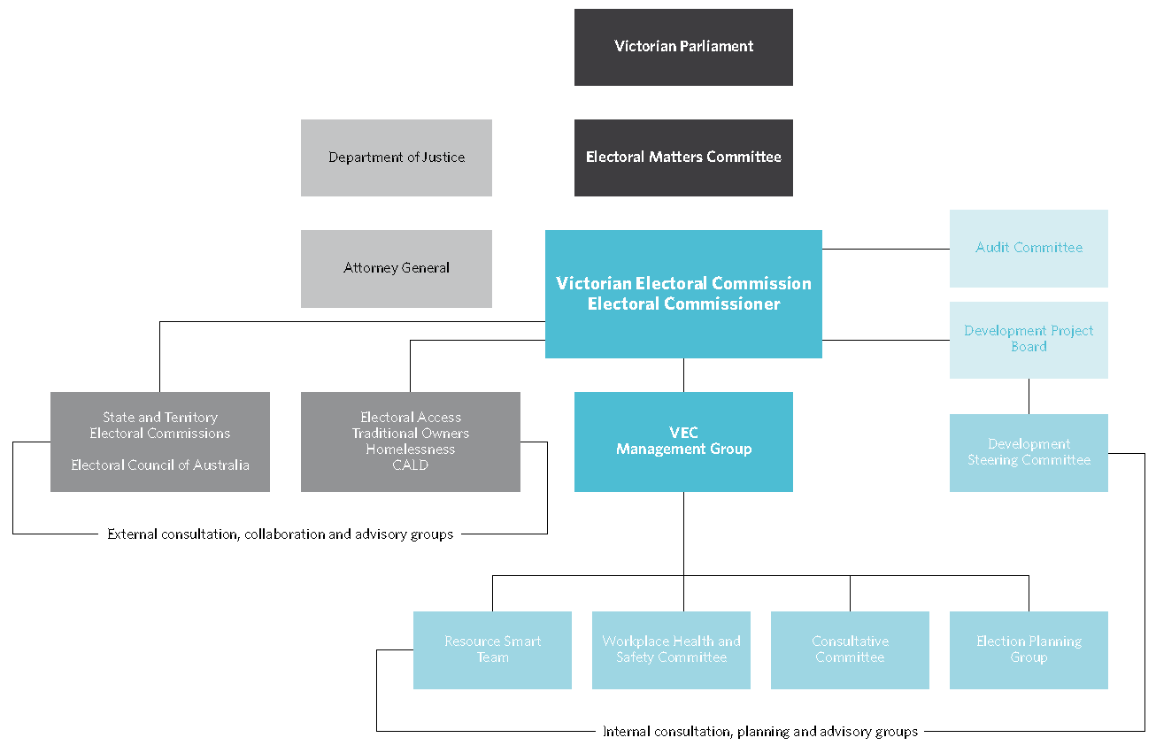
Figure 3 – Governance and consultation structure of the VEC

Organisational structure
The VEC’s organisational structure reflects the main activity areas of the VEC: Election Services, Election Administration, Electoral Enrolment, Finance and Budget, Information Technology, Communication, Education and Research, and Human Resources.
Figure 4 – VEC Organisational Structure
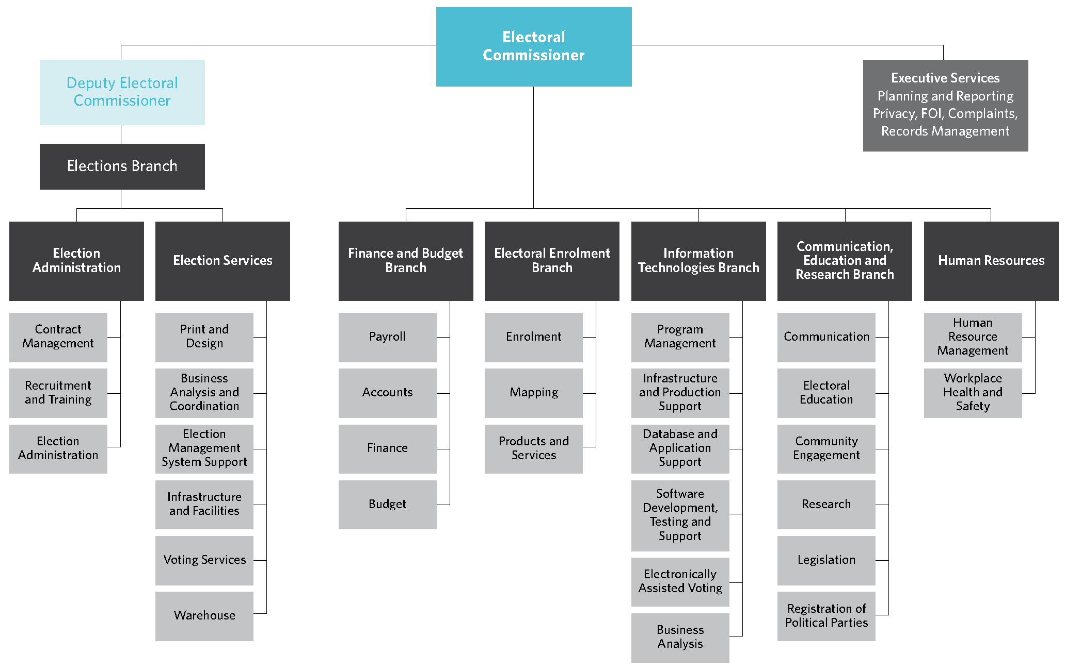

Figure 5 – VEC staff profile, 30 June 2012
Ongoing |  | Fixed Term |  | Casual |  | Total
Headcount | FTE | Headcount | FTE | Headcount | FTE | Headcount | FTE
60 | 56.7 | 16 | 16 | 9 | 5.2 | 85 | 77.9

 | Ongoing and Fixed Term |  | Casual |  | Total
Gender | Headcount | FTE | Headcount | FTE | Headcount | FTE
Male | 25 | 25 | 8 | 7 | 33 | 32
Female | 35 | 31.7 | 17 | 14.2 | 52 | 45.9
Totals | 60 | 56.7 | 25 | 21.2 | 85 | 77.9

 | Ongoing and Fixed Term |  | Casual |  | Total
Age | Headcount | FTE | Headcount | FTE | Headcount | FTE
Under 25 | 3 | 3 | 1 | 1 | 4 | 4
25-34 | 7 | 7 | 8 | 7.4 | 15 | 14.4
35-44 | 14 | 13.7 | 9 | 8 | 23 | 21.7
45-54 | 10 | 9 | 4 | 2.7 | 14 | 11.7
55-64 | 23 | 21.6 | 3 | 2.1 | 26 | 23.7
Over 64 | 3 | 2.4 | 0 | 0 | 3 | 2.4
Totals | 60 | 56.7 | 25 | 21.2 | 85 | 77.9

 | Ongoing and Fixed Term |  | Casual |  | Total
Classification | Headcount | FTE | Headcount | FTE | Headcount | FTE
Specialist technical staff | 2 | 1.6 | 0 | 0 | 2 | 1.6
VPS Executives | 0 | 0 | 1 | 1 | 1 | 1
VPS Grade 1 | 1 | 1 | 2 | 0.8 | 3 | 1.8
VPS Grade 2 | 12 | 9.8 | 3 | 2.6 | 15 | 12.4
VPS Grade 3 | 14 | 14 | 12 | 11.2 | 26 | 25.2
VPS Grade 4 | 8 | 7.8 | 4 | 2.6 | 12 | 10.4
VPS Grade 5 | 18 | 17.5 | 3 | 3 | 21 | 20.5
VPS Grade 6 | 5 | 5 | 0 | 0 | 5 | 5
Total | 60 | 56.7 | 25 | 21.2 | 85 | 77.9

The Electoral Commissioner

Electoral Commissioner (January 2005 to April 2012) – Steve Tully
The Electoral Commissioner is appointed by the Governor in Council and holds office for a period of 10 years. The Electoral Commissioner is ultimately responsible for the administration of the enrolment process and the conduct of parliamentary elections and referendums in Victoria.
Steve Tully commenced his appointment as Victoria’s Electoral Commissioner on 24 January 2005. Having commenced his career in the South Australian Premier’s Department in 1972, Steve went on to hold positions in the South Australian Department of Agriculture, the Public Service Board, the Department for Local Government and the Arts, as well as in the Mental Health Service of South Australia as the Chief 0perating 0fficer.
Steve joined the VEC from his previous position as South Australia’s Electoral Commissioner, a position he held from 1997 to 2005, after holding the position of South Australia’s Deputy Electoral Commissioner from 1996.
As the Victorian Electoral Commissioner, Steve has led the VEC through two State parliamentary elections, over 120 electoral representation reviews, and the conduct of local elections for Victorian councils in 2005 and 2008. Driving the VEC’s pursuit of innovation and excellence is Steve’s belief in the provision of high quality, accessible electoral services and education tailored to meet the needs of all Victorian electors.
Steve Tully resigned his position in April 2012, and the Deputy Electoral Commissioner, Liz Williams has been Acting Electoral Commissioner since 1 May 2012.
The Electoral Commissioner is assisted by the Deputy Commissioner and the Executive Services team with responsibility for:
- corporate planning and reporting
- records management
- freedom of information
- information privacy awareness
- management of electoral information access applications.

Deputy Electoral Commissioner (Acting Electoral Commissioner) – Liz Williams

Liz Williams has worked closely with the Electoral Commissioner in the management and administration of the VEC, and has been Acting Electoral Commissioner since May 2012.
Liz has significant electoral experience gained in various roles held during the numerous State, council and non-government elections that have been conducted since starting with the VEC.
Commencing as a Returning 0fficer in 1992, Liz moved to an ongoing full-time appointment in 1996 and was appointed Deputy Electoral Commissioner in 2005. Liz also managed the Election Administration Sub-branch until taking on the role of Acting Electoral Commissioner.
Liz believes fostering a working environment that promotes learning and collaboration drives innovation and excellence in election administration, and that efficient and inclusive electoral processes are integral to full democratic participation.

The VEC Management Group

Elections Branch

Responsible for the planning and conduct of State, council and commercial elections, the Elections Branch is divided into two sub-branches, Election Administration and Election Services.
Elections Branch:
- promotes the VEC’s council election services and tendering to conduct council elections
- recruits, trains and assesses election managers and election officials
- develops election manuals and handbooks
- acquires and resources election offices, early voting centres and voting centres
- develops and implements election management systems.

Election Services Sub-branch Manager – Glenda Frazer
The Election Services sub-branch aims to provide accessible and well-equipped voting centres and election offices, and to ensure that voting materials are accurate, easily understood and available on time.
Glenda Frazer commenced with the VEC in 1988 and has been a Returning 0fficer at three State elections and one council election. She moved to a full-time position in 1995. Glenda has extensive knowledge of the conduct of elections with significant experience in the application of information technology to elections.
Glenda is responsible for major large scale operations for the VEC and is the State election program manager. She believes thorough planning and preparation enables voters to experience trouble-free elections. Glenda and her team are focused on the efficient and effective delivery of election services.
Since May 2012, Glenda has also taken on a number of responsibilities previously held by the Deputy Electoral Commissioner.

Election Administration Sub-branch Acting Manager – Ruth Coulson

The Election Administration sub-branch undertakes large- scale recruitment and training projects, providing information and support for Returning 0fficers and their staff. The team also manages substantial election contracts with council, statutory and fee-for-service clients.
Ruth Coulson has been Acting Manager of the Election Administration Sub-branch since May 2012. After starting her career in teaching and teacher education, Ruth commenced with the VEC, being appointed as Returning Officer for the Districts of Northcote and Preston for the 1999 State election. She moved to head office in 2001, initially working on the development of training materials as part of the Election Administration Team.
Ruth has broad election experience, and has made a significant contribution to the training and development of election officials, both practically and in the development of training materials. With her strong background in election administration and education, Ruth believes that comprehensive training supported by good processes and documentation is critical for the successful conduct of elections.

Communication, Education and Research Branch Manager – Sue Lang

The Communication, Education & Research Branch provides information and education services to stakeholders about key electoral events, including:
- development and implementation of communication strategies for electoral events
- delivery of information services to stakeholders
- development of strategies to promote and encourage electoral enrolment and involvement
- provision of electoral education and outreach services
- provision of advice on electoral legislation and strategic matters
- provision of research services and information.
Sue joined the VEC in 2006 after spending much of her career in senior communication roles within the metropolitan water industry, local government, statutory authorities and State Government. She has particular experience in major public awareness programs.
Sue and her team aim to effectively communicate electoral information and education to the many diverse groups throughout Victoria. An area of increasing interest to Sue is the use of social media to inform, engage and provide services to the community.

Electoral Enrolment Branch Manager – Paul Strickland

In addition to maintaining an up-to-date and accurate electoral roll, the Electoral Enrolment Branch provides the following services:
  - implementation of electoral enrolment programs
  - conduct of electoral representation reviews for councils and supports electoral boundary work by the Electoral Boundaries Commission
  - production of electoral rolls and other roll products
  - provision of advice on electoral enrolment matters.
Paul has comprehensive experience and expertise in election operations gained during more than 25 years with the VEC. He joined the management team in 2005, and is responsible for the preparation and provision of accurate electoral rolls and mapping data.
Paul views the integrity of the Enrolment Register as paramount. He and his team make sure that electors’ personal details are accurate, up-to-date and securely stored. Also involved in managing electoral representation reviews, Paul’s team employ a variety of administrative, technological, mapping and geospatial knowledge and skills to help ensure that Victorian electors have fair and equitable representation.

Information Technology Branch Manager – Simon Hancock

Providing information technology expertise and support across the VEC, both at head office and throughout the State, the Information Technology Branch:
- provides a stable and reliable technology environment for the VEC
- plans, sets up and supports the technology used during the conduct of all elections
- maintains and enhances the VEC’s enterprise software
- maintains and administers the VEC’s corporate databases
- manages the VEC technology environment.
Simon commenced at the VEC in 2000 and has managed the Information Technology (IT) Branch since 2003. Prior to working at the VEC, Simon worked for a number of information technology companies providing project management and technical consultancy over a range of industry settings.
Simon considers that the provision of excellent IT services is vital for the success of all VEC operations. Simon’s team provides hardware and software support for everyday VEC activities, providing extremely high volume support during election periods.

Finance and Budget Branch Manager – David Clarke CPA

The Finance and Budget Branch maintains the VEC financial management systems, manages the VEC’s budget and expenditure and provides VEC payroll services.
David Clarke joined the VEC in 2004, coming from local government, after 20 years service with various councils and in the private sector. David views sound budgeting and accounting as crucial to good business and to maintaining Victorians’ confidence in the VEC. David and his team ensure that the organisation complies with all financial and auditing requirements. The Finance and Budget Branch also manages payroll services for core VEC staff and up to 17,000 casual appointees over election periods.

Human Resources Manager – Gill Kelly

Gill commenced with the VEC in 2000 in the position of Human Resources Manager. Gill has significant experience in people management initiatives. Gill believes that people must be supported and motivated, as well as being provided with a safe and enjoyable working environment. Gill consults with various VEC representative groups to develop and implement performance management, learning and development, occupational health and safety and employee relations programs.

Internal committees and groups
A number of consultation groups and committees assist the Electoral Commissioner and Management Group with the development and implementation of strategies and policies, providing expertise and promoting staff consultation.

Election Planning Group
The Election Planning Group (EPG) is the major cross- organisational work group. Operating continuously, the EPG plans, tracks and monitors the implementation of elections across the VEC.

Consultative Committee
The Consultative Committee (CC) provides a mechanism for communication flow between management and employees on major people management and organisational policy issues. Meeting monthly, the group is comprised of a representative from each area of the VEC. The CC incorporates the Workplace (0ccupational) Health and Safety Committee, with each member being a designated health and safety representative.
During 2012–13, as part of a realignment of organisational culture, the CC charter and the roles of the CC members will be reviewed.

Development Steering Committee
The Development Steering Committee (DSC) meets fortnightly and provides strategic oversight to the VEC’s Information Technology (IT) development program. The DSC is responsible for ensuring the program is consistent with the VEC’s business strategy and that appropriate controls are in place. DSC members include Branch Managers, the IT Program Manager and the Business Development Coordinator. The DSC is chaired by the Deputy Electoral Commissioner or delegate.

ResourceSmart Committee
The ResourceSmart Committee oversees the implementation of the VEC’s Environmental Management Plan with the purpose of raising awareness of environmentally sound work practices and reducing the negative environmental impact of the organisation.

Homeless not Voteless
The Community Education and Engagement Team has fostered strong partnerships with homelessness agencies through its Homelessness Advisory Group. Statutory changes that enable easier identification requirements for potential electors have provided a focus.
An awareness campaign complemented a resource kit developed specifically for agencies supporting people experiencing homelessness. The campaign and kit explain changes and raise awareness of the services available to engage people experiencing homelessness in the electoral process. The team has established several new relationships with agencies across the State and intends to deliver an extensive State-wide package of outreach to support the participation in council elections by those experiencing homelessness.


External advisory groups
The VEC has established a number of advisory groups to provide advice and assistance with service provision, employment and electoral education for specific groups in the community.

Electoral Access Advisory Group
The Electoral Access Advisory Group (EAAG) provides advice and knowledge to the VEC in relation to accessibility, continually challenging and assisting the VEC in its aim to provide universal access across all organisational functions.
The EAAG met twice during 2011–12; firstly as a subgroup to discuss workplace health and safety aspects outlined in the VEC’s recently revised Disability Action Plan. The EAAG agreed on an approach that initially considers whether an individual meets the requirements of the role and if so, consultation with that person will identify adjustments reasonably required in the workplace.
The second meeting focussed on the 2012 council elections. The VEC’s election plan was considered and items discussed included the proposed reintroduction of Braille and large print ballot papers (on request), the production of an Auslan DVD containing general information about enrolling and voting, accessible voting venues, outreach education services and employment opportunities.

Homelessness Advisory Group
The VEC’s Homelessness Advisory Group provides advice and assistance in relation to working with homelessness agencies to ensure that everyone has access to the electoral process, regardless of their current living situation. During 2011–12 the Group considered ways to raise awareness of the availability and importance of voting in the upcoming council elections among people experiencing homelessness. Following these elections the Group will reconvene to evaluate the programs and explore opportunities for the VEC to offer employment to people experiencing homelessness.

Aboriginal Advisory Group
The VEC’s Aboriginal Advisory Group (AAG) includes Traditional Owners, the Victorian Electoral Commissioner and VEC staff. The group advises and assists the VEC in its aim to develop effective resources and materials, and deliver education, seminars and workshops.
During 2011–12, the AAG met to consider strategies to raise awareness of the upcoming council elections and to explore ways that the VEC can acknowledge and celebrate the 50th anniversary of the right to vote being granted to Indigenous Australians. The group also considered the findings of the Colmar Brunton Social Research on voting behaviour among Indigenous communities. The VEC will continue to strengthen its working relationships with providers of services to Indigenous communities across Victoria to increase electoral engagement.

Culturally and Linguistically Diverse Advisory Group
The VEC also works with representatives from agencies working with culturally and linguistically diverse (CALD) communities, meeting less frequently, and generally working with particular agencies to develop resources in response to community specific needs.

Governing legislation
The two pieces of legislation that set out the VEC’s primary responsibilities are the Constitution Act 1975 and the Electoral Act 2002.
In accordance with this legislation, the VEC conducts State and local government elections and by-elections, and certain statutory and fee-for-service elections. The VEC also provides advice to the Attorney-General and Parliament on electoral issues. 0ther legislation and regulations imposing certain duties on the Electoral Commissioner are listed in Appendix B.

Legislative and regulatory amendments
Section 35 of the Equal Opportunity Amendment Act 2011 amended the Electoral Act 2002 to enable the VEC to ask applicants for appointment or employment for disclosure of specific political activities. This amendment replaces the previous exemption granted to the VEC in 2009–10, and came into force on 1 August 2011.
The VEC assisted Local Government Victoria with the review of the Local Government (Electoral) Regulations 2005.
The Local Government (Electoral) Amendment Regulations 2012 were passed in June 2012, effective immediately. The amendments are summarised in Appendix C.
Legislative changes enacted during 2011–12 and affecting the VEC include:
- The City of Melbourne Amendment (Enrolment) Act 2012, amending the City of Melbourne Act 2001 to clarify the persons entitled to apply to be enrolled on the voters roll (June 2012)
- The City of Melbourne Amendment Act 2011, containing minor amendments to apply election-related amendments made in the Local Government Act 1989, to change a number of timeframes and to fill vacancies that result from general elections (February 2012)
- The Local Government (Brimbank City Council) Act 2009 was amended to provide for the next general election of the Brimbank City Council to be held on the fourth Saturday in March 2015 rather than in October 2012.

Court of Disputed returns
Parliament alone has the authority and jurisdiction to determine who and how a person can be elected to Parliament, and to determine whether a person has been validly elected. To ensure disputes are settled in a bi-partisan manner, Parliament creates an independent, neutral body (Court of Disputed Returns) to make these determinations. Under the Electoral Act 2002, the Supreme Court of Victoria is the Court of Disputed Returns. There were no petitions brought before the Court during 2011–12.

Municipal Electoral Tribunal
The Local Government Act 1989 (LGA) (s.45) provides for a candidate in the election, or ten voters who dispute the validity of the election, to apply for an inquiry into the election by a Municipal Electoral Tribunal (MET). Applications must be lodged within 14 days of the declaration of the result of an election. No applications were lodged with MET during 2011–12

Victorian Civil and Administrative Tribunal
Section 48(2) of the LGA allows a person whose interests are affected by a MET decision to apply to the Victorian Civil and Administrative Tribunal (VCAT) for a review of that decision. No applications were lodged with VCAT in relation to local government election matters during 2011–12.
One matter concerning political party registration that had been ongoing for a number of years went before VCAT and subsequently to the Supreme Court. The matter was decided in 2011–12 and is detailed on page 40.

Accountability and transparency
The VEC has legislated and organisational processes in place to ensure transparency and accountability to the Victorian public. These include internal and external auditing, regular reporting to stakeholders including Parliament, Government and the public, and tabling of audited financial statements as part of this report.

Financial Management Compliance Framework
The Financial Management Compliance Framework has been developed to provide the Minister for Finance an assurance that Victorian Police Service entities have implemented the appropriate systems to ensure compliance with the framework directions to provide for effective, efficient and responsible financial management of public resources.
The directions include:
- financial management governance and oversight – which includes financial code of conduct, financial governance including the establishment of an Audit Committee, financial risk management, authorisations, and internal and external audits
- financial management structure, systems, policies and procedures – which includes roles and responsibilities of the financial management team, policies and procedures, managing outsourced services, information technology management, operations, development and change, education and training
- financial management reporting – which includes internal and external reporting; reporting requirements for Financial Statements and Report of Operations in accordance with part 7 of the Financial Management Act, performance management and evaluation, financial management compliance obligations, tax compliance, purchasing cards and thefts and losses compliance.
- the Financial Management Framework is audited by the internal auditor, and reviewed by the Audit Committee. The VEC is fully compliant with the framework directions.

Development Project Board
The VEC has established a governance model for the program of works to redevelop the systems used to support and manage electoral events. This model includes the establishment of a Development Project Board to ensure that appropriate controls are in place, and to provide advice to the Development Steering Committee.
The Board consists of the Electoral Commissioner, the Director of the Major Procurement Program Office (MPPO) in the Department of Justice (or delegate) and a member of the VEC’s Audit Committee.
The VEC’s IT Manager and the Deputy Electoral Commissioner (or delegate) are ex-officio members who provide information and secretarial support to the Board.

Passport to Democracy – youth engagement
The message, promoted by ‘Passport to Democracy’, that young people can take action in their community on issues important to them, will be prominent in a lift out supplement and online teacher guide to be produced in partnership with The Age newspaper. The aim of the supplement is to raise awareness of the council elections among young people and teachers. The lift-out will encourage students to see the council elections as an opportunity to have their voices heard and their concerns considered by candidates and councillors.
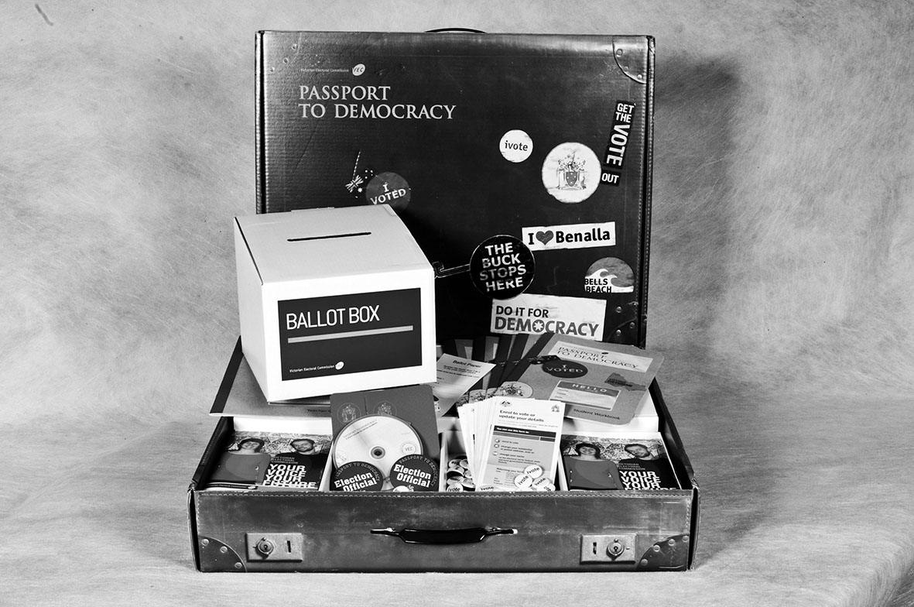

Audit Committee
The primary objective of the Audit Committee is to assist the Electoral Commissioner in fulfilling the VEC’s responsibilities and to add value to the accounting, operational practices, controls and risk strategies of the Commission. This involves overseeing:
- financial performance and reporting including the financial statements
- the scope of work, performance and independence of the internal and external audit
- monitoring VEC compliance with the Financial Management Compliance Framework including financial policies and procedures and the Victorian Government Risk Management Framework including the attestation by the Electoral Commissioner in the Annual Report
- matters of accountability and internal control.
In 2011–12 the Committee comprised:
- Mr Robert Yeo (Chairman), consultant
- Ms Elizabeth Reeves, accountant and senior election official
- Mr David Fahey, accountant.
The Committee held four formal meetings during the year, with other informal meetings and discussions between members and the Electoral Commissioner and Manager of Finance and Budget on various issues and outcomes. The internal and external auditors attended meetings as required.
During the year, the internal audit function was performed by HLB Mann Judd, and the external audit by the Auditor General’s agent, LDAssurance.
At its meetings, the Audit Committee considered and discussed the following:
Financial and other reports
- review of the financial statements and audit management letter, and follow up action taken in relation to outcomes raised
- receipt and review the Auditor General’s audit program
- a report on the VEC’s use of portable storage devices
- insurance coverage
- review status of the implementation of the Privacy and Occupational Health and Safety audit recommendations.
Internal Audit program and a review of outcomes of audits conducted for:
- VicRoads – Statement of Compliance of confidentiality of data
- fringe benefits tax
- taxation compliance
- Financial Management Compliance and Risk Management Framework
- travel approvals and expenditure
- trust account management, compulsory voting and candidates deposits
- local government charging framework.

Corporate planning
The VEC Corporate Plan provides the strategic basis for operations. The VEC reports against the Plan in its annual report, and the Plan is central to staff performance planning and review. Staff training is linked to corporate objectives and strategies as well as to organisational and professional needs.
The previous Plan came to a close in June 2012, just after Steve Tully left the role of Electoral Commissioner. Prior to his leaving, an interim plan was developed to provide strategic direction, certainty of purpose and goal congruence to the VEC staff and suppliers, and assurance to the many stakeholders, including Parliament. The Plan will continue to be developed for review by the incoming Electoral Commissioner and will help ensure that the VEC continues to deliver its statutory mandate in a fair, transparent, effective and accountable manner.
In addition, managers develop operational plans across all areas including human resources, information technology, governance, finance and budget, and communication, all of which are essential enablers in meeting objectives.

Corporate reporting
The VEC has a comprehensive program of reporting to stakeholders that supports our goals of accountability and transparency. During 2011–12 the VEC tabled two reports before Parliament: the 2010–11 Annual report and the Report of the conduct of the Niddrie District by-election. A Report of Local Government Activity for 2010–11 was provided to the Minister for Local Government. The VEC’s 2010–11 Annual Report was provided to the Attorney-General and delivered to Parliament in accordance with the tabling schedule. Official tabling was delayed by one month. All reports are available on vec.vic.gov.au and from the VEC.

Disclosures

Public administration values and employment principles
The VEC maintains and implements a suite of policies and guidelines with respect to upholding public sector conduct, managing and valuing diversity, employment, managing underperformance, reviewing personal grievances, and selecting on merit.

Human resource management
The goal of the VEC’s Occupational Health and Safety (OHS) strategy is to ensure all staff remain safe and healthy at work. An OHS management system has been put in place and branches within the VEC have implemented OHS local action plans aimed at enhancing safety performance and ensuring safe systems of work. There were no lost time injuries during 2011–12. For more on human resource management at the VEC, including our performance against OHS management measures, see the Our People section of this report.

Executive officer data
The Electoral Commissioner and Deputy Electoral Commissioner are appointed by the Governor in Council as statutory office holders. These appointments do not fall within the definition of executive officer under Public Administration Act 2004.

Implementation of the Victorian Industry Participation Policy
The Victorian Industry Participation Policy Act 2003 which requires public bodies and departments to report on the implementation of the Victorian Industry Participation Policy.
No contracts to which the VIPP apply were commenced or completed by the VEC during 2011–12.

Disclosure of grants and transfer payments (other than contributions by owners)
Included in the ‘Total expenses from transactions’ are payments of grants and assistance to certain companies and organisations. During 2011–12, the VEC provided grants to two organisations (see Figure 6).

REAL Camps for Indigenous youth
The VEC has developed partnerships with external organisations such as the Tigers in the Community Foundation Ltd, Korin Gamadji REAL Camps. The VEC supports REAL camps, and helps deliver electoral education to young Aboriginal Australians identified as being potential role models and leaders.
our voters


Figure 6 – Grants to external bodies, 2011–12
Organisation | Purpose of grant | Amount
Tigers in the Community Foundation Ltd – Richmond Emerging Aboriginal Leadership (REAL) Camps | Support of Richmond Emerging Aboriginal Leaders camps (at Korin-Gamadji-Institute) for Indigenous youth to build their leadership skills and position them as role models within the community | $77,000
Electoral Regulation Research Network | Support the establishment of the Electoral Regulation Research Network to foster exchange and discussion on research relating to electoral regulation | $25,000

Contracts and consultancies
The VEC lodged a submission with the Accredited Purchasing Unit for approval of a contract to develop a personnel management system. At the time of this report, the VEC is awaiting the outcome of the submission.

Consultancies over $10,000
In 2011–12, the total for the consultancies engaged during the year, where the total fees payable to the consultants was more than $10,000, was $65,286. All figures exclude GST. (See figure 7).

Consultancies under $10,000
In 2011–12, the total for the consultancies engaged during the year, where the total fees payable to the consultants was less than $10,000, was $14,128. All figures exclude GST. (See figure 8).

Disclosure of major contracts
In accordance with the requirements of Government policy and accompanying guidelines, the VEC discloses all contracts greater than $10 million in value which it entered into during the year ended 30 June 2012. No contracts greater than $10 million in value were entered into by the VEC during 2011–12.

Compliance with the Building Act 1993
The VEC does not own or control any Government buildings and consequently is exempt from notifying its compliance with the building and maintenance provisions of the Building Act 1993.

National Competition Policy
Competitive neutrality requires government businesses to ensure where services compete, or potentially compete with the private sector, any advantage arising solely from their government ownership be removed if they are not in the public interest. Government businesses are required to cost and price these services as if they were privately owned and thus be fully cost reflective. Competitive neutrality policy provides government businesses with a tool to enhance decisions on resource allocation. This policy does not override other policy objectives of government and focuses on efficiency in the provision of service.
The VEC continues to comply with the requirements of the National Competition Policy.
Figure 7 – Consultancies over $10,000
 | Amount
Electoral Representation Reviews | $21,281
Electoral Representation Reviews | $13,292
Electoral Representation Reviews | $12,531
Population projections for 2013 State boundary redivision | $18,182

Figure 8 – Consultancies under $10,000
 | Amount
Occupational Health and Safety | $5,220
Occupational Health and Safety | $2,998
Professional Development | $5,910

Freedom of information
The Freedom of Information Act 1982 gives Victorians the right to access certain classes of documents held by Government agencies. Staff are regularly reminded of their obligations under the Freedom of Information Act 1982 and staff memorandums relating to registration, retention and storage of documents were regularly issued. One Freedom of Information application was received by the VEC in 2011–12. The request was from a member of the general public and was acceded to in full.

Making a request
Access to documents may be obtained through written request to the Freedom of Information (FOI) Officer, as detailed in s17 of the Freedom of Information Act 1982. In summary, the requirements for making a request are:
- it should be in writing
- it should identify as clearly as possible which document is being requested
- it should be accompanied by the appropriate application fee (the fee may be waived in certain circumstances).
Requests for documents in the possession of the VEC should be lodged by email to foi@vec.vic.gov.au or by mail addressed to:
Freedom of Information Officer
Victorian Electoral Commission
Level 11, 530 Collins Street
Melbourne VIC 3000
Access charges may also apply once documents have been processed and a decision on access is made; for example photocopying and search and retrieval charges.
Further information regarding Freedom of Information can be found at www.foi.vic.gov.au.

Information privacy
The VEC collects and handles personal information in relation to both the Victorian public and VEC staff in order to fulfil its functions under the Electoral Act 2002. The VEC’s policies regarding management of personal information comply with the Information Privacy Act 2000 and are set out in its Privacy Policy, which is available at vec.vic.gov.au or at the VEC.
During 2011–12, the VEC Privacy Awareness 0fficer attended privacy network meetings on a regular basis and relevant information was disseminated to staff. Privacy awareness activity continued during 2011–12 to ensure that VEC staff continue to implement information privacy procedures.
Two complaints in relation to breaches of information privacy were received by the VEC during 2011–12. In response to these complaints, the VEC conducted investigations and found that in each instance a breach had occurred. In one case a procedural error had been made, and in the other a computer application fault had contributed to the cause. The VEC immediately implemented procedures and remedies to eliminate the risk of a recurrence of the breach.
The VEC also received a number of inquiries relating to the discretionary granting of access to enrolment information. The VEC provided responses outlining the granting of access and explaining that it is lawful, being authorised under the Electoral Act 2002 and the Information Privacy Act 2000.

Information and records management
The VEC has responsibility for election materials and other documents that must be stored and kept for the future. The VEC has directed considerable effort to training staff in records management, and updating and maintaining its document control, filing and archiving.
During 2011–12, the systematic upgrade of document filing, archiving, retention and destruction continued. The VEC upgraded its records management system in order to expand its capacity to comply with the Victorian Electronic Records Strategy in the future. A review of information and records management processes and support will be undertaken in 2012–13.

Disclosure index
The Annual Report of the VEC is prepared in accordance with all relevant Victorian legislations and pronouncements. A disclosure index has been prepared to facilitate identification of the VEC’s compliance with statutory disclosure requirements. The disclosure index is included as Appendix A.

Compliance with Whistleblowers Protection Act 2001
The Whistleblowers Protection Act 2001 encourages and assists people in making disclosures of improper conduct by public officers and public bodies. The Act provides protection to people who make disclosures in accordance with the Act and establishes a system for the matters disclosed to be investigated and rectifying action to be taken.
The VEC does not tolerate improper conduct by employees, nor the taking of reprisals against those who come forward to disclose such conduct. It is committed to ensuring transparency and accountability in its administrative and management practices and supports the making of disclosures that reveal corrupt conduct, conduct involving a substantial mismanagement of public resources, or conduct involving a substantial risk to public health and safety or the environment.
The VEC will take all reasonable steps to protect people who make such disclosures from any detrimental action in reprisal for making the disclosure. It will also afford natural justice to the person who is the subject of the disclosure to the extent it is legally possible.

Reporting procedures
Disclosures of improper conduct or detrimental action by the VEC or its employees may be made to the following officer:
Human Resources Manager
Victorian Electoral Commission
Phone 03 8620 1100

Further information
Written guidelines outlining the system for reporting disclosures of improper conduct or detrimental action by the VEC or its employees are available on the VEC website.

Disclosures under the Whistleblowers Protection Act 2001
There were no disclosures during 2011–12.

Pecuniary interest declarations
The Electoral Commissioner, Mr Steve Tully, the Deputy Electoral Commissioner, Ms Liz Williams, and all VEC managers have completed declarations of pecuniary interests as required.

Attestation to Public Sector Standards Commissioner
The Electoral Commissioner, Steve Tully, completed the annual attestation of hospitality and gifts as required.

Compliance with the Disability Act 2006
The Disability Act 2006 requires that all public sector bodies prepare a disability action plan and that departments report on the implementation of their disability action plan in their annual report. See page 49 for information on the VEC Disability Action Plan.

Compliance with other legislation
The VEC is subject to, and complies with a range of legislation as listed in Appendix B, and detailed in this report as applicable.

Indigenous Victorians
During 2011–12 the VEC was involved with The Long Walk Festival at Birrarung Marr for the first time. Over 2,000 people engaged with the VEC, updating enrolment details and learning about the upcoming council elections.
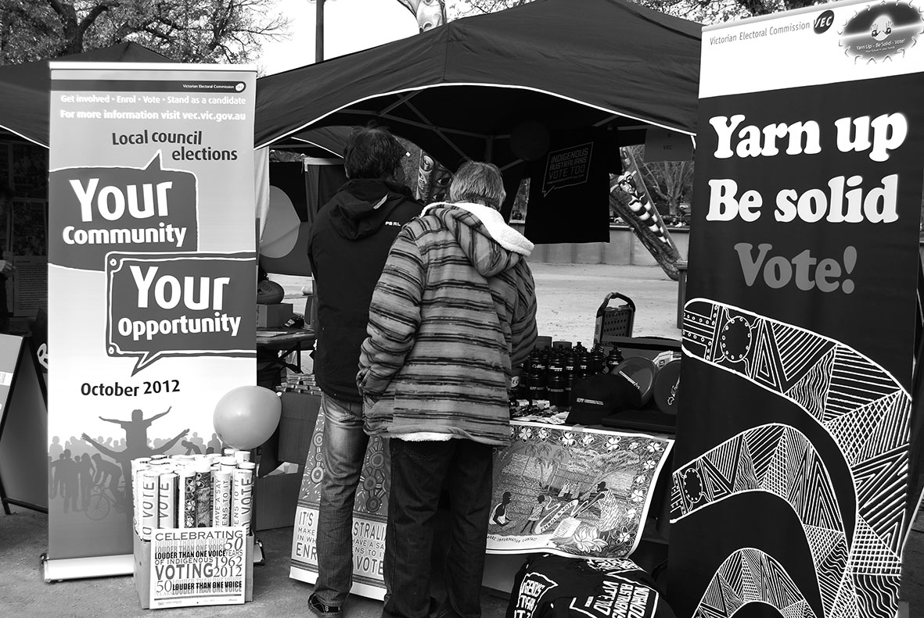

Additional information available on request
Information relating to the 2011–12 reporting period is made available to Ministers, Members of Parliament and the public on request (subject to the Freedom of Information Act 1982) is listed in Appendix D.

Identifying and managing risk
The Victorian Government Risk Management Framework provides for a minimum risk management standard across public sector entities. The Electoral Commissioner is responsible for the development and implementation of the framework and processes to ensure that risks are being managed in a consistent manner.
Risk management is built into the planning and reporting processes. The risk package is audited and reviewed by the Audit Committee. The VEC conducts assessments to identify other organisational risks, evaluates risk controls in place and develops new controls where required.
Risks are rated according to their hazard potential across operational and non-operational activities. Risk ratings are presented to the Audit Committee in accordance with its charter. This Committee determines whether adequate controls in place, and whether a periodic review of those controls is required.
At an operational level, the VEC has comprehensive risk management plans for all electoral events. These are developed, discussed and analysed at branch level during the planning phase and cover election management, infrastructure, communication, recruitment and information technology. Risk management is addressed at senior management level and in staff meetings.
Legal and compliance issues associated with occupational health and safety are managed through the VEC’s Consultative Committee, which meets every month.
The Audit Committee recommends new (or amendments to existing) policies and procedures, and considers the method by which information is provided to employees.

Attestation for compliance with the Australian/New Zealand Risk Management Standard
I, Liz Williams, certify that the Victorian Electoral Commission has risk management processes in place consistent with the Australian/New Zealand Risk Management Standard [or designated equivalent] and an internal control system is in place that enables the executive to understand, manage and satisfactorily control risk exposures.
The Audit Committee verifies this assurance and that the risk profile of the Victorian Electoral Commission has been critically reviewed within the last 12 months.
Liz Williams
Acting Electoral Commissioner
9 August 2012

Environmental sustainability
In 2011–12, the VEC continued its commitment to reducing the negative impact of its operations on the environment with ongoing communication and information programs to encourage continued positive behavioural changes, and a focus on achieving WasteWise re-accreditation in 2012–13. An update of the Environmental Management Plan has commenced and will be completed in 2012–13.

Energy
The ResourceSmart activities of the VEC have received a boost from its move to a modern 5-star NABERS rated building that has proactive, environmentally aware building management. Up-to-date recycling facilities, efficient building design, smart lighting and a positive attitude have seen the VEC show a measurable improvement in resource efficiency.
A significant decrease in energy consumption has been recorded since the VEC moved to its new premises (see Figure 9). The number of printing devices has been dramatically reduced with individual printers replaced by shared multi-functional devices with a high energy efficiency rating. It should be noted that, while staff continue to pursue energy-efficiencies in their daily activities, the building is fitted with a cogeneration plant which provides energy for the building’s core services such as air conditioning. The advantages of the VEC being able to plan and implement the fit-out of the tenancy to take advantage of the available technology and efficiencies were able to be included from the outset.
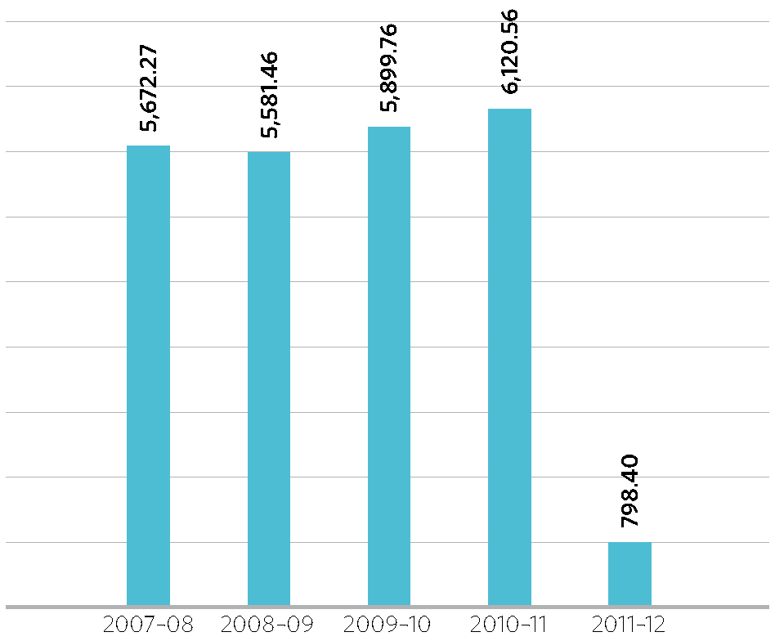
Figure 9 – Energy consumption at VEC head office, annual KWh per FTE, 2007–08 to 2011–12
Note: Previously reported as monthly average KWh per FTE

Waste management
A waste audit conducted after 12 months at the new site showed a recycling rate of 88.2%, which is the percentage of materials discarded for recycling as a percentage of all the materials discarded (see Figure 10). However, 63.9% of materials discarded to landfill were found to be recyclable or compostable. Paper cups, which are not accepted in the building’s recycling program form 12.3% of this total, and the VEC will continue to encourage the use of reusable cups, and on improving staff knowledge and motivation to comply with sorting guidelines.
The ResourceSmart Committee is keen to build on these gains by assisting and encouraging staff to go the ‘extra mile’. The Committee will continue to conduct waste audits and monitor power, water and paper usage, and aims to make the results of this work available to all staff in a meaningful and accessible way.
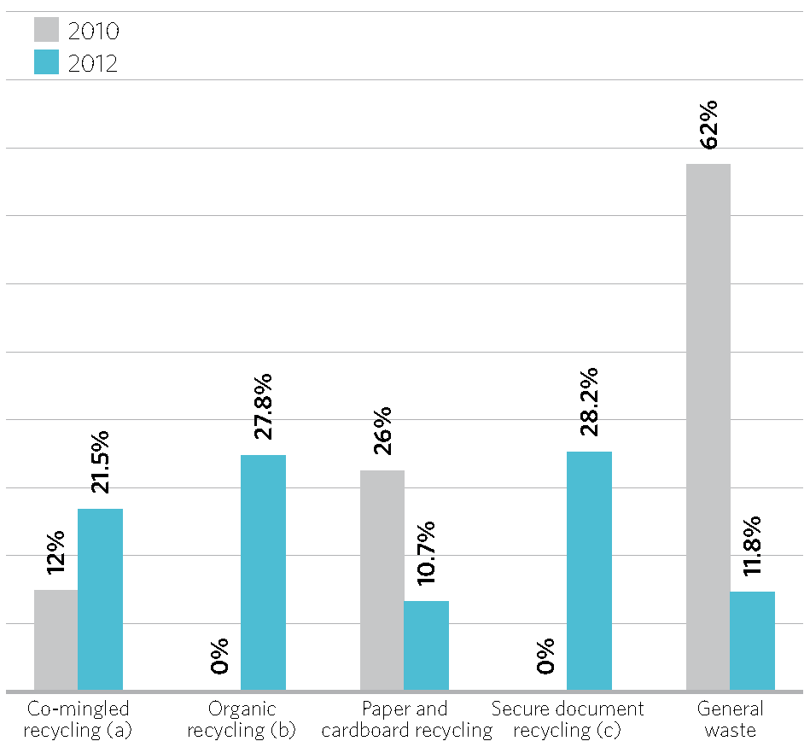
Figure 10 – Waste by stream, VEC, June 2010 and 2012
(a) Paper cups are not accepted into the comingled recycling stream at current premises
(b) Organic recycling was not available at old premises
(c) Secure document recycling was not audited in 2010

Easy English guides
The Communication Education and Research Branch has produced and distributed five Easy English guides containing information targeted to specific audiences.
- Easy English Guide to Voting in Council Elections – Postal, Attendance , Greater Geelong and Melbourne City Council; produced and distributed to more than 3,000 community groups in preparation for the 2012 council elections
- Easy English Guide – Homeless Doesn’t Mean Voteless; distributed to more than 300 homelessness agencies and support services.

Procurement
Procurement of the required stock and equipment for the conduct of the 2012 Council elections is a complex and lengthy task. It involves projects including developing estimates based on past elections, algorithms to calculate requirements, quote and tender sourcing and contract negotiation and back-up planning so that the requirements are fulfilled with best use of public funds. Stock and equipment organised by the VEC procurement team includes:
- ballot paper stock – 1,880,000 sheets of 80gsm reprint recycled stock purchased and delivered to storage
- City of Melbourne Leadership and Councillor booklet stock – 700,000 sheets of 73gsm Alpha Matt purchased and delivered to storage
- cardboard equipment – 600 ballot boxes, 200 clerical desks, 100 pigeon hole sets, 2,000 security boxes, 4,200 voting compartments (with multi-language voting instructions printed on inside panel) and 25,000 archive boxes purchased to supplement existing stock
- 5,000,000 “special make” ballot paper and declaration envelopes manufactured, printed and delivered to storage
- 10 photocopiers and 10 fax machines purchased to supplement existing stock, and assorted stationery items for Election Offices have been purchased and delivered to storage
- the majority of council elections will be by postal voting. To assist with the extraction process, 60 envelope opening machines were purchased to supplement existing stock.

Our Core Business

Achievements 2011–2012

Aim
High quality election services, in accordance with legislation

Strategies
- Collaborate across all business areas to ensure effective delivery of increasingly accessible election services so that all elections, by-elections and polls are conducted on time, within budget and in accordance with legislation, rules and guidelines
- Use information technology and specialised electoral expertise to support and enhance the delivery of electoral services
- Collaborate with other electoral bodies to continually improve electoral service capacity and staff knowledge and skills

Result
- The VEC conducted all elections, by-elections and polls on time, within budget and in accordance with legislation or rules
- No matters taken to tribunal, no elections failed or overturned
- Redevelopment of Election Management System software to support nominations, results and computer count on schedule for 2012 Council elections

Aim
Fair and equitable representation at State and local government levels

Strategies
- Conduct electoral representation and subdivision reviews on time, within budget and in accordance with legislation
- Use geospatial mapping technology, cross-organisational collaboration, independent local government expertise and public consultation to ensure accurate research and well-informed decision-making

Result
- The VEC conducted 28 representation reviews and three subdivision reviews on time, within budget and in accordance with legislation
- All VEC recommendations were approved by the Minister for Local Government without amendment
- Predominantly positive feedback from review evaluation survey participants

Highlights
- Electronic roll mark-off successfully implemented at all voting centres for the first time at a State by-election
- Supported the establishment of the University of Melbourne Electoral Regulation Research Network in conjunction with NSW Electoral Commission

Outlook, 2012–13
- Conduct of the 2012 council elections, providing electoral services to over 4.1 million voters
- Provide secretarial, enrolment data and mapping assistance to Electoral Boundaries Commission for 2013 State boundary redivision
- Achieve ‘communication access’ accreditation with SCOPE
- Relocation of the VEC warehouse

Our core business
The VEC is an independent election services provider, with a recognised reputation for excellence and electoral innovation. Although the VEC’s workload fluctuates with election cycles, with work peaking in a major election event every two years, minor elections, by-elections and polls are conducted throughout each year, and electoral representation reviews of councils take place within each four year cycle.

Core business development
The VEC has commenced a program of works to redevelop the systems used by the VEC to support electoral events. The program timeline extends to the next State election in November 2014. The system redevelopment plan was developed after a strategic assessment of the current systems and the VEC’s ability to meet future requirements and expectations.
A major part of the program involves the redevelopment of the VEC’s Election Management System (EMS) which has served the VEC well since its introduction in 1999. The redevelopment addresses identified process inefficiencies and data management overheads that have grown over the life of the existing application. Objectives include improved integration between systems, enhanced reporting capability, increased on-line ‘self-service’ access to data, and improved processes to minimize the negative impact of VEC functions on the environment.
The program objectives for the 2011–12 financial year included the redevelopment of the EMS Nominations, Results and Computer Count modules in readiness for the 2012 council elections, the development of an electronic voting prototype for the 2014 State election, and completion of the procurement process for an application to support the VEC’s personnel, payroll and human resource management functions.
The governance model for the program includes a Development Project Board (see Our Commission).

Community elections
Under Victorian legislation, the VEC is required to conduct certain elections and polls. Depending on the legislation, these elections and polls may be partly or wholly funded by the VEC. The VEC also conducts fee-for-service and non- statutory elections that meet certain criteria, including the number of voters, the existence of formal election rules and election timing.
The VEC conducted three statutory polls and six fee-for- service elections and polls during 2011–12 (see Appendix E). All statutory and fee-for-service elections and polls were conducted on schedule and within budget, with no elections or polls failed or overturned.
Figure 11 – Electoral activity, 2007–08 to 2011–12
Type of activity | 2011–12 | 2010–11 | 2009–10 | 2008–09 | 2007–08
State elections | 0 | 1 | 0 | 0 | 0
State by-elections | 1 | 1 | 1 | 0 | 3
Local government elections | 0 | 0 | 0 | 1 | 0
Local government by-elections | 3 | 6 | 4 | 2 | 9
Local government countbacks | 6 | 15 | 8 | 0 | 2
Liquor licencing polls | 2 | 10 | 5 | 4 | 3
Commercial elections, by-elections and polls | 7 | 4 | 5 | 12 | 9
Representation reviews | 28 | 9 | 0 | 0 | 31
Subdivision reviews | 3 | 0 | 0 | 0 | 6
Total | 50 | 46 | 23 | 19 | 63

State Government electoral activity

State elections
The Report of the 2010 State election was tabled in Parliament in August 2011. The report highlights matters relating to election administration and the responsibilities of the VEC, provides information on the impact of current laws and contains a number of recommendations for Parliament to consider. The report, including full results, is available on the VEC website.

State by-elections
A State by-election occurs if a Member of Parliament resigns or can no longer hold office. The VEC maintains the capability and capacity to conduct State by-elections as required, within minimum prescribed timeframes.

Niddrie district by-election
One State by-election was conducted during 2011–12 after the resignation of The Hon. Rob Hulls MP, the member for Niddrie District. The full Report of the Niddrie District by-election was tabled in Parliament in May 2012. Copies are available from the VEC and on the VEC website. Key statistics from the Niddrie District by-election are presented in Figure 12.
Highlights of the by-election include the implementation of electronic roll mark-off at all voting centres for the first time at a State by-election. This enabled on-line reporting of votes issued to be instantly available to Voting Centre Managers, along with speedy ballot paper reconciliation. The risk of a voter being marked off the roll more than once is eliminated. User acceptance of the technology was high and there was no reported issue of difficulty in the roll-marking operation.
A significant benefit is that for the first time, the VEC was able to obtain rich data about the flow of voters through voting centres, which will assist with estimating staffing requirements more accurately for future elections.
The turnout rate of 84.80% for the Niddrie District by-election was lower than the turnout rate at Niddrie District in the 2010 State election (93.63%) but higher than the average turnout for the five most recent State by-elections (80.65%).
The informality rate of 11.48%, with nine candidates, was an increase from the informality rate of 8.31% for the Niddrie District with nine candidates at the 2010 State election. The informality rate was also higher than the average informality rate of 7.00% for the five most recent State by-elections. Niddrie District also had the highest informality rate in the State at the 2010 State election. The high levels of people with English as a second language may be a contributing factor.
Advertising in print media and elector information mailouts included multi-lingual telephone enquiry service numbers that operate all year round. Translated introductory information on the by-election was recorded in each of the languages advertised, with callers able to hold the line for interpreter assistance via a three-way phone call between staff at the Victorian Interpreting and Translating Service, the VEC and the caller.
Voting instructions were translated into the main languages spoken in the District and placed inside each voting screen. Across 12 of the 13 election day voting centres, 25 election staff spoke a language other than English and were on hand to assist with interpreting where required.
Legislative changes introduced in 2010 enabled votes to be cast by electors who were not on the roll and who claimed to be entitled to enrol and vote. Votes cast in this manner were classified as ‘provisional’ votes until the elector’s enrolment details could be verified through confirmation by VicRoads, an electricity utility or a council. A total of 238 provisional votes (78.29% of the 304 provisional votes received) were admitted to the count.
The VEC did not request additional funding for the conduct of the Niddrie District by-election as it was possible to absorb these costs into regular expenditure. Total costs for the Niddrie District by-election amounted to $314,982, which was below the allocated budget of $350,000. This figure excludes the cost of ongoing enforcement of compulsory voting, which is scheduled to conclude during 2012–13.
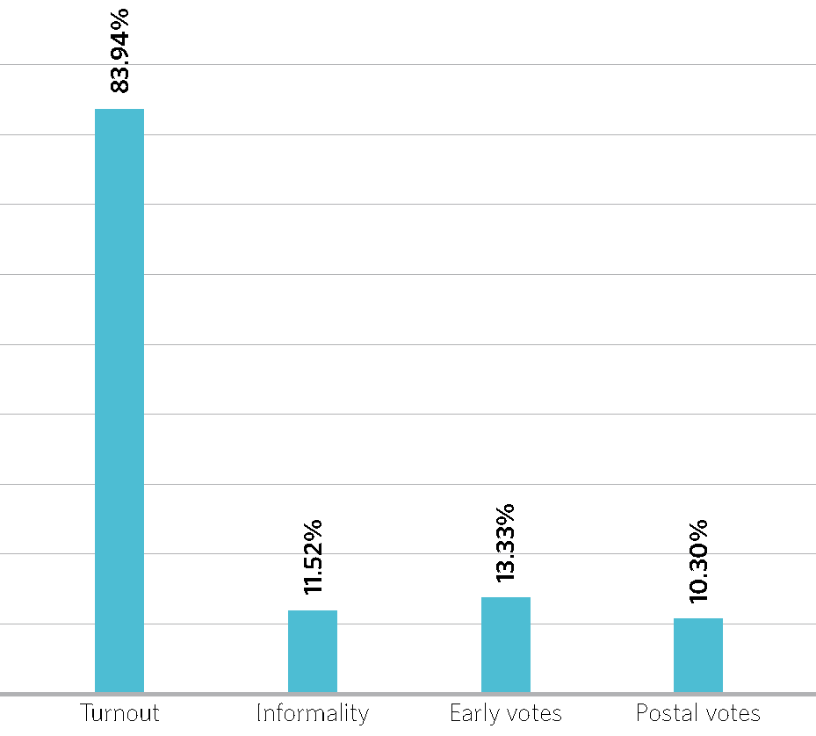
Figure 12 – Key statistics, Niddrie District by-election 2012

Melbourne District by-election
Following the resignation of The Hon. Bronwyn Pike MP, the member for Melbourne District, a writ was issued on
28 May, for a by-election to be held on 21 July 2012. The roll closed on 4 June with 44,889 electors enrolled. At the close of nominations at 12 noon on Friday 22 June, 16 candidates had nominated for the by-election. Postal and early voting are underway at the time of this Report.

Local government electoral activity

Extraordinary vacancies
An extraordinary vacancy arises in a council when a councillor resigns or can no longer hold office as a councillor. The Local Government Act 1989 provides for a countback to be conducted when an extraordinary vacancy arises in a multi-councillor ward or unsubdivided council. A by-election is necessary when an extraordinary vacancy arises in a single-councillor ward or when the vacancy cannot be filled by a countback because of a failed countback or because there are no eligible candidates for election.

Council by-elections and countbacks
During 2011–12, the VEC conducted three council by-elections and six countbacks to fill nine extraordinary vacancies that occurred leading into or during the year. Details of the by- elections and countbacks conducted during the year are included in Appendix E. A report on each by-election and countback was prepared and provided to the relevant council within the legislated three month period.
The number of by-elections and countbacks was lower than in previous years. This may be due to the proximity of the general elections.
The average cost per voter for the three council by-elections was $10.83. All three by-elections were conducted using postal voting. This average does not include compulsory voting enforcement services, which councils may engage the VEC to undertake.
The VEC’s Election Management System is equipped to conduct a countback as requested by a council either within the municipality or at the VEC’s office in Melbourne. The average cost of the countbacks conducted within the municipality during 2011–12 was $6,619.48. The average cost of the two countbacks conducted at the VEC’s office during 2011–12 was $7,159.19. The cost of a countback includes public notices, system extraction and set-up, and staff time. The reduced resource requirements of countbacks held at the VEC’s office generally make them less expensive than those conducted within the municipality. The countback for the City of Melbourne included high costs for statutory notices placed with major media outlets, skewing the average.
A modified countback procedure is necessary when there is only one remaining eligible candidate for election but public notice of the countback is still necessary. There were two countbacks that required a modified countback procedure during 2011–12 and both were held within the municipality. The average cost of the modified countback procedure was $901.38.
The VEC provided the Minister for Local Government with a Report on Local Government Electoral Activity for 2010–11. The report provides details, statistics, analysis and results of council by-elections and countbacks, and is available from the VEC and on the VEC website in electronic format.
All by-elections and countbacks were conducted in compliance with legislative requirements, with no elections failed or overturned. The VEC achieved its aim of providing value for money council election services.

Election tenders and contracts
The VEC must contract with individual councils for the conduct of their elections, and the associated procurement process commenced in January 2012.
The procurement process was aided by an exemption from tendering granted by the Minister for Local Government under section 186(5)(c) of the Local Government Act 1989 in December 2011. The exemption enabled councils to work directly with the VEC to negotiate the requirements of their elections including roll preparation, conduct of the general election, by-elections and countbacks, and compulsory voting enforcement.

2012 council election preparations
Initially scheduled for the fourth Saturday in November, the legislation was amended in 2011 so that general elections for all Victorian councils (except Brimbank City Council) are now scheduled for the fourth Saturday in October 2012. The VEC has developed close partnerships with councils since commencing the conduct of council elections in the 1990s. The partnership was consolidated when all 79 local councils went to election in 2008 simultaneously for the first time. The VEC was engaged to conduct all general elections, by- elections and countbacks during the 2008–2012 council term.
Seventy-eight councils will go to election during 2012–13. At the time of this report, the VEC has either been contracted by or is negotiating with councils to conduct their elections. Brimbank City Council is exempt through the Local Government (Brimbank City Council) Amendment Act 2012. The next general election for Brimbank City Council is scheduled for March 2015.
The VEC is not the statutory provider of local government election services. Under the Local Government Act 1989, councils may engage an electoral commission or another council to conduct their elections. The VEC is subject to the procurement requirements established in local government legislation.
The VEC commenced preparations for the 2012 Council elections by developing a draft service plan. The draft plan was distributed to councils and local government stakeholders in October 2011 and published on the VEC website for feedback. The Electoral Commissioner also presented the plan at a series of workshops with council officers from across Victoria. After considering all feedback, the Election Plan was released in December 2011. The Election Plan provided key dates and timelines necessary to adequately prepare for the activities involved in conducting council elections.
To assist councils with budgeting, the VEC provided all councils with an estimated cost for their election based on the specifications in the Election Plan. Estimates showed an overall marginal cost increase of 17.18 per cent since the 2008 council elections.
The procurement process commenced in January 2012, with the VEC aiming to finalise all contracts by 31 May 2012 to allow time to confirm individual council’s election requirements. The procurement process was aided by an exemption from tendering granted by the Minister for Local Government under section 186(5)(c) of the Local Government Act 1989 in December 2011. The exemption enabled councils to work directly with the VEC to negotiate the requirements of their elections including roll preparation, conduct of the general election, by-elections and countbacks, and compulsory voting enforcement.
Despite the Ministerial exemption, 54 of the 78 councils chose to participate in an agency tender. The tender process was not concluded with councils until late May and as a result, the VEC did not meet its target of finalising all contracts by 31 May 2012.
Commencing in June 2012, the VEC’s council contract managers will meet with each of the councils to confirm their electoral service requirements, resolve outstanding matters and provide councils with information about formally engaging the VEC to conduct their elections. At the time of this report, the VEC has either been contracted by, or received notice of intention to contract from all 78 councils going to election. Election office accommodation is provided by some councils; others request the VEC to source the accommodation. The VEC was required to source 29 election offices, 15 of which were leased at the time of this report.
The VEC also conducted recruitment and election training for its senior election officials during 2011–12. Training of the VEC’s nominated Returning Officers and Deputy Returning Officers was held in April and May 2012. Further training is scheduled for early in 2012–13. Returning Officers will commence work in their offices in September 2012, in time for the opening of nominations.

Election services
As part of election preparation, premises must be leased and set up as election offices. A total of 49 councils are able to provide a venue, with the VEC sourcing premises for the remaining 29 councils.
Returning Officers investigate venues in designated localities, recommending three preferences per locality, and the VEC negotiates leases based on this information. As part of this process, Returning Officers conduct an accessibility audit of available premises to help ensure the VEC leases offices with maximum accessibility. Leases for 15 of the 29 required election offices are in place at the time of this report.
The VEC has placed orders for 553 phone lines, 73 fax lines and 54 data lines, and Returning Officers will arrange connection of utilities and any other services required.

Review of council structures

Electoral representation reviews
During 2011–12, the VEC completed electoral representation reviews of 28 councils in accordance with Division 2 of Part 10 of the Local Government Act 1989 (LGA).
Councils underwent an initial representation review between 2004 and 2008. The councils reviewed ranged from relatively stable inner Melbourne municipalities to fast-growing outer suburban municipalities such as Wyndham, and smaller rural shires such as Loddon and Pyrenees.
Melbourne City Council, which is subject to different legislation, and Surf Coast Shire Council, which was reviewed in 2003 before the current legislation was in place, were not reviewed during that time.
There was significant legislative change between 2008 and the recently completed reviews. Under amendments passed in 2010, the VEC was required to conduct all representation reviews; the period between reviews was increased from two Council terms to three; and the period to lodge public submissions was extended from 14 days to 28 days. Legislation passed in 2011–12 provided for representation reviews of the City of Melbourne, and the Minister requested that the VEC conduct a review of the Latrobe City Council.
Representation reviews are conducted in two main phases. In the first phase, the VEC advertises the review, invites and considers public submissions, and prepares a preliminary report containing a range of options. In the second phase, the VEC advertises the preliminary report, invites and considers public submissions in response to the report, conducts a public hearing at which submitters can speak, prepares a final report with a recommended electoral structure, and provides the report to the Minister for Local Government. Occasionally the need arises for a third phase. There were three stages in the review of Mornington Peninsula Shire Council. At the end of the second stage the VEC needed more information on a particular option, and released an addendum report inviting further public submissions before making the final recommendation.
As in the 2004–08 reviews, the VEC proceeded on the basis of three main principles:
- ensuring that the number of voters represented by each councillor is within 10 per cent of the average number of voters per municipality; this is the “one vote one value” principle, and is required by law
- taking a consistent, State-wide approach to the total number of councillors
- ensuring that communities of interest are as fairly represented as possible.
In addition, the VEC respected the previous reviews’ recommendations, and did not overturn them lightly. In the 2011–12 reviews, the VEC recommended changes to the electoral structure where there had been substantial change in the municipality.
In five cases, the VEC did not recommend any change at all. In 10 councils, the VEC moved ward boundaries to allow for population shifts, but left the underlying electoral structure untouched. The VEC recommended an increase in the number of councillors for five councils whose population is growing rapidly. In 12 reviews the VEC recommended changes in the council’s electoral structure, such as altering the number of wards or the number of councillors per ward.
Public input is an important part of the process, and the VEC welcomed the information and perspectives coming from local residents and organisations. The number of public submissions ranged from 899 for Latrobe to five for Whittlesea. In 12 reviews the VEC’s final recommendation differed from its initial preferred option, largely as a consequence of information provided by the public.
The VEC surveyed participants about the representation reviews. Feedback included a wide range of individual ideas. In general, responses were positive about the process: 100 percent of respondents found the VEC’s Guide for Submissions useful on understanding how to make a submission; 90 per cent found the public hearing helpful; and 88 per cent thought the time provided to speakers at the public hearing was fair.
The Minister for Local Government has accepted all of the VEC’s recommendations, and the recommended electoral structures and ward boundaries will apply at the October 2012 Council elections. The final reports on reviews conducted in 2011–12 are available at vec.vic.gov.au or from the VEC.

Print and design
During 2011–12, the VEC Print and Design team undertook the automation of the Melbourne City Council ballot pack products. Previously these products were produced manually. Considerable time-savings will result from the creation of “print ready” ballot material. The inclusion of the Melbourne City Council products in the automation process means that now all ballot material is generated using XML into InDesign templates.
Statutory advertisement templates were created with XML script to extract data directly from a central source. This increases accuracy and reduces the time and resources required to create statutory advertisements considerably.

Subdivision reviews
Subdivision reviews apply to councils that are not scheduled to have an electoral representation review before their next general election, and where, two years before the council’s general election, the VEC considers that the ward boundaries are unlikely to meet the equality requirements of the legislation at the time of the election. A subdivision review is only required when the Minister for Local Government so directs.
The scope of subdivision reviews is limited to considering ward boundaries, and adjusting them to return enrolments to approximate equality. In general the VEC adopts a minimal change approach, so that as few electors as possible are affected by boundary changes, while also considering communities of interest.
The Local Government Act 1989 (LGA) provides that the reviewer may conduct a subdivision review in any manner that the reviewer considers appropriate, and may engage in community consultation. The VEC conducts subdivision reviews as an abbreviated version of electoral representation reviews. First, the VEC prepares and releases a report containing proposed ward boundaries, and calls for submissions from the public. Then the VEC considers any submissions, conducts a public hearing if required, and prepares a subdivision review report for the Minister for Local Government.
The VEC conducted three subdivision reviews during 2011–12. No boundary changes were required for Port Phillip City Council, as enrolments for the two wards of concern (Emerald Hill Ward and Carlisle Ward) returned to within the 10 per cent tolerance allowed by the LGA.
The VEC recommended minor ward boundary changes for the City of Knox and Yarra Ranges Shire. The VEC failed to place an advertisement in a local newspaper covering an area (Mount Evelyn) where the VEC was proposing a boundary change that was opposed by a submitter. The VEC released an addendum report with the intention of ensuring that all residents knew and had an opportunity to comment on a proposed modification of the ward boundary in the Mount Evelyn area. Although two submitters argued that the whole review should be put aside on legal grounds, the VEC was satisfied that it complied with the Act and that the ward boundaries recommended in its final report were the best possible and took account of local concerns.

Electoral representation and subdivision reviews
Where considered necessary to ensure fair and equitable representation for voters, changes to structures were recommended to the Minister for Local Government. All VEC recommendations were approved by the Minister, and any changes will take affect at the 2012 Council elections.
The representation review project is lengthy and complex, with all Branches of the VEC involved. At the conclusion of the reviews, staff got together to celebrate their achievements with a cake, which also made use of the VEC Mapping team’s skills.

Interaction with electoral bodies
Remaining a leader in the Australian electoral industry, the VEC will continue to introduce innovations to increase efficiency, transparency and participation in elections, by developing and maintaining relationships with a range of organisations in the electoral industry. The VEC is also committed to recommending and advising on relevant legislative change.
During 2011–12, the VEC worked with various electoral bodies to help advance the industry practically and legislatively in an effort to increase innovation and electoral harmonisation across Australia.

Electoral Council of Australia
The Electoral Council of Australia (ECA) is a consultative forum with membership comprising Commonwealth, State and Territory Electoral Commissioners. It met four times in 2011–12. The ECA considers best practice and innovation in activities such as the maintenance of electoral rolls, the operation of new electoral legislation and the management of elections. During 2011–12, the ECA undertook projects and consulted on a range of issues including:
- the activity relating to updating the national electoral roll
- the use of new technology to assist in electoral processes including electronic voting
- electoral education and electoral research
- participation trends in enrolment and voting.
These themes will continue to be a focus for the ECA in 2012–13.

State and Territory Electoral Commissions
State and Territory Electoral Commissions (STEC) is a forum established by State and Territory Electoral Commissioners to consider electoral policy, research and operational matters of mutual interest. STEC consists of the Electoral Commissioner from each State and Territory. The Australian Electoral Commission also participates in STEC activities other than those related to the conduct of council elections.
STEC provides the opportunity for personnel within each commission to collaborate on projects with similar objectives and to share resources across jurisdictions. STEC projects during 2011–12 included:
- electronic roll marking and returns from voting centres
- continued work on performance measurement and common reporting definitions
- continuation of the Electoral Educators’ Network
- continued collaboration regarding matters relating to election officials
- social media.
Proposed projects for 2012–13 include:
- best use of information technology for future elections
- continued work on performance measurement and common reporting definitions
- engagement of CALD communities.
During 2011–12, Elections New Zealand accepted invitations to join the two major collaborative groups, the Electoral Council of Australia and the State and Territories Electoral Commissions. The VEC looks forward to further developing its existing relationship with Elections New Zealand.

Electoral Boundaries Commission
The VEC is required by legislation to provide administrative and technical services to the Electoral Boundaries Commission. The Report of the Electoral Boundaries Commission 2011–12 is included in this Report.
A redivision of State electoral boundaries will begin in November 2012. The VEC is planning the administration of the redivision, and has engaged the Department of Planning and Community Development to provide population projections down to a local level. These projections will be valuable to the Electoral Boundaries Commission, and will be publicly available to assist political parties and others who may wish to make submissions about the redivision.

Electoral Matters Committee
The VEC has an interest in the work of the Electoral Matters Committee (EMC), a Joint Investigatory Committee of the Parliament of Victoria. The EMC comprises five Members of Parliament drawn from both Houses. Its powers and responsibilities are determined by the Parliamentary Committees Act 2003.
The EMC’s report Inquiry into the Conduct of 2010 Victorian State Election was tabled in May 2012, and contained a range of recommendations that were significant for the VEC. These recommendations will be considered and implemented as appropriate.

Arrangements with other electoral agencies
In a reciprocal arrangement, the VEC provides election services such as voting services and information provision for other Australian electoral agencies. The VEC also provides staff secondment to other electoral agencies in Australia (and occasionally overseas) for short periods to provide assistance and expertise at electoral events. During Victorian election periods, reciprocal services are provided to Victorian voters by these agencies. Figure 13 and Figure 14 indicate the services and staff provided in these areas by the VEC during 2011–12.
Figure 13 – Election services provided by the VEC to electoral agencies in other jurisdictions, 2011–12
Election date | Jurisdiction | Election | Total votes
19-Nov-11 | New South Wales | Clarence State By-election | 0
26-Nov-11 | New Zealand | General Election & Referendum | 359
11-Feb-12 | South Australia | District of Port Adelaide By-election | 6
11-Feb-12 | South Australia | District of Ramsey By-election | 6
24-Mar-12 | Queensland | 2012 State Election | 652
28-Apr-12 | Queensland | Quadrennial Local Government Elections | 0
5-May-12 | Tasmania | Legislative Council Elections - Divisions of Hobart and Western Tiers | 2

Figure 14 – Secondment of VEC staff to other Australian electoral agencies, 2011–12
Election date | Jurisdiction | Election | Total Staff | Total days
25-Oct-11 | Tasmania | 2011 Local Government Elections | 3 | 15 days

Register of political parties
The Electoral Act 2002 (the Act) requires the VEC to establish and maintain a register of political parties. In order to qualify for registration, a political party must have a written constitution and at least 500 members who are Victorian electors, party members in accordance with the party’s rules, and not members of another registered political party or of a party applying for registration.
It is not compulsory for political parties to be registered to contest an election, but registration gives a party a number of important entitlements. These include:
- the right to have the party’s name on ballot papers
- access to enrolment and voter information on a periodic basis
- public funding for parties that attain a specified level of first preference votes.

Change of details
The National Party, Family First Party and Country Alliance updated their contact details in May–June 2012.
In February 2012, the VEC received an application from the Christian Democratic Party (Fred Nile Group) to change the party’s name to Australian Christians. As required by the Act, the VEC advertised the application, informing readers about the ability to object to the application. The VEC received a total of seven objections by the deadline of 21
May. The objections were all essentially on the same ground: that the new name misleadingly implied that the party was representative of all Christians in Australia who, it was argued, are in fact diverse in their political opinions.
Under the Act, there are limited grounds for objecting to the name of a registered political party. A name is not allowed if it:
- comprises more than six words
- is obscene
- is the name, or confusingly similar to the name, of another registered political party
- comprises the words “Independent Party”, or contains the word “Independent” plus the name of a registered party or a name confusingly similar to a registered party’s name.
The proposed new name of the party did not infringe any of these conditions. Therefore, the VEC accepted the new name of the party on 25 May 2012.
See Appendix H for the details of registered political parties.

Legal proceedings relating to political parties
Since 2009, the VEC has been engaged in litigation with Mr John Mulholland in relation to the VEC’s 2008 decision not to recognise Mr Mulholland as the secretary and registered officer of the Democratic Labor Party (DLP) following a party conference at which Mr Mulholland was defeated in an election for party secretary. The Court of Appeal heard the case in January–February 2012 and handed down its decision on 14 June 2012. Mr Mulholland’s appeal was successful. In summary, the case turned on the interpretation of the DLP’s rules and of the Commonwealth Electoral Act 1918. The DLP’s rule 4 provides that “The members shall be those eligible to vote in Commonwealth elections”.
The Court concluded that because two of the delegates at the party conference lived in different divisions from where they were enrolled, they were not eligible to vote in Commonwealth elections, and so were not members of the DLP and not legitimate delegates at the party conference. As the margin in the election for secretary at the conference was one vote, the Court declared the election null and void.
The Court ordered that “the decision of the Commission dated 18 December 2008 to register, and the registration of, Mark Farrell as the registered officer of the DLP be set aside provided that such setting aside is without prejudice to and does not affect the validity of the change of the name of the registered officer in the Register from Mark Farrell to Michael Casanova on 3 August 2009 and any subsequent change”.
The VEC also notes that in his decision, Williams J. stated that the [Victorian Electoral] Commission followed the s.51 procedures in reaching its decision and … [the VEC] was correct to consider the issue of validity was appropriately to be resolved within the party or by the courts.

Research and development

Researching barriers to participation
During 2011–12, the VEC focused on two areas: attitudes to enrolment and voting among Aboriginal Victorians, and barriers to enrolment and voting in the Arabic and Turkish speaking communities.
The Aboriginal research project (begun in 2010–11) was completed with quantitative research to discover how widely ideas and attitudes are held. Findings suggest that most Aboriginal Victorians are engaged in the electoral system, but that there is a significant group, particularly among younger people, who do not fully know how to participate or who are resistant to participation.
The report recommended working with established Aboriginal networks, using the messages that your vote can make a difference, that voting is honouring the struggles of ancestors who fought for equality, and that voting shows that you care enough to stand up and be counted.
Another research project examined barriers to enrolment and voting in the Arabic and Turkish speaking communities. The project included the scope for electronic voting in these communities. Electronic voting was available at the 2010 State election for voters who were not fluent in English, but there was minimal take-up.

Position papers
Three position papers were produced by the VEC this year. These papers are available on the VEC’s website and cover the following topics:
- The Postal Voting Process (Updated)
- Multiple Voting
- In-language Electoral Information

Electoral Regulation Research Network
The VEC joined with the New South Wales Electoral Commission and the University of Melbourne to establish the Electoral Regulation Research Network. The purpose of the Network is to foster exchange and discussion among academics, electoral commissions and other interested groups on research relating to electoral regulation. The Network has hosted seminars on matters including election communication law, money in the 2012 American presidential election, and the Victorian Independent Broad-based Anti-Corruption Commission.

Development of electronic voting
At the 2006 and 2010 State elections, the VEC provided supervised electronic voting (e-voting) systems for people with impairments and disabilities and those out of Victoria, scaling up this new service between elections. The VEC is confident that electronic voting will be an important service for elections ongoing and wants to build and deeply integrate an e-voting system. The VEC also wants to find the best fit between these new services and the Victorian voting communities who can most benefit.
The VEC has commenced outreach programmes for the new system, including outreach to the culturally and linguistically diverse (CALD) community so that feedback on translations, prototype devices and voting behaviours can be collected. Also included is outreach to the print disabled (PD) communities so that the very diverse needs of these communities can be identified in more detail. Finally, outreach has included academics who are specialists in e-voting design and security.
Major features of the proposed system that are of importance to the democracy community include:
- the ability to serve the VEC’s legislated special needs, and remote voters in supervised locations. If legislation allows, the system will have the capacity to provide remote unsupervised voting to voters who struggle to attend a supervised location
- an end-to-end verifiable voting solution to meet concerns here and overseas about the automation of electoral processes. End-to-end verification is a new technique which better balances the trust and security of e-voting across systems and people and to an extent reduces the reliance on very few IT people or individual computers for the integrity of e-voting
- the ability for the VEC to own, operate and understand e-voting so that best use can be made of it and risks and rewards can be known as far as is possible. In the past the products of e-voting vendors have had to be customised to the extent that operation of those systems becomes difficult or risky for VEC personnel on their own. VEC staff should be confident in their control and knowledge of e-voting as they are in their stewardship of paper ballot voting
- an open source application, which means that it will be made freely available to anyone to examine, test or even use it. This last feature is very important as it provides transparency. The VEC hopes this will create a cycle of community and expert feedback so that the product continues to improve. The VEC is confident this can be done without sacrificing security or intellectual property, and that other electoral commissions may benefit.
The e-voting project started in November 2011 and has involved collaboration with a wide range of specialists. As the project continues the various prototypes will be rigorously analysed and tested to make sure they meet VEC objectives for security, integrity and usability.
Our Voters

Aim
An accurate, complete and secure register of electors

Strategies
- Develop and implement the 2011–14 Enrolment Strategy
- Identify and evaluate opportunities to improve the effectiveness and efficiency of the enrolment process, incorporating these into the continuous roll update process
- Observe information privacy principles in the collection, use and storage of electors’ data

Result
- 99.50% of enrolment transactions processed within the target timeframe (above target)
- 91.87% of voting eligible population enrolled (above target)
- 81.52% youth enrolment (above target)
- After a successful pilot, automatic roll update was implemented in accordance with legislation. A total of 37,162 enrolment transactions were carried out. One resultant privacy breach was identified, and immediate and effective mitigation action was implemented

Aim
Increased ease of access to, and participation in the electoral system

Strategies
- Conduct, analyse and respond to research to better understand industry and community issues and implement activities that engage and educate the Victorian community
- Develop and deliver communication products that improve accessibility and clarity of electoral information
- Maintain a responsive Disability Action Plan

Result
- Communication and Community Education Programs developed in response to research findings and delivered in accordance with plans
- Programs received positive feedback from key stakeholders
- Disability Action Plan reviewed and redeveloped

Highlights 2011–12
- The VEC’s advanced geospatial mapping services enabled trouble-free updates of enrolment data to reflect changes as a result of representation and subdivision reviews
- Successful expansion of the VEC’s direct enrolment program
- Highlights of the VEC’s work to increase ease of access to, and participation in the electoral system including electoral education and engagement in preparation for the 2012 Council elections are featured throughout this report (see logo)

Outlook, 2012–13
- Conduct the 2012 council elections, involving around 4.1 million voters, an estimated 1,900 candidates and 8,000 election officials appointed to short term positions across the State
- Implementation of a pilot ‘Democracy Ambassador’ program with African communities
- Research into the barriers faced by Arabic communities will inform the development of the ‘Democracy Ambassadors’ program

Enrolment
Facilitation of participation in the democratic process by all Victorians is a central aim of the work of the VEC. Activities undertaken in the electoral enrolment, communication, electoral education and electoral engagement areas throughout 2011–12 supported this aim.
Key objectives for the VEC are to maintain the accuracy and security of the register of electors, to annually increase the proportion of eligible electors enrolled and to maintain this measure at a level higher than the national average. The VEC undertakes a range of activities to keep the enrolment register current and complete, and to ensure electors vote and vote correctly.

Register of electors
The VEC exceeded its target of processing 98% of elector enrolment changes and new enrolments within set timeframes, achieving 99.5%, helping ensure that the register of electors is as accurate as possible.
The number of Victorians enrolled to vote increased by 44,211 to 3,623,594 in 2011–12. Using available data, it is estimated that 91.87% of eligible electors are enrolled. This is slightly more than the national figure of 90.57% and just over the VEC’s target of at least 1% higher than the national average. The VEC enrolment rate decreased by 0.41 percentage points on the previous year. The national decline was slightly less at 0.29 percentage points (see Figure 15).

Youth enrolment
Victoria continues to have one of the highest youth enrolment rates in Australia, which may be attributable to the 17th birthday card program and the school and school-leavers education activities. In addition, 11,426 eighteen year olds were added to the register of electors this year as a result of the VEC’s direct enrolment activities.
The number of young Victorians enrolled is around 10% below that of the general eligible population. Figure 16 shows the extent to which Victorian young people aged 17 years and 18 to 25 years are represented on the electoral roll. Since 2007–08, Victorian figures have been consistently higher than the national average, and youth enrolment in 2011–12 is higher than the VEC’s target of at least two percentage points above the national average for the first time since 2005–06.
Electoral education focusing on youth participation is a key element of the VEC’s Community Education Strategy 2007–12. At 30 June 2012, the estimated percentage of eligible 17-year-olds provisionally enrolled on the electoral register was 28.19%. Passport to Democracy, a school education program, is an effective way of encouraging interest in and knowledge about the democratic process in upper secondary students. A VEC presence at events involving young people and teachers is also part of the strategy.
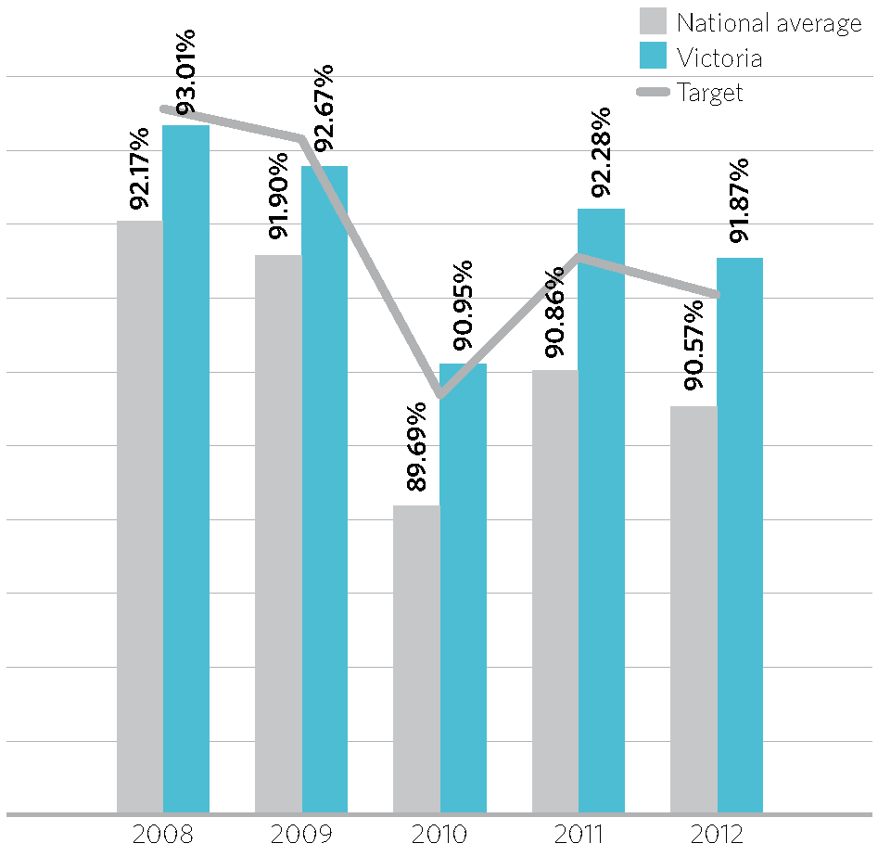
Figure 15 – Proportion of voter eligible population enrolled, 30 June 2008–12
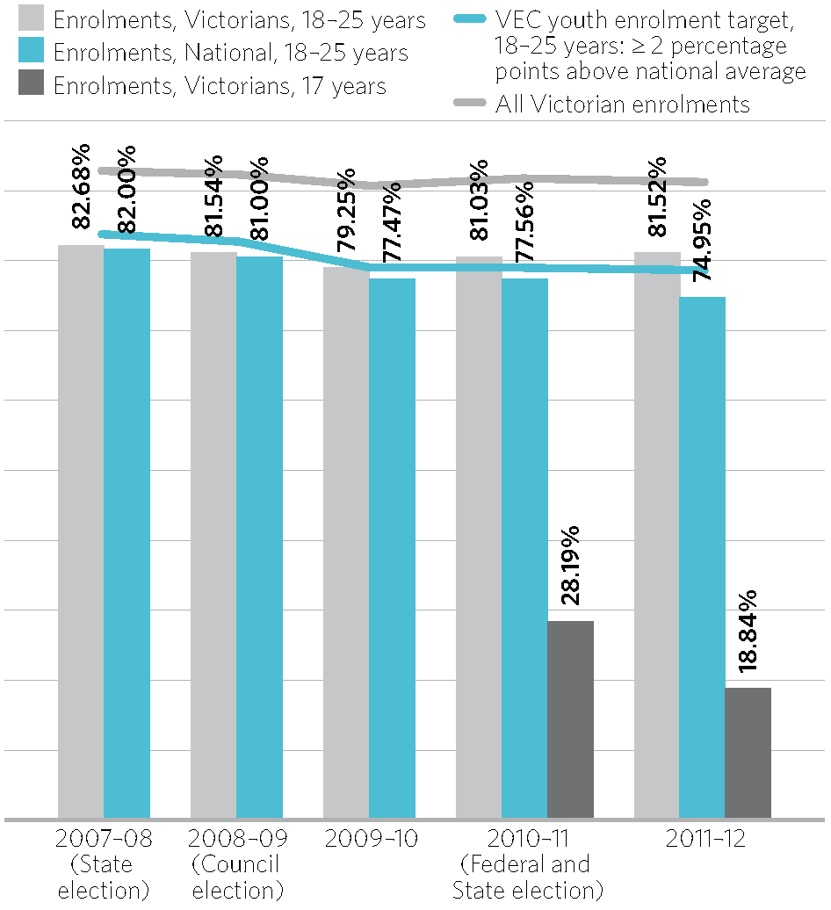
Figure 16 – Youth enrolment, 2007–08 to 2011–12

Continuous roll update
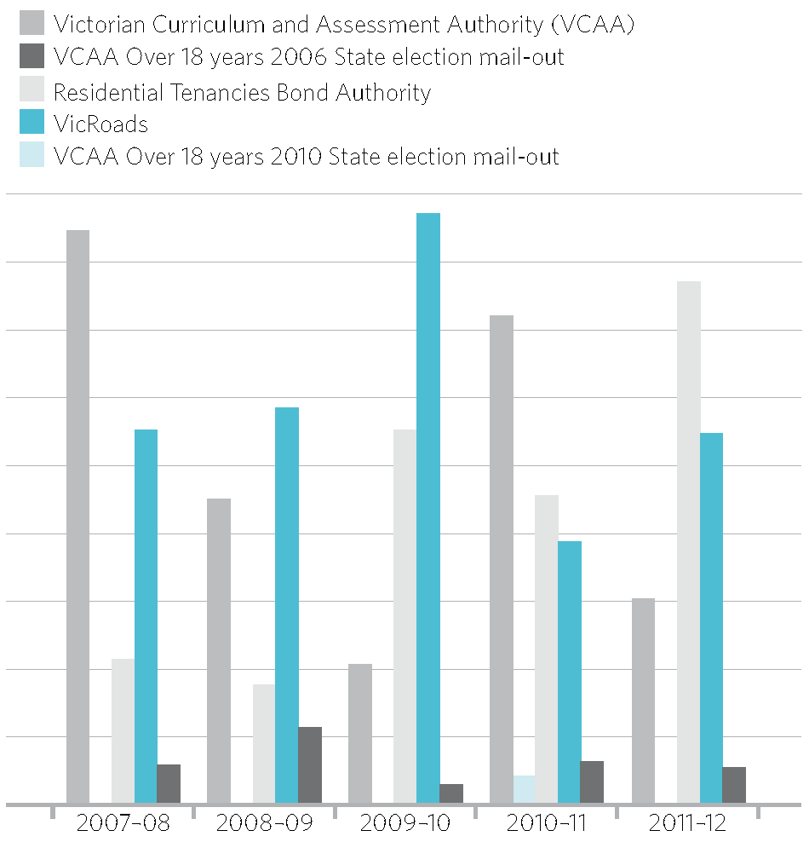
Figure 17 – Enrolments from VEC programs, 2007–08 to 2011–12
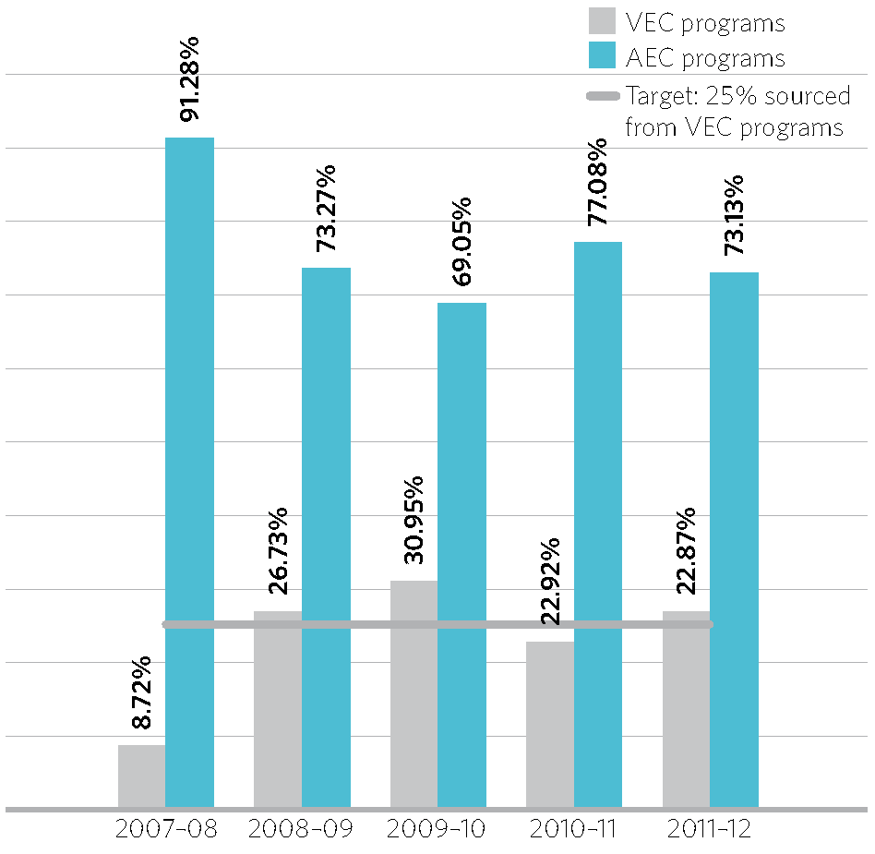
Figure 18 – Enrolments sourced from VEC and AEC programs
The VEC undertakes a number of continuous roll update (CRU) programs. In the past these programs solely assisted electors to enrol and to keep their enrolment details up-to-date. Mail-out activities targeted potential electors using data provided by the Residential Tenancies Bond Authority, the Victorian Tertiary Admissions Centre and VicRoads. People who registered or updated their address details with one of these agencies were sent an enrolment form if they were not already enrolled. See Appendix K for details of enrolment transactions for 2007–08 to 2011–12.
With the introduction by legislation of automatic enrolment, eligible electors can be added to the register, or their details can be updated, without them completing an enrolment form. As part of the Enrolment Strategy 2011–14, the VEC’s CRU programs were modified to enable the VEC to automatically enrol members of the voting-eligible population using its external data sources instead of sending them an enrolment form. These people are sent a letter advising them of the VEC’s intention to automatically enrol them, and asking them to advise the VEC if they are not eligible to be enrolled. Where eligibility cannot be confirmed, an enrolment form is sent.
Eligible Victorians may enrol at 17 years of age, but cannot vote until they turn 18. Data is provided by the Victorian Curriculum and Assessment Authority (VCAA) to enable the VEC to send a birthday card and enrolment form to Victorians in the education system after they turn 17 years of age. According to VEC tracking of enrolments, 13.2% of 17-year-olds who received a birthday card in 2011–12 enrolled as a result of this program. A further 3,188 students enrolled during 2011–12 as a result of receiving a birthday card in 2010–11. See Figure 17 for details of enrolments sourced from VEC programs from 2007–08 to 2011–12.
Applications to the Victorian Commission for Gambling and Liquor Regulation for proof-of-age cards also act as electoral enrolment applications for State and local government elections. The VEC received 1,790 of these applications in 2011–12. During 2011–12, enrolment forms were available at the VEC, on the VEC website, at local council offices, Australia Post offices, Centrelink and Australian Electoral Commission divisional offices.
The VEC’s traditional CRU activities generated 100,162 enrolment applications in 2011–12, amounting to 26.87% of total Victorian applications received. This is an excellent result, exceeding the VEC’s target of 25% (see Figure 18).
The VEC’s automatic enrolment CRU activities generated 36,779 enrolments in 2011–12 (18,014 new and 18,765 change of address). It is expected that this figure will significantly increase in 2012–13 as the VEC expands its automatic enrolment program.

Compulsory enrolment
Compulsory enrolment has been a feature of Victoria’s electoral legislation since 1923. By law, eligible electors who do not enrol or keep their enrolment details current can be prosecuted and fined one penalty unit, and a conviction may be recorded.
The VEC has traditionally taken the position of encouraging eligible electors to enrol and maintain their enrolment to protect their right to vote should an election (local, State or Federal) be called. With the introduction and success of automatic enrolment, compulsory enrolment becomes less problematic for the majority of electors, and the VEC will investigate ways of targeting the voting-eligible population that is not captured by automatic enrolment activities. With a focus on automatic enrolment and other continuous roll update activities, no follow-up of compulsory enrolment provisions was undertaken in 2011–12.

Updates to voter details
Around 1.6 million State roll electors were enrolled within municipalities that had electoral representation reviews and subdivision reviews conducted in 2011–12. Using geo-spatial technology developed by the VEC, the Electoral Enrolment Branch updated voter details on the enrolment register to reflect changes made to council structures as a result of the reviews. These changes take effect at the 2012 elections.

Enforcement of compulsory voting
After the conduct of elections, by-elections and polls in which voting is compulsory, the VEC carries out compulsory voting enforcement where legislated, and when a council contracts the VEC to do so. In order to conduct compulsory voting follow-up for councils, the Chief Executive 0fficer must appoint a VEC staff member as the prosecution officer.
Three stages of enforcement (or non-voter follow-up) are managed by the VEC.
- Dispatch of Apparent Failure to Vote Notices to those electors who appear not to have voted in an election. Apparent non-voters have 28 days from the date of the notice to provide a valid excuse for failing to vote.
- Follow-up (by Infringement Notice) of electors who did not respond, or who provided an invalid response to the Apparent Failure to Vote Notice. A penalty amount is applied (currently set at $61.00). Non-voters have 42 days to respond to the Infringement Notice by either submitting a valid response or by making the penalty payment.
- A Penalty Reminder Notice is sent to those who do not respond to the Infringement Notice. An amount for prescribed costs is added to the original penalty amount.
Where the VEC conducts non-voter follow-up for State elections, by-elections or liquor licensing polls, a final non-voter file is lodged with the Infringements Court for further action. In 2011–12, the VEC continued enforcement of compulsory voting for ten elections, by-elections and polls including the 2010 State election. Enforcement of compulsory voting commenced for the Niddrie District by-election, three council by-elections and three liquor licensing polls (one of which was conducted in June 2011).
Where non-voter follow-up is conducted on behalf of a council, the VEC provides a final non-voter list and an Infringements Court file. The council makes a decision about further follow-up. The VEC concluded non-voter follow-up for five council by-elections. Penalties collected are transferred to the council at the end of the infringements stage. Appendix F provides details of all non-voter follow-up and compulsory voting enforcement conducted during 2011–12.

Turnout
Turnout is measured as the number of formal and informal votes received by the close of voting in an election as a proportion of enrolment. The VEC provides an increasing number of services to electors to help ensure that all enrolled electors turn out to cast their vote. These include information services prior to, and on election day, as well as a variety of voting options and aids.

Turnout at State by-elections
The turnout at the Niddrie State District by-election was 84.80%. This is an increase on the turnout at the Broadmeadows State District by-election in 2011, and higher than the VEC target of 78.46%.
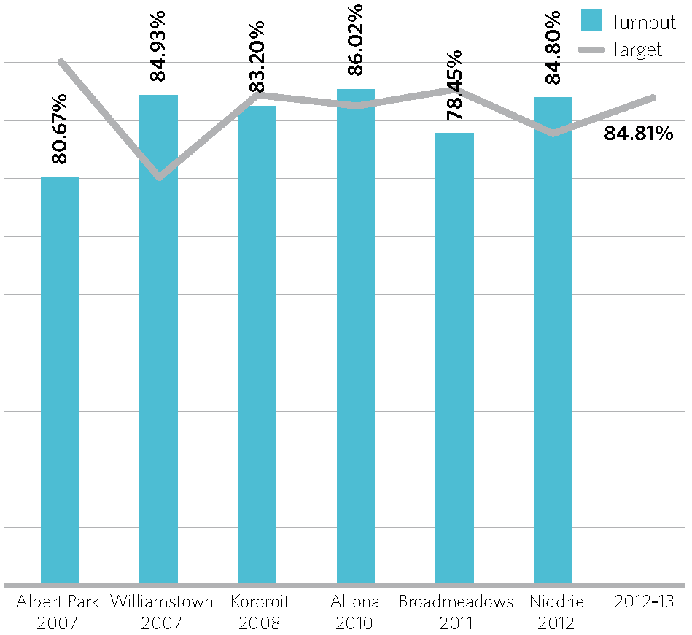
Figure 19 – Turnout, State by-elections, 2007–08 to 2011–12

Turnout at Council By-elections
The average turnout rate for council by-elections held during 2011–12 was 73.76%, meeting the VEC’s target of an increase year to year, but still lower than the average turnout of 2009–10 (74.60%). It is an increase on the average turnout for the five-year period (72.83%), and slightly less favourable than the average turnout rate for the council general elections held in November 2008 (74.36%).
Council by-election turnout rates are generally lower than the turnout at State by-elections. The main reason is that voting at council by-elections is not compulsory for non-residents. 0ther factors include lower awareness of the election due to less media attention and (generally) less candidate activity, the perception that only property owners (as opposed to tenants) are required to vote in council by-elections, and the fact that people over 70 years of age are automatically excused if they do not vote.
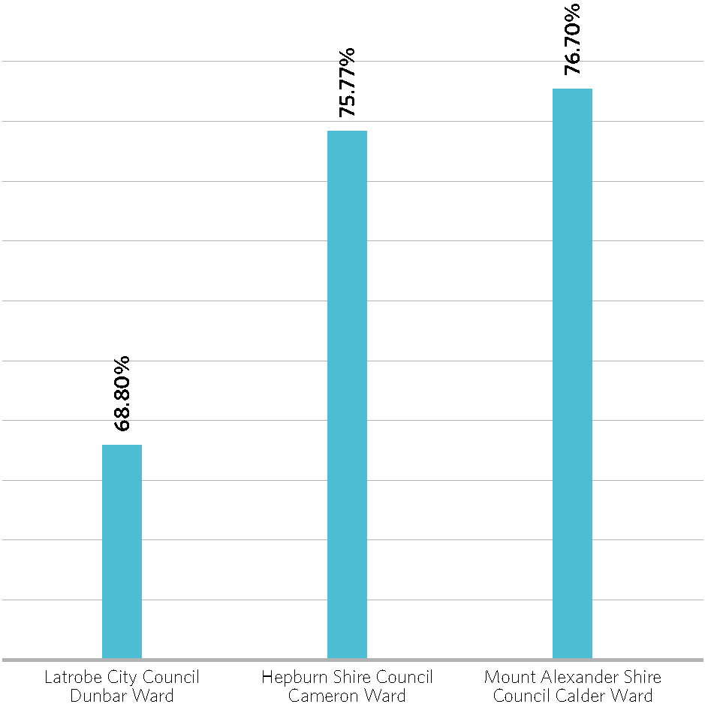
Figure 20 – Turnout, council by-elections, 2011–12
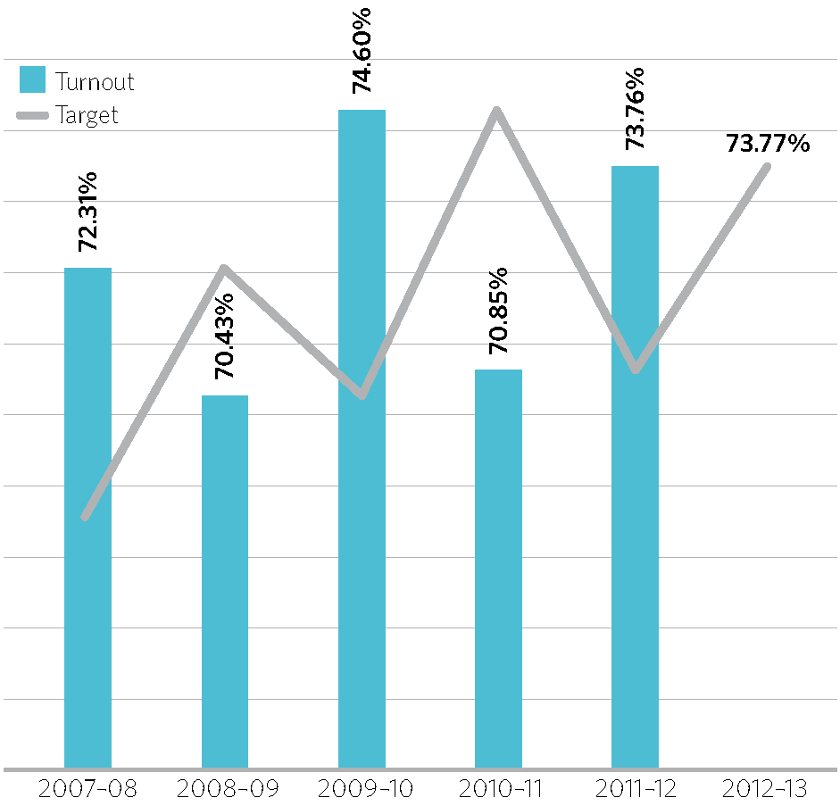
Figure 21 – Average turnout, council by-elections, 2007–08 to 2011–12

Informality of voting
A vote is declared informal when an elector does not complete their ballot paper according to the instructions, and their voting intention is not clear. Ballot papers that do not comply with the formality rules are not admitted to the count.

Informality rate at State by-elections
The informality rate for the Niddrie District by-election was 11.48%, a 3.17 percentage point increase on the informality rate for that District at the 2010 State election (8.31%). This is also more than the average informality rate for the most recent State by-elections, conducted in 2007–11 (7.00%), and appears to have been the second highest informal voting rate for an electorate in Victorian history (see figure 22).
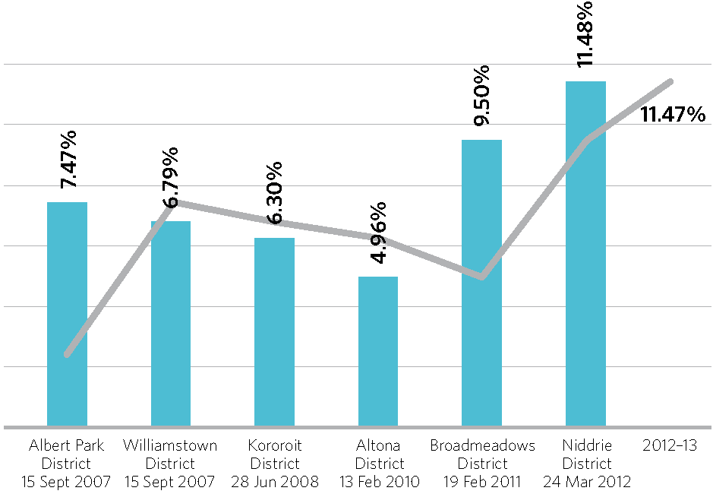
Figure 22 – Proportion of informal votes, State by-elections, 2007–2012

Informality rate at council by-elections
The average informality rate at council by-elections conducted in 2011–12 is 2.21%, which is lower than the average for by-elections conducted in the past five years (3.42%). All three by-elections were conducted by post. Informality rates are generally lower at elections conducted by post than those conducted by attendance voting.
A higher incidence of informal voting has often been observed in electorates in which Census data indicate a high proportion of people with low or no fluency in English, and at elections in which there are high numbers of candidates. The highest informality rate for 2011–12 by-elections was 3.23% at the Latrobe City Council, Dunbar Ward by-election with eight candidates. In contrast, at the Hepburn Shire, Cameron Ward by-election, there were three candidates and an informality rate of 1.25% (see Figure 23 and 24).
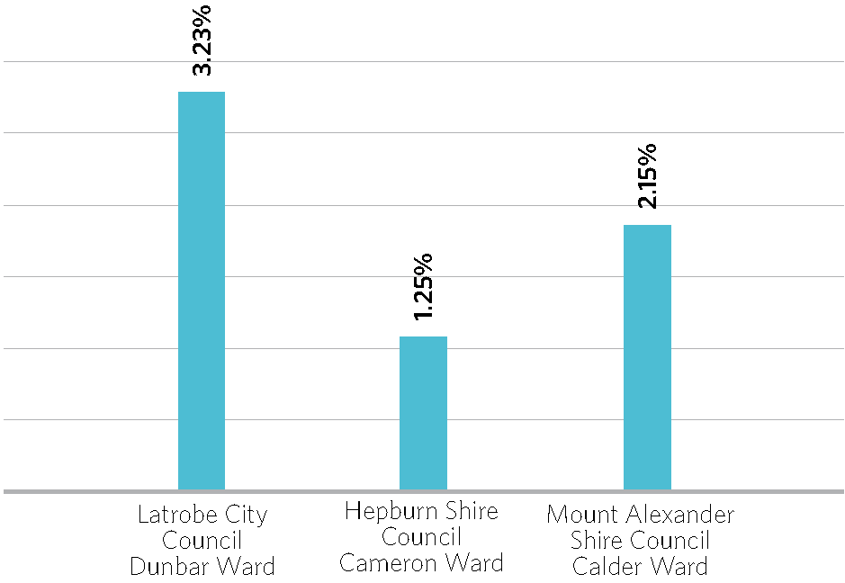
Figure 23 – Proportion of informal votes, council by-elections, 2011–12
The VEC aims to increase electors’ understanding of how to cast a formal vote and advertising and communication campaigns help ensure that Victorians are provided with voting information in accessible formats. Information is available in languages other than English, and telephone interpreter services are provided all year round. VEC electoral education and engagement programs aim to provide Victorians with the motivation and knowledge to cast a valid vote.
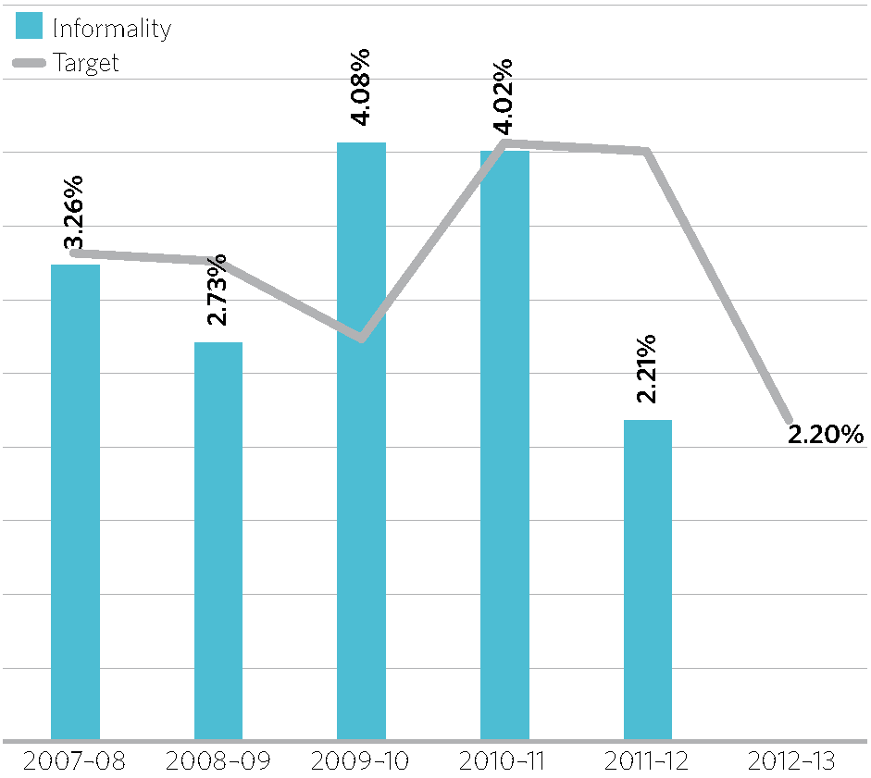
Figure 24 – Average informality rate, council by-elections, 2007–08 to 2011–12

Services for voters with specific needs
A wide range of services, information and education is provided to help voters participate in the electoral process. Along with resources, and education and communication campaigns that inform and engage electors, the VEC also strives to ensure that voting is made as easy as possible for all electors, including electors with disabilities and those who are unable to attend a voting centre on election day.
During 2011–12, the VEC provided a range of services for electors participating in elections conducted by the VEC. These included the provision of early and postal voting services for electors unable to vote on election day or who were away during the voting period for postal elections.
Braille ballot papers were provided on request for electors at the Niddrie by-election, assistive aides were provided in voting centres, and voting instructions in multiple languages were printed on voting screens and included in ballot packs sent to electors. Internet services such as voting centre look-up tools, online enrolment forms, recruitment and nomination services were also provided at vec.vic.gov.au. The VEC also used Facebook to aid the distribution of election information.
The VEC will continue to provide early and postal voting services for electors who are unable to vote on election day or who will be away during the voting period. This will include a special postal voting service for armed services personnel stationed overseas.

Disability Action Plan
During 2011–12, the VEC met with its Electoral Access Advisory Group (EAAG) to evaluate and update the VEC’s Disability Action Plan. Of the 28 actions in the previous Disability Action Plan, 26 have been fully achieved and two partially achieved. Highlights include:
- expansion of mobile voting services
- effective communication of voting centre accessibility status in print and online
- production of the Voting is for Everyone resource, originating from research conducted by the VEC
- production of a brochure for carers, with advice about voting and electoral access for people with a disability.
The redeveloped plan resulted in several workshops with sub-committees of the EAAG, specifically investigating the employment of, and task allocation for people with a disability. The draft revised plan was circulated to over 300 disability groups and agencies within Victoria for comment. The Disability Action Plan 2011–15 is available at vec.vic.gov.au.

Auslan DVD
An Easy English Auslan DVD containing information about the council elections has been produced for people who are deaf or have a hearing impairment. The DVD was distributed to 2,150 individuals with a hearing impairment or who were deaf, and a further 800 were sent to community organisations.
This resource is a visual version of the VEC’s very successful Easy English Guides.

Easy English Guides
The following updated and new print Easy English Guides were produced in 2011–12:
- Easy English Guide to Postal Council Elections
- Easy English Guide to Attendance Council Elections
- Easy English Guide to Melbourne City Council Elections
- Easy English Guide to Greater Geelong City Council Elections.
- Easy English Guide – Homeless Doesn’t Mean Voteless

Voting is for Everyone DVD
A revised form of the VEC’s Voting is for Everyone DVD was produced and 240 copies of the DVD were distributed to key disability agencies. This resource focuses on the importance of inclusion of people with a disability or multiple disabilities in the electoral process, and the practicalities for family members and carers. Through links with the Disability Advocacy Resource Unit, the team presented at events such as the Strengthening Disability Advocacy Conference and the Public Relations Institute’s Masterclass on Accessible Communication.

Website accessibility
The VEC renewed its subscription to provide website users with the free application BrowseAloud. This software enables website text to be read aloud as the cursor is moved over the text.

SCOPE
The VEC commenced a training and accreditation process with SCOPE to be certified as ‘Communication Accessible’. This accreditation will assure the public that the VEC has staff who are specially trained to provide services to people who have difficulty communicating verbally.

Accessibility of voting centres
The lack of fully accessible voting centres continues to be of deep concern to the VEC, and efforts are made to lease buildings and facilities that are accessible to people with disabilities. The VEC provides equipment and aids at voting centres to help meet voters’ needs.
Every early voting and election day voting centre is rated according to its wheelchair accessibility. The audit complies with relevant Australian Standards and assesses building access as well as the availability of accessible parking. The VEC has been working with the Australian Electoral Commission to ensure that standardised ratings are applied.
For the Niddrie District by-election in March 2012, of the two early voting centres one (located within the District) was ‘Fully Wheelchair Accessible’ and the other was rated as ‘Assisted Wheelchair Accessible’. 0f the 13 election day voting centres in Niddrie District, three were ‘Fully Wheelchair Accessible’, eight were rated ‘Assisted Wheelchair Accessible’, and the remaining two were rated as ‘No Wheelchair Access’.
All voting centres for the 2012 Council elections were booked early in 2012. Returning officers will complete accessibility audits at all venues in advance of the election period and all ratings will be well-publicised.
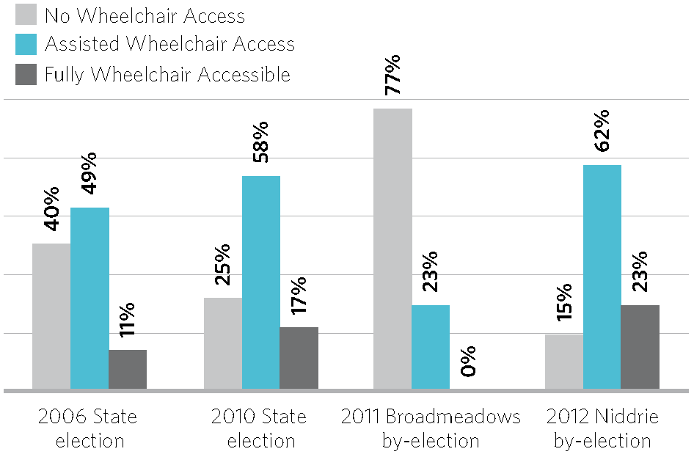
Figure 25 – Wheelchair accessibility ratings, State election and by-election voting centres, 2006–2010

Community education and engagement
The VEC’s Community Education Program has continued to strengthen relationships with community organisations and education institutions, offering a range of outreach services and education materials. The Program aims are to assist people to develop a broader understanding of how democracy is relevant to their lives, and to support positive experiences of engagement with electoral processes.
Research and project evaluation has guided the focus of this year’s work largely towards Indigenous communities, schools and new and emerging communities. The Community Education and Engagement Team offered specialised and tailored support presenting 57 activities to 7,568 participants across Victoria. A total of 51 enrolment forms were lodged at the events, with many more forms distributed for completion and lodging at the participants’ convenience.
Planning for the upcoming council elections has been a key focus. The Team aims to help ensure that the general public and the hard-to-reach communities are informed and well- placed to participate in the electoral process.
Highlights of the Community Education and Engagement Program relating to the 2012 Council elections are featured throughout this Report.

Passport to Democracy – schools program
The ‘Passport to Democracy’ program continues to inspire teachers and young people across Victoria, and in 2011–12 it was presented in the 100th secondary school. The success of the program is evidenced by the number of secondary schools that continue their involvement year after year, and in the increasing demand for the program in primary schools and alternative community education settings.
Following an extensive evaluation of the program in the year prior, the materials have been revised and redesigned to address learning styles and participatory learning methodologies. Available on the program’s independent blog is an expanded range of resources to support the revised materials. These resources are proving to be a hit with teachers repeatedly visiting the site to download them.
The VEC’s ongoing presence at major teacher conferences and the targeting of pre-service teachers is ensuring the ongoing popularity and demand of the program.

Democracy Ambassadors – relationships with CALD communities
New and emerging communities may experience a range of barriers to electoral engagement that can result in low levels of enrolment and higher than average levels of voting informality. The VEC is developing a ‘Democracy Ambassadors’ program, an engagement model targeting CALD communities. The program aims to provide information about enrolment and voting processes, and to foster greater community engagement in Victoria’s democratic processes by employing community leaders who will advocate electoral engagement within their communities.
The model is being developed for piloting with African communities. The VEC’s CALD Engagement Officer is working closely with community organisations and community leaders to explore models of engagement.

Engagement with Indigenous communities
Research on the electoral engagement of Indigenous Victorians has been instrumental to the VEC’s work with Indigenous communities, and in particular is guiding work with young Aboriginal people participating in the Korin Gamadgi camps. In partnership with Richmond Football Club, the VEC has co-presented at eight Richmond Emerging Aboriginal Leadership (REAL) camps throughout the year to develop future leaders. The VEC presented to 200 students – exploring with them the history and importance of Indigenous suffrage, and their rights and responsibilities as leaders in their communities.
A focus of the team has been the expansion of networks through working closely with local Indigenous networks, to raise awareness and levels of electoral engagement.

Parliament Open Day
Always a great opportunity to engage with the general public, Parliament Open Day this year did not disappoint. Over 4,000 people attended on the day and the VEC had over 1,000 enquiries. A mock election, our Democracy snakes and ladders game and a Democracy Diary Room game helped increase knowledge of Victoria’s electoral processes. Many visitors checked the roll onsite to ensure their enrolment details were up-to-date.

SELECTIONS newsletter
The annual stakeholder newsletter, SELECTIONS was distributed to key stakeholders and is available on vec.vic.gov.au or at the VEC.

Mapping services
As part of the process of ensuring the integrity of the Victorian register of electors, the Mapping Team conducts validation checks using spatial information to determine the accuracy of the coding assigned by the Australian Electoral Commission (AEC) to new addresses. A total of 72,109 records were checked in 2011–12, and 666 inconsistencies were identified and reported to the AEC.
In 2011–12, the VEC’s Mapping Team worked on a number of significant projects for the 2012 council elections including the production of voting centre planning maps and an online voting centre look-up facility.
Significant progress has been made on the hundreds of maps required for the council elections including maps of municipalities and ward, voting centre locality maps for a variety of purposes including election administration by the VEC, and for use by electors, candidates, the media and electoral commentators.
0ther projects included an assessment of the VEC’s Electoral Boundaries Mapping System (the tool used to model boundaries during local government electoral representation reviews and State re-divisions) and geo-coding the addresses on the Victorian register of electors. All addresses on the register have been geo-coded to the required level of accuracy. The supply of maps available to the general public was maintained, and more refined district maps were made available on the VEC website.
The VEC records inconsistencies with address information identified during enrolment processing in the Department of Sustainability and Environment’s Notification and Editing Service. This contributes to the accuracy of Victoria’s authoritative spatial datasets. The VEC logged seven transactions in 2011–12.
Candidate maps, advertisement maps and voting centre maps were provided for State and local council by-elections. The VEC also prepared reference maps of the Dry Area boundaries in the City of Boroondara and Whitehorse for the Victorian Commission for Gambling and Liquor Regulation. These maps differentiated between the area in Boroondara, which is an active poll zone, and the area in the City of Whitehorse, which has more limited requirements for licensing polls.

Maps
The Mapping Team has created around 1050 maps during 2011–12. An important component of this work was approximately 500 maps of possible boundary models of councils for which a representation or subdivision review was being conducted. Around 350 maps have been prepared for a range of purposes related to the 2012 Council elections, including advertisements, website, voting centres and EasyVote letters.
The remaining maps were created for Liquor Licensing Polls, the Niddrie and Melbourne District by-elections, and other map requests received by the Mapping team from internal and external stakeholders.

Roll products and services
The compilation of rolls and the production of roll products for elections, by-elections and polls conducted by the VEC is carried out by the Roll Products and Services Team.
This includes state and local government elections and liquor licensing polls. The team prepares extracts of data for the provision of electoral information access granted under s.34 of the Electoral Act 2002.
After the resignation of the member for Niddrie District, the roll of electors was prepared for the by-election in March 2012 in a very short time frame of three days after the close of rolls. Similarly, after the resignation of the member for Melbourne District, the roll of electors was prepared for the by-election to be held in July 2012.
Boundaries for the two liquor licensing polls conducted in 2011–12 were determined in conjunction with the Victorian Commission for Gambling and Liquor Regulation. Details pertaining to the relevant properties and electors were then extracted from the State roll database to compile the rolls for these polls.
Council voters rolls are compiled from a State roll extract for the municipality (88% of voters), combined with a ratepayer extract from the municipality (12% of voters). The process of combining the two datasets involves complex checking processes to try to ensure that voters in the State roll extract are not duplicated in the council data. Voters rolls were also produced for the local government by-elections and liquor licensing polls that were conducted during 2011–12.
Rolls for commercial elections conducted in 2011–12 were prepared from the particular organisation’s member-lists using a computer program (roll creation applet) developed by the VEC.

Provision of enrolment information
The register of electors contains personal enrolment information, including name, address, date of birth and gender. Protecting the privacy of electors’ personal enrolment information is of fundamental importance to the VEC, and information is only disclosed according to legislation.

Mandatory provision of enrolment information
The Electoral Act 2002 stipulates that electoral information must be provided as follows:
- The list of Victorian electors (names and addresses only) excluding silent electors, must be made available for public inspection at the offices of the VEC and updated every six months. Information can only be searched by name.
- The latest print of any electoral roll produced for an election (which contains name and address details only) must be made available for public inspection, free of charge, at locations and during times determined by the VEC.
- Enrolment information, excluding silent electors, must be provided a number of times each year (and at the time of an election) to registered political parties, Members of Parliament and election candidates for permitted purposes.
Enrolment information is also provided under other legislation as follows:
- Under section 19 of the Juries Act 2000, to enable people to be called for jury duty, jury rolls are prepared as requested by the Juries Commission for any of the 14 jury districts (silent electors are included in this process). A total of 49 jury rolls were provided under this legislation during 2011–12.
- Under section 21 of the Local Government Act 1989, enrolment information is provided to municipal councils for elections.

Discretionary provision of enrolment information
Under section 34 of the Electoral Act 2002, (the Act) the VEC has the discretion to release enrolment information to other individuals or organisations under certain circumstances. Strict conditions apply to the provision of information and severe penalties apply to non-compliance or misuse of enrolment information.
During 2011–12, the VEC received 13 requests for access to enrolment information from individuals or organisations, approving six (one was received in 2010–11) and declining five. At the Electoral Commissioner’s discretion, letters were sent to two electors whose information was sought. One application is still in progress at the time of this report. A number of other queries were received, and either did not result in an application, or the information requested was not held by the VEC.
See Appendix G for a list of organisations and individuals to which the VEC has provided enrolment information, under section 34 of the Act.
Our People

Aim
A safe, supportive and professional workplace

Strategies
- Implement preventative measures and respond to incidents, reports and evaluation in order to minimise risk and maximise workplace health and safety

Result
- No lost time injuries incurred
- No days of lost time recorded
- State Services Authority People Matter Survey results indicated a comparatively good performance overall

Highlights 2011–12
- No lost time injuries incurred
- Health and well-being season was extended to five weeks and activities were enthusiastically attended by staff
- Seven VEC staff achieved semi- accreditation as BRIDGE facilitators

Outlook, 2012–13
- The performance management and professional development program will be reviewed and redeveloped to provide staff with a more user- friendly process that continues to address both personal and organisational objectives
- The VEC will be working on a long-term collaborative realignment of organisational culture
- Review of VEC policies, guidelines and procedures having regard to Australian and international best practice and experience will continue

Human resource management
The VEC strives to foster a happy, supportive, challenging and safe work environment, demonstrating this commitment through policy and procedures that support the values and aims of the organisation.
During 2011–12 human resource management at the VEC focused on regular activities, special activities such as Health Month, and the analysis of and response to the State Services Authority People Matter Survey (PMS) conducted in 2011.
The collaborative analysis and follow-up of the PMS resulted in an agreement and commitment by the organisation to work on a realignment of the organisational culture. This aims to address concerns that were raised in the survey and in subsequent discussions.
As part of a now ongoing Consultative Committee initiative, Health Month, all staff were offered workplace health checks, as well as the opportunity to participate in a range of activities including mental health awareness, CPR and defibrillator instruction, yoga and meditation, preparing healthy food, ergonomics, and massages. These activities are designed to raise health awareness and improve stress management, and to assist staff to deal with the issues associated with the cyclical and often demanding workloads of VEC activities.
Figure 26 – Active staff in last pay period June 2012
 | Ongoing |  | Fixed Term |  | Casual
 | Headcount | FTE | Headcount | FTE | Headcount |  | FTE
2012 | 60 | 56.7 | 16 | 16 | 9 |  | 5.2
2011 | 59 | 55.0 | 14 | 13.5 | 9 |  | 6.1
2010 | 59 | 54.9 | 17 | 16.3 | 10 |  | 5.3
 | Ongoing |  |  | Fixed Term and Casual
 | Headcount | FTE |  | Headcount |  | FTE
2009 | 60 | 54.5 |  | NR |  | 17.6
2008 | 61 | 56.7 |  | NR |  | 17.3

Figure 27 – Recruitment, departures and turnover, 2007–08 to 2011–12
 | Headcount | FTE | Recruitment (FTE) | Departures (FTE) | Turnover
2011–12 | 85 | 77.9 | 12.0 | 15.0 | 19.26%
2010–11 | 81 | 74.6 | 6.0 | 9.0 | 12.06%
2009–10 | 86 | 76.5 | 11.5 | 5.0 | 6.54%
2008–09 | NR | 72.1 | 9.0 | 7.2 | 9.99%
2007–08 | NR | 74.0 | 14.2 | 6.8 | 9.19%

Notes: NR = Not reported. Reporting format changed at the 2009–10 period
FTE = Full time equivalent
Excluded are those on leave without pay, or absent on secondment, external contractors and temporary staff employed by employment agencies.
Included are appointees to statutory offices as defined in the Public Administration Act 2004.

Recruitment and turnover
Individual differences are recognised and valued at the VEC, and organisational functions are delivered fairly, without discrimination or harassment. Employment decisions relating to appointment, promotion and career development are based on the competency and skill of the person selected.
The recruitment process is carried out with the highest regard to merit and equity, and to the skills required or desirable for successful applicants. In some cases, the VEC may require an employee with specialised knowledge, technical experience, the ability to speak a second language or experience working with people with cultural and linguistically diverse backgrounds. For elections, the VEC actively recruits through Traditional Owner groups and organisations providing employment assistance to people with disabilities and those with cultural and linguistic diversity.
Figure 27 (previous page) shows staff (FTE) recruited to and departing from ongoing and fixed term positions from 2007–8 to 2011–12. The increase in turnover in 2011–12 (see Figure 28) is attributable to a higher than usual number of staff retirements, and of departures for family reasons. Recruitment requirements vary according to electoral activity and staff movement. Peaks every two years are reflective of the VEC’s electoral activity cycle.
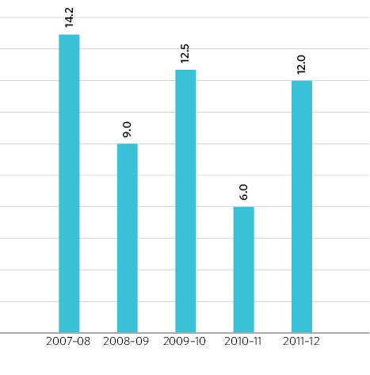
Figure 28 – Recruitment (headcount) 2007–08 to 2011–12

Employment exemptions
The VEC has been granted an exemption from provisions of the Equal Opportunity Act 1995 to enable it to employ Aboriginal-identifying applicants for the role of Aboriginal Engagement 0fficer. The exemption was granted for three years from January 2010. A copy of the VCAT decision is available from the VEC and on the VEC website.
It is essential that all VEC employees, members of its Audit Committee, contractors and election officials are, and are seen to be, truly independent and impartial in the conduct of their official duties. The appointment of a person to any position within the VEC whose current or previous actions could give rise to a perception of political bias potentially compromises the perceived independence of the VEC. This does not imply that the VEC believes that a person would not be capable of impartial conduct – rather how this may be perceived by a candidate for election, political party or members of the public.
Replacing the previous exemption granted by VCAT in 2009–10, section 17A of the Electoral Act 2002 came into effect in August 2011. This section enables the VEC to ask job applicants and potential Audit Committee members for disclosure of specific political activities. Disclosure of this information does not necessarily mean that an applicant will not be employed. Disclosure provides the VEC with the opportunity to consider whether an applicant is suitable for allocation to certain areas or on certain elections. For example, a person who had been involved in lobbying their local council on a particular issue may be excluded from working on projects related to that particular council.
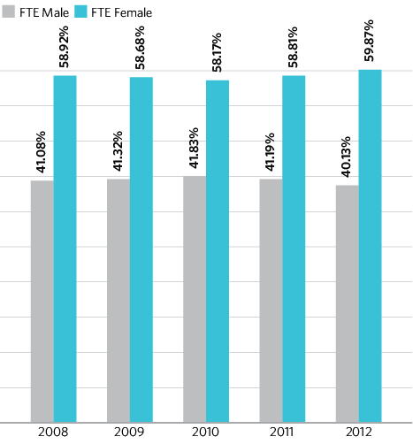
Figure 29 – VEC staff by gender, 30 June 2008–12

Staffing for 2012 council elections
In October 2011, orientation training commenced for 70 newly-recruited senior election officials. Training for 200 senior election officials selected to work as Election Support Officers, Returning Officers and Deputy Returning Officers, or who were being trained as emergencies, commenced in April 2012. Approximately 8,000 casual staff will be recruited to work as election officials at the 2012 council elections. As in the past, efforts will be made to attract, and appoint to suitable positions, people with fluency in a foreign language, those who identify themselves as Traditional Owners and people who identify themselves as having a disability.

Employment Diversity
The VEC’s aim is to recruit and support personnel who represent the diversity of the Victorian community. Practices recognise and value individual differences within the workplace. Adherence to the principles of merit and equity ensure that organisational functions are delivered in a fair and equitable manner, and that employees and stakeholders are not subject to discrimination or harassment.
The VEC has an inclusive employment policy, and where practicable, the VEC makes more than the minimum required adjustments for staff with specific needs. The new head office premises, while not fully accessible due to a road crossing that must be made from an accessible car space, is a vast improvement on the previous premises and offers a range of facilities to assist those with a disability.
The VEC recognises cultural diversity in employment practices and policies where appropriate, and in an informal manner with staff-initiated celebrations arranged and supported usually in conjunction with staff meetings or special morning teas.

Voters rolls
Voters rolls for council elections are compiled from a State roll extract for the municipality (around 85% of voters), combined with a ratepayer extract from the municipality (around 15% of voters). The process of combining the two datasets involves complex checking processes to try to ensure that voters in the State roll extract are not duplicated in the council data.
The close of rolls for the 2012 Council elections is scheduled for 31 August 2012, and the VEC Roll Products and Services Team will have all 78 rolls, containing around 4.1 million voters details, ready for the certification process within 14 days. In order to meet this very tight timeline, the team has been working with councils to help them add dates of birth to their rate records to avoid duplicate voters on the certification roll.
They have also worked through a preliminary roll production process, feeding back data issues and duplicates to councils for correction before the process starts in earnest.
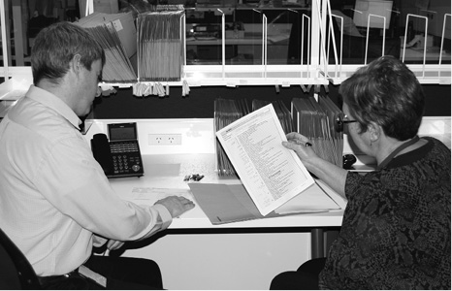

Knowledge capital
Along with formal and informal qualifications, VEC staff have a wide range of experience and high level knowledge and skills relating to electoral activity. This “knowledge capital” is highly valued by the VEC not only because it helps ensure the achievement of corporate objectives, but because it is passed between staff to ensure continual professional growth and capacity in this specialised field. The VEC ensures that staff have a variety of training opportunities, and the opportunity to gain election experience at other electoral agencies whenever possible.

Performance management
The VEC adheres to the VPS Workplace Agreement 2006 extended and varied version 2009, maintaining a performance management and progression system that aligns individual performance objectives with the VEC’s strategic direction. Each employee’s performance is assessed annually and reviewed half-yearly against individual and corporate objectives and outcomes.
The VEC believes that it has a responsibility to foster and maintain a culture that provides the right balance of challenge, satisfaction and achievement, and endeavours to provide a good mix of motivators, goals, encouragement and reward.
During 2011–12, as a response to staff feedback, the VEC made a commitment to formally evaluate and redevelop the performance review, management and professional development processes.

Training
As part of the performance management process, data relating to staff skills and experience is collected and, working with managers, staff match their skills, knowledge and learning goals with corporate objectives to which they can contribute. This overall picture of current knowledge capital enables managers to make informed decisions about staffing and project allocation, and to form teams which will assist with professional learning and leadership growth.
The Human Resources Manager uses the information to present a professional development plan that provides targeted development opportunities in response to identified needs. In this way, the VEC ensures growth in staff skills and knowledge, staff are supported to achieve their own performance goals as well as the corporate objectives, and succession planning is addressed.
The VEC builds on the skills and knowledge of the staff, identifying opportunities for training and professional development on both an individual and organisation-wide basis. 0rganisation-wide training addresses areas of identified need, contributing to the achievement of organisational objectives and supporting staff in their personal and professional development.
During 2011–12, training focused on leadership, management, cultural re-alignment, privacy, Occupational Health and Safety (OHS), and electoral administration.
0nline training for election officials was again used to complement intensive face-to-face and hands-on training. 0ther training made available online during 2011–12 covered OHS, diversity and inclusion, recruitment and selection.
Staff were again offered the opportunity to complete fire warden, first aid and defibrillator training and 18 staff participated.
During 2011–12, the VEC provided an average of 3.35 days of formal training per full-time equivalent (FTE). VEC staff also undertook informal learning opportunities, including workshops and a variety of network meetings.
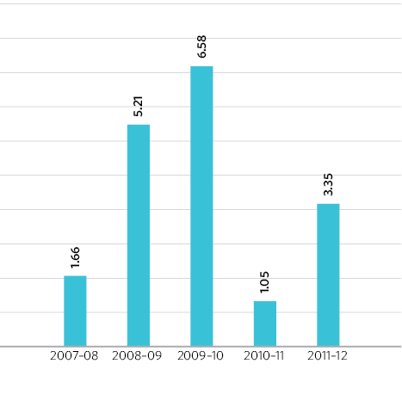
Figure 30 – Training days per FTE, 2007–08 to 2011–12
Note: Figures are for core staff, excludes training for election officials.

BRIDGE
BRIDGE stands for Building Resources in Democracy, Governance and Elections. It is a modular professional development program with a particular focus on electoral processes. BRIDGE represents a unique initiative where five leading organisations in the democracy and governance field, including the Australian Electoral Commission (AEC), have jointly committed to developing, implementing and maintaining the most comprehensive curriculum and workshop package available. Bridge is designed to be used as a tool within a broader capacity development framework.
In February 2012, as a result of close collaboration with the AEC, the VEC hosted a Train the Facilitator course. Eight VEC staff participated, and along with 12 AEC staff, achieved semi-accreditation and are now well on their way to becoming accredited BRIDGE facilitators.


Information technology
After successful electronic roll mark-off at a number of election events, the decision was made to conduct electronic roll mark-off at the 2012 Council elections. The projected number of electors to be marked off electronically considerably exceeds the numbers dealt with during the 2010 State election. Additional devices are required. All netbooks are connected wirelessly to the VEC using the Telstra Next-G network, and the procurement of 240 suitable machines was required.
For the 2010 State election, the VEC borrowed around 400 netbooks from the Tasmanian Electoral Commission for use in election offices for Early Voting. These were not available in 2012 as they were already committed to Elections ACT for the Australian Capital Territory 2012 general elections. The VEC has purchased 100 machines, and sourced 140 from the Western Australian Electoral Commission. This will enable the servicing of all early voting and all attendance voting centres for the 2012 Council attendance elections.
Software changes were deployed and tested at the Niddrie District by-election in March 2012, and will again been deployed for the Melbourne District by-election, which is underway at the time of this report.


Occupational Health and Safety
The VEC continued its commitment to Occupational Health and Safety (0HS) compliance as well as general staff health and well being during 2011–12. Quarterly workplace inspections by VEC health and safety representatives continued with the aim of identifying and eliminating hazards, thereby preventing and reducing injuries. Regular clearing and tidying of work areas was organised and available staff were encouraged to participate. 0HS policies, procedures and action plans are subject to ongoing review by the Consultative Committee and Management Group.
Table 1 – The VEC’s performance against OHS management measures
Measure |  | KPI |  | 2007–08 | 2008–09 | 2009–10 | 2010–11 | 2011–12
Incidents |  | No. of incidents |  | 74  10 | 72.1  2 | 76.5  8 | 72.6  12 | 77.9  6
 |  | Rate per 100 FTE |  | 13.51 | 2.77 | 10.46 | 16.53 | 7.70
Claims |  | No. of standard claims (i) |  | 1 | 2 | 2 | 5 | 0
 |  | Rate per 100 FTE |  | 1.35 | 2.77 | 2.61 | 6.89 | 0.00
 |  | No. of lost time claims (i) |  | 2 | 0 | 27 | 4.25 | 0
 |  | Rate per 100 FTE |  | 2.70 | 0.00 | 35.29 | 5.85 | 0.00
 |  | No. of claims exceeding 13 weeks (i) |  | 0 | 0 | 0 | 0 | 0
 |  | Rate per 100 FTE |  | 0.00 | 0.00 | 0.00 | 0.00 | 0.00
Fatalities |  | Fatality claims |  | 0 | 0 | 0 | 0 | 0
Claim costs |  | Average cost per standard claim.(i) |  | 0 | $6,408 | $5,723 | $14,095 | 0
Return to work |  | Percentage of claims with RTW plan <30 days. |  | NA | 0 | 0 | 0 | NA
Management commitment |  | Evidence of OHS policy statement, OHS objectives, regular reporting to senior management of OHS, and OHS plans (signed by CEO or equivalent). |  | completed | completed | completed | completed | completed
 |  | Evidence of OHS criteria(s) in purchasing guidelines (including goods, services and personnel). |  | completed | completed | completed | completed | completed
Consultation and participation |  | Evidence of agreed structure of designated workgroups (DWGs), health and safety representatives (HSRs), and issue resolution procedures (IRPs). |  | completed | completed | completed | completed | completed
 |  | Compliance with agreed structure on DWGs, HSRs, and IRPs. |  | completed | completed | completed | completed | completed
Figure 31: The VEC’s performance against OHS management measures (continued)

Measure | KPI |  | 2007–08 | 2008–09 | 2009–10 | 2010–11 | 2011–12
Risk management | Percentage of internal audits/inspections conducted as planned. |  | 45% | 42.5% | 53% | 60% | 75%
 | Percentage of issues identified actioned arising from:
 | – internal audits |  | NR | NR | NR | NR | NR
 | – HSR provisional improvement notices (PINs) |  | NA | NA | NA | NA | NA
 | – WorkSafe notices |  | NA | NA | NA | NA | NA
Training | Percentage of managers and staff that have received OHS training:
 | – induction |  | 100% | 0% | 100% | 0% | 100%
 | – management training |  | 100% | 0% | 100% | 0% | 100%
 | – contractors, temps, and visitors. |  | NA | NA | NA | NA | NA
 | Percentage of HSRs trained:
 | – acceptance of role |  | 100% | 100% | 27/08/2012 | 100% | 100%
 | – re-training (refresher) |  | 100% | 100% |  | 100% | 100%
 | – reporting of incidents and injuries |  | 100% | 100% |  | 100% | 100%
NR: not reported

Election training
The VEC conducted recruitment and election training for its senior election officials during 2011–12. Training of the VEC’s nominated Returning Officers and Deputy Returning Officers was held in April and May 2012. Further training is scheduled for early in 2012–13 and Returning Officers will commence working in election offices in September 2012, in time for the opening of nominations.

Occupational health and safety audit
An occupational health and safety (0HS) audit was conducted in 2010–11, and an action plan was developed to address areas that were identified as requiring attention. Implementation of the action plan commenced in July 2011 and has continued throughout the year.

Hazards, incidents and injuries
During 2011–12, the VEC received six incident notifications, four hazard notifications, and no claims for compensation (see Figures 32 and 33). For the second time in the five-year period, no lost time injuries were incurred by the VEC during 2011–12, so there were no days of lost time recorded. While the VEC’s target is no lost time injuries, the VEC believes that its ongoing focus on occupational health and safety training and practices, and responsiveness to incidents and injuries, contributes to a culture of safety in the organisation. The VEC responds promptly to notifications of potential hazards by staff in Near Miss Incident Reports.

Staff services and employment conditions
The Consultative Committee contributes to the VEC’s culture and working environment by acting as a conduit for policy review, communication and decision-making. The Committee also actively supports the well-being of all employees by promoting staff initiatives such as staff social events, fund-raising and sustainability.
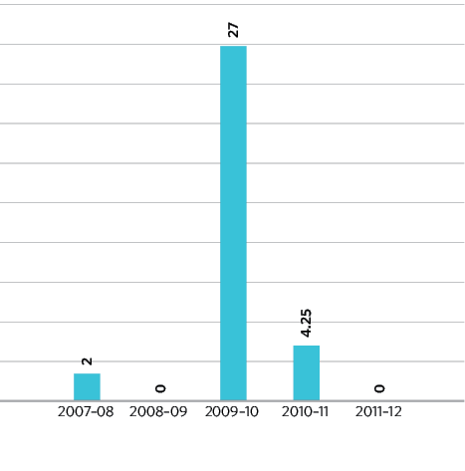
Figure 31 – Days lost as a result of workplace-related injury, 2007–08 to 2011–12

Flexible work arrangements
The VEC believes that flexibility in the workplace contributes to a supportive environment. VEC staff are able to access a variety of options available under the VEC’s Flexible Work Arrangements Policy. This policy provides strategies to manage fluctuating work requirements, while providing a supportive environment especially during the busiest times.
During election time and at other busy times, staff at Victorian Public Service Grades 1–4 who work outside normal hours accrue flexi-time. A regularly reviewed and updated policy framework places limits on the number of hours that may be accrued. This helps ensure that the health of staff remains a priority during the VEC’s most demanding periods.
While staff may accrue additional flexi-time during major electoral events, these hours are managed to ensure staff are able to reduce these accrued hours once the work demand reduces.

Grievances
Issue resolution processes relate to the maintenance of healthy and productive working relationships. The VEC is committed to ensuring that principles of merit and equity are applied throughout the VEC, and work-related complaints are resolved quickly, confidentially and without prejudice. One complaint was received during 2011–12. This was resolved using one of the VEC’s informal resolution strategies.
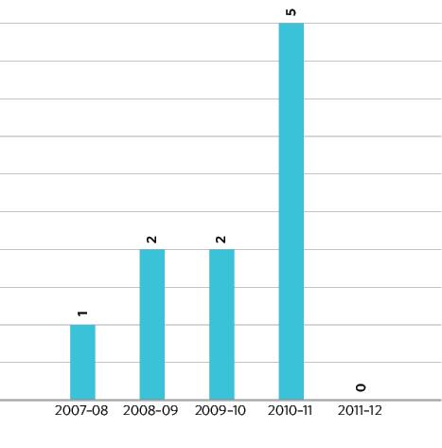
Figure 32 – Claims for WorkCover or workers compensation, 2007–08 to 2011–12
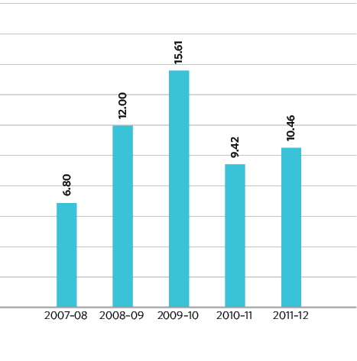
Figure 33 – Accrued hours of flexi-time per FTE, VPS grades 1–4, 2007–08 to 2011–12

Community Sector Information Kits
Over 3,000 resource kits have been sent out to community agencies, predominantly those connected with ethno-specific communities across Victoria. With the catch phrase ‘Your Community, Your Opportunity’ the resource packs aim to raise awareness, participation and understanding of how everyone in the community can participate in their council election and benefit from their involvement. Resource kits, tailored to the voting requirements of each local council, include Easy English Guides to elections and materials to promote involvement.

State-wide communication campaign
The Communication Team has commenced the implementation of a State-wide communication campaign to publicise and provide information about the 2012 Council elections. Features of the campaign include:
- 93 State-wide press advertisements
- 1,126 statutory press advertisements
- 23 CALD press advertisements
- 735 metro radio advertisements
- 3,675 regional radio advertisements
- 966 CALD radio advertisements
- 210 planned web changes


Code of Conduct
Employees of the VEC are bound by the guidelines outlined in the Code of Conduct for Victorian Public Sector Employees of Special Bodies. The code provides guidance to staff and is a measure by which the VEC expects to be perceived and, ultimately, judged. Staff are provided with a copy of the code and these values are included in the performance review documents and are addressed as part of the review process.

People matters and the realignment of organisational culture
During 2011–12 human resource management at the VEC focused on realigning the VEC’s culture in response to the results of the People Matter survey conducted in 2011. Several workshops were conducted with the management group and the Consultative Committee which resulted in the development of a discussion paper ‘Building a Progressive, Integrity Based Culture’ released in May 2012. The VEC has a set of values which are highly regarded by staff. A progressive, integrity-based culture based on these values underpins all VEC activities.
A number of strategies were identified to establish high standards of integrity and promote our values through leadership, clear objectives and targeted training. The VEC will enforce these standards through decision-making, monitoring, reporting, complaints-handling and auditing.
Work has begun on the implementation of a framework to support the necessary adjustments. In April 2012, the VEC rolled out two Equal Opportunity programs with the aim of continuing to raise awareness of expectations of conduct, understanding and respect. These programs dealt with Equal Opportunity Responsibilities for Managers and Team Leaders, and Equal Opportunity Awareness for all staff.

Women’s affairs
The VEC supports staff attendance at International Women’s Day events. In 2011–12, the VEC sponsored a number of staff to attend the Institute of Public Administration Australia International Women’s Day event.

Staff well-being services
The VEC supports staff to maintain well-being using preventative and responsive measures. The VEC also makes it a priority to support individual staff experiencing ongoing personal or health issues in a formal and informal manner as appropriate.
As well as the range of services offered during Health Month, all VEC staff have access to a counselling service through the Department of Justice Employee Assistance Program.
During 2011–12, in response to staff feedback, the VEC also made arrangements with a conflict management service to provide independent services if required. This service has not been accessed during 2011–12.

Voting is for Everyone
The Communication Education and Research Branch produced a revised Voting is for Everyone DVD facilitation kit for carers and families of people with an intellectual or multiple impairments.
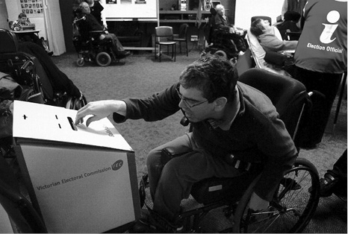

Audited Financial Statements
Inside this section
Comprehensive operating statement | 66
Balance sheet | 67
Statement of changes in equity | 68
Cash flow statement | 69
Notes to the financial statements | 70
Electoral Commissioner and Accountable officer’s declaration | 109
Auditor-General’s Report | 110

Comprehensive operating statement

Comprehensive operating statement for the financial year ended 30 June 2012

 | Notes | 2012  $’000 | 2011  $’000
Continuing operations
Income from transactions
Special appropriations | 1F,4,21 | 21,685 | 51,415
Total income from transactions |  | 21,685 | 51,415
Expenses from transactions
Employee expenses | 1G,5 | 8,460 | 23,210
Supplies and services | 1G,5 | 10,888 | 28,577
Depreciation and amortisation | 1G,5 | 1,345 | 1,442
Interest expense | 1G,5 | 5 | 5
Capital asset charge | 1G | 129 | 129
Operating lease rental expense | 1N | 1,419 | 1,229
Total expenses from transactions |  | 22,246 | 54,592
Net result from transactions (net operating balance) |  | (561) | (3,177)
Other economic flows included in net result
Other gains / (losses) from other economic flows | 6 | (31) | -
Total other economic flows included in net result |  | (31) | -
Net result from continuing operations |  | (592) | (3,177)
Net result from discontinued operations |  | - | -
Net result | 20b | (592) | (3,177)
Comprehensive result |  | (592) | (3,177)

The comprehensive operating statement should be read in conjunction with the accompanying notes.

Balance sheet

as at 30 June 2012
 | Notes | 2012  $’000 | 2011  $’000
Assets
Financial assets
Cash and deposits | 1K,20 | 2 | 3
Receivables | 1K,7 | 483 | 428
Other financial assets | 11 | 687 | 429
Total financial assets |  | 1,172 | 860
Non-financial assets
Inventories | 1L,8 | 848 | 611
Property, plant and equipment | 1L,9 | 3,330 | 3,709
Intangible assets | 1L,10 | 3,667 | 3,143
Other non-financial assets | 11 | - | -
Total non-financial assets |  | 7,845 | 7,463
Total assets |  | 9,017 | 8,323
Liabilities
Payables | 1M,12 | 279 | 762
Borrowings | 1N,13 | 84 | 61
Provisions | 1M,14 | 1,626 | 1,593
Total liabilities |  | 1,989 | 2,416
Net assets |  | 7,028 | 5,907
Equity
Accumulated surplus/(deficit) |  | (18,879) | (18,287)
Contributed capital | 1O | 25,907 | 24,194
Net worth |  | 7,028 | 5,907
Commitments for expenditure | 17
Contingent liabilities and contingent assets | 18
The balance sheet should be read in conjunction with the accompanying notes.

Statement of changes in equity

for the financial year ended 30 June 2012
 | Notes | Accumulated  Surplus | Contributions  by Owners | Total
Balance at 1 July 2010 |  | (15,110) | 21,020 | 5,910
Net result for the year | 21 | (3,177) | 3,174 | (3)
Other comprehensive income for the year |  | - | - | -
Transfer to accumulated surplus |  | - | - | -
Capital appropriations |  | - | - | -
Balance at 30 June 2011 |  | (18,287) | 24,194 | 5,907
Net result for the year |  | (592) | 1,713 | 1,121
Other comprehensive income for the year |  | - | - | -
Capital appropriations |  | - | - | -
Balance at 30 June 2012 |  | (18,879) | 25,907 | 7,028

The statement of changes in equity should be read in conjunction with the accompanying notes.

Cash flow statement

for the financial year ended 30 June 2012
 | Notes | 2012  $’000 | 2011  $’000
Cash flows from operating activities
Receipts
Receipts from Government |  | 23,016 | 54,452
Total receipts |  | 23,016 | 54,452
Payments
Payments to suppliers and employees |  | (21,553) | (51,279)
Goods and Services Tax paid to the ATO | (i) | (1,331) | (3,037)
Capital asset charge payments |  | (129) | (129)
Interest and other costs of finance paid |  | (5) | (5)
Total payments |  | (23,018) | (54,450)
Net cash flows from / (used in) operating activities | 20(b) | (2) | 2
Cash flows from investing activities
Purchases of non-financial assets | 21 | (1,713) | (3,174)
Sales of non-financial assets |  | - | -
Net cash flows from / (used in) investing activities |  | (1,713) | (3,174)
Cash flows from financing activities
Owner contributions by State Government |  | 1,713 | 3,152
Net cash flows from / (used in) financing activities |  | 1,713 | 3,152
Net increase / (decrease) in cash and cash equivalents |  | (2) | (20)
Cash and cash equivalents at the beginning of the financial year |  | 1 | (1)
Cash and cash equivalents at the end of the financial year | 20(a) | (1) | (21)
The above cash flow statement should be read in conjunction with the accompanying notes.
Notes: (i) Goods and Services Tax paid to the ATO is presented on a net basis

Notes to the financial statements

for the financial year ended 30 June 2012

Note 1. Summary of significant accounting policies
The annual financial statements represent the audited general purpose financial statements for the Victorian Electoral Commission for the period ending 30 June 2012.
The purpose of the report is to provide users with information about the Commission’s stewardship of resources entrusted to it.

(A) Statement of compliance
These general purpose financial statements have been prepared in accordance with the Financial Management Act 1994 and applicable Australian Accounting Standards, (AAS) which include Interpretations, issued by the Australian Accounting Standards Board (AASB). In particular, they are presented in a manner consistent with the requirements of the AASB 1049 Whole of Government and General Government Sector Financial reporting.
Where appropriate, those AAS paragraphs applicable to not-for-profit entities have been applied.
Accounting policies are selected in a manner which ensures that the resulting financial information satisfies the concepts of relevance and reliability, thereby ensuring that the substance of the underlying transactions or other events is reported.
To gain a better understanding of the terminology used in this report, a glossary of terms and style conventions can be found in Note 28.
The annual financial statements were authorised for issue by the Acting Electoral Commissioner of the Victorian Electoral Commission on 15 August 2012.

(B) Basis of accounting preparation and measurement
The accrual basis of accounting has been applied in the preparation of these financial statements whereby assets, liabilities, equity, income and expenses are recognised in the reporting period to which they relate, regardless of when cash is received or paid.
Judgements, estimates and assumptions are required to be made about the carrying values of assets and liabilities that are not readily apparent from other sources. The estimates and associated assumptions are based on professional judgements derived from historical experience and various other factors that are believed to be reasonable under the circumstances. Actual results may differ from these estimates.
Revisions to accounting estimates are recognised in the period in which the estimate is revised and also in future periods that are affected by the revision. Judgements and assumptions made by management in the application of AASs that have significant effects on the financial statements and estimates, are disclosed throughout the notes to the financial statements.
These financial statements are presented in Australian dollars, and prepared in accordance with the historical cost convention.

(C) Reporting entity
The financial statements cover the Victorian Electoral Commission as an individual reporting entity.
The Commission is a government department of the State of Victoria, established pursuant to an order made by the Premier under the Electoral Act 2002.
Its principal address is:
Victorian Electoral Commission
Level 11, 530 Collins Street
Melbourne VIC 3000
The Commission is an administrative agency acting on behalf of the Crown.
The financial statements include all the controlled activities of the Victorian Electoral Commission.
A description of the nature of the Commission’s operations and its principal activities is included in the report of operations which does not form part of these financial statements.

Objectives and funding
The Commission’s overall objective is to provide election services to State and Local Government, as well as conducting various fee for service elections.
The Commission is funded by accrual-based parliamentary appropriations for the provision of outputs. It provides on a fee for service basis election services for Local Government and Commercial elections. The fees charges for these services are determined by prevailing market forces.

Outputs of the Commission
Information about the Commission’s output activities, and the expenses, income, assets and liabilities which are reliably attributable to those output activities, is set out in the output activities schedule (Note 2). Information about expenses, income, assets and liabilities administered by the Commission are given in the schedule of administered expenses and income and the schedule of administered assets and liabilities (see Note 3).

(D) Basis of consolidation
In accordance with AASB 127 Consolidated and Separate Financial Statements:
- The consolidated financial statements of the Commission incorporates assets and liabilities of all reporting entities controlled by the Commission as at 30 June 2012, and their income and expenses for that part of the reporting period in which control existed.
- The consolidated financial statements exclude bodies that are not controlled by the Commission and therefore are not consolidated. Bodies and activities that are administered are also not controlled and not consolidated.
There were no bodies consolidated into the Commissions reporting entity during the reporting period.

Administered items
Certain resources are administered by the Commission on behalf of the State. While the Commission is accountable for the transactions involving administered items, it does not have the discretion to deploy the resources for its own benefit or the achievement of its objectives. Accordingly, transactions and balances related to administered items are not recognised as Commission income, expenses, assets or liabilities within the body of the financial statements.
Administered income includes taxes, fees and fines. Administered assets include government income earned but yet to be collected. Administered liabilities include government expenses incurred but yet to be paid.
Except as otherwise disclosed, administered resources are accounted for on an accrual basis using the same accounting policies adopted for recognition of the Commission items in the financial statements. Both controlled and administered items of the Commission are consolidated into the financial statements of the State.
Disclosures related to administered items can be found in Note 3.

Funds held in trust

Other trust activities on behalf of parties external to the Victorian Government
The Commission has responsibility for transactions and balances relating to trust funds on behalf of third parties external to the Victorian Government. Income, expenses, assets and liabilities managed on behalf of third parties are not recognised in these financial statements as they are managed on a fiduciary and custodial basis, and therefore are not controlled by the Commission or the Victorian Government. Funds under management are reported in the Note 3.

(E) Scope and presentation of financial statements

Comprehensive operating statement
Income and expenses in the comprehensive operating statement are classified according to whether or not they arise from ‘transactions’ or ‘other economic flows’. This classification is consistent with the whole of government reporting format and is allowed under AASB 101 Presentation of financial statements.
Transactions’ and ‘other economic flows’ are defined by the Australian system of government finance statistics: concepts, sources and methods 2005 and Amendments to Australian System of Government Finance Statistics, 2005 (ABS Catalogue No 5514.0) (the GFS Manual, refer to Note 28).
Transactions’ are those economic flows that are considered to arise as a result of policy decisions, usually interactions between two entities by mutual agreement. Transactions also include flows within an entity, such as depreciation where the owner is simultaneously acting as the owner of the depreciating asset and as the consumer of the service provided by the asset. Taxation is regarded as mutually agreed interactions between the Government and taxpayers. Transactions can be in kind (e.g. assets provided/given free of charge or for nominal consideration) or where the final consideration is cash.
Other economic flows’ are changes arising from market remeasurements. They include:
- gains and losses from disposals,
- revaluations and impairments of non-financial physical and intangible assets,
- actuarial gains and losses arising from defined benefit superannuation plans,
- fair value changes of financial instruments and agricultural assets; and
- depletion of natural assets (non-produced) from their use or removal.
The net result is equivalent to profit or loss derived in accordance with AASs.

Balance sheet
Assets and liabilities are presented in liquidity order with assets aggregated into financial assets and non-financial assets.
Current and non-current assets and liabilities (those assets or liabilities expected to be recovered or settled more than 12 months) are disclosed in the notes, where relevant.

Cash flow statement
Cash flows are classified according to whether or not they arise from operating, investing, or financing activities. This classification is consistent with requirements under AASB 107 Statement of Cash Flows.

Statement of changes in equity
The statement of changes in equity presents reconciliation of non-owner and owner changes in equity from opening balance at the beginning of the reporting period to the closing balance at the end of the reporting period. It also shows separately changes due to amounts recognised in the ‘Comprehensive result’ and amounts recognised in ‘Other economic flows – other movements in equity’ related to ‘Transactions with owner in its capacity as owner’.

Rounding
Amounts in the financial statements have been rounded to the nearest thousand dollars, unless otherwise stated. Please refer to the end of Note 28 for a style convention explaining that minor discrepancies in totals of tables are due to rounding.

(F) Income from transactions
Income is recognised to the extent that it is probable that the economic benefits will flow to the entity and the income can be reliably measured at fair value.

Special appropriations
Appropriation income becomes controlled and is recognised by the Commission when it is appropriated from the Consolidated Fund by the Victorian Parliament via the Department of Justice, and applied to the purposes defined under the Electoral Act 2002.
Where applicable, amounts disclosed as income are net of returns, allowances, duties and taxes. All amounts of income over which the Commission does not have control are disclosed as administered income in the schedule of administered income and expenses (see Note 3).

(G) Expenses from transactions
Expenses are recognised as they are incurred and reported in the financial year to which they relate.

Employee expenses
Refer to the section in Note 1 (M) regarding employee benefits.
These expenses include all costs related to employment (other than superannuation which is accounted for separately) including wages and salaries, fringe benefits tax, leave entitlements, redundancy payments and workcover premiums.

Superannuation
The amount recognised in the comprehensive operating statement in relation to employer contributions for members of both defined benefit and defined contribution superannuation plans that are paid or payable during the reporting period.
The Department of Treasury and Finance (DTF) in their Annual Financial Statements, disclose on behalf of the State as the sponsoring employer, the net defined benefit cost related to the members of these plans as an administered liability. Refer to DTF’s Annual Financial Statements for more detailed disclosures in relation to these plans.

Other operating expenses
Other operating expenses generally represent the day-to-day running costs incurred in normal operations.

Supplies and services
Supplies and services costs are recognised as an expense in the reporting period in which they are incurred. The carrying amounts of any inventories held for distribution are expensed when distributed.

Bad and doubtful debts
Refer to Note 1 (K) Impairment of financial assets.

Depreciation
All property, plant and equipment and other non-financial physical assets (excluding items under operating leases) that have finite useful lives are depreciated. Depreciation is generally calculated on a straight-line basis, at rates that allocate the asset’s value, less any estimated residual value, over its estimated useful life. Refer to Note 1 (L) for the depreciation policy for leasehold improvements.
The estimated useful lives, residual values and depreciation method are reviewed at the end of each annual reporting period, and adjustments made where appropriate.
The following are typical estimated useful lives for the different asset classes for current and prior years.
Asset class | Useful life
Leasehold Improvements | Term of lease
Leased motor vehicles | 3 years
Plant & equipment | 2 – 10 years
Furniture & fittings | 5 – 14 years
Computer equipment | 2 – 3 years
Intangible assets – software development | 3 election periods (12 years)

Intangible produced assets with finite useful lives are depreciated as an expense from transactions on a systematic (typically straight-line) basis over the asset’s useful life. Depreciation begins when the asset is available for use, that is, when it is in the location and condition necessary for it to be capable of operating in the manner intended by management.
The consumption of intangible non-produced assets with a finite useful life is not classified as a transaction, but as amortisation and is included in the net result as an other economic flow.
Intangible assets with indefinite useful lives are not depreciated or amortised, but are tested annually for impairment.

Interest expense
Interest expense is recognised in the period in which it is incurred. Refer to Glossary of terms and style conventions in Note 28 for an explanation of interest expense items.

Capital asset charge
The capital asset charge is calculated on the budgeted carrying amount of applicable non-financial physical assets.

(H) Other economic flows included in the net result
Other economic flows measure the change in volume or value of assets or liabilities that do not result from transactions.

Net gain/(loss) on non-financial assets
Net gain/(loss) on non-financial assets and liabilities includes realised and unrealised gains and losses as follows:

Disposal of non-financial assets
Any gain or loss on the disposal of non-financial assets is recognised at the date of disposal and is determined after deducting from the proceeds the carrying value of the asset at that time.

Impairment of non-financial assets
Intangible assets with indefinite useful lives (and intangible assets not yet available for use) are tested annually for impairment (as described below) and whenever there is an indication that the asset may be impaired.
All other assets are assessed annually for indications of impairment, except for inventories.
If there is an indication of impairment, the assets concerned are tested as to whether their carrying value exceeds their recoverable amount. Where an asset’s carrying value exceeds its recoverable amount, the difference is written off as an other economic flow, except to the extent that the write-down can be debited to an asset revaluation surplus amount applicable to that class of asset.
If there is an indication that there has been a change in the estimate of an asset’s recoverable amount since the last impairment loss was recognised, the carrying amount shall be increased to its recoverable amount. This reversal of the impairment loss occurs only to the extent that the asset’s carrying amount does not exceed the carrying amount that would have been determined, net of depreciation or amortisation, if no impairment loss had been recognised in prior years.
It is deemed that, in the event of the loss or destruction of an asset, the future economic benefits arising from the use of the asset will be replaced unless a specific decision to the contrary has been made. The recoverable amount for most assets is measured at the higher of depreciated replacement cost and fair value less costs to sell. Recoverable amount for assets held primarily to generate net cash inflows is measured at the higher of the present value of future cash flows expected to be obtained from the asset and fair value less costs to sell.
Refer to Note 1 (L) in relation to the recognition and measurement of non-financial assets.

(I) Administered income

Taxes, fines and regulatory fees
The Commission does not gain control over assets arising from taxes, fines and regulatory fees, consequently no income is recognised in the Commission’s financial statements.
The Commission collects these amounts on behalf of the State. Accordingly, the amounts are disclosed as income in the schedule of Administered Items (see Note 3).

(J) Financial instruments
Financial instruments arise out of contractual agreements that give rise to a financial asset of one entity and a financial liability or equity instrument of another entity. Due to the nature of the Commission’s activities, certain financial assets and financial liabilities arise under statute rather than a contract. Such financial assets and financial liabilities do not meet the definition of financial instruments in AASB 132 Financial Instruments: Presentation. For example, statutory receivables arising from taxes, fines and penalties do not meet the definition of financial instruments as they do not arise under contract. However, guarantees issued by the Treasurer on behalf of the Commission are financial instruments because, although authorised under statute, the terms and conditions for each financial guarantee may vary and are subject to an agreement.
Where relevant, for note disclosure purposes, a distinction is made between those financial assets and financial liabilities that meet the definition of financial instruments in accordance with AASB 132 and those that do not.
The following refers to financial instruments unless otherwise stated.

Categories of non-derivative financial instruments

Loans and receivables
Loans and receivables are financial instrument assets with fixed and determinable payments that are not quoted on an active market. These assets are initially recognised at fair value plus any directly attributable transaction costs. Subsequent to initial measurement, loans and receivables are measured at amortised cost using the effective interest method, less any impairment. Loans and receivables category includes cash and deposits ( refer to Note 19.1, trade receivables and other receivables, but not statutory receivables.

Available-for-sale financial assets
Available-for-sale financial instrument assets are those designated as available-for-sale or not classified in any other category of financial instrument asset.
Such assets are initially recognised at fair value. Subsequent to initial recognition, they are measured at fair value with gains and losses arising from changes in fair value, recognised in “Other economic flows – other non owner changes in equity” is transferred to other economic flows in the net result.
Fair value is determined in the manner described in Note 19(e) Financial Instruments.

Financial assets and liabilities at fair value through profit and loss
Financial assets are categorised as fair value through profit or loss at trade date if they are classified as held for trading or designated as such upon initial recognition. Financial instrument assets are designated at fair value through profit or loss on the basis that the financial assets form part of a group of financial assets that are managed by the entity concerned based on their fair values, and have their performance evaluated in accordance with documented risk management and investment strategies.
Financial instruments at fair value through profit or loss are initially measured at fair value and attributable transaction costs are expensed as incurred. Subsequently, any changes in fair value are recognised in the net result as other economic flows.

Financial liabilities at amortised cost
Financial instrument liabilities are initially recognised on the date they are originated. They are initially measured at fair value plus any directly attributable transaction costs. Subsequent to initial recognition, these financial instruments are measured at amortised cost with any difference between the initial recognised amount and the redemption value being recognised in profit and loss over the period of the interest-bearing liability, using the effective interest rate method (refer to Note 19(d)).
Financial instrument liabilities measured at amortised cost include all of the Commissions contract payables, deposits held and advances received, and interest-bearing arrangements other than those designated at fair value through profit or loss.

(K) Financial assets

Cash and deposits
Cash and deposits, including cash equivalents, comprise cash on hand and cash at bank.

Receivables
Receivables consist of:
- contractual receivables, which include mainly debtors in relation to goods and services.
- statutory receivables, which include predominantly amounts owing from the Victorian Government and GST input tax credits recoverable. Receivables that are contractual are classified as financial instruments. Statutory receivables are not classified as financial instruments.
Contractual receivables are classified as financial instruments and categorised as loans and receivables (refer to Note (19.1) for recognition and measurement). Statutory receivables, are recognised and measured similarly to contractual receivables (except for impairment), but are not classified as financial instruments because they do not arise from a contract.
Receivables are subject to impairment testing as described below. A provision for doubtful receivables is recognised when there is objective evidence that the debts may not be collected, and bad debts are written off when identified.

Impairment of financial assets
At the end of each reporting period, the Commission assesses whether there is objective evidence that a financial asset or group of financial assets is impaired. All financial instrument assets, except those measured at fair value through profit or loss, are subject to annual review for impairment.
Receivables are assessed for bad and doubtful debts on a regular basis. Those bad debts considered as written off by mutual consent are classified as a transaction expense. Bad debts not written off by mutual consent and the allowance for doubtful receivables are classified as other economic flows in the net result.
The amount of the allowance is the difference between the financial asset’s carrying amount and the present value of estimated future cash flows, discounted at the effective interest rate.
In assessing impairment of statutory (non-contractual) financial assets, which are not financial instruments, professional judgement is applied in assessing materiality using estimates, averages and other computational methods in accordance with AASB 136 Impairment of assets.

(L) Non-Financial assets

Inventories
Inventories include goods and other property for distribution at zero or nominal cost, or for consumption in the ordinary course of business operations.
Inventories held for distribution are measured at cost, adjusted for any loss of service potential.
Bases used in assessing loss of service potential for inventories held for distribution include current replacement cost and technical or functional obsolescence. Technical obsolescence occurs when an item still functions for some or all of the tasks it was originally acquired to do, but no longer matches existing technologies. Functional obsolescence occurs when an item no longer functions the way it did when it was first acquired.

Plant and equipment
All non-financial physical assets are measured initially at cost and subsequently revalued at fair value less accumulated depreciation and impairment.
The initial cost for non-financial physical assets under a finance lease (refer to Note 1 (N)) is measured at amounts equal to the fair value of the leased asset or, if lower, the present value of the minimum lease payments, each determined at the inception of the lease.
The fair value of plant, equipment and vehicles, is normally determined by reference to the asset’s depreciated replacement cost. For plant, equipment and vehicles, existing depreciated historical cost is generally a reasonable proxy for depreciated replacement cost because of the short lives of the asset concerned.
For the accounting policy on impairment of non-financial physical assets, refer to impairment of non-financial assets under Note 1(H) Impairment of non-financial assets.

Leasehold improvements
The cost of leasehold improvements is capitalised as an asset and depreciated over the shorter of the remaining term of the lease or the estimated useful life of the improvements.

Revaluations of non-current physical assets
Non-financial physical assets are measured at fair value on a cyclical basis, in accordance with Financial Reporting Directions (FRDs) issued by the Minister for Finance.
The Commission controls plant and equipment, furniture and fittings, motor vehicles, and leasehold improvements which are measured at cost, and are not subject to revaluation.

Intangible assets
Purchased intangible assets are initially recognised at cost. Subsequently, intangible assets with finite useful lives are carried at cost less accumulated depreciation / amortisation and accumulated impairment losses. Costs incurred subsequent to initial acquisition are capitalised when it is expected that additional future economic benefits will flow to the Commission.
When the recognition criteria in AASB 138 Intangible Assets are met, internally generated intangible assets are recognised and measured at cost less accumulated depreciation / amortisation and impairment.
Refer to Note 1(G) Depreciation and amortisation of non-produced intangible assets and Note 1 (H) Impairment of non-financial assets.
An internally-generated intangible asset arising from development (or from the development phase of an internal project) is recognised if, and only if, all of the following are demonstrated:
- the technical feasibility of completing the intangible asset so that it will be available for use or sale;
- an intention to complete the intangible asset and use or sell it;
- the ability to use or sell the intangible asset;
- the intangible asset will generate probable future economic benefits;
- the availability of adequate technical, financial and other resources to complete the development and to use or sell the intangible asset; and
- the ability to measure reliably the expenditure attributable to the intangible asset during its development.
Costs associated with the development of computer software relating to the Election Management and Roll Management system totalling $0.5 million or more are capitalised and amortised on a straight line basis over a twelve year (three State election periods) being the period in which the related benefits are expected to be realised. Costs associated with the acquisition or development of computer software which are less than $0.5 million are charged as expenses in the period as incurred.

Other non-financial assets

Prepayments
Other non-financial assets include prepayments which represent payments in advance of receipt of goods or services or that part of expenditure made in one accounting period covering a term extending beyond that period.

(M) Liabilities

Payables
Payables consist of:
- contractual payables, such as accounts payable. Accounts payable represents liabilities for goods and services provided to the Commission prior to the end of the financial year that are unpaid, and arise when the Commission becomes obliged to make future payments in respect of the purchase of those goods and services; and
- statutory payables such as goods and services tax and fringe benefits tax payable.
Contractual payables are classified as financial instruments and categorised as financial liabilities at amortised cost (refer to Note 1 (J). Statutory payables are recognised and measured similarly to contractual payables, but are not classified as financial instruments and not included in the category of financial liabilities at amortised cost, because they do not arise from a contract.

Borrowings
All interest bearing liabilities are initially recognised at fair value of the consideration received, less directly attributable transaction costs ( refer also to Note 1(N) Leases). The measurement basis subsequent to initial recognition depends on whether the Commission has categorised its interest-bearing liabilities as either financial liabilities designated at fair value through profit or loss, or financial liabilities at amortised cost. Any difference between the initial recognised amount and the redemption value is recognised in net result over the period of the borrowing using the effective interest method.

Provisions
Provisions are recognised when the Commission has a present obligation, the future sacrifice of economic benefits is probable, and the amount of the provision can be measured reliably.
The amount recognised as a liability is the best estimate of the consideration required to settle the present obligation at reporting period, taking into account the risks and uncertainties surrounding the obligation. Where a provision is measured using the cash flows estimated to settle the present obligation, its carrying amount is the present value of those cash flows, using discount rate that reflects the time value of money and risks specific to the provision.

Employee benefits
Provision is made for benefits accruing to employees in respect of wages and salaries, annual leave and long service leave for services rendered to the reporting date.

(i) Wages and salaries, annual leave
Liabilities for wages and salaries, including non-monetary benefits annual leave are recognised in the provision for employee benefits, classified as current liabilities. Those liabilities which are expected to be settled within 12 months of the reporting period, are measured at their nominal values.
Those liabilities that are not expected to be settled within 12 months are also recognised in the provision for employee benefits as current liabilities, but are measured at present value of the amounts expected to be paid when the liabilities are settled using the remuneration rate expected to apply at the time of settlement.

(ii) Long service leave
Liability for long service leave (LSL) is recognised in the provision for employee benefits.
Unconditional LSL is disclosed in the notes to the financial statements as a current liability even where the Commission does not expect to settle the liability within 12 months because it will not have the unconditional right to defer the settlement of the entitlement should an employee take leave within 12 months:
The components of this current LSL are measured at:
- nominal value – component that the Commission expects to settle within 12 months: and
- present value – component that the Commission does not expect to settle within 12 months.
Conditional LSL is disclosed as a non-current liability. There is an unconditional right to defer the settlement of the entitlement until the employee has completed the requisite years of service. This non-current LSL liability is measured at present value.
Any gain or loss following revaluation of the present value of non-current LSL liability is recognised as a transaction, except to the extent that a gain or loss arises due to changes in bond interest rates for which it is then recognised as an other economic flow (refer to Note 1 (H)).

(iii) Termination benefits
Termination benefits are payable when employment is terminated before the normal retirement date, or when an employee accepts voluntary redundancy in exchange for these benefits. The Commission recognises termination benefits when it is demonstrably committed to either terminating the employment of current employees according to a detailed formal plan without possibility of withdrawal or providing termination benefits as a result of an offer made to encourage voluntary redundancy. Benefits falling due more than 12 months after the end of the reporting period are discounted to present value.

Employee benefits on-costs
Employee benefits on-costs such as payroll tax, workers compensation and superannuation are recognised separately from the provision for employee benefits.

(N) Leases
A lease is a right to use an asset for an agreed period of time in exchange for payment.
Leases are classified at their inception as either operating or finance leases based on the economic substance of the agreement so as to reflect the risks and rewards incidental to ownership. Leases of property, plant and equipment are classified as finance infrastructure leases whenever the terms of the lease transfer substantially all the risks and rewards of ownership from the lessor to the lessee. All other leases are classified as operating leases.

Finance leases

Commission as lessee
At the commencement of the lease term, finance leases are initially recognised as assets and liabilities at amounts equal to the fair value of the lease property or, if lower, the present value of the minimum lease payment, each determined at the inception of the lease. The lease asset is depreciated over the shorter of the estimated useful life of the asset or the term of the lease.
Minimum finance lease payments are apportioned between reduction of the outstanding lease liability, and periodic finance expense which is calculated using the interest rate implicit in the lease and charged directly to the comprehensive operating statement. Contingent rentals associated with finance leases are recognised as an expense in the period in which they are incurred.

Operating leases

Commission as lessee
Operating lease payments, including any contingent rentals, are recognised as an expense in the comprehensive operating statement on a straight-line basis over the lease term, except where another systematic basis is more representative of the time pattern of the benefits derived from the use of the leased asset. The leased asset is not recognised in the balance sheet.
All incentives for the agreement of a new or renewed operating lease are recognised as an integral part of the net consideration agreed for the use of the leased asset, irrespective of the incentive’s nature or form or the timing of payments.
In the event that lease incentives are received to enter into operating leases, the aggregate cost of incentives are recognised as a reduction of rental expense over the lease term on a straight-line basis, unless another systematic basis is more representative of the time pattern in which economic benefits from the leased asset are consumed.

(O) Equity
Contributions by owners
Additions to net assets which have been designated as contributions by owners are recognised as contributed capital. Other transfers that are in the nature of contributions or distributions have also been designated as contributions by owners.

(P) Commitments
Commitments for future expenditure include operating and capital commitments arising from contracts. These commitments are disclosed by way of a note (refer to Note 17) at their nominal value and inclusive of the goods and services tax (GST) payable. In addition, where it is considered appropriate and provides additional relevant information to users, the net present values of significant individual projects are stated. These future expenditures cease to be disclosed as commitments once the related liabilities are recognised in the balance sheet.

(Q) Contingent assets and contingent liabilities
Contingent assets and contingent liabilities are not recognised in the balance sheet, but are disclosed by way of a note (refer to Note 18) and, if quantifiable, are measured at nominal value. Contingent assets and liabilities are presented inclusive of GST receivable or payable respectively.

(R) Accounting for the Goods and Services Tax (GST)
Income, expenses and assets are recognised net of the amount of associated GST, except where GST incurred is not recoverable from the taxation authority. In this case, the GST payable is recognised as part of the cost of acquisition of the asset or as part of the expense.
Receivables and payables are stated inclusive of the amount of GST receivable or payable. The net amount of GST recoverable from, or payable to, the taxation authority is included with other receivables or payables in the balance sheet.
Cash flows are presented on a gross basis. The GST components of cash flows arising from investing or financing activities which are recoverable from, or payable to the taxation authority, are presented as operating cash flows.
Commitments and contingent assets and liabilities are also stated inclusive of GST.

(S) Events after reporting date
Assets, liabilities, income or expenses arise from past transactions or other past events. Where the transactions result from an agreement between the Commission and other parties, the transactions are only recognised when the agreement is irrevocable at or before the end of the reporting period. Adjustments are made to amounts recognised in the financial statements for events which occur after the reporting period and before the date the financial statements are authorised for issue, where those events provide information about conditions which existed in the reporting period. Note disclosure is made about events between the end of the reporting period and the date the financial statements are authorised for issue where the events relate to condition which arose after the end of the reporting period and which may have a material impact on the results of subsequent years.

(T) AASs issued that are not yet effective
Certain new AASs have been published that are not mandatory for the 30 June 2012 reporting period. DTF assesses the impact of these new standards and advises the Commission of their applicability and early adoption where applicable.
As at 30 June 2012, the following AASs have been issued by the AASB but not yet effective. They become effective for the first financial statements for reporting periods commencing after the stated operative dates as follows:
Standard / Interpretation | Summary | Applicable for annual reporting periods beginning or ending on | Impact on VEC financial statements
AASB 9 Financial instruments | This standard simplifies requirements for the classification and measurement of financial assets resulting from Phase 1 of the IASB’s project to replace IAS 39 Financial Instruments: Recognition and Measurement (AASB 139 Financial Instruments: Recognition and Measurement). | 1 Jan 2013 | Detail of impact is still being assessed.
AASB 13 Fair Value Measurement | This standard outlines the requirements for measuring the fair value of assets and liabilities and replaces the existing fair value definition and guidance in other AASs. AASB 13 includes a ‘fair value hierarchy’ which ranks the valuation technique inputs into three levels using unadjusted quoted prices in active markets for identical assets or liabilities; other observable inputs; and unobservable inputs. | 1 Jan 2013 | Disclosure for fair value measurements using unobservable inputs are relatively onerous compared to disclosure for fair value measurements using observable inputs. Consequently, the Standard may increase the disclosures for public sector entities that have assets measured using depreciated replacement cost.
AASB 119 Employee Benefits | In this revised Standard for defined benefit superannuation plans, there is a change to the methodology in the calculation of superannuation expenses, in particular there is now a change in the split between superannuation interest expense (classified as transactions) and actuarial gains and losses (classified as ‘Other economic flows – other movements in equity’) reported on the comprehensive operating statement. | 1 Jan 2013 | Not-for-profit entities are not permitted to apply this Standard prior to the mandatory application date. While the total superannuation expense is unchanged, the revised methodology is expected to have a negative impact on the net result from transactions of the general government sector and for those few Victorian public sector entities that report superannuation defined benefit plans.
AASB 1053 Application of Tiers of Australian Accounting Standards | This standard establishes a differential financial reporting framework consisting of two tiers of reporting for preparing general purpose financial statements. | 1 July 2013 | The Victorian Government is currently considering the impacts of Reduced Disclosure Requirements (RDRs) for certain public sector entities and has not decided if RDRs will be implemented in the Victorian public sector.
AASB 2009-11 Amendments to Australian Accounting Standards arising from AASB 9 [AASB 1, 3, 4, 5, 7, 101, 102, 108, 112, 118, 121, 127, 128, 131, 132, 136, 139, 1023 and 1038 and Interpretations 10 and 12] | This Standard gives effect to consequential changes arising from the issuance of AASB 9. | 1 Jan 2013 | No significant impact is expected from these consequential amendments on entity reporting.
AASB 2010-2 Amendments to Australian Accounting Standards arising from Reduced Disclosure Requirements | This Standard makes amendments to many Australian Accounting Standards including Interpretations, to introduce reduced disclosure requirements to the pronouncements for application by certain types of entities. | 1 July 2013 | The Victorian Government is currently considering the impacts of Reduced Disclosure Requirements (RDRs) for certain public sector entities and has not decided if RDRs will be implemented in the Victorian public sector.
AASB 2010-7 Amendments to Australian Accounting Standards arising from AASB 9 (December 2010) [AASB 1, 3, 4, 5, 7, 101, 102, 108, 112, 118, 120, 121, 127, 128, 131, 132, 136, 137, 139, 1023 & 1038 and Interpretations 2, 5, 10, 12, 19 & 127] | These consequential amendments are in relation to the introduction of AASB 9. | 1 Jan 2013 | No significant impact is expected from these consequential amendments on entity reporting.
AASB 2010-10 Further Amendments to Australian Accounting Standards – Removal of Fixed Dates for First-time Adopters [AASB 2009-11 & AASB 2010-7] | The amendments ultimately affect AASB 1 First-time Adoption of Australian Accounting Standards and provide relief for first-time adopters of Australian Accounting Standards from having to reconstruct transactions that occurred before their date of transition to Australian Accounting Standards. | 1 Jan 2013 | No significant impact is expected on entity reporting.
AASB 2011-8 Amendments to Australian Accounting Standards arising from AASB 13 [AASB 1, 2, 3, 4, 5, 7, 9, 2009-11, 2010-7, 101, 102, 108, 110, 116, 117, 118, 119, 120, 121, 128, 131, 132, 133, 134, 136, 138, 139, 140, 141, 1004, 1023 &1038 and Interpretations 2, 4, 12, 13, 14, 17, 19, 131 &132] | This amending Standard makes consequential changes to a range of Standards and Interpretations arising from the issuance of AASB 13. In particular, this Standard replaces the existing definition and guidance of fair value measurements in other Australian Accounting Standards and Interpretations. | 1 Jan 2013 | Disclosures for fair value measurements using unobservable inputs is potentially onerous, and may increase disclosures for assets measured using depreciated replacement cost
AASB 2011-10 Amendments to Australian Accounting Standards arising from AASB 119 (September 2011) [AASB 1, AASB 8, AASB 101, AASB 124, AASB 134, AASB 1049 & AASB 2011-8 and Interpretation 14] | This Standard makes consequential changes to a range of other Australian Accounting Standards and Interpretation arising from the issuance of AASB 119 Employee Benefits. | 1 Jan 2013 | No significant impact is expected from these consequential amendments on entity reporting.
AASB 2011-11 Amendments to AASB 119 (September 2011) arising from Reduced Disclosure Requirements | This Standard makes amendments to AASB 119Employee benefits (September 2011) to incorporate reduced disclosure requirements into the Standard for entities applying Tier 2 requirements in preparing general purpose financial statements. | 1 July 2013 | The Victorian Government is currently considering the impacts of Reduced Disclosure Requirements (RDRs) and has not decided if RDRs will be implemented in the Victorian public sector.
2011-13 Amendments to Australian Accounting Standard – Improvements to AASB 1049 | This Standard aims to improve the AASB 1049 Whole of Government and General Government Sector Financial Reporting at the operational level. The main amendments clarify a number of requirements in AASB 1049, including the amendment to allow disclosure of other measures of key fiscal aggregates as long as they are clearly distinguished from the key fiscal aggregates and do not detract from the information required by AASB 1049. Furthermore, this Standard provides additional guidance and examples on the classification between ‘transactions’ and ‘other economic flows’ for GAAP items without GFS equivalents. | 1 July 2012 | No significant impact is expected from these consequential amendments on entity reporting.
2012-1 Amendments to Australian Accounting Standards – Fair Value Measurement – Reduced Disclosure Requirements [AASB 3, AASB 7, AASB 13, AASB 140 & AASB 141] | This amending Standard prescribes the reduced disclosure requirements in a number of Australian Accounting Standards as a consequence of the issuance of AASB 13 Fair Value Measurement. | 1 July 2013 | As the Victorian whole of government and the general government (GG) sector are subject to Tier 1 reporting requirements (refer to AASB 1053Application of Tiers of Australian Accounting Standards), the reduced disclosure requirements included in AASB 2012-1 will not affect the financial reporting for Victorian whole of government and GG sector.

Note 2. Departmental (controlled) outputs
A description of Departmental outputs performed during the year ended 30 June 2012, and the objectives of these outputs, are summarised below.

Election Services

Description of output
Maintaining the electoral enrolment register, conducting State elections, local government elections, statutory elections, commercial and community elections, and boundary reviews.
Provision of electoral research and communication and education services.

Objectives
Inform Victorians and engage them in actively participating in the democratic process.
Refer to “Comprehensive operating statement” and “Balance sheet” for the controlled income and expenses for the year ended 30 June 2012

Note 3. Administered (non-controlled) items
In addition to the specific Commission operations which are included in the financial statements (comprehensive operating statement, balance sheet, statement of changes in equity and cash flow statement), the Commission administers or manages other activities and resources on behalf of the State and Local Government. The transactions relating to these activities are reported as administered items (refer to Note 1 (D) and (I)).
 | State |  | Local Government
 | 2012  $’000 | 2011  $’000 | 2012  $’000 | 2011  $’000
Administered income from transactions
Sales of goods and services | 1,332 | 891 | - | -
Fines | 2,519 | 797 | 101 | 76
Candidates deposits | 9 | 252 | 4 | 7
Electoral entitlements | 41 | 8,845 | - | -
Total administered income from transactions | 3,901 | 10,785 | 105 | 83
Administered expenses from transactions
Payments into the Consolidated Fund | 4,175 | 1,503 | - | -
Payments to Local Government | - | - | 136 | 48
Payments made on behalf of the State | 44 | 9,000 | - | -
Payments made on behalf of Local Government | - | - | 4 | 11
Total administered expenses from transactions | 4,219 | 10,503 | 140 | 59
Total administered net result from transactions (net operating balance) | (318) | 282 | (35) | 24
Administered financial assets
Bank | 18 | 14 | 3 | 38
Receivables | 140 | 465 | - | -
Total administered financial assets | 158 | 479 | 3 | 38
Administered liabilities
Candidates deposits | 6 | - | - | -
Compulsory voting fines | 12 | 14 | 3 | 38
Creditors and accruals | 68 | 75 | - | -
Total administered liabilities | 86 | 89 | 3 | 38
Total administered net assets | 72 | 390 | - | -

Note 4. Income from transactions
 | 2012  $’000 | 2011  $’000
(a) Revenue from government
Special appropriations | 21,685 | 51,415
Total revenue from government | 21,685 | 51,415

Note 5. Expenses from transactions
 | 2012  $’000 | 2011  $’000
(a) Employee expenses
Post employment benefits
Defined contribution superannuation expense | 647 | 1,375
Salaries, wages and long service leave | 7,813 | 21,835
Total employee expenses | 8,460 | 23,210
(b) Depreciation
Plant, equipment and vehicles | 560 | 385
Infrastructure
Intangible produced assets | 785 | 1,057
Total depreciation | 1,345 | 1,442
(c) Interest expense
Interest on finance leases | 5 | 5
Total interest expense | 5 | 5
(d) Other operating expenses
Supplies and services
Purchase of supplies and consumables | 3,119 | 3,510
Purchase of services | 7,396 | 23,522
Maintenance | 249 | 1,297
Other | 124 | 248
Total operating expenses | 10,888 | 28,577

Note 6. Other economic flows included in net result
 | 2012  $’000 | 2011  $’000
(a) Net gain/(loss) on non-financial assets
Net gain/(loss) on disposal of property plant and equipment | (31) | -
Total net gain/(loss) on non-financial assets | (31) | -
(b) Other gains/(losses) from other economic flows
Other | - | -
Total Other gains/(losses) from other economic flows | - | -

Note 7. Receivables
 | 2012  $’000 | 2011  $’000
Current receivables
Statutory
Amounts owing from Victorian Government (i) | 68 | 72
GST input tax credit recoverable | 366 | 305
Other receivables | 49 | 51
Total current receivables | 483 | 428
Non-current receivables
Statutory
Other receivables | - | -
Total non-current receivables | - | -
Total receivables | 483 | 428

Notes: (i) The amounts recognised from Victorian Government represent funding for all commitments incurred through the appropriations and are drawn from the Consolidated Fund as the commitments fall due. [Appropriations are amounts owed by Victorian Government as legislated in the Appropriations Act. Due to the existence of a legislative instrument, the appropriation receivable to an entity is statutory in nature, and hence not within the scope of financial instrument standards.]

Note 8. Inventories
 | 2012  $’000 | 2011  $’000
Current inventories
Supplies and consumables
At cost | 848 | 611
Total inventories | 848 | 611

Note 9. Property, plant and equipment
Table 9.1: Classification by ‘Purpose Group’ – carrying amounts (i)
 | Public Administration
 | 2012  $’000 | 2011  $’000
Nature-based classification
Plant, equipment and vehicles at fair value | 758 | 795
Leasehold Improvements | 2,572 | 2,723
Assets under construction at cost | - | 191
Net carrying amount of PPE | 3,330 | 3,709

Notes: (i) Plant and equipment are classified primarily by the ‘purpose’ for which the assets are used, according to one of six ‘purpose groups’ based upon government purpose classifications (GPC). All assets within a purpose group are further sub categorised according to the asset’s ‘nature’, with each sub category being classified as a separate class of asset for financial reporting purposes.
Table 9.2: Gross carrying amounts and accumulated depreciations
 | Gross carrying amount |  | Accumulated depreciation |  | Net carrying amount
 | 2012  $’000 | 2011  $’000 | 2012  $’000 | 2011  $’000 | 2012  $’000 | 2011  $’000
Plant, equipment and vehicles at fair value | 3,338 | 3,331 | (2,580) | (2,536) | 758 | 795
Leasehold Improvements | 2,949 | 2,863 | (377) | (140) | 2,572 | 2,723
Assets under construction at cost | - | 191 | - | - | - | 191
Net carrying amount of PPE | 6,287 | 6,385 | (2,957) | (2,676) | 3,330 | 3,709
Table 9.3: Classification by ‘Public Administration’ Purpose Group – Movements in carrying amounts
 | Plant, equipment and vehicles at fair value |  | Leasehold improvements |  | Assets under construction at cost |  | Total
 | 2012  $’000 | 2011  $’000 | 2012  $’000 | 2011  $’000 | 2012  $’000 | 2011  $’000 | 2012  $’000 | 2011 $’000
Opening balance | 795 | 706 | 2,723 | 49 | 191 | - | 3,709 | 755
Additions | 373 | 427 | 86 | 2,762 | - | 191 | 459 | 3,380
Disposals | (87) | (25) | - | (16) | (191) | - | (278) | (41)
Depreciation | (323) | (313) | (237) | (72) | - | - | (560) | (385)
Closing balance | 758 | 795 | 2,572 | 2,723 | - | 191 | 3,330 | 3,709

Note: (i) Fair value assessments have been performed for all classes of assets within this purpose group and the decision was made that movements were not material (less than or equal to 10 per cent) for a full revaluation. The next scheduled full revaluation for this purpose group will be conducted in 2014.
Table 9.3: Aggregate depreciation recognised as an expense during the year
 | 2012  $’000 | 2011  $’000
Leasehold Improvements | 237 | 72
Plant, equipment and vehicles at fair value | 323 | 313
 | 560 | 385

Note: (i) The useful lives of assets as stated in Policy Note 1 are used in the calculation of depreciation.

Note 10. Intangible assets
 | 2012  $’000 | 2011  $’000
Gross carrying amount
Opening balance | 13,684 | 13,684
Election management software under development | 1,309 | -
Closing balance | 1,309 | 13,684
Accumulated depreciation, amortisation and impairment
Opening balance | (10,541) | (9,484)
Amortisation expense (i) | (785) | (1,057)
Impairment losses charged to net result | - | -
Closing balance | (11,326) | (10,541)
Net book value at the end of the financial year | 3,667 | 3,143

Note: (i) The consumption of intangible produced assets is included in ‘depreciation’ line item, where the consumption of the intangible non-produced assets is included in ‘net gain / (loss) on non-financial assets’ line item on the comprehensive operating statement.

Significant intangible assets
The Commission has capitalised software development expenditure for the development of its election management and electoral rolls development. The carrying amount of the capitalised software development expenditure of $3.6 million (2011: $3.1 million). This includes existing developed software and software under development. The existing election management software was fully amortised in 2011 and the electoral rolls software development will be fully amortised in 2015.

Note 11. Other non-financial assets
 | 2012  $’000 | 2011  $’000
Current other assets
Prepayments | 687 | 429
Total current other assets | 687 | 429

Note 12. Payables
 | 2012  $’000 | 2011  $’000
Current payables
Contractual
Employee deductions | 81 | 96
Supplies and services (i) | 198 | 666
 | 279 | 762
Statutory
Other taxes payable | - | -
Total current payables | 279 | 762
Non-current payables
Contractual
Other payables | - | -
Total non-current payables | - | -
Total payables | 279 | 762
Note: (i) The average credit period is 30 days. No interest is charged on payables.

(a) Maturity analysis of contractual payables
Please refer to table 19.5 in Note 19 for the maturity analysis of contractual payables.

(b) Nature and extent of risk arising from contractual payables
Please refer to Note 19 for the nature and extent of risks arising from contractual payables.

Note 13. Borrowings
 | 2012  $’000 | 2011  $’000
Current borrowings
Lease liabilities (i) (Note 16) | 34 | 41
Bank overdraft | 3 | 2
Total current borrowings | 37 | 43
Non-current borrowings
Lease liabilities (i) (Note 16) | 47 | 18
Total non-current borrowings | 47 | 18
Total borrowings | 84 | 61

Note: (i) Secured by the assets leased. Finance leases are effectively secured as the rights to the leased assets revert to the lessor in the event of default.

(a) Maturity analysis of borrowings
Please refer to table 19.5 in Note 19 for the maturity analysis of borrowings.

(b) Nature and extent of risk arising from borrowings
Please refer to Note 19 for the nature and extent of risks arising from borrowings

(c) Defaults and breaches
During the current and prior year, there were no defaults and breaches of any of the loans.

Note 14. Provisions
 | 2012  $’000 | 2011  $’000
Current provisions
(i) Employee benefits (Note 14 (a)) – annual leave
(ii) Unconditional and expected to be settled within 12 months | 488 | 450
(iii) Unconditional and expected to be settled after 12 months | 54 | 50
(i) Employee benefits (Note 14 (a)) – long service leave
(ii) Unconditional and expected to be settled within 12 months | 725 | 669
(iii) Unconditional and expected to be settled after 12 months | 81 | 74
 | 1,348 | 1,243
Provisions related to employee benefit on-costs (Note 14(a) and Note 14(b))
(ii) Unconditional and expected to be settled within 12 months | 121 | 187
(iii) Unconditional and expected to be settled after 12 months | 13 | 21
 | 134 | 208
Total current provisions | 1,482 | 1,451
Non-current provisions
(i) Employee benefits (i) (Note 14 (a)) | 125 | 123
Employee benefit on-costs (Note 14(a) and Note 14(b)) | 19 | 19
Total non-current provisions | 144 | 142
Total provisions | 1,626 | 1,593
(a) Employee benefits and related on-costs (i)
Current employee benefits
Annual leave entitlements | 542 | 500
Long service leave entitlements | 806 | 743
Non-current employee benefits
Long service leave entitlements | 125 | 123
Total employee benefits | 1,473 | 1,366
Current on-costs | 134 | 208
Non-current on-costs | 19 | 19
Total on-costs | 153 | 227
Total employee benefits and related on-costs | 1,626 | 1,593

Note: (i) Provisions for employee benefits consist of amounts for annual leave and long service leave accrued by employees, not including on-costs
(ii) The amounts disclosed are nominal amounts
(iii) The amounts disclosed are discounted to present values

Note 14. Provisions (continued)
 | 2012  $’000 | 2011  $’000
(b) Movement in provisions
Opening balance | 1,366 | 1,286
Additional provisions recognised | 794 | 547
Reductions arising from payments / other sacrifices of future economic benefits | (654) | (467)
Reductions due to transfer out | (33) | -
Closing balance | 1,473 | 1,366
Current | 1,348 | 1,243
Non-current | 125 | 123
 | 1,473 | 1,366

Note 15. Superannuation
Employees of the Commission are entitled to receive superannuation benefits and the Commission contributes to both defined benefit and defined contribution plans. The defined benefit plan(s) provides benefits based on years of service and final average salary.
The Commission does not recognise any defined benefit liability in respect of the plan(s) because the entity has no legal or constructive obligation to pay future benefits relating to its employees; its only obligation is to pay superannuation contributions as they fall due. The Department of Treasury and Finance discloses the State’s defined benefit liabilities in its disclosure for administered items.
However, superannuation contributions paid or payable for the reporting period are included as part of employee benefits in the comprehensive operating statement of the Commission.
The name, details and amounts expensed in relation to the major employee superannuation funds and contributions made by the Commission are as follows:
 | Paid Contribution for the Year |  | Contribution Outstanding at Year End
 | 2012  $’000 | 2011  $’000 | 2012  $’000 | 2011  $’000
Defined benefit plans:
State Superannuation Fund – revised and new (i) | 67 | 86 | - | -
Defined contribution plans:
Australian Super | 38 | 50 | 2 | 1
BT | 15 | 7 | 1 | 1
Colonial First State | 25 | 39 | - | 1
HESTA | 26 | 32 | 1 | 1
REST | 7 | 19 | - | 1
Unisuper | 21 | 26 | 1 | 1
Vicsuper | 373 | 903 | 14 | 16
Other | 75 | 173 | 4 | 3
Total | 647 | 1,335 | 23 | 25

Notes: (i) The bases for determining the level of contributions is determined by the various actuaries of the defined benefit superannuation plans

Note 16. Leases

Disclosures for lessees – finance leases

Leasing arrangements
Finance leases relate to motor vehicles leased through the Department of Justice. The Commission has options to purchase the vehicles for a nominal amount at the conclusion of the lease agreements.
 | Minimum future lease payments (i) |  | Present value of minimum future lease payments
 | 2012  $’000 | 2011  $’000 | 2012  $’000 | 2011  $’000
Other finance lease liabilities payable
Not longer than one year | 34 | 41 | 33 | 39
Longer than one year and not longer than five years | 47 | 18 | 45 | 17
Longer than five years | - | - | - | -
Minimum future lease payments | 81 | 59 | 78 | 56
Less future finance charges | 7 | 2 | 7 | 2
Present value of minimum lease payments | 74 | 57 | 71 | 54
Included in the financial statements as:
Current borrowings lease liabilities (Note 13) |  |  | 34 | 41
Non-current borrowings lease liabilities (Note 13) |  |  | 47 | 18
 |  |  | 81 | 59

Note: (i) Minimum future lease payments include the aggregate of all lease payments and any guaranteed residual.

Disclosure for lessees-operating leases

Leasing arrangements
Operating leases relate to office and warehouse facilities with lease terms between one to twelve years. All operating lease contracts contain market review clauses in the event that the Commission exercises its option to renew. The Commission does not have an option to purchase the leased asset at the expiry of the lease period.
 | 2012  $’000 | 2011  $’000
Other non-cancellable operating lease payables
Not longer than one year | 1,142 | 1,906
Longer than one year and not longer than five years | 4,750 | 4,766
Longer than five years | 11,476 | 13,078
 | 17,368 | 19,750

Maturity analysis of finance lease liabilities and the nature and extent of risk arising from finance lease liabilities are disclosed in Note 19.

Note 17. Commitments for expenditure
The following commitments have not been recognised as liabilities in the financial statements:

(a) Commitments payable (i)
 | 2012  $’000 | 2011  $’000
(i) Other expenditure commitments
Outsourcing commitments (ii)
Payable:
Not longer than one year | 2,369 | 2,231
Total commitments for expenditure (inclusive of GST) | 2,369 | 2,231
Less GST recoverable from the Australian Taxation Office | (215) | (203)
Total commitments for expenditure (exclusive of GST) | 2,154 | 2,028

Notes: (i) All amounts shown in the commitments note are nominal amounts inclusive of GST.
(ii) Commitments under outsourcing contracts are for joint electoral roll procedure at the end of the reporting period.

Note 18. Contingent assets and contingent liabilities (i)
 | 2012  $’000 | 2011  $’000
Contingent liabilities
Legal proceedings and disputes (ii) | - | -
 | - | -

Notes: (i) There were no contingent assets as at 30 June 2012.
(ii) A contingent liability exists for legal action in relation to Electoral Act decisions, Municipal Electoral Tribunals, and offences. However, as at 30 June 2012, there is no reliable estimate of the liability.

Note 19. Financial instruments

(a) Financial risk management objectives and policies
The Commission’s principal financial instruments comprise of:
- cash assets
- receivables (excluding statutory receivables)
- payables (excluding statutory payables)
- borrowings
- finance lease payables
Details of the significant accounting policies and methods adopted, including the criteria for recognition, the basis of measurement, and the basis on which income and expenses are recognised, with respect to each class of financial asset, financial liability and equity instrument above are disclosed in Note 1 to the financial statements.
The main purpose in holding financial instruments is to prudentially manage the Commission’s financial risks within the Government policy parameters.
The Commission’s main financial risks include credit risk, liquidity risk and interest rate risk. The Commission manages these financial risks in accordance with its financial risk management policy.
The Commission uses different methods to measure and manage the different risks to which it is exposed. Primary responsibility for the identification and management of financial risks rests with the Electoral Commissioner in consultation with the Audit Committee.
The carrying amounts of the Commission’s contractual financial assets and financial liabilities by category are in table 19.1 below.
Table 19.1 Categorisation of financial instruments ($ thousand)
 | Contractual financial assets/liabilities designated at fair value through profit/loss | Contractual financial assets/liabilities held-for-trading at fair value through profit/loss | Contractual financial assets – loans and receivables | Contractual financial assets available-for-sale | Contractual financial liabilities at amortised cost | Total
2012
Contractual financial assets
Cash and deposits | - | - | 2 | - | - | 2
Receivables (i)
Sale of goods and services | - | - | 49 | - | - | 49
Other receivables | - | - | - | - | - | -
Total contractual financial assets | - | - | 51 | - | - | 51
Contractual financial liabilities
Payables (i)
Supplies and services | - | - | 279 | - | - | 279
Amounts payable to government and agencies
Borrowings:
Lease liabilities | - | - | 81 | - | - | 81
Total contractual financial liabilities | - | - | 360 | - | - | 360
2011
Contractual financial assets
Cash and deposits | - | - | 3 | - | - | 3
Receivables (i)
Sale of goods and services | - | - | 51 | - | - | 51
Total contractual financial assets | - | - | 54 | - | - | 54
Contractual financial liabilities
Payables (i)
Supplies and services | - | - | 762 | - | - | 762
Amounts payable to government and agencies | - | - | - | - | - | -
Borrowings:
Lease liabilities | - | - | 59 | - | - | 59
Total contractual financial liabilities | - | - | 821 | - | - | 821
Note (i) The total amount disclosed here exclude statutory amounts (e.g. amounts owing from Victorian Government and GST input tax credit recoverable, and taxes payable)

Table 19.2 Net holding gain/(loss) on financial instruments by category ($ thousand)
 | Net holding gain/ (loss) | Total interest income/ (expense) | Fee income/ (expense) | Impairment loss | Total
2012
Contractual financial assets
Financial assets designated at fair value through profit/loss | - | - | - | - | -
Financial assets – loans and receivables | - | - | - | - | -
Financial assets available-for-sale recognised in net result | - | - | - | - | -
Total contractual financial assets | - | - | - | - | -
Contractual financial liabilities
Financial liabilities at amortised cost | - | - | - | - | -
Financial liabilities designated at fair value through profit/loss | - | - | - | - | -
Total contractual financial liabilities | - | - | - | - | -
2011
Contractual financial assets
Financial assets designated at fair value through profit/loss | - | - | - | - | -
Financial assets – loans and receivables | - | - | - | - | -
Financial assets available-for-sale recognised in net result | - | - | - | - | -
Total contractual financial assets | - | - | - | - | -
Contractual financial liabilities
Financial liabilities at amortised cost | - | - | - | - | -
Financial liabilities designated at fair value through profit/loss | - | - | - | - | -
Total contractual financial liabilities | - | - | - | - | -

The net holding gains or losses disclosed above are determined as follows:
- for cash and cash equivalents, loans or receivables and available-for-sale financial assets, the net gain or loss is calculated by taking the movement in the fair value of the asset, the interest income, plus or minus foreign exchange gains or losses arising from revaluation of the financial assets, and minus any impairment recognised in the net result;
- for financial liabilities measured at amortised cost, the net gain or loss is calculated by taking the interest expense, plus or minus foreign exchange gains or losses arising from the revaluation of financial liabilities measured at amortised cost; and
- for financial assets and liabilities that are held for trading or designated at fair value through profit or loss, the net gain or loss is calculated by taking the movement in the fair value of the financial asset or liability.

(b) Credit risk
Credit risk arises from the contractual financial assets of the Commission, which comprise cash and deposits, non-statutory receivables and available for sale contractual financial assets. The Commission’s exposure to credit risk arises from the potential default of a counter party on their contractual obligations resulting in financial loss to the Commission. Credit risk is measured at fair value and is monitored on a regular basis.
Credit risk associated with the Commission’s contractual financial assets is minimal because the main debtor is the Victorian Government. For debtors other than the Government, it is the Commission’s policy to only deal with entities with high credit ratings of a minimum Triple-B rating and to obtain sufficient collateral or credit enhancements, where appropriate.
In addition, the Commission does not engage in hedging for its contractual financial assets and mainly obtains contractual financial assets that are on fixed interest, except for cash assets, which are mainly cash at bank. As with the policy for debtors, the Commission’s policy is to only deal with banks with high credit ratings.
Provision of impairment for contractual financial assets is recognised when there is objective evidence that the Commission will not be able to collect a receivable. Objective evidence includes financial difficulties of the debtor, default payments, debts which are more than 60 days overdue, and changes in debtor credit ratings.
Except as otherwise detailed in the following table, the carrying amount of contractual financial assets recorded in the financial statements, net of any allowances for losses, represents the Commission’s maximum exposure to credit risk without taking account of the value of any collateral obtained.
Table 19.3 Credit quality of contractual financial assets that are neither past due nor impaired ($ thousand)
 | Financial institutions (Triple-A credit rating) | Government agencies (Triple-A credit rating) | Government agencies (Triple-B credit rating) | Other (min Triple-B credit rating) | Total
2012
Cash and deposits | - | - | - | - | -
Receivables (i) | 49 | - | - | - | 49
Other financial assets | - | - | - | - | -
Total contractual financial assets | 49 | - | - | - | 49
2011
Cash and deposits | - | - | - | - | -
Receivables (i) | 51 | - | - | - | 51
Other financial assets | - | - | - | - | -
Total contractual financial assets | 51 | - | - | - | 51

Note: (i) The total amounts disclosed here exclude statutory amounts (e.g. Amounts owing from Victorian Government and GST input tax credit recoverable)

Table 19.4 Ageing analysis of contractual financial assets ($ thousand)
 | Carrying amount | Not past due and not impaired | Past due but not impaired
 | Carrying amount | Not past due and not impaired | less than  1 month | 1–3 months | 3 months  -1 year | 1–5 years
2012
Receivables (i)
Other receivables | 49 | - | - | - | - | -
Total | 49 | - | - | - | - | -
2011
Receivables (i)
Other receivables | 51 | - | - | - | - | -
Total | 51 | - | - | - | - | -

Note: (i) The carrying amounts disclosed here exclude statutory amounts (e.g. Amounts owing from Victorian Government and GST input tax credit recoverable)

Contractual financial assets that are either past due or impaired
There are no material financial assets which are individually determined to be impaired. Currently the Commission does not hold any collateral as security nor credit enhancements relating to any of its financial assets.
There are no financial assets that have had their terms renegotiated so as to prevent them from being past due or impaired, and they are stated at the carrying amounts as indicated. The ageing analysis table above discloses the ageing only of contractual financial assets that are past due but not impaired.

(c) Liquidity risk
Liquidity risk is the risk that the Commission would be unable to meet its financial obligations as and when they fall due. The Commission operates under the Government fair payments policy of settling financial obligations within 30 days and in the event of a dispute, making payments within 30 days from the date of resolution.
The Commission’s maximum exposure to liquidity risk is the carrying amounts of financial liabilities as disclosed in the face of the balance sheet.
The Commission’s exposure to liquidity risk is deemed insignificant based on prior periods’ data and current assessment of risk.
The following table discloses the contractual maturity analysis for the Commission’s contractual financial liabilities:
Table 19.5 Maturity analysis of contractual financial liabilities (ii) ($ thousand)

 |  |  | Maturity dates
 | Carrying amount | Nominal Amount | less than 1 month | 1–3 months | 3 months -1 year | 1–5 years | 5+ years
2012
Payables (i)
Supplies and services | - | - | - | - | - | - | -
Amounts payable to government and agencies | - | - | - | - | - | - | -
Other payables | 279 | 279 | 279 | - | - | - | -
Borrowings
Bank overdrafts | 3 | 3 | 3 | - | - | - | -
Lease liabilities | 81 | 81 | 3 | 5 | 30 | 50 | -
Advances from government | - | - | - | - | - | - | -
Total | 363 | 363 | 285 | 5 | 30 | 50 | -
2011
Payables (i)
Supplies and services | - | - | - | - | - | - | -
Amounts payable to government and agencies | - | - | - | - | - | - | -
Other payables | 762 | 762 | 762 | - | - | - | -
Borrowings
Bank overdrafts | 2 | 2 | 2 | - | - | - | -
Lease liabilities | 59 | 59 | 18 | 3 | 21 | 17
Advances from government | - | - | - | - | - | - | -
Total | 823 | 823 | 782 | 3 | 21 | 17 | -

Note: (i) The carrying amounts disclosed exclude statutory amounts (e.g. GST payables).
(ii) Maturity analysis is presented using the contractual undiscounted cash flows.

(d) Market risk
The Commission’s exposures to market risk are primarily through foreign currency risk, interest rate risk and equity price risks. Objectives, policies and processes used to manage each of these risks are disclosed below.

Foreign currency risk
The Commission is exposed to foreign currency risk mainly through its payables relating to purchases of supplies and consumables from overseas. This is because of a limited amount of transactions denominated in foreign currencies and a relatively short timeframe between commitment and settlement.
Based on past and current assessment of economic outlook, it is deemed unnecessary for the Commission to enter into any hedging arrangements to manage the risk.
The Commission’s sensitivity to foreign currency movements is set out in the Table 20.7.

Interest rate risk
Fair value interest rate risk is the risk that the fair value of a financial instrument will fluctuate because of changes in market interest rates. The Commission does not hold any interest bearing financial instruments that are measured at fair value, therefore has no exposure to fair value interest rate risk.

Notes to the financial statements for the financial year ended 30 June 2012
Cash flow interest rate risk is the risk that the future cash flows of a financial instrument will fluctuate because of changes in market interest rates.
The Commission has minimal exposure to cash flow interest rate risks through its cash and bank overdrafts that are at a floating rate.
The Commission manages this risk by mainly undertaking fixed rate or non-interest bearing financial instruments with relatively even maturity profiles, with only insignificant amounts of financial instruments at floating rate. The Commission’s exposure to interest rate risk is limited to finance leases.
The carrying amounts of financial assets and financial liabilities that are exposed to interest rates are set out in Table 19.6. In addition, the Commission’s sensitivity to interest rate risk is set out in the Table 19.7.
Table 19.6: Interest rate exposure of financial instruments ($ thousand)
 | Weighted average interest rate % | Carrying amount | Interest rate exposure
 | Weighted average interest rate % | Carrying amount | Fixed interest rate | Variable interest rate | Non-interest bearing
2012
Financial assets
Cash and deposits | - | 2 | - | - | 2
Receivables (i)
Other receivables | - | - | - | - | -
Total financial assets |  | 2 | - | - | 2
Financial liabilities
Payables (i)
Other payables | - | 279 | - | - | 279
Borrowings
Lease liabilities | 6.58 | 81 | 81 | - | -
Bank overdraft | - | 3
Total financial liabilities |  | 363 | 81 | - | 279
2011
Financial assets
Cash and deposits | - | 3 | - | - | 3
Receivables (i)
Other receivables | - | - | - | - | -
Total financial assets |  | 3 | - | - | 3
Financial liabilities
Payables (i)
Other payables | - | 762 | - | - | 762
Borrowings
Lease liabilities | 7.58 | 59 | 59 | - | -
Bank overdraft | - | 2
Total financial liabilities |  | 823 | 59 | - | 762

Note: (1) The carrying amounts disclosed here exclude statutory amounts (e.g. Amounts owing from Victorian Government, GST input tax credit recoverable, and GST payables).

Sensitivity disclosure analysis
The Commission’s sensitivity to market risk is determined based on the observed range of actual historical data for the preceding five year period, with all variables other than the primary risk variable held constant. The following movements are ‘reasonably possible’ over the next 12 months:
- a movement of 100 basic points up and down (2011: 200 basis points up and down) in market interest rates (AUD);
- proportional exchange rate movement of 15 per cent down (2011: 5 per cent, depreciation of AUD) and 15 per cent up (2011: 10 per cent, appreciation of AUD) against the USD, from the year-end rate of 0.90 (2010: 0.90); and
- a movement of 15 per cent up and down (2011: 10 per cent) for the top ASX 200 index.
Table 19.7 over the following pages shows the impact on the Commission’s net result and equity for each category of financial instrument held by the Commission at the end of the reporting period as presented to key management personnel, if the above movements were to occur.
Table 19.7: Foreign exchange risk sensitivity ($ thousand)
 |  | Foreign exchange
 |  | -15 % |  | +15 %
 | Carrying amount | Net result | Available-for-sale revaluation surplus | Net result | Available-for-sale revaluation surplus
2012
Contractual financial assets
Cash and deposits | 2 | - | - | - | -
Receivables (i) | - | - | - | - | -
Total impact | 2 | - | - | - | -
Contractual financial liabilities
Payables (i) | 279 | - | - | - | -
Borrowings | 81 | - | - | - | -
Bank overdraft | 3 | - | - | - | -
Total impact | 363 | - | - | - | -
2011
Contractual financial assets
Cash and deposits | 3 | - | - | - | -
Receivables (i) | - | - | - | - | -
Total impact | 3 | - | - | - | -
Contractual financial liabilities
Payables (i) | 762 | - | - | - | -
Borrowings | 59 | - | - | - | -
Bank overdraft | 2 | - | - | - | -
Total impact | 823 | - | - | - | -

Notes: (i) The carrying amounts disclosed here exclude statutory amounts (e.g. amounts owing from the Victorian Government, GST input tax credit recoverable, and GST payables).

Table 19.7 (cont): Interest rate risk sensitivity ($ thousand)
 |  | Interest rate
 |  | -100 basis points |  | +100 basis points
 | Carrying amount | Net result | Available-for-sale revaluation surplus | Net result | Available-for-sale revaluation surplus
2012
Contractual financial assets
Cash and deposits | 2 | - | - | - | -
Other contractual financial assets | - | - | - | - | -
Total impact | 2 | - | - | - | -
Contractual financial liabilities
Borrowings | 81 | - | - | - | -
Bank overdraft | 3 | - | - | - | -
Total impact | 84 | - | - | - | -
2011 |  | -200 basis points |  | +200 basis points
Contractual financial assets
Cash and deposits | 3 | - | - | - | -
Other contractual financial assets | - | - | - | - | -
Total impact | 3 | - | - | - | -
Contractual financial liabilities
Borrowings | 59 | - | - | - | -
Bank overdraft | 2 | - | - | - | -
Total impact | 61 | - | - | - | -

Table 19.7 (cont): Other price risk sensitivity ($ thousand)
 |  | Other price
 |  | -15 % |  | +15%
 | Carrying amount | Net result | Available-for-sale revaluation surplus | Net result | Available-for-sale revaluation surplus
2012
Contractual financial assets
Other contractual financial assets | - | - | - | - | -
Total impact |  | - | - | - | -
2011 |  | -1% |  | +1%
Contractual financial assets
Other contractual financial assets | - | - | - | - | -
Total impact |  | - | - | - | -

(e) Fair value
The fair values and net fair values of financial instrument assets and liabilities are determined as follows:
- Level 1 – the fair value of financial instruments with standard terms and conditions and traded in active liquid markets are determined with reference to quoted market prices;
- Level 2 – the fair value is determined using inputs other than quoted prices that are observable for the financial asset or liability, either directly or indirectly; and
- Level 3 – the fair value is determined in accordance with generally accepted pricing models based on discounted cash flow analysis using unobservable market inputs.
The Commission considers that the carrying amount of financial instrument assets and liabilities recorded in the financial statements to be a fair approximation of their fair values, because of the short-term nature of the financial instruments and the expectation that they will be paid in full.
The following table shows that the fair values of most of the contractual financial assets and liabilities are the same as their carrying amounts:
Table 19.8: Comparison between carrying amount and fair value ($ thousand)
 | Carrying amount | Fair value | Carrying amount | Fair value
 | 2012 | 2012 | 2011 | 2011
Contractual financial assets
Cash and deposits | 2 | 2 | 3 | 3
Receivables (i)
Other receivables | 49 | 49 | 51 | 51
Total contractual financial assets | 51 | 51 | 54 | 54
Contractual financial liabilities
Payables (i)
Supplies and services | 155 | 155 | 96 | 96
Amounts payable to government | - | - | - | -
Other payables | 124 | 124 | 666 | 666
Borrowings
Bank overdrafts | 3 | 3 | 2 | 2
Lease liabilities | 81 | 81 | 59 | 59
Advances from government | - | - | - | -
Total contractual financial liabilities | 363 | 363 | 823 | 823

Note: (i) The carrying amounts disclosed here exclude statutory amounts (e.g. Amounts owing from Victorian Government, GST input tax credit recoverable, and GST payables).

Note 20. Cash flow information
(a) Reconciliation of cash and cash equivalents ($ thousand)
 | 2012 | 2011
Total cash and deposits disclosed in the balance sheet (i) | 2 | 3
Bank overdraft | (3) | (2)
Balance as per cash flow statement | (1) | 1

Note: (i) Due to the State of Victoria’s investment policy and government funding arrangements, the Commission does not hold a large cash reserve in its bank accounts. Cash received by the Commission from the generation of income is generally paid into the State’s bank account, known as the public account. Similarly, any Commission expenditure, including those in the form of cheques drawn by the Commission for the payment of goods and services to its suppliers and creditors are made via the Public Account. The process is such that, the public account would remit to the Commission the cash required for the amount drawn on the cheques. This remittance by the public account occurs upon the presentation of the cheques by the Commission’s suppliers or creditors.

The above funding arrangements often result in the Commission having a notional shortfall in the cash at bank required for payment of unpresented cheques at the reporting date.

(b) Reconciliation of net result for the period ($ thousand)
 | 2012 | 2011
Net result for the period | (592) | (3,177)
Non-cash movements:
(Gain)/loss on sale or disposal of non-current assets | 31 | 25
Depreciation and amortisation of non current assets | 1,345 | 1,442
Movements in assets and liabilities
(Increase)/decrease in receivables | (55) | (2)
(Increase)/decrease in inventories | (237) | 936
(Increase)/decrease in other non-financial assets | (66) | 203
Increase/(decrease) in payables | (483) | 475
Increase/(decrease) in provisions | 33 | 101
Increase/(decrease) in other liabilities | 23 | (2)
Net cash from/(used in) operating activities | (1) | 1

At 30 June 2012, cash at bank included the amount of a notional shortfall for the payment of unpresented cheques of $3,000 (2011 – $2,000)
(c) Financing facilities ($ thousand)
 | 2012 | 2011
Unsecured loan facilities with various maturity dates through to 2012
and which may be extended by mutual agreement
Amount used | - | -
Amount unused | 3 | 3
Total | 3 | 3

Note 21. Summary of compliance with annual special approprations
The following table discloses the details of the annual Parliamentary appropriations received by the Commission via the Department of Justice for the year. In accordance with accrual output-based management procedures provisions of ‘outputs’ and ‘additions to net assets’ are disclosed as ‘controlled’ activities of the Commission. Administered transactions are those that are undertaken on behalf of the State over which the Commission has no control or discretion.
Revenue from government ($ thousand)
 | 2012 | 2011
Controlled
Provision for outputs | 21,685 | 51,415
Additions to net assets | 1,713 | 3,174
Administered
Payments made on behalf of the State (Note 3) | 41 | 8,845
Total | 23,439 | 63,434

Note 22. Ex-gratia payments
The Commission made no ex-gratia payments during the reporting period. (2011 – Nil)

Note 23. Trust account balances

(a) Trust account balances relating to trust accounts controlled and/or administered by the Commission ($ thousand)
 | 2012 | 2011
Cash and cash equivalents
Administered trusts
Candidates deposits State and Local Governments | 6 | -
Fines State and Local Governments | 15 | 52
Total administered trusts | 21 | 52

(b) Trust accounts opened and closed by the Commission during 2012
The Commission did not open or close any trust account during 2012.

Note 24. Responsible persons
In accordance with the Ministerial Directions issued by the Minister for Finance under the Financial Management Act 1994, the following disclosures are made regarding responsible persons for the reporting period.
Section 7 of the Electoral Act 2002 states that the ‘Commission consists of one member being the person who is appointed as the Electoral Commissioner’.

Names
The persons who held the positions of Accountable Officers in the Commission are as follows:
Electoral Commissioner
Mr Steven Tully
1 July 2011 to 27 April 2012
Acting Electoral Commissioner
Ms Liz Williams
28 April 2012 to 30 June 2012
Deputy Electoral Commissioner
Ms Liz Williams
1 July 2011 to 27 April 2012

Note 25. Remuneration of executives
There were no executive officers, other than accountable officers shown in Note 24, during the reporting period.

Note 26. Remuneration of auditors
 | ($ thousand)
 | 2012 | 2011
Victorian Auditor General’s Office
Audit of the financial statements | 18 | 17
 | 18 | 17

Note 27. Subsequent events
The Victorian Electoral Commission has no material or significant events occurring after the reporting date.
Section 10 of the Electoral Act 2002 also states that the ‘Commission is not subject to the direction or control of the Minister in respect of the performance of its responsibilities and functions and the exercise of its powers’, therefore the accountable officers of the Commission are as listed below.

Remuneration
Remuneration received or receivable by the Accountable Officers in connection with the management of the Commission during the reporting period was in the range:
$250,000 – $259,999 ($250,000 – $259,999 in 2011)
$210,000 – $219,999 ($160,000 – $169,999 in 2011)

Related party transactions
There were no related party transactions during 2012. (2011 – Nil).
Note 28. Glossary of Terms and style conventions

Amortisation
Amortisation is the expense which results from the consumption, extraction or use over time of a non-produced physical or intangible asset. This expense is classified as an other economic flow.

Borrowings
Borrowings refers to finance leases.

Comprehensive result
The net result of all items of income and expense recognised for the period. It is the aggregate of operating result and other non-owner movements in equity.

Capital asset charge
The capital asset charge represents the opportunity cost of capital invested in the non-financial physical assets used in the provision of outputs.

Commitments
Commitments include those operating, capital and other outsourcing commitments arising from non-cancellable contractual or statutory sources.

Depreciation
Depreciation is an expense that arises from the consumption through wear or time of a produced physical or intangible asset. This expense is classified as a ‘transaction’ and so reduces the ‘net result from transaction’.

Employee benefits expenses
Employee benefits expenses include all costs related to employment including wages and salaries, fringe benefits tax, leave entitlements, redundancy payments, defined benefit superannuation plans and defined contribution superannuation plans.

Ex gratia payments
Ex gratia payment is the gratuitous payment of money where no legal obligation exists.

Financial asset
A financial asset is any asset that is:
- cash;
- an equity instrument of another entity;
- a contractual or statutory right:
  - to receive cash or another financial asset from another entity; or
  - to exchange financial assets or financial liabilities with another entity under conditions that are potentially favourable to the entity; or
- a contract that will or may be settled in the entity’s own equity instruments and is:
  - a non-derivative for which the entity is or may be obliged to receive a variable number of the entity’s own equity instruments; or
  - a derivative that will or may be settled other than by the exchange of a fixed amount of cash or another financial asset for a fixed number of the entity’s own equity instruments.

Financial instrument
A financial instrument is any contract that gives rise to a financial asset of one entity and a financial liability or equity instrument of another entity. Financial assets or liabilities that are non contractual (such as statutory receivables or payables that arise as a result of statutory requirements imposed by governments) are not financial instruments.

Financial liability
A financial liability is any liability that is:
- A contractual obligation:
  - To deliver cash or another financial asset to another entity; or
  - To exchange financial assets or financial liabilities with another entity under conditions that are potentially unfavourable to the entity; or
- A contract that will or may be settled in the entity’s own equity instruments and is:
  - A non-derivative for which the entity is or may be obliged to deliver a variable number of the entity’s own equity instruments; or
  - A derivative that will or may be settled other than by the exchange of a fixed amount of cash or another financial asset for a fixed number of the entity’s own equity instruments. For this purpose the entity’s own equity instruments do not include instruments that are themselves contracts for the future receipt or delivery of the entity’s own equity instruments.

Financial statements
Depending on the context of the sentence where the term ‘financial statements’ is used, it may include only the main financial statements (i.e. comprehensive operating statement, balance sheet, cash flow statements, and statements of changes in equity); or it may also be used to replace the old term ‘financial report’ under the revised AASB 101 (Sept 2007), which means it may include the main financial statements and the notes.

General government sector
The general government sector comprises all government departments, offices and other bodies engaged in providing services free of charge or at prices significantly below their cost of production. General government services include those which are mainly non-market in nature those which are largely for collective consumption by the community and those which involve the transfer or redistribution of income. These services are financed mainly through taxes, or other compulsory levies and user charges.

Intangible produced assets
Refer to non-produced asset in this glossary.

Interest expense
Costs incurred in connection with the borrowing of funds includes the interest component, of finance lease repayments.

Net result
Net result is a measure of financial performance of the operations for the period. It is the net result of items of income, gains and expenses (including losses) recognised for the period, excluding those that are classified as ‘other non-owner changes in equity’.

Net worth
Assets less liabilities, which is an economic measure of wealth.

Non-financial assets
Non-financial assets are all assets that are not ‘financial assets’. It includes inventories, plant and equipment and intangible assets.

Non-profit institution
A legal or social entity that is created for the purpose of producing or distributing goods and services but is not permitted to be a source of income, profit or other financial gain for the units that establish, control or finance it.

Other economic flows
Other economic flows are changes in the volume or value of an asset or liability that do not result from transactions. It includes gains and losses from disposals, revaluations and impairments of non-financial physical and intangible assets and fair value changes of financial instruments. In simple terms, other economic flows are changes arising from market re-measurements.

Payables
Includes short and long term trade debt and accounts payable, grants, taxes and interest payable.

Produced assets
Produced assets include plant and equipment, inventories and certain intangible assets. Intangible produced assets may include computer software.

Receivables
Includes amounts owing from government through appropriation receivable, short and long term trade credit and accounts receivable.

Sales of goods and services
Refers to income from the direct provision of goods and services and includes fees and charges for services rendered, sales of goods and services, fees from regulatory services and work done as an agent for private enterprises. It also includes rental income under operating leases and on produced assets such as buildings and entertainment, but excludes rent income from the use of non-produced assets such as land. User charges includes sale of goods and services income.

Supplies and services
Supplies and services generally represent cost of goods sold and the day-to-day running costs, including maintenance costs, incurred in the normal operations of the Commission.

Transactions
Transactions are those economic flows that are considered to arise as a result of policy decisions, usually an interaction between two entities by mutual agreement. They also include flows within an entity such as depreciation where the owner is simultaneously acting as the owner of the depreciating asset and as the consumer of the service provided by the asset. Taxation is regarded as mutually agreed interactions between the government and taxpayers. Transactions can be in kind (e.g. assets provided/given free of charge or for nominal consideration) or where the final consideration is cash. In simple terms, transactions arise from the policy decisions of the government.

Style conventions
Figures in the tables and in the text have been rounded. Discrepancies in tables between totals and sums of components reflect rounding. Percentage variations in all tables are based on the underlying unrounded amounts.
The notation used in the tables is as follows:
- zero, or rounded to zero
(xxx.x) negative numbers
200x year period
200x–0x year period
The financial statements and notes are presented based on the illustration for a government department in the 2011–12 Model Report for Victorian Government departments. The presentation of other disclosures is generally consistent with the other disclosures made in earlier publications of the Commission’s annual reports.

Electoral Commissioner and Accountable officer’s declaration
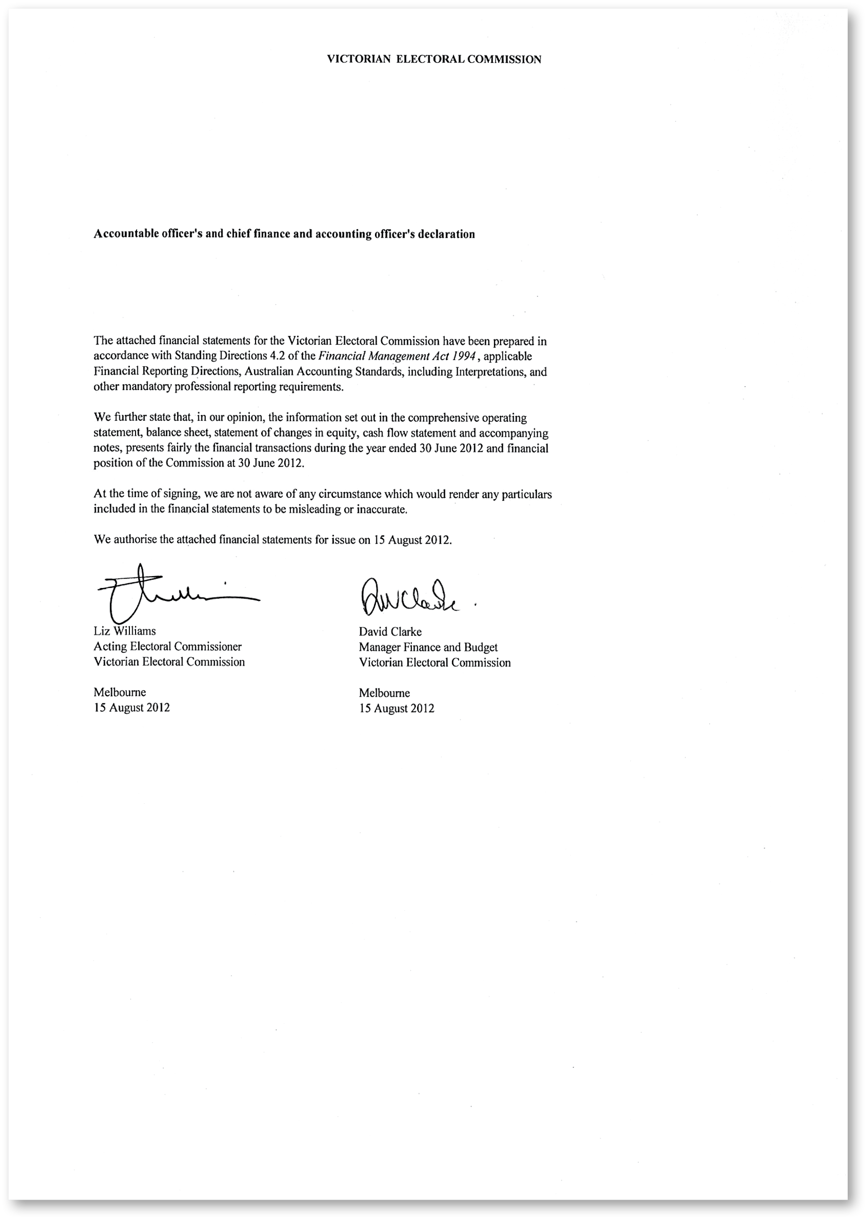

Auditor-General’s Report
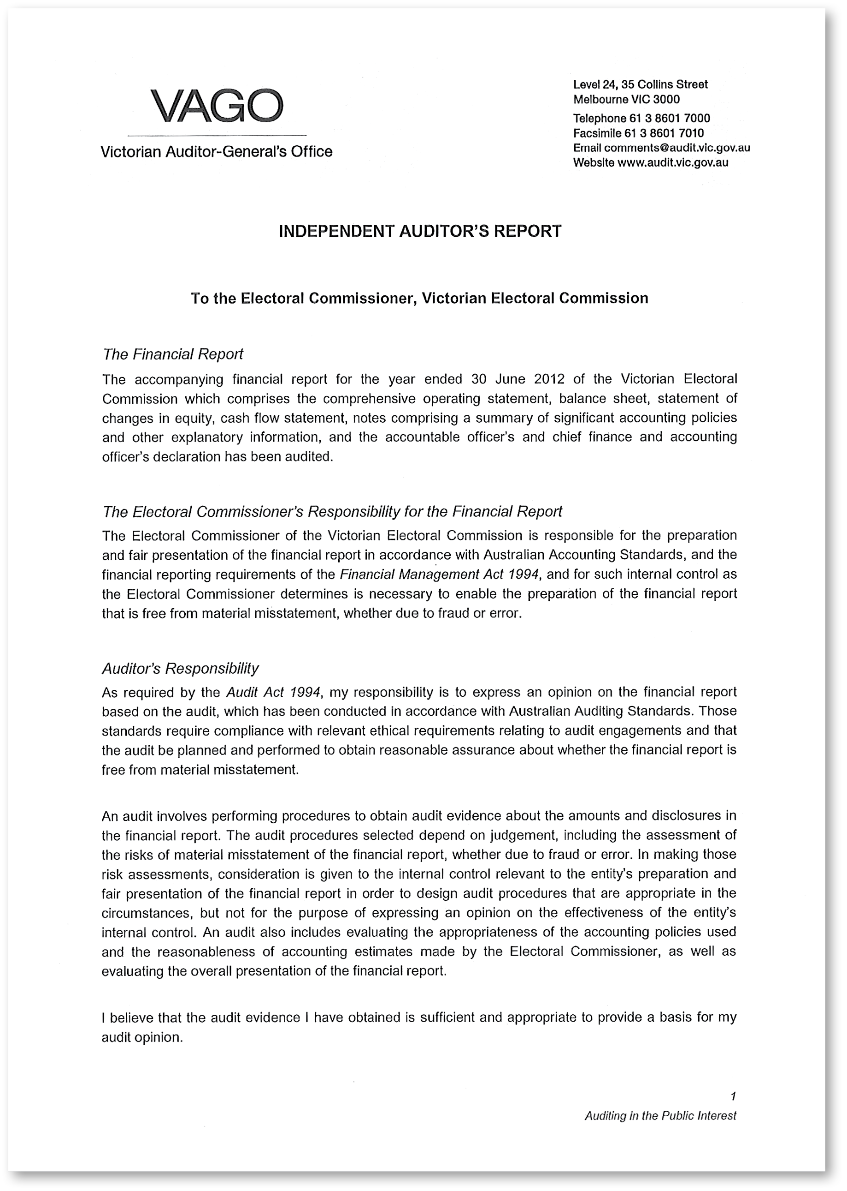
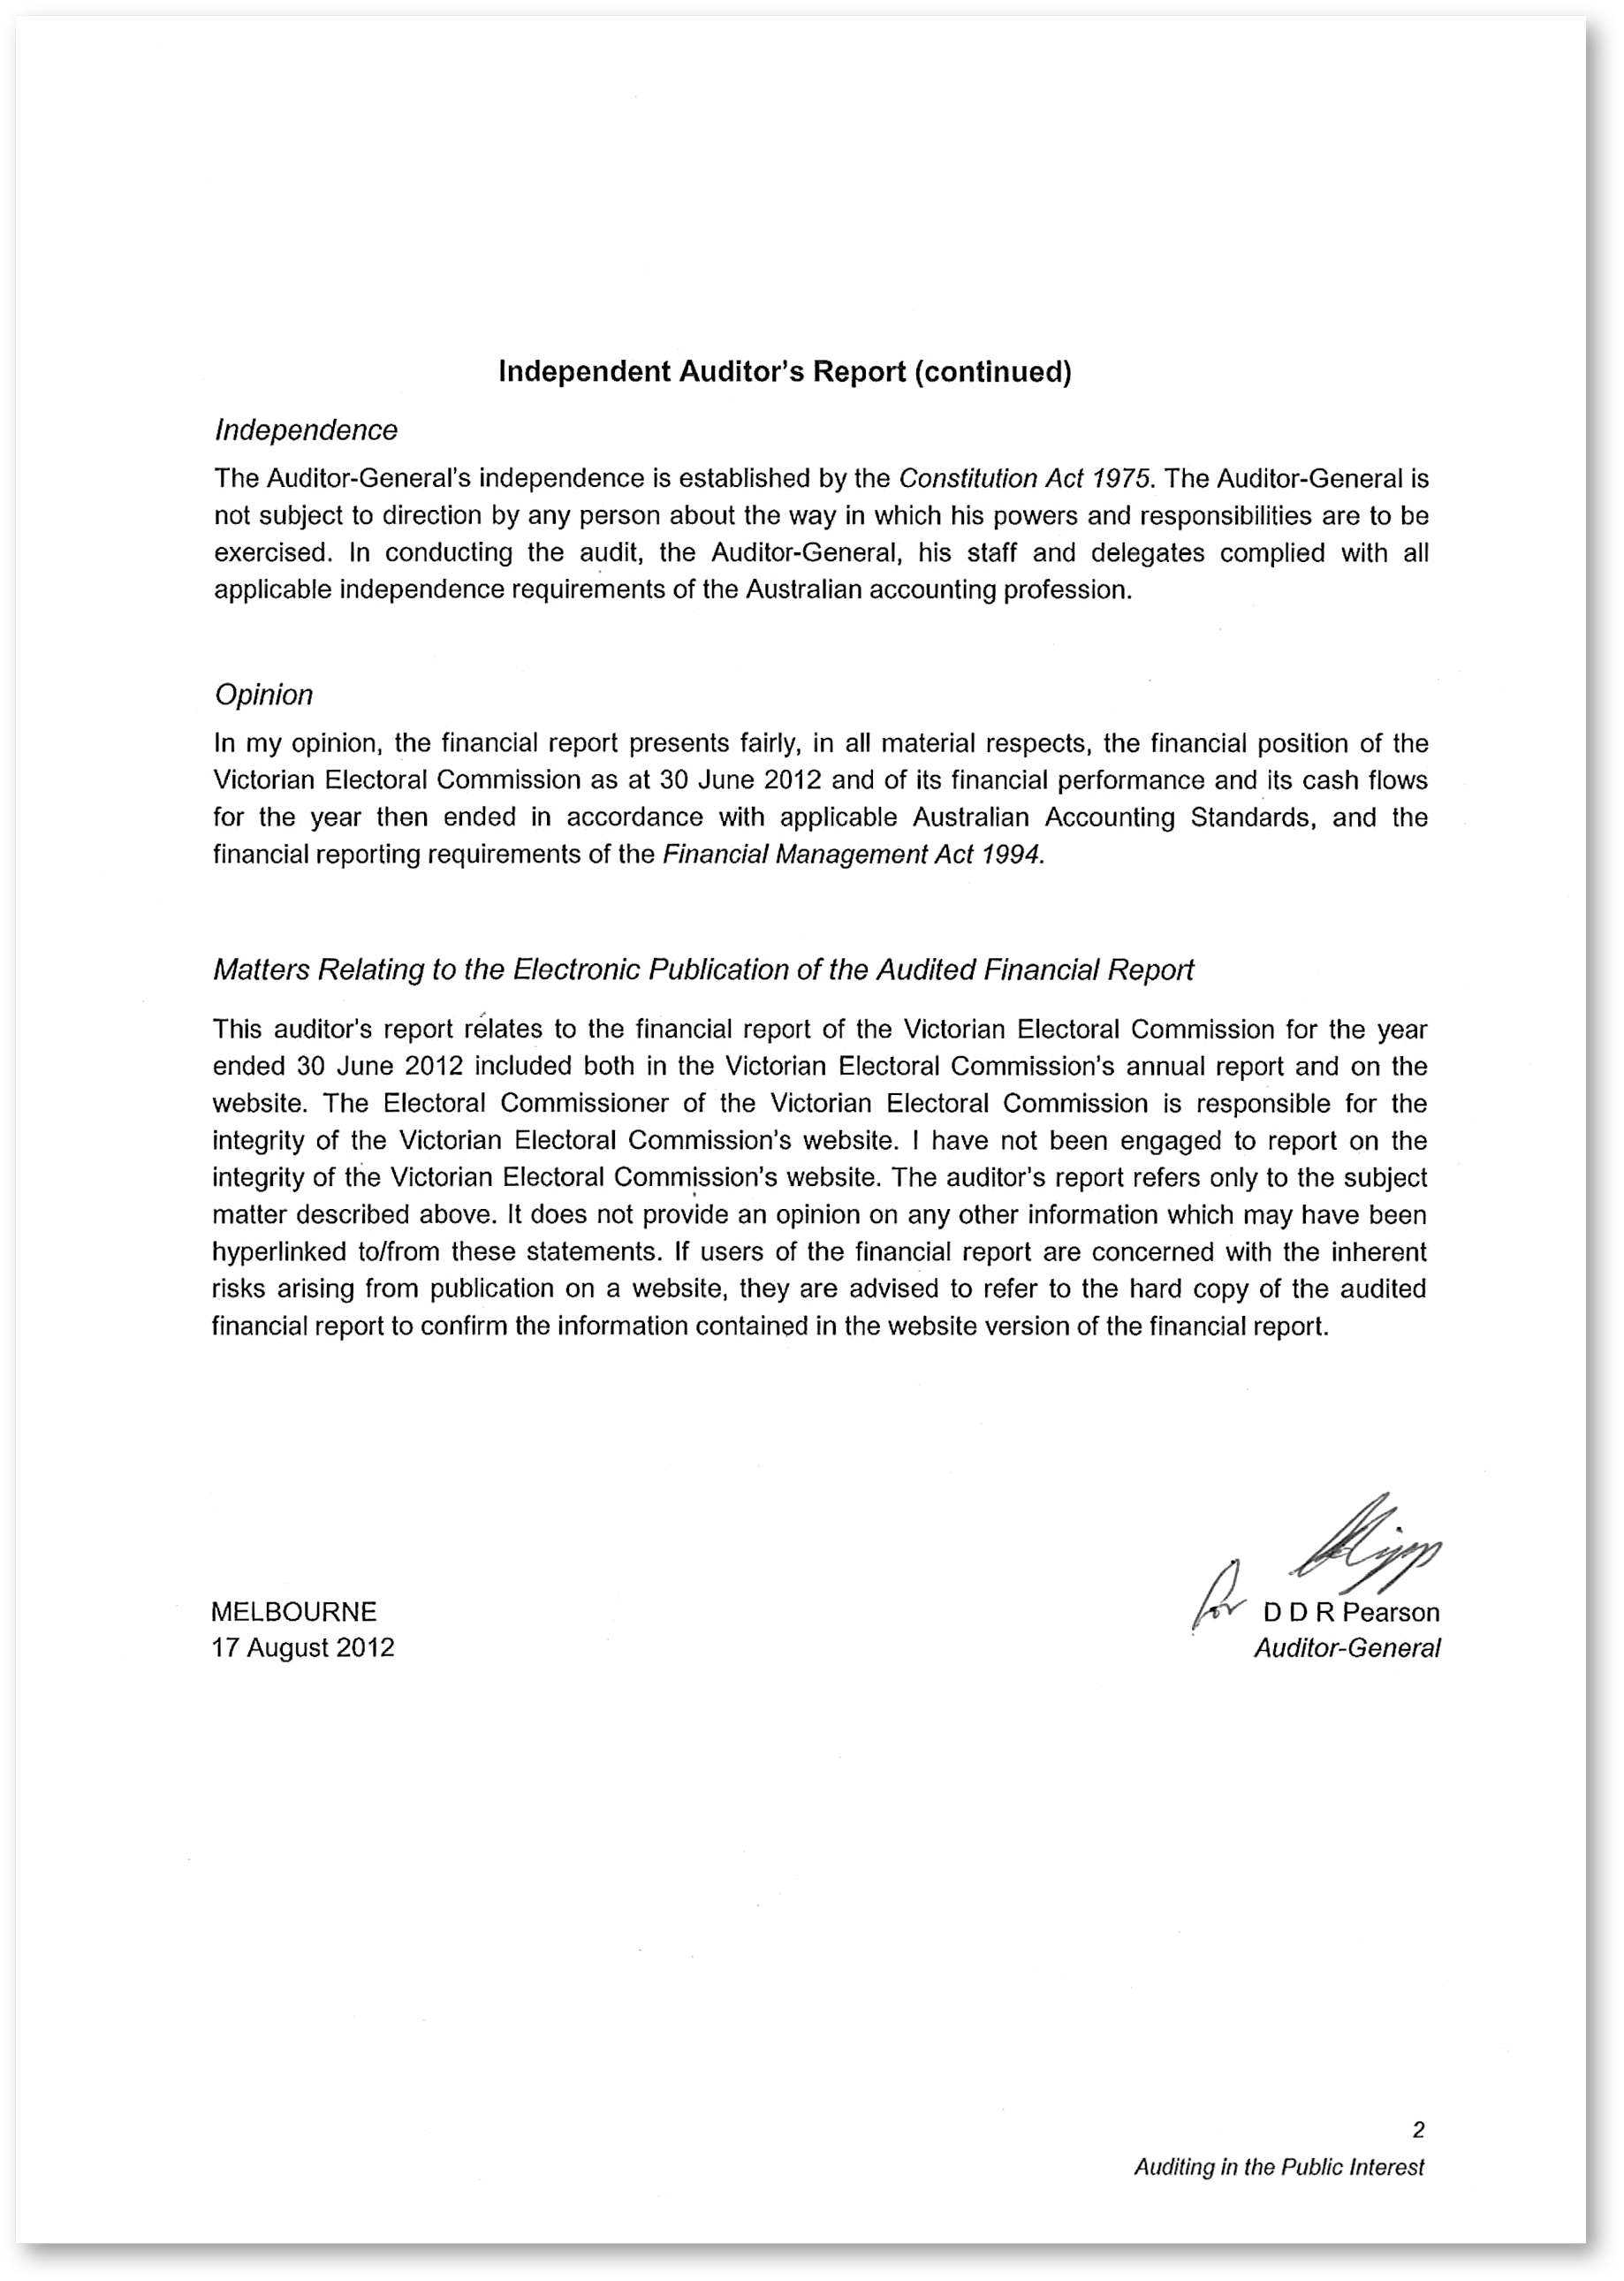

Appendices

Appendix A
Disclosure index 154
Appendix B
Governing legislation and regulations 157
Appendix C
New legislation 158
Appendix D
Additional information available on request 159
Appendix E
Elections, by-elections, countbacks and polls, 2011–12 160
Appendix F
Enforcement of compulsory voting, 2011–12 (continued) 163
Appendix G
Information provided under section 34 of the Electoral Act 2002 165
Appendix H
Registered political parties, 30 June 2012 167
Appendix I
Elector statistics by Region, 30 June 2012 168
Appendix J
Elector statistics by District, 30 June 2012 169
Appendix K
Enrolment transactions, 2007–08 to 2011–12 172
Appendix L
Report of the Electoral Boundaries Commission 2011–12 174

Appendix A

Disclosure index
Ministerial Directions
Report of operations – FRD Guidance |  | Page
Charter and purpose
FRD 22B | Manner of establishment and the relevant Ministers | 2, 11
FRD 22B | Objectives, functions, powers and duties | 2, 3
FRD 22B | Nature and range of services provided | 2
Management and structure
FRD 22B | Organisational structure | 12
Financial and other information
FRD 8B | Budget portfolio outcomes | 3
FRD 10 | Disclosure index | 113
FRD 12A | Disclosure of major contracts | 24
FRD 15B | Executive officer disclosures | 26
FRD 22B, SD 4.2(k) | Operational and budgetary objectives and performance against objectives | 3
FRD 22B | Employment and conduct principles | 23, 58, 64
FRD 22B | Occupational health and safety policy | 23
FRD 22B | Summary of the financial results for the year | 8
FRD 22B | Significant changes in financial position during the year | 66
FRD 22B | Major changes or factors affecting performance | 8
FRD 22B | Subsequent events | 106
FRD 22B | Application and operation of Freedom of Information Act 1982 | 25
FRD 22B | Compliance with building and maintenance provisions of Building Act 1993 | 24
FRD 22B | Statement on National Competition Policy | 24
FRD 22B | Application and operation of the Whistleblowers Protection Act 2001 | 26
FRD 22B | Details of consultancies over $10,000 | 24
FRD 22B | Details of consultancies under $10,000 | 24
FRD 22B | Statement of availability of other information | 27
FRD 24C | Reporting of office-based environmental impacts | 28
FRD 25A | Victorian Industry Participation Policy disclosures | 23
FRD 29 | Workforce Data disclosures | 13
SD 4.5.5 | Risk management compliance attestation | 27
SD 4.2(g) | General information requirements | 6
SD 4.2(j) | Sign-off requirements | 109
FRD 10 | Disclosure index | 113

Legislation Requirement
Financial Report |  | Page
Financial statements required under Part 7 of the FMA
SD4.2(a) | Statement of changes in equity | 68
SD4.2(b) | Operating statement | 66
SD4.2(b) | Balance sheet | 67
SD4.2(b) | Cash flow statement | 69
Other requirements under Standing Directions 4.2
SD4.2(c) | Compliance with Australian accounting standards and other authoritative pronouncements | 109
SD4.2(c) | Compliance with Ministerial Directions | 109
SD4.2(d) | Rounding of amounts | 78
SD4.2(c) | Accountable officer’s declaration | 109
SD4.2(f) | Compliance with Model Financial Report | 109
Other disclosures as required by FRDs in notes to the financial statements
FRD 9A | Departmental disclosure of administered assets and liabilities | 83
FRD 11 | Disclosure of ex gratia payments | 105
FRD 13 | Disclosure of parliamentary appropriations | 105
FRD 21A | Responsible person and executive officer disclosures | 106
FRD 102 | Inventories | 86
FRD 103D | Non-current physical assets | 82
FRD 104 | Foreign currency | 105
FRD 106 | Impairment of assets | 80
FRD 109 | Intangible assets | 82
FRD 107 | Investment properties | 86
FRD 110 | Cash flow statements | 104
FRD 112C | Defined benefit superannuation obligations | 79
FRD 113 | Investments in subsidiaries, jointly controlled entities and associates | 79
FRD 114A | Financial Instruments – General Government Entities and public non-financial corporations | 94
FRD 119 | Contributions by owners | 84
Legislation
Freedom of Information Act 1982 |  | 25
Building Act 1983 |  | 24
Whistleblowers Protection Act 2001 |  | 26
Victorian Industry Participation Policy Act 2003 |  | 24
Financial Management Act 1994 |  | 109

Appendix B

Governing legislation and regulations
Legislation
- Agricultural Industry Development Act 1990
- Building Act 1993
- Charter of Human Rights and Responsibilities Act 2006
- City of Melbourne Act 2001
- Education and Training Reform Act 2006
- Electoral Boundaries Commission Act 1982
- Essential Services Act 1958
- Freedom of Information Act 1982
- Information Privacy Act 2000
- Infringements Act 2006
- Juries Act 2000
- Legal Profession Act 2004
- Liquor Control Reform Act 1998
- Local Government Act 1989
- Monetary Units Act 2004
- Public Records Act 1973
- Senate Elections Act 1958
- Shop Trading Reform Act 1996
- Vital State Projects Act 1976

Regulations
- Agricultural Industry Development (Polls) Regulations 2011
- City of Melbourne (Electoral) Regulations 2012
- Education and Training Reform Regulations 2007
- Electoral Regulations 2002
- Infringements (General) Regulations 2006
- Infringements (Reporting and Prescribed Details) Regulations 2006
- Legal Profession (Board Election) Regulations 2006
- Liquor Control Reform Regulations 2009
- Local Government (Electoral) Regulations 2005

Appendix C

New legislation
Section 35 of the Equal Opportunity Amendment Act 2011 amended the Electoral Act 2002 to enable the VEC to ask applicants for appointment or employment for disclosure of specific political activities. This amendment replaces the exemption granted to the VEC in 2009–10, and came into force on 1 August 2011.
The Local Government (Electoral) Amendment Regulations 2012 were passed in June 2012, effectively immediately.
The amendments made by these Regulations are summarised below.
- Various time of day deadlines relating to lodgement of candidate statements and indication of preferences, were brought forward from 4.00pm to 12 noon (Reg. 34, 36, 37)
- Details of registered how-to-vote cards published on the VEC web site will include the names of submitters and organisations they represent, if any (Reg. 31)
- The requirement for candidates to supply additional registered how-to-vote cards for all voting centres is removed. Copies must still be supplied to Returning Officer (Reg. 31)
- The deadline by which voters can request redirection of postal ballot packs, is brought forward from close of nominations to the certification of the voters’ roll (opening of nominations) (Reg. 87)
- The penalty for making false statements re how-to-vote cards (Reg. 28(5)) is removed. This is now covered by s.238A of the Local Government Act 1989.
- The requirement for destruction of electoral records after four years (Reg. 114(3)) is removed. The disposal of such records
is dealt with in the Public Records Act 1973.
- Part 11 – Consequential amendments to the City of Melbourne (Elections) Regulations 2001 – is revoked.

Appendix D

Additional information available on request
- Details of shares held by a senior officer as nominee or held beneficially in a statutory authority or subsidiary
- Details of publications produced by the VEC about itself, and where these can be obtained
- The VEC Environmental Management Plan
- Details of changes in prices, fees, charges, rates and levies charged by the VEC
- Details of any major external reviews carried out in respect of the operation of the VEC
- Details of major research and development activities undertaken by the VEC that are not otherwise covered in this report
- Details of overseas visits undertaken, including a summary of the objectives and outcomes of each visit
- Details of assessments and measures undertaken to improve the occupational health and safety of employees not otherwise detailed in this report
- A general statement on industrial relations within the VEC and details of time lost through industrial accidents and disputes

Appendix E

Elections, by-elections, countbacks and polls, 2011–12
Election Name | Type | Election Date | Voting Method | Location | Voters On the Roll
Manningham City, Koonung Ward | Municipal Countback | 11/07/11 | NA | VEC | NA
Melbourne City | Municipal Countback | 19/07/11 | NA | VEC | NA
Baw Baw Shire, Mount Worth Ward | Municipal Countback | 30/09/11 | NA | Council | NA
Moira Shire | Municipal Countback | 14/11/11 | NA | Council | NA
Benalla Rural City | Municipal Countback | 1/12/11 | NA | Council | NA
Moreland City, North-East Ward | Municipal Countback | 11/01/12 | NA | Council | NA
Latrobe City Council, Dunbar Ward | Municipal By-election | 13/08/11 | Postal |  | 5,814
Hepburn Shire Council, Cameron Ward | Municipal By-election | 27/08/11 | Postal |  | 2,010
Mount Alexander Shire Council, Calder Ward | Municipal By-election | 25/02/12 | Postal |  | 2,060
University of Melbourne Graduate Student Association | CCE | 7/10/11 | Postal |  | 15,720
Emergency Services Superannuation Scheme Board | CCE | 20/10/11 | Postal |  | 35,000
Victorian Institute of Teaching Council | CCE | 20/10/11 | Postal |  | 83,000
Victoria Police Force Enterprise Agreement 2011 | CCE | 17/11/11 | Postal |  | 12,853
Maroondah City Council Enterprise Agreement 2011–2014 | CCE | 2/03/12 | Postal |  | 937
Victorian Canine Association Committee | CCE | 9/03/12 | Postal |  | 13,000
Balwyn (Taste East) LLP | Poll | 17/10/11 | Postal |  | 1,679
Ashburton (E'Latte 204) LLP | Poll | 19/03/12 | Postal |  | 1,370
Murray Valley Citrus Growers Industry Development | Poll | 8/06/12 | Postal |  | 363

Appendix F
Enforcement of compulsory voting, 2011–12
Table 2 – InsertCaptionHere
Election Type/Date | Notice Type |  | Mailout Date | Records | Penalties collected to  30 June 2012 | Infringements Court Lodgement Date | Number of records lodged
Niddrie | 1 | Apparent Failure to Vote | 17-Apr | 4,239 | N/A
District By-election | 2 | Infringement | 23-May | 2,746 | $24,888.00 | due to be lodged
24-Mar-12 | 3 | Penalty Reminder | 19-Jul | 1,852 | N/A | 23-Nov-12
Ashburton | 1 | Apparent Failure to Vote | 10-Apr | 192 | N/A
(E’Latte 204) | 2 | Infringement | 18-May | 166 | $2,318.00 | due to be lodged
19-Mar-12 | 3 | Penalty Reminder | 13-Jul | 89 | N/A | 18-Nov-12
Mount Alexander  Calder Ward | 1 | Apparent Failure to Vote | 16-Mar | 192 | N/A
By-election | 2 | Infringement | 27-Apr | 121 | $3,111.00 | due to be lodged
25-Feb-12 | 3 | Penalty Reminder | 29-Jun | 56 | N/A | 27-Oct-12
Balwyn LLP | 1 | Apparent Failure to Vote | 16-Nov | 272 | N/A
(Taste East) | 2 | Infringement | 4-Jan | 148 | $2,601.00
17-Oct-11 | 3 | Penalty Reminder | 8-Mar | 73 | $1,035.00 | 17-May-12 | 58
Hepburn Cameron Ward | 1 | Apparent Failure to Vote | 14-Sep | 154 | N/A | Not lodged  with Court
By-election | 2 | Infringement | 26-Oct | 77 | $914.00 | forwarded to council
27-Aug-11 | 3 | Penalty Reminder | 11-Jan | 52 | $310.00 | 26-Mar-12 | 49
Latrobe Dunbar Ward | 1 | Apparent Failure to Vote | 14-Sep | 928 | N/A | Not lodged  with Court
By-election | 2 | Infringement | 26-Oct | 626 | $10,157.00 | forwarded to council
13-Aug-11 | 3 | Penalty Reminder | 11-Jan | 420 | $4,576.01 | 26-Mar-12 | 340
Camberwell LLP | 1 | Apparent Failure to Vote | 7-Jul | 325 | N/A
(Charntra) | 2 | Infringement | 23-Aug | 214 | $5,641.00
06-Jun-11 | 3 | Penalty Reminder | 26-Oct | 85 | $1,896.00 | 23-Dec-11 | 45
Cardinia Bunyip Ward | 1 | Apparent Failure to Vote | 20-Apr | 1,180 | N/A | Not lodged  with Court
By-election 19 Mar | 2 | Infringement | 8-Jun | 692 | $10,500.00 | forwarded to council
 | 3 | Penalty Reminder | 3-Aug | 344 | $7,650.00 | 4-Oct-11 | 207
Greater Geelong  Deakin Ward | 1 | Apparent Failure to Vote | 20-Apr | 1,879 | N/A | Not lodged  with Court
By-election 5 Mar | 2 | Infringement | 8-Jun | 1,279 | $18,900.00 | forwarded to council
 | 3 | Penalty Reminder | 3-Aug | 685 | $12,722.00 | 4-Oct-11 | 429

Appendix F

Enforcement of compulsory voting, 2011–12 (continued)
Table 3 – InsertCaptionHere
Election Type/Date | Notice Type |  | Mailout Date | Records | Penalties collected to  30 June 2012 | Infringements Court Lodgement Date | Number of records lodged
Banyule Olympia Ward | 1 | Apparent Failure to Vote | 20-Apr | 2,735 | N/A | Not lodged  with Court
By-election 5 Mar | 2 | Infringement | 8-Jun | 2,077 | $19,679.58 | forwarded  to council
 | 3 | Penalty Reminder | 3-Aug | 1,364 | $13,430.58 | 4-Oct-11 | 1,065
Camberwell LLP | 1 | Apparent Failure to Vote | 8-Apr | 225 | N/A
(Caffe Moravia) | 2 | Infringement | 7-Jun | 137 | $1,920.00
22-Mar-11 | 3 | Penalty Reminder | 29-Jul | 81 | $1,656.00 | 4-Oct-11 | 52
Broadmeadows | 1 | Apparent Failure to Vote | 8-Apr | 6,519 | N/A
By-election 19 Feb 2010 | 2 | Infringement | 9-Jun | 5,059 | $38,460.00
 | 3 | Penalty Reminder | 5-Aug | 3,771 | $33,351.14 | 06-Dec-11 | 2,982
State Election 2010 | 1 | Apparent Failure to Vote | 5,8,13 Apr | 179,646 | N/A
27-Nov-10 | 2 | Infringement | 6, 9 Jun | 113,375 | $709,067.03
 | 3 | Penalty Reminder | 5-Aug | 85,740 | $754,038.77 | 01-Dec-11 | 66,312
Camberwell LLP | 1 | Apparent Failure to Vote | 24-Feb | 268 | N/A
(Zous Cafe) | 2 | Infringement | 6-Apr | 124 | N/A
14-Feb-11 | 3 | Penalty Reminder | 8-Jun | 60 | $566.00 | 17-Aug-11 | 43
Camberwell LLP | 1 | Apparent Failure to Vote | 24-Feb | 357 | N/A
(Juventino) | 2 | Infringement | 6-Apr | 209 | N/A
14-Feb-11 | 3 | Penalty Reminder | 8-Jun | 95 | $467.50 | 17-Aug-11 | 68
Camberwell LLP | 1 | Apparent Failure to Vote | 24-Feb | 223 | N/A
(Brunetti) | 2 | Infringement | 6-Apr | 127 | N/A
14-Feb-11 | 3 | Penalty Reminder | 8-Jun | 65 | $875.00 | 17-Aug-11 | 47
Canterbury LLP | 1 | Apparent Failure to Vote | 21-Jan | 435 | N/A
(Cornelius Cheese,  Coffee & Wine) | 2 | Infringement | 9-Mar | 206 | N/A
20-Dec-10 | 3 | Penalty Reminder | 6-May | 95 | $244.50 | 27-Jul-11 | 56

Appendix G

Information provided under section 34 of the Electoral Act 2002
During 2011–12, the VEC provided electoral enrolment information to the following organisations under section 34 of the Electoral Act 2002 or other legislation.

BreastScreen Victoria

The Cancer Council Victoria, Cancer Epidemiology Centre – Prostate Cancer Program and Melbourne Collaborative Cohort Study

State Revenue Office

Victoria Police
The Ethical Standards, Records Services, Licensing Services, State Intelligence and Major Fraud Investigation Service divisions of Victoria Police registered 1,680 logons to the VEC’s dedicated, secure facility generating 5,101 searches for information during 2011–12.

Department of Justice – Bushfire Buy-back Scheme
The VEC conducted verification of the status of certain electors or addresses for the purpose of assisting the Department of Justice Bushfire Buy-back Scheme to ensure that the Scheme engaged with eligible landowners. The details of silent electors were not used or transmitted.

Alfred Health’s Department of Allergy, Asthma & Clinical Immunology at the Alfred Hospital (Alfred Health)
The VEC facilitated the use of name and address information from a random extract of 9,000 electors aged 65 years and over, from the Victorian State electoral districts of Albert Park, Burwood and Hawthorn, for the purposes of inviting participants for the Lung Health in Older Australian research program being conducted by the Alfred Hospital. The details of silent electors, overseas electors and those electors who have requested to be omitted from such lists were excluded.

The University of Melbourne – Beyond Bushfires project
The Victorian Electoral Commission facilitated a single mail-out (in two stages) of information on behalf of The University of Melbourne – Beyond Bushfires project to electors who are currently resident in selected rural communities and those who were resident in these areas at the time of the 2009 bushfires but are no longer enrolled at those addresses, in order to invite them to participate in an Australian Research Council funded study of community resilience and recovery after bushfire. Silent electors, overseas electors and those electors who have requested to be omitted from such lists were not included in the mail-out.

Country Fire Authority (CFA)
The VEC will facilitate the use of name and postal address information of all electors (excluding silent electors, overseas electors and those electors who have requested to be omitted from such lists) in the areas designated by the CFA as “high risk of bushfire” in 2011–12, 2012–13 and 2013–14 so that community safety information related to fire preparedness can be mailed to those electors by the CFA.

Melbourne IVF
The VEC has agreed to perform up to 20 individual data matching searches per year, and to contact the person on behalf of Melbourne IVF. At the time of this report, one search has been requested.

Department of Human Services
The VEC conducted a search of an elector’s details for the purpose of a court hearing.

Appendix H

Registered political parties, 30 June 2012
Political party | Registered Officer
Australian Christians | Mr Spero Katos  Registered Officer  PO Box 99  Sandown Village Vic. 3171
Australian Labor Party – Victorian Branch | Mr Noah Carroll  State Secretary  360 King Street  West Melbourne Vic. 3003
Australian Sex Party – Victoria | Ms Ange Hopkins  Registered Officer  34 Richardson Street  Brunswick Vic. 3056
Citizens Electoral Council (Victorian Division) | Ms Gabrielle Marie Peut  Registered Officer  PO Box 376  Coburg Vic. 3058
Country Alliance | Mr Russell William Bate  Registered Officer  PO Box 24415  Melbourne Vic. 3001
Democratic Labor Party (DLP) of Australia | Mr Kevin Butler  Secretary  GPO Box 1402  Melbourne Vic. 3001
Family First Party Victoria Inc. | Mr Aaron D’Orival  Secretary  PO Box 83  Canterbury Vic. 3126
Liberal Party of Australia – Victorian Division | Mr Damian Mantach  State Director  104 Exhibition Street  Melbourne Vic. 3000
National Party of Australia – Victoria | Mr Stuart Copeland  State Director  Level 5, 30 Collins Street  Melbourne Vic. 3000
Socialist Alliance – Victoria | Ms Susanne Bolton  Registered Officer  PO Box 12427  A’Beckett Street Vic. 8006
The Australian Greens – Victoria | Mr Gurmeet Sekhon  Registered Officer  GPO Box 4589  Melbourne Vic. 3001

Appendix I

Elector statistics by Region, 30 June 2012
Area No | Area Name | Elector Count | Variance to Average (%)
1 | Eastern Metropolitan | 425,427 | -6.08
2 | Eastern Victoria | 463,253 | 2.27
3 | Northern Metropolitan | 458,570 | 1.24
4 | Northern Victoria | 433,183 | -4.36
5 | South Eastern Metropolitan | 449,238 | -0.82
6 | Southern Metropolitan | 429,695 | -5.13
7 | Western Metropolitan | 491,046 | 8.41
8 | Western Victoria | 473,185 | 4.47

Total number of electorates: 8
Total number of electors: 3,623,597
Average number of electors: 452,949

Appendix J

Elector statistics by District, 30 June 2012
Area No | Area Name | Elector Count | Variance to Average (%)
1 | Albert Park | 47,102 | 14.39
2 | Altona | 54,294 | 31.86
3 | Ballarat East | 41,187 | 0.02
4 | Ballarat West | 44,614 | 8.35
5 | Bass | 51,793 | 25.78
6 | Bayswater | 36,717 | -10.83
7 | Bellarine | 45,321 | 10.06
8 | Benalla | 36,964 | -10.23
9 | Benambra | 37,742 | -8.34
10 | Bendigo East | 41,301 | 0.30
11 | Bendigo West | 42,011 | 2.03
12 | Bentleigh | 39,219 | -4.76
13 | Box Hill | 38,921 | -5.48
14 | Brighton | 38,670 | -6.09
15 | Broadmeadows | 37,118 | -9.86
16 | Brunswick | 42,714 | 3.73
17 | Bulleen | 35,315 | -14.24
18 | Bundoora | 36,213 | -12.06
19 | Burwood | 39,194 | -4.82
20 | Carrum | 42,651 | 3.58
21 | Caulfield | 37,495 | -8.94
22 | Clayton | 33,886 | -17.71
23 | Cranbourne | 50,307 | 22.17
24 | Dandenong | 35,214 | -14.48
25 | Derrimut | 41,762 | 1.42
26 | Doncaster | 36,415 | -11.56
27 | Eltham | 39,219 | -4.76
28 | Essendon | 40,057 | -2.72
29 | Evelyn | 40,424 | -1.83
30 | Ferntree Gully | 44,551 | 8.19
31 | Footscray | 40,860 | -0.77
32 | Forest Hill | 35,886 | -12.85
33 | Frankston | 36,286 | -11.88
34 | Geelong | 40,010 | -2.83
35 | Gembrook | 44,037 | 6.95
36 | Gippsland East | 41,792 | 1.49
37 | Gippsland South | 39,466 | -4.16
38 | Hastings | 45,815 | 11.26
39 | Hawthorn | 38,867 | -5.61
40 | Ivanhoe | 38,500 | -6.50
41 | Keilor | 53,751 | 30.54
42 | Kew | 37,007 | -10.13
43 | Kilsyth | 41,085 | -0.22
44 | Kororoit | 43,552 | 5.77
45 | Lara | 45,144 | 9.63
46 | Lowan | 38,305 | -6.97
47 | Lyndhurst | 42,660 | 3.60
48 | Macedon | 48,602 | 18.03
49 | Malvern | 38,268 | -7.06
50 | Melbourne | 44,931 | 9.12
51 | Melton | 45,462 | 10.41
52 | Mildura | 37,924 | -7.90
53 | Mill Park | 41,547 | 0.90
54 | Mitcham | 36,932 | -10.31
55 | Monbulk | 37,899 | -7.96
56 | Mordialloc | 42,130 | 2.31
57 | Mornington | 40,870 | -0.75
58 | Morwell | 38,837 | -5.68
59 | Mount Waverley | 36,824 | -10.57
60 | Mulgrave | 34,848 | -15.37
61 | Murray Valley | 38,852 | -5.65
62 | Narracan | 43,390 | 5.37
63 | Narre Warren North | 40,448 | -1.77
64 | Narre Warren South | 53,984 | 31.10
65 | Nepean | 38,929 | -5.46
66 | Niddrie | 36,603 | -11.11
67 | Northcote | 40,902 | -0.67
68 | Oakleigh | 35,822 | -13.00
69 | Pascoe Vale | 40,924 | -0.61
70 | Polwarth | 42,352 | 2.85
71 | Prahran | 39,813 | -3.31
72 | Preston | 38,957 | -5.39
73 | Richmond | 41,826 | 1.58
74 | Ripon | 37,670 | -8.52
75 | Rodney | 36,738 | -10.78
76 | Sandringham | 38,238 | -7.14
77 | Scoresby | 38,893 | -5.55
78 | Seymour | 41,515 | 0.82
79 | Shepparton | 38,566 | -6.34
80 | South Barwon | 49,523 | 20.27
81 | South-West Coast | 43,597 | 5.88
82 | Swan Hill | 32,968 | -19.94
83 | Tarneit | 49,232 | 19.56
84 | Thomastown | 36,545 | -11.25
85 | Warrandyte | 41,491 | 0.76
86 | Williamstown | 39,328 | -4.49
87 | Yan Yean | 59,317 | 44.05
88 | Yuroke | 50,683 | 23.09

Total number of electorates: 88
Total number of electors: 3,623,594
Average number of electors: 41,177

Appendix K

Enrolment transactions, 2007–08 to 2011–12
Table 4 – InsertCaptionHere
Enrolment transaction summary | 2007–08 | 2008–09 | 2009–10 | 2010–11 | 2011–12
Direct enrolments |  |  |  |  | 36,779
Enrolment application transactions
VEC mailout programs
Current | 2007–08 | 2008–09 | 2009–10 | 2010–11 | 2011–12
Victorian Curriculum and Assessment Authority (VCAA) | 11,898 | 13,372 | 13,598 | 10,639 | 15,043
VCAA Over 18 years 2010 State election mail-out | 0 | 0 | 0 | 603 | 0
Residential Tenancies Bond Authority | 3,017 | 5,179 | 36,347 | 6,706 | 38,623
VicRoads | 7,750 | 17,351 | 57,653 | 5,754 | 27,252
Victorian Tertiary Admissions Centre | 799 | 3,356 | 1,771 | 935 | 2,624
Non-current
Local government post-election follow-up | NA | 10,323 | 898 | 112 | 0
TRU Energy | 4 | 1 | 0 | 0 | 0
Yarra Valley Water | 1 | 0 | 0 | 0 | 0
2000–01 redivision mailout | 32 | 16 | 2 | 0 | 0
Subtotal | 23,501 | 49,598 | 110,269 | 24,749 | 83,542
VEC non-mailout programs
VEC general enrolment form | 6,055 | 21,185 | 9,628 | 31,355 | 7,288
On-the-day enrolment/Provisional votes | na | na | na | 33,593 | 289
Joint AEC/VEC enrolment form | 1,851 | 2,829 | 5,824 | 2,971 | 2,396
Liquor Licencing Victoria | 931 | 1,411 | 1,418 | 1,398 | 1,790
VEC website | 5,048 | 11,295 | 7,787 | 35,838 | 3,687
VEC municipal enrolment form (M) | 491 | 1,449 | 1,054 | 981 | 1,155
Community programs | na | na | na | 77 | 15
Supermarkets | 1,860 | 1,351 | 350 | 0 | 0
Subtotal | 16,236 | 39,520 | 26,061 | 106,213 | 16,620
Enrolment applications collected through  VEC’s enrolment programs | 39,737 | 89,118 | 136,330 | 130,962 | 100,162
Enrolment application transactions provided by the
AEC and imported into Victorian register of electors
Additions
New to roll | 90,386 | 85,758 | 104,174 | 116,395 | 101,759
Reinstatements | 62,885 | 18,580 | 41,343 | 76,331 | 24,071
Subtotal | 153,271 | 104,338 | 145,517 | 192,726 | 125,830
Changes
Change of address | 302,183 | 229,094
Subtotal | 302,183 | 229,094 | 294,938 | 378,685 | 260,883
Less
State direct enrolments in additions and changes |  |  |  |  | 13,915
Combined subtotal | 455,454 | 333,432 | 440,455 | 571,411 | 372,798
Enrolment applications collected through  AEC’s enrolment programs | 415,717 | 244,314 | 304,125 | 440,449 | 272,636
Other enrolment transactions
Non-application changes
Amendments to elector details | 2,323 | 9,176 | 5,560 | 7,605 | 4,856
Return to sender mail
BreastScreen Victoria Inc | 259 | 162 | 221 | 786 | 394
Members of Parliament RTS mail | 408 | 5,708 | 7,793 | 6,404 | 2,783
Youth booklet “Your Voice Your Future” | 1 | 5 | 6 | 0 | 0
Election mailouts | 253 | 57,758 | NA | 38,204 | 3,448
PapScreen Victoria | 484 | 24 | 0 | 21 | 0
Non-voter follow-up | NA | 16,347 | NA | 4,819 | 12,137
Subtotal | 1,405 | 80,004 | 8,020 | 50,234 | 18,762
Special category applications
GPV applications | 274 | 371 | 367 | 1801 | 379
Overseas elector applications | 478 | 721 | 758 | 2371 | 853
Itinerant elector applications | 102 | 64 | 55 | 77 | 54
Silent elector applications | 75 | 149 | 301 | 102 | 248
Subtotal | 929 | 1,305 | 1,481 | 4,351 | 1,534
Combined subtotal | 4,657 | 90,485 | 15,061 | 62,190 | 25,152
TOTAL VEC enrolment transactions | 44,394 | 179,603 | 151,391 | 193,152 | 125,314

Appendix L

Report of the Electoral Boundaries Commission 2011–12
The Electoral Boundaries Commission (EBC) is constituted under the Electoral Boundaries Commission Act 1982. The EBC must establish and maintain electorates of approximately equal enrolment (that is, not varying by more than 10% from the average for each House of Parliament) for the conduct of parliamentary elections.
The members of the EBC during 2011–12 were:
- His Honour, Chief Judge Michael Rozenes QC, Chief Judge of the County Court (Chairman);
- Mr Steve Tully (Electoral Commissioner) – resigned 29 April 2012 and replaced by Ms Liz Williams, Acting Electoral Commissioner;
- Mr John Tulloch, Surveyor-General.
The VEC provides administrative and technical support to the EBC, and Dr Paul Thornton-Smith of the VEC is the secretary to the EBC.
During 2011–12 the EBC conducted planning work for the redivision, which is to commence in December 2012.
EBC files are maintained at the VEC’s head office at Level 11, 530 Collins Street, Melbourne, separate from the VEC registry.
Glossary

Attendance election
In an attendance election most voting is conducted at voting centres on election day, although voters may vote at early voting centres or by pre-poll postal votes.

Accredited Purchasing Unit
Accredited Purchasing Units approve procurement processes up to each department’s level of accreditation under delegated authority from the Victorian Government Purchasing Board.

Ballot
A method of secret voting.

By-election
A by-election is an election in a single electorate to fill a casual vacancy caused by the departure of a sitting Member of Parliament or local government councillor before the term expires.

Candidate
A candidate is an eligible elector who nominates for election.

Coding
Coding is the process of classifying information.
In communications and computer systems, this involves implementing rules that are used to map the elements of one set onto the elements of another set, usually on a one-to-one basis.

Community of interest
The VEC defines a community of interest as a group of
people who share a range of common concerns or aspirations. A community of interest may occur where people are linked with each other geographically (e.g. a town or valley) or economically, such as where people work in similar industries (e.g. tourism) or where people work in mutually-dependant industries (e.g. fruit growers, transporters and canners).
A community of interest may also appear where people share a number of special needs because of similar circumstances (such as new immigrants who may have little English, require assistance with housing or need help finding employment).

Compulsory enrolment
All Australian citizens 18 years and over are required by law to enrol.

Compulsory voting
All enrolled electors must vote at State elections. With some exceptions, enrolled voters must vote at local government elections.

Contested election
A contested election is an election where more candidates than the number of vacancies for the election have nominated by the close of nominations.

Continuous roll update (CRU)
The CRU process consists of a range of strategies to ensure that the electoral roll is continuously kept up-to-date by using internal and external data to direct roll review activities to targeted people and residences.

Councillor
An elected representative on a local government council.

Countback
Method of filling extraordinary vacancies in multi-member wards and unsubdivided municipalities in electorates where general election results were obtained using the proportional representation method. The votes of the vacating councillor are transferred to the previously unelected candidates to fill the vacancy.

District
One of the 88 Legislative Assembly electorates in Victoria. Each District elects one member and comprises approximately 41,000 electors (see page 125).

Election
The choosing of representatives by the voters.

Election date
The date electors cast their votes.

Election Manager
A person appointed by the Electoral Commissioner to conduct an election for an electoral District or Region.

Elector
A person whose name appears on the register of electors
and who is entitled to vote in elections.

Electoral Commissioner
The statutory officer appointed by the Governor-in-Council with responsibility for the proper conduct of parliamentary, local government and statutory elections.

Electoral enrolment register
The VEC’s database of all Victorian electors.

Electoral Matters Committee (EMC)
The EMC comprises seven Members of Parliament drawn from both Houses and is a Joint Investigatory Committee of the Parliament of Victoria. Its powers and responsibilities are determined by the Parliamentary Committees Act 2003. The EMC inquires into, considers and reports to the Parliament on any proposal, matter or thing concerned with the conduct of parliamentary elections and referendums in Victoria, the conduct of elections of councillors under the Local Government Act 1989 and the administration of, or practices associated with, the Electoral Act 2002 and any other law relating to electoral matters.

Electoral roll
A list of names of all the people who are entitled to vote
in an election under relevant legislation.

Electronically Assisted Voting
A method of casting a vote by kiosk or telephone available under legislation to electors who are blind or have low vision, are not literate in English, have a motor impairment or are located overseas.

Enrolment
The placement of a person’s name and address on the electoral enrolment register. A person cannot vote at an election unless they are enrolled.

Enrolment information
The information about electors that is held by the VEC.

Entitlement date
To be eligible to vote at a council election, people must be on the State or local council voters roll 57 days before election day. This is called the “entitlement date”.

Environmental Management Plan
The VEC’s Environmental Management Plan is used to identify, manage and reduce the organisation’s impact on the environment and guides the generation of reports on environmental performance progress. It provides a systematic and methodical approach to planning, implementing and reviewing the VEC’s response to those impacts.

Extensible Markup Language (XML)
XML is a data format for structured document exchange.

General Postal Voter (GPV)
A voter who always has difficulty getting to a voting centre on election day can register as a GPV. GPVs include people who are infirm, prisoners, those in remote communities and people who are 70 or over. After the close of nominations for an election, GPVs are automatically sent postal ballot papers and certificate envelopes.

Geo-coding
Geo-coding is the process of assigning geographic identifiers (e.g. codes or geographic coordinates expressed as latitude-longitude) to map features and other data records, such as street addresses.

How-to-vote cards
Cards handed out to voters by party supporters at voting centres showing how a party or candidate would like voters to fill in their ballot papers. In Victoria, how-to-vote cards handed out within 400 metres of a voting centre on election day for State elections must be registered with the VEC.

Informal voting
A ballot paper that is either left blank or is incorrectly marked. These ballot papers are excluded from the count and, therefore, do not contribute to the election of a candidate.

Legislative Assembly (Lower House)
One of the two Houses in the Victorian State Parliament. There are 88 Members of the Legislative Assembly (MLAs), one from each electoral district. The party or coalition of parties that wins majority support in this House forms the Government.

Legislative Council (Upper House)
One of the two Houses in the Victorian State Parliament. There are 40 Members of the Legislative Council (MLCs), five from each region. The Legislative Council is often referred to as the “House of review”.

Lost Time Injury (LTI)
An LTI is an occupational injury or illness that results in days away from work on any rostered shift subsequent to that on which the injury occurred. A fatality is also recorded as an LTI.

Marginal costs
Marginal costs include direct labour and associated on-costs, materials, equipment, mail processing, postage, advertising, printing, rent, utilities, insurance, IT equipment and software licences purchased especially for the specific activity.

Postal election
In an all-postal election, voting papers are posted to voters
by the Returning Officer and a vote is made by completing
a ballot paper and returning it to the Returning Officer in the reply-paid envelope provided.

Preferential voting
A vote for all candidates in order of preference. If no candidate has an absolute majority or first preference votes, preferences are distributed until one candidate has an absolute majority.

Proportional representation
A system of voting designed to elect representatives in proportion to the amount of support each has in the electorate.

Redivision
The redrawing of electoral boundaries to ensure that there are, as near as possible, equal numbers of voters in each electorate within Victoria.

Region
One of the eight Legislative Council electorates. Each Region comprises approximately 453,000 electors and elects five Members.

Registered political party (RPP)
A political party that is registered under the Electoral Act 2002. A registered party must have at least 500 members who are Victorian electors and not members of another registered political party.

ResourceSmart team
Comprising a representative from each branch of the VEC, the ResourceSmart team oversees the implementation of the VEC’s Environmental Management Strategy.

Senior Election Official
A trained electoral official who may be appointed to act as an Election Manager for a parliamentary election. Senior Election Officials may be also be appointed to act as Returning Officers or Deputy Returning Officers for a local government election.

Victorian Electoral Commission (VEC)
The VEC is the independent statutory body that conducts State elections and certain statutory elections. The VEC may also conduct local council elections, commercial and community elections. The VEC also conducts boundary reviews, maintains the Victorian electoral enrolment register, conducts electoral research and provides education services.

Voter
A person whose name appears on the register of electors
and who is entitled to vote in elections.

Voting centre
A place at which electors can vote in an election. The three types of voting centres that operate in State elections are early voting centres, mobile voting centres and election day voting centres.

Feedback on this report is welcome
Please mark to the attention of:
Corporate Planning and Reporting Officer
Victorian Electoral Commission
Level 11, 530 Collins Street
Melbourne Vic 3000
Phone: (03) 8620 1100
Email: info@vec.vic.gov.au

