Report of Local Government electoral activity

2010-11

Foreword by the Electoral Commissioner
I am pleased to present the Victorian Electoral Commission Report of Local Government Electoral Activity 2010-11.
This report provides an overview of the current year’s activity including commentary on the local government by-elections, countbacks and electoral representation reviews conducted during the period, along with key figures and results. A brief description of legislative changes affecting the work of the VEC is included. A number of recommendations are included for consideration by the Minister.
I take this opportunity to formally record my appreciation for the assistance provided by Local Government Victoria, the Municipal Association of Victoria and the Victorian Local Governance Association. The VEC looks forward to continuing to assist these organistations in their consideration of electoral matters.
I would like to thank our contractors and suppliers for their continued support and service, contributing invaluably to the success of VEC activities.
Congratulations and thanks go to my staff for their efforts in ensuring that all VEC activity is carried out with care and diligence.
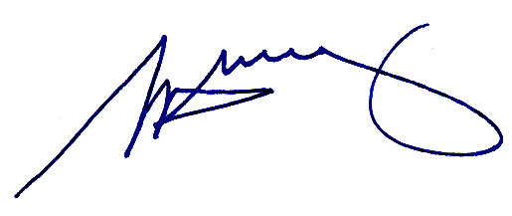
Steve Tully
Electoral Commissioner

Contents
Foreword by the Electoral Commissioner i
Contents ii
Executive Summary 1
Snapshot 2010-11 2
1. Legislative framework 4
1.1. Changes in legislation 4
2. Extraordinary vacancies 5
2.1. By-elections 5
2.2. Countbacks 5
2.3. Costs 7
2.4. Participation 7
2.5. Enrolment 9
2.6. Voter turnout 9
2.7. Informality 10
2.8. Method of election 11
3. Compulsory voting enforcement 11
4. Municipal Electoral Tribunal 13
5. Victorian Civil and Administrative Tribunal 13
6. Electoral representation reviews 14
6.1. Final reports and recommendations 15
6.2. Feedback 17
6.3. Additional reviews 17
6.4. Subdivision reviews 17
7. Recommendations 18
7.1. Timing of Minister’s orders in relation to electoral representation reviews and subdivision reviews 18
7.2. Exhibition rolls 18
7.3. Redirection of Ballot Material – Postal elections 19
7.4. Electronic Voting Franchise at local government elections 19
7.5. Multiple countbacks in an electorate 20
8. Prior Recommendations 21
8.1. Deadline for Lodgement of Candidate Statements and Indication of Preferences 21
8.2. Provision of Braille ballot papers 21
8.3. Procedure if recount results in a further tie 21
8.4. How-to-vote cards 22
8.4.1. Registration of How-To-Vote cards 22
8.4.2. Printing of How-To-Vote cards 22
8.4.3. Publication of names of those registering How-To-Vote cards 23
Appendix A: Results, By-elections 24
Appendix B: Results, countbacks 27

Executive Summary
The Local Government Act 1989 (LGA) is the primary legislation under which the Victorian Electoral Commission (VEC) conducts local government electoral activity.
The Local Government and Planning Legislation Amendment Act 2010, which came into operation on 30 June 2011, amended the Local Government Act 1989 so that the VEC is now specified as the only agency authorised to conduct electoral representation reviews for all Victorian local councils.
Of particular interest to the VEC are the provisions of the Local Government Amendment (Electoral Matters) Bill 2011, which is currently before the Parliament. This Bill proposes to move the general elections from November to October, and to make provision for the conduct of regular electoral representation reviews of the City of Melbourne.
The VEC has responded to all relevant legislative amendments and will continue to respond to new and proposed legislation as appropriate.
The VEC conducted six by-elections and 15 countbacks to fill 21 vacancies during 2010-11. Each by-election was conducted using the same method of voting (postal or attendance) as had been used at the previous general election for the particular council. Five of the by-elections were conducted by post and one by attendance.
The average cost per elector for a postal by-election during 2010-11 was $4.15. For the attendance by-election the cost per elector was $5.14. The average cost per elector for a countback was $0.21. The average cost per elector is derived by dividing the total cost of all by-elections or countbacks by the total number of eligible electors.
The average turnout rate for by-elections held during 2010-11 was 70.85%. This is a decrease on the average for the five-year period 2006-07 to 2010-11 (71.81%) and for the local government general elections held in November 2008 (74.36%).
The average informality rate for by-elections conducted in 2010-11 was 4.02%, which is higher than the 3.40% average for by-elections conducted in the past five years, and for elections conducted by post at the 2008 general elections (3.75%).
The VEC’s role in the enforcement of compulsory voting for a by-election for one council was continued from 2009-10, and finalised in September 2010. The VEC was appointed to conduct compulsory voting enforcement by six councils for which it conducted by-elections in 2010-11.
The VEC conducted nine electoral representation reviews during 2010-11. The average cost to Council for an electoral representation review was $34,742.28. At the time of this report final reports for all nine reviews completed in 2010-11 were with the Minister awaiting orders.

Snapshot 2010-11
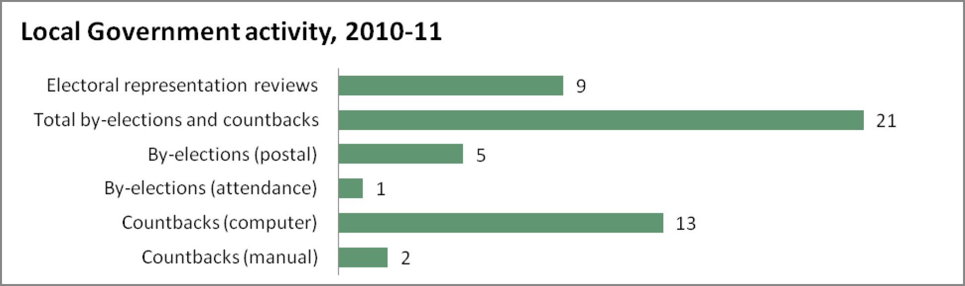
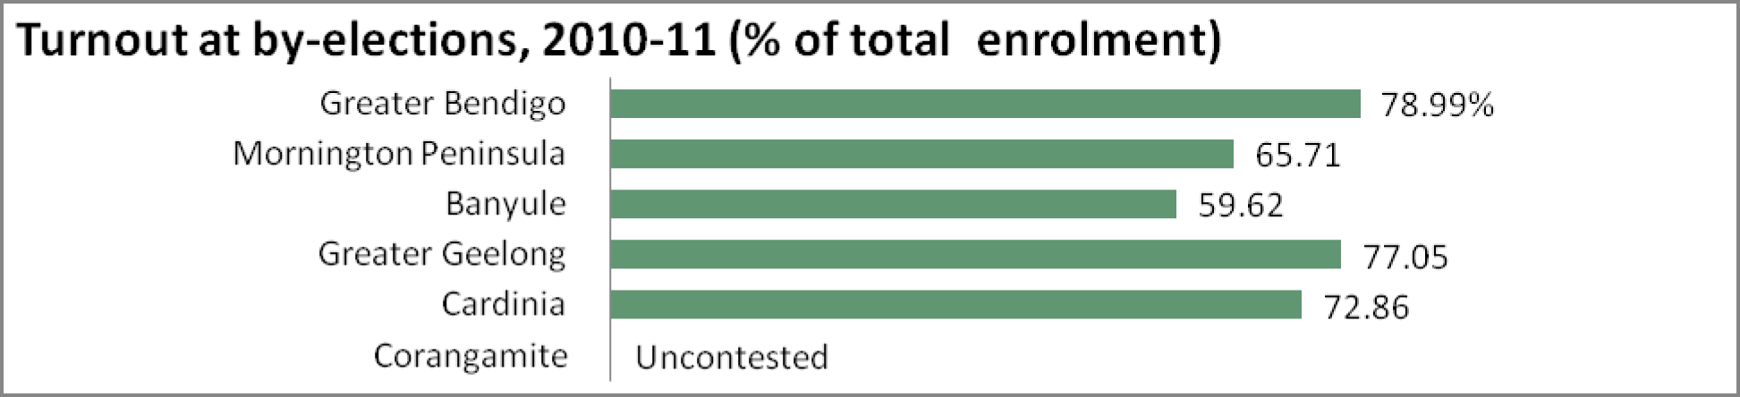
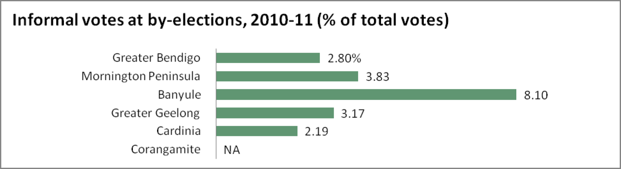
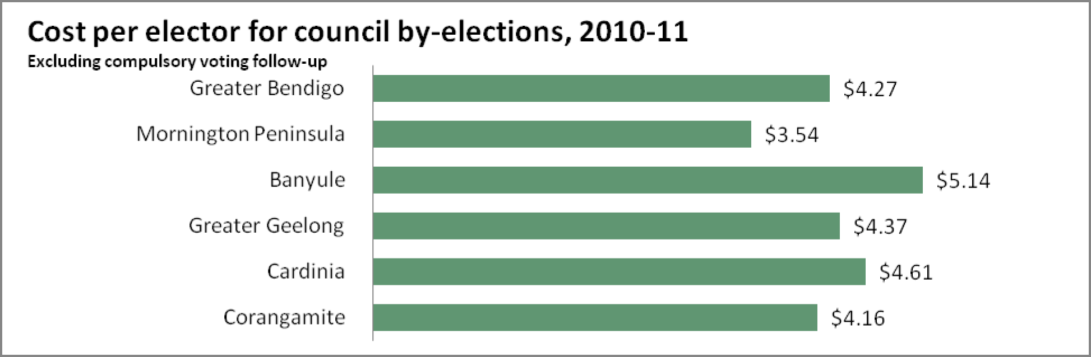
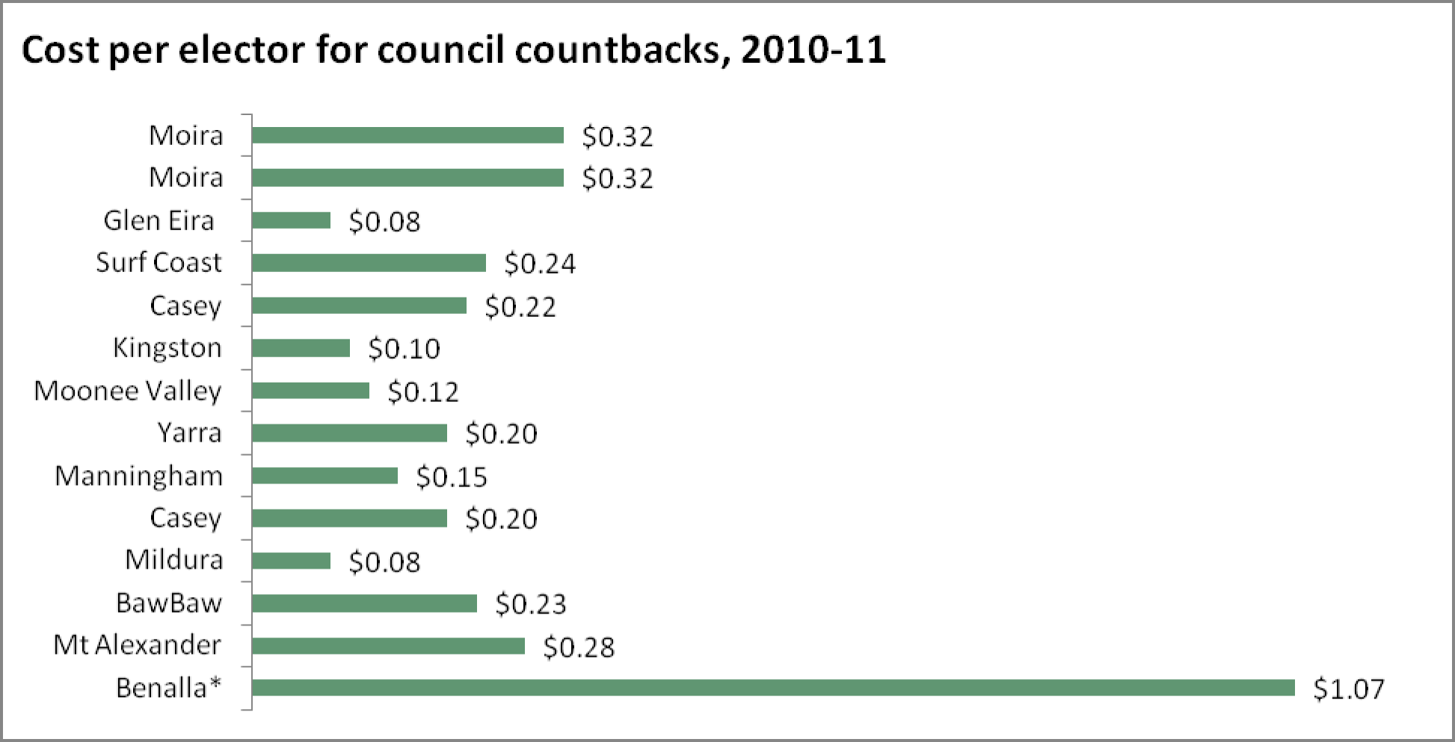
*see note page 5
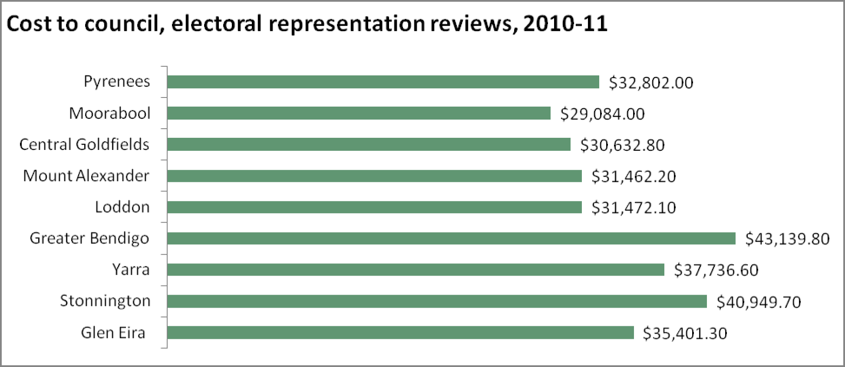

- Legislative framework
Local government elections, by-elections and countbacks are conducted within a legislative and regulatory framework. Section 74A(1) of the Constitution Act 1975 provides that local government is a distinct and essential tier of government, consisting of democratically elected councils.
The Local Government Act 1989 (LGA) establishes a legislative scheme that supports the system of local government and is the primary legislation under which the Victorian Electoral Commission (VEC) conducts local government electoral activity.
Part 3 of the LGA is the principal legislation for the conduct of local government elections in Victoria, including the filling of extraordinary vacancies. The Local Government (Electoral) Regulations 2005 make detailed provisions for the conduct of local government elections. Part 10 of the LGA guides the conduct of electoral representation and subdivision reviews.
  - Changes in legislation
The Local Government and Planning Legislation Amendment Act 2010 (LGPLAA) amended the LGA so that electoral representation reviews would be conducted after every third general election rather than after every second.
The VEC reviewed its schedule of reviews in response to this amendment, completing nine reviews in 2010-11, and proceeding with 19 of the 31 that were previously scheduled for 2011-12.
The LGPLAA also amended the LGA so that the VEC is now specified as the only agency authorised to conduct electoral representation reviews for all Victorian local councils.
This amendment provides certainty for councils and the VEC, and will enable planning and preparations to be undertaken in a timely and efficient manner across the 12 year period.

- Extraordinary vacancies
If, more than six months before a general council election, a councillor in a single-councillor ward resigns or can no longer hold office, an extraordinary vacancy arises, and a by-election is conducted. If this occurs in a multi-councillor electorate and there were unsuccessful candidates at the general election, a countback is conducted. Where there were no unsuccessful candidates, or none of the unsuccessful candidates is eligible to become a councillor, a by-election is conducted.
Twenty-five extraordinary vacancies arose during 2010-11. Four of these will be filled in the 2011-12 reporting period. This is a reasonably high number of vacancies but may be reflective of this stage of the election cycle — three years after a general election. In the past, a general election would be scheduled at this time, but with a four year cycle now legislated, the number of vacancies may be a result of the length of the commitment required.
  - By-elections
Over the past 12 months, the VEC has conducted six by-elections to fill extraordinary vacancies that have arisen in councils. A further two by-elections were in progress at the time of this report. Results of the by-elections are included in Appendix A.
Municipality  Ward | Method | Election day | Electors | Turnout | Informal votes | Cost to council (ex.GST)
Greater Bendigo North West Plains | Postal | 17/07/2010 | 8,314 | 78.99% | 2.80% | $4.27
Mornington Peninsula Truemans | Postal | 17/07/2010 | 12,039 | 65.71% | 3.83% | $3.54
Banyule Olympia | Attendance | 5/03/2011 | 13,184 | 59.62% | 8.10% | $5.14
Greater Geelong Deakin | Postal | 5/03/ 2011 | 14,513 | 77.05% | 3.17% | $4.37
Cardinia Bunyip | Postal | 19/03/2011 | 6,526 | 72.86% | 2.19% | $4.61
Corangamite South Central | Postal | 7/05/2011 | 2,018 | Uncontested | NA | $4.16
Figure 1: By-elections conducted, 2010-11
Municipality  Ward | Method | Election day
Latrobe Dunbar | Postal | 13/08/2011
Hepburn Cameron | Postal | 27/08/2011
Figure 2: By-elections in progress, 30 June 2011
  - Countbacks
A countback is conducted where a vacancy arises in an unsubdivided municipality or a ward represented by two or more councillors.
Where the original election result was determined by a manual proportional representation count, the countback is conducted manually. Where the original election result was determined by a computerised proportional representation count, the countback is conducted by computer.
Countbacks are conducted to fill extraordinary vacancies unless or until there are no unsuccessful candidates remaining. In that situation, extraordinary vacancies are filled by a by-election.
The countback process involves counting the ballot papers that elected the vacating councillor. The ballot papers are distributed, according to the next available preference, to the eligible candidates. The candidate who achieves an absolute majority of these votes is the successful candidate in the countback process. The VEC conducted 15 countbacks during 2010-11 (see Figure 3). A further two countbacks were in progress at the time of this report. Results of all countbacks conducted in 2010-11 are included in Appendix B.
Council | Ward | Location | Date | Cost to Council  (ex GST) | Cost per elector (ex GST)*
Moira |  | Cobram | 9/08/2010 | $7,092.75 | $0.32
Moira |  | Cobram | 13/09/2010 | $7,091.75 | $0.32
Glen Eira | Camden | VEC | 31/08/2010 | $2,537.83 | $0.08
Surf Coast |  | Torquay | 23/09/2010 | $6,571.17 | $0.24
Casey | Edrington | Narre Warren | 20/12/2010 | $6,091.35 | $0.22
Kingston | South | VEC | 11/01/2011 | $3,788.47 | $0.10
Moonee Valley | Myrnong | VEC | 11/01/2011 | $3,274.83 | $0.12
Yarra | Nicholls | VEC | 11/01/2011 | $3,949.73 | $0.20
Manningham | Koonung | VEC | 12/01/2011 | $4,186.83 | $0.15
Casey | Springfield | Narre Warren | 13/01/2011 | $6,091.35 | $0.20
Mildura |  | VEC | 31/03/2011 | $2,843.86 | $0.08
Baw Baw | North | Warragul | 27/05/2011 | $1,734.02 | $0.23
Mt Alexander | Castlemaine | Castlemaine | 2/06/2011 | $1,846.75 | $0.28
Benalla |  | Benalla ** | 16/06/2011 | $12,051.64 | $1.07
Benalla |  | Benalla ** | 21/06/2011 | $12,051.64 | $1.07
Figure 3: Countbacks conducted, 2010-11
* Cost per elector is based on the number of electors on the certified roll at the general election for that ward/municipality.
** Benalla countbacks: At the countback held on 16 June 2011, Mr Geoffrey Oliver was the successful candidate.
Mr Oliver did not lodge a written declaration as to his eligibility to become a councillor within the required 48 hours. A further count back was conducted on Tuesday 21 June. Mr Oliver was excluded from this countback and the votes were distributed, according to the next preference, to the remaining unsuccessful candidates from the November 2008 general election. The elected candidate was Mr Ken Whan.
  - Costs
The average cost per elector for a postal by-election during 2010-11 was $4.15 compared with $8.74 per elector in 2009-10. The cost for the attendance by-election was $5.14 per elector (13,184 electors). This was the first by-election to be conducted by attendance since the Maribyrnong, Stony Creek Ward by-election in 2007-08, when the cost per elector was around $10.00 (6,542 electors).
The base cost of a by-election is determined by the costs for advertising, design and printing layout, infrastructure and personnel, and the final cost for conducting the by-election is affected by the number of voters, candidates and other variables.
The reason for the significant decrease in average cost in 2010-11 is that the cost of the 2009-10 by-election for Strathbogie, Hughes Creek Ward (1400 voters) was $15.21 per voter. While an electorate may have a relatively small number of voters, the base cost is much the same as for an electorate with many more voters.
The VEC believes that it has achieved its target to provide value for money election services in the conduct of six by-elections during 2010-11. Costs do not include any compulsory voting enforcement services that a council may have appointed the VEC to undertake on its behalf. Under the LGA, councils can decide to conduct computer countbacks either locally or at the VEC.
The average cost per elector across all countbacks in 2010-11 was $0.21.
The average cost to council of a countback in 2010-11 (whether conducted centrally or locally) was just over $4,610.16. The average for a countback conducted at the VEC was $3,430.26 (excluding GST), and for a countback conducted within the municipality, $5,396.75 (excluding GST).
  - Participation
Participation is a measure of enrolment, voter turnout and informality rates. Figure 4 provides details of by-elections conducted over the past five years including voter turnout and informality rates.

 | Council | Ward | Election Type | Voter  Turnout  % | Informality rate % | #  Candidates
2010-11 | Greater Bendigo | North West Plains | Postal | 78.99 | 2.80 | 7
2010-11 | Mornington Peninsula | Truemans | Postal | 65.71 | 3.83 | 7
2010-11 | Banyule | Olympia | Attendance | 59.62 | 8.10 | 10
2010-11 | Greater Geelong | Deakin | Postal | 77.05 | 3.17 | 10
2010-11 | Cardinia | Bunyip | Postal | 72.86 | 2.19 | 8
2010-11 | Corangamite | South Central | Postal | UC* | NA | 1
2009-10 | Nillumbik | Ellis | Postal | 80.63 | 2.93 | 12
2009-10 | Murrindindi | King Parrot | Postal | 78.07 | 3.79 | 2
2009-10 | Greater Geelong | Cowie | Postal | 77.03 | 6.22 | 10
2009-10 | Strathbogie | Hughes Creek | Postal | 62.66 | 3.39 | 2
2008-09 | Pyrenees | Goldsmith | Postal | UC* | N/A | 1
2008-09 | Moorabool | Bungal | Postal | 70.43 | 2.73 | 4
2007-08 | Central Goldfields | Maryborough | Postal | 79.01 | 2.76 | 2
2007-08 | Greater Geelong | Deakin | Postal | 77.64 | 2.06 | 6
2007-08 | Ballarat | Alfredton | Postal | 75.45 | 1.67 | 4
2007-08 | Ballarat | Learmonth | Postal | 77.32 | 2.06 | 5
2007-08 | Pyrenees | Warrenmang | Postal | 73.51 | 1.91 | 3
2007-08 | Colac Otway | Otway | Postal | 70.40 | 1.01 | 3
2007-08 | Mornington Peninsula | Truemans | Postal | 66.37 | 2.09 | 4
2007-08 | Maribyrnong | Stony Creek | Attendance | 62.01 | 9.42 | 10
2007-08 | Boroondara | Cotham | Postal | 69.09 | 6.38 | 16
2006-07 | Latrobe | Galbraith | Postal | 69.34 | 2.88 | 6
2006-07 | Baw Baw | Tarago | Postal | 75.87 | 2.48 | 7
2006-07 | Moonee Valley | Debney | Postal | 60.82 | 4.70 | 12
 |  |  | Average | 72.41 | 3.40 | 6
Figure 4: Details of council by-elections 2006-07 to 2010–11
* Uncontested

  - Enrolment
Those electors who reside within a municipality and are enrolled on the State register of electors are automatically included on the voters roll for local government elections and by-elections. This category forms approximately 86% of the roll across all municipalities.
In addition, non-resident ratepayers are enrolled automatically — these records are extracted from the council property database. This group forms less than 14% of the roll across all municipalities.
Other council entitlements include non-citizen owner occupiers and company nominees. This group must complete an application form each election cycle to be entitled to vote, and usually comprises less than 1% of the roll. Those voters who have multiple entitlements within one municipality are only entitled to vote once.
The exhibition roll for a by-election is prepared at a date determined by the Registrar (S.23A(4)(a)), usually as soon as possible after the need for a by-election is determined. A new roll is also prepared for certification.
  - Voter turnout
The average turnout rate for by-elections held during 2010-11 was 70.85%, a decrease on the average turnout rate for by-elections held during 2009-10 (74.60%). It was also lower than the average for the five-year period 2006-07 to 2010-11 (72.41%). See Figure 5.
The average turnout was lower than turnout for the local government general elections held in November 2008 (74.68%). All council by-election figures are lower than the November 2010 State election turnout rate of 92.96%.
One of the main reasons for lower turnout rates for council elections and by-elections is the fact that voting is not compulsory for non-residents. Other factors include lower awareness of the election (due to less media attention and a lower rate of candidate activity); the perception that only property owners (as opposed to tenants) are required to vote in council elections and by-elections; and the fact that while voting is compulsory for residents over 70 years of age, these people are not fined if they do not vote. In addition the few by-elections that are conducted by attendance voting consistently show a lower turnout rate.
Notably, in the Banyule City Council, Olympia ward by-election, the turnout, at 59.62%, was well below the average, perhaps reflecting the fact that voting is not compulsory for non- residents (over 21% of people are in rented premises, the owners of which may have chosen not to attend to vote on election day). Also, around 9% of the population of Banyule is over 70 years of age.
Average Turnout | 2008  % | 2010-11  % | 2006-07 to 2010-11  %
Postal | 75.96 | 73.65 | 73.47
Attendance | 70.03 | 59.62 | 60.82
All | 74.68 | 70.85 | 72.41
Figure 5: Average turnout over time
  - Informality
The average informality rate for all by-elections conducted in 2010-11 was 4.02%, which is higher than the 3.40% average for by-elections conducted in the past five years, and the informality rate of 3.75% for postal elections conducted at the 2008 general elections (see Figure 6).
Notably, the highest informality rate for 2010-11 by-elections was 8.10% at the Banyule Olympia Ward by-election. Reasons for this could include the relatively high number of people with low fluency in English in the City of Banyule (9%), and the fact that this was conducted by attendance voting. If this figure is excluded, the average informality rate is 3.00%; lower than the average for the past 5 years.
The VEC has previously reported that the rate of informality tends to increase as the number of candidates increases (see Figure 7). There were 10 candidates for the Banyule Council, Olympia Ward by-election. However, by contrast, at the Greater Geelong, Deakin Ward election, there were also 10 candidates and an informality rate of 3.17%. Although there may be many factors contributing to the informality rate, the Greater Geelong by-election was a postal election, whereas the Banyule by-election was an attendance election.
The VEC’s ongoing electoral education and community engagement programs aim to increase electors’ understanding of how to cast a formal vote. These programs will now be focused on the council election processes and will complement the VEC’s tailored communication campaign in the lead up to the 2012 general elections.
Average Informality | 2008  % | 2010-11  % | 2006-07 to 2010-11  %
Postal | 3.75 | 3.00 | 2.92
Attendance | 9.90 | 8.10 | 8.76
All | 4.99 | 4.02 | 3.40
Figure 6: Average informality rate over time
Number of candidates | 2005  % | 2008  % | 2010-11  % | 2006-07  to  2010-11  %
2-5 | 2.59 | 2.05 | NA | 2.38
6-10 | 3.38 | 2.72 | 4.02 | 4.17
11-15 | 4.67 | 4.05 | NA | 3.82
>15 | 7.76 | 6.28 | NA | 6.38
Figure 7: Informality rates compared with number of candidates
  - Method of election
Under S41 A(2B) LGA (introduced by the Local Government Amendment (Elections) Act 2008), voting at a by-election must be conducted by the same means, attendance voting or postal voting, as the previous general election was conducted unless the council has decided, not later than seven days after the extraordinary vacancy occurred, to change the means of conducting the voting.
The vast majority of councils choose postal voting as the preferred option, and all councils that conducted by-elections during 2010-11 chose to do so using the same method of voting used in their previous general election. The cost of a postal election is generally lower than that for an attendance election and participation rates are generally higher.
- Compulsory voting enforcement
Councils are obliged to enforce the compulsory voting provisions of the LGA. Where the councils contract the VEC to conduct compulsory voting enforcement, the Chief Executive Officer is required to formally appoint the Prosecution Officer in accordance with S.40(2)(a) of the LGA.
Non-voter follow-up following a by-election is conducted by the VEC in three stages.

Stage one – Apparent Failure to Vote Notice
Stage one is a mandatory requirement. An Apparent Failure to Vote Notice is sent to each voter who appears to have failed to vote. No penalties are collected against this notice.

Stage two – Infringement Notice
At stage two, an Infringement Notice is sent to each voter who did not respond to the initial Apparent Failure to Vote Notice, or who did not provide a valid excuse for failing to vote.
The Infringement Notice includes the request for the payment of the penalty amount. Penalty amounts are indexed each year on 1 July and the penalty amount for the 2010-11 compulsory voting enforcement process was $60.00.

Stage three – Penalty Reminder Notice
At stage three, a Penalty Reminder Notice is sent to each voter who did not reply at stage two. The same processing provisions apply to the Penalty Reminder Notice as for the Infringement Notice. However, an amount of $22.00 for prescribed costs was added to the penalty amount of $60.00.
The VEC conducted non-voter follow-up for Cardinia Shire Council, Greater Geelong City Council (Cowie and Deakin Wards), Greater Bendigo City Council, Mornington Peninsula Shire Council, Banyule City Council, and Nillumbik Shire Council. On average, non-voter follow-up for councils cost $0.99 per enrolled voter.
Figure 8 provides details of non-voter follow-up and compulsory voting enforcement conducted during 2010-11.

Election  Date | Notice type | Mailout Date | # Records | Penalties collected 2010-11 | Court lodgement or forwarding date | # Records  lodged or forwarded to council
Greater Geelong Cowie  6 March 2010 | Penalty Reminder | July 2010 | 2,180 | $6,150.00 | Forwarded to Council  7 September 2010 | 466
Mornington Peninsula Truemans  17July 2010 | Apparent  Failure to Vote | 5 August 2010 | 891 |  | Not lodged with Court
Mornington Peninsula Truemans  17July 2010 | Infringement | 21 September 2010 | 571 | $5,640.00 | Forwarded to council
Mornington Peninsula Truemans  17July 2010 | Penalty Reminder | 14 December 2010 | 422 | $2,809.50 | 16 February 2011 | 367
Greater Bendigo North West Plains  17 July 2010 | Apparent Failure to Vote | 5 August 2010 | 731 |  | Not lodged with Court
Greater Bendigo North West Plains  17 July 2010 | Infringement | 21 September 2010 | 429 | $7,980.00 | Forwarded to council
Greater Bendigo North West Plains  17 July 2010 | Penalty Reminder | 14 December 2010 | 265 | $5,188.50 | 16 February 2011 | 200
Greater Geelong Deakin  5 March 2011 | Apparent Failure to Vote | 20 April 2011 | 1879
Greater Geelong Deakin  5 March 2011 | Infringement | 8 June 2011 | 1,279 | $12,840.00
Greater Geelong Deakin  5 March 2011 | Penalty Reminder | 3 August 2011 | 685
Banyule Olympia  5 March 2011 | Apparent Failure to Vote | 20 April 2011 | 2735
Banyule Olympia  5 March 2011 | Infringement | 8 June 2011 | 2,077 | $16,620.00
Banyule Olympia  5 March 2011 | Penalty Reminder | 3 August 2011 | N/A
Cardinia Bunyip  19 March  2011 | Apparent Failure to Vote | 20 April 2011 | 1,180
Cardinia Bunyip  19 March  2011 | Infringement | 8 June 2011 | 692 | $7,440.00
Cardinia Bunyip  19 March  2011 | Penalty Reminder | 3 August  2011 | N/A
Figure 8: Compulsory voting enforcement activity, 2010-11

- Municipal Electoral Tribunal
A Municipal Electoral Tribunal (MET) is appointed by the Attorney-General to consider disputes as to the validity of local government elections. Tribunals are constituted under the LGA and are intended to provide a forum for settling such disputes. A tribunal consists of a magistrate appointed by the Attorney-General.
A candidate, or any group of at least 10 voters at an election, who disputes the validity of the election may apply for an inquiry into the election by a municipal electoral tribunal. The application must be in writing and must contain the grounds on which the inquiry into the validity of the election is sought. The application must be lodged with the principal registrar of the Magistrates’ Court within 14 days of the declaration of the result of the election.
There were no MET applications in relation to by-elections or countbacks during 2010-11.
- Victorian Civil and Administrative Tribunal
Section 48 of the LGA provides that a person whose interests are affected by a decision of a MET can apply to the Victorian Civil and Administrative Tribunal (VCAT) for a review of the decision. There were no matters concerning decisions of a MET in relation to local government elections, by-elections or countbacks before VCAT during 2010-11.

- Electoral representation reviews
The Local Government and Planning Legislation Amendment Act 2010 amended the Local Government Act 1989, so that the VEC is now specified as the only agency authorised to conduct electoral representation reviews for all Victorian local councils. The timeframe for the reviews was also amended, and reviews are now due before every third council election instead of every second council election. Reviews must be completed at least six months prior to a general election. The VEC will complete all scheduled reviews by April 2012.
The VEC initiated work on the first round of electoral representation reviews in January 2011. All recommendations for electoral representation are based on internal research, modeling by VEC mapping experts, public submissions, and advice from external consultants with considerable experience in local government.
During 2010-11, electoral representation reviews were completed for the following nine councils:
- Glen Eira City Council
- Stonnington City Council
- Yarra City Council
- Greater Bendigo Shire Council
- Loddon Shire Council
- Mount Alexander Shire Council
- Central Goldfields Shire Council
- Moorabool Shire Council
- Pyrenees Shire Council
Details of these reviews are included in Figure 9.
The VEC has been pleased to find that most of the electoral structures it recommended in the previous representation reviews have been serving communities well. The VEC’s approach to this round of reviews is, therefore, to recommend improvements to the existing structures as its preferred option – providing that the electoral structure effectively captures communities of interest and protects against population fluctuations in the future.

  - Final reports and recommendations
At the time of this report, final reports for councils had been forwarded to the Minister for Local Government. The VEC recommended boundary changes for five councils, a ward name change for one council and no change for one council. For the remaining two councils – Loddon Shire Council and Greater Bendigo Shire Council the VEC recommended different structures.

Loddon Shire Council
Loddon Shire Council strongly advocated against retaining the status quo in their submission and at the public hearing. The Chief Executive Officer put forward the case for a change to their structure (favoring the alternative recommended option in the preliminary report) on the grounds that single-councillor wards would guarantee local representation. Interestingly, this option would have been the VEC’s preferred option at the last review had the voter numbers been sufficient to make the structure work. Upon considering all the evidence, including public submissions, the VEC decided to recommend the alternative structure in its Final Report to the Minister for Local Government.

Greater Bendigo Shire Council
An initial examination of Greater Bendigo City Council’s current electoral structure revealed that it would not withstand future growth. There was already a clear imbalance of voters across the municipality. Nearly all the preliminary submissions called for a change to multi-councillor wards. The VEC presented five different options in the Preliminary Report.
The VEC was persuaded by the evidence in the response submissions that the fourth of these options would provide the most effective and sustainable representation to the municipality.
At the time of this report, the Final Reports from the first round of reviews are with the Minister for Local Government. Any changes to the electoral structures will take effect at the next local government election in 2012.

 | Preliminary submissions | Response submissions | Public hearing  speakers | # of options |  | Current structure | Recommended structure | Cost to  Council
Glen Eira City Council | 4 | 7 | 2 | 2 | 9 councillors, 3 X 3 councillor wards |  | 9 councillors, 3 X 3 councillor wards. Minor change to ward boundaries | $35,401.30
Stonnington City Council | 10 | 17 | 7 | 4 | 9 councillors, 3 X 3 councillor wards |  | 3x 3 councillor wards, using the existing ward boundaries put in place following the 2004 review of the municipality. | $40,949.70
Yarra City Council | 6 | 6 | 2 | 2 | 9 councillors, 3 X 3 councillor wards |  | 9 councillors, 3 X 3 councillor wards. Minor change to ward boundaries | $37,736.60
Greater Bendigo City Council | 9 | 0 | 0 | 5 | 9 councillors, 9 x 1 councillor wards |  | 9 councillors, 3 X 3 councillor wards, Major change to electoral structure | $43,139.80
Loddon Shire Council | 7 | 8 | 2 | 3 | 5 councillors, 1 X 2 councillor,3 X 1 councillor wards |  | 5 x 1 councillor wards: | $31,472.10
Mount Alexander Shire Council | 4 | 5 | 1 | 2 | 7 councillors, 1 X 3 councillor, 4 x 1 councillor wards |  | 7 councillors, 1 X 3 councillors, 4 x 1 councillor wards. Change to name of one ward. | $31,462.20
Central Goldfields Shire Council | 7 | 3 | 1 | 3 | 7 councillors, 1 x 4 councillor, 3 x 1 councillor wards |  | 7 councillors, 1 x 4 councillor, 3 x 1 councillor wards Minor boundary adjustments and ward name change | $30,632.80
Moorabool Shire Council | 6 | 10 | 6 | 4 | 7 councillors, 1 x 4 councillor, 3 x 1 councillor wards |  | 7 councillors, 1 x 4 councillors, 3 x 1 councillor wards. Substantial changes to ward boundaries and change to one ward name. | $29,084.00
Pyrenees Shire Council | 3 | 3 | 2 | 2 | 5 councillors, 5 X 1 councillor wards |  | 5 councillors, 5 X 1 councillor wards. Minor change to ward boundaries and changes to 3 ward names | $32,802.00
Figure 9: Electoral representation reviews, statistics
  - Feedback
This first round of representation reviews attracted 126 public submissions. To ensure the transparency of the process, all submissions were published on the VEC website within 24 hours of receipt. Everyone who took part in the process was asked to fill in a survey about their experience and the feedback to date has been overwhelmingly positive.
Of the people surveyed:
- 97% found the public information session useful
- 100% found the public hearing helpful
- 84% of people rated the preliminary report as average or above for clarity, length, use of data and analysis of submissions.
The VEC is constantly striving to improve the process and is working with councils to find new ways of engaging with their communities. A set of posters was designed in response to a request from one council and a video presentation of the information session is being considered for people who are unable to attend in person.
  - Additional reviews
In May 2011, following a petition from local residents calling on the government to review the boundaries of the Latrobe City Council, the Minister for Local Government, Jeanette Powell, requested an electoral representation review of that Council. Of particular note is Burnet Ward, which is predicted to have a ratio of voters per councillor that is 16.2 per cent above the average ratio by the 2012 council elections. The Latrobe City Council review is scheduled to commence in October 2011.
Melbourne City Council also requested that it undergo a representation review due to the significant demographic changes that have taken place over the past ten years, including the expansion of the City to incorporate Docklands and parts of Kensington. Currently, Melbourne City Council’s electoral structure is defined by the City of Melbourne Act 2001. At the time of this report it is expected that legislation will be introduced to enable Melbourne City Council to undertake regular representation reviews in line with all Victorian councils, and that a review will be conducted during 2011-12.
  - Subdivision reviews
The VEC must notify the Minister in writing at least two years before the next general election if it considers that the boundaries for the wards of a council are unlikely to meet the 10% tolerance in voter/councillor ratio at the time of the next general election, and the council is not scheduled to conduct an electoral representation review before the next general election.
The Minister may then require that the VEC conduct a subdivision review and notify the relevant councils that a subdivision review is required.
Subdivision reviews have been requested by the Minister for the following Councils:
- Port Phillip City Council
- Yarra Ranges Shire Council
- Knox City Council.
In accordance with legislation, all subdivision reviews will be completed by April 2012.
- Recommendations
The VEC administers the laws as passed by Parliament, remaining neutral on policy matters, and providing advice and information relating to the impact of current laws and proposed legislative amendments. The VEC makes the following recommendations for the Minister to consider, along with some recommendations from the VEC’s Report on the 2008 local government elections. The VEC respectfully urges the Minister to consider the recommendations relating to local government elections as a priority, so that any consequent amendments to legislation affecting the 2012 elections can be implemented in a timely manner.
  - Timing of Minister’s orders in relation to electoral representation reviews and subdivision reviews
The VEC must, no later than 6 months before the general election in respect of which a representation review or subdivision is to be implemented, submit a copy of the final report to the Council and the Minister.
The Minister may recommend to the Governor in Council the making of such orders as are necessary to implement the final report. An order may provide that the changes are to have effect for the purposes of the next general election.
The VEC considers that for the efficient conduct of a council election, it is advisable that any orders made by the Minister as a result of an electoral representation review or subdivision review are made within a time frame that enables enough time for the VEC to give effect to any changes prior to the conduct of an election, and for voters and candidates to become familiar with any changes.
The VEC recommends that consideration be given to include in the LGA a provision that any orders made by the Minister as a result of an electoral representation review or subdivision review are made within one month of the release of the final report for that review, or not later than five months before the general election in respect of which the review is to be implemented.
  - Exhibition rolls
Under Section 11(5)(b) and (c) of the LGA (Entitlements relating to enrolment), under certain circumstances, a person can apply to be enrolled on the voters' roll. Section 11(7) of the LGA specifies that an enrolment as a result of an application under section 5(b) or (c) has effect from the next entitlement date after it is accepted, and continues in force until the day before the subsequent entitlement date for a general election.
In effect, this means that applicants who were enrolled at the 2008 election under S.11 (5)(b) or (c) will appear on 2012 exhibition rolls, and will then be removed from the certification roll if council does not receive a renewal application. The result being that some people who are entitled to be enrolled, will not make application because a check of the exhibition roll gives the impression that they are enrolled and the logical assumption that they would then be included on the certified roll. This issue caused some confusion at the 2008 elections.
A number of councils removed electors who had been enrolled under S11 (5)(b) and (c) applications from the exhibition roll, only adding them to the certification roll if a renewal was received. The practice is not strictly within the LGA, but is far more practical.
The VEC recommends that consideration be given to amending the LGA so that an enrolment under S.11 (5)(b) or (c) has effect from the next entitlement date after it is accepted and continues in force until the day before the subsequent exhibition roll date for a general election.
  - Redirection of Ballot Material – Postal elections
Regulation 87 of the Local Government (Electoral) Regulations 2005 allows for a voter, at a postal election, to request that their ballot material be redirected to another address. Such requests must be received by the Returning Officer by the day that nominations close, or a later date as specified by the Returning Officer.
When conducting simultaneous elections for up to 70 postal elections, the VEC must commence the preparation of ballot packs prior to the close of nominations to meet regulatory timelines for the dispatch of ballot packs. This strategy includes pre-printing voters’ addresses on envelopes.
If an elector requests redirection of their ballot pack after the roll is certified, removal of their particular envelope from the mailout is problematic. Accordingly, the VEC proceeds with the mailout as prepared, but cancels ballot packs sent to voters who have requested redirection. Cancelling the ballot pack ensures that it cannot be included in the count if it is inadvertently returned. The VEC sends a replacement ballot pack to the address requested by the voter seeking redirection. A covering letter is included with this pack, informing the voter that the original pack was sent to their enrolled address, but was cancelled to ensure that it could not be included in the count.
The VEC recommends that consideration is given to amending Regulation 87 so that requests for redirection of ballot material must be received by the returning officer by the date that the roll is certified. Any voters requiring their ballot material to be redirected, who miss this deadline, could apply to have a replacement ballot pack sent to a different address under Regulation 89.
  - Electronic Voting Franchise at local government elections
Due to legislative constraints, the VEC is unable to provide electronic voting at local government elections. The LGA and the City of Melbourne Act 2001 do not have provision for electronic voting. However, the VEC considers that electronic voting would provide the same benefits to electors at this level of government as it does to electors at State level. Currently electronic voting is available at State elections to electors who have low vision, are blind, have a motor skill impairment, whose first language is not English or those with low or no English literacy.
The VEC included in its Report to Parliament on the conduct of the 2010 Victorian State election a recommendation for consideration of broadening the operation of electronic voting to include local government elections. The VEC recommends that consideration be given to support that recommendation.
  - Multiple countbacks in an electorate
The VEC has considered a scenario whereby a countback is conducted for a particular ward in a Council to fill an extraordinary vacancy. If candidate A was the successful candidate at the countback, but did not complete a written declaration within 48 hours of the completion of the countback, stating that he/she was still eligible to become a Councillor (Sch 3A cl 7(1)), a further countback will be conducted to fill the vacancy.
Some time later, a further vacancy may arise for the same ward in the same Council where the vacating Councillor was elected at the general election, not at the previous countback.
The VEC sought advice on whether candidate A, who had failed to complete a written declaration at the initial countback, would still be eligible to participate in the subsequent countback.
Advice received by the VEC stated that under the current legislation, candidate A would be again be eligible to participate in the countback for a further extraordinary vacancy.
The VEC recommends that consideration is given to clarifying the eligibility of candidates to participate in a countback, where a previous countback has been conducted for the same electorate since the last general election, and the successful candidate failed to complete a declaration of eligibility within the required timeframe.
- Prior Recommendations
A number of recommendations for legislative or regulatory amendment were included in the VEC’s 2008-2009 report of local government electoral activities for consideration prior to the conduct of the 2012 general elections. These matters continue to be of interest or concern and the VEC draws the Minister’s attention to the recommendations in that report, with particular attention to those noted below.
  - Deadline for Lodgement of Candidate Statements and Indication of Preferences
The deadlines for lodging candidate statements and indications of preferences in postal elections are set at 4.00pm. (Local Government (Electoral) Regulations 2005, Reg 34(2) and 37(2)(c)). All other candidate related deadlines (nominations, lodgement of how-to- vote cards) are 12.00 noon.
The VEC recommends that for consistency, the timeline for lodgement of candidates’ statements and preferences be amended to be 12.00 noon.
  - Provision of Braille ballot papers
The VEC provides with the opportunity to request a Braille or large print ballot paper to voters who are blind or have low vision. There is currently no provision in the legislation that specifically provides for this. The VEC treats requests from these voters at an attendance election as applications for postal votes. The VEC assists voters to complete a postal vote application as required by the current provisions of the LGA. The administration of Braille applications is difficult to achieve within current legislative timeframes.
The VEC recommends that consideration is given to removing the requirement to complete a written application for a postal vote, for a voter requesting a Braille ballot paper.
  - Procedure if recount results in a further tie
Where an election results in a tie, the LGA (Sch 3.10(g) and 11B(25)) require that the returning officer conducts a draw by lot to determine the successful candidate. It is likely that a recount will be requested where a result is tied. If a recount results in a further tie, the current legislation is silent on whether a further draw by lot to determine the successful candidate is required, or whether the result of the original draw by lot stands.
A Municipal Electoral Tribunal, responding to an application in relation to the 2008 Moyne Shire Council election, ordered that a second draw by lot should be conducted when a recount produced a second tied result. The same candidate was elected after the recount in this case, but it could also have gone the other way.
The VEC recommends that consideration is given to clarifying the returning officer’s responsibilities in determining the successful candidate if a tie is the outcome of both the original count and a recount.
  - How-to-vote cards
    - Registration of How-To-Vote cards
Division 2 of the Local Government (Electoral) Regulations 2005 (LGR) provides for how- to-vote cards at attendance elections. Only registered how-to-vote cards can be distributed within 400 metres of a voting centre during early voting, or within 400 metres of a voting centre during the hours of voting on election day.
The requirement to register how-to-vote cards for distribution at early voting centres puts pressure on candidates to finalise preference allocations and complete the registration process quickly. This often leads to candidates registering more than one card to cover a range of preference allocations.
The Electoral Act 2002 requires that HTV cards for State elections to be registered for distribution within 400 metres of election day voting centres only, and there is no requirement to register cards distributed at early voting centres. A possible reason for this differentiation is that there is more time to address any matters relating to election material during the early voting period, via other channels, than there is on election day.
The Local Government Act 1989 (LGA) already includes provisions that prohibit the distribution of election material that is misleading or deceptive in addition to the provisions relating to the registration of HTV cards. There is also provision in the LGA for a person to seek an injunction to restrain another person from distributing material that is misleading and deceptive. Registration provisions are not included in Commonwealth legislation, or in electoral legislation in Western Australia, Tasmania, the Australian Capital Territory, or the Northern Territory.
The VEC recommends that consideration is given to:
- Removal of the requirement to register how-to-vote cards or
- Removing the requirement to register HTV cards for early voting and/or
- Placing a limit on the number of HTV cards that can be registered by one applicant.
    - Printing of How-To-Vote cards
Regulation 31(1)(a) of the LGR requires the returning officer to provide their voting centre managers with copies of all registered HTV cards. This is difficult to administer because candidates do not always provide printed copies to the returning officer in sufficient time to make them available to voting centre managers. This requirement also generates large volumes of paper which must subsequently be disposed of. For State elections, a full set of registered cards is held by the election manager and voting centre managers make contact with them if any matters relating to HTV cards arise on election day.
In practice, voting centre managers at council elections need to contact their returning officer if issues arise, as it is possible that not all candidates have provided the returning officer with printed copies of their registered card(s) prior to election day.
The VEC recommends that consideration is given to amending Regulation 31(1)(a) of the LGA to require the returning officer to have a complete set of registered HTV cards available to inspect should any enquiry be received by a voting centre manager on election day, as is currently the case for State elections.
    - Publication of names of those registering How-To-Vote cards
Regulation 31(1)(b) requires that a list of names of candidates for whom HTV cards have been registered be published on a web site maintained by or on behalf of the returning officer. In practice, HTV cards are registered by applicants other than candidate and can be community groups or other parties.
The VEC recommends that consideration is given to amending Regulation 31(1)(b) of the LGR to include applicants (other than candidates) who register HTV cards into this requirement.
Appendix A: Results, By-elections
Results for Greater Bendigo City Council By-Election 2010 North West Plains Ward (1 vacancy)
Voting Count Method Preferential
Elected PHILLIPS, Bruce
Enrolment 8,314
Formal Votes 6,383
Informal Votes 184 (2.80% of the total votes)
Voter Turnout 6,567 (78.99% of the total enrolment)
First preference votes
Candidate Number of first preference votes
PHILLIPS, Bruce 1,517
ZEGERS, Karel 1,478
HARRINGTON, Elaine 915
ROBINSON, Stephen 367
RADFORD, Wendy 462
SYMES, Stuart 992
BEATH, Ian 652
Results for single vacancy after distribution of preferences
Candidate Votes after distribution
PHILLIPS, Bruce 3,363
SYMES, Stuart 3,020

Results for Mornington Peninsula Shire Council By-Election 2010 Truemans Ward (1 vacancy)
Voting Count Method Preferential
Elected CELI, Antonella
Enrolment 12,039
Formal Votes 7,608
Informal Votes 303 (3.83% of the total votes)
Voter Turnout 7,911 (65.71% of the total enrolment)
First preference votes
Candidate Number of first preference votes
CELI, Antonella 1,965
SHERRY, Matt 1,212
BURGMANN, Jade 546
LAMBERT, Roger 1,364
SOUTHALL, Terry 1,344
LENZO, Joe 677
TAYLOR, James Benjamin 500
Results for single vacancy after distribution of preferences
Candidate Votes after distribution
CELI, Antonella 4,457
LAMBERT, Roger 3,151

Results for Banyule City Council By-Election 2011 Olympia Ward (1 vacancy)
Count Method Preferential
Elected LANGDON, Craig
Enrolment 13,184
Formal Votes 7,223
Informal Votes 637 (8.10% of the total votes)
Voter Turnout 7,860 (59.62% of the total enrolment)
Recheck results for first preference votes
Candidate Number of first preference votes
HEBBARD, Adam Thomas 212
ANDERSEN, Lisa 195
SCHUTENKO, Marcus 752
CELESTIN, Rose-Marie 158
SCHOREL-HLAVKA, Gerrit Hendrik 74
LANDSBERG, Ben 814
LANGDON, Craig 2,826
McCOLL, Karen-Joy 275
MULHOLLAND, Evan 1,031
PAVLOVIC, Nancy 886
Results for single vacancy after distribution of preferences
Candidate Votes after distribution
SCHUTENKO, Marcus 1,854
LANGDON, Craig 3,775
MULHOLLAND, Evan 1,594

Greater Geelong City Council By-Election 2011 Deakin Ward (1 vacancy)
Voting Count Method Preferential
Elected NELSON, Ron
Enrolment 14,513
Formal Votes 10,827
Informal Votes 355 (3.17% of the total votes)
Voter Turnout 11,182 (77.05% of the total enrolment)
First preference votes
Candidate Number of first preference votes
NELSON, Ron 2,622
PODVINSEK, Matt 935
WHIMPRESS, Craig 384
SYDDALL, Cassandra 568
JEFFREYS, Amber J. 329
BAULCH, Phil 608
O'BRIEN, David 1,182
YOUNG, Kimberley 875
KAKOUROS, Angelo 2,850
WESTGARTH, Rick 474
Results for single vacancy after distribution of preferences
Candidate Votes after distribution
NELSON, Ron 5,905
KAKOUROS, Angelo 4,922
Results for Cardinia Shire Council By-Election 2011 Bunyip Ward (1 vacancy)
Voting Count Method Preferential
Elected MOORE, Graeme
Enrolment 6,526
Formal Votes 4,651
Informal Votes 104 (2.19% of the total votes)
Voter Turnout 4,755 (72.86% of the total enrolment)
First preference votes
Candidate Number of first preference votes
HARRIS, Dorle 365
O'CONNOR, Gloria 406
OSTROM BROWN, Hayden 188
SCHILLING, Michael 292
MOORE, Graeme 1,730
ANDERSON, John 827
VAN GRAMBERG, Vanessa 64
FRY, George 779
Results for single vacancy after distribution of preferences
Candidate Votes after distribution
O'CONNOR, Gloria 1,082
MOORE, Graeme 2,486
ANDERSON, John 1,083

Results for Corangamite Shire Council By-Election 2011 South-Central Ward (1 vacancy)

Voting Count Method Uncontested

Elected BEARD, Joanne (Unopposed)

Appendix B: Results, countbacks

Council | Electorate | Vacancy Date | Election Date | Vacated Candidate | Elected Candidate
Benalla Rural City Council | Benalla Rural City Council | 18 May 2011 | 21 Jun 2011 | CLARIDGE, Pat | WHAN, Ken
Benalla Rural City Council | Benalla Rural City Council | 18 May 2011 | 16 Jun 2011 | CLARIDGE, Pat | OLIVER, Geoff
Mount Alexander Shire Council | Castlemaine Ward | 3 May 2011 | 2 Jun 2011 | SCHIER, Philip | MACHIN, Bronwen
Baw Baw Shire Council | North Ward | 27 Apr 2011 | 27 May 2011 | McGOWAN, Ruth | NEIL, Mel
Mildura Rural City Council | Mildura Rural City Council | 25 Mar 2011 | 3 May 2011 | KNIGHT, Vernon Andrew | PEART, Sharyon
Casey City Council | Springfield Ward | 8 Dec 2010 | 13 Jan 2011 | WREFORD, Lorraine | HALSALL, Bob
Manningham City Council | Koonung Ward | 13 Dec 2010 | 12 Jan 2011 | CHUAH, Fred | YANG, Jennifer
Kingston City Council | South Ward | 1 Dec 2010 | 11 Jan 2011 | BAUER, Donna Jane | MOLONEY, Dan
Moonee Valley City Council | South Ward | 30 Nov 2010 | 11 Jan 2011 | ISER, Rose | GILLIS, Miriam
Yarra City Council | Nicholls Ward | 8 Dec 2010 | 11 Jan 2011 | GARRETT, Jane | MAIN, Anthony
Casey City Council | Edrington Ward | 17 Nov 2010 | 20 Dec 2010 | MULINO, Daniel | OWEN, Judy
Surf Coast Shire Council | Surf Coast Shire Council | 25 Aug 2010 | 23 Sep 2010 | SCHROETER, Lindsay A. | HUMPHREY, Ron
Glen Eira City Council | Camden Ward | 30 Jul 2010 | 31 Aug 2010 | WHITESIDE, Helen | FORGE, Cheryl
Moira Shire Council | Moira Shire Council | 14 Jul 2010 | 9 Aug 2010 | McCURDY, Tim | BUCK, Wendy

Victorian Electoral Commission
Level 11, 530 Collins Street
Melbourne VIC 3000
Telephone: +61 3 8620 1100
Fax: +61 3 9629 8632
Website: vec.vic.gov.au

