Subdivision Review
Knox City Council
Subdivision Review Report

20 February

19 March 2012

Summary of Recommendation
The Victorian Electoral Commission (VEC) recommends that the boundaries of the following wards be slightly modified:

- Taylor Ward
- Tirhatuan Ward

The recommended ward boundaries can be seen in the map at the back of this report.

Background
Legislative basis
Subdivision reviews are allowed for by the Local Government Act 1989 (the Act). Their purpose is to consider the location of the ward boundaries to ensure the number of electors represented by each councillor in the municipality is within 10 per cent of the average number of electors represented by all councillors (compliance may be determined by reference to the number of electors at the time of the review or the projected number electors as at the entitlement date for the next general election).
Subdivision review provisions only apply to councils:
- that are not scheduled to conduct an electoral representation review before the next general election; and
- where two years before the council is to hold a general election, the VEC considers that the boundaries for the wards of the Council are unlikely to meet the equality requirements of the legislation as at the time of their next general election.
A subdivision review is only required where the Minister for Local Government writes to a Council and directs them to undertake a review pursuant to section 219K of the Act.
Knox City Council received notice in April 2010, from the Minister of Local Government, that the Council must appoint the VEC to conduct an independent subdivision review. Based on the projected enrolment estimates, Taylor Ward was considered unlikely to conform to the equality requirements of the legislation.

Scope of the review
Subdivision reviews can only examine the location of ward boundaries. They cannot look at the total number of councillors, the number of councillors in a ward, ward names, the external boundaries of a municipality or whether a municipality should be divided into two municipalities or amalgamated.
Electoral representation reviews (as opposed to subdivision reviews) consider a broader range of topics, including the number of councillors, whether or not there should be wards, how many councillors there should be in a ward and how many wards there should be (if any). Knox City Council is scheduled to undergo an electoral representation review considering these matters in 2020.

The VEC and subdivision reviews
The VEC has conducted subdivision reviews since 2008 on appointment by local councils. The Act was changed in 2010 to define the VEC as the only agency authorised to undertake the reviews.
Subdivision review process
- Changes are modelled to the location of ward boundaries to achieve the equality requirements. The VEC uses both the current number of voters and the voters projected to be on the roll for the next general election, in addition to data supplied by the Department of Planning and Community Development and Forecast.id.

- Where possible, a “minimal change” approach is used when moving the location of ward boundaries, to ensure that changes affect as few electors as possible. (It should be noted that changes to the boundaries of wards that do not conform to the equal voter number requirements often have a flow-on effect and changes may need to be made to the boundaries of other wards, even through they may currently conform to the voter number requirements).

- When modelling changes to ward boundaries, due consideration is given to the following factors:
- relevant issues that were considered as part of the representation review;
- area and physical features of the terrain;
- means of travel, traffic arteries, and any special difficulties in connection;
- clear boundary delineators;
- communities of interest and;
- the likelihood of changes in the number of voters before the next election.

- A map of the proposed boundary was published in the Knox Leader on
Tuesday, 31 January 2012 and the Knox Weekly on Wednesday, 1 February 2012, informing the community of the review and inviting written comments or objections to the proposed change.

- A report containing a detailed map of the proposed boundaries together with the rationale for the boundary changes and information about the process was made available for inspection at the offices of the VEC and the Council. The Report was also made available on the VEC's website at vec.vic.gov.au. Hard copies could be requested by contacting the VEC’s dedicated helpline – 131 832.

- Two written submissions were considered by the panel.

- This Final Report is made available from the VEC and Council Offices and any changes accepted by the Minister will apply at the next general election in October 2012.
Current Electoral Structure
The electoral representation review for Knox City Council took place in 2007. Following the review, the Minister for Local Government determined that the structure of Knox City Council should be:
- Nine councillors elected from nine wards.
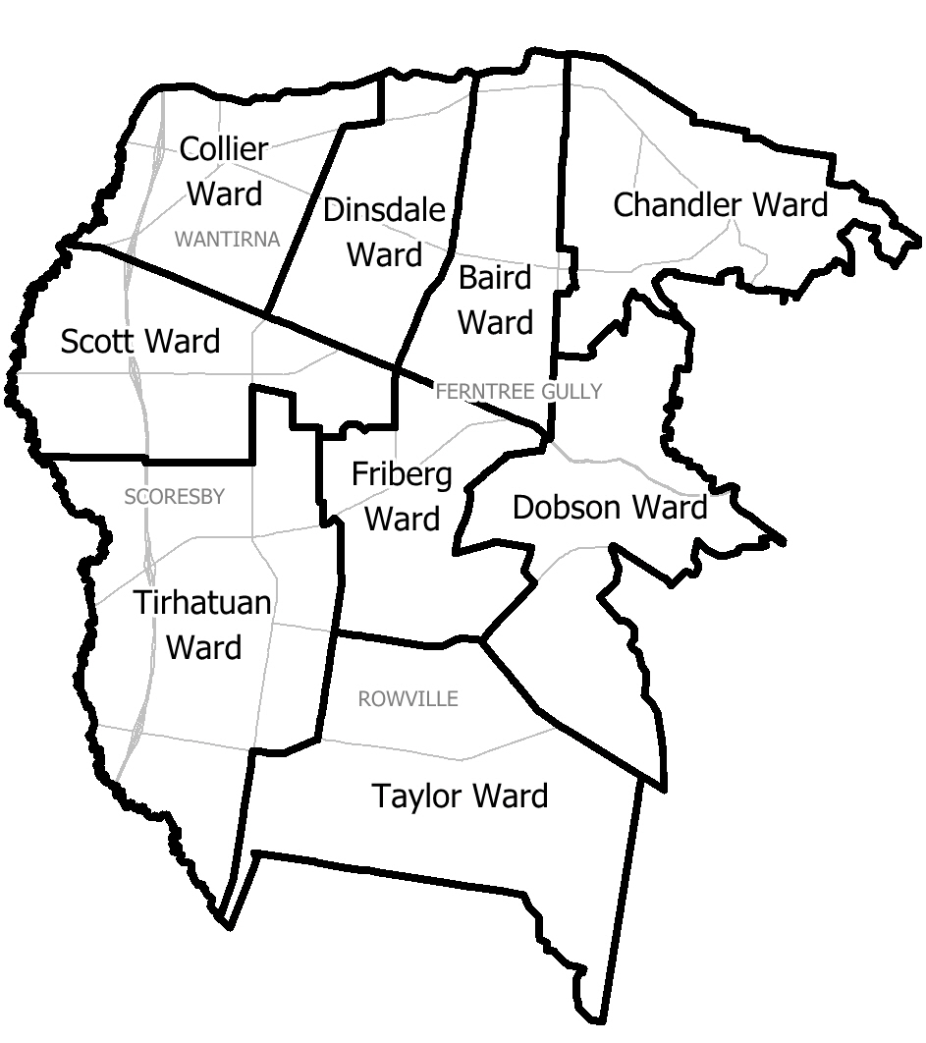

Profile of Knox City Council
The City of Knox is located approximately 25 kilometres east of the Melbourne CBD in the foothills of the Dandenong Ranges. It is a large municipality of 114 square kilometres that has passed through a period of rapid housing and business development over the past three decades and is now emerging from this period of high growth to a time of maturation and consolidation.
Knox has now all but it exhausted its supply of broad hectare land for new dwellings and its population growth is predicted to slow down, especially as the children of those who first settled there grow up and move out of home.
It is one of the most populous municipalities in Victoria with over 155,000 residents living in eleven main suburbs. Seventeen per cent of residents are from non-English speaking backgrounds and 15 per cent of residents are aged 65 and older. Thirty-one per cent of the resident workforce works in Knox.

Number of voters
The table below shows the number of current electors in each ward and their deviation from the average number of voters per ward.

Ward name | Electors | Deviation
Baird Ward | 12,332 | -2.27%
Chandler Ward | 11,822 | -6.31%
Collier Ward | 11,696 | -7.31%
Dinsdale Ward | 11,465 | -9.14%
Dobson Ward | 13,262 | +5.10%
Friberg Ward | 13,443 | +6.53%
Scott Ward | 13,221 | +4.77%
Taylor Ward | 14,347 | +13.70%
Tirhatuan Ward | 11,981 | -5.05%

The table shows that Taylor Ward is currently outside the 10 per cent deviation allowed by legislation and it is anticipated that this could further increase in the period leading up to the election in October this year. Taylor Ward must be adjusted to bring it into line with the average number of voters for all wards.
Although Dinsdale Ward is close to the average at -9.14 per cent the VEC is confident that it will remain within the ten per cent tolerance margin. Data supplied by Forecast.id shows an increase in residential development in Bayswater is expected to attract families, older adults and retirees and this is confirmed by the VEC’s projected enrolment data.

Findings and Recommendation
The VEC always prefers to make the most minimal modifications possible in subdivision reviews in order to affect the least possible number of voters.
Taylor Ward adjoins Dobson Ward, Friberg Ward and Tirhatuan Ward. As Tirhatuan Ward is recording a deviation below the average, it makes sense to adjust the boundary with Tirhatuan Ward and increase the number of voters in that ward. Although, Friberg Ward also has a low deviation there were no logical boundaries to follow in this ward. This recommended boundary change has the advantage of only affecting two wards and represents the most minimal change possible.
Only two submissions were received in response to the Proposed Boundary Report. The first submitter, Mr Massin, expressed concerns that the VEC had not taken into consideration the major development in Rowville, specifically within the Rowville Major Activity Centre at Stud Park, which would increase enrolment numbers in Tirhatuan Ward.
The VEC can confirm that in addition to the enrolment statistics from the Victorian electoral roll, the VEC also used projections from the Department of Planning and Community Development and Forecast,id. The growth in Tirhatuan Ward was factored into the data the VEC used to formulate its recommendation.
The submitter also suggested it was short-sighted to change the boundaries at this time and suggested that the VEC take a long-term view that the wards may start to equal out again once the growth in Tirhatuan Ward is realised.
The VEC understands that populations are continually changing but it is bounded by the Local Government Act 1989, and must ensure that the number of electors represented by each councillor is within 10 per cent of the average number of electors represented by all councillors. This average is calculated to ensure that each ward has a roughly equal number of electors and is particularly important in consideration of the upcoming Council election in October.
The second submission was put forward by Knox City Council and acknowledged the difficulty of determining a logical boundary between Taylor Ward and Friberg Ward or Taylor Ward and Dobson Ward. The Council considered the proposed boundary offered the most logical and sustainable solution in the short to medium term, having looked at a range of alternative boundaries at the north-western point of Taylor and Tirhatuan Wards.
In the current structure, the boundary runs along Wellington Road between Taylors Lane and Stud Road. The VEC recommends that the new boundary should use Wellington Road in an easterly direction to the corner of Braeburn Parade and then follow the drainage reserve, back along the property boundary in a westerly direction, to Stud Road. The current boundary follows major roads but the recommended boundary is also recognisable from the ground.
The drainage reserve encompasses a discrete residential area and this minor modification will transfer 832 voters in the suburb of Rowville from Taylor Ward to Tirhatuan Ward. The suburb of Rowville is currently split between Taylor and Tirhatuan Wards and the recommended modification does not significantly change this situation.
The boundary changes can be seen in the map at the end of this report. The thick black line illustrates the recommended new boundary and the black dotted line represents the current boundary. The coloured areas represent the current wards.

Recommendation
The VEC recommends that a minor change be made to the boundary between Taylor Ward and Tirhatuan Ward, as presented in the map at the back of this report.

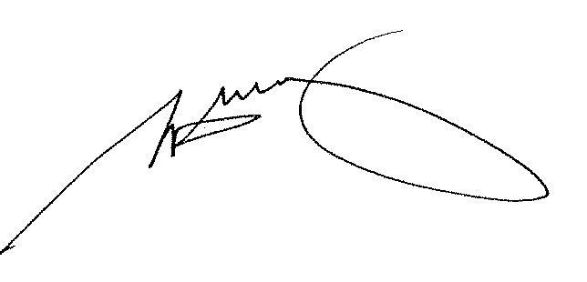

Steve Tully
Electoral Commissioner

List of submitters
- Massin, C
- Knox City Council

Map of recommended structure

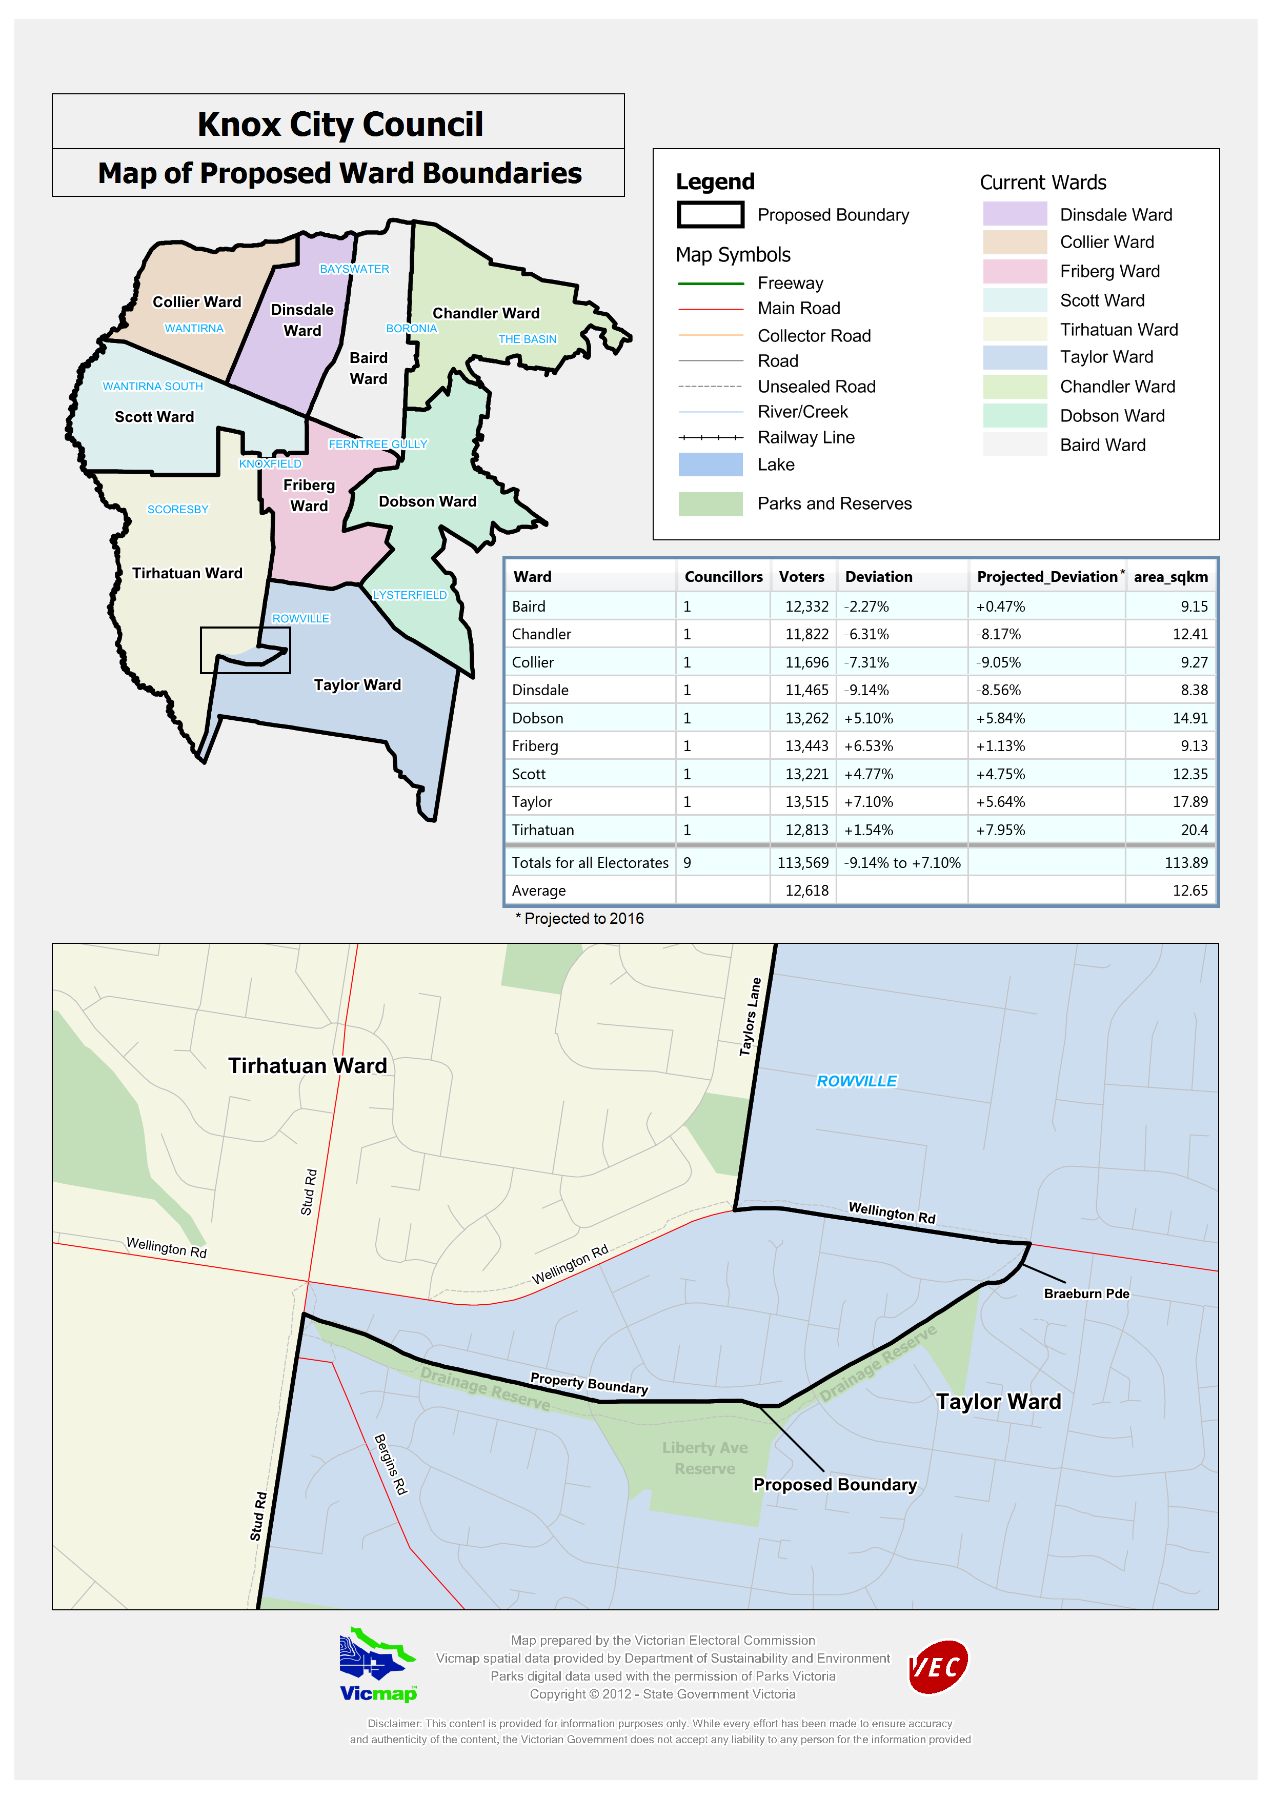

Victorian Electoral Commission
Level 11, 530 Collins Street
Melbourne, Vic 3000

131 VEC (131 832)
knox.review@vec.vic.gov.au
vec.vic.gov.au

Department of Planning and Community Development website: dpcd.vic.gov.au
Victoria in Future 2008, Department of Planning and Community Development
Knox City Council Annual Report 2009-10
Forecast.id data – Key drivers of change – City of Knox

