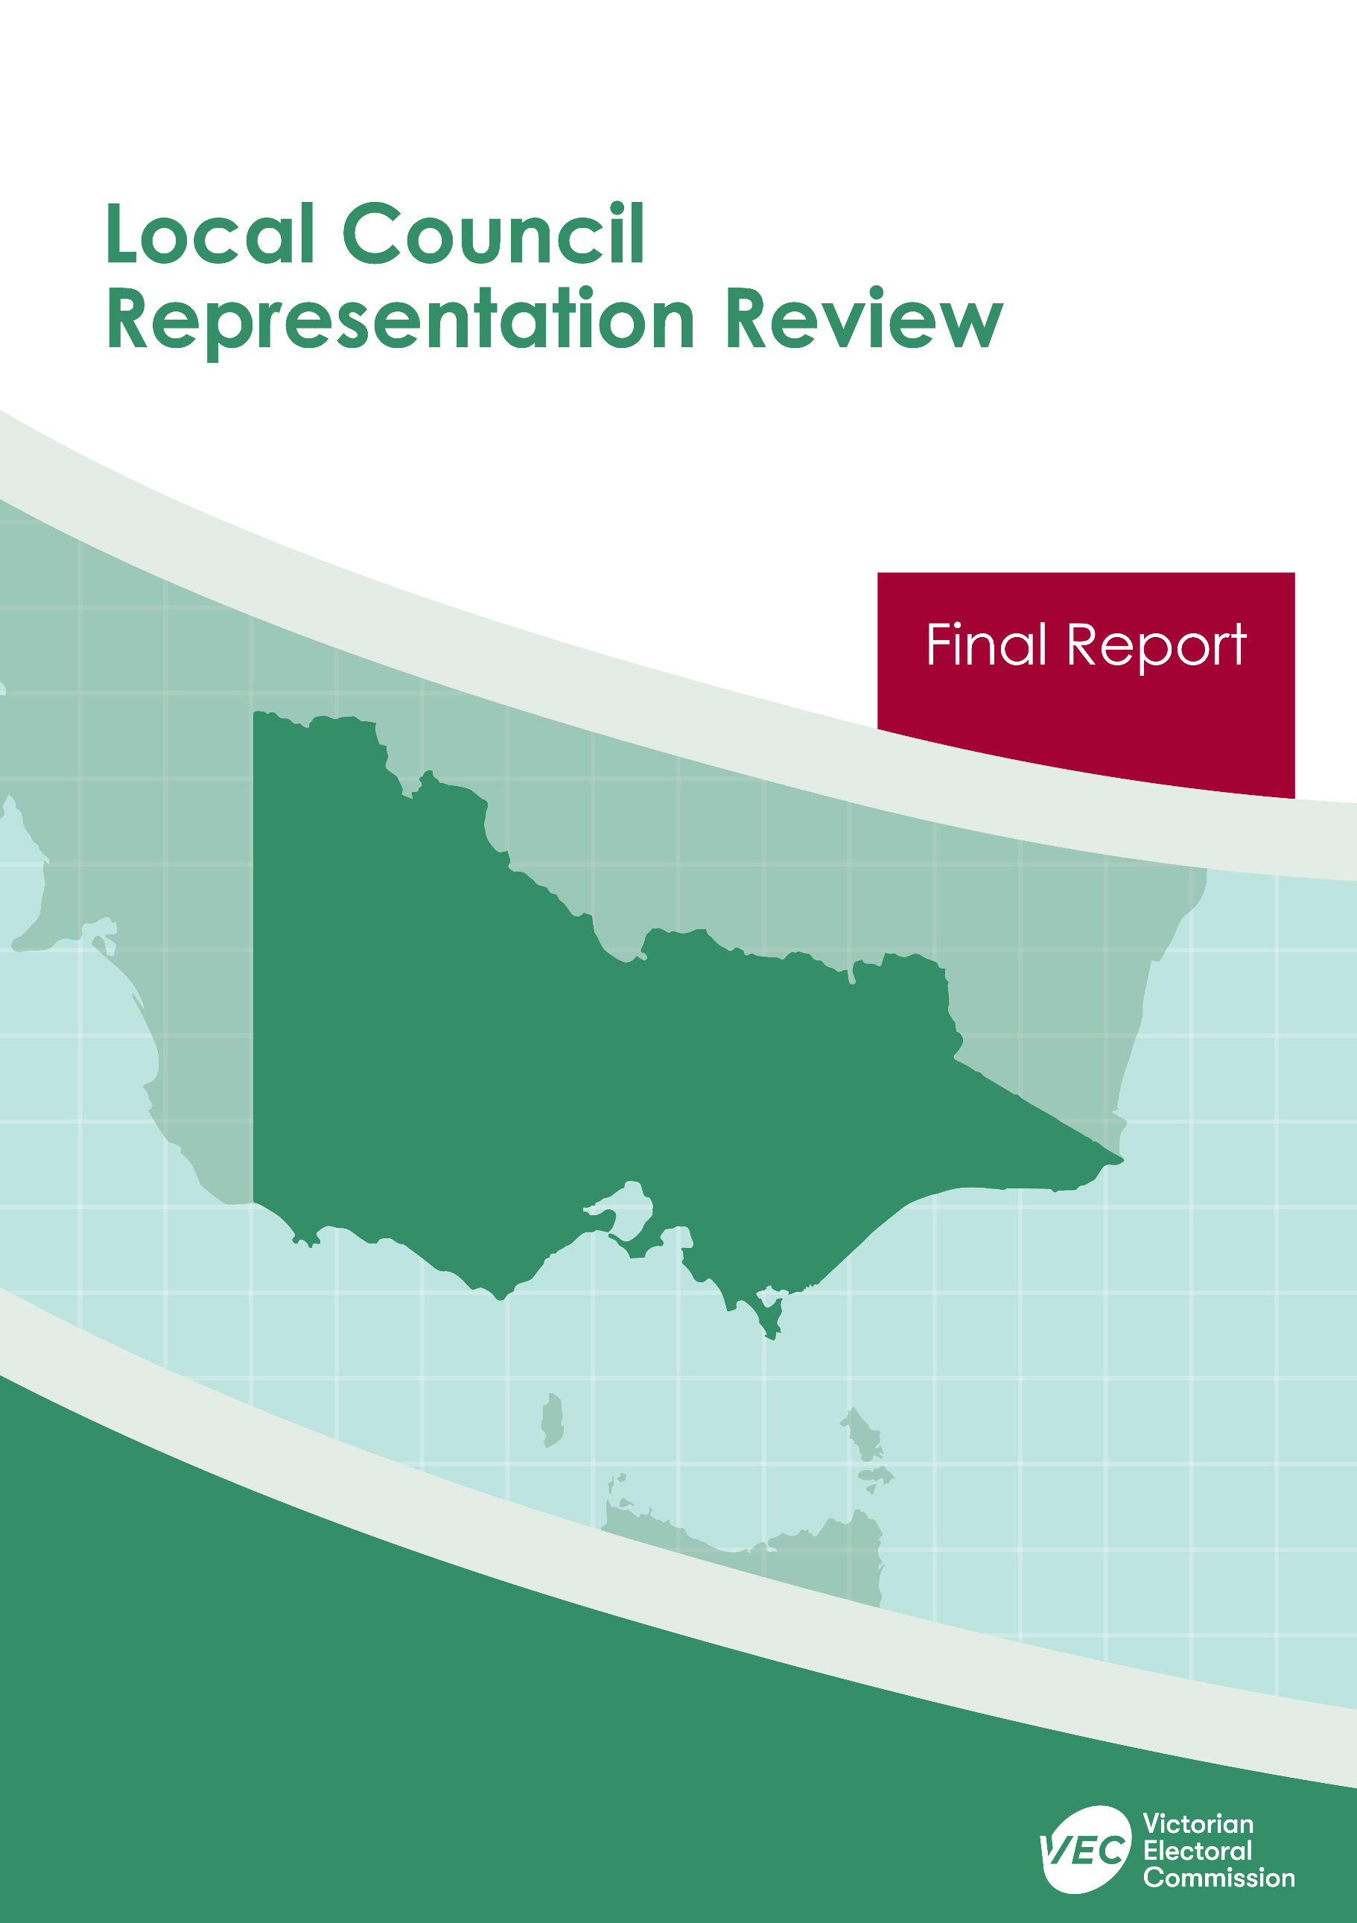



**Cardinia Shire Council**

**April 2020**

Contents

Recommendation 1

Executive summary 2

Background 5

Legislative basis 5

Public engagement 5

The VEC’s principles 6

Developing recommendations 7

Cardinia Shire Council representation review 10

Profile of Cardinia Shire Council 10

Current number of councillors and electoral structure 12

Preliminary submissions 12

Preliminary report 14

Public response 19

Response submissions 19

Public hearing 20

Findings and recommendation 21

The VEC’s findings 21

The VEC’s recommendation 24

Appendix 1: Public involvement 25

Appendix 2: Map 26

Appendix 3: Public information program 27

Recommendation

The Victorian Electoral Commission recommends that Cardinia Shire Council continue to consist of nine councillors elected from three wards, with adjustments to the current ward boundaries (one four-councillor ward, one three-councillor ward and one two-councillor ward).

This recommendation is submitted to the Minister for Local Government as required by the *Local Government Act 1989*.

Please see Appendix 2 for a detailed map of this recommended structure.

Executive summary

The *Local Government Act 1989* (the Act) requires the Victorian Electoral Commission (VEC) to conduct an electoral representation review of each local council in Victoria before every third council general election.

The purpose of an electoral representation review is to recommend the number of councillors and the electoral structure that provides ‘fair and equitable representation for the persons who are entitled to vote at a general election of the Council.’[1] The matters considered by a review are:

* the number of councillors
* the electoral structure of the council (whether the council should be unsubdivided or divided into wards and, if subdivided, the details of the ward boundaries and the number of councillors per ward).

The VEC conducts all reviews based on three main principles:

1. taking a consistent, State-wide approach to the total number of councillors
2. if subdivided, ensuring the number of voters represented by each councillor is within plus-or-minus 10% of the average number of voters per councillor for that local council
3. ensuring communities of interest are as fairly represented as possible.

Current number of councillors and electoral structure

Cardinia Shire Council currently comprises nine councillors elected from three wards (one four-councillor ward, one three-councillor ward and one two-councillor ward).   
Prior to the representation review in 2012, Cardinia Shire Council was comprised of seven councillors elected from four wards (one three-councillor ward, one two-councillor ward and two single-councillor wards).

Due to changes in the growth and distribution of the voter population in Cardinia Shire a subdivision review was conducted in 2015. The VEC recommended adjustments to the internal ward boundaries to ensure that the number of voters represented by each councillor was within plus‑or-minus 10% of the average number of voters per councillor before the 2016 general elections.

Visit the VEC website at [vec.vic.gov.au](http://vec.vic.gov.au) for more information on Cardinia Shire Council and to access copies of the 2012 representation review final report and the 2015 subdivision review final report.

Preliminary submissions

Preliminary submissions opened at the commencement of the current review on Wednesday 6 November 2019. The VEC received eight submissions for the representation review of Cardinia Shire Council by the deadline of 5.00 pm on Wednesday 4 December 2019.

Preliminary report

A preliminary report was released on Wednesday 5 February 2020 with the following options for consideration:

* Option A (preferred option)  
  **Cardinia Shire Council consist of nine councillors elected from three wards, with adjustments to the current ward boundaries (one four-councillor ward, one three-councillor ward and one two-councillor ward).**
* Option B (alternative option)  
  **Cardinia Shire Council consist of nine councillors elected from three wards (three three-councillor wards).**

Response submissions

The VEC received four submissions responding to the preliminary report by the deadline of 5.00 pm on Wednesday 4 March 2020.

Public hearing

The VEC scheduled a public hearing for those wishing to speak about their response submission at 7.00 pm on Tuesday 10 March 2020. There were no requests to speak so the hearing was not held.

Recommendation

**The Victorian Electoral Commission recommends that Cardinia Shire Council continue to consist of nine councillors elected from three wards, with adjustments to the current ward boundaries (one four-councillor ward, one three-councillor ward and one two-councillor ward).**

This electoral structure was designated as Option A in the preliminary report. Please see Appendix 2 for a detailed map of this recommended structure.

Background

Legislative basis

The Act requires the VEC to conduct a representation review of each local council in Victoria before every third general council election, or earlier if gazetted by the Minister for Local Government.

The Act states that the purpose of a representation review is to recommend the number of councillors and the electoral structure that provides ‘fair and equitable representation for the persons who are entitled to vote at a general election of the Council.’[2]

The Act requires the VEC to consider:

* the number of councillors in a local council
* whether a local council should be unsubdivided or subdivided.

If a local council is subdivided, the VEC must ensure that the number of voters represented by each councillor is within plus-or-minus 10% of the average number of voters per councillor for that local council.[3] On this basis, the review must consider the:

* number of wards
* ward boundaries
* number of councillors to be elected for each ward.

Public engagement

### Public information program

The VEC conducted a public information program to inform the community of the representation review, including:

* public notices printed in local and State-wide papers
* a public information session to outline the review process and respond to questions from the community
* media releases announcing the commencement of the review and the release of the preliminary report
* a submission guide to explain the review process and provide background information on the scope of the review
* an information email campaign targeted at known community groups and communities of interest in the local council area
* sponsored social media advertising geo-targeted to users within the local council   
  area
* ongoing information updates and publication of submissions on the VEC website.

More information on the VEC’s public information program for the representation review of Cardinia Shire Council can be found at Appendix 3.

### Public consultation

Public input was encouraged by the VEC via:

* preliminary submissions at the start of the review
* response submissions to the preliminary report

Public submissions are an important part of the review process but are not the only consideration. The VEC ensures its recommendations comply with the Act and are formed through careful consideration of public submissions, independent research, and analysis of all relevant factors.

The VEC’s principles

Three main principles underlie all the VEC’s work on representation reviews:

1. **Taking a consistent, State-wide approach to the total number of councillors.**

The VEC is guided by its comparisons of local councils of a similar size and category to the council under review. The VEC also considers any special circumstances that may warrant the local council having more or fewer councillors than similar local councils.

1. **If subdivided, ensuring the number of voters represented by each councillor is within plus-or-minus 10% of the average number of voters per councillor for that local council.**

This is the principle of ‘one vote, one value’, which is enshrined in the Act and is common across all three levels of government: local, state and federal. This means that every person’s vote counts equally.

1. **Ensuring communities of interest are as fairly represented as possible.**

Each local council contains a number of communities of interest. Where practicable, the electoral structure should be designed to ensure they are fairly represented, and that geographic communities of interest are not split by ward boundaries. This allows elected councillors to be more effective representatives of the people and interests in their particular local council or ward.

Developing recommendations

The VEC bases its recommendations for the number of councillors and electoral structure on the following information:

* internal research specifically relating to the local council under review, including data from the Australian Bureau of Statistics and .id[4]; voter statistics from the Victorian electoral roll; and other State and local government data sets
* small area forecasts provided by .id for relevant local council areas
* the VEC’s experience conducting previous electoral representation reviews of local councils and similar reviews for State elections
* the VEC’s expertise in mapping, demography and local government
* consideration of all input from the public in written submissions received during the review
* advice from consultants with extensive experience in local government.

### Deciding on the number of councillors

The Act allows for a local council to have between five and 12 councillors but does not specify how to decide the appropriate number.[5] In considering the number of councillors for a local council, the VEC is guided by the Victorian Parliament’s intention for fairness and equity in the local representation of voters under the Act.

The starting point in deciding the appropriate number of councillors for a local council is comparing the local council under review to other local councils of a similar size and type (Principle 1). Generally, local councils that have a larger number of voters will have a higher number of councillors. Often large populations are more likely to be diverse, both in the nature and number of their communities of interest and the issues of representation.

However, the VEC also considers the particular circumstances of each local council which could justify fewer or more councillors, such as:

* the nature and complexity of services provided by the Council
* geographic size and topography
* population growth or decline
* the social diversity of the local council.

### Deciding the electoral structure

The Act allows for a local council ward structure to be unsubdivided—with all councillors elected ‘at-large’ by all voters—or subdivided into a number of wards.

If the local council is to be subdivided into wards, there are three options available:

1. single-councillor wards
2. multi-councillor wards
3. a combination of single-councillor and multi-councillor wards.

A subdivided electoral structure must be developed with internal ward boundaries that provide for a fair and equitable division of the local council.

The Act allows for wards with different numbers of councillors, as long as the number of voters represented by each councillor is within plus-or-minus 10% of the average number of voters per councillor for that local council (Principle 2). For example, a local council may have one three-councillor ward with 15,000 voters and two single-councillor wards each with 5,000 voters. In this case, the average number of voters per councillor would be 5,000.

Over time, population changes can lead to some wards in subdivided local councils having larger or smaller numbers of voters. As part of the review, the VEC corrects any imbalances and considers likely population changes to ensure ward boundaries provide equitable representation for as long as possible.

In determining the most appropriate electoral structure, the VEC considers the following matters:

* the VEC’s recommendation at the previous representation review and the reasons for that recommendation
* the longevity of the structure, with the aim of keeping voter numbers per councillor within the 10% tolerance for as long as possible (Principle 2)
* communities of interest, consisting of people who share a range of common concerns, such as geographic, economic or cultural associations (Principle 3)
* the number of candidates in previous elections, as outcomes from previous elections indicate that large numbers of candidates can lead to an increase in the number of informal (invalid) votes
* geographic factors, such as size and topography
* clear ward boundaries.

Cardinia Shire Council representation review

Profile of Cardinia Shire Council

Cardinia Shire Council is an interface council area located on the south-eastern fringe of metropolitan Melbourne. Measuring 1,281 square kilometres, it contains urban and rural residential areas, areas of land allocated for future urban development, farmlands, as well as protected natural landscapes.[6] The Shire’s major attractions include Cardinia Reservoir, Emerald Lake Park, Bunyip State Forest, part of the Puffing Billy Railway route and RAMSAR wetlands.[7]

Cardinia Shire had a population of 94,128 at the 2016 Census. Its population is expected to grow rapidly (at an annual average rate of 2.9%) to reach an estimated 177,870 by 2036.[8] Much of this growth is forecast for the area within Melbourne’s Urban Growth Boundary, which extends from Beaconsfield to Officer and Pakenham in the Shire.[9]

Like other rapidly growing interface councils, the Shire’s median age (34 years) is younger than the average for Victoria (37 years). The Shire also includes a larger percentage of couples with children, and households with a mortgage. Approximately 50.5% of family units are couples with children, compared with 46.3% for Victoria and 48.5% for Greater Melbourne. Homeowners with a mortgage comprised 49.1%, compared with Greater Melbourne’s 36%.

Broadly, the Shire falls into three main parts:

* The urban growth corridor running east from Beaconsfield and Officer to Pakenham. This area is growing rapidly. It has a younger age profile and includes most of the Shire’s residents who speak non-English languages.
* The northern hills area is at the foothills of the Dandenong Ranges, and include Upper Beaconsfield, Emerald, Cockatoo, Gembrook and Maryknoll. This is a rural and semi-rural area, and its population is distinguished by an older age profile and generally higher median weekly incomes compared with the rest of the Shire.
* The southern area includes the fertile plains in the south and towns such as   
  Koo Wee Rup and Lang Lang. This area is strongly rural. It has a slightly older median age compared to the urban growth corridor and in some rural areas the median age is closer to that of the northern hills area.[10]

Cardinia Shire’s key industries are construction, health care and social assistance, retail trade, food manufacturing, agriculture, and motor vehicle parts manufacturing.[11] The most common occupations are technicians and trades workers, professionals, clerical and administrative workers, managers, and labourers. Agriculture is more prominent in the southern areas of the Shire, with Koo Wee Rup and Dalmore renowned for growing most of Australia’s asparagus crop for local and overseas consumption.[12]

The percentage of residents born overseas at approximately 18.9% is far below the average for Greater Melbourne at 33.8%. However, it is above average for rural and regional Victoria at 11%. The most common ancestries in Cardinia Shire are English, Australian, Irish, Scottish and Italian. Over 80% of residents speak only English at home.   
Of the languages other than English spoken at home, Punjabi, Sinhalese, Italian, Arabic and Spanish are among the most common. Approximately 95% of residents are proficient in English in the Shire.

The Socio-Economic Index for Areas (SEIFA) Index of Relative Socio-Economic Disadvantage (IRSD) score for Cardinia Shire was 1,021 in 2016.[13] This is the same score as Greater Melbourne overall. The Shire is ranked in the seventy-third percentile meaning that about 73% of Victorian local government areas were more socio-economically disadvantaged. There are some differences across the Shire. For example, there are smaller areas within Pakenham and Koo Wee Rup that have lower SEIFA IRSD scores than the Shire average.[14]

The traditional owners of the area known as Cardinia Shire are the Bunurong/Boon Wurrung and Wurundjeri people of the Kulin Nation. At the 2016 Census, residents of Aboriginal and/or Torres Strait Islander heritage comprised about 0.8% of the total population.[15]

Current number of councillors and electoral structure

Cardinia Shire Council currently comprises nine councillors elected from three wards (one four-councillor ward, one three-councillor ward and one two-councillor ward).   
Prior to the representation review in 2012, Cardinia Shire Council comprised of seven councillors elected from four wards (one three-councillor ward, one two-councillor ward and two single-councillor wards).

Due to changes in the growth and distribution of the voter population in Cardinia Shire Council a subdivision review was conducted in 2015. The VEC recommended adjustments to the internal ward boundaries to ensure that the number of voters represented by each councillor was within plus‑or-minus 10% of the average number of voters per councillor before the 2016 general elections.

Visit the VEC website at [vec.vic.gov.au](http://vec.vic.gov.au) for more information on Cardinia Shire Council and to access copies of the 2012 representation review final report and the 2015 subdivision review final report.

Preliminary submissions

At the close of submissions on Wednesday 4 December 2019, the VEC had received eight submissions for the representation review of Cardinia Shire Council. A list of people who made a preliminary submission can be found in Appendix 1.

### Number of councillors

Most submitters (six out of eight) supported retaining nine councillors. There were few reasons given for their support of the current number of councillors. One submitter commented that nine councillors had worked well for Cardinia Shire Council.   
The Proportional Representation Society of Australia (Victoria-Tasmania) Inc. (PRSA) supported nine councillors because an odd number would help to avoid tied votes at Council meetings.

### Electoral structure

Three out of eight submitters supported the current structure. Two of these submitters supported the current structure because it would continue to recognise the three broad communities of interest – the urban growth area, the towns of Upper Beaconsfield, Emerald, Cockatoo and the other surrounding ‘lifestyle’ communities in the Shire’s north, and the remainder of the Shire, which was more rural in nature. A third submitter supported the current structure for several reasons. They felt that the current multi-councillor ward structure enabled a broad focus on issues combined with a sense that councillors were responsible for the area within their ward. This submitter also considered multi-councillor wards preferable because they were less susceptible to future ward boundary adjustments than single-councillor wards.

The VEC also received submissions supporting other types of electoral structures. One submitter supported an electoral structure that consisted of three two-councillor wards and three single-councillor wards. The submitter stated that having experienced wards with one, two and three councillors in the neighbouring City of Casey, this submitter believed two councillors should be the maximum number of councillors per ward.

The PRSA supported a three three-councillor ward structure. Three three-councillor wards would mean that all candidates need to reach an equal quota of votes to be elected. The PRSA believed that a multi-councillor ward structure with equal numbers of councillors in each ward would avoid the current unfair situation of candidates in some wards reaching a smaller percentage of votes for election compared to candidates in other wards. The PRSA also supported an unsubdivided structure.

Overall, three out of eight submitters supported an unsubdivided structure. One of these submitters commented that rapid urban growth had led to the need for ward boundaries in the central growth corridor to be adjusted before each general election. This submitter commented that it has been particularly confusing for voters affected by the ward boundary changes and they felt that an unsubdivided structure was better for the Shire. Another submitter believed that wards promoted parochialism and reasoned that the Shire was not too large for councillors to reach all communities in an unsubdivided structure. They further reasoned that an unsubdivided structure would promote shire-wide representation and would remove the need for future boundary adjustments.

Preliminary report

A preliminary report was released on Wednesday 5 February 2020. The VEC considered public submissions and research findings when formulating the options presented in the preliminary report.

### Number of councillors

While the population in Cardinia Shire is expected to grow rapidly, the VEC found nine councillors continued to be appropriate and it did not recommend more councillors for several reasons.

Firstly, the VEC observed that Cardinia Shire Council was comfortably within the middle of the nine-councillor range for interface councils. While recognising there is rapid population growth in the Shire, the VEC found that increasing the number of councillors would reduce the number of voters per councillor in Cardinia Shire Council and make the Shire an outlier among interface councils in Victoria. The VEC noted that the number of councillors could be increased at the next scheduled representation review.

The VEC also found that there were no special circumstances in Cardinia Shire Council for more councillors. Demographic information on the Shire’s population did not indicate the types of special circumstances to justify increasing the number of councillors. The population, for example, was neither distinctly culturally and linguistically diverse, or socio-economically disadvantaged.

Equally, the VEC did not consider a smaller number of councillors to be warranted. Cardinia Shire Council is the third-largest interface council area after Mitchell and Yarra Ranges Shire Councils. Further, the landscape in Cardinia Shire is diverse, with much of the Shire lying within three green wedges, which undoubtedly adds complexity to the community’s needs and planning issues for Cardinia Shire Council. The VEC also noted that there was no support for a different number of councillors in the preliminary submissions. For these reasons, the VEC recommended continuing with nine councillors.

### Electoral structure

At the preliminary stage of the review, the VEC considered various possible electoral structures including those proposed in the submissions before reaching its preliminary options.

The VEC found that an electoral structure consisting of three two-councillor wards and three single-councillor wards (which one preliminary submitter had proposed) would contain wards that were likely to exceed the legislated plus-or-minus 10% tolerance well before the next scheduled review. Further, to ensure that wards in this structure would remain within tolerance, Pakenham would need to be divided in half and more arbitrary boundaries used. For these reasons the VEC did not present this structure as an option in its preliminary report.

The VEC also closely considered the same submitter’s proposed single-councillor ward structures. While these electoral structures presented wards that were currently within the accepted deviation, several wards would soon be outside of the legislative requirement. The VEC modelled its own single-councillor ward electoral structure that would meet the legislated deviation in the period to 2028 but found the wards in this structure would divide known communities of interest. Pakenham, for example, would be split four ways. Ward boundaries were also less than ideal in this structure. In addition, there were some distinctly large rural wards, which could lead to greater workloads for the single councillors representing these wards. A single-councillor ward electoral structure was therefore not included among the options for further consultation.

An unsubdivided electoral structure was among the alternative proposals considered. The VEC noted that the pattern of rapid population growth in the central urban growth area has meant boundary changes have been necessary during each term of council since 2005. It reasoned that while an unsubdivided structure would have the advantage of removing the need for regular boundary adjustments, there has been a growing number of candidates. The Shire had an average of 19 candidates over the past three general elections (2008, 2012 and 2016). The VEC considered the Shire to have a large number of candidates for a single ballot paper. In its experience, longer ballot papers can be confusing for voters and contribute to a higher rate of informal voting. An unsubdivided structure could also lead to reduced levels of representation for the rural and semi-rural areas in the Shire. Therefore, an unsubdivided structure was also not presented as a preliminary option.

Having explored alternative proposals, the VEC returned to the current electoral structure and found that it presented some significant advantages. The current structure would continue to reflect the Shire’s geographic communities of interest, which consisted of the central urban growth corridor, the ‘Hills’ area, and the predominantly agricultural area in the south towards Western Port.

Furthermore, relevant past general election data indicated that democratic principles were thriving at the Shire’s elections. The VEC observed that the percentage of voters turning out to vote at the past three general elections largely reflected the average voter turnout across Victoria’s local government elections. There have been no uncontested wards in these elections and each ward has generally had enough candidates to allow voters a choice. The VEC’s internal data on the locations of the candidates also indicated that candidates and councillors have tended to be located within their wards, revealing a good spread of elected representatives across the Shire.

Based on its analysis, the VEC presented the current electoral structure with boundary adjustments as Option A. The proposed boundary adjustments would return Ranges Ward (currently at +12.62%) to the legislated plus-or-minus 10% deviation. In Option A, a part of Officer neighbouring Pakenham would be included in Central Ward. The VEC also proposed to include a part of rural Nar Nar Goon North (currently in Port Ward), into Ranges Ward, in Option A.

The VEC’s Option B was a three three-councillor ward structure, which the PRSA had proposed in its submission. The VEC modelled this structure and found it presented potential advantages and fewer disadvantages for fair and equitable representation compared to the other electoral structures proposed in the preliminary submissions. In Option B, a smaller part of Officer neighbouring Pakenham would be included in Central Ward, while a larger area of Pakenham currently in Central Ward would become a part of Port Ward.

Option B, the VEC had reasoned, would provide an equal number of councillors in each ward, which could bolster the Shire’s confidence in the fairness of its electoral structure. By doing more to share the central areas that will sustain rapid residential growth with Ranges and Port Wards, this option could promote ward councillors’ representation of a mix of urban, rural and semi-rural interests in the Shire and it could promote further collaboration between councillors.

The key considerations for Options A and B, as well as the models explored at the preliminary stage of the review were summarised in the table on the next page.

|  |  |  |
| --- | --- | --- |
| Overview of models considered | | |
| **Electoral structure** | **Option in preliminary report** | **Key Considerations** |
| Current (with adjustments) | Option A | * Minimal change * Supported through submissions * Current and projected elector population data indicates that this electoral structure will be viable until the next scheduled review in 2031 |
| 3 x three-councillor wards | Option B | * Splits the growth areas between three wards * Provides an equal number of councillors for each ward * Current and projected elector population data indicates that this electoral structure will be viable until the next scheduled review in 2031 |
| 3 x two-councillor wards 3 x single-councillor wards |  | * Arbitrarily splits the Pakenham community of interest into two wards * Current and projected elector population data indicates that this electoral structure will exceed legislated tolerances before the next scheduled review in 2031 (requiring a subdivision review) |
| 9 x single-councillor wards |  | * Arbitrarily splits the Pakenham community of interest into four wards * Current and projected elector population data indicates that this electoral structure will exceed legislated tolerances before the next scheduled review in 2031 (requiring a subdivision review) |
| 11 Councillors 1 x five-councillor ward  1 x four-councillor ward and  1 x two councillor ward |  | * Additional councillors are not required based on comparisons to similar councils and/or special circumstances * No support through submissions |
| Unsubdivided |  | * History of large fields of candidates which can lead to increased informal voting |

### Options

After careful consideration, the VEC put forward the following options:

**Option A (preferred option)  
Cardinia Shire Council consist of nine councillors elected from three wards, with adjustments to the current ward boundaries (one four-councillor ward, one three-councillor ward and one two-councillor ward).**

**Option B (alternative option)  
Cardinia Shire Council consist of nine councillors elected from three wards (three three-councillor wards).**

Public response

Response submissions

The VEC accepted submissions responding to the preliminary report from Wednesday   
5 February 2020 until 5.00 pm on Wednesday 4 March 2020. The VEC received four response submissions. A list of people who made a response submission can be found in Appendix 1. The table below indicates the level of support for each option.

|  |  |
| --- | --- |
| *Preferences expressed in response submissions* | |
| **Option A** | **Option B** |
| 1 | 3 |

#### Numbers of councillors

The VEC did not receive response submissions that supported a different number of councillors to nine, as the VEC had proposed in its preliminary report.

#### Electoral structure

At the final stage of the review, the VEC received one submission in support of Option A and three submissions in support of Option B.

Adam Newman of Wollert supported Option A. Mr Newman commented that as a minimal change option, Option A would ‘continue to benefit the Shire’. He also felt that the new boundary between Central and Ranges Wards in Option A would be easy to identify for residents and voters in the Shire. In contrast, Mr Newman considered that Option B offered less advantage for fair and equitable representation. While Option A would divide Officer and would continue to divide Pakenham, Mr Newman stated that   
Option B would divide Pakenham ‘to a worse degree’.

Three submitters wrote to the VEC in support of Option B. In her submission, Lorris Jones of Garfield North stated that while Option B involved more complex ward boundary adjustments, this potential problem outweighed the advantage of a greater mix of urban, rural and semi-rural interests that currently exists in each ward. Mrs Jones considered Option B could lead to fairer representation in the Shire.

Albert (aka Peter) Angwin of Pakenham also supported Option B. He provided little detail in his submission to explain his support for Option B. Mr Angwin stated a hope that   
Option B will mean that members of the community would ‘see’ their councillors ‘occasionally’, indicating a degree of dissatisfaction with the current representation.

The PRSA supported Option B. The PRSA stated that a three three-councillor ward structure enabled proportional representation to ‘work best’ because this type of electoral structure presented wards that would return the same odd number of councillors in each ward. The PRSA opposed Option A because the first option ‘lacked the advantage of parity among the wards’, meaning that candidates in some wards needed to reach a smaller percentage of votes for election, compared to candidates in other wards.

The PRSA also considered Option A less preferable because the even number of councillors in two of its wards could lead to two ‘stalemate wards’. The PRSA considered that Option A is likely to create a situation where the sole ward with an odd number of councillors can act as a ‘kingmaker’ for the Council whenever the wards with an even number of councillors are ‘stalemated’ in a vote in the Council.

Public hearing

The VEC scheduled a public hearing for those wishing to speak about their response submission at 7.00 pm on Tuesday 10 March 2020 in the Council Chambers, Civic Centre, 20 Siding Avenue, Officer. There were no requests to speak so the hearing was not held.

Findings and recommendation

The VEC’s findings

The VEC proposed two options in its preliminary report. Both options would provide fair and equitable representation in accordance with the Act. Each option had potential advantages and disadvantages, which were discussed in the preliminary report. At the final stage of the review, the VEC considered both options in relation to its own research and the submissions received. On balance, it considered Option A to provide greater advantage and less potential disadvantage for fair and equitable electoral representation in Cardinia Shire Council.

### Numbers of councillors

Determining the number of councillors for Cardinia Shire Council was not a substantially disputed element of this review. The VEC recommends continuing with nine councillors. Based on current and future population figures, the VEC found nine councillors to be an appropriate number of councillors for Cardinia Shire Council. Notably, all preliminary submitters who commented on this aspect of the review supported nine councillors and the VEC did not receive any response submissions, which supported a different number of councillors.

### Electoral structure

The VEC considers Option A to be more appropriate for several reasons.

In its preliminary report, the VEC considered that Option B had several possible advantages for fair representation in the Shire. It would provide an equal number of councillors for each ward. It would do more to distribute the densely populated central area across all wards, which would improve deviations from the average voter-to-councillor ratio for all wards in the Shire. In addition, the VEC considered that a greater mix of urban, rural and semi-rural interests could promote greater collaboration between councillors on issues affecting different communities in the Shire. However, the VEC found no substantial evidence that the current electoral structure was deficient in any way. The VEC also noted that there was no substantial support from the community for changing the electoral structure.

The Shire’s lower than average percentage of informal voting, average voter turnout and lack of uncontested wards over the past three general elections were taken as indicators of a healthy democracy. The VEC’s internal information on the locations of the Shire’s election candidates also revealed a good spread of candidates and councillors from different areas in the Shire. It also indicated that there has been an appropriate level of local council representation for different parts of the Shire.

In other reviews, where there has been substantial support for an alternative electoral structure, the VEC has noted that there were generally a greater number of submissions with strong arguments and evidence to illustrate the deficiencies in local council representation with the current structure for the entire council area or for certain communities. In this case, the VEC received a small number of response submissions (just four in total). Although three response submitters supported changing to Option B, including a submission from the PRSA, the VEC considered that there was ultimately insufficient evidence to support a change.

The VEC also considered the minimal change option of Option A preferable because it would affect a smaller percentage of voters at 5,553 voters (or approximately 6.7% of the enrolment). Option B’s ward boundary adjustments, on the other hand, would affect 16,210 voters (or 19.7% of the enrolment). The VEC reasoned that Option A would minimise disruption and confusion for the Shire’s voters because fewer voters would be affected by its proposed ward boundary adjustments, resulting in a smaller number of voters who would be in different wards at the next general election.

While both Options A and B would continue to recognise the Shire’s three broad geographic communities of interest (the semi-rural ‘Hills’, central urban growth, and the rural areas) the VEC considers Option A to be better for communities of interest because it would result in less division of Pakenham. Pakenham contains approximately 49% or close to half of the Shire’s population and must be divided in some way to ensure all wards are within plus-or-minus 10% deviation.[16] Under Option A, a small slice of central Pakenham, south of Princes Highway and east of Racecourse Road, would continue to be outside Central Ward, but it would not further split the central Pakenham area.

In contrast, Option B proposes further dividing Pakenham’s urban area, with about a third of Pakenham, south of the railway line, being in Port Ward. Given the lack of evidence that the current structure is not performing in the ways that it should for the Shire’s voters, and the absence of substantial community support for change, the VEC reasoned that this greater division of Pakenham could disadvantage the urban voters in this area who will be voting in the predominantly rural Port Ward in Option B.

Instead, the VEC considers that Option A could do more to reflect the Shire’s main communities of interest by ensuring that urban Pakenham is not divided any further, and by including a part of Officer into Central Ward. Officer has been developing rapidly and shares a similar residential character to the adjacent urban Pakenham precinct. Both urban areas in the Shire also share some key demographic characteristics. These include a younger median age (Pakenham precinct 31 years and Officer precinct 32 years); a relatively high percentage of couples with children (Pakenham precinct 34% and Officer precinct 41%); a higher percentage of homeowners with a mortgage (Pakenham precinct 43% and Officer precinct 55%) and a similarly high percentage born overseas (at about 20% for both areas).[17] In many ways, Officer is the newer residential area for young families moving into the Shire. Both Options A and B need to include a part of Officer in their Central Wards to balance the voter-to-councillor ratios in all wards to 2028, but the VEC notes that Option A would do so without splitting Pakenham’s central urban area any further.

The VEC reasoned that Option A is also preferable because it presents ward boundaries that are less complex for voters. In Option A, the adjusted western boundary in Central Ward is formed by Lower Gum Scrub Creek and a smaller number of local roads (such as McMullen and Brown Roads). In contrast, Option B presents a more complex western boundary in Central Ward, which consists of a combination of local roads and highway (including Officer South Road, Siding Avenue, Princes Highway, Majestic Drive and Grandvue Boulevard). The VEC reasoned that Option A’s ward boundary adjustments would be less confusing for voters in this area.

In its preliminary report, the VEC noted that a possible drawback of Option A was the boundary adjustment between Ranges and Port Wards, which would divide the rural locality of Nar Nar Goon North. In Option A, the town centre of Nar Nar Goon North would remain in Port Ward, while 225 rural voters would switch to Ranges Ward. In the final stage of the review, the VEC found that the response submissions did not oppose or mention this feature of Option A. It therefore concludes that this minor boundary adjustment between Ranges and Port Wards in Option A is unlikely to be a serious issue for voters. Instead, the VEC considers the proposed boundary adjustment between Ranges and Port Wards is likely to be an improvement to the current electoral structure’s boundaries because it will use a more easily recognisable local road (Bessie Creek Road) instead of the locality boundary between Nar Nar Goon North and Upper Pakenham.

On balance, the VEC considers Option A to present potentially greater advantage and less disadvantage compared with Option B. The VEC therefore recommends Option A, the current electoral structure with minor boundary adjustments, for Cardinia Shire Council.

The VEC’s recommendation

**The Victorian Electoral Commission recommends that Cardinia Shire Council continue to consist of nine councillors elected from three wards, with adjustments to the current ward boundaries (one four-councillor ward, one three-councillor ward and one two-councillor ward).**

This recommendation is submitted to the Minister for Local Government as required by the *Local Government Act 1989*. The model was designated as Option A in the VEC’s preliminary report for this review.

If this recommendation is accepted, any changes to the number of councillors and electoral structure will apply at the October 2020 general election.

Please see Appendix 2 for a detailed map of this recommended structure.

# Appendix 1: Public involvement

Preliminary submissions

Preliminary submissions were made by:

Anderson, Susan

Blenkhorn, George

Mayall, Rene

Newman, Adam

O’Hara, Anthony

Proportional Representation Society of Australia (Victoria-Tasmania) Inc.

Wales, Susan

Young, David

Response submissions

Response submissions were made by:

Angwin, Albert (Peter)

Jones, Lorris

Newman, Adam

Proportional Representation Society of Australia (Victoria-Tasmania) Inc.

# Appendix 2: Map

The map is provided on the next page.

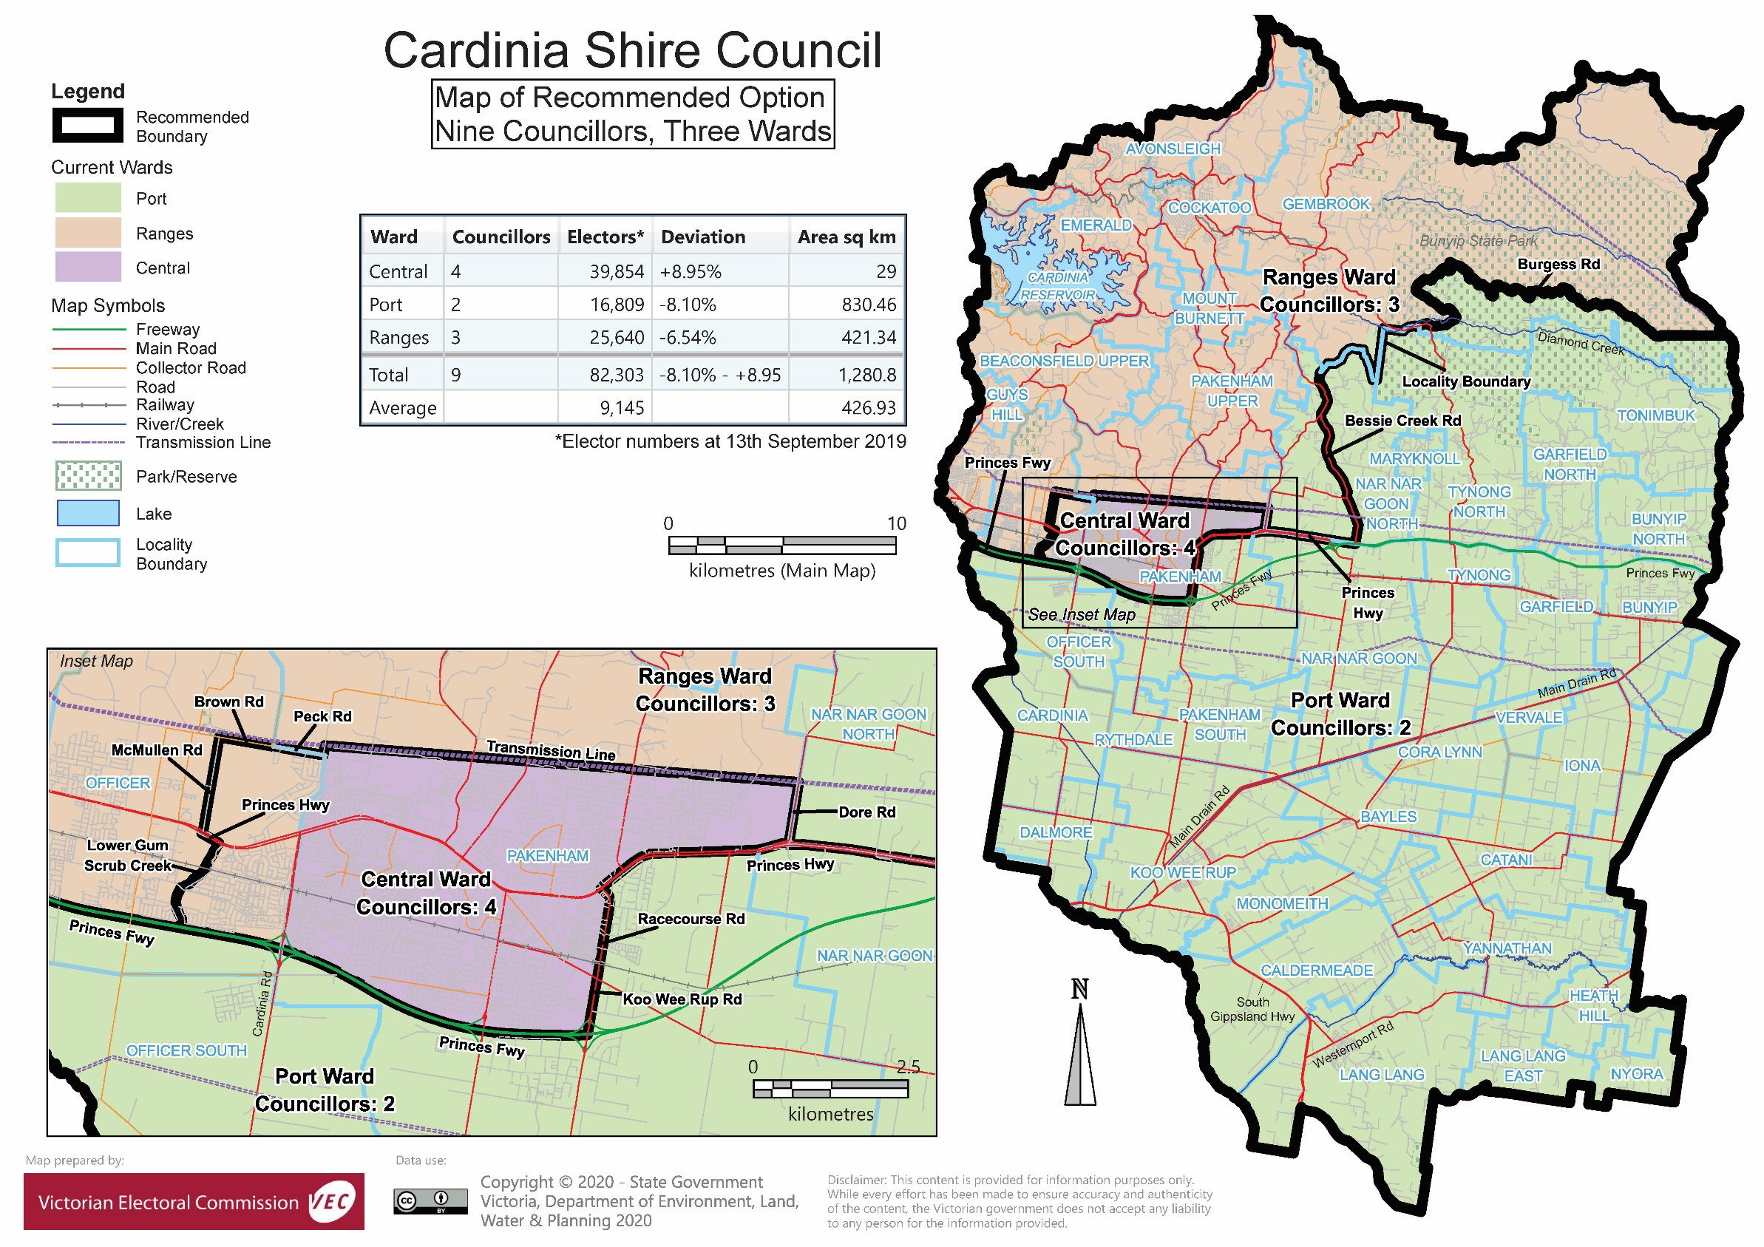

# Appendix 3: Public information program

Advertising

In accordance with the Act, public notices of the review and the release of the preliminary report were placed in the following newspapers:

|  |  |  |
| --- | --- | --- |
| **Newspaper** | **Notice of review** | **Notice of preliminary report** |
| *Herald Sun* | Wednesday 15 July | Wednesday 9 September |
| *Pakenham Gazette* | Wednesday 30 October | Wednesday 5 February |
| *Warragul Drouin Gazette* | Tuesday 29 October | Tuesday 4 February |

Media releases

A media release was prepared and distributed to local media to promote the commencement of the review on Thursday 24 October 2019. A further release was distributed with the publication of the preliminary report on Wednesday 5 February 2020. A final media advisory was circulated on the publication date of this final report.

Public information session

A public information session for people interested in the review process was held on Thursday 7 November 2019 in the Council Chamber, Civic Centre, 20 Siding Avenue, Officer.

Submissions guide

A submission guide was developed and made available on the VEC website, or in hardcopy on request, throughout the review timeline. The submission guide provided information about the review, the review timeline and how to make submissions to the review.

Online submission tool

An online submission tool was developed and made available during the submission periods of the review. The tool allowed people to make a submission from the VEC website. During the preliminary submission stage, users also had the opportunity to map out their preferred subdivisions through the online submission tool using Boundary Builder. Boundary Builder included real elector numbers so that users could see if their preferred structures and numbers of councillors met the plus-or-minus 10% rule.

VEC website

The VEC website delivered up-to-date information to provide transparency and facilitate public participation during the review process. All public submissions were published on the website.

Email and social media engagement

The VEC delivered an information email campaign targeted at known community groups and communities of interest in the local council area. This included a reminder email at each milestone of the representation review process.

The VEC also published sponsored social media advertising that was geo-targeted to users within the local council area. This included advertising at both the preliminary submission and response submission stages. The total reach of these posts was 5,532 during the preliminary submission stage and 6,858 during the response submission stage.

Council communication resources

The VEC provided the Council with a communication pack that included information on the review in various formats. While the council is encouraged to distribute this information and raise awareness about the review, the VEC is an independent reviewer and all communications resources include reference and links to the VEC website and core materials.

This page has been left intentionally blank

|  |
| --- |
| **© State of Victoria**  (Victorian Electoral Commission) **April 2020** |
| This work, Local Council Representation Review – Final Report Cardinia Shire Council 2019-20, is licensed under a Creative Commons Attribution 4.0 licence (http://creativecommons.org/ licenses/ by/4.0/). You are free to re-use the work under that licence, on the condition that you credit the State of Victoria (Victorian Electoral Commission) as author, indicate if changes were made and comply with the other licence terms. The licence does not apply to any branding, including government logos. |
|  | |
| Level 11, 530 Collins Street  Melbourne Victoria 3000  T 131 832  info@vec.vic.gov.au  vec.vic.gov.au | |
|  | |





1. Section 219D of the *Local Government Act* *1989.*
2. Section 219D of the *Local Government Act* *1989.*
3. Ibid.
4. .id is a consulting company specialising in population and demographic analysis and prediction information products in most jurisdictions in Australia and New Zealand.
5. Section 5B(1) of the *Local Government Act 1989.*
6. .id, ‘Cardinia Shire: about the profile areas’, accessed 4 March 2020, <https://profile.id.com.au/cardinia/about>.
7. .id, ‘Cardinia Shire: about the profile areas’.
8. The Department of Environment, Land, Water and Planning (DELWP) estimates that the Shire will grow by 66% from 2018-36, at an annual average rate of change of 2.9%. The population is expected to reach 177,870 by 2036. The consulting company .id, estimates a similar annual average rate of change from 2016-41 at 2.88%.
9. .id, ‘Cardinia Shire: about the profile areas’.
10. See for example, .id, ‘Population highlights: Koo Wee Rup’, accessed 4 March 2020, <https://profile.id.com.au/cardinia/highlights-2016?WebID=180>; .id. ‘Population highlights: Lang Lang’, accessed 4 March 2020, <https://profile.id.com.au/cardinia/highlights-2016?WebID=190>; .id, ‘Population highlights: Southern Rural’, accessed 4 March 2020, <https://profile.id.com.au/cardinia/highlights-2016?WebID=250>.
11. Know your council, ‘Cardinia Shire’, State Government of Victoria, accessed 4 March 2020, <http://knowyourcouncil.vic.gov.au/councils/cardinia>. See also, .id, ‘Cardinia Shire: industry sector of employment’, accessed 4 March 2020, <https://profile.id.com.au/cardinia/industries>.
12. Australian Asparagus Council (AAC), ‘About us: AAC’, accessed 4 March 2020, <https://www.asparagus.com.au/about-us/aac.php>.
13. .id, ‘Cardinia Shire: SEIFA by Local Government Area’, accessed 4 March 2020, <https://profile.id.com.au/cardinia/seifa-disadvantage?WebID=210>. The SEIFA is based on a range of characteristics derived from recent Census data such as, low income, low educational attainment and high unemployment. ABS, ‘Socio-Economic Indexes for Areas’, accessed 12 August 2019, <https://www.abs.gov.au/websitedbs/censushome.nsf/home/seifa>.
14. .id, ‘Cardinia Shire: SEIFA by profile area’, .id, accessed 4 March 2020, <https://profile.id.com.au/cardinia/seifa-disadvantage-small-area>.
15. Cardinia Shire Council, ‘Our Aboriginal community’, Cardinia Shire Council, accessed 4 March 2020, <https://www.cardinia.vic.gov.au/info/20007/your_shire_and_council/295/our_aboriginal_community>.
16. ABS, ‘2016 Census Quickstats: Cardinia (S)’, accessed 4 March 2020, <https://quickstats.censusdata.abs.gov.au/census_services/getproduct/census/2016/quickstat/LGA21450?opendocument>. ABS, ‘2016 Census Quicstats: Pakenham’, accessed 4 March 2020, <https://quickstats.censusdata.abs.gov.au/census_services/getproduct/census/2016/quickstat/SSC22015?opendocument>.
17. .id, ‘Pakenham Precinct: population highlights’, accessed 4 March 2020, <https://profile.id.com.au/cardinia/highlights-2016?WebID=240>. .id, ‘Officer Precinct: population highlights’, accessed 4 March 2020, <https://profile.id.com.au/cardinia/highlights-2016?WebID=220>.