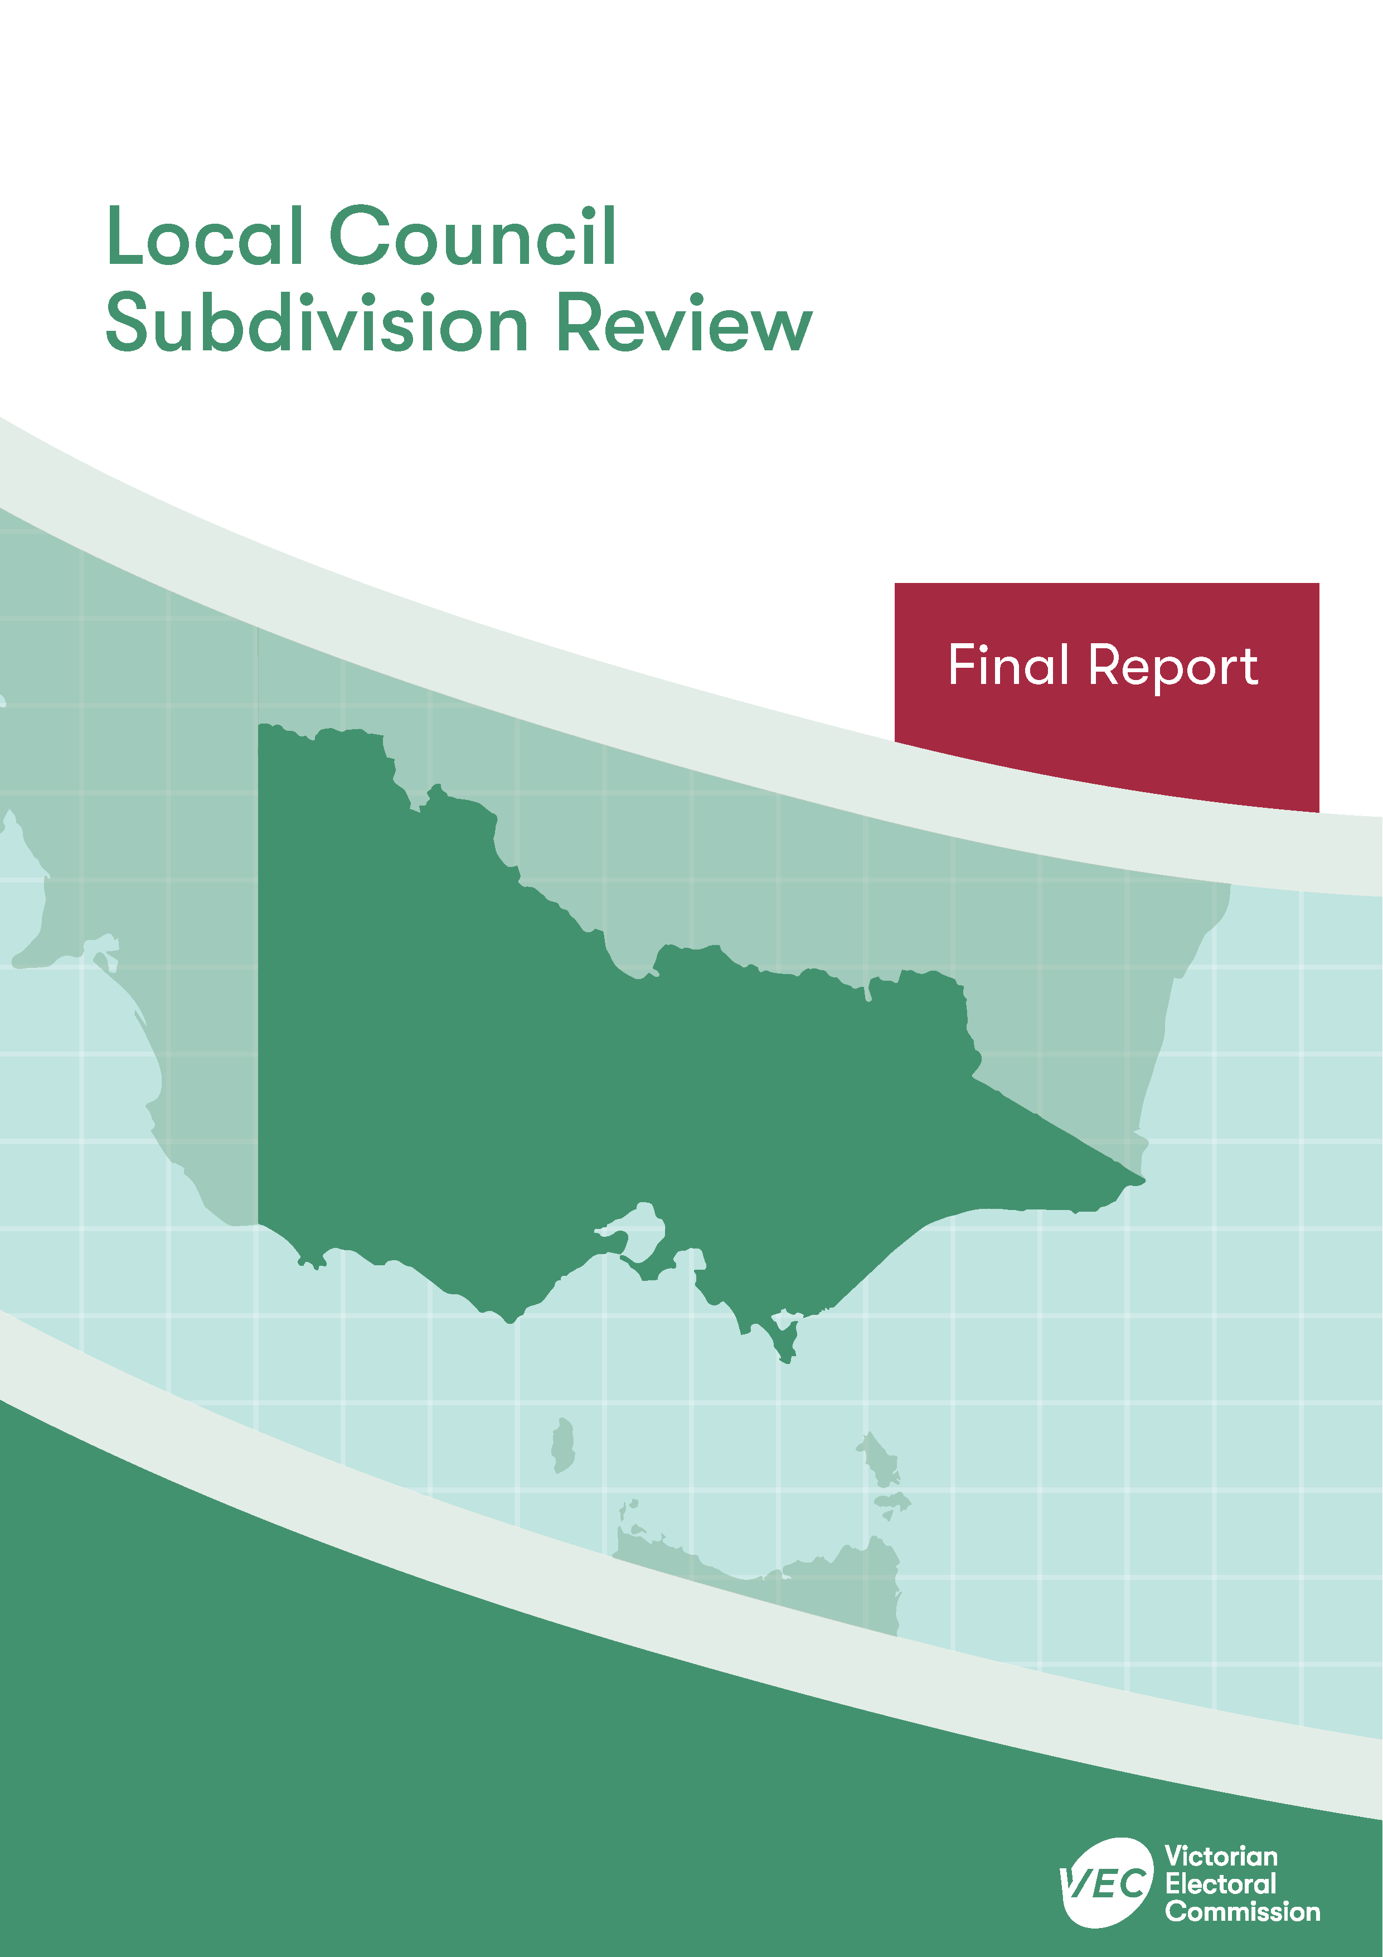



**Wyndham City Council**

**April 2020**

Contents

Recommendation 1

Executive summary 2

Background 4

Legislative basis 4

The VEC’s approach 5

Profile of Wyndham City Council 7

Population trends 8

Current number of councillors and electoral structure 9

Current subdivision review 11

Preliminary report 11

Public response 12

Response submissions 12

Public hearing 13

Findings and recommendation 14

The VEC’s findings 14

The VEC’s recommendation 16

Appendix 1: Public involvement 17

Appendix 2: Recommended ward boundaries map 18

Appendix 3: Public information program 20

Recommendation

The Victorian Electoral Commission recommends adjustments to the boundaries between Chaffey Ward and Harrison Ward within Wyndham City Council.

This recommendation is submitted to the Minister for Local Government as required by the *Local Government Act 1989*.

Please see Appendix 2 for a detailed map of the recommended ward boundaries.

Executive summary

The *Local Government Act 1989* (LG Act) requires the Victorian Electoral Commission (VEC) to conduct a subdivision review to ensure the equitable representation of all voters in a local council.[1] The LG Act prescribes that the number of voters per councillor in each ward must be within plus-or-minus 10% of the average number of voters per councillor across the local council. [2] This is known as the ‘equality requirement’.

As population changes affect voter numbers and distribution in subdivided local councils, one or more wards may be unlikely to meet this requirement at the next general election. In such circumstances, the VEC recommends adjustments to internal ward boundaries to ensure that all wards meet the equality requirement before the next election and ideally, until the next scheduled electoral representation review.

Current number of councillors and electoral structure

Wyndham City Council currently comprises 11 councillors elected from three wards   
(one three-councillor ward and two four-councillor wards). More information on Wyndham City Council is available on the VEC website at [vec.vic.gov.au](http://vec.vic.gov.au).

In 2018, the VEC notified the Minister for Local Government that one or more wards were unlikely to meet the equality requirement at the 2020 general election. Accordingly, the Minister notified the VEC that a subdivision review of Wyndham City Council was required before the 2020 general election.

Preliminary report

A preliminary report was released on Wednesday 12 February 2020 proposing adjustments to the boundary between Chaffey Ward and Harrison Ward within Wyndham City Council.

Response submissions

The VEC received three submissions responding to the preliminary report by the deadline of 5.00 pm on Wednesday 11 March 2020.

Public hearing

The VEC scheduled a public hearing for those wishing to speak about their response submission at 7.00 pm on Thursday 19 March 2020. There were no requests to speak so the hearing was not held.

Recommendation

The Victorian Electoral Commission recommends adjustments to the boundaries between Chaffey Ward and Harrison Ward within Wyndham City Council.

This recommendation is submitted to the Minister for Local Government as required by the *Local Government Act 1989*.

Please see Appendix 2 for a detailed map of the recommended ward boundaries.

Background

Legislative basis

The *Local Government Act 1989* (LG Act) requires the Victorian Electoral Commission (VEC) to conduct a subdivision review to ensure the equitable representation of all voters in a local council. The LG Act prescribes that the number of voters per councillor in each ward must be within plus-or-minus 10% of the average number of voters per councillor across the local council. [3] This is known as the ‘equality requirement’.

As population changes affect voter numbers and distribution in subdivided local councils, one or more wards may be unlikely to meet this requirement at the next general election. In such circumstances, the VEC recommends adjustments to internal ward boundaries to ensure that all wards meet the equality requirement before the next election and ideally, until the next scheduled electoral representation review.

Subdivision reviews only apply to subdivided councils:

* that are not scheduled for an electoral representation review before the next general election

and

* where, two years before the council is to hold a general election, the VEC considers one or more wards are unlikely to meet the equality requirement at the time of the next general election.

### Scope

A subdivision review only considers the location of ward boundaries. A subdivision review cannot consider changes to the number of councillors or wards.

These changes are considered in a council’s periodic electoral representation review. The next scheduled representation review for Wyndham City Council will be held before the 2024 general election. An earlier review may take place if required.

A subdivision review also cannot change the external boundaries of the local council, divide local councils, or amalgamate local councils. These changes can only be made by an Order in Council.

The VEC’s approach

### Public information program

The VEC conducted a public information program to inform the community of the subdivision review, including:

* a public notice printed in local papers
* a media release announcing the release of the preliminary report
* an information email campaign targeted at known community groups and communities of interest in the local council area
* sponsored social media advertising geo-targeted to users within the local council   
  area
* ongoing information updates and publication of submissions on the VEC website.

More information on the VEC’s public information program for the subdivision review of Wyndham City Council can be found at Appendix 3.

### Public consultation

Public input was encouraged by the VEC via response submissions to the preliminary report.

### Developing recommendations

The VEC bases its recommendations for ward boundaries on:

* internal research specifically relating to the local council under review, including voter statistics from the Victorian electoral roll
* small area forecasts provided by .id[4]
* the VEC’s expertise in mapping, demography and local government
* consideration of all input from the public in written submissions received during the review.

In determining which ward boundaries are most appropriate, the VEC considers the:

* number of voters in each ward, to ensure that each ward meets the equality requirement for the next election
* number of voters affected by the changes, with the aim of affecting as few voters as possible
* communities of interest
* significance of natural and man-made features (such as roads and waterways), to ensure clear and identifiable ward boundaries
* geographic factors, such as size and topography
* longevity of the structure.

### Communities of interest

Each local council contains a number of communities of interest. Where practicable, ward boundaries should be designed to ensure they are fairly represented, and that geographic communities of interest are not split. This allows communities with shared concerns to elect a councillor.

Wyndham City Council

Profile of Wyndham City Council

Wyndham City Council is located south-west of the Melbourne CBD, at the interface between metropolitan Melbourne and the surrounding rural area. The local council includes the localities of Cocoroc, Hoppers Crossing, Laverton North, Mambourin, Manor Lakes, Point Cook, Quandong, Tarneit, Werribee, Werribee South, Williams Landing and Wyndham Vale, as well as parts of Eynesbury, Laverton, Little River, Mount Cottrell and Truganina.

The City of Wyndham comprises both urban and rural areas. The Melbourne Urban Growth Boundary extends into the north-east and central areas of the local council. Within the Urban Growth Boundary, the local council is mostly residential with large areas of former agricultural land undergoing residential development. A significant industrial area is also present in Laverton North and Truganina, with smaller industrial areas in Hoppers Crossing and Werribee. The area outside the Urban Growth Boundary consists of parts of the Western Plains South Green Wedge and Werribee South Green Wedge. This area includes agricultural land, conservation areas, the Western Treatment Plant and the town of Little River. The City of Wyndham also includes Port Phillip Prison, RAAF Williams Base (Laverton and Point Cook), Werribee Park and Mansion, Werribee Open Range Zoo, and Werribee campuses of The University of Melbourne and Victoria University.

Compared to Greater Melbourne averages, socio-economic conditions within the City of Wyndham population are mixed. Some areas of the local council are experiencing lower than average levels of disadvantage compared to Greater Melbourne, but overall disadvantage across the City of Wyndham is higher than the Greater Melbourne average.[5] Although the weekly median household income ($1,620) and median personal income ($685) within Wyndham is higher than for Greater Melbourne ($1,542 and $673 respectively)[6], a number of factors contribute to higher disadvantage overall. A smaller proportion of the Wyndham population hold tertiary qualifications or earn a high income, while larger proportions of the population work in less skilled occupations or earn no income.[7] The unemployment rate within the City of Wyndham (8.2%) is also higher than average for Greater Melbourne (6.8%).[8]

The population has higher levels of cultural and linguistic diversity compared to Greater Melbourne and has become increasingly more diverse over time.[9] At least 41.5% of the population was born overseas and 44.6% speak a language other than English at home, compared to 33.8% and 34.9% respectively across Greater Melbourne. For those born overseas, the most common countries of birth are India (10.3%), New Zealand (3.6%), Philippines (2.6%), China (2.5%) and England (2.3%).[10]

Aboriginal and Torres Strait Islander people comprise 0.8% of the population, which is higher than the Greater Melbourne average of 0.5%.[11] The Wathaurung, Woiwurrung and Boonwurrung peoples of the Kulin Nation are the traditional custodians of the land known as Wyndham City Council.[12]

The median age within the local council (32 years) is lower than that of Greater Melbourne (36 years), and families are predominantly comprised of couples with children (56.5%).[13]

Population trends

At the time of the 2016 Census, the City of Wyndham had a population of 217,122[14], with most of the population residing within the Urban Growth Boundary.

Being an interface council, the City of Wyndham is experiencing high population growth. From 2011–2018, the population is estimated to have grown at an average of 6.4% per annum.[15] The population is expected to continue growing at an average rate of 3.3% per annum from 2018–2036, reaching 459,220 by 2036.[16] This rate of growth is significantly higher than the overall growth rate of 1.9% per annum expected for Greater Melbourne over the 2018–2036 period.[17]

The highest rates of population growth are expected in areas with new residential developments such as Manor Lakes, Wyndham Vale, Tarneit, Truganina and outer Werribee. In contrast, population decline is expected for the established suburb of Hoppers Crossing.[18]

There are currently an estimated 166,210 registered voters for Wyndham City Council, with an average of 15,110 voters per councillor.

Current number of councillors and electoral structure

Wyndham City Council currently comprises 11 councillors elected from three wards   
(one three-councillor ward and two four-councillor wards). Prior to the last representation review in 2012, Wyndham City Council was comprised of nine councillors elected from three three-councillor wards.

Diagram 1 (on the next page) illustrates the current electoral structure and voter statistics by ward as at 14 October 2019.

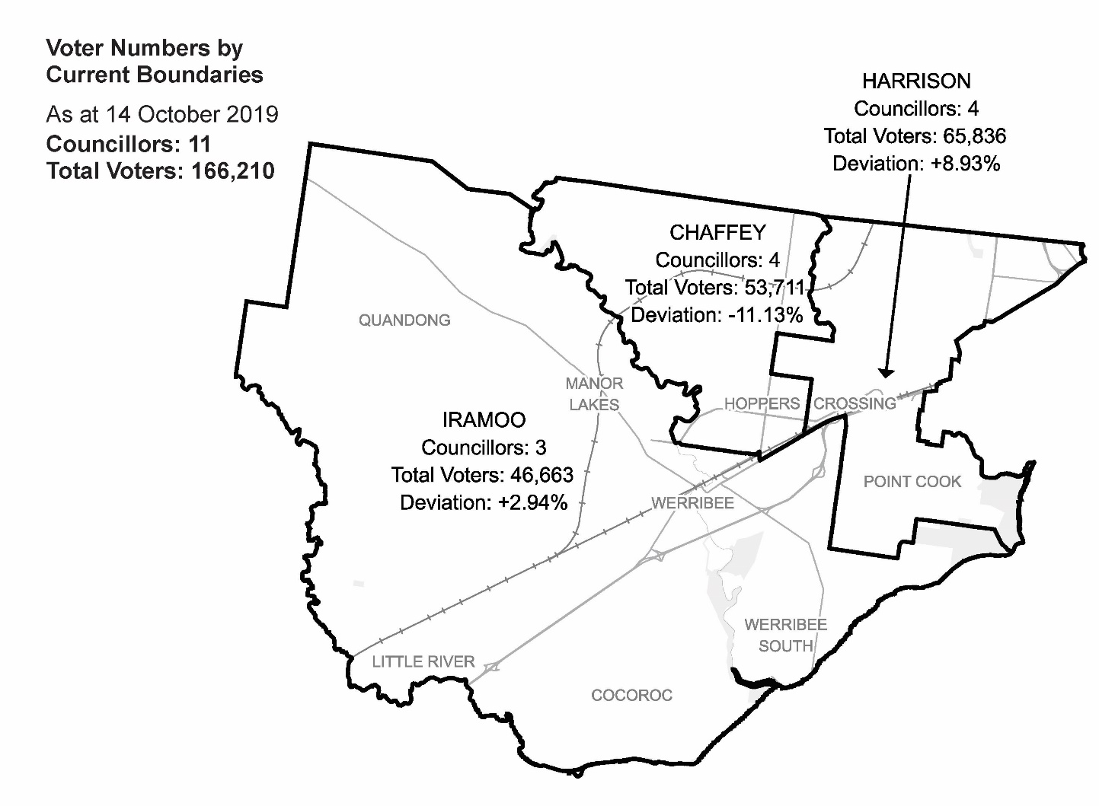  
Diagram 1: Wyndham City Council electoral structure and voter statistics

Current subdivision review

The current subdivision review of Wyndham City Council is required due to the voter‑to‑councillor ratio in Chaffey Ward being more than 10% below the average voter‑to-councillor ratio for the local council. Consequently, Chaffey Ward will need to be expanded so that its enrolment will be within the 10% tolerance at the 2020 general election.

Table 1 shows the number of voters in each ward as at 14 October 2019, with wards ranked by the percentage each deviates from the average number of voters per councillor for the whole local council.

|  |  |  |  |
| --- | --- | --- | --- |
| Table 1: Voter numbers per ward | | | |
| **Ward** | **Councillors** | **Voters** | **Deviation (%)** |
| Chaffey | 4 | 53,711 | -11.13 |
| Harrison | 4 | 65,836 | +8.93 |
| Iramoo | 3 | 46,663 | +2.94 |
| **Total for council** | **11** | **166,210** |  |

Preliminary report

The VEC’s subdivision review of Wyndham City Council commenced with the release of a preliminary report on Wednesday 12 February 2020. The report contained proposed ward boundary changes based on analysis of enrolment information and internal research.

The main aim of this subdivision review was to devise a ward boundary adjustment that would ensure that voter-to-councillor ratios for all wards were within the legislated plus‑or-minus 10% tolerance at the time of the 2020 local government elections. More substantial changes to ward boundaries or the electoral structure of Wyndham City Council may be considered at the next scheduled representation review, which is expected to occur prior to the 2024 local government elections.

In the preliminary report, the VEC proposed a minor adjustment to the ward boundary between Chaffey and Harrison Wards. This proposed adjustment would result in the area of Hoppers Crossing bounded by Sayers Road, Hogans Road, Derrimut Road and Morris Road becoming part of Chaffey Ward. The adjusted boundary between Chaffey and Harrison Wards would follow, from north to south: Skeleton Creek, Sayers Road, Morris Road and Old Geelong Road.

The proposed ward boundary change would impact 2,997 voters (1.8% of the total current enrolment) who are currently in Harrison Ward.

Table 2 details the number of voters in each ward as a result of the proposed boundary change.

|  |  |  |  |
| --- | --- | --- | --- |
| Table 2: Voter numbers per ward with proposed boundaries | | | |
| **Ward** | **Councillors** | **Voters** | **Deviation (%)** |
| Chaffey | 4 | 56,708 | -6.17 |
| Harrison | 4 | 62,839 | +3.97 |
| Iramoo | 3 | 46,663 | +2.94 |
| **Total for council** | **11** | **166,210** |  |

Public response

Response submissions

The VEC accepted submissions responding to the preliminary report from Wednesday 12 February 2020 until 5.00 pm on Wednesday 11 March 2020. The VEC received three response submissions. A list of people who made a response submission can be found in Appendix 1.

### Boundary adjustment (Point Cook)

In his submission, Paul Rogers of Werribee supported the VEC’s proposed ward boundary adjustment between Chaffey and Harrison Wards. Mr Rogers also proposed adjusting the boundary between Iramoo and Harrison Wards, which would affect an area of Point Cook in Iramoo Ward. As a result of the additional boundary adjustment, this area would be in Harrison Ward.

Mr Rogers explained that residents in this area of Point Cook between Hacketts Road and Princes Highway have ‘nothing in common’ with residents in Iramoo Ward. Instead, they share schools, shopping centres, public transport and sporting facilities with residents in Harrison Ward. Mr Rogers also argued that by reducing its voter numbers, this additional boundary adjustment would accommodate the more rapid population growth expected in Iramoo Ward up to the 2020 general council election.

### Out of scope submissions

The other two submissions dealt with wider-reaching changes to the electoral structure and were outside the scope of this review. The first of these submissions, from Tim Newhouse of Point Cook, supported changing the current multi-councillor ward structure to a single-councillor ward structure.

The second submission was from Wyndham City Council and focused on changes to the Local Government Act, which passed through the Victorian Parliament during the later stage of this review. The Council commented that it would write to the Victorian Minister of Local Government to clarify whether the Minister’s intention was to instruct the VEC to implement single-councillor wards for Wyndham City Council before the commencement of the 2020 local government elections.[19]

The VEC could not consider either of these submissions in this review because they did not respond to the terms of the subdivision reviews.

Public hearing

The VEC scheduled a public hearing for those wishing to speak about their response submission at 7.00 pm on Thursday 19 March 2020 in the Council Chamber, Civic Centre, Wyndham City, 45 Princes Highway, Werribee. There were no requests to speak so the hearing was not held.

Findings and recommendation

The VEC’s findings

The VEC maintains the view that its proposed boundary adjustment between Chaffey and Harrison Wards would provide a ward boundary that is simpler and easier to identify than the existing ward boundary. It would also unite a greater proportion of Hoppers Crossing within Chaffey Ward, which would improve the way the current electoral structure recognises communities of interest in the City of Wyndham.

In the final stage of the review, the VEC considered Mr Rogers’ additional proposed boundary adjustment between Iramoo and Harrison Wards. Mr Rogers presented some sound arguments for his proposed boundary adjustment, which would unite a small part of Point Cook between Hacketts Road and Princes Freeway with the rest of Point Cook in Harrison Ward. The VEC recognises that in recent years, this part of Point Cook close to the freeway has experienced residential growth, and that residents and voters in this area are likely to rely on services and facilities in the established areas of Point Cook, over the freeway. However, the VEC does not recommend the additional Iramoo-Harrison Ward boundary adjustment, for several reasons.

A subdivision review recommends boundary adjustments to wards that have increased or decreased outside of the legislated plus-or-minus 10% deviation, between scheduled electoral representation reviews. These reviews are often necessary for council areas where the population is changing rapidly. The VEC takes a ‘minimal change’ approach in its subdivision reviews. The VEC considers communities of interest and provides clear ward boundaries, where possible. However, the main aim of the subdivision review is to correct wards which no longer meet the legislated plus-or-minus 10% tolerance.

In this review, the VEC found that its proposed boundary adjustment alone would be enough to return Chaffey Ward to the accepted deviation. Mr Rogers’ additional boundary adjustment would do more to recognise communities of interest, particularly for voters in the area of Point Cook close to the freeway, but the VEC determined that this second boundary adjustment was not necessary to fulfil the requirement of the present subdivision review.

In its preliminary report, the VEC noted that it was logical to adjust the boundary between Chaffey and Harrison Wards. Since the 2012 electoral representation review, the number of voters within Harrison Ward (formerly known as Truganina Ward) has increased at a faster rate relative to Chaffey and Iramoo Wards, leading to the deviation of Chaffey Ward currently sitting at -11.13%. As a result, the boundary of Chaffey Ward must be adjusted to bring its deviation back within the legislated plus‑or‑minus 10% deviation. Given that the current deviation for Harrison Ward is +8.93%, it is logical to adjust the boundary between Chaffey and Harrison Wards to enable Chaffey Ward to absorb voters from Harrison Ward – which has the largest number of voters per councillor – in order to bring the deviations of both wards closer to the average.

The VEC found Mr Rogers’ additional boundary adjustment would indeed improve Iramoo Ward’s deviation from the average voter-to-councillor ratio but reasoned that it was unnecessary to make boundary changes that would affect Iramoo Ward. Iramoo Ward is currently well within the legislated deviation (at +2.94%), and, based on voter population projections data, the ward will remain comfortably within the legislated deviation for the October 2020 election. Moreover, including the area west of Hacketts Road in Harrison Ward would increase that ward’s deviation from the average to +6.89%. Under the VEC’s boundary adjustment, Harrison Ward’s deviation from the average would be +3.97%.

The VEC also considers its sole boundary adjustment to be preferable because it would affect fewer voters at 2,997 (or 1.8% of the total enrolment). In contrast, the additional proposed Iramoo‑Harrison Ward boundary adjustment would take the total number of voters affected by the boundary adjustments in this review to 4,763 voters (or 2.87% of the total enrolment). The VEC reasoned that this was a substantially larger number of voters who would be in different wards at the next general election. This would likely add to the disruption and potential confusion for voters in the areas affected by the changes.

The VEC further found that its Chaffey-Harrison Ward boundary adjustment would result in more balanced voter-to-councillor ratios for all wards, with less difference in deviations between the ward with the lowest voter-to-councillor ratio (Chaffey Ward) and the ward with the highest ratio (Harrison Ward). Including the proposed Iramoo‑Harrison Ward boundary adjustment would not improve the balance of voters per councillor across all wards. Instead, it would lead to a greater difference in deviations from the average voters per councillor across wards.

For these reasons, the VEC recommends its proposed ward boundary adjustment between Chaffey and Harrison Wards without any further amendments. Following its boundary adjustment, the VEC is confident that all wards would remain within the 10% tolerance for the October 2020 general election

The VEC’s recommendation

The Victorian Electoral Commission recommends adjustments to the boundaries between Chaffey Ward and Harrison Ward within Wyndham City Council.

This recommendation is submitted to the Minister for Local Government as required by the *Local Government Act 1989*.

Please see Appendix 2 for a detailed map of the recommended ward boundaries.

# Appendix 1: Public involvement

Response submissions

Response submissions were made by:

Newhouse, Tim

Rogers, Paul

Wyndham City Council

# Appendix 2: Recommended ward boundaries map

The map is provided on the next page.

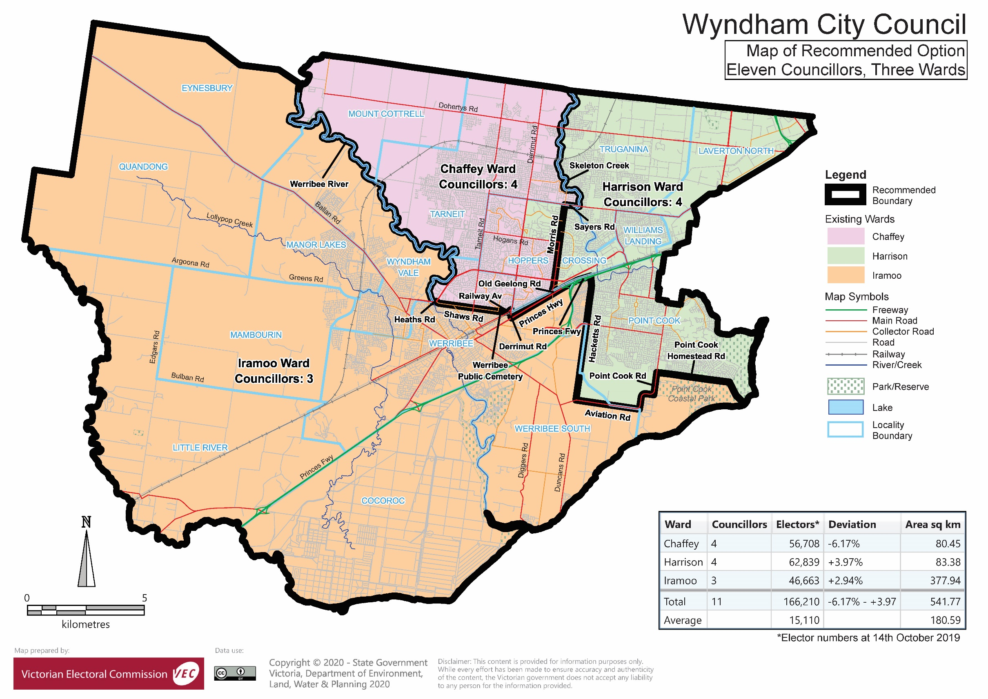

# Appendix 3: Public information program

Advertising

A public notice of the release of the preliminary report was placed in the *Wyndham Star Weekly* on Wednesday 12 February 2020.

Media releases

A media release was prepared and distributed to local media to promote the publication of the preliminary report on Wednesday 12 February 2020. A final media advisory was circulated on the publication date of this final report.

VEC website

The VEC website delivered up-to-date information to provide transparency and facilitate public participation during the review process. All public submissions were published on the website.

### Online submission tool

An online submission tool was developed and made available during the submission period of the review. The tool allowed people to make a submission from the VEC website.

Email and social media engagement

The VEC delivered an information email campaign targeted at known community groups and communities of interest in the local council area. This included a reminder email at each milestone of the subdivision review process.

The VEC also published sponsored social media advertising that was geo-targeted to users within the local council area. The total reach of these posts was 11,916.

Council communication resources

The VEC provided the Council with a communication pack that included information on the review in various formats. While the council is encouraged to distribute this information and raise awareness about the review, the VEC is an independent reviewer and all communications resources include reference and links to the VEC website and core materials.

This page has been left intentionally blank

|  |
| --- |
| **© State of Victoria**  (Victorian Electoral Commission) **April 2020** |
| This work, Local Council Subdivision Review – Final Report Wyndham City Council 2020, is licensed under a Creative Commons Attribution 4.0 licence (http://creativecommons.org/ licenses/ by/4.0/). You are free to re-use the work under that licence, on the condition that you credit the State of Victoria (Victorian Electoral Commission) as author, indicate if changes were made and comply with the other licence terms. The licence does not apply to any branding, including government logos. |
|  | |
| Level 11, 530 Collins Street  Melbourne Victoria 3000  T 131 832  info@vec.vic.gov.au  vec.vic.gov.au | |
|  | |



1. Section 219H of the *Local Government Act* *1989.*
2. Section 219L of the *Local Government Act* *1989.*
3. Section 219L of the *Local Government Act* *1989.*
4. .id is a consulting company specialising in population and demographic analysis and prediction information products in most jurisdictions in Australia and New Zealand.
5. .id, ‘City of Wyndham: SEIFA by profile area’, <https://profile.id.com.au/wyndham/seifa-disadvantage-small-area>, accessed 26 March 2020.
6. Australian Bureau of Statistics, ‘2016 Census QuickStats: Wyndham (C)’, <https://quickstats.censusdata.abs.gov.au/census_services/getproduct/census/2016/quickstat/LGA27260?opendocument>, accessed 26 March 2020. See also: ‘2016 Census QuickStats: Greater Melbourne’.
7. Australian Bureau of Statistics, ‘Data by Region: Wyndham (C)(LGA)’, <https://itt.abs.gov.au/itt/r.jsp?RegionSummary&region=27260&dataset=ABS_REGIONAL_LGA2018&geoconcept=LGA_2018&maplayerid=LGA2018&measure=MEASURE&datasetASGS=ABS_REGIONAL_ASGS2016&datasetLGA=ABS_REGIONAL_LGA2018&regionLGA=LGA_2018&regionASGS=ASGS_2016>, accessed 26 March 2020. See also: ‘Data by Region: Greater Melbourne’.
8. Australian Bureau of Statistics, ‘2016 Census QuickStats: Wyndham (C)’, loc. cit.   
   See also: ‘2016 Census QuickStats: Greater Melbourne’.
9. .id, ‘City of Wyndham, population highlights’, <https://profile.id.com.au/wyndham/highlights-2016>, accessed 26 March 2020.
10. Australian Bureau of Statistics, ‘2016 Census QuickStats: Wyndham (C)’, loc. cit.
11. Ibid.
12. Wyndham City Council, ‘Acknowledgement of Traditional Custodians’, <https://www.wyndham.vic.gov.au/acknowledgement-traditional-custodians>, accessed 26 March 2020.
13. Australian Bureau of Statistics, ‘2016 Census QuickStats: Wyndham (C)’, loc. cit.
14. Ibid.
15. .id, ‘City of Wyndham: Estimated Resident Population (ERP)’, <https://profile.id.com.au/wyndham/population-estimate>, accessed 26 March 2020.
16. Department of Environment, Land, Water and Planning, ‘Victoria in Future 2019’, <https://www.planning.vic.gov.au/land-use-and-population-research/victoria-in-future>, accessed 26 March 2020.
17. Calculated from the VIF2019 Major Regions 2056 Data Table accompanying:   
    Department of Environment, Land, Water and Planning, ‘Victoria in Future 2019’, loc. cit.
18. .id, ‘City of Wyndham, population and age structure map’, <https://forecast.id.com.au/wyndham/population-age-structure-map>, accessed 26 March 2020.
19. For more on the *Local Government Act 2020*, which passed the Victorian Parliament on 17 March 2020, see: Department of Environment, Land, Water and Planning (DELWP), Local Government Victoria, ‘Local Government Act 2020’, accessed 24 March 2020, <https://www.localgovernment.vic.gov.au/our-programs/local-government-act-2020>. The VEC notes that the new legislation does not impact the subdivision reviews.