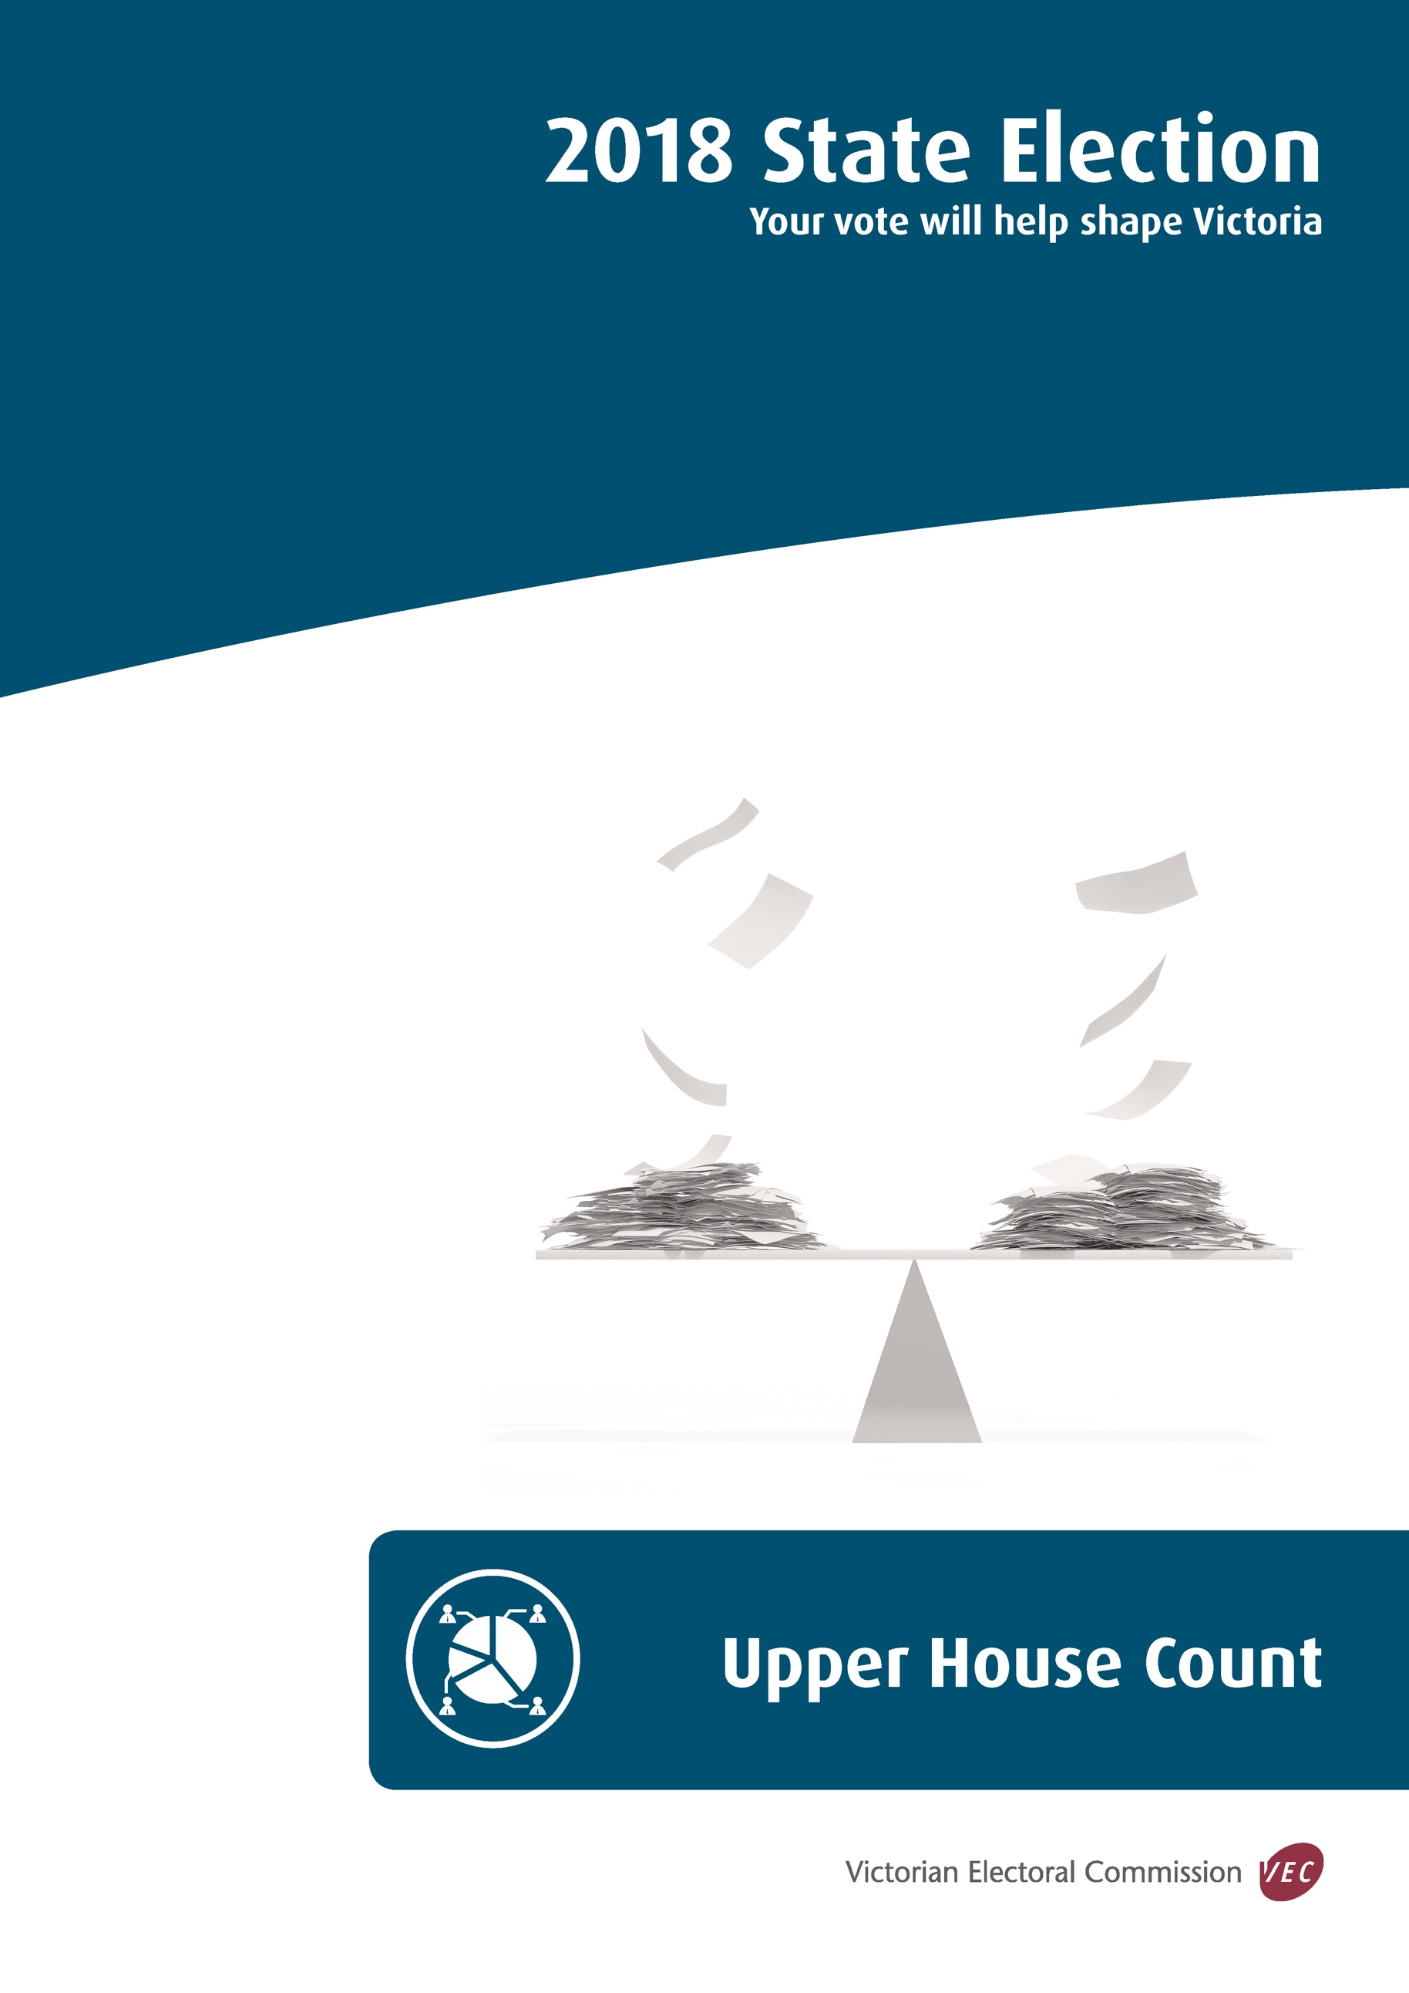

State of Victoria (Victorian Electoral Commission)
October 2018
Version 1.0

This work, Upper House Count, is licensed under a Creative Commons Attribution 4.0 licence [http://creativecommons.org/licenses/by/4.0/]. You are free to share this work under that licence, on the condition that you do not change any content and you credit the State of Victoria (Victorian Electoral Commission) as author and comply with the other licence terms. The licence does not apply to any branding, including Government logos.
Contents
Introduction 1
Count overview 3
Vote types 5
Scrutineers 6
Detailed count process 7
Voting centres – election night 7
District election offices primary counts 7
Postal vote count centre (PVCC) – primary counts 8
Region rechecks 8
Computer count process 9
Recounts 13
Declaration of result 14
Appendix 1: Formality of ballot papers 15
Damaged ballot papers 24
Appendix 2: Upper house count timetable 25

Introduction
There are 40 members of the Victorian Legislative Council (Upper House) with five members representing each electoral region. Optional preferential voting applies for the Upper House and electors may either vote for a single group above-the-line, or vote for at least five candidates below-the-line. A guide to ballot paper formality for the Upper House in included in Appendix 3.
The VEC will establish 1,795 voting centres across Victoria to facilitate voting on election day and will establish approximately 150 early voting centres within Victoria, at interstate venues and at overseas locations.
The VEC will provide mobile voting services at approximately 1,100 venues in the two weeks before election day to enable those in aged care facilities, hospitals, homeless agencies and prisons the opportunity to vote.
Accordingly, votes for one District could come from up to 3,000 voting locations across Victoria, from interstate and overseas.
In addition, the VEC is expecting to process in excess of 350,000 postal vote applications from electors. Completed postal votes are returned to a central location and marked as returned through the election management system (EMS).
The Victorian Electoral Commission (VEC) has established 88 election offices for the conduct of the 2018 State election. Election managers responsible for these offices will manage one of the 88 District elections and will be responsible for issuing ballot papers for the eight regions.
Two region election managers have been appointed to oversee the conduct of the eight region elections. Thirty five region recheck centres will be established for the conduct of rechecks for the eight regions. Above-the-line and informal ballot papers will be fully rechecked, below-the-line will not be rechecked at this time, instead will be data entered twice at the count centre.
Three region coordinators have been appointed to oversee the recheck of region ballot papers for each of the three country regions (Eastern Victoria, Northern Victoria and Western Victoria). Rechecks for these regions will take place at each District election office within the region.
Two region coordinators will be responsible for overseeing rechecks for the five metropolitan regions (Eastern Metropolitan, Northern Metropolitan, Southern Metropolitan, South-Eastern Metropolitan and Western Metropolitan) at the centralised rechecking centre at the Showgrounds at Ascot Vale.
Centralised counting centres will be established for the conduct of the Upper House proportional representation count. For the three country regions, computer counts will take place at Ballarat, Shepparton and Warragul. Computer counts for metropolitan regions will take place at the Showgrounds.
Only below-the-line ballot papers will be transported to the count centre for data entry for country regions. The above-the-line and informal ballot papers will remain at District election offices.
Below-the-line ballot papers will be double keyed before entry of the above-the-line and informal vote totals.
The VEC computer count application to support the counting and calculation of election results has been used at State and local government elections since 1999.
Section 115 of the Electoral Act 2002 allows for the counting of votes electronically. The count application used by the VEC and the procedures for the computer count has been developed in accordance with the provisions within the legislation.
An independent auditor has certified the VEC’s computer count application, and the audit confirms that the system conforms to legislative requirements.
This document outlines the process that the VEC will follow in conducting the Upper House count at the 2018 Victorian State election.

Count overview
After the close of voting at 6.00 pm on election day, ordinary votes issued in election day voting centres will be counted in voting centres. The primary (first preference) and two-candidate-preferred (2CP) counts for the Lower House will take place first followed by the primary count for the Upper House.
Counting of postal votes for Districts only will commence at 6.00 pm on election night at the centralised Postal Vote Count Centre (PVCC). No counting of region postal ballot papers will take place on election night. Region ballot papers for postal votes in the hands of the PVCC at close of voting on Friday 23 November will be counted commencing the Sunday after election night and be finalised on Monday 26 November.
Remaining postal votes will continue to be counted at the PVCC from Monday 26 November.
During the week following election day the PVCC will also be responsible for counting postal and early votes cast at interstate and overseas early voting centres, and early votes cast using Telephone Assisted Voting (TAV).
Counting of early votes will commence in election offices and some standalone early voting centres on election night, Saturday 24 November. Only District ballot papers will be counted at this time. Counting of early vote region ballot papers will commence from Monday 26 November, and will continue until all early votes received have been counted. Absent votes will be counted following the completion of the declaration exchange from Tuesday after election day, once these votes are returned to the relevant District office.
Counting of accepted provisional votes will take place during the week following election day.
As a summary, primary region counts will take place in voting centres, district election offices and the PVCC. Upper House ballot papers for metropolitan regions, will then be securely transported to region recheck centres at the Showgrounds where a manual recheck of primary counts, formality and sorting (above-the-line and informal ballot papers only) will take place. Rechecks for country regions will take place at district election offices within each region.
The table below provides an overview of the counts to be conducted for the region and the location of each count. Appendix 1 outlines the proposed timetable for the Upper House count.
Count type | Location
Primary counts | Voting centres  District election offices  Postal Vote Count Centre (PVCC) at Showgrounds
Rechecks –Upper House above-the-line and informal ballot papers | District election offices (country regions)
Rechecks – all Upper House above-the-line and informal ballot papers | Region recheck centres at Showgrounds (metropolitan regions)
Data entry – all below-the-line Upper House ballot papers | Count centres at Showgrounds, Ballarat, Shepparton and Warragul

Vote types
Ordinary | A vote issued to an elector who attends an election day voting centre in the District for which they are enrolled.
Absent | A vote issued to an elector who attends a voting centre outside their enrolled District on election day (s 109 EA)
Marked-as-voted | A vote issued to an elector who is found to be marked off the roll as having voted but declares they have not voted in the election (s 110 EA)
Early | A vote cast at an early or mobile voting centre before election day by an elector who is unable to attend a voting centre on election day (s 99 EA)
Postal | A vote cast by an elector who is unable to attend a voting centre on election day, and who has successfully applied for postal ballot paper(s)  (s 101 EA)
Provisional | A vote cast by a person who cannot be found on the roll but declares they are eligible to enrol and provides prescribed proof of identity (s 108 EA)
EA – Electoral Act 2002

Scrutineers
Candidates may appoint scrutineers to observe all counting processes in voting centres, at election offices and at central counting locations. Scrutineers must submit to the person in charge at the counting venue a completed Appointment of Scrutineer form which has been signed by the candidate.
Each form must contain the candidate’s original signature; electronic signatures will not be accepted. The Election Manager or person in charge of central count venues can provide candidates with copies of these forms, or alternatively, they can be downloaded from the VEC website at vec.vic.gov.au.
Candidates may appoint one scrutineer for every election official involved in the counting or rechecking of ballot papers. Candidates will be advised of counting times and the number of election officials expected to be involved in the count.
The VEC has published a handbook for scrutineers which outlines their role and responsibilities. Election Managers and centralised count venues will have copies of the handbook and they will be available at vec.vic.gov.au.

Detailed count process

Voting centres – election night
After the close of voting at 6.00 pm on election day, ordinary votes issued in election day voting centres will be counted in voting centres. The primary (first preference) and two-candidate-preferred (2CP) counts for the Lower House will take place first followed by the primary count for the Upper House. Region ballot papers will be sorted as follows:
- formal ballot papers marked above-the-line will be sorted by group according to the elector’s preferred group;
- formal ballot papers marked below-the-line will be sorted according to the group the elector’s first preferred candidate belongs to; and
- informal (Appendix 1 includes a guide to formality for Upper House elections)
Voting Centre Managers will phone results through to election offices where they will be entered into the VEC’s computerised election management system (EMS).
Voting Centre Managers will package all Upper House ballot papers in separate above-the-line, below-the-line and informal parcels and return them to their district election office on election night.
For metropolitan regions, these parcels will then be boxed and dispatched, without opening, to the region recheck centre from Monday 26 November. Voting centre parcels for country regions will remain at the district election office for rechecking.

District election offices primary counts
All first preference counting of early, absent, marked-as-voted and provisional votes for the Upper House will take place in district election offices.
Counting of early votes will commence in election offices and some standalone early voting centres on election night, Saturday 24 November. However only district ballot papers will be counted at this time. Counting of region early vote ballot papers will commence from Monday 26 November, and will continue until all early votes received have been counted.
Absent votes will be counted following the completion of the declaration exchange from the Tuesday after election day, once these votes are returned to the relevant district office. Marked-as-voted votes will also be counted at this time.
Region ballot papers from accepted Provisional votes will be counted from Tuesday 27 November.

Postal vote count centre (PVCC) – primary counts
Primary counting of region postal vote ballot papers in the hands of the PVCC at close of business on Friday 23 November will be counted commencing the Sunday after election night and finalised on Monday 26 November.
Remaining postal votes will continue to be counted at the PVCC from Monday 26 November.

Region rechecks
The recheck of Upper House ballot papers for metropolitan regions, will take place at the region recheck centres established at the Showgrounds. A manual recheck of primary counts, formality and sorting (above-the-line and informal ballot papers only) will take place. Rechecks for country regions will take place at district election offices within each region.
The recheck of Upper House ballot papers will commence at metropolitan region recheck centres commencing Monday 26 November, and for country regions from Tuesday 27 November. Region ballot papers will remain in their original vote parcel (i.e. voting centre/vote type) throughout the process.
Parcels will not be amalgamated – they will remain labelled with the voting centre/vote type they originated from throughout the rechecking process.
Teams of election officials will work systematically, one parcel at a time, and will check correct sorting and counting of Upper House ballot papers. Rechecked results will be recorded in EMS.
As rechecks are completed for each parcel, ballot papers marked below-the-line will be packaged and labelled in preparation for dispatch to the relevant count centre for data entry.

Computer count process
The VEC will conduct centralised counting of Upper House ballot papers. For the five metropolitan regions (Eastern Metropolitan, Northern Metropolitan, Southern Metropolitan, South-Eastern Metropolitan and Western Metropolitan) this will be at the Showgrounds, Ascot Vale – the same location where rechecking of Upper House ballot papers will take place. The location of the count within the Showgrounds will be clearly signposted on site.
For the three country regions, computer counts will take place at Ballarat, Shepparton and Warragul.
Prior to count
VEC – The VEC arranges the booking and resourcing of the central count venues. Resources include establishing the number of computers to be used for the data entry of ballot papers.
Count Team – The computer count team is appointed by the VEC. Data entry operators (DEOs), usually sourced from agencies, will satisfy strict competency standards and complete a disclosure of political activities before their appointment is finalised. The DEOs receive orientation training from the Team Leader responsible for the data entry immediately prior to commencing their operations. A number of election casuals will also be appointed to assist with the management of ballot papers during the count.
Site of count – IT support staff establish data entry and supervisor terminals for the count. The count centre Team Leaders prepare the venue for data entry and conduct tests of the computer count application on all terminals prior to the count commencing.
Election Managers – Two region Election Managers have been appointed by the VEC to manage the eight regions. They will be required to review Upper House ballot papers challenged at the central count centre in relation to their formality.
Region Recheck Leaders (country regions) – Rechecked ballot papers marked below-the-line are packaged, sealed in security boxes at each district election office and forwarded to the central count centre for the region. All boxes are security sealed, security seal numbers are recorded and a copy kept by each Region Recheck Lead.
Region Recheck Leaders (metropolitan regions) – Rechecked ballot papers marked below-the-line will be transferred to the computer count area adjacent to the recheck area at the Showgrounds. Specific computerised counting locations have been established for each of the five metropolitan regions within the Showgrounds – this will be clearly defined for scrutineers.
During data entry
- As below-the-line ballot papers arrive at the central count centre after being rechecked, the voting centre/vote type parcels are reconciled. Any discrepancies are resolved before proceeding further through the count.
- The number of below-the-line ballot papers received are confirmed for each voting centre/vote type.
- Working parcel by parcel, batches are created within the VEC’s computer count application and batch cover sheets generated from the system are attached to ballot paper bundles.
Batches of ballot papers are allocated to data entry operators for the first round entry of preferences from each below-the-line ballot paper into the computer count application.
The computer count application tests for the formality of each ballot paper during data entry. Informal ballot papers that are identified are not saved to the database. Only preferences contained on formal ballot papers are saved in the application.
At the completion of each batch, data entry operators record on each batch cover slip:
- the total ballot papers in the batch;
- the number of formal ballot papers saved; and
- the number of informal ballot papers identified during data entry.
Completed batches are reconciled against the information stored in the computer and discrepancies resolved where necessary. Informal ballot papers identified during data entry are removed for manual checking. Prior to removal they are marked on the reverse as to which parcel the ballot paper belongs to in case on checking, the ballot paper is deemed formal and needs to be returned to the batch. This ensures all ballot papers remain within their voting centre/vote type parcel.
Informal ballot paper checking takes place progressively during the count. Scrutineers are able to observe this process. Ballot papers determined to be formal during this check are passed back to data entry. Ballot papers confirmed as informal are set aside until all formal ballot paper entry has been completed.
Once all below-the-line ballot papers have been entered into the system and reconciled, the second round data entry of ballot papers commences.
Batches of ballot papers are redistributed to data entry operators. Batches will not be distributed to the same operator who data entered that batch during the first round of data entry.
The computer count application identifies ballot paper preferences at second entry that differ from first entry and alerts the data entry operator. In each instance, the data entry operator must confirm or correct their data entry and save it to the system.
All other procedures during second round data entry are the same as for the first round.
Once all formal below-the-line ballot papers have been data entered and reconciled, entry of above-the-line ticket votes commences. Above-the-line ballot papers identified during data entry are recorded against the relevant group and voting centre/vote type and added to the number of above-the-line ballot papers for each above-the-line each group held at each region recheck centre by voting centre/vote type.
Above-the-line ticket batches are created in the computer count application for each voting centre/vote type following the guidelines prescribed in legislation. Ticket batches will be created for each above-the-line group as follows:
- above-the-line ticket batch sizes will be determined depending on the number of above-the line votes per group and the number of tickets registered;
- ticket batches will be created in the EMS as per the batch sizes determined above.
Above-the-line ticket batches are saved to the computer application. Each above-the-line ticket batch can be reported on to confirm the preferences entered and the number of ballot papers saved against the preferences.
At the completion of batch creation for all above-the-line votes, reconciliation of formal ballot papers takes place.
Once reconciliation is confirmed, informal ballot paper totals for each voting centre/vote type are included into the computer count application. An individual informal batch will be created for each voting centre/vote type.
Calculation of result
Validation of data entry within the computer count application takes place to ensure that all expected batches have been entered and that the totals reconcile before the result can be calculated.
The calculation of results take place after all regions have been data entered and data entry verified and validated.
Results are calculated using the proportional representation count method as required by legislation. Under this counting method, a candidate must achieve a ‘quota’ in order to be elected. The quota is proportional to the number of vacancies to be filled. For the Upper House, with five vacancies in each region, the quota required to be elected for a region is 16.7% of the formal vote.
All results calculation will take place at the Showgrounds at Ascot Vale. The calculation of the result will be projected onto a screen at the count centre and observers are able to watch the computer calculation occur.
Scrutineers and transparency
Each candidate can be represented by one scrutineer for every election official involved in the count and scrutineers are able to observe all aspects of the computer count process.
During data entry at each count centre, the Team Leader will generate and display hard copy reports for scrutineers, showing the progressive first preference results for each candidate. This report can also be made available to scrutineers at other times on request.
Scrutineers may also request that a particular batch or batch range be scrutinised further. This may be done using a computer terminal or a report can be generated that shows the preferences recorded for each ballot paper for a defined batch or batch range. This allows scrutineers to verify the accuracy of data entry by comparing the preferences shown on each ballot paper in a batch against the preferences recorded for the corresponding batch on the computer.
During data entry, scrutineers may also challenge the validity of individual ballot papers by noting the batch and ballot paper number. These are extracted from completed batches and referred to the Election Manager in charge for a ruling.

Recounts
Following the calculation of the result, but before a candidate has been declared elected, a recount may be conducted at the Election Manager’s discretion, at the request of a candidate, or if directed by the VEC.
The VEC aims to achieve an accuracy of 99.98% via its counting and rechecking processes and has a proven track record of achieving at least this. Accordingly as a general guide, a recount will only take place if the margin at a critical exclusion is less than 0.05% of total votes counted.
A document detailing recount procedures will be made available as a separate publication.

Declaration of result
The VEC is required to publicly declare the result of each election and to announce the names of the elected candidates. Region results cannot be declared until the completion of computer count and calculation of the result.
Candidates will be advised by the VEC as to the time and place of the declaration.
It is expected that Upper House declaration ceremonies will take place from Tuesday 11 December 2018.

Appendix 1: Formality of ballot papers
A Region vote can be made in one of two ways:
- by showing a preference in one of the squares above-the-line on the ballot paper;
- by showing a number 1 and continuing preferences up to at least 5 opposite candidates’ names below-the-line on the ballot paper.
Formality above-the-line
Ballot papers are formal if:
- the number one appears by itself in a single square;
- a single tick, cross, or mark (of any kind) or “yes” (or similar) appears in a single square and the voter’s intention is clear;
- more than one preference, commencing with the number 1, appears (the preferences after number 1 are ignored);
- more than one preference appears, but one is the number 1 and any other marks are crossed out as mistaken attempts to mark a preference;
- The number one, a tick, cross, mark, or more than one preference must be placed above-the-line for the ballot paper to be formal as an above-the-line ballot paper.
Formality below-the-line
Ballot papers are formal if at least the numbers 1 to 5 appear in sequential order.
Alterations made to numbers or numbers placed outside the boxes do not make a ballot paper informal, providing the elector’s intention is clear.
Informality above-the-line
Ballot papers marked only above-the-line are informal if:
- the number 1 appears more than once;
- the number 1 and a tick appear in different boxes;
- the number 1 and a cross appear in different boxes;
- a tick and a cross appear in different boxes;
- a tick or a cross and a mark appear in different boxes;
- a tick appears more than once in different boxes;
- a cross appears more than once in different boxes;
- a mark appears more than once in different boxes;
- a single number other than the number 1 appears above-the-line (elector’s intention unclear);
- the elector’s intention to record a single preference above-the-line is not clear.
Informality below-the-line
Ballot papers marked only below-the-line are informal if:
- the number 1 does not appear against any candidate’s name (a tick or a cross is not acceptable as an indicator of preference below-the-line on a Region ballot paper);
- any of the numbers 1 to 5 are repeated against two or more candidates’ names;
- any of the numbers between 1 and 5 are missing.
As long as the numbers 1 to 5 are sequential, mistakes in numbering outside this range do not make the ballot paper informal
Ballot papers marked both above- and below-the-line
Where an elector has marked both above and below-the-line, the ballot paper is treated as follows:
- when both above and below are formal, below-the-line is used for counting;
- when only one part is formal, the formal part is used for counting;
- when both above and below are informal, the ballot paper is informal.
Other Region formality rules
Other general formality rules are:
- amendments are acceptable providing the elector’s intention is clear;
- poorly formed numbers must be considered in the context of the whole ballot paper and are acceptable if they can reasonably be construed as numbers comprising part of the sequence;
- unconventional but recognisable numbers such as continental 1s and 7s are acceptable. Roman numerals are also acceptable if all numbers are clearly represented in this format. Other ‘non-English’ characters are not acceptable. Numbers may be written one, two, etc., but only in English;
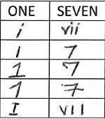
- a ballot paper that has not been initialled by an election official is not excluded for that reason alone provided it is printed on VEC official security paper.
Examples of recognisable numbering
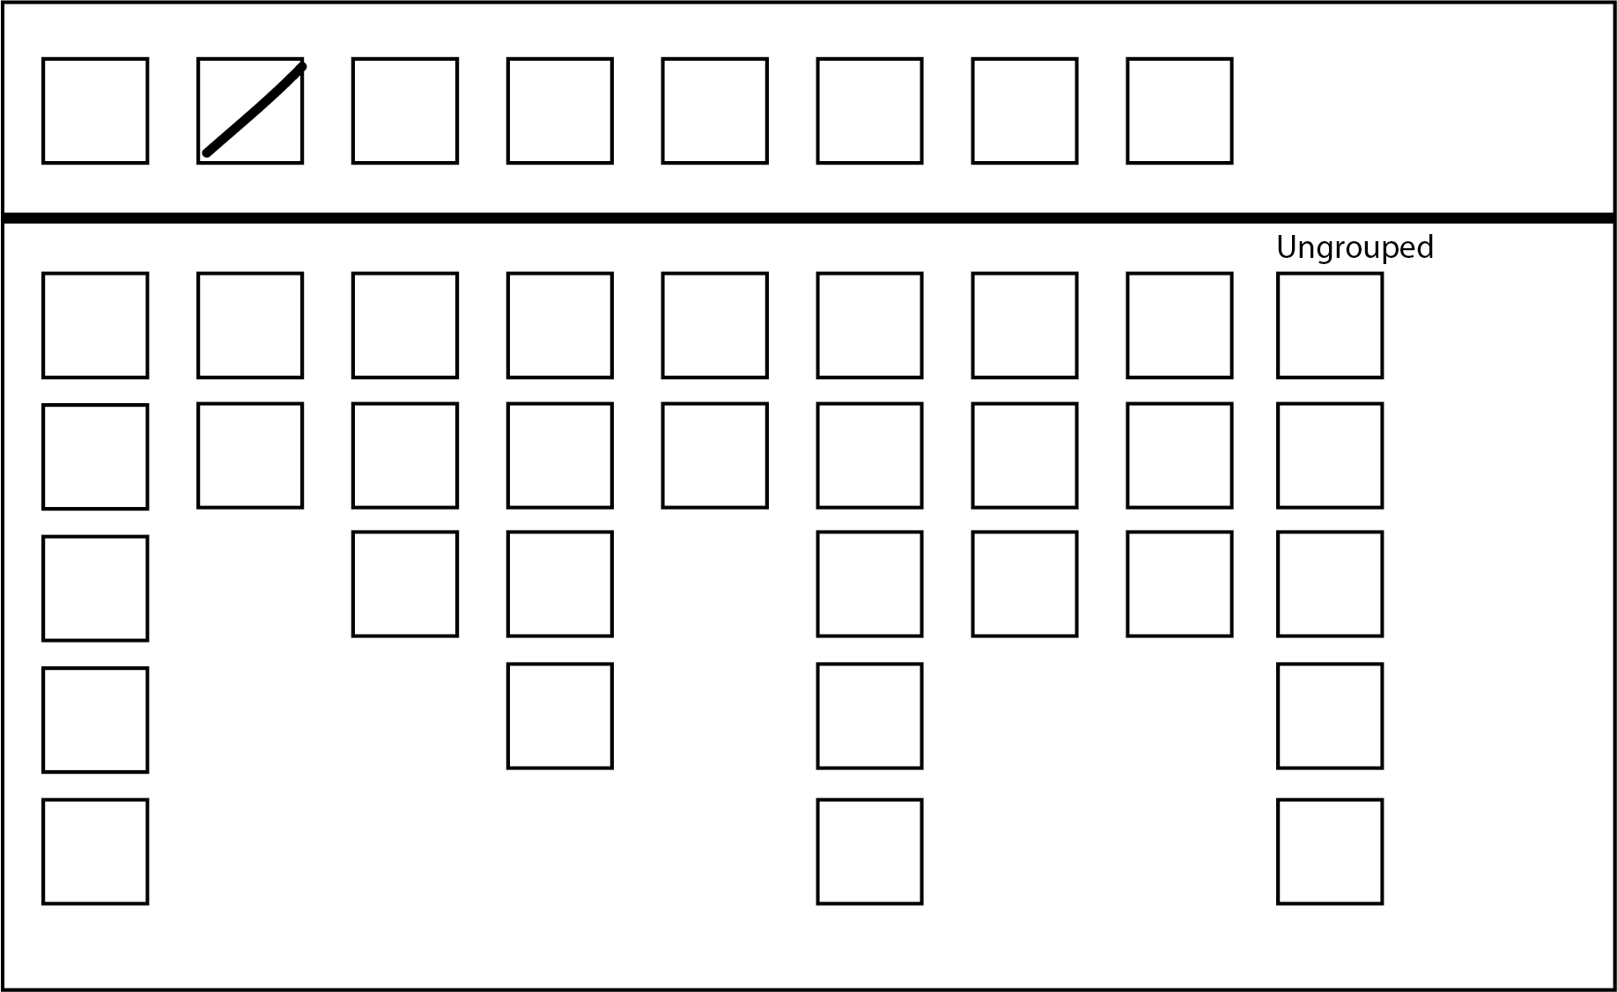
Formal: The elector has made a mark in one box above-the-line.

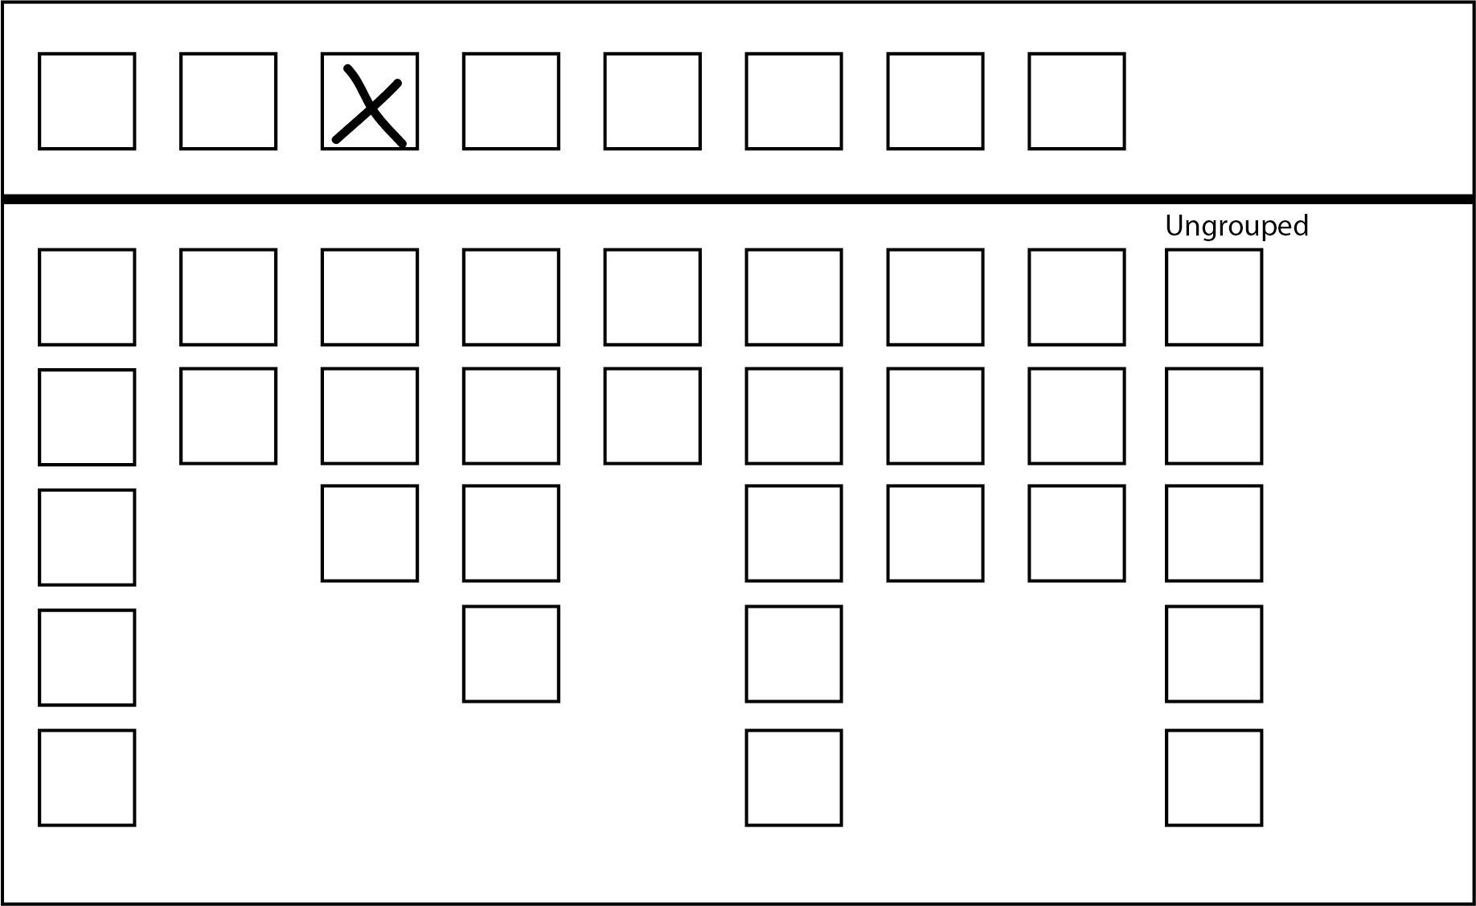
Formal: A number 1, a tick, or a cross appears by itself above-the-line.
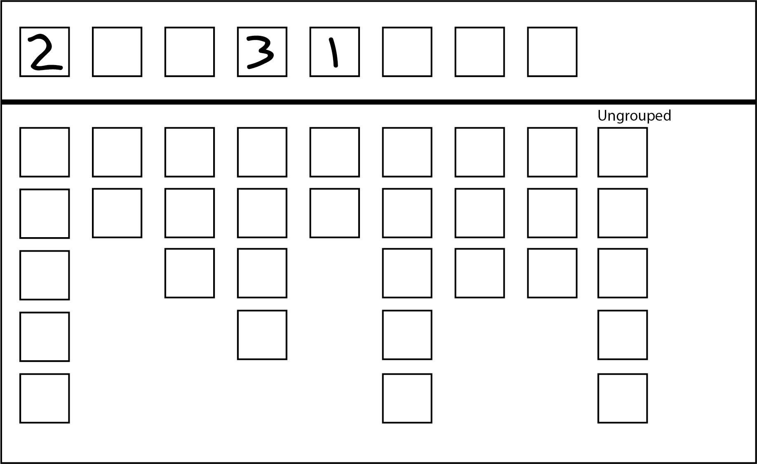
Formal: A first preference appears above-the-line. The numbers after 1 are ignored.

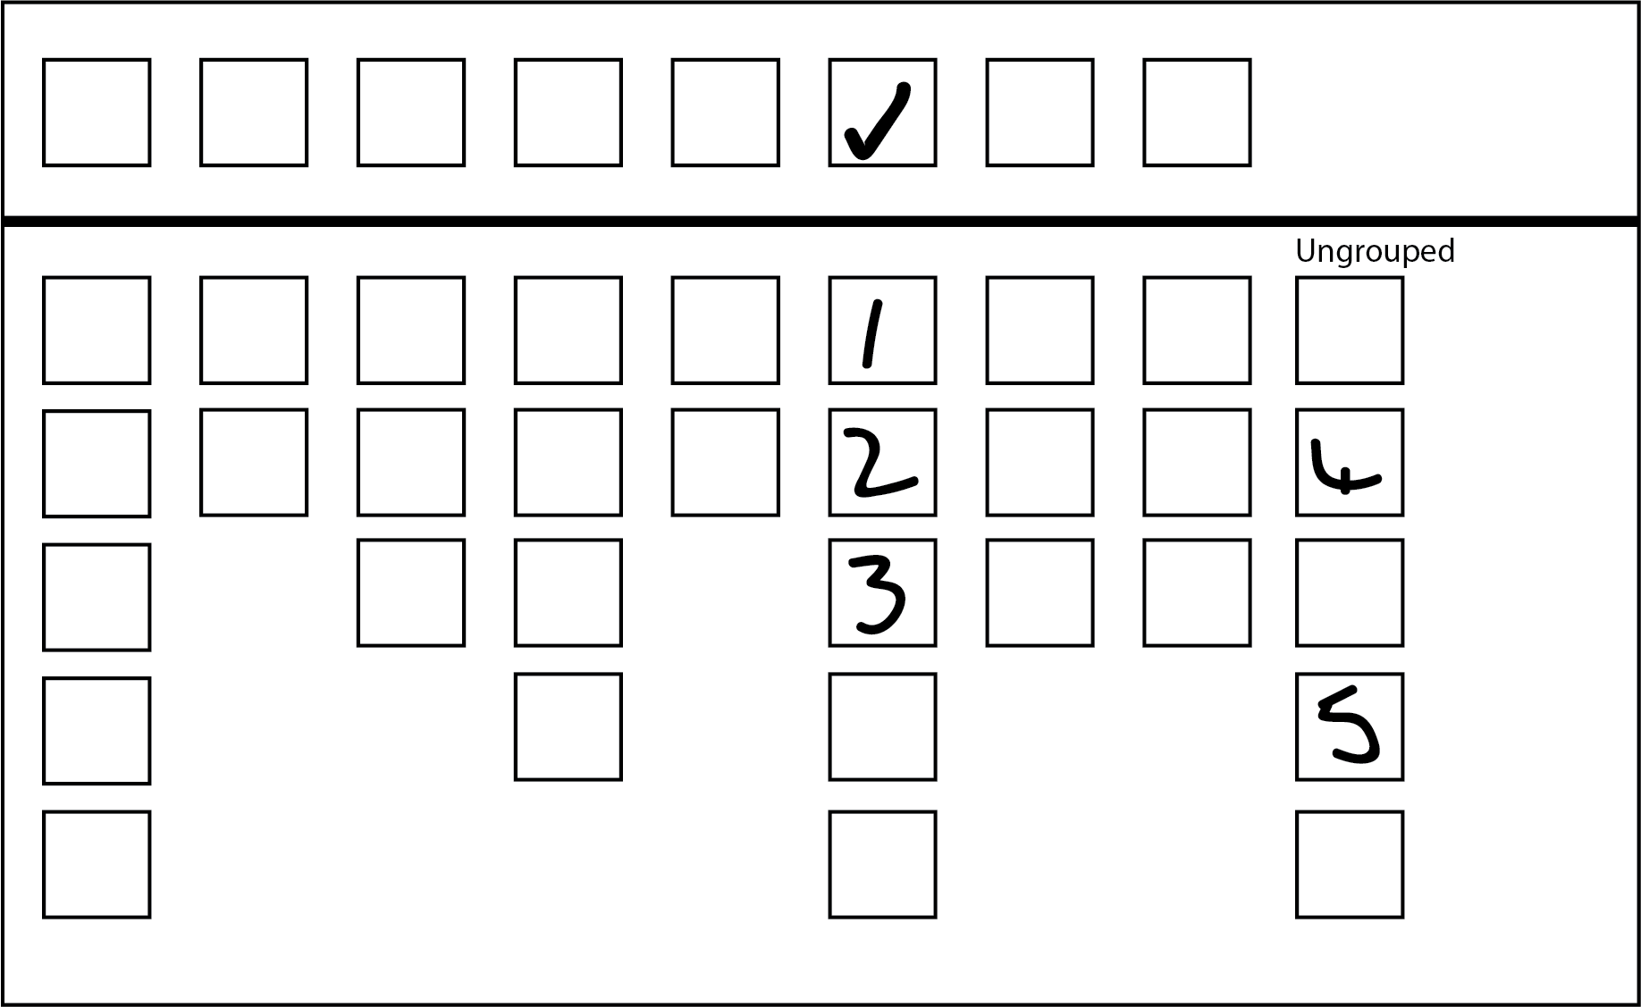
Formal: Both above and below-the-line are formal – use below-the-line for the count.
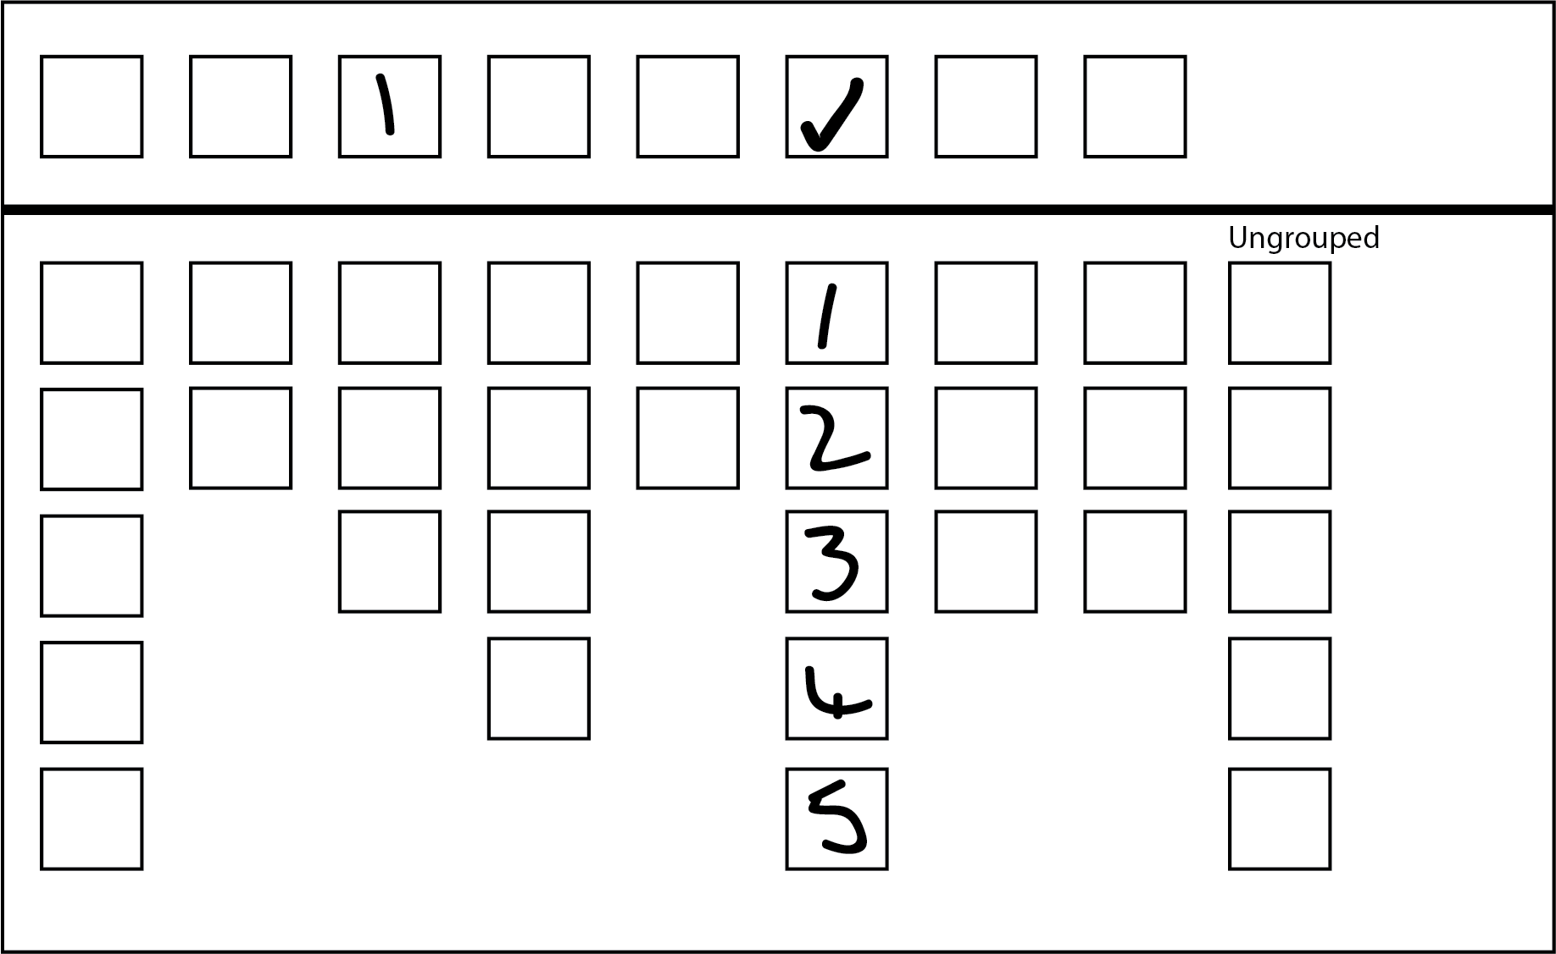
Formal: The below-the-line section is formal. At least the numbers 1 to 5 appear.

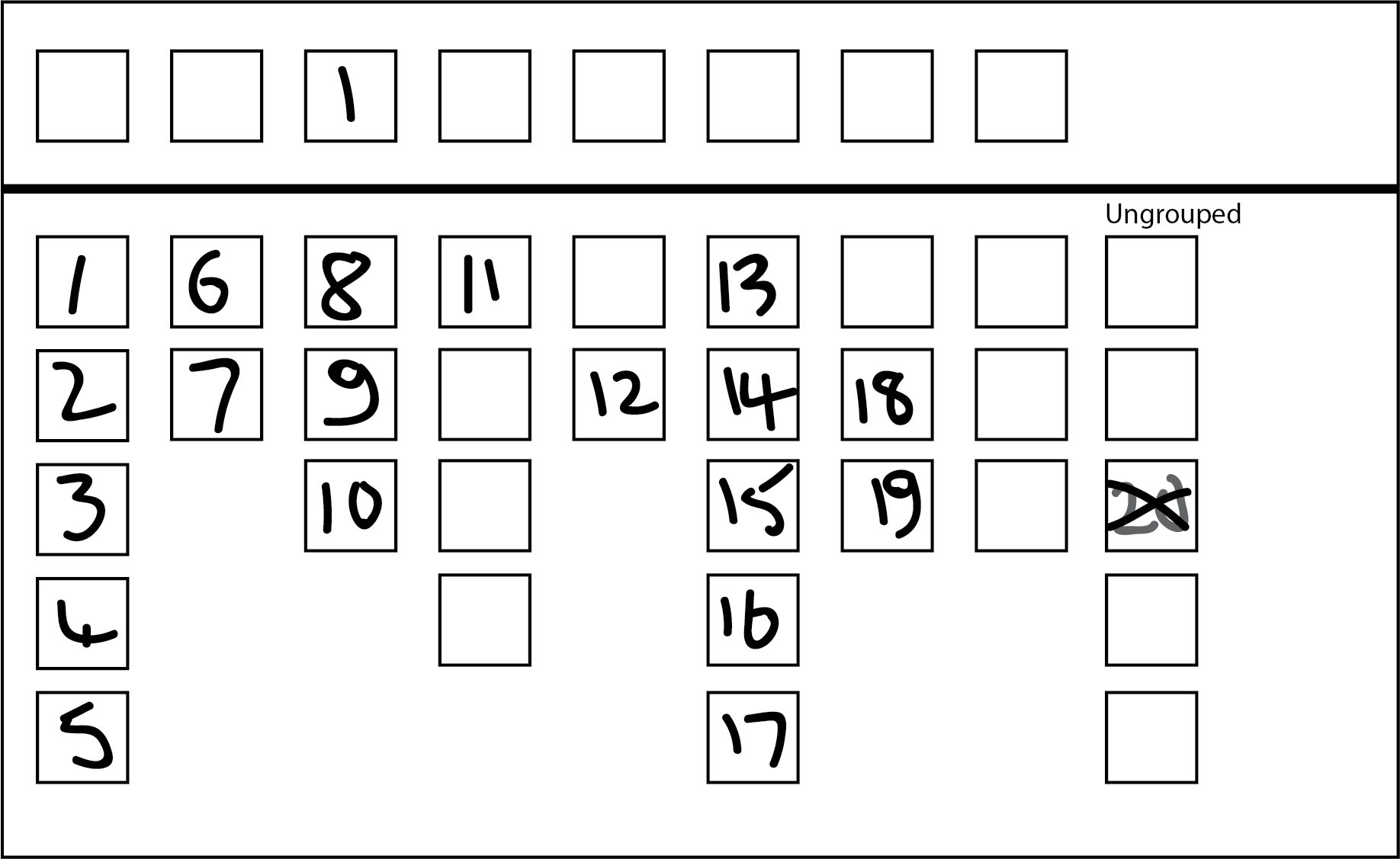
Formal: The above-the-line section is formal and the below-the-line section is formal – both a 1 and a cross appear. A cross is not an indicator of preference below-the-line so it is ignored. Use below-the-line for the count.
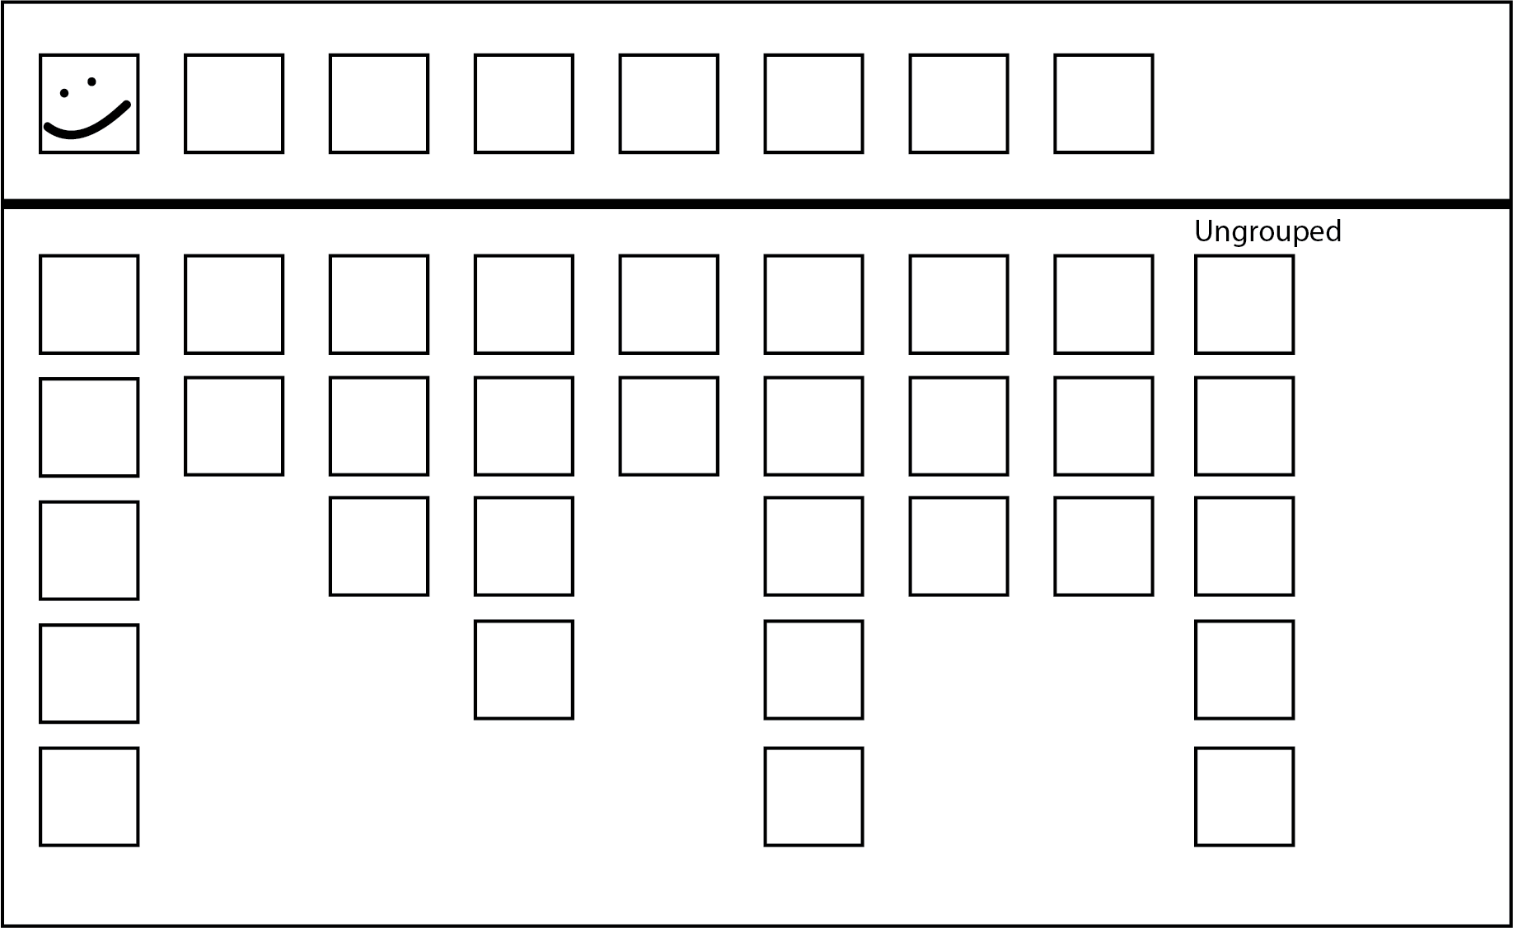
Formal: The elector has made a mark in a single box above-the-line

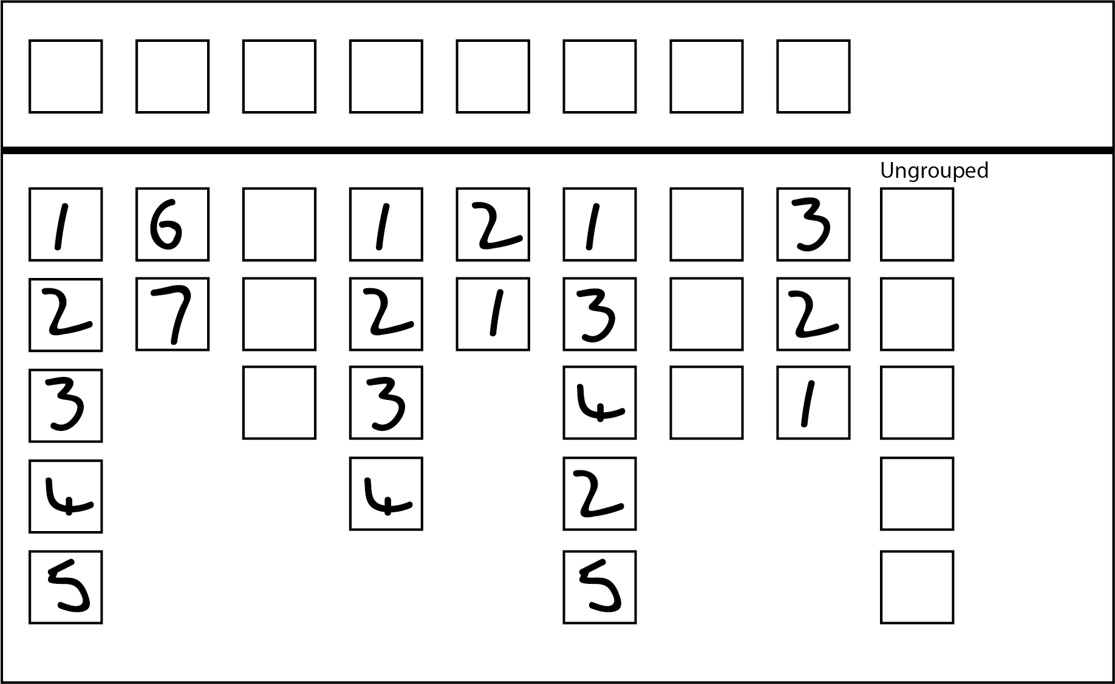
Informal: The numbers 1 to 5 appear more than once below-the-line.

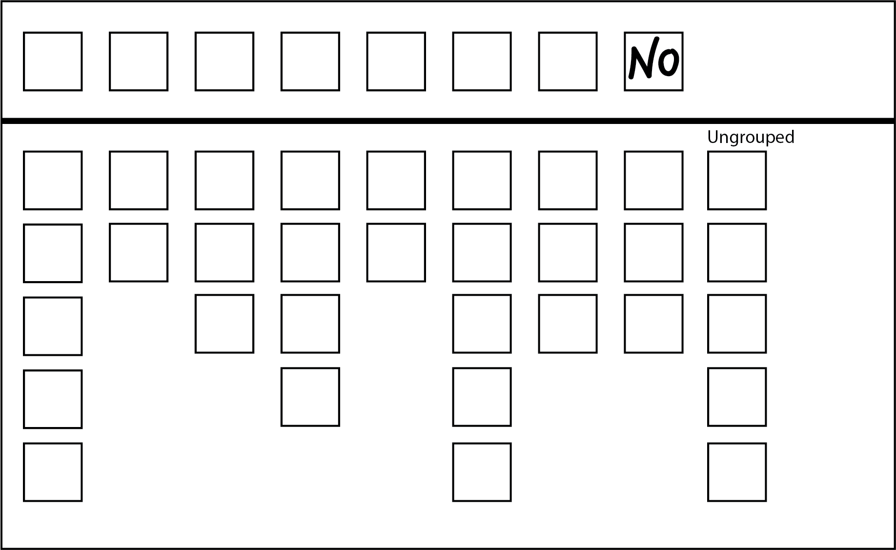
Informal: Elector’s intention is not clear.

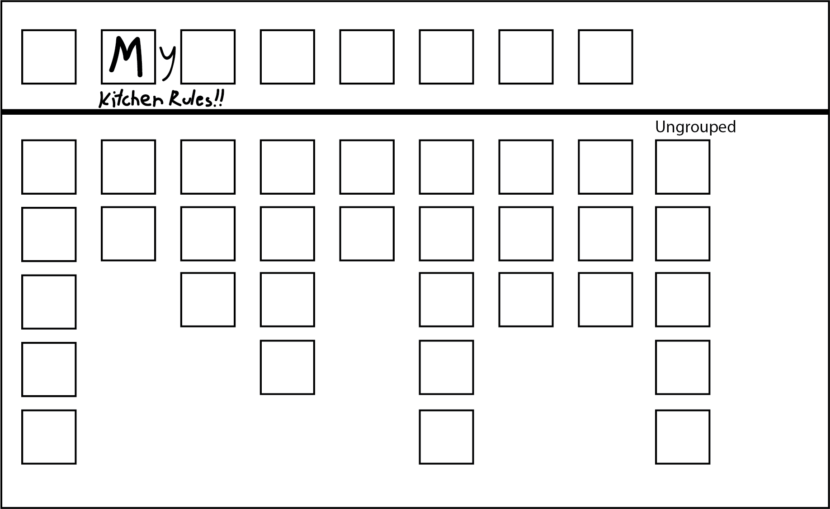
Formal: A single mark appears above-the-line. Marks outside the box are ignored.
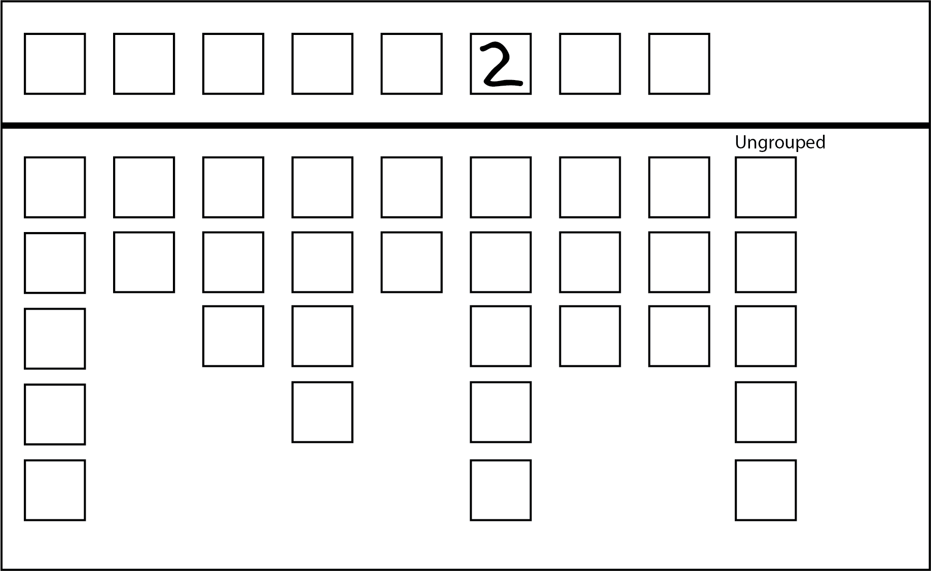
Informal: Single number other than 1 appears above-the-line. Elector’s intention unclear.

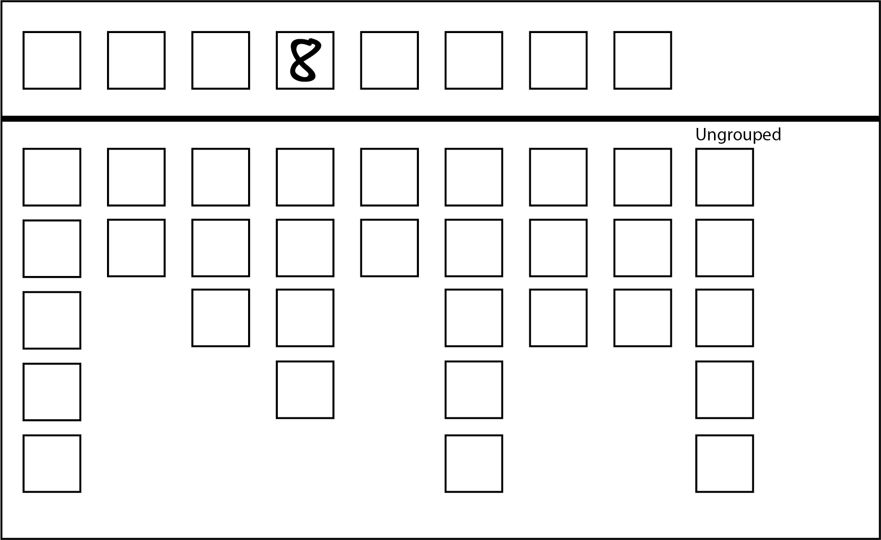
Informal: Single number other than 1 appears above-the-line. Elector’s intention unclear.

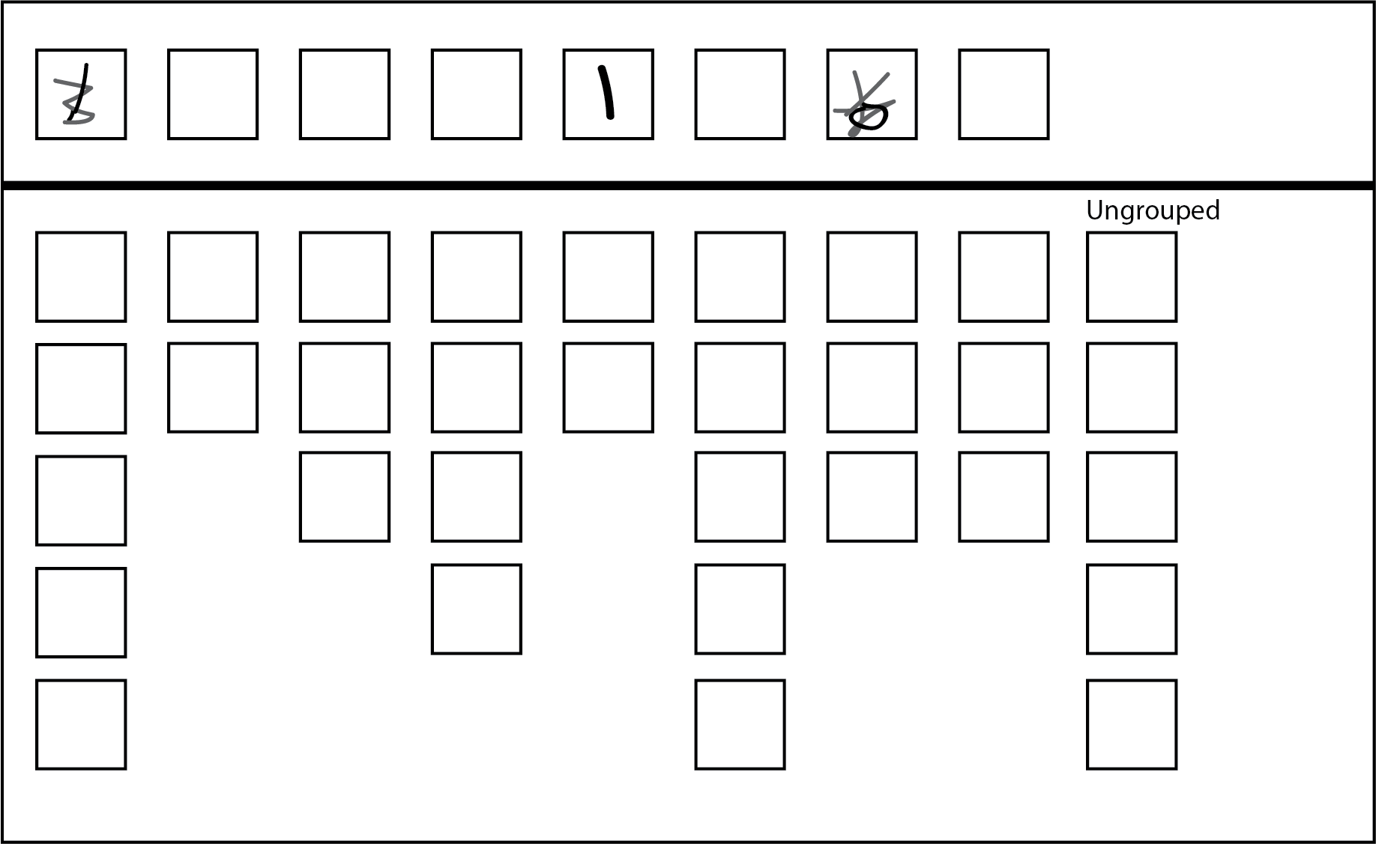
Formal: The elector’s intention is clear.

Damaged ballot papers
Election officials from time to time may come across ballot papers that have been torn or cut. Where ballot papers are cut or torn during processing by an election official, and the different parts can be identified beyond doubt as having originated from the same ballot paper, officials will tape the pieces and count as one ballot paper.
Where an official can determine an elector had access to all candidate and party information on the ballot paper when recording their preferences, such a ballot paper can be ruled ‘formal’ if all formality requirements have otherwise been met. If from the intact part the official can determine that the elector had access to the names of all candidates, their affiliations and, in the case of the Legislative Council (Region ballot papers) their locality, then look at the formality requirements.
In situations where the ballot paper has been torn across one of the boxes for recording preferences, the ballot paper may still be deemed formal if the preference recorded in the box can be determined. See the following examples for illustrations of these principles.
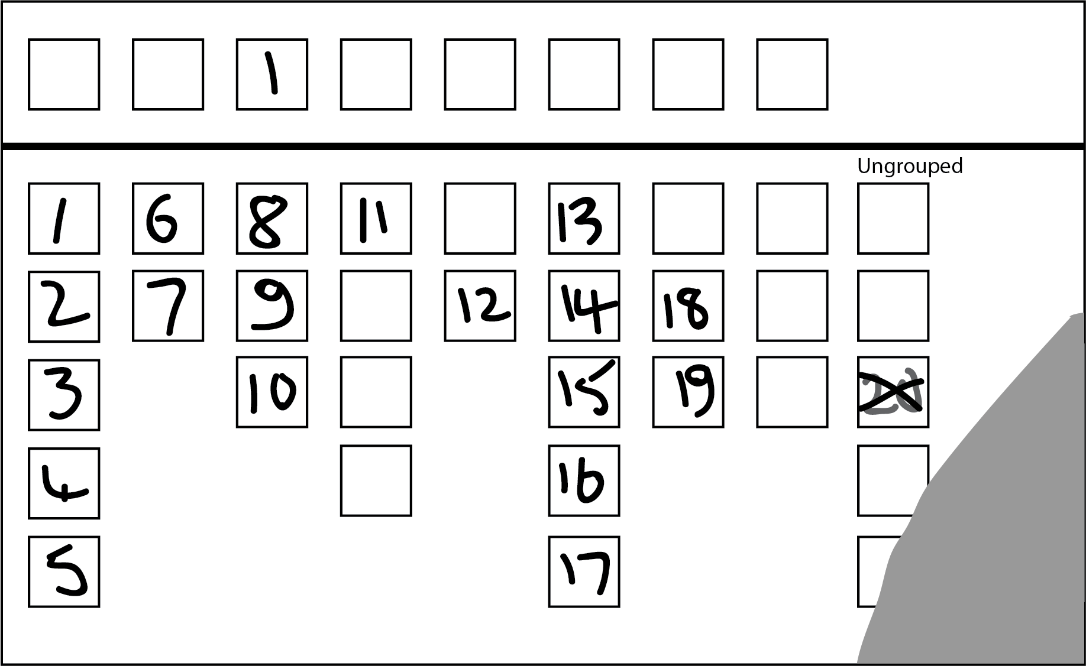
Formal: Formal below-the-line. All the squares below are visible, even though the paper is damaged.

Appendix 2: Upper house count timetable
Date / Venue | Notes | Early Voting Centres, Voting Centres  and Election Offices |  |  | Postal Vote Count Centre (PVCC) | Metro Region Recheck Centre (MRRC) | Country Region Election Offices | Metro Region Computer Count Centre (MCCC) | Country Region Computer Count Centres (RCCC)
Date / Venue | Notes | Early Votes  Primary | Ordinary Votes  Primary | Absent, Marked as Voted (MAV) & Provisional Votes  Primary | Postal Votes  Primary and Recheck | Rechecks – all vote types (ex. Postal) | Rechecks – all vote types (ex. Postal) | BTL Data Entry and loading of ATL votes – 5 Metro Regions | BTL Data Entry and loading of ATL votes – 1 Region each
Saturday 24 November | Election Day | Sort own and other Region papers | Primary count in Voting Centres | Commence sort/package for dec exchange | 8.00 am: Extract and sort admitted votes
Sunday 25 November | Preparation for dec exchange | Complete sort/ package for dec exchange |  | Complete sort/ package for dec exchange | Primary count all extracted papers
Monday 26 November | Dec exchange collected | Commence Primary count | Metro offices dispatch to MRRC |  |  | Receive Ordinary Votes. Start rechecks
Tuesday 27 November | Dec exchange received | Commence further Primary counts |  |  | Commence rechecks (all Regions) | Ordinary Vote rechecks continue | Commence Ordinary Vote rechecks
Wednesday 28 November |  | Complete further Primary counts |  | Commence Primary counts of Absent votes | Continue rechecks (all Regions) | Ordinary Vote rechecks continue | Ordinary Vote rechecks continue
Thursday 29 November |  |  |  | Commence Primary count of Prov and MAV votes, and complete Absent count | Complete rechecks (all Regions) of all papers counted on Sunday | Ordinary Vote rechecks continue | Complete Ordinary Vote rechecks
Friday 30 November | Last day to accept postal votes into count (6.00 pm) | Metro election offices dispatch votes to MRRC |  | Complete Primary count of Provisional votes.  Metro election offices dispatch votes to MRRC |  | Ordinary Vote rechecks continue.  Receive other vote types. | Commence rechecks of all other vote types | Commence first round of BTL data entry
Saturday 1 December |  |  |  |  | Extract and sort all other postal votes (plus any early votes from interstate / overseas) | Complete Ordinary vote rechecks. Commence rechecks of all other vote types
Sunday 2 December |  |  |  |  | Primary count and recheck | Rechecks of all other vote types continue
Monday 3 December |  |  |  |  | Transfer BTL votes for 5 Metro regions to MCCC | Rechecks of all other vote types continue | Rechecks of all other vote types continue | Continue first round of BTL data entry.
Tuesday 4 December |  |  |  |  |  | Rechecks of all other vote types continue | Rechecks of all other vote types continue | Continue first round of BTL data entry
Wednesday 5 December |  |  |  |  | Dispatch all BTL votes to RCCC | Rechecks of all other vote types continue | Complete rechecks & dispatch BTLs to RCCC | Continue first round of BTL data entry | Receive BTL votes from country offices
Thursday 6 December |  |  |  |  |  | Complete rechecks of all other vote types |  | Complete first round of BTL data entry | Commence first round BTL data entry
Friday 7 December |  |  |  |  |  |  |  | Commence second round of BTL data entry | Complete first round of BTL data entry
Saturday 8 December |  |  |  |  |  |  |  | Continue second round of BTL data entry | Commence second round BTL data entry
Sunday 9 December |  |  |  |  |  |  |  | Complete second round of BTL data entry | Complete second round BTL data entry
Monday 10 December |  |  |  |  |  |  |  | Entry of ATL votes | Entry of ATL votes
Tuesday 11 December |  |  |  |  |  |  |  | Calculate results (all Regions)  Commence declarations
Wednesday 12 December |  |  |  |  |  |  |  | Any recounts commence
Thursday 13 December |  |  |  |  |  |  |  | Any recounts are completed
Friday 14 December
Saturday 15 December | Last Day for Return of Writs
Notes:
This is a proposed timeline only. Timings are subject to change
BTL = below-the-line / ATL = above-the-line
Metro Regions Recheck Centre is in the same building as the Metro Regions Computer Count Centre (so papers are not dispatched from one to other)



