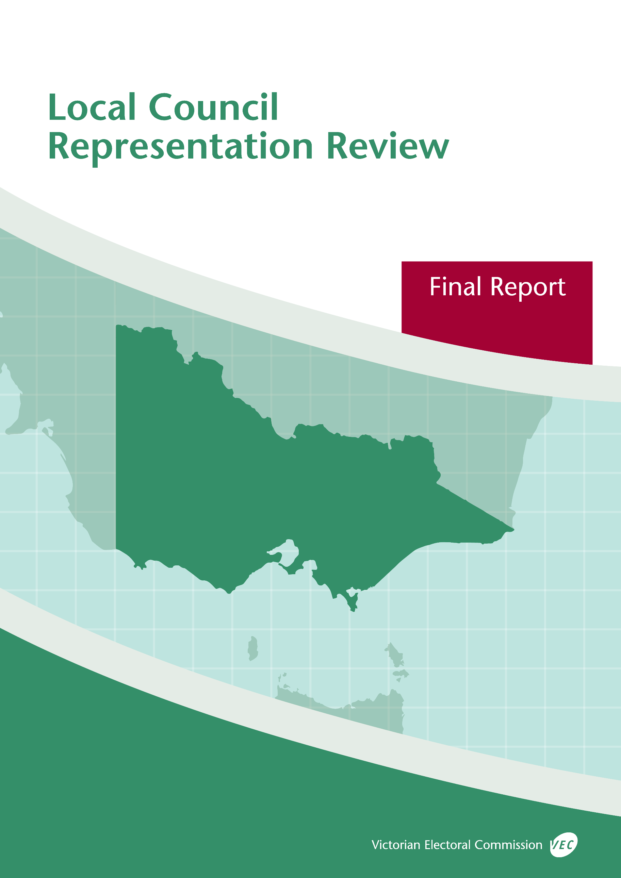



**October 2019**

**Murrindindi Shire Council**

© State of Victoria (Victorian Electoral Commission)   
Wednesday 23 October 2019

Version 1  
  
cid:image001.png@01D4D431.F774F3F0

This work, Local Council Representation Review Final Report – Murrindindi Shire Council, is licensed under a Creative Commons Attribution 4.0 licence [<http://creativecommons.org/licenses/by/4.0/>]. You are free to share this work under that licence, on the condition that you do not change any content and you credit the State of Victoria (Victorian Electoral Commission) as author and comply with the other licence terms. The licence does not apply to any branding, including Government logos.

Contents

Recommendation 1

Executive summary 2

Legislative basis 4

Public engagement 4

The VEC’s principles 5

Developing recommendations 6

Murrindindi Shire Council representation review 8

Profile of Murrindindi Shire Council 8

Current electoral structure 10

Preliminary submissions 10

Preliminary report 12

Public response 16

Response submissions 16

Public hearing 21

Findings and recommendation 25

The VEC’s findings 25

The VEC’s recommendation 29

Appendix 1: Public involvement 30

Appendix 2: Map 31

Appendix 3: Public information program 33

Recommendation

The Victorian Electoral Commission recommends that Murrindindi Shire Council consist of seven councillors elected from three wards (two two-councillor wards and one three-councillor ward).

This recommendation is submitted to the Minister for Local Government as required by the *Local Government Act 1989*.

Please see Appendix 2 for a detailed map of this recommended structure.

Executive summary

The *Local Government Act 1989* (the Act) requires the Victorian Electoral Commission (VEC) to conduct an electoral representation review of each municipality in Victoria before every third council general election.

The purpose of an electoral representation review is to recommend an electoral structure that provides ‘fair and equitable representation for the persons who are entitled to vote at a general election of the Council.’[1] The matters considered by a review are:

* the number of councillors
* the electoral structure of the council (whether the council should be unsubdivided or divided into wards and, if subdivided, the details of the ward boundaries and the number of councillors per ward).

The VEC conducts all reviews based on three main principles:

1. taking a consistent, State-wide approach to the total number of councillors
2. if subdivided, ensuring the number of voters represented by each councillor is within   
   plus-or-minus 10% of the average number of voters per councillor for that local   
   council
3. ensuring communities of interest are as fairly represented as possible.

Current electoral structure

Murrindindi Shire Council currently comprises seven councillors elected from seven single‑councillor wards. More information on Murrindindi Shire Council and the current electoral structure is available in the council fact sheet on the VEC website at [vec.vic.gov.au](http://vec.vic.gov.au).

Prior to the last representation review in 2007, Murrindindi Shire Council was comprised of six councillors elected from six single-councillor wards. Visit the VEC website at [vec.vic.gov.au](http://www.vec.vic.gov.au/) to access a copy of the 2007 review final report.

Preliminary submissions

Preliminary submissions opened at the commencement of the current review on Wednesday   
3 July 2019. The VEC received nine submissions for the representation review of Murrindindi Shire Council by the deadline at 5.00 pm on Wednesday 31 July 2019.

Preliminary report

A preliminary report was released on Wednesday 28 August 2019 with the following options for consideration:

* Option A (preferred option)  
  **Murrindindi Shire Council consist of seven councillors elected from three wards (two two-councillor wards and one three-councillor ward).**
* Option B (alternative option)  
  **Murrindindi Shire Council consist of seven councillors elected from seven single‑councillor wards, with adjustments to the current ward boundaries.**
* Option C (alternative option)  
  **Murrindindi Shire Council consist of seven councillors elected from an unsubdivided electoral structure.**

Response submissions

The VEC received 10 submissions responding to the preliminary report by the deadline at   
5.00 pm on Wednesday 25 September 2019.

Public hearing

The VEC conducted a public hearing for those wishing to speak about their response submission at 6.00 pm on Tuesday 1 October 2019. Three people spoke at the hearing.

Recommendation

**The Victorian Electoral Commission recommends that Murrindindi Shire Council consist of seven councillors elected from three wards (two two-councillor wards and one three‑councillor ward).**

This electoral structure was designated as Option A in the preliminary report. Please see Appendix 2 for a detailed map of this recommended structure.

Background

Legislative basis

The Act requires the VEC to conduct a representation review of each local council in Victoria before every third general council election, or earlier if gazetted by the Minister for Local Government.

The Act states that the purpose of a representation review is to recommend the number of councillors and the electoral structure that provides ‘fair and equitable representation for the persons who are entitled to vote at a general election of the Council.’[2]

The Act requires the VEC to consider:

* the number of councillors in a local council
* whether a local council should be unsubdivided or subdivided.

If a local council is subdivided, the VEC must ensure that the number of voters represented by each councillor is within plus-or-minus 10% of the average number of voters per councillor for that local council.[3] On this basis, the review must consider the:

* number of wards
* ward boundaries
* number of councillors that should be elected for each ward.

Public engagement

### Public information program

The VEC conducted a public information program to inform the community of the representation review, including:

* public notices printed in local and State-wide papers
* public information sessions to outline the review process and respond to questions from the community
* media releases announcing the commencement of the review and the release of the preliminary report
* a submission guide to explain the review process and provide background information on the scope of the review
* an information email campaign targeted at known community groups and communities of interest in the local council area
* sponsored social media advertising geo-targeted to users within the local council   
  area
* ongoing information updates and publication of submissions on the VEC website.

More information on the VEC’s public information program for the representation review of Murrindindi Shire Council can be found at Appendix 3.

### Public consultation

Public input was accepted by the VEC via:

* preliminary submissions at the start of the review
* response submissions to the preliminary report
* a public hearing that provided an opportunity for people who had made a response submission to expand on their submission.

Public submissions are an important part of the review process but are not the only consideration. The VEC ensures its recommendations comply with the Act and are formed through careful consideration of public submissions, independent research, and analysis of all relevant factors.

The VEC’s principles

Three main principles underlie all the VEC’s work on representation reviews:

1. **Taking a consistent, State-wide approach to the total number of councillors.**

The VEC is guided by its comparisons of local councils of a similar size and category to the council under review. The VEC also considers any special circumstances that may warrant the local council having more or fewer councillors than similar local councils.

1. **If subdivided, ensuring the number of voters represented by each councillor is within plus-or-minus 10% of the average n****umber of voters per councillor for that local council.**

This is the principle of ‘one vote, one value’, which is enshrined in the Act. This means that every person’s vote counts equally.

1. **Ensuring communities of interest are as fairly represented as possible.**

Each local council contains a number of communities of interest. Where practicable, the electoral structure should be designed to ensure they are fairly represented, and that geographic communities of interest are not split by ward boundaries. This allows elected councillors to be more effective representatives of the people and interests in their particular local council or ward.

Developing recommendations

The VEC bases its recommendations for particular electoral structures on the following information:

* internal research specifically relating to the local council under review, including data from the Australian Bureau of Statistics and .id[4]; voter statistics from the Victorian electoral roll; and other State and local government data sets
* the VEC’s experience conducting previous electoral representation reviews of local councils and similar reviews for State elections
* the VEC’s expertise in mapping, demography and local government
* careful consideration of all input from the public in written submissions received during the review and via oral submissions at the public hearing
* advice from consultants with extensive experience in local government.

### Deciding on the number of councillors

The Act allows for a local council to have between five and 12 councillors but does not specify how to decide the appropriate number.[5] In considering the number of councillors for a local council, the VEC is guided by the Victorian Parliament’s intention for fairness and equity in the local representation of voters under the Act.

The starting point in deciding the appropriate number of councillors for a local council is comparing the local council under review to other local councils of a similar size and type (Principle 1). Generally, local councils that have a larger number of voters will have a higher number of councillors. Often large populations are more likely to be diverse, both in the nature and number of their communities of interest and the issues of representation.

However, the VEC also considers the particular circumstances of each local council which could justify fewer or more councillors, such as:

* the nature and complexity of services provided by the Council
* geographic size and topography
* population growth or decline
* the social diversity of the local council.

### Deciding the electoral structure

The Act allows for a local council ward structure to be unsubdivided—with all councillors elected ‘at-large’ by all voters—or subdivided into a number of wards.

If the local council is to be subdivided into wards, there are three options available:

1. single-councillor wards
2. multi-councillor wards
3. a combination of single-councillor and multi-councillor wards.

A subdivided electoral structure must be developed with internal ward boundaries that provide for a fair and equitable division of the local council.

The Act allows for wards with different numbers of councillors, as long as the number of voters represented by each councillor is within plus-or-minus 10% of the average number of voters per councillor for that local council (Principle 2). For example, a local council may have one   
three-councillor ward with 15,000 voters and two single-councillor wards each with 5,000 voters. In this case, the average number of voters per councillor would be 5,000.

Over time, population changes can lead to some wards in subdivided local councils having larger or smaller numbers of voters. As part of the review, the VEC corrects any imbalances and considers likely population changes to ensure ward boundaries provide equitable representation for as long as possible.

In considering which electoral structure is most appropriate, the VEC considers the following matters:

* the VEC’s recommendation at the previous representation review and the reasons for that recommendation
* the longevity of the structure, with the aim of keeping voter numbers per councillor within the 10% tolerance for as long as possible (Principle 2)
* communities of interest, consisting of people who share a range of common concerns, such as geographic, economic or cultural associations (Principle 3)
* the number of candidates in previous elections, as outcomes from previous elections indicate that large numbers of candidates can lead to an increase in the number of informal (invalid) votes
* geographic factors, such as size and topography
* clear ward boundaries.

Murrindindi Shire Council representation review

Profile of Murrindindi Shire Council

Murrindindi Shire Council is located approximately 45 kilometres north-east of the Melbourne CBD and covers 3,889 square kilometres. The Shire contains many National and State parks as well as other natural attractions, including Lake Eildon National Park, Cathedral Range State Park, Yarra Ranges National Park and the Goulburn River. Lake Mountain Alpine Resort and Lake Eildon border the Shire.

Approximately 46% of the local council area is forested public land, most of which is managed by the State Government. Much of this forested land is rugged and mountainous. Parts of Murrindindi Shire have a significant bushfire risk and were heavily affected by the 2009 Black Saturday bushfires.[6]

At the 2016 Census Murrindindi Shire had a population of 13,732.[7] The population resides within many small towns and localities across the local council area, with the largest towns being Alexandra (population 2,695), Yea (1,587), Kinglake (1,536), Kinglake West (1,166) and Eildon (974).[8]

The Murrindindi Shire economy focuses mainly on agriculture, forestry, tourism and hospitality.[9] Diverse agricultural activities are undertaken in the Shire. Grazing occurs mainly in the north and west, while mixed farming occurs within the central part of the Shire. This includes cattle, sheep and wool production, production of exotic animals (rabbits, deer, alpaca), plant nurseries, and production of stone fruit, berries, grapes, olives, seed and turf. Irrigation farming occurs close to the Goulburn River.[10] Aquaculture is also an important industry, with Murrindindi Shire a major producer of trout.[11] Tourism is largely focused around the natural environment and outdoor education is an expanding industry.[12] Construction, manufacturing, tourism and the services sector are also important contributors to the economy. Residents within the Shire mainly work in construction (11.6%), health care and social assistance (10.9%), agriculture/forestry/fishing (10.5%), and education and training (9.3%).[13]

The unemployment rate in the Shire (5.1%) is lower than both the regional Victorian average (6%) and the State-wide average (6.6%).[14] The median weekly household income for Murrindindi Shire residents is lower than that of regional Victoria ($1,071 versus $1,124). Likewise, the median weekly personal income ($553) is also lower than for regional Victoria overall ($576).[15] Although some areas within the local council are experiencing higher levels of disadvantage compared to regional Victoria (for example, Flowerdale, Eildon and Yea), disadvantage is below average for the Shire overall.[16]

The population within the local council area is older and ageing. The median age is 48 years, which is higher than both the regional Victorian average (43 years) and the State-wide average (37 years). Compared to regional Victoria, Murrindindi Shire has lower proportions of residents in younger age classes (44 years and younger) and higher proportions of people in older age classes (45 years and older).[17] The proportion of people aged over 60 years is expected to increase in the future.[18]

Most residents were born in Australia (79.2%) and speak only English at home (88.6%). This is characteristic for regional Victoria, where 80.7% of the population were born in Australia and 86.6% speak only English at home. Murrindindi Shire residents who were born overseas mainly come from England (3.9%), New Zealand (1.2%), the Netherlands (0.6%), Germany (0.6%) and Scotland (0.5%).[19]

The proportion of the Shire’s population identifying as Aboriginal and Torres Strait Islander (1.3%) is slightly lower than the average for regional Victoria (1.6%). The Taungurung and Wurundjeri peoples are the traditional custodians of the land known as Murrindindi Shire.[20] The majority of Murrindindi Shire is located on Taungurung Country.

There are an estimated 14,685 registered voters for Murrindindi Shire Council, with a ratio of 2,097 voters per councillor. The population is expected to increase at a rate of 0.9% per annum between 2021-2026 and 0.8% per annum between 2026-2031, reaching approximately 15,600 residents by the time of the next scheduled representation review prior to the 2032 Murrindindi Shire Council general election. This rate of growth is below average compared to the expected growth for regional Victoria overall (1.3% p.a.).[21]

Current electoral structure

Murrindindi Shire Council currently comprises seven councillors elected from seven single‑councillor wards. More information on Murrindindi Shire Council and the current electoral structure is available in the council fact sheet on the VEC website at [vec.vic.gov.au](http://vec.vic.gov.au).

Prior to the last representation review in 2007, Murrindindi Shire Council was comprised of six councillors elected from six single-councillor wards. Visit the VEC website at [vec.vic.gov.au](http://www.vec.vic.gov.au/) to access a copy of the 2007 review final report.

Preliminary submissions

At the close of submissions on Wednesday 31 July 2019, the VEC had received nine submissions for the representation review of Murrindindi Shire Council. A list of people who made a preliminary submission can be found in Appendix 1.

Submissions were received from a range of stakeholders including individuals and community organisations. The submissions were made available on the VEC website.

### Number of councillors

Six preliminary submissions supported maintaining the number of councillors for Murrindindi Shire Council at seven. Submitters supporting the current number of councillors thought that seven councillors is appropriate for the size and population of the local council area, and that the uneven number of councillors resulted in few instances of tied votes during the Council’s decision-making. One submitter also stated that, based on their previous experience as a local councillor, councillor workloads were manageable with seven councillors. One submitter supported two different electoral structures, one of which allowed seven councillors while the other required an increase to nine councillors.

Two preliminary submissions did not indicate a preference regarding the total number of councillors.

### Electoral structure

Three submitters supported the current single-councillor wards, arguing that the current structure works well for the Shire, the ward boundaries are reasonable, and that single-councillor wards deliver local representatives and ensure that different parts of the local council area are represented on the Council.

Two additional submitters also largely supported the existing electoral structure, but proposed boundary changes to correct the voter-to-councillor ratio of Red Gate Ward exceeding the +10% tolerance. Both submitters proposed merging Red Gate and Koriella Wards to create a two-councillor ward, while retaining the remaining five single-councillor wards. Both submitters believed that this combination of wards was logical, with one submitter indicating that Red Gate Ward shares closer social networks with Koriella Ward than with other wards. One submitter also proposed a modified boundary between Cheviot and King Parrot Wards. This submitter proposed that more of the Flowerdale locality be brought into King Parrot Ward, and that the Glenburn locality be enclosed within Cheviot Ward, arguing that this would improve representation for these localities as both communities are split by current ward boundaries.

Two submitters supported an unsubdivided electoral structure with seven councillors. One submitter argued that an unsubdivided electoral structure would be best for the long-term social and economic development of the Shire as it would encourage a cooperative, Shire-wide approach from communities, interest groups and the Council. This submitter argued that an unsubdivided electoral structure would mean unbalanced voter-to-councillor ratios would not be an issue, geographic communities would not be divided by ward boundaries, and the risk of uncontested elections would be reduced. The second submitter also argued that an unsubdivided electoral structure would enable both geographic and non-geographic communities of interest to gain representation on the Council.

One submitter supporting an unsubdivided electoral structure also supported a multi-councillor ward structure comprising three wards with three councillors per ward. The number of councillors would need to increase to nine in order to provide balanced proportional representation in this proposal.

Three submitters expressed opposition to an unsubdivided electoral structure. These submitters were concerned that an unsubdivided structure could lead to multiple councillors being elected from the same part of the Shire, leaving some areas without a local representative, and that this could result in a Council that unfairly favoured one part of the local council area.

Two submitters expressed opposition to single-councillor wards for Murrindindi Shire Council. One submitter argued that single-councillor wards hinder social and economic development, embed parochialism, and do not promote the best interests of the Shire as a whole. This submitter also raised concerns about the history of uncontested elections for Murrindindi Shire Council, and believed that geographic communities of interest were poorly represented by the current single-councillor wards. This submitter argued that although many supporters of single-councillor wards believe that they ensure local representatives, Murrindindi Shire’s last three Councils have included several councillors representing wards in which those councillors did not reside. The second submitter argued that a single-councillor ward structure is the least favourable for voters as meaningful and sustainable ward boundaries are difficult to establish and voters are restricted to selecting from the candidates nominating for their ward.

Overall, the majority of preliminary submissions supported a subdivided electoral structure for Murrindindi Shire Council.

Preliminary report

A preliminary report was released on Wednesday 28 August 2019. The VEC considered public submissions and research findings when formulating the options presented in the preliminary report.

### Number of councillors

When considering the appropriate number of councillors for a local council, the VEC reviews population data and assesses other factors which may warrant an increase or decrease in the number of councillors, such as projected population growth or special circumstances relating to distinct communities of interest.

Murrindindi Shire Council sits in the middle of the range of seven-councillor local councils when compared to other regional Victorian local councils of similar size and voter numbers. Although some population growth is expected in the short- to medium-term, this is not significant enough to warrant increasing the number of councillors until at least the next scheduled electoral representation review.

The Murrindindi Shire population is largely socially and linguistically homogenous. Although there are varying levels of disadvantage across the local council area, overall the Shire has lower disadvantage compared to other regional Victorian local councils. The Shire’s population is ageing, which is also the case for much of regional Victoria.

The foremost special circumstance of the Shire is the ongoing impact of the 2009 Black Saturday bushfires. The recovery process from these bushfires, facilitated by the Council and other levels of government, could warrant increasing the number of councillors. However, preliminary submissions did not express support for more councillors and strongly supported retaining the current number of councillors. Despite this unique circumstance of Murrindindi Shire, the lack of support for an increased number of councillors coupled with the absence of other special circumstances indicates that an increased number of councillors for Murrindindi Shire Council is not warranted at this time.

For these reasons, the VEC considered that seven councillors continued to be appropriate for Murrindindi Shire Council, and all options put forward by the VEC in the preliminary report consisted of seven councillors.

### Electoral structure

The VEC observed that, since the introduction of the current electoral structure at the 2008 general election, there has been a clear and consistent pattern of low candidate numbers and uncontested wards at elections for Murrindindi Shire Council. Low candidate numbers and uncontested ward elections were also a pattern of the previous electoral structure of six single-councillor wards and concern about this issue was also raised during the last representation review in 2007.

The VEC also observed an unusually high rate of informal voting for Cathedral and Cheviot Wards at the 2016 general election. While the reasons for these high informal voting rates are not clear, they indicate that Murrindindi Shire may be experiencing issues with representation under single-councillor wards.

The VEC found another major issue with the current electoral structure regarding voter-to-councillor ratios across wards. The current deviation for Red Gate Ward is +11.11%, which is outside the legislated plus-or-minus 10% range. This means the current ward boundaries are not viable, even if the current electoral structure is to be retained, as it is not compliant with legislated requirements.

The VEC concluded that, at the very least, adjustments to the current internal ward boundaries must be made as part of this review. However, the characteristics of Murrindindi Shire make it difficult to cleanly capture communities of interest within wards while also balancing voter-to-councillor ratios. Because of the difficulties establishing meaningful ward boundaries within Murrindindi Shire, as well as the extensive history of uncontested elections and high levels of informal voting for some wards, the VEC decided both unsubdivided and subdivided electoral structures should be examined during this representation review.

The VEC explored many possible mixed electoral structures, consisting of both multi- and single-councillor wards. The models included six-ward models proposed by two preliminary submitters and a range of four- and five-ward models. The major benefit of these models was that they enabled some of the current wards or ward boundaries to be retained, providing some continuity for voters. The major drawback was that these mixed models did not address the serious issue of uncontested elections for the Shire. They also could not effectively capture geographic communities of interest and some models could not balance voter-to-councillor ratios across wards. Therefore, these models were not put forward for consultation. However, ward boundaries proposed by preliminary submitters were considered during the development of the preliminary options. After examining a range of electoral structures, the VEC put forward three options for public consultation.

Option A grouped the seven single-councillor wards of the current electoral structure to form three new multi-councillor wards:

* a proposed King Parrot Ward, represented by three councillors
* a proposed Cathedral Ward, represented by two councillors
* a proposed Koriella Ward, represented by two councillors.

Option A presented a compromise between the current single-councillor wards that were supported by many preliminary submitters, and an unsubdivided electoral structure that would address a number of concerns with the single-councillor ward structure. Option A would provide representation for different regions of the local council area, unite some geographic communities that are currently split across wards, provide some continuity for voters, balance current and projected voter-to-councillor ratios, reduce the risk of uncontested elections, and potentially help to address high informal voting rates seen in some wards.

Option B was a seven single-councillor ward structure. In Option B, the internal boundaries of the current electoral structure were adjusted to balance current and projected voter-to-councillor ratios across wards. Adjustments were made to the Cheviot/Koriella Ward boundary, Red Gate/Eildon Ward boundary, Red Gate/Koriella Ward boundary, and the Koriella/Eildon Ward boundary. An additional adjustment was made to the western end of the ward boundary between Cheviot and King Parrot Wards to provide a clearer boundary that better aligns with current geographic features. The ward boundaries of Kinglake and Cathedral Wards remained unchanged. Although Option B responded to the support for single-councillor wards expressed in preliminary submissions and enabled the current system of representation to continue with the least disruption to the voters, it did not respond to the significant and repeated problem of uncontested elections. Also, there was some risk that this single-councillor ward structure would not remain viable through to the next scheduled representation review, as Koriella Ward was likely to approach -10% deviation by this time. Finally, the single-councillor ward boundaries divided some geographic communities. For example, the Red Gate/Koriella Ward boundary abutted the town of Alexandra, excluding voters just outside this ward boundary who are likely to have a close connection with Alexandra. It was also likely that, as the population of Alexandra grows, the Red Gate Ward boundaries would need to shift progressively closer to the town in the future, further shrinking the size of the ward and splitting the community.

The VEC put forward an unsubdivided electoral structure as Option C in the preliminary report. The VEC considered that Option C would address many concerns regarding the current single-councillor ward structure, such as difficulties balancing voter-to-councillor ratios, ward boundaries that do not effectively capture geographic communities of interest, the history of uncontested elections, and the risk of future failed elections. The VEC considered that an unsubdivided electoral structure may also benefit the Shire by supporting a Shire-wide approach to representation and enabling voters to choose their preferred candidate from across the local council area. It would also provide an opportunity for geographic and non-geographic communities of interest to gain representation, and enable councillors to equitably share responsibilities and workloads.

### Options

After careful consideration, the VEC put forward the following options:

* Option A (preferred option)  
  **Murrindindi Shire Council consist of seven councillors elected from three wards (two two-councillor wards and one three-councillor ward).**
* Option B (alternative option)  
  **Murrindindi Shire Council consist of seven councillors elected from seven single‑councillor wards, with adjustments to the current ward boundaries.**
* Option C (alternative option)  
  **Murrindindi Shire Council consist of seven councillors elected from an unsubdivided electoral structure.**

Public response

Response submissions

The VEC accepted submissions responding to the preliminary report from Wednesday 28 August 2019 until 5.00 pm on Wednesday 25 September 2019. The VEC received 10 response submissions. A list of people who made a response submission can be found in Appendix 1. Table 1 indicates the level of support for each option.

|  |  |  |  |
| --- | --- | --- | --- |
| Preferences expressed in response submissions | | | |
| **Option A** | **Option B** | **Option C** | **Other** |
| 3 | 3 | 3 | 1 |

A range of arguments were put forward in favour of the three options. Arguments seen in response submissions were similar to those at the preliminary submission stage.

#### Support for Option A

Option A was supported by three response submitters, including Murrindindi Shire Council, a separate submission from one current councillor (Councillor Eric Lording), and Louise Flowers.

In its submission, Murrindindi Shire Council argued that Option A would provide a more effective representation structure than seven single-councillor wards, and that Option A would provide a good balance between Options B and C. The Council argued that Option A would preserve a level of local representation in the Shire while also going some way to addressing the main shortcomings of the current single-councillor ward structure, which has a history of uncontested elections and ward boundaries that divide some geographic communities.

The Council’s submission noted that, although the population distribution and geographic characteristics of Murrindindi Shire make it difficult to develop ideal ward boundaries, Option A appeared to provide appropriate regional groupings with minimal division of geographic communities of interest. Murrindindi Shire Council submitted that the current single-councillor ward boundaries divide the geographic communities associated with the localities of Kinglake, Kinglake West, Flowerdale, Glenburn and Alexandra, and that Option A would reduce this division. The Council also argued that Option A would better allow for uneven population growth across the local council area, resulting in a more sustainable electoral structure in the long-term.

In its submission, Murrindindi Shire Council also noted other benefits of multi-councillor wards over single-councillor wards, including:

* voters in single-councillor wards are unrepresented if their councillor is absent, whereas those within a multi-councillor ward have more than one representative
* with single-councillor wards, councillor workloads can vary due to different demands arising in different areas whereas multi-councillor wards enable sharing of workloads within the ward
* voters have a choice of councillors to approach, which may encourage greater public participation in local issues relevant to council.

Ms Flowers and Cr Lording also expressed strong support for Option A.   
Ms Flowers argued that Option A would address the issue of uncontested elections, and expressed a hope that this option would result in candidates and communities engaging in greater debate and discussion at election time. Ms Flowers also stated that Option A would unite the Shire while also allowing for some parochialism. Cr Lording indicated strong support for the VEC’s rationale behind Option A (as expressed in the preliminary report) and the distribution of councillors across wards.

#### Opposition to Option A

Four response submissions raised concerns about Option A.

Pauline Roberts submitted that Option A would likely provide reasonable representation for communities within the proposed Cathedral and King Parrot Wards, but was concerned about representation of small communities in the area covered by the current Koriella Ward.   
Ms Roberts argued that under Option A it was likely that voters from the small, dispersed communities outside Alexandra would be out-voted by those within Alexandra, resulting in both councillors being elected from the town. Ms Roberts also argued that Alexandra is physically divided from some parts of Koriella Ward by the Black Range and Switzerland Ranges, and therefore people who live in Alexandra have little interaction with the residents of Glenburn[22], Terip Terip, Highlands, Murrindindi (locality) or Killingworth. Ms Roberts concluded that, if both councillors were elected from Alexandra, this would result in reduced representation for communities located far from the town.

John Walsh submitted that many of the positive features of Option A would be better achieved by Option C, which would remove all community divisions, and would not require balancing of voter-to-councillor ratios across wards. Mr Walsh argued that the ward boundaries of Option A still split some geographic communities and ignored some potential communities of interest, such as those associated with the Goulburn Valley Highway. Mr Walsh also disputed the notion that Alexandra shared social networks with the current Koriella Ward, arguing that the western half of Koriella Ward (including Highlands, Ghin Ghin, Murrindindi (locality), Limestone, Molesworth and Killingworth) shared greater social and commercial links with Yea. Mr Walsh argued that, by including small communities in the same ward as larger towns, Option A would diminish the chances that small communities would be well represented on the Council. Mr Walsh disputed that Option A would provide more continuity for voters than Option C, arguing that Option A would introduce changes such as different sized wards, different numbers of councillors per ward, different counting methods at an election and, for some voters, a change of ward name.

Adam Newman submitted that, although the multi-councillor wards of Option A were preferable to the single-councillor wards of Option B, Option A still carried a risk of uncontested elections.

In its submission, the Proportional Representation Society of Australia (Victoria-Tasmania) Inc (PRSA) indicated a belief that—although multi-councillor wards were preferable to single-councillor wards—each ward should contain an equal number of councillors to enable proportional representation to function effectively.

#### Support for Option B

The three submitters supporting Option B (Wendy Dare, Pauline Roberts and Steven Bahlen) variously argued that single-councillor ward structures were the most effective method of representation for small communities.

Ms Dare stated that the current electoral structure had worked well in the past and was the fairest method of representation.

Ms Roberts supported Option B but also acknowledged that the structure was not perfect, with Koriella Ward somewhat of a ‘leftovers’ ward. Ms Roberts stated that the current councillor group was a more effective, cohesive decision-making group than previous councillor groups and appeared to be more interested in and active across their local communities. Ms Roberts was not concerned with the history of uncontested elections in the Shire, arguing that if a candidate would be an effective representative, it was unimportant whether or not they were elected unopposed. Ms Roberts acknowledged that an uncontested election could also result in the community receiving a poor representative, but argued that a poor representative could also be elected in a contested election. Ms Roberts felt that it was more important to ensure the representation of local communities through single-councillor wards than to reduce the risk of uncontested elections.

Mr Bahlen stated that the electoral structure should remain as it currently is and felt that Option B was essentially the same as the current electoral structure (with ward boundary modifications). In contrast to Ms Roberts, Mr Bahlen shared the VEC’s concerns about the history of uncontested elections in the Shire. Mr Bahlen stated that an uncontested election leads to a councillor who is not elected by voters and that this issue needed to be addressed.

#### Opposition to Option B

Many submitters raised concerns regarding the consistent history of uncontested elections under the current electoral structure, and the risk of this pattern continuing under Option B. Supporters of Option A (Ms Flowers and Murrindindi Shire Council), Option B (Mr Bahlen) and Option C   
(Mr Newman, Mr Walsh and the PRSA) all raised concerns with the history of uncontested elections under single-councillor ward electoral structures in the Shire.

Mr Newman argued that Option B was unfavourable as the single-councillor ward structure made it easier for party structures to dominate the Council.

Mr Walsh argued that remaining with a single-councillor ward structure would not support the development of a consistent, cohesive whole-of-shire approach to representation, which he believed to be essential for the long-term development of the Shire.

Submitters also argued that the current single-councillor ward boundaries (and those of   
Option B) divide geographic communities within the Shire, particularly those associated with the localities of Kinglake, Kinglake West, Flowerdale, Glenburn and Alexandra. The Council’s submission expressed concern that, if single-councillor wards were retained, the uneven population growth across the local council area and the need to keep voter-to-councillor ratios within the legislated plus-or-minus 10% tolerance would lead to ward boundary adjustments that further divided geographic communities over time. As a result, the Council argued that a single-councillor ward structure would be unsustainable for Murrindindi Shire in the long-term.

#### Support for Option C

Option C was supported by three response submitters (Mr Walsh, Mr Newman and the PRSA), including two submitters from outside the local council area (Mr Newman and the PRSA).

Mr Walsh agreed with the advantages of Option C as outlined in the VEC’s preliminary report, noting that the positive features of Option C out-numbered those of the other two options.   
Mr Walsh argued that some of the advantages of Option A would be better achieved by   
Option C, which would remove all community divisions and would not require periodic adjustment of ward boundaries to balance voter-to-councillor ratios across wards. Mr Walshargued that Option C would enable widespread communities of interest in the Shire, such as smaller rural communities and retirees, to gain or maintain representatives on the Council, whereas it would be more difficult for widespread communities to gain representation under a ward-based structure. Mr Walsh disputed that there was a risk of all councillors coming from one town and dominating the Shire under an unsubdivided electoral structure. Mr Walsh argued that there was little chance of this occurring as voters are inherently parochial and that candidates needed to appeal to and serve the interests of voters in order to be elected. Mr Walsh stated that if there was an election that returned all councillors from one area, this would be rectified at the next election.

Mr Newman supported similar arguments in favour of Option C to those in the preliminary report. Mr Newman argued that Option C would:

* allow candidates from any area of the local council to be elected
* provide greater choice for voters and enable voters to contribute to the election of all councillors
* reduce the risk of uncontested or failed elections
* allow communities of interest to exist undivided
* enable communities to elect local representatives if they gained sufficient support
* support a whole-of-shire approach from the Council.

Mr Newman argued that the proportional representation counting system would be enhanced under Option C (compared to Option A) and that, compared to single-councillor wards in   
Option B, the quota of votes needed for a candidate to be elected would be lower. Mr Newman stated that there was little risk of an unsubdivided structure leading to long and unmanageable ballot papers, as there was a trend of low numbers of candidates at previous elections for Murrindindi Shire Council.

Although indicating some support for Option A, the PRSA submitted more strongly in favour of Option C. The PRSA indicated that Option C would enable the proportional representation counting system to function more effectively, would minimise uncontested elections, and would ensure that the community’s views were reflected by their representatives.

#### Opposition to Option C

The main concern raised by those submitters opposed to Option C was a potential risk that most councillors would be elected from the more highly populated areas of the local council, and a belief that this would result in reduced representation for smaller communities in the Shire.

In its submission, Murrindindi Shire Council indicated that, of the three options put forward in the preliminary report, Option C was the Council’s least favoured option. The Council’s and   
Ms Robert’s submissions both argued that, although Option C may address the history of uncontested elections and concerns about parochialism within wards, there was a risk of most councillors being elected from high population areas.

The Council’s submission also indicated that this situation would leave other areas of the local council unrepresented by councillors with adequate local knowledge and community connections. Similarly, Ms Roberts argued that this situation would be detrimental to smaller communities and result in a Council that was not representative of the Shire as a whole.

Drawing on personal experience as a landowner in a different local council, Ms Roberts also expressed concern that an unsubdivided electoral structure may result in ballot papers that were long and unmanageable for voters.

#### Other arguments in response submissions

One response submitter (Lynette Gunter) did not address the three options put forward in the preliminary report. Ms Gunter’s response submission was identical to her preliminary submission. The views expressed in this submission were considered and responded to during the VEC’s preparation of the preliminary report.

Public hearing

The VEC conducted a public hearing for those wishing to speak about their response submission at 6.00 pm on Tuesday 1 October 2019 in Yea Council Chambers, Civic Centre, Semi Circle, Yea. A list of people who spoke at the hearing can be found in Appendix 1.

The first speaker was Mr Walsh, former councillor for Murrindindi Shire Council. Mr Walsh spoke to his submission in support of Option C, indicating that at the VEC’s last representation review of Murrindindi Shire Council in 2007 he supported the current single-councillor ward structure but now believed an unsubdivided electoral structure was needed to address the problems of the single-councillor ward model.

Mr Walsh argued that the benefits of Option A were better achieved by an unsubdivided electoral structure. Mr Walsh maintained that Option C would best address the problems with single-councillor wards as this structure would minimise the chances of uncontested elections and remove issues associated with ward boundaries. Mr Walsh stated that an unsubdivided structure would ensure that each vote is of equal value and provide the best opportunity for the wide range of community interests across the Shire to be properly represented on the Council. Mr Walsh stated that there was an inherent geographic bias associated with ward-based electoral structures, whereas an unsubdivided structure would encourage councillors to take a Shire-wide approach to representation and decision-making. Mr Walsh argued that this Shire-wide approach was important for the economic development of Murrindindi Shire as development had been hindered in the past by parochialism on Council.

Mr Walsh indicated that although Option A united some geographic communities, others were left divided. Mr Walsh argued that combining the current Koriella and Red Gate Wards was not wholly appropriate as approximately half of Koriella Ward (including Highlands, Terip Terip, Ghin Ghin, Killingworth, Limestone, Murrindindi (locality) and Molesworth) was more closely associated with the town of Yea and had little interaction with the town of Alexandra. Mr Walsh also believed that small communities and the farming sector, a major community of interest in the Shire, may be disenfranchised under Option A. Mr Walsh argued that the makeup of the current Koriella Ward had provided the farming sector and all small communities throughout the Shire a knowledgeable representative on Council. Mr Walsh reasoned that these communities would not have sufficient voters in any ward to elect a representative under Option A, but that an unsubdivided electoral structure would provide a better chance of these communities maintaining a representative.

Mr Walsh believed that emphasising local representation for geographic communities of interest was somewhat out-dated and that greater emphasis should instead be placed on communities of interest that align with the services provided by Murrindindi Shire Council, as those were the areas where councillors made decisions.

In response to questions from the VEC’s public hearing panel, Mr Walsh expanded on why he considered uncontested elections to be unfavourable. Mr Walsh stated that, in order to justify their position as a councillor, provide themselves with guidance, and to be held accountable, it was essential for a candidate to explain to voters what their goals were while in office, and what their general position was likely to be on certain matters. Mr Walsh believed that it was important for all candidates to communicate this information, including sitting councillors. Mr Walsh stated that uncontested elections were unfavourable as voters are not given an opportunity to assess the candidate or gain an understanding of how well they are likely to perform on the Council.

Ms Roberts spoke to her submission in support of Option B and stated that the current councillor group was working well and in the interests of the whole Shire, which she believed negated one of the arguments in favour of an unsubdivided electoral structure. Ms Roberts also argued that under the current structure, voters have locally-based representatives.

Ms Roberts spoke against Option C, believing it likely that an unsubdivided electoral structure would result in the majority of councillors coming from Yea and Alexandra (the towns with the largest populations in the Shire). Ms Roberts argued that it would be more difficult for candidates from smaller communities to gain sufficient votes from across the local council area, whereas it would be easier for candidates from the bigger towns as they would be known by more people. Ms Roberts also raised the possibility of an unsubdivided electoral structure leading to long ballot papers and higher levels of informal voting, citing her negative experience of long ballot papers in previous elections for the unsubdivided Colac Otway Shire Council.

Like Mr Walsh, Ms Roberts also raised concerns about the proposed combining of Koriella and Red Gate Wards under Option A. Ms Roberts argued that the inclusion of Alexandra in this ward would likely result in both councillors for this ward residing in Alexandra. Ms Roberts argued that Koriella Ward was already large, and it would be difficult for councillors from Alexandra to travel across and represent the whole ward.

Ms Roberts suggested exploring an alternative ward arrangement at a future representation review to improve representation of geographic communities in the north of the Shire.   
Ms Roberts suggested splitting Koriella Ward in a north-south direction, grouping Yea with areas closely associated with Yea (Limestone, Glenburn, Highlands, Ghin Ghin, Killingworth) and grouping Alexandra with the more closely associated Gobur, Yarck and Terip Terip.

In response to questions from the VEC’s public hearing panel, Ms Roberts stated that voters were more likely to favour a local candidate they knew personally, and less likely to vote for a candidate that lived at the other end of the Shire. Ms Roberts was not concerned that current ward boundaries divide some geographic communities nor about the history of uncontested elections in the Shire. Ms Roberts argued that, although an uncontested election is not ideal, it was possible to gain both good quality and poor quality councillors under any electoral structure, regardless of whether the election is contested or not.

The final speaker was Michael Chesworth, Director of Corporate and Shared Services at Murrindindi Shire Council, who spoke on behalf of the Council’s submission in support of   
Option A.

Mr Chesworth stated that there was no easy solution to determining the appropriate electoral structure for Murrindindi Shire. Mr Chesworth indicated that the Council had examined all options put forward by the VEC in the preliminary report and recognised that all options had both opportunities and risks. However, the Council had reached its position on the basis that Option A represented the best balance between the other two options. Mr Chesworth stated that Option A preserved a degree of local representation (which, he argued, the Council and the community both believed to be important) and addressed uncontested elections and splitting of geographic communities.

Mr Chesworth stated that with wards there will always be some division of geographic communities, but that Option A improved on the current seven-ward structure by reducing the division of communities in the localities of Kinglake, Kinglake West, Flowerdale, Glenburn and Alexandra. Mr Chesworth reasoned that although the characteristics of the Shire meant that an ideal arrangement of ward boundaries was not possible, the ward boundaries in Option A appeared to reflect appropriate regional groupings, with minimal division of geographic communities of interest.

Mr Chesworth stated the Council believed retaining single-councillor wards would result in further segmentation of communities, especially for the town of Alexandra, whereas Option A would better cater for population growth in the Shire and was more sustainable. Mr Chesworth indicated that, overall, the Council considered Option A to be the best option for the Shire in the long-term.

Mr Chesworth also outlined the potential advantages of multi-councillor wards over single-councillor wards that were discussed in the Council’s written submission, such as:

* a reduced likelihood that voters would be left unrepresented if a ward councillor is absent or resigns
* councillor workloads could vary between wards, but would be easier to manage if workloads are shared between councillors in multi-councillor wards
* having a choice of councillor to approach about ward matters may encourage increased public participation in local council issues.

Mr Chesworth stated that Option C was the Council’s least preferred option. Mr Chesworth reasoned that, although Option C may address uncontested elections and reduce the parochialism sometimes seen in ward-based structures, it could lead to most representatives coming from high population areas of the local council. Mr Chesworth indicated that the Council was concerned this would result in other areas being either under-represented or unrepresented by councillors with adequate local knowledge and community connections. Mr Chesworth also argued that an unsubdivided structure would not necessarily reduce parochialism as it was possible under any electoral structure for a councillor to have an affinity, identity or passion for a particular area within the local council.

In response to questions from the VEC’s public hearing panel, Mr Chesworth explained that the Council recognised that the community valued local representation and councillors who had a good understanding of, and affinity for, local communities. Mr Chesworth argued that although there would be fewer wards in Option A, it would still preserve a sense of local representation.

When asked about the representation of communities offered by the specific ward boundaries of Option A, Mr Chesworth responded to concerns raised by previous speakers regarding the proposed Koriella Ward. Mr Chesworth stated that there was some concern with the locality of Murrindindi being split by the Koriella/Cathedral Ward boundary, but that the Council was not overly concerned at Alexandra being included within Koriella Ward. Mr Chesworth argued that both Alexandra and Yea were rural communities with a strong history of supporting the farming community, and as such there was a shared community of interest between the towns and their surrounding farming areas. He also argued that, although communities north of Yea within Koriella Ward (such as Highlands, Ghin Ghin, Killingworth and Caveat) had an affinity with the town of Yea, that residents in these areas also travelled west to Seymour in Mitchell Shire for their goods and services. Mr Chesworth indicated that overall, Option A was a reasonable and acceptable attempt to maintain local representation while limiting the extent of segmentation that currently exists under single-councillor wards.

Findings and recommendation

The VEC’s findings

Throughout this review there has been strong consensus regarding the appropriate number of councillors for Murrindindi Shire Council. The VEC recommends retaining the existing number of seven councillors on the basis that this number is consistent with other country Victorian local councils of similar size and voter numbers, and no increase or decrease is warranted considering population trends or special circumstances.

Determining the electoral structure for Murrindindi Shire Council was a more complex matter to resolve. Most preliminary submitters supported the current electoral structure, either with or without modifications, while others supported an unsubdivided electoral structure or multi-councillor wards.

As described earlier in this report, the VEC put forward three electoral structures in its preliminary report. An equal number of response submissions supported each of the three options.

It was clear from both preliminary and response submissions that those wishing to retain a single-councillor ward structure believed that this electoral structure provided the most effective representation for the various communities spread across the local council area. These submitters were concerned that any other structure would result in decreased representation for smaller communities. Despite this, the VEC’s analysis and other submissions to this review have raised significant concerns about the stability of the current electoral structure and its ability to provide fair representation for the voters of Murrindindi Shire Council.

As described in the preliminary report, the last three general elections for Murrindindi Shire Council have shown a clear and consistent pattern of low candidate numbers and uncontested wards:

* 2016 general election: 11 candidates in total, four uncontested wards (Eildon Ward,   
  King Parrot Ward, Koriella Ward and Red Gate Ward)
* 2012 general election: 12 candidates in total, four uncontested wards (Cheviot Ward, King Parrot Ward, Kinglake Ward and Koriella Ward)
* 2008 general election: 13 candidates in total, three uncontested wards (Cheviot Ward, Eildon Ward and King Parrot Ward).

Concern about uncontested elections was also raised during the last representation review in 2007, as this same pattern of low candidate numbers and uncontested wards occurred under the previous electoral structure of six single-councillor wards. As pointed out by one submitter to the current review, Murrindindi Shire Council has had multiple uncontested wards at every general election since at least 2000. Although one response submitter and speaker at the public hearing (Ms Roberts) was not concerned about the risk of uncontested elections, many submitters and speakers expressed concern with the prospect of this situation continuing. The VEC considers the risk of uncontested elections to be a major disadvantage of Option B. Although an uncontested ward may mean the community is entirely satisfied with its representation, uncontested elections are not conducive to achieving fair and equitable representation, as voters are not given the opportunity to elect a representative of their choice. The trend of low candidate numbers at Murrindindi Shire Council elections also signals a risk of failed elections for some wards under Option B, which would leave those wards unrepresented and require by-elections to be held at additional cost to the community.

The VEC also observed an unusually high rate of informal voting for Cathedral and Cheviot Wards at the 2016 general election. Higher rates of informal voting are usually associated with longer ballot papers, when it can be more difficult for voters to fill out their ballot paper correctly,[23] yet there were only two candidates for each of these wards at these elections. While the reasons for these high informal voting rates are not clear, this may be related to the limited choice of candidates at these elections. Overall, these high rates of informal voting provide further indication that Murrindindi Shire is experiencing issues with representation under single-councillor wards.

A single-councillor ward structure significantly limits the possibility of creating meaningful ward boundaries for Murrindindi Shire. The population is unevenly distributed throughout the Shire and population growth is also uneven. This, combined with the legislated requirement for all wards to remain within the legislated plus-or-minus 10% tolerance, has led to a single-councillor ward structure that does not effectively capture geographic communities of interest in the Shire. Specifically, the VEC’s analysis and submissions to this review indicate that the current ward boundaries do not accurately encompass the geographic communities associated with Alexandra and district, Yea and district, the Kinglake Ranges, and the northern region of the Shire. Due to uneven population growth across the local council area, the ward boundaries of Option B have further divided some geographic communities in order to bring Red Gate Ward within the legislated plus-or-minus 10% requirement. It is anticipated that, if Option B were adopted, periodic ward boundary adjustments would be required to maintain voter-to-councillor ratios within the legislated tolerance, resulting in the further division of geographic communities over time. There is also a risk that Option B would not remain viable through to the next scheduled representation review prior to the 2032 local council elections, potentially triggering a subdivision review for Murrindindi Shire Council within the next 12 years.

As a result of the issues observed with single-councillor wards and the limited arguments put forward in support of Option B, the VEC considered Option B to be the least favourable option for ensuring fair and equitable representation and removed this option from further consideration.

The VEC recognised that an unsubdivided electoral structure (Option C) would effectively address the issues relating to the division of geographic communities, the maintenance of voter-to-councillor ratios within legislated requirements, and uncontested elections. However, the VEC had some reservations about the appropriateness of an unsubdivided electoral structure for Murrindindi Shire Council.

The VEC observed little support in submissions from the Murrindindi Shire community for a change to an unsubdivided electoral structure, and strong support for the retention of a ward-based structure from both the community and the Council. The major concern raised by those opposed to Option C was that an unsubdivided electoral structure may lead to a situation where most councillors were elected from the more highly populated areas of the local council, resulting in decreased representation for smaller communities. However, the VEC notes that locally-based representatives are not guaranteed by any electoral structure. Also, the VEC has observed varied outcomes for other local councils with unsubdivided electoral structures. In some local councils there can be a trend towards a pooling of candidates and councillors in higher population areas, while in others there may be a spread of candidates and councillors from across the local area, including from smaller communities.

Of greater concern is the suitability of an unsubdivided electoral structure to a local council with the characteristics of Murrindindi Shire. As discussed in the 2007 representation review, Murrindindi Shire is not typical of a local council suited to an unsubdivided electoral structure. Local councils with a large population centre surrounded by smaller communities and open landscapes with few geographic barriers to movement are better suited to unsubdivided structures. In this type of local council, smaller communities would generally focus on the main town and regard this as their ‘urban centre’. In contrast, Murrindindi Shire does not have a single large population centre. Instead, there are three small population concentrations (Alexandra, Yea and Kinglake/Kinglake West) with many smaller towns and communities scattered throughout the remainder of the local council area. In addition, heavily forested mountain ranges act as geographic barriers that limit movement across the local council area, leading to limited interactions between some communities. For example, the Black Range divides the south-east and south-west regions of the local council and residents must generally take a long detour around this mountain range to reach communities on the other side. The geographic features of the Shire divide the local council area into distinct regions, each with potentially different concerns and needs from their local representatives. The geographic barriers limiting movement across the local council area would also impact councillors, potentially posing a challenge under an unsubdivided electoral structure for all councillors to engage with and gain knowledge of the issues and concerns of all communities, and to provide effective representation.

Overall, the dispersed and distinct geographic communities of Murrindindi Shire are more likely to be effectively represented under a ward-based electoral structure, with multiple councillors representing each region. As such, the VEC considers Option A to be most appropriate for the Shire. As described in the VEC’s preliminary report, Option A provides a compromise between the local representation offered by the current single-councillor wards and an unsubdivided electoral structure that would address the numerous concerns with the current single-councillor ward structure.

By combining existing wards and retaining many of the existing internal ward boundaries,   
Option A provides representation for different regions of the local council area while also providing a degree of continuity for voters. Option A groups major regions of the Shire that are likely to share some similar interests and concerns, ensuring representation for these different geographic regions. Option A improves on the current electoral structure by uniting some geographic communities that are currently split across wards. For example, under Option A the localities of Glenburn, Flowerdale and Alexandra are each contained wholly within a ward, and the closely associated towns of Kinglake and Kinglake West are also grouped together.

Option A accounts for future population growth within the Shire and balances voter-to-councillor ratios across wards through to the next scheduled representation review. By combining existing wards, Option A reduces[24] the risk of uncontested elections, which have been an ongoing issue in the Shire under the current electoral structure. Providing a wider choice of candidates for voters in each ward may also help to address the high informal voting rate that was observed in the current Cathedral and Cheviot Wards at the 2016 general election.

Two submitters raised a concern that under Option A small communities in Koriella Ward may not gain a local representative if they are included in a ward with the larger town of Alexandra. These submitters argued that Alexandra has a larger and more concentrated voting population compared to the rest of the ward, and that it was likely that the two Koriella Ward councillors would be elected from Alexandra. The VEC notes that multi-councillor wards use the proportional representation counting system at an election, and under this system a candidate in a two-councillor ward would need to gain at least one-third of the votes to be elected. Currently, the area covered by the proposed Koriella Ward contains 4,171 voters (2,387 in the Alexandra locality and 1,784 in small communities outside of Alexandra). Based on these enrolment figures, there would be sufficient voters in the smaller communities outside of Alexandra to elect a local candidate if they voted solely based on their geographical community.

The VEC recognises that the unique features of Murrindindi Shire pose challenges for fair and equitable representation for voters. There are valid arguments in favour of and against the unsubdivided and subdivided electoral structures examined in this review, as each have their own benefits and drawbacks. While it is not possible for an electoral structure to address all the issues at play in the local council, the VEC considers that, on balance, Option A is the best model for ensuring fair and equitable representation for voters in Murrindindi Shire Council.

The VEC’s recommendation

**The Victorian Electoral Commission recommends that Murrindindi Shire Council consist of seven councillors elected from three wards (two two-councillor wards and one three‑councillor ward).**

This recommendation is submitted to the Minister for Local Government as required by the *Local Government Act 1989*. The model was designated as Option A in the VEC’s preliminary report for this review.

Please see Appendix 2 for a detailed map of this recommended structure.

# Appendix 1: Public involvement

Preliminary submissions

Preliminary submissions were made by:

Bahlen, Steven

Cumming, Lynette

Dare, Wendy

Exton, Charles

Griffiths, John

Gunter, Lynette

Howard, Greg

Proportional Representation Society of Australia (Victoria-Tasmania) Inc

Walsh, John

Response submissions

Response submissions were made by:

Bahlen, Steven

Dare, Wendy

Flowers, Louise

Gunter, Lynette

Lording, Eric (Councillor)

Murrindindi Shire Council

Newman, Adam

Proportional Representation Society of Australia (Victoria-Tasmania) Inc

Roberts, Pauline

Walsh, John

Public hearing

The following individuals spoke at the public hearing:

Chesworth, Michael (Director of Corporate and Shared Services, Murrindindi Shire Council) on behalf of Murrindindi Shire Council

Roberts, Pauline

Walsh, John

# Appendix 2: Map

The map is provided on the next page.

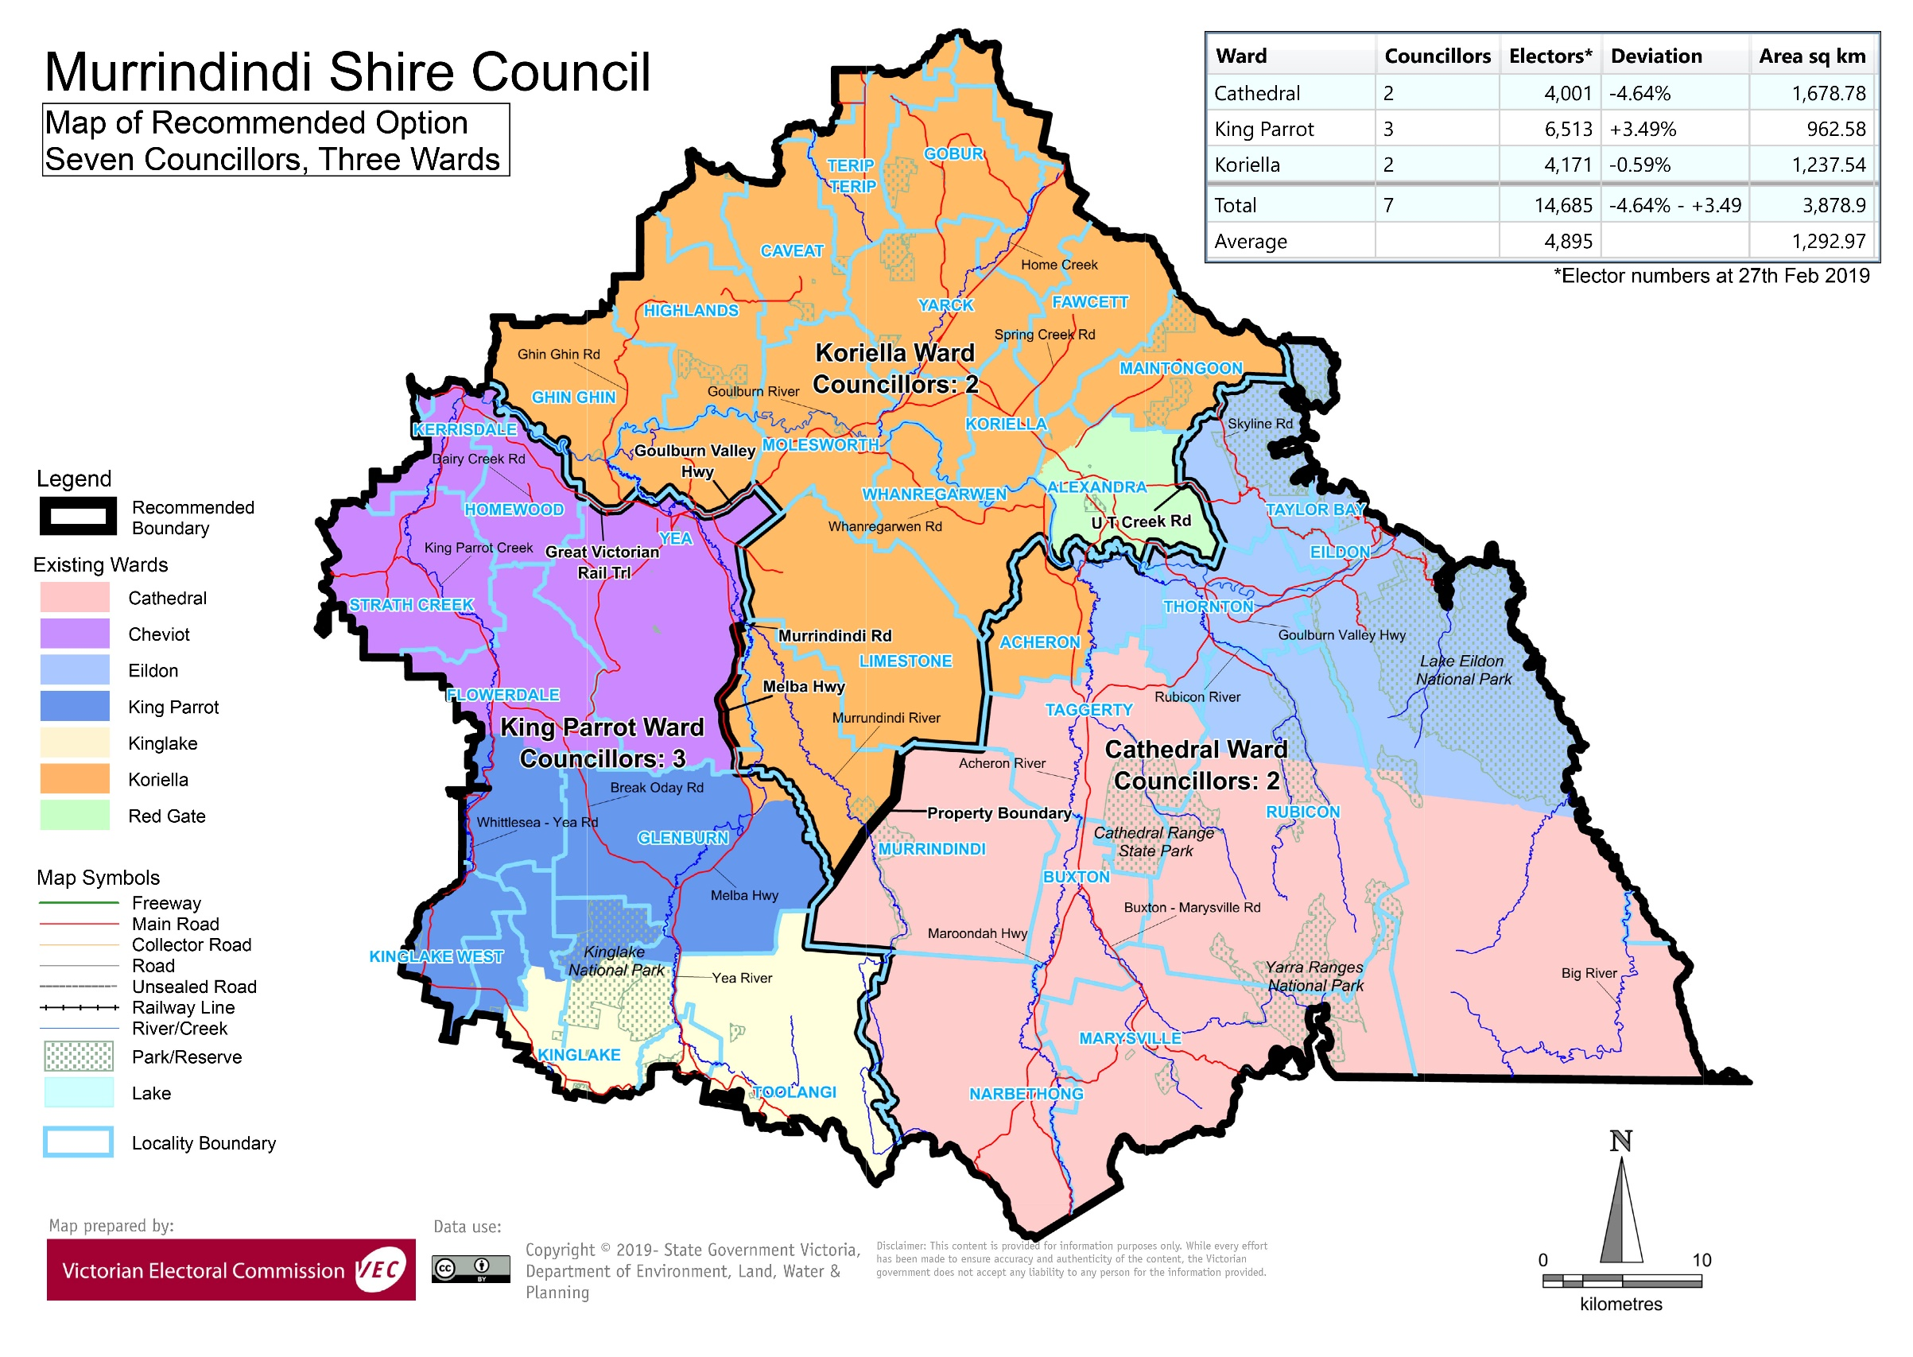

# Appendix 3: Public information program

Advertising

In accordance with the Act, public notices of the review and the release of the preliminary report were placed in the following newspapers:

|  |  |  |
| --- | --- | --- |
| **Newspaper** | **Notice of review** | **Notice of preliminary report** |
| *Herald Sun* | Thursday 6 June | Wednesday 7 August |
| *Alexandra Eildon Marysville Standard* | Wednesday 26 June | Wednesday 28 August |
| *Yea Chronicle* | Wednesday 26 June | Wednesday 28 August |
| *Marysville Triangle News* | Friday 28 June | Friday 23 August |
| *The Local Paper/Murrindindi Shire (circulation)* | Saturday 29 June | Wednesday 28 August |

Media releases

A media release was prepared and distributed to local media to promote the commencement of the review. A further release was distributed with the publication of the preliminary report. A final media advisory was circulated on the publication date of this final report.

Public information sessions

Public information sessions for people interested in the review process were held on:

* Monday 1 July 2019 in Alexandra Council Chambers, 28 Perkins Street, Alexandra
* Tuesday 2 July 2019 at Kinglake Community Centre, 436 Whittlesea-Kinglake Road, Kinglake.

Submissions guide

A submission guide was developed and made available on the VEC website, or in hardcopy on request, throughout the review timeline. The submission guide provided information about the review, the review timeline and how to make submissions to the review.

Online submission tool

An online submission tool was developed and made available during the submission periods of the review. The tool allowed people to make a submission from the VEC website. During the preliminary submission stage, users also had the opportunity to map out their preferred subdivisions through the online submission tool using Boundary Builder. Boundary Builder included real elector numbers so that users could see if their preferred structures and numbers of councillors met the plus-or-minus 10% rule.

VEC website

The VEC website delivered up-to-date information to provide transparency and facilitate public participation during the review process. All public submissions were published on the website.

Email and social media engagement

The VEC delivered an information email campaign targeted at known community groups and communities of interest in the local council area. This included a reminder email at each milestone of the representation review process.

The VEC also published sponsored social media advertising that was geo-targeted to users within the local council area. This included advertising at both the preliminary submission and response submission stages. The total reach of these posts was 1,630 during the preliminary submission stage and 1,795 during the response submission stage.

Council communication resources

The VEC provided the Council with a communication pack that included information on the review in various formats. While the council is encouraged to distribute this information and raise awareness about the review, the VEC is an independent reviewer and all communications resources include reference and links to the VEC website and core materials.

This page has been left intentionally blank

This page has been left intentionally blank

This page has been left intentionally blank

This page has been left intentionally blank

This page has been left intentionally blank

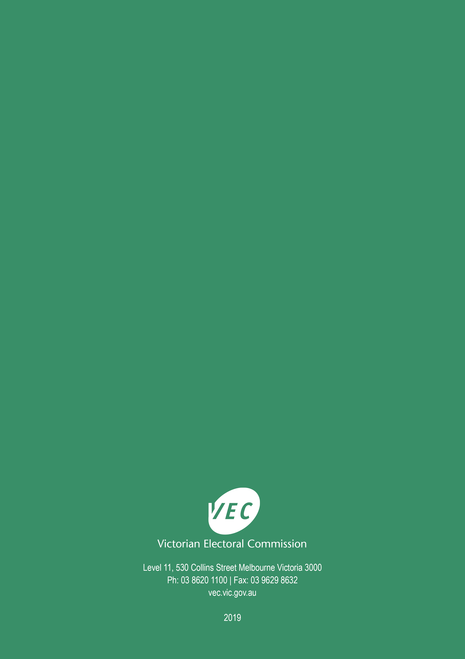

1. Section 219D of the *Local Government Act* *1989.*
2. Section 219D of the *Local Government Act* *1989.*
3. Ibid.
4. .id is a consulting company specialising in population and demographic analysis and prediction information products in most jurisdictions in Australia and New Zealand.
5. Section 5B(1) of the *Local Government Act 1989.*
6. Murrindindi Shire Council and Lake Mountain Alpine Resort Municipal Fire Management Planning Committee, ‘Municipal Fire Management Plan – Murrindindi Shire Council and Lake Mountain’, available from <https://www.murrindindi.vic.gov.au/Your-Council/Publications/Strategies>, accessed 10 October 2019.
7. Australian Bureau of Statistics, ‘2016 Census QuickStats: Murrindindi (S)’, <https://quickstats.censusdata.abs.gov.au/census_services/getproduct/census/2016/quickstat/LGA25620?opendocument>, accessed 10 October 2019.
8. Australian Bureau of Statistics, ‘2016 Census QuickStats’, <https://quickstats.censusdata.abs.gov.au/census_services/getproduct/census/2016/quickstat/036>, accessed 10 October 2019.
9. Murrindindi Shire Council, ‘Business/Industry Overview’, <https://www.murrindindi.vic.gov.au/Your-Business/BusinessIndustry-Overview>, accessed 10 October 2019.
10. Murrindindi Shire Council and Lake Mountain Alpine Resort Municipal Fire Management Planning Committee, loc. cit..
11. Murrindindi Shire Council, loc. cit..
12. Murrindindi Shire Council and Lake Mountain Alpine Resort Municipal Fire Management Planning Committee, loc. cit..
13. Australian Bureau of Statistics, ‘Region Data Summary: Murrindindi (S) (LGA)’, <https://itt.abs.gov.au/itt/r.jsp?databyregion&ref=CTA2#/>, accessed 10 October 2019.
14. Australian Bureau of Statistics, ‘2016 Census QuickStats: Murrindindi (S)’, loc. cit. See also: ‘2016 Census QuickStats: Rest of Vic’.
15. Ibid.
16. Australian Bureau of Statistics, ‘Census of Population and Housing: Socio-Economic Indexes for Areas (SEIFA), Australia, 2016’, <http://www.abs.gov.au/AUSSTATS/abs@.nsf/DetailsPage/2033.0.55.0012016?OpenDocument>, accessed 10 October 2019.
17. Australian Bureau of Statistics, ‘Region Data Summary: Murrindindi (S) (LGA)’, loc. cit. See also ‘Region Data Summary: Rest of Vic. (GCCSA)’.
18. Department of Environment, Land, Water and Planning, ‘Victoria in Future 2019’, <https://www.planning.vic.gov.au/land-use-and-population-research/victoria-in-future>, accessed 10 October 2019.
19. Australian Bureau of Statistics, ‘2016 Census QuickStats: Murrindindi (S)’, loc. cit. See also: ‘2016 Census QuickStats: Rest of Vic’.
20. Aboriginal Victoria, ‘Acknowledgement of Traditional Owners’, <https://www.aboriginalvictoria.vic.gov.au/acknowledgement-traditional-owners>, accessed 10 October 2019.
21. Department of Environment, Land, Water and Planning, loc. cit..
22. The VEC notes that under Option A, the entire Glenburn locality would be included in the proposed King Parrot Ward, not the proposed Koriella Ward.
23. Victorian Electoral Commission, *2016 Local Government Elections Report*, 2017, Figure 9, pp. 26, <https://www.vec.vic.gov.au/files/Report%20on%20the%20conduct%20of%20the%202016%20Local%20Government%20Elections.pdf>
24. No electoral structure will entirely remove the possibility of uncontested (or, indeed, failed) elections.