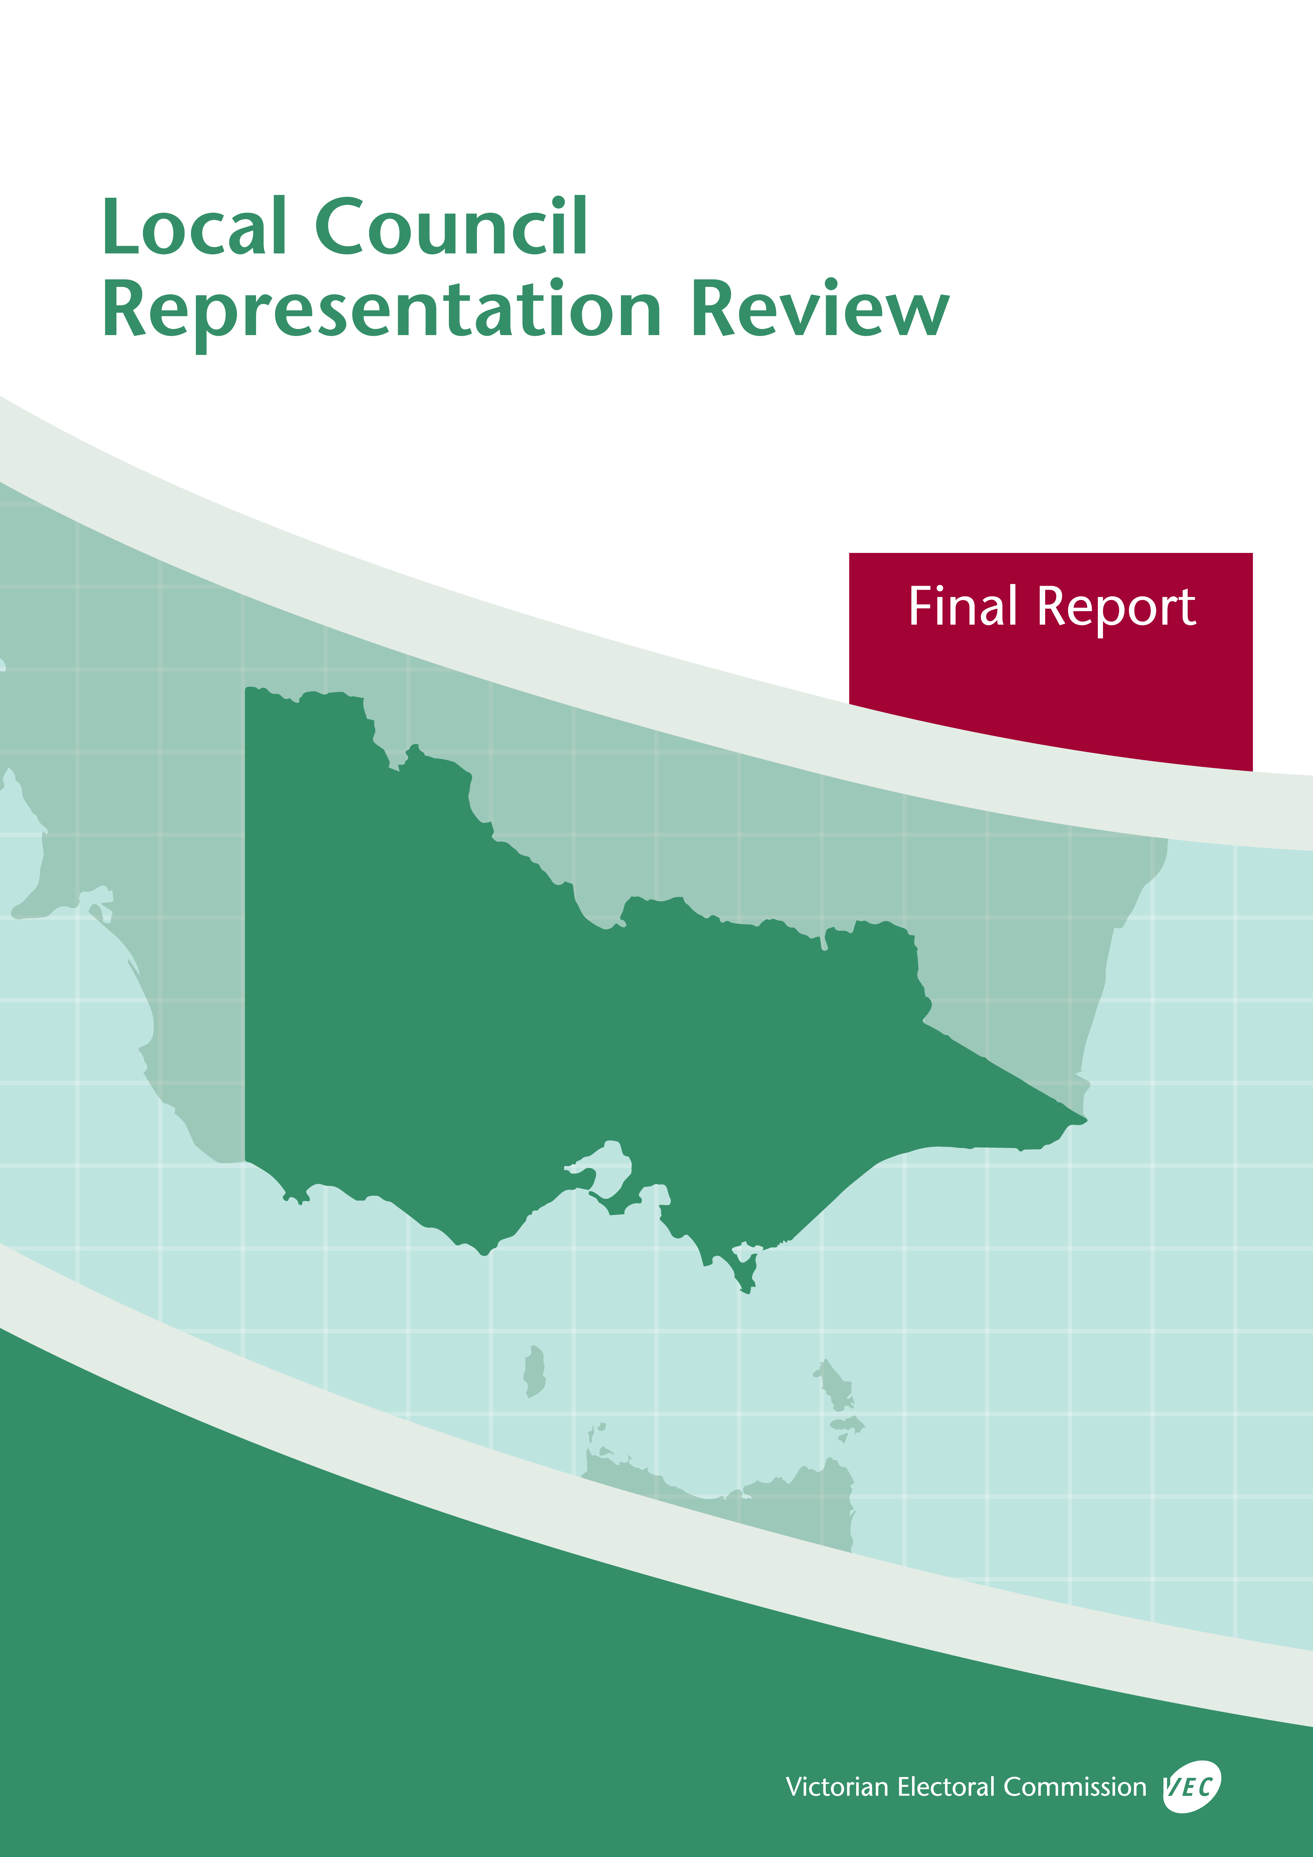

**October 2019**

**Bayside City Council**

© State of Victoria (Victorian Electoral Commission)   
Wednesday 9 October 2019

Version 1



This work, Local Council Representation Review Final Report – Bayside City Council, is licensed under a Creative Commons Attribution 4.0 licence [<http://creativecommons.org/licenses/by/4.0/>]. You are free to share this work under that licence, on the condition that you do not change any content and you credit the State of Victoria (Victorian Electoral Commission) as author and comply with the other licence terms. The licence does not apply to any branding, including Government logos.

Contents

Recommendation 1

Executive summary 2

Background 4

Legislative basis 4

Public engagement 4

The VEC’s principles 5

Developing recommendations 6

Bayside City Council representation review 8

Profile of Bayside City Council 8

Current electoral structure 9

Preliminary submissions 9

Preliminary report 11

Public response 15

Response submissions 15

Public hearing 16

Findings and recommendation 19

The VEC’s findings 19

The VEC’s recommendation 21

Appendix 1: Public involvement 22

Appendix 2: Map 23

Appendix 3: Public information program 25

Recommendation

The Victorian Electoral Commission recommends that Bayside City Council consist of seven councillors elected from three wards, with adjustments to the current ward boundaries (one three-councillor ward and two two-councillor wards).

This recommendation is submitted to the Minister for Local Government as required by the *Local Government Act 1989*.

Please see Appendix 2 for a detailed map of this recommended structure.

Executive summary

The *Local Government Act 1989* (the Act) requires the Victorian Electoral Commission (VEC) to conduct an electoral representation review of each municipality in Victoria before every third council general election.

The purpose of an electoral representation review is to recommend an electoral structure that provides ‘fair and equitable representation for the persons who are entitled to vote at a general election of the Council.’[1] The matters considered by a review are:

* the number of councillors
* the electoral structure of the council (whether the council should be unsubdivided or divided into wards and, if subdivided, the details of the ward boundaries and the number of councillors per ward).

The VEC conducts all reviews based on three main principles:

1. taking a consistent, State-wide approach to the total number of councillors
2. if subdivided, ensuring the number of voters represented by each councillor is within   
   plus-or-minus 10% of the average number of voters per councillor for that local   
   council
3. ensuring communities of interest are as fairly represented as possible.

Current electoral structure

Bayside City Council currently comprises seven councillors elected from three wards (one three‑councillor ward and two two-councillor wards). More information on Bayside City Council and the current electoral structure is available in the council fact sheet on the VEC website at [vec.vic.gov.au](http://vec.vic.gov.au).

Prior to the last representation review in 2007, Bayside City Council was comprised of nine councillors elected from nine single-councillor wards. Visit the VEC website at [vec.vic.gov.au](http://www.vec.vic.gov.au/) to access a copy of the 2007 review final report.

Preliminary submissions

Preliminary submissions opened at the commencement of the current review on Wednesday   
19 June 2019. The VEC received 11 submissions for the representation review of Bayside City Council by the deadline at 5.00 pm on Wednesday 17 July 2019.

Preliminary report

A preliminary report was released on Wednesday 14 August 2019 with the following options for consideration:

* Option A (preferred option)  
  **Bayside City Council consist of seven councillors elected from three wards with** **adjustments to the current ward boundaries (one three-councillor ward and two two-councillor wards).**
* Option B (alternative option)  
  **Bayside City Council consist of seven councillors elected from three wards, retaining the current electoral structure and ward boundaries (one three-councillor ward and two two-councillor wards).**

Response submissions

The VEC received eight submissions responding to the preliminary report by the deadline at   
5.00 pm on Wednesday 11 September 2019.

Public hearing

The VEC conducted a public hearing for those wishing to speak about their response submission at 7.00 pm on Monday 16 September 2019. One person spoke at the hearing.

Recommendation

**The Victorian Electoral Commission recommends that Bayside City Council consist of seven councillors elected from three wards, with adjustments to the current ward boundaries (one three-councillor ward and two two-councillor wards).**

This electoral structure was designated as Option A in the preliminary report. The recommended ward boundaries include a minor adjustment from those designated in Option A in the preliminary report.

Please see Appendix 2 for a detailed map of this recommended structure.

Background

Legislative basis

The Act requires the VEC to conduct a representation review of each local council in Victoria before every third general council election, or earlier if gazetted by the Minister for Local Government.

The Act states that the purpose of a representation review is to recommend the number of councillors and the electoral structure that provides ‘fair and equitable representation for the persons who are entitled to vote at a general election of the Council.’[2]

The Act requires the VEC to consider:

* the number of councillors in a local council
* whether a local council should be unsubdivided or subdivided.

If a local council is subdivided, the VEC must ensure that the number of voters represented by each councillor is within plus-or-minus 10% of the average number of voters per councillor for that local council.[3] On this basis, the review must consider the:

* number of wards
* ward boundaries
* number of councillors that should be elected for each ward.

Public engagement

### Public information program

The VEC conducted a public information program to inform the community of the representation review, including:

* public notices printed in local and State-wide papers
* a public information session to outline the review process and respond to questions from the community
* media releases announcing the commencement of the review and the release of the preliminary report
* a submission guide to explain the review process and provide background information on the scope of the review
* an information email campaign targeted at known community groups and communities of interest in the local council area
* sponsored social media advertising geo-targeted to users within the local council   
  area
* ongoing information updates and publication of submissions on the VEC website.

More information on the VEC’s public information program for the representation review of Bayside City Council can be found at Appendix 3.

### Public consultation

Public input was accepted by the VEC via:

* preliminary submissions at the start of the review
* response submissions to the preliminary report
* a public hearing that provided an opportunity for people who had made a response submission to expand on their submission.

Public submissions are an important part of the review process but are not the only consideration. The VEC ensures its recommendations comply with the Act and are formed through careful consideration of public submissions, independent research, and analysis of all relevant factors.

The VEC’s principles

Three main principles underlie all the VEC’s work on representation reviews:

1. **Taking a consistent, State-wide approach to the total number of councillors.**

The VEC is guided by its comparisons of local councils of a similar size and category to the council under review. The VEC also considers any special circumstances that may warrant the local council having more or fewer councillors than similar local councils.

1. **If subdivided, ensuring the number of voters represented by each councillor is within plus-or-minus 10% of the average number of voters per councillor for that local council.**

This is the principle of ‘one vote, one value’, which is enshrined in the Act. This means that every person’s vote counts equally.

1. **Ensuring communities of interest are as fairly represented as possible.**

Each local council contains a number of communities of interest. Where practicable, the electoral structure should be designed to ensure they are fairly represented, and that geographic communities of interest are not split by ward boundaries. This allows elected councillors to be more effective representatives of the people and interests in their particular local council or ward.

Developing recommendations

The VEC bases its recommendations for particular electoral structures on the following information:

* internal research specifically relating to the local council under review, including data from the Australian Bureau of Statistics and .id[4]; voter statistics from the Victorian electoral roll; and other State and local government data sets
* small area forecasts provided by .id for relevant local council areas
* the VEC’s experience conducting previous electoral representation reviews of local councils and similar reviews for State elections
* the VEC’s expertise in mapping, demography and local government
* careful consideration of all input from the public in written submissions received during the review and via oral submissions at the public hearing
* advice from consultants with extensive experience in local government.

### Deciding on the number of councillors

The Act allows for a local council to have between five and 12 councillors but does not specify how to decide the appropriate number.[5] In considering the number of councillors for a local council, the VEC is guided by the Victorian Parliament’s intention for fairness and equity in the local representation of voters under the Act.

The starting point in deciding the appropriate number of councillors for a local council is comparing the local council under review to other local councils of a similar size and type (Principle 1). Generally, local councils that have a larger number of voters will have a higher number of councillors. Often large populations are more likely to be diverse, both in the nature and number of their communities of interest and the issues of representation.

However, the VEC also considers the particular circumstances of each local council which could justify fewer or more councillors, such as:

* the nature and complexity of services provided by the Council
* geographic size and topography
* population growth or decline
* the social diversity of the local council.

### Deciding the electoral structure

The Act allows for a local council ward structure to be unsubdivided—with all councillors elected ‘at-large’ by all voters—or subdivided into a number of wards.

If the local council is to be subdivided into wards, there are three options available:

1. single-councillor wards
2. multi-councillor wards
3. a combination of single-councillor and multi-councillor wards.

A subdivided electoral structure must be developed with internal ward boundaries that provide for a fair and equitable division of the local council.

The Act allows for wards with different numbers of councillors, as long as the number of voters represented by each councillor is within plus-or-minus 10% of the average number of voters per councillor for that local council (Principle 2). For example, a local council may have one   
three-councillor ward with 15,000 voters and two single-councillor wards each with 5,000 voters. In this case, the average number of voters per councillor would be 5,000.

Over time, population changes can lead to some wards in subdivided local councils having larger or smaller numbers of voters. As part of the review, the VEC corrects any imbalances and considers likely population changes to ensure ward boundaries provide equitable representation for as long as possible.

In considering which electoral structure is most appropriate, the VEC considers the following matters:

* the VEC’s recommendation at the previous representation review and the reasons for that recommendation
* the longevity of the structure, with the aim of keeping voter numbers per councillor within the 10% tolerance for as long as possible (Principle 2)
* communities of interest, consisting of people who share a range of common concerns, such as geographic, economic or cultural associations (Principle 3)
* the number of candidates in previous elections, as outcomes from previous elections indicate that large numbers of candidates can lead to an increase in the number of informal (invalid) votes
* geographic factors, such as size and topography
* clear ward boundaries.

Bayside City Council representation review

Profile of Bayside City Council

Bayside City Council is located within metropolitan Melbourne, approximately 8 kilometres   
south-east of the Melbourne CBD. The Nepean Highway and Frankston railway line form much of the eastern boundary of the local council, while the western boundary is formed by 17 kilometres of Port Phillip Bay coastline. The local council area covers the suburbs of Brighton, Hampton, Hampton East, Sandringham, Black Rock and Beaumaris, and includes parts of Highett and Cheltenham and much of Brighton East.

The City of Bayside is primarily residential with small commercial and industrial areas, golf courses, parks and the Cheltenham Cemetery. The Sandringham and Frankston railway lines and East Brighton tram service the local council. The City contains many well-known metropolitan beaches, including the iconic Brighton Beach Bathing Boxes.

At the 2016 Census, Bayside City Council had a population of 97,087.[6] As of January 2019, there were an estimated 78,937 registered voters for Bayside City Council, with an average of 11,277 voters per councillor. Slow population growth is expected for the local council area over the coming decade, at an approximate rate of 0.8% per annum.[7]

The population is largely affluent with relatively low socio-economic disadvantage. The median personal weekly income for the City of Bayside ($897) is higher than for Greater Melbourne ($673). Likewise, the median household weekly income of $2,145 is also higher compared to   
$1,582 for Greater Melbourne. The unemployment rate for the City of Bayside (4.6%) is lower than the rates for both Greater Melbourne (6.8%) and Victoria (6.6%),[8] and the City has one of the lowest levels of disadvantage of any Victorian local council. Within the local council area, Hampton East and Highett are experiencing higher levels of disadvantage than the rest of the local council area, while Black Rock and Beaumaris are experiencing the least disadvantage.[9]

The City of Bayside has a relatively older population, with a higher median age (44 years) compared to that of Greater Melbourne (36 years) and a higher proportion of people aged over 45 years compared to Greater Melbourne.[10] The City’s population is expected to age further in the future.[11]

Although there is some linguistic and cultural diversity within the local council area, the population is less diverse compared to Greater Melbourne overall. The City of Bayside has higher proportions of people born in Australia (69% compared to 59.8%) and who speak only English at home (80.2% compared to 62%).[12] Other languages spoken at home in the City of Bayside include Greek (2.2%), Mandarin (2.1%), Russian (1.3%), Italian (1.3%) and German (0.8%). Of residents born overseas, the largest groups are from England (6%), China (1.8%), New Zealand (1.8%), South Africa (1.2%) and the United States of America (0.9%).[13]

The City of Bayside also has a lower proportion of Aboriginal and Torres Strait Islander peoples in the population (0.2%) compared to Greater Melbourne (0.5%). The Boonwurrung people are the original inhabitants of the land now known as the City of Bayside.[14]

Current electoral structure

Bayside City Council currently comprises seven councillors elected from three wards (one three‑councillor ward and two two-councillor wards). More information on Bayside City Council and the current electoral structure is available in the council fact sheet on the VEC website   
at [vec.vic.gov.au](http://vec.vic.gov.au).

Prior to the last representation review in 2007, Bayside City Council was comprised of nine councillors elected from nine single-councillor wards. Visit the VEC website at [vec.vic.gov.au](http://www.vec.vic.gov.au/) to access a copy of the 2007 review final report.

Preliminary submissions

At the close of submissions on Wednesday 17 July 2019, the VEC had received 11 submissions for the representation review of Bayside City Council. A list of people who made a preliminary submission can be found in Appendix 1. Submissions were received from a range of stakeholders including individuals, community organisations and the Bayside City Council. The submissions were made available on the VEC website.

### Number of councillors

Five preliminary submissions supported maintaining the number of councillors on Bayside City Council at seven. Submitters supporting the current number of councillors generally thought that seven councillors was an appropriate number for the local council and that an increased number of councillors was not required.

Three submissions proposed increasing the number of councillors to nine to enable their preferred electoral structure. An additional submitter proposed increasing the number of councillors to nine or 10, with the aim of increasing local representation across the local council area. One submission supported two different electoral structures, one of which allowed seven councillors while the other required an increase to nine councillors.

One preliminary submission did not indicate a preference regarding the number of councillors.

### Electoral structure

All preliminary submissions supported a subdivided electoral structure. Of these, two submitters also supported an unsubdivided electoral structure.

Five submitters supported the current electoral structure and distribution of councillors across wards, arguing that the existing electoral structure works well for Bayside City Council. Supporters of the current electoral structure believed that the current wards provide appropriate representation for the different parts of the City of Bayside, reflect the different historical periods of construction and development within the City, and correspond with the different environmental management needs of the local council area.

Three submitters (Ian Farrow, Derek Screen and Bayside City Council) supporting the current electoral structure also proposed minor boundary improvements. Two submitters suggested that ward boundaries would be simplified if Dendy Street formed the entire boundary between Northern and Central Wards, and Bay Road formed the entire boundary between Central and Southern Wards. A third submitter (Bayside City Council) also proposed that Bay Road form most of the boundary between Southern and Central Wards, with the exception of a small deviation along Bluff Road, Holloway Road and George Street, and another in the vicinity of Sandringham Station. The changes suggested by Bayside City Council were intended to accommodate expected growth within the local council area and address concerns that the Sandringham activity centre is currently split by a ward boundary. Two submitters argued in favour of keeping the Pennydale neighbourhood of Cheltenham within one ward, and Bayside City Council argued that the Cheltenham/Pennydale area was suited for inclusion within the Southern Ward.

Four preliminary submissions supported the existing three ward electoral structure, but with an increase to nine councillors. All were supporters of the proportional representation system and felt representation would be further improved if the three wards were each represented by an equal number of councillors.

Some support for single-councillor wards was expressed in two submissions, while four submissions opposed single-councillor wards. Support for single-councillor wards was based on a desire to improve local representation, however one supporter also noted that single-councillor wards had not worked well in the past for Bayside City Council. Those opposed to a return to single-councillor wards argued that it would be a ‘backwards step’ which would be less democratic and less representative of the different communities in the local council area. Opponents of single-councillor wards argued that they would reduce choice for voters and increase the risk of uncontested elections, which were a concern under the single-councillor electoral structure that was in place prior to the 2008 general election. It was also argued that single-councillor wards would make it easier for organised groups to gain a majority of seats on the Council. The Proportional Representation Society of Australia (Victoria-Tasmania) Inc. (PRSA) also argued that a single-councillor ward structure is the least favourable for voters as this structure maximises the number of wasted votes at an election, vacancies must be filled via a by‑election, meaningful and sustainable ward boundaries are difficult to establish, and communities of interest are not necessarily geographic.

In addition to supporting a subdivided electoral structure, two submitters expressed support for a change to an unsubdivided electoral structure. One submitter supported an unsubdivided electoral structure with seven councillors, while one submitter felt that an increased number of councillors would be needed. Supporters of an unsubdivided electoral structure argued that this was the fairest and most democratic option for voters, as councillors would be accountable to all voters within the local council, and representation for communities of interest dispersed across the local council area may improve. It was also argued that unsubdivided electoral structures reduce the risk of uncontested elections, help foster a council-wide approach to representation, provide voters with the greatest choice of councillors to discuss issues with, and remove confusion about the location of ward boundaries. Two submitters specifically opposed an unsubdivided electoral structure, arguing that it would not be suitable for a metropolitan local council, and would not provide adequate representation for different environmental groups and environmental needs of distinct parts of the local council area.

Preliminary report

A preliminary report was released on Wednesday 14 August 2019. The VEC considered public submissions and research findings when formulating the options presented in the preliminary report.

### Number of councillors

Victorian metropolitan local councils with a similar size and number of voters to Bayside City Council generally also have seven councillors, although Bayside City Council is near the top of the list of comparative local councils, which prompts consideration of increasing the number of councillors.

When considering the appropriate number of councillors for a local council, the VEC reviews population data and assesses other factors which may warrant an increase or decrease in the number of councillors, such as projected population growth or special circumstances relating to distinct communities of interest.

Bayside City Council is experiencing some population growth, although this is not significant enough to consider increasing the number of councillors until at least the next scheduled electoral representation review. Although the population is ageing, the population is largely socially and linguistically homogenous, and the local council area overall has the second-lowest level of disadvantage of all local councils in Victoria.[15] Industries and land use within the local council area are also reasonably homogenous: Bayside City Council is largely residential, with a small industrial area, small local retail centres, as well as areas of coastal parkland.

When compared to other local councils of similar size and voter numbers (such as Yarra City Council), Bayside City Council has less complexity in terms of land use and social issues, resulting in comparatively smaller workloads for councillors. Increasing the number of councillors to eight would reduce the average number of voters per councillor to 9,867, which would be on par with councils of similar size and voter numbers. However, preliminary submitters did not indicate a desire to increase to eight councillors and there was some opposition to an even number of councillors. Increasing the number of councillors to nine would reduce the average number of voters per councillor to 8,771, which is significantly below that of any other metropolitan local council.

Although five submissions supported an increased number of councillors, four of these submitters did not provide substantial reasons for why there was a specific community need for increased representatives on Bayside City Council. Those in support of more councillors largely called for this increase to improve the system of proportional representation within the   
local council.

Overall, no special circumstances have arisen in Bayside City Council since it was last reviewed in 2007 that would support an increase in the number of councillors. For these reasons, the VEC concentrated its modelling on seven-councillor options.

### Electoral structure

The VEC found that, based on current and projected voter information and preliminary submissions, retaining the current electoral structure remains a viable option for Bayside City Council. The majority of preliminary submissions also supported a three-ward, multi-councillor electoral structure for Bayside City Council, although some preliminary submissions suggested modifications to the existing electoral structure or a different electoral structure entirely. Each suggestion was examined by the VEC to test its viability.

The VEC considered an unsubdivided electoral structure, however concerns were raised that a move to this structure would likely result in increased levels of informal voting at elections. The total number of candidates seen at the last three elections for Bayside City Council has ranged from 33 to 48, which would result in a lengthy ballot paper under an unsubdivided electoral structure. Longer ballot papers can be confusing for voters and more difficult for voters to fill out correctly, leading to higher levels of informal voting through voter error.[16] As a result of these concerns, the VEC did not consider an unsubdivided electoral structure to be appropriate for Bayside City Council.

The VEC also considered different single-councillor ward arrangements and found that these electoral structures did not provide improved representation over the existing multi-councillor ward structure. Due to the need to balance voter-to-councillor ratios across wards,   
single-councillor ward boundaries were somewhat arbitrary, tended to split communities such as suburbs and neighbourhoods across multiple wards, and were likely to be confusing for voters to identify. Also, because single-councillor wards are more sensitive to population changes than multi-councillor wards, there was some risk a single-councillor ward structure would not remain viable through to the next scheduled representation review. As the VEC did not consider that single-councillor wards would improve representation for voters within Bayside City Council, and as there was minimal support for single-councillor wards within preliminary submissions, electoral structures based on single‑councillor wards were not put forward for further consultation.

After modelling alternative electoral structures, the VEC found that the current electoral structure continues to be the strongest option for fair and equitable representation in Bayside City Council.

The VEC put forward the current electoral structure, with adjusted boundaries as its preferred option (Option A). The VEC took into account the ward boundary modifications suggested by three submitters (Mr Farrow, Mr Screen and Bayside City Council) when adjusting the existing boundaries and considers that these adjustments improve the ward boundaries of the existing electoral structure. In Option A, Dendy Street formed the boundary between Northern Ward and Central Ward, including more of Brighton East in Northern Ward and providing a simpler and clearer ward boundary. Most of the boundary between Central and Southern Wards was formed by Bay Road, with a minor deviation at the western end to include the entire Sandringham activity within Central Ward. Option A also included Pennydale, which is a neighbourhood in Cheltenham, in Southern Ward, keeping this community intact and incorporating nearly all of Cheltenham into Southern Ward. The improved ward boundaries also enabled two small shopping areas in Sandringham and Brighton to no longer be divided across wards. Option A also accounts for projected population change throughout the local council area and provides a substantial buffer to absorb growth predicted for Central Ward. Overall, the VEC considered that Option A improved the existing electoral structure while minimising disruption to voters.

The VEC put forward the current electoral structure, with no changes, as Option B. The VEC observed that current and projected voter-to-councillor ratios balanced well in this model, and that a three-ward structure was supported by many preliminary submissions. Although the current electoral structure has certain drawbacks that are resolved by Option A, the VEC considered that Option B provided continuity for voters and continued to provide good representation for the different areas of Bayside City Council.

### Options

After careful consideration, the VEC put forward the following options:

* Option A (preferred option)  
  **Bayside City Council consist of seven councillors elected from three wards with adjustments to the current ward boundaries (one three-councillor ward and two two-councillor wards).**
* Option B (alternative option)  
  **Bayside City Council consist of seven councillors elected from three wards, retaining the current electoral structure and ward boundaries (one three-councillor ward and two two-councillor wards).**

Public response

Response submissions

The VEC accepted submissions responding to the preliminary report from Wednesday 14 August 2019 until 5.00 pm on Wednesday 11 September 2019. The VEC received eight response submissions. A list of people who made a response submission can be found in Appendix 1. Table 1 indicates the level of support for each option.

|  |  |  |
| --- | --- | --- |
| Preferences expressed in response submissions | | |
| **Option A** | **Option B** | **Other** |
| 6 | 1 | 1 |

Six response submissions supported Option A. The main argument put forward in favour of Option A was that this model was the most favourable as it retained the existing electoral structure which works well, while also making minor practical improvements with minimal impact to voters. Supporters of Option A argued that the current ward boundaries had caused confusion, whereas those of Option A were simpler and easier to identify.

One submitter reasoned that although the voter-to-councillor ratios of Option A deviated further from zero than those of Option B, all wards within Option A were still within the legislated   
plus-or-minus 10% tolerance. One submitter also argued that the current ward boundaries had not catered for expected population growth in Central and Southern Wards, however the VEC notes that the current and projected voter-to-councillor ratios of all wards in Option B are sustainable through to the next scheduled representation review.

In its submission, Bayside City Council indicated support for Option A and also expressed a desire for a minor boundary adjustment to this model. Bayside City Council suggested the western end of the ward boundary between Central and Southern Wards be shifted to follow the northern and eastern borders of the Sandringham activity centre’s commercial core. The Council argued that the adjusted boundary would better reflect communities of interest within the local council area. The Council reasoned that this would place the Sandringham Village Major Activity Centre within Southern Ward, ensuring that each ward would retain at least one major activity centre that would attract population growth. The Council also argued that the VEC’s suggested boundary along Tennyson Street and Gladstone Street was unfavourable, as it would split these residential streets across two wards and be confusing for voters.

One response submission supported Option B. Michael Norris stated that the ward boundaries of Option A would result in Southern Ward being the only ward without a major activity centre, and the only ward with inland bushland reserves. Mr Norris argued that this would isolate Southern Ward from the other wards, and that Option B was more favourable as it was important for there to be shared interests between the wards in the local council.

The PRSA did not indicate support for either Option A or Option B. Instead, the PRSA reiterated its preference for either a seven-councillor unsubdivided electoral structure, or a multi-councillor electoral structure consisting of three wards with three councillors per ward. These electoral structures were considered previously by the VEC when preparing the preliminary report and were not put forward as options.

One submitter (Adam Newman) suggested alternative ward names for Bayside City Council. These were:

* ‘Brighton Ward’ for the ward currently known as Northern Ward
* ‘Hampton Ward’ for the ward currently known as Central Ward
* ‘Beaumaris Ward’ for the ward currently known as Southern Ward.

Public hearing

The VEC conducted a public hearing for those wishing to speak about their response submission at 7.00 pm on Monday 16 September 2019 in the Council Chambers, Civic Centre, 15 Boxshall Street, ​Brighton. One person, Deputy Mayor Councillor Rob Grinter, spoke in support of Option A on behalf of Bayside City Council. Cr Grinter covered similar topics to those outlined in the response submission from Bayside City Council.

Cr Grinter indicated that Bayside City Council supported the retention of a structure similar to the current electoral structure, consisting of seven councillors across three wards (two two-councillor wards and one three-councillor ward). The Deputy Mayor argued that Bayside City Council had functioned well under this electoral structure since it was introduced in 2008, and that this electoral structure was the most efficient, productive, appropriate and effective structure for representation in Bayside City Council. Cr Grinter also noted that most submissions had also supported retaining a multi-councillor structure composed of three wards.

Cr Grinter indicated that although Bayside City Council wished to retain a three-ward electoral structure, it did not support Option B. Cr Grinter explained that although Option B retains the current model with no boundary changes, that the current boundaries had caused confusion and had not catered for the expected population growth in Central and Southern Wards. Cr Grinter indicated that confusion was largely caused by the boundary between Central and Southern Wards, in the vicinity of George Street, Sandringham and Tulip Street, Cheltenham.

Cr Grinter stated that Option A was preferred as it essentially retained the existing electoral structure while also improving the current ward boundaries. The Deputy Mayor argued that using Dendy Road and Bay Street provided boundaries that were appropriate, simple and easy to identify. Cr Grinter indicated other positives of Option A were that communities of interest were maintained within wards, shopping centres were not split across wards, and that the distribution of voters across wards would provide a buffer that would absorb the population growth expected in Central Ward.

Cr Grinter also indicated that Bayside City Council believed that an increased number of councillors was not required for the local council, as the land use and social issues within the local council area were less complex than other local councils of similar size and number of voters. On behalf of Council, the Deputy Mayor stated that increasing the number of councillors to eight would result in an average number of voters per councillor that was similar to comparable local councils, but argued that an even number of councillors was not desirable as this may result in tied votes during the Council’s decision-making requiring the use of the Mayor’s casting vote.

Cr Grinter stated that the Council did not support a return to single-councillor wards as its experience under the previous single-councillor ward electoral structure (in place until 2008) had not been positive. Cr Grinter explained that single-councillor wards had led to confusion in the community about the location of ward boundaries, with voters unsure which ward they were in or who their councillor was. Cr Grinter argued that under the single-councillor ward structure, voters had limited choice of councillors to discuss issues with and this had resulted in a siloed mentality in the community which had made it more difficult for councillors to achieve action on Council matters.

Cr Grinter re-stated that although the Council supported Option A, it believed Option A would be improved with a minor adjustment to the boundary between Central and Southern Wards, in the vicinity of the Sandringham activity centre. This boundary adjustment would ensure that the Sandringham activity centre remained entirely within Southern Ward and that residential streets (Tennyson Street and Gladstone Street) were not split across Central and Southern Wards.   
Cr Grinter stated that if the suggested boundary amendment was incorporated into Option A, this electoral structure would maintain communities of interest and result in the best possible outcome for the local council.

In response to questions from the VEC’s public hearing panel, Cr Grinter indicated that Bayside City Council wished to ensure each ward retained at least one major activity centre and that the electoral structure works well with the current spread of activity centres across wards. Also, that the Sandringham activity centre, along with most of the suburb of Sandringham, was considered by the Council and the community to be part of Southern Ward, with a clear Southern Ward identity and strong connections to Beaumaris and Black Rock. Cr Grinter indicated that, if Sandringham activity centre were to be incorporated into Central Ward, that this would be a dramatic change.

In response to questions about Bayside City Council’s suggested boundary adjustment,   
Cr Grinter indicated that the Council believed the suggested boundaries were the known delineation of the Sandringham activity centre’s commercial area and would be less confusing to voters than the boundaries put forward by the VEC, which split residential streets. Cr Grinter acknowledged that it is difficult to define where the activity centre ends, but argued that the Council believed its alternative boundary placement would capture the whole Sandringham activity centre, including shops and council services, within Southern Ward.

Findings and recommendation

The VEC’s findings

### Number of councillors

Compared to other local councils of similar size and number of voters, Bayside City Council sits near the top of the list of comparative seven-councillor local councils. However, the VEC’s analysis and information provided in submissions did not identify any special circumstances that would support a recommendation to change the number of councillors. The City of Bayside’s population is largely socially and linguistically homogenous, and the local council area has less complexity in terms of land use and social issues, suggesting councillor workloads are smaller than comparative local councils. In addition, the local council area is not expected to experience significant population growth between now and the next scheduled representation review prior to the 2032 local government elections. Therefore, the VEC considers that seven continues to be the most appropriate number of councillors for Bayside City Council.

### Electoral structure

The VEC considers Option A to be the best option for ensuring fair and equitable representation for all voters across Bayside City Council.

In 2007, the VEC recommended that Bayside City Council change to an electoral structure composed of seven councillors distributed across three multi-councillor wards. The current electoral structure has been in place since the 2008 general election and appears to be functioning well.

The three wards provide representation for the northern, central and southern areas of the local council, and the multi-councillor ward structure provides opportunity for a variety of groups within the community to gain representation on the Council. The current voter‑to‑councillor ratios are evenly balanced across wards, and projections indicate that these wards will remain within the plus-or-minus 10% tolerance over the next decade. At Bayside City Council’s 2008, 2012 and 2016 general elections, the number of candidates per ward ranged from nine to 20, resulting in competitive elections and providing voters in all wards with a wide choice of candidates.

There was minimal call for change to the electoral structure in submissions to the current review. Most submitters supported retaining a three-ward electoral structure, with some suggestions for minor improvements to ward boundaries. Bayside City Council itself indicated satisfaction with the current electoral structure through its written submissions and the Deputy Mayor’s presentation at the public hearing.

Although the existing electoral structure appears to be functioning well, the VEC’s analysis and information provided in submissions indicated that the current electoral structure could be improved through adjustments to the existing ward boundaries. As such, the VEC put forward a model with boundary adjustments as its preferred Option A in the preliminary report, with the current electoral structure and ward boundaries as Option B. The VEC considers that Option A improves ward boundaries of the existing electoral structure by providing boundaries that are simpler and easier to identify than the current ward boundaries, that unite two small shopping areas split by current ward boundaries, while also minimising disruption to voters.

Most response submissions also supported Option A. Bayside City Council’s submission supported the use of Dendy Street and Bay Road as ward boundaries, although its response submission and presentation at the public hearing put forward a minor boundary adjustment to further improve Option A. The Council maintained that the Sandringham activity centre had a Southern Ward identity, was more appropriately placed within Southern Ward, and that placing the activity centre in Central Ward would be a dramatic change for the electoral structure and community perceptions. The Council also argued that the ward boundary along Tennyson Street and Gladstone Street in Option A was not favourable as it splits these residential streets across two wards.

The VEC considers the reasoning behind Bayside City Council’s suggested boundary adjustment to be valid. The VEC also notes that one response submitter supported Option B, partly because Option A would result in the Sandringham activity centre being in Central Ward rather than Southern Ward. In the interests of minimising disruption and maintaining existing communities of interest in the local council area, minor ward boundary adjustments have been made to the ward boundaries proposed in Option A (described below). The VEC considers that the ward boundaries of this option are improved through these adjustments.

**Minor boundary adjustments to Option A**

The VEC has made a minor change to the ward boundary between Central and Southern Wards, in the vicinity of the Sandringham activity centre. This is in response to information provided by Bayside City Council in its response submission and its presentation at the public hearing, and acknowledges concern raised in the response submission from Mr Norris.

Travelling from west to east, the adjusted ward boundary follows:

1. east along Abbott Street, Sandringham (the current ward boundary) until Harston Street
2. south along Harston Street to the entrance of 10 Harston Street (Sandringham bus depot)
3. south along the property boundary between 10 Harston Street (Sandringham bus depot) and 2 Sandringham Road, until reaching the unnamed laneway abutting the bus depot (known as ‘Kellys Lane’)
4. east along the unnamed laneway (known as ‘Kellys Lane’) until Trentham Street
5. south along Trentham Street until Bay Road
6. east along Bay Road.

This adjustment further minimises the impact of changing to Option A, with the commercial core of the Sandringham activity centre, as defined by Bayside City Council, remaining within Southern Ward. As a result of this adjustment, the impact of these ward boundary changes is:

* 3,096 voters who are currently in Central Ward (9.5% of Central Ward voters) would be in either Northern Ward or Southern Ward
* 1,317 voters who are currently in Southern Ward (5.7% of Southern Ward voters) would be in Central Ward
* a total of 4,413 voters in Bayside City Council (5.6% of current enrolment) would be impacted.

Although the voter-to-councillor ratios of this recommended model deviate further from zero compared to those of Option A as it appeared in the preliminary report, the ratios are still currently within the legislated plus-or-minus 10% tolerance and are projected to be sustained over time in response to population growth in Central Ward.

**Ward names**

The VEC acknowledges the suggested changes to ward names put forward by one response submitter. While input regarding ward names is welcomed, there was no significant support for changing the ward names and the VEC considers that changing the ward names when there is little community support for this would only cause unnecessary confusion for voters. As such, the VEC considers it appropriate to retain the existing ward names for Bayside City Council. Should the community prefer alternative names to those provided, the Act provides for ward names to be altered by an Order in Council.

The VEC’s recommendation

**The Victorian Electoral Commission recommends that Bayside City Council consist of seven councillors elected from three wards with adjustments to the current ward boundaries (one three-councillor ward and two two-councillor wards).**

This recommendation is submitted to the Minister for Local Government as required by the *Local Government Act 1989*. The final recommended electoral structure includes a minor adjustment to one of the ward boundaries from what was designated as Option A in the preliminary report.

Please see Appendix 2 for a detailed map of this recommended structure.

# Appendix 1: Public involvement

Preliminary submissions

Preliminary submissions were made by:

Bayside City Council

Beaumaris Conservation Society Inc.

Farrow, Ian

Howard, Kevin

Morey, Stephen

Proportional Representation Society of Australia (Victoria-Tasmania) Inc.

Raverty, Susan

Saunders, Robert

Screen, Derek

Symmons, Scott

Young, Denis

Response submissions

Response submissions were made by:

Bayside City Council

Farrow, Ian

Lea, David

Newman, Adam

Norris, Michael

Proportional Representation Society of Australia (Victoria-Tasmania) Inc.

Saunders, Robert

Screen, Derek

Public hearing

The following individuals spoke at the public hearing:

Grinter, Robert (Deputy Mayor), on behalf of Bayside City Council

# Appendix 2: Map

The map is provided on the next page.

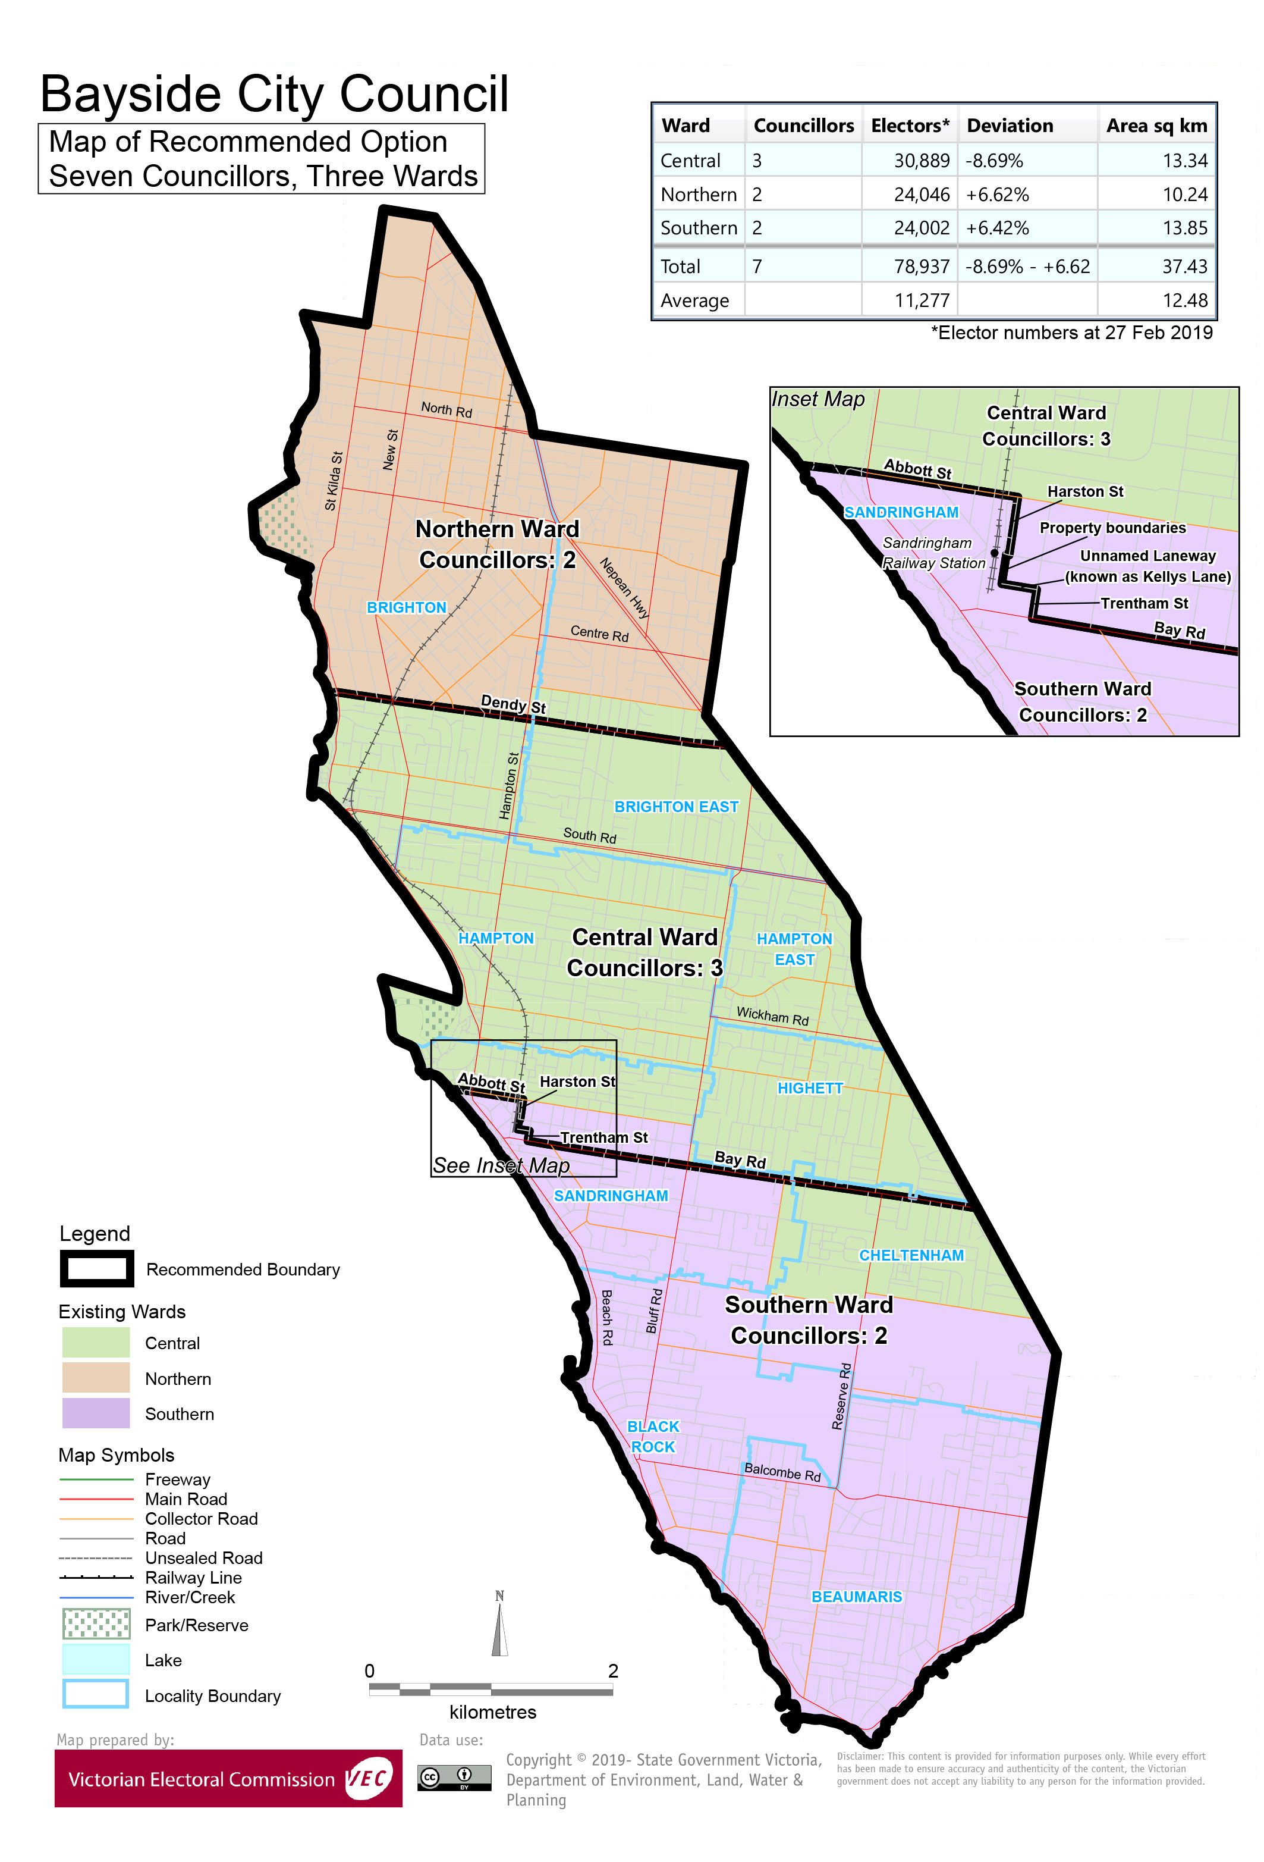

# Appendix 3: Public information program

Advertising

In accordance with the Act, public notices of the review and the release of the preliminary report were placed in the following newspapers:

|  |  |  |
| --- | --- | --- |
| **Newspaper** | **Notice of review** | **Notice of preliminary report** |
| *Herald Sun* | Thursday 6 June | Wednesday 7 August |
| *Bayside Leader* | Tuesday 11 June | Tuesday 13 August |

Media releases

A media release was prepared and distributed to local media to promote the commencement of the review. A further release was distributed with the publication of the preliminary report. A final media advisory was circulated on the publication date of this final report.

Public information session

A public information session for people interested in the review process was held on Monday   
17 June 2019 at the Bayside Corporate Centre, 76 Royal Avenue, Sandringham.

Submissions guide

A submission guide was developed and made available on the VEC website, or in hardcopy on request, throughout the review timeline. The submission guide provided information about the review, the review timeline and how to make submissions to the review.

Online submission tool

An online submission tool was developed and made available during the submission periods of the review. The tool allowed people to make a submission from the VEC website. During the preliminary submission stage, users also had the opportunity to map out their preferred subdivisions through the online submission tool using Boundary Builder. Boundary Builder included real elector numbers so that users could see if their preferred structures and numbers of councillors met the plus-or-minus 10% rule.

VEC website

The VEC website delivered up-to-date information to provide transparency and facilitate public participation during the review process. All public submissions were published on the website.

Email and social media engagement

The VEC delivered an information email campaign targeted at known community groups and communities of interest in the local council area. This included a reminder email at each milestone of the representation review process.

The VEC also published sponsored social media advertising that was geo-targeted to users within the local council area. This included advertising at both the preliminary submission and response submission stages. The total reach of these posts was 7,562 during the preliminary submission stage and 8,134 during the response submission stage.

Council communication resources

The VEC provided the Council with a communication pack that included information on the review in various formats. While the council is encouraged to distribute this information and raise awareness about the review, the VEC is an independent reviewer and all communications resources include reference and links to the VEC website and core materials.

This page has been left intentionally blank



1. Section 219D of the *Local Government Act* *1989.*
2. Section 219D of the *Local Government Act* *1989.*
3. Ibid.
4. .id is a consulting company specialising in population and demographic analysis and prediction information products in most jurisdictions in Australia and New Zealand.
5. Section 5B(1) of the *Local Government Act 1989.*
6. Australian Bureau of Statistics, ‘2016 Census QuickStats - Bayside (C)’, <https://quickstats.censusdata.abs.gov.au/census_services/getproduct/census/2016/quickstat/LGA20910?opendocument>, accessed 30 September 2019.
7. Department of Environment, Land, Water and Planning, ‘Victoria in Future 2019’, <https://www.planning.vic.gov.au/land-use-and-population-research/victoria-in-future>, accessed 30 September 2019.
8. Australian Bureau of Statistics, ‘2016 Census QuickStats - Bayside (C)’, loc. cit..   
   See also: ‘2016 Census QuickStats - Greater Melbourne’.
9. id, ‘City of Bayside: SEIFA by profile area’, <https://profile.id.com.au/bayside/seifa-disadvantage-small-area>, accessed 30 September 2019.
10. Australian Bureau of Statistics, ‘2016 Census QuickStats - Bayside (C)’, loc. cit..   
    See also: ‘2016 Census QuickStats – Greater Melbourne’.
11. Department of Land, Water and Planning, ‘Victoria in Future 2016: Bayside (C)’, loc. cit.
12. Australian Bureau of Statistics, ‘2016 Census QuickStats - Bayside (C)’, loc. cit..   
    See also: ‘2016 Census QuickStats – Greater Melbourne’.
13. Australian Bureau of Statistics, ‘2016 Census QuickStats - Bayside (C)’, loc. cit..
14. Boon Wurrung Foundation, ‘Boon Wurrung Foundation’, [http://www.boonwurrung.org](http://www.boonwurrung.org/), accessed 30 September 2019.
15. .id, ‘City of Bayside: SEIFA by Local Government Area’, <https://profile.id.com.au/bayside/seifa-disadvantage>, accessed 30 July 2019.
16. *2016 Local Government Elections Report*, 2017, pp. 26, <https://www.vec.vic.gov.au/files/Report%20on%20the%20conduct%20of%20the%202016%20Local%20Government%20Elections.pdf>