ELECTORAL REPRESENTATION REVIEW
Central Goldfields Shire Council
Final Report
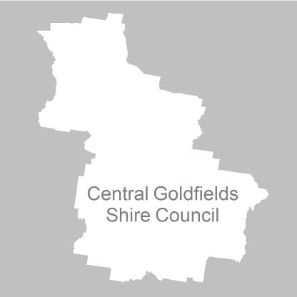
31 May 2011

Contents
Recommendation 3
Background 4
Legislative basis 4
The VEC and Electoral Representation Reviews 4
Profile of Central Goldfields Shire 4
Current electoral structure 5
The electoral representation review process 5
VEC research 6
Public involvement 6
Preliminary report 8
Preliminary submissions 8
Preliminary options 9
Public response 11
Response submissions 11
Analysis of submissions 11
Public hearing 12
Findings and Recommendation 13
Recommendation 16
Appendix 1: List of submitters 17
Appendix 2: Map 18

Recommendation
The Victorian Electoral Commission (VEC) recommends that Central Goldfields Shire Council consists of seven councillors to be elected from one four-councillor ward and three single-councillor wards, with small adjustments to the current boundaries for population change.

Background

Legislative basis
The Local Government Act 1989 (the Act) requires the VEC to conduct an Electoral Representation Review of each municipality in Victoria at least every 12 years. The Act specifies that the purpose of a representation review is to recommend to the Minister for Local Government the number of councillors and the electoral structure for a municipality, which will provide ‘fair and equitable representation for the persons who are entitled to vote at a general election of the Council’.
The Act requires the VEC, as part of an Electoral Representation Review, to consider:
- the number of councillors in a municipality;
- whether a municipality should be unsubdivided or subdivided;
- if it should be subdivided, whether ward boundaries:
  - provide for fair and equitable division of the municipality;
  - ensure equality of representation through the number of voters being represented by each councillor being within 10 per cent of the average number of voters represented by all councillors; and,
- if it should be subdivided, the number of councillors that should be elected for each ward.

The VEC and Electoral Representation Reviews
The VEC has conducted Electoral Representation Reviews since 2004 on appointment by local councils. The Act was changed in 2010 to define the VEC as the only agency authorised to undertake the reviews.
The VEC drew on its experience in mapping and boundary modelling and also engaged consultants with experience in local government to provide advice on specific local representation issues during the review.

Profile of Central Goldfields Shire
Central Goldfields Shire was formed in 1995 by the amalgamation of the City of Maryborough and parts of the Shires of Tullaroop, Bet Bet, Talbot and Clunes.
At the 2006 census, the Shire recorded a population of 12,325 people. According to the Department of Planning and Community Development’s Victoria in Future projections, Central Goldfields Shire’s population will grow by 3.33% by 2020.

Current electoral structure
The last Electoral Representation Review for Central Goldfields Shire Council took place in 2004–2005. Following the review, the Minister for Local Government determined the structure of Central Goldfields Shire Council would be:
- seven councillors;
- divided into four wards — Daisy Hill Ward, Flynn Ward, Maryborough Ward and Tullaroop Ward; and,
- with four councillors from Maryborough Ward and one councillor from each of the remaining wards.

The electoral representation review process
The VEC proceeded on the basis of three main principles:
- Ensuring the number of voters represented by each councillor is within 10 per cent of the average number of voters per councillor for that municipality.
Populations are continually changing. Over time these changes can lead to some wards having larger or smaller numbers of voters. As part of the review, the VEC corrected any imbalances and also took into account likely population changes to ensure these boundaries provide equitable representation until the next review.
- Taking a consistent, State-wide approach to the total number of councillors.
The VEC was guided by its comparisons of municipalities of a similar size and category to the council under review. The VEC also considered any special circumstances that may warrant the municipality having more or fewer councillors than similar municipalities.
- Ensuring communities of interest are as fairly represented as possible.
Each municipality contains a number of communities of interest and, where practicable, the electoral structure should be designed to take these into account. This allows elected councillors to be more effective representatives of the people in their particular municipality or ward.
The recommendation is based on:
- internal research specifically relating to the municipality under review;
- VEC experience from its work with other municipalities and in similar reviews for State elections;
- VEC expertise in mapping, demography and local government;
- careful consideration of all public input in the form of written and verbal submissions received during the review; and,
- advice received from consultants with wide experience in local government.
Public submissions were an important part of the process, but were not the only consideration during the review. The VEC seeks to combine the information gathered through public submissions with its own research and analysis of other factors, such as the need to give representation to communities of interest. The recommendation is not based on a ‘straw poll’ of the number of submissions supporting a particular option.

VEC research
In addition to the information provided in submissions, the VEC created a profile of the municipality based on population trends, development projections and demographic indicators. The VEC used the Australian Bureau of Statistics 2006 census community profiles, the Department of Planning and Community Development projections and voter statistics from the Victorian electoral roll. The VEC also undertook field work to view current and possible boundaries for each of the options presented in the preliminary report to evaluate their effectiveness.

Public involvement
The VEC values the local knowledge and perspectives presented by the public in written submissions. The public were given two opportunities to provide submissions during the review. Their input was considered by the panel in forming the options in the preliminary report and the public was also invited to respond to these options. In addition, a public hearing was held to enable people to speak in support of their submissions and supplement it with information.
To ensure transparency in the process, all written submissions were published on the VEC website and all verbal submissions were heard in a public environment.
To raise awareness of the review and encourage the public to engage with the process, a full public information campaign was undertaken.

Advertising
In accordance with sections 219F(4) and 219F(7) of the Act, the VEC ensured public notices were placed in local newspapers.
Notification of the review appeared in the Maryborough Advertiser and Dunolly Welcome on Friday, 11 February 2011, in the Talbot Today Tomorrow on Monday, 14 February 2011, and in the Carisbrook Mercury on Thursday, 17 February 2011. The notice detailed the process for the review and called for public submissions. A general notice covering several reviews was printed in The Age and Herald Sun on Tuesday, 1 February 2011.
Notification of the release of the preliminary report appeared in the Carisbrook Mercury on Thursday, 7 April 2011, in the Maryborough Advertiser and Dunolly Welcome on Friday, 8 April 2011, and in the Talbot Today Tomorrow on Wednesday, 20 April 2011. The notice detailed the options contained in the preliminary report, including a map of each option, instructions on how to access a copy of the preliminary report and how to make a submission in response to the report.

Media releases
The VEC produced two media releases for this review. The first release, distributed to local media through the Council, provided information on the review and overall process. A second release, distributed to local media by the VEC, detailed the options in the preliminary report and how to make a submission in response to the report.

Public information session
The VEC held a public information session for people interested in the review process on Monday, 28 February 2011 at the Community Hub on Nolan Street, Maryborough.

Information brochure and poster
An information brochure was provided to the Council to be distributed to residents through the Council’s network, such as in libraries and service centres.
A poster was provided to the Council to be displayed in public spaces.

Helpline
A dedicated helpline was established to assist with public enquiries concerning the review process.

VEC website
The VEC website delivered up-to-date information to provide transparency during the preliminary and response stages of the review process. All submissions were posted on the website and an online submission tool was created to facilitate the submission process. The preliminary report was available for electronic download on the website.

Guide for submissions
A guide for submissions was developed and distributed to those interested in making submissions. Copies of the guide for submissions were available on the VEC website, in hardcopy on request, and were provided to the Council.

Preliminary report
In accordance with the Act, the VEC produced a preliminary report outlining its proposed options for Central Goldfields Shire Council. The report was released on Thursday, 7 April 2011.

Preliminary submissions
By the close of preliminary submissions at 5.00pm on Monday, 14 March 2011, the VEC received seven submissions.
Three submissions supported the current structure. The submitters, however, noted that minor boundary adjustments were needed to bring Tullaroop Ward back within the 10 per cent allowable deviation from the average number of voters per councillor. The submissions discussed the advantage of having separate representatives for the rural and urban areas given that these areas face different issues and service priorities. The personal submission from current councillor and the submission from Central Goldfields Shire Council supported this option.
Three submissions supported moving to an unsubdivided municipality. Submitters felt that an unsubdivided council would help promote a whole-of-municipality approach to strategy and policy development. Submissions argued that local representation was still achievable in an unsubdivided municipality because of the proportional allocation of votes during an election (whereas single-member wards use the preferential vote counting system). One submitter argued that this would reduce the number of ‘wasted’ votes across the Shire.
The personal submission by the Mayor of Central Goldfields Shire supported an unsubdivided municipality. However, as an alternative to unsubdivided, the Mayor’s second preference was minor changes to the current boundaries by combining localities that are currently split (such as Daisy Hill, Bowenvale, Timor and Red Lion) and changing the name of Daisy Hill Ward to better reflect the ward as a whole. The Mayor also provided the VEC with a range of documents illustrating the Shire’s strategic objectives for economic development and prosperity, highlighting relationships with other agencies and setting an ambitious work plan of capital and infrastructure development.
Finally, one submitter believed that rural representation on Council needed to be increased. The submitter supported reducing the current Maryborough Ward to three councillors and adding another rural ward to cover the community of interest of Carisbrook, with the suggested name of Aston Ward.
A list of submitters, by name, is available in Appendix 1. Copies of the submissions can be viewed on the VEC website at vec.vic.gov.au.

Preliminary options
The VEC assessed a range of electoral representation models that may suit Central Goldfields Shire. The VEC considered the projected population change, the desire to maintain communities of interest and the number of voters and number of councillors compared with other rural municipalities, such as Alpine and Northern Grampians Shires. Three options were developed for public consultation.
Central Goldfields Shire sits comfortably in the lower quartile of municipalities that have seven councillors. There were no arguments raised in submissions that supported changing the number of councillors and, with modest population growth projected, the VEC has only considered seven-member councils.
The preliminary report noted that since the previous review in 2004–2005, the current single-councillor wards had proved vulnerable to a marginal change in voter numbers within the Shire. For example, growth of 154 voters in Tullaroop Ward between the time of the review and January 2011 raised the Ward’s deviation from 3.06 per cent to 12.39 per cent. The Act requires the number of voters represented by each councillor in each ward to be within a +/- 10 per cent deviation from the average voter to councillor ratio across the municipality.
The VEC developed two options which addressed the deviation and retained the current ward arrangements. The structures in these two options aimed to provide, as far as possible, longevity in the wards until the Shire’s next review. Both options suggested changing the ward name of Daisy Hill Ward to avoid confusion with the locality of Daisy Hill. The VEC considered the name ‘Karri Ward’ in reference to the eucalyptus oil production in the area during the 1800s, but also invited submitters to suggest alternative names that may be more meaningful for local residents. A third option, proposing an unsubdivided structure, was also put forward.
In response to a proposal from a preliminary submitter, the VEC investigated a model that created an additional single-councillor ward to represent the rural area around Carisbrook with the suggested name of ‘Aster Ward’. The proposal included reducing the number of councillors in the current Maryborough Ward to three, so would not have increased the overall number of councillors for the Shire. However, the Act requires each ward in a municipality to fall within a +/- 10 per cent tolerance of the voter to councillor ratio in the Shire overall. A model including four rural wards would create wards that would not sit within the accepted tolerance and provide clear boundaries. Therefore, the VEC did not provide this as an option in the preliminary report.

The preliminary report detailed three options that were under consideration by the VEC. The options were:
- Option A (Preferred Option) that Central Goldfields Shire Council should consist of seven councillors to be elected from one four-councillor ward and three single-councillor wards. Small adjustments for population change and communities of interest should be made using locality boundaries with a view to better absorb likely changes.
- Option B (Alternative Option) that Central Goldfields Shire Council should consist of seven councillors to be elected by the municipality at-large (an unsubdivided municipality).
- Option C (Alternative Option) that Central Goldfields Shire Council should consist of seven councillors to be elected from one four-councillor ward and three single-councillor wards. Small adjustments for population change and communities of interest should be made using locality boundaries.

Public response

Response submissions
Response submissions on the electoral representation review of Central Goldfields Shire Council opened on Thursday, 7 April 2011 and closed at 5.00pm on Friday, 6 May 2011. Three response submissions were received. Table 1 shows the levels of support for each option based on the preferences expressed in each response submission.
Table 1: Preferences expressed in response submissions for each option
Option A  (Preferred Option) | Option B  (Alternative Option) | Option C  (Alternative Option) | Other
2 | 1 | — | —

Analysis of submissions
One submission, from the Proportional Representation Society of Australia (Victoria–Tasmania) Inc., supported Option B, which proposed an unsubdivided municipality with seven councillors. The submission argued that an unsubdivided option permits greater voting power across the municipality for the most number of voters. As single-councillor wards are required to use a preferential vote counting method, the proportional vote counting method in place in multi-councillor wards or in unsubdivided municipalities introduces higher ‘quotas’ as votes compete with each other, rather than a simple majority. The Society also argued against Options A and C as both include a four-councillor ward and three single-councillor wards, which would lead to ‘distortions in voting results’.
Two submissions, from Central Goldfields Shire Council and a currently serving councillor, supported Option A, which proposed the current structure with a four-councillor ward and three single-councillor wards, but with slightly adjusted boundaries. The councillor’s submission argued the current structure is working well and believed the model allows for population change, so has ‘the capacity to last 12 years.’ The councillor also noted in his submission that the model allowed communities to retain their identity and to have close association with their councillor/s. In addition to noting its support for Option A, the Council’s submission also recommended the proposed ‘Karri Ward’ be renamed ‘Chapman Ward’ or ‘Paddys Ranges Ward’.
A list of submitters, by name, is available in Appendix 1. Copies of the submissions can be viewed on the VEC website at vec.vic.gov.au.

Public hearing
A public hearing was held at the Community Hub, Nolan Street, Maryborough on Monday, 9 May 2011 at 6.30pm. Everyone who made a submission in response to the report was invited to speak to their submissions and one individual accepted.
The submitter, a current councillor, spoke in favour of Option A and supported the Council’s suggestion of renaming Daisy Hill Ward either ‘Chapman Ward’ or ‘Paddys Ranges Ward’. The submitter believed the current structure worked well and had capacity to allow for growth over the next 12 years. The submitter felt that despite the size of the current rural wards, it was still possible for a single-councillor ward to be well represented. The submitter explained that the current arrangements suited communities of interest through the various agricultural activities that take place.

Findings and Recommendation
The VEC consulted on three options, including its preferred option of retaining the current structure with slight changes to the boundaries. This report has summarised the process the VEC completed to gather information, including public submissions, and to develop and consult on the options under consideration. The VEC now provides its findings for recommendation to the Minister.

Number of councillors
As part of its electoral representation review, the Act requires the VEC to recommend the appropriate number of councillors for Central Goldfields Shire. The Act allows for a municipality to have between five and 12 councillors. Currently, Central Goldfields Shire, with seven councillors, is within the lower quartile of the band of rural councils with seven councillors.
At the Shire’s previous review in 2004–2005, the VEC felt seven councillors offered the Council extra diversity to enable it to deal with issues more effectively. The reservations expressed by some submitters at the time appear to have been resolved as no arguments were raised in submissions that supported changing the number of councillors.
In addition, while Central Goldfields Shire is a rural municipality, its population is largely concentrated in the major towns of Maryborough, Carisbrook, Dunolly and Talbot. As modest growth is projected in the Shire over the next 10 years,
the VEC only considered options for a seven-member Council.
The VEC is confident that seven councillors will continue to provide fair and equitable representation for the residents of Central Goldfields Shire.

Electoral structure
The Act also requires the VEC to recommend an appropriate electoral structure within the municipality. The VEC considers whether a municipality should be unsubdivided or subdivided into wards and, if subdivided, the positioning of ward boundaries and the number of councillors to be elected for each ward to provide fair and equitable division and ensure equality of representation. Currently, the municipality is divided into four wards with three single-councillor wards and one four-councillor ward. The options put forward by the VEC included two models that retained the current structure with slight changes to internal boundaries and one unsubdivided structure.
All of the options were put forward in the preliminary report as they were considered to be most likely to meet the VEC’s main electoral representation review principles. In addition, the VEC looked for longevity in the boundaries — allowing options that contained wards to carry through to the next scheduled electoral representation review without the need for a subdivision review in the interim. The Act requires the ratio of voters per councillor in each ward to be within +/- 10 per cent of the average across the municipality overall. The preliminary report noted that uneven population change within the Shire meant that, as at January 2011, Tullaroop Ward was above the tolerance (at 12.39 per cent). The VEC was conscious of correcting this imbalance while allowing for future change using available population and development projections. No tolerance level applies to an unsubdivided municipality.
The VEC also undertakes to recommend an electoral structure that allows fair representation for communities of interest. Central Goldfields Shire is comprised of a number of separate communities, each with their own identity, tied together through a prominent economic activity — the agricultural industry. The urban issues faced by the Shire’s major service town, Maryborough, are significantly different to the issues faced by the Shire’s rural areas. The VEC shares the view of submitters that these separate issues are more suited to representation through a subdivided electoral structure, such as Options A or C in the preliminary report, rather than through the unsubdivided structure recommended as Option B. Consequently, while an unsubdivided municipality addresses concerns about the changing population, the VEC sees value in retaining a four-ward structure that allows each of the major geographic communities to be represented on the Council.
However, given the situation in Tullaroop Ward, boundary changes are required in order for the ward to be brought back within the legislated tolerance level. The VEC provided two similar ward structures for public consultation: Option A and Option C. The current arrangement splits particular localities into different wards, whereas locality boundaries proposed in these two options mean that residents from the same locality will all be in the one ward catchment. Public submissions supported the VEC’s preferred option, Option A, which included some minor shifts in the boundaries between Tullaroop Ward/Flynn Ward and Tullaroop Ward/Karri Ward using locality boundaries. There were no submissions that supported Option C, which provided the same shifts to the Tullaroop Ward/Karri Ward boundary as in Option A, but incorporated a larger shift to the Flynn Ward/Karri Ward boundary to unite the localities of Timor and Bowenvale into the Karri Ward. When comparing Option A to Option C, the VEC considers that Option A best accounts for projected population change and the desire for clearer boundaries. The VEC has made a slight adjustment to the eastern end of the proposed Flynn Ward/Karri Ward boundary recommended in Option A in the preliminary report. The part of the current boundary aligned along the perimeter of the Timor Nature Conservation Reserve has been shifted north to the nearest property boundary. This change does not affect any electors and is reflected in the map of the recommended electoral structure in Appendix 2.
In addition, the VEC asked for feedback on the renaming of the current Daisy Hill Ward as the name can be confused with the existing locality of Daisy Hill. The two suggestions received through submissions were: Chapman Ward, after early goldminer Thomas Chapman; and Paddys Ranges Ward, after the State forest present in the area. The VEC feels that the significance of Paddys Ranges State Forest on the Shire’s landscape, and in particular, for the communities surrounding it, means ‘Paddys Ranges Ward’ is an ideal ward name as it carries meaning for local residents.

Summary
The VEC believes Option A (Preferred Option), with a slight change to one of the ward boundaries, with seven councillors elected from three single-councillor wards and one four-councillor ward, provides the most effective electoral structure for the residents of the Central Goldfields Shire. Option A corrects the current imbalance in the wards through minor boundary shifts to ensure that all wards are within the tolerance accepted by the Act and, using projected population changes and development, carry longevity until the next scheduled review. The VEC supports the submitters’ view to rename the current Daisy Hill Ward to Paddys Ranges Ward.

Recommendation
The Victorian Electoral Commission (VEC) recommends that Central Goldfields Shire Council consists of seven councillors to be elected from the following five wards:
- Flynn Ward, with one councillor (a current ward with slightly adjusted boundaries);
- Maryborough Ward, with four councillors (a current ward using the current boundaries);
- Paddys Ranges Ward, with one councillor (formed from the current Daisy Hill Ward with slightly adjusted boundaries); and,
- Tullaroop Ward, with one councillor (a current ward with slightly adjusted boundaries).

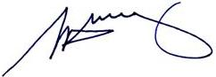
S. H. Tully
Electoral Commissioner

Appendix 1: List of submitters
Preliminary submissions were received from:
Name
L Allan
Bealiba Progress Asssociaiton
Central Goldfields Shire Council
A Doran
C Meddows-Taylor
Proportional Representation Society of Australia (Victoria-Tasmania) Inc.
J Smith

Response submissions were received from:
Name
Central Goldfields Shire Council
Proportional Representation Society of Australia (Victoria-Tasmania) Inc.
J Smith*
* Indicates the submitter who spoke at the public hearing on Monday, 9 May 2011.

Appendix 2: Map
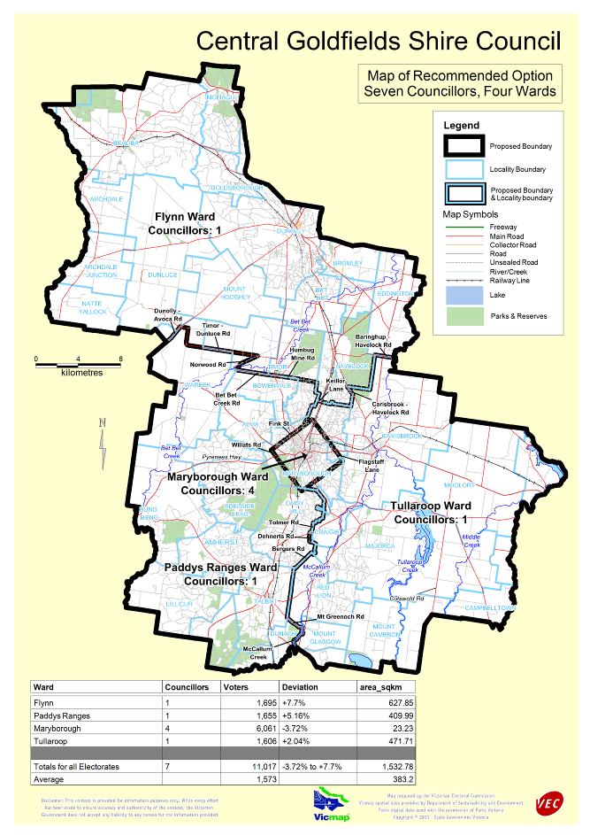

Victorian Electoral Commission
Level 11, 530 Collins Street
Melbourne, Vic 3000

131 VEC (131 832)
info@vec.vic.gov.au
vec.vic.gov.au

Section 219D of the Local Government Act 1989.

