

Report of Local Government Electoral Activity 2009–10

Foreword by the Electoral Commissioner
I am pleased to present the Victorian Electoral Commission Report of Local Government Electoral Activity 2009–10.
This report provides an overview of the current year’s activity, including commentary about the local government by-elections and countbacks conducted during 2009–10, along with key figures and results. We also highlight the preparations for the conduct of the next round of electoral representation reviews, which will commence early in 2011.
I draw your attention to the post-election information booklet series published since my last report. Topics relate to the 2008 local government elections and include Voter Conformity With Candidate How-To-Vote Preferences; Ballot Paper Scanning; Municipal Electoral Tribunals; and Computer Counting. These booklets are available from vec.vic.gov.au or from the VEC.
I take this opportunity to formally record my appreciation for the assistance provided by Local Government Victoria, the Municipal Association of Victoria and the Local Governance Association of Victoria. The VEC looks forward to continuing to assist these organistations in their consideration of electoral matters.
I would like to thank our contractors and suppliers for their continued support and service, contributing invaluably to the success of VEC activities.
Congratulations and thanks go to my staff for their efforts in ensuring that all VEC activity
is carried out with care and diligence.

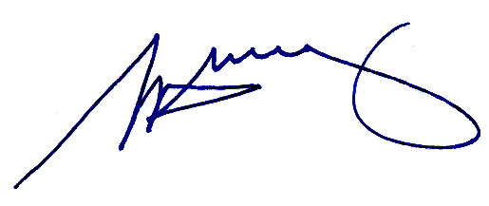

Steve Tully
Electoral Commissioner
Contents
Executive Summary 2
Facts and figures 3
1. Legislative framework 4
1.1. Changes in legislation 4
2. Extraordinary vacancies 4
3. By-elections 5
4. Countbacks 6
4.1. Baw Baw Shire Council, Warragul Ward countback 6
5. Costs 7
6. Participation 7
7. Enrolment 8
8. Voter turnout 8
9. Informality 8
10. Method of election 9
11. Compulsory voting enforcement 9
12. Municipal Electoral Tribunal 11
13. Victorian Civil and Administrative Tribunal 11
14. Electoral representation reviews 11
Appendix A - Results of by-elections conducted during 2009–10 13
Appendix B: Results of countbacks conducted during 2009–10 15
Appendix C: Baw Baw Shire Council 2008, Warragul Ward, amended figures 17

Executive Summary
There have been no major changes in legislation to affect the VEC’s local government electoral activity. The VEC will continue to respond to new and proposed legislation as it arises.
All the councils that conducted by-elections during the year used the same method of voting (postal) as had been used in their previous general election.
The VEC conducted four by-elections and eight countbacks to fill 12 vacancies during 2009–10. A further two by-elections are currently being conducted at the time of this report.
The average cost per voter for a by-election during 2009–10 was $8.74 compared with $8.12 per voter in 2008-09. The average cost of all countbacks (whether conducted centrally or locally) was $3,556.57.
The average turnout rate for by-elections held during 2009–10 was 74.60%, an increase on the figures for the five-year period 2005–06 to 2009–10 (72.83%) and for the local government general elections held in November 2008 (74.36%).
The average informality rate for by-elections conducted in 2009–10 was 4.08%, which is higher than the 3.24% average for by-elections conducted in the past five years, and the informality rate of 3.75% for postal elections conducted at the 2008 general elections.
The VEC’s role in the enforcement of compulsory voting, conducted for a number of councils after the 2008 elections, was finalised in August 2009. Enforcement of compulsory voting for by-elections for one council was continued from 2008-09, and finalised in January 2010. The VEC was appointed to conduct compulsory voting enforcement by two of the four councils for which it conducted by-elections in 2009–10.
Under S.219E, the 40 councils that are due for review prior to the 2012 general elections were required to appoint a reviewer at least 30 months before the next general election. At the time of this report, all 40 councils have appointed the VEC to conduct their review.

Facts and figures
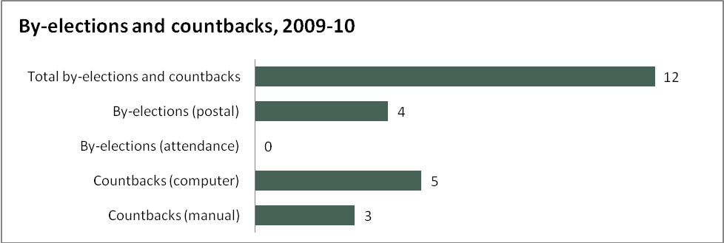
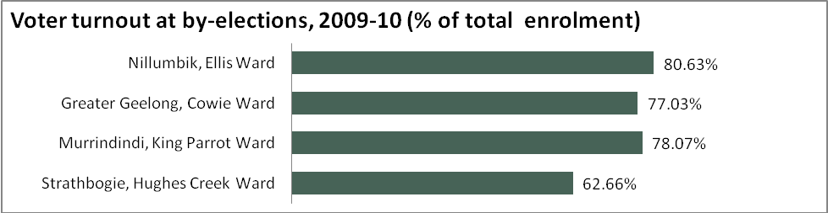
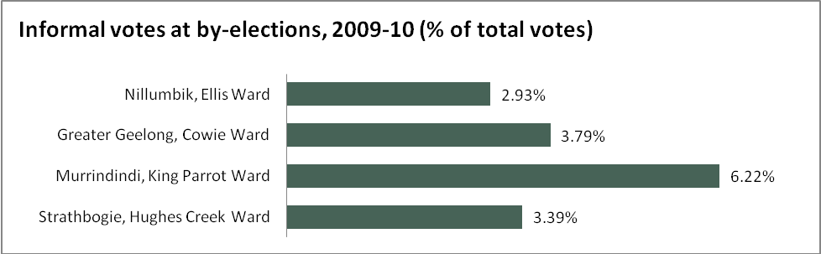
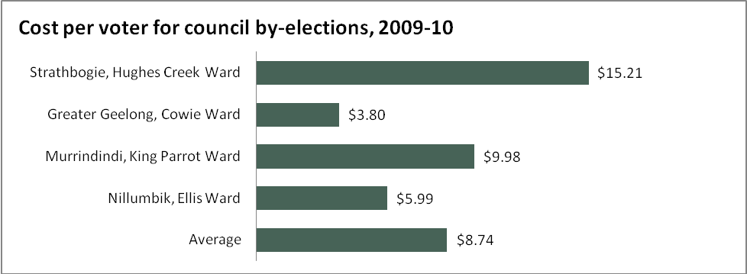

Legislative framework
Local government elections, by-elections and countbacks are conducted within a legislative and regulatory framework. Section 74A(1) of the Constitution Act 1975 provides that local government is a distinct and essential tier of government, consisting of democratically elected councils. The Local Government Act 1989 (LGA) establishes a legislative scheme that supports the system of local government.
Part 3 of the LGA is the principal legislation for the conduct of local government elections in Victoria, including the filling of extraordinary vacancies. The Local Government (Electoral) Regulations 2005 make detailed provisions for the conduct of local government elections.
Part 10 of the LGA guides the conduct of electoral representation and subdivision reviews.

Changes in legislation
In September 2009, the Local Government Amendment (Conflicting Duties) Act 2009 amended the LGA to regulate situations where people who are, or want to be, councillors have conflicting duties.
In effect a person can no longer become or continue to be a councillor or nominate as a candidate at an election if the person is a Member of Parliament or employed as a ministerial officer, parliamentary adviser or electorate officer or is a Councillor of another Council.
The VEC anticipated that a number of by-elections or countbacks could occur as a result of the amendments. In fact, only two vacancies arose, and any other instances of conflicting duties were resolved without the need for a by-election or countback.
In November 2009, the Local Government Amendment (Offences and Other Matters) Act 2009 amended the LGA in relation to penalties for certain offences relating to local government electoral matters so that they are consistent with community expectations and with the Sentencing Act 1991.

Extraordinary vacancies
If, more than six months before a general council election, a councillor in a single-councillor ward resigns or can no longer hold office, an extraordinary vacancy arises, and a by-election is conducted. If this occurs in a multi-councillor electorate and there were unsuccessful candidates at the general election, a countback is conducted. Where there were no unsuccessful candidates, or none of the unsuccessful candidates is eligible for the vacancy, a by-election is conducted. Fourteen extraordinary vacancies arose during 2009–10. Two of these will be filled in the 2010–11 reporting period. This is a comparatively high number for this stage of the election cycle — 18 months after general elections. In the corresponding period after the 2005 round of council elections (2006-07), there were six extraordinary vacancies.

By-elections
Over the past 12 months, the VEC has conducted four by-elections to fill extraordinary vacancies that have arisen in councils. A further two by-elections were in progress at the time of this report. Results of the by-elections are included in Appendix A.
Municipality | Ward | Method | Election day | Voters  roll | Voter turnout | Informal votes | Cost to council ($ ex.GST)
Strathbogie  Shire Council | Hughes Creek | Postal | 19 Sept 2009 | 1,400 | 1,093  (78.07%) | 32  (2.93%) | 21,287.69
Greater Geelong  City Council | Cowie | Postal | 6 March 2010 | 13,342 | 10,277  (77.03%) | 390  (3.79%) | 50,753.51
Murrindindi  Shire Council | King Parrot | Postal | 6 March 2010 | 2,054 | 1,287  (62.66%) | 80  (6.22%) | 20,489.03
Nillumbik  Shire Council | Ellis | Postal | 12 June 2010 | 6,029 | 4,861  (80.63%) | 165  (3.39%) | 36,107.05
Table 1: By-elections conducted during 2009–10

Municipality | Ward | Method | Election day | Voters  roll | Voter turnout | Informal votes | Cost to council ($ex.GST)
Greater Bendigo  City Council | North West Plains | Postal | 17 July 2010 | NA | NA | NA | NA
Mornington Peninsula  Shire Council | Truemans | Postal | 17 July 2010 | NA | NA | NA | NA
Table 2: By-elections in progress at 30 June 2010

Countbacks
A countback is conducted where a vacancy arises in an unsubdivided municipality or a ward represented by two or more councillors.
Where the original election result was determined by a manual proportional representation count,
the countback is conducted manually. Where the original election result was determined by a computerised proportional representation count, the countback is conducted by computer.
Countbacks are conducted to fill extraordinary vacancies unless or until there are no unsuccessful candidates remaining. In that situation, extraordinary vacancies are filled by a by-election.
The countback process involves isolating the vacating councillor’s ballot papers from the general election, at the point in the count at which they were elected. The ballot papers are then distributed, according to the next available preference, to the unsuccessful candidates. The candidate who achieves an absolute majority of these votes is the successful candidate in the countback process.
The VEC conducted eight countbacks during 2009–10 (see Table 3). Results of these countbacks are included in Appendix B.
Council | Ward | Method | Location | Countback date | Cost to council  ( ex. GST)
Glen Eira | Tucker | Computer | VEC | 19 October 2009 | $3,214.83
Wyndham | Chaffey | Computer | VEC | 19 October 2009 | $3,526.83
Maroondah | Arrabri | Computer | Ringwood | 27 January 2010 | $6,349.75
Mansfield | Mansfield | Manual | Mansfield | 29 January 2010 | $1,575.31
Casey | Four Oaks | Computer | Narre Warren | 15 March 2010 | $6,915.84
Mount Alexander | Castlemaine | Manual | Castlemaine | 27 May 2010 | $1,831.01
Wyndham | Chaffey | Computer | VEC | 7 June 2010 | $3,117.91
Baw Baw | Warragul | Manual | Warragul | 16 June 2010 | $20,489.03
Table 3: Countbacks conducted during 2009–10

Baw Baw Shire Council, Warragul Ward countback
During the Baw Baw Shire Council, Warragul Ward countback, the Returning Officer identified four informal ballot papers that had been incorrectly assigned to the vacating Councillor at the original 2008 count. This error did not affect either the outcome of the 2008 election or the result of the countback. The ballot papers were removed from the parcel and all figures for the original election were amended (see Appendix C).

Costs
The average cost per voter for a postal by-election was $8.74. The VEC believes that it has achieved its target to provide value for money election services in the conduct of four by-elections during 2009–10. Costs do not include any compulsory voting enforcement services that a council may have appointed the VEC to undertake on its behalf. Under the LGA, councils can decide to conduct computer countbacks either locally or at the VEC. The average cost of a countback conducted during 2009–10
was $3,556.57, with the average for countback conducted centrally being $3,286.52, and for a countback conducted locally, $3,718.59.

Participation
Participation looks at enrolment, voter turnout and informality rates. Table 4 provides details of by-elections conducted over the past five years including voter turnout and informality rates.
Year | Council | Ward | Election Type | Voter turnout % | Informality rate % | Number of Candidates
2009–10 | Nillumbik | Ellis | Postal | 80.63 | 2.93 | 12
2009–10 | Murrindindi | King Parrot | Postal | 78.07 | 3.79 | 2
2009–10 | Greater Geelong | Cowie | Postal | 77.03 | 6.22 | 10
2009–10 | Strathbogie | Hughes Creek | Postal | 62.66 | 3.39 | 2
2008–09 | Pyrenees | Goldsmith | Uncontested | N/A | N/A | 1
2008–09 | Moorabool | Bungal | Postal | 70.43 | 2.73 | 4
2007–08 | Central Goldfields | Maryborough | Postal | 79.01 | 2.76 | 2
2007–08 | Greater Geelong | Deakin | Postal | 77.64 | 2.06 | 6
2007–08 | Ballarat | Alfredton | Postal | 75.45 | 1.67 | 4
2007–08 | Ballarat | Learmonth | Postal | 77.32 | 2.06 | 5
2007–08 | Pyrenees | Warrenmang | Postal | 73.51 | 1.91 | 3
2007–08 | Colac Otway | Otway | Postal | 70.40 | 1.01 | 3
2007–08 | Mornington Peninsula | Truemans | Postal | 66.37 | 2.09 | 4
2007–08 | Maribyrnong | Stony Creek | Attendance | 62.01 | 9.42 | 10
2007–08 | Boroondara | Cotham | Postal | 69.09 | 6.38 | 16
2006–07 | Latrobe | Galbraith | Postal | 69.34 | 2.88 | 6
2006–07 | Baw Baw | Tarago | Postal | 75.87 | 2.48 | 7
2006–07 | Moonee Valley | Debney | Postal | 60.82 | 4.70 | 12
2005–06 | Hepburn | Cameron | Postal | 77.65 | 2.04 | 4
2005–06 | Corangamite | Central | Postal | 80.42 | 1.09 | 4
 |  |  | Average | 72.83 | 3.24 | 6
Table 4: Details of council by-elections 2005-06 to 2009–10

Enrolment
Those electors who reside within a municipality and are enrolled on the State register of electors are automatically included on the voters roll for local government elections and by-elections.
This category forms approximately 86% of the roll across all municipalities.
In addition, non-resident ratepayers are enrolled automatically — these records are extracted from the council property database. This group forms less than 14% of the roll across all municipalities.
Other council entitlements include non-citizen owner occupiers and company nominees. This group must complete an application form each election cycle to be entitled to vote. This group usually comprises less than 1% of the roll. Those voters who have multiple entitlements within one municipality are only entitled to vote once.
The exhibition roll for a by-election is prepared at a date determined by the Registrar (S.23A(4)(a)) usually as soon as possible after the need for a by-election is determined. A new roll is also prepared for certification.

Voter turnout
The average turnout rate for by-elections held during 2009–10 was 74.60%.
This is a slight increase on the average turnout for the five-year period 2005–06 to 2009–10 (72.83%), and slightly more favourable than the average turnout rate for the local government general elections held in November 2008 (74.36%). All by-election figures are lower than the November 2006 State election turnout rate of 92.73%.
One of the main reasons for lower turnout rates for council elections and by-elections is the fact that voting is not compulsory for non-residents. Other factors include lower awareness of the election (due to less media attention and a lower rate of candidate activity); the perception that only property owners (as opposed to tenants) are required to vote in council elections and
by-elections; and the fact that while voting is compulsory for residents over 70 years of age, these people are not fined if they do not vote.

Informality
The average informality rate for by-elections conducted in 2009–10 is 4.08%, which is higher than the average for by-elections conducted in the past five years (3.24%). Notably, the highest informality rate for 2009–10 by-elections was 6.22% at the Greater Geelong, Cowie Ward
by-election. In contrast, at the Nillumbik, Ellis Ward election, there were 12 candidates and an informality rate of 2.93%.
The VEC has previously reported that the rate of informality tends to increase as the number of candidates increases (see Table 5).

Number of Candidates | Average % informal votes  2005 | Average %  informal votes  2008 | Average %  informal votes  2005–06 to 2009–10 | Average % informal votes 2009–10
2-5 | 2.59 | 2.05 | 2.23 | 3.59
6-10 | 3.38 | 2.72 | 3.41 | 6.22
11-15 | 4.67 | 4.05 | 4.67 | 2.93
>15 | 7.76 | 6.28 | NA | NA
Table 5: Informality rates for postal elections and by-elections
A factor for consideration may be the relatively high number of candidates (10) in the Cowie Ward by-election compared with that in past elections (5 candidates in 2008 and 5 in 2004). At the past two general elections 9 and 11 candidates stood for election in Ellis Ward in 2008 and 2004 respectively. The VEC’s ongoing electoral education program aims to increase electors’ understanding of how to cast a formal vote.

Method of election
Under S41 A(2B) LGA (introduced by the Local Government Amendment (Elections) Act 2008), voting at a by-election must be conducted by the same means, attendance voting or postal voting, as the previous general election was conducted unless the Council has decided, not later than seven days after the extraordinary vacancy occurred, to change the means of conducting the voting.
The vast majority of councils choose postal voting as the preferred option, and all councils that conducted by-elections during 2009–10 chose to do so by post, which was the same method of voting used in their previous general election. The cost of a postal election is lower than that for an attendance election and participation rates are generally higher.

Compulsory voting enforcement
Councils are obliged to enforce the compulsory voting provisions of the LGA. Where the councils contract the VEC to conduct compulsory voting enforcement, the Chief Executive Officer is required to formally appoint the Prosecution Officer in accordance with S.40(2)(a) of the LGA.
Non-voter follow-up following a by-election is conducted by the VEC in three stages.

Stage one – Apparent Failure to Vote Notice
Stage one is a mandatory requirement. An Apparent Failure to Vote Notice is sent to each voter who appeared to have failed to vote. No penalties are collected against this notice.

Stage two – Infringement Notice
At stage two, an Infringement Notice is sent to each voter who did not respond to the initial Apparent Failure to Vote Notice or who did not provide a valid excuse for failing to vote.
The Infringement Notice includes the request for the payment of the penalty amount. Penalty amounts are indexed each year on 1 July and the penalty amount for the 2009–10 compulsory voting enforcement was $58.00.

Stage three – Penalty Reminder Notice
At stage three a Penalty Reminder Notice is sent to each voter who did not reply at stage two. The same processing provisions apply to the Penalty Reminder Notice as for the Infringement Notice.
Compulsory voting enforcement for all of the 70 councils for whom the VEC was appointed to conduct non-voter follow-up after the 2008 local government elections was completed on 31 August 2009. By that date, the VEC had collected $6 million in penalty payments on behalf of councils for the 2008 elections. In general, this revenue offsets total election expenses, including compulsory voting enforcement, by around 27%. The effort required to administer the process equates to around $2 million.
From 1 September 2009, the VEC ceased collection of electronic penalty payments. Penalties received by cheque, money order or cash were forwarded to council for banking. Any further revenue collected by councils will further offset election expenses.
At the conclusion of the compulsory voting process, all councils were provided with a final list of non-voters. Councils proposing to lodge outstanding infringements with the Infringement Court must do so within six months of the issuing of the Infringement Notice. Those councils intending to lodge with the Infringement Court were also provided with an Infringement Court file.
All materials relating to compulsory voting enforcement were returned to councils for storage in compliance with Section 15, Schedule 3 of the Local Government Act 1989 and Regulation 114 of the Local Government (Electoral) Regulations 2005.
The VEC was not appointed to conduct compulsory voting enforcement for the Strathbogie Shire Council, Hughes Creek Ward or the Murrindindi Shire, King Parrot Ward by-elections, but provided non-voter lists to both councils with 116 and 333 records respectively. Total penalties collected for Greater Geelong for the Infringement stage was $10,266 during the 2009–10 financial period. Payments were transferred to council at the end of Infringement stage.
Municipality | Ward | Stage 1 | Stage 2 | Stage 3 | Status at 30 June 2010
Greater Geelong | Cowie | 1,378 | 836 | N/A | Finalisation of stage two.  Mailout of stage three notices scheduled for July 2010.
Table 6: Compulsory voting enforcement activity, 2009–10

Municipal Electoral Tribunal
A Municipal Electoral Tribunal is appointed by the Attorney-General to consider disputes as to the validity of local government elections. Tribunals are constituted under the LGA and are intended to provide a forum for settling such disputes. A tribunal consists of a magistrate appointed by the Attorney-General.
A candidate, or any group of at least 10 voters at an election, who disputes the validity of the election may apply for an inquiry into the election by a municipal electoral tribunal. The application must be in writing and must contain the grounds on which the inquiry into the validity of the election is sought. The application must be lodged with the principal registrar of the Magistrates’ Court within 14 days of the declaration of the result of the election.
There were no Municipal Electoral Tribunal (MET) applications in relation to by-elections or countbacks during 2009–10.
Two MET applications were outstanding from the 2008 local government elections — one in which the VEC appeared as amicus curiae only.
In relation to the other outstanding application, the Tribunal did not accept that any of the matters established by the applicant were sufficient to justify the making of any order affecting the outcome of the election. Neither the Returning Officer, nor the VEC were impugned in this matter.
For more information about MET applications relating to the 2008 local government elections, a booklet that forms part of a Post-Election Information Series is available at vec.vic.gov.au or from the VEC.

Victorian Civil and Administrative Tribunal
Section 48 of the LGA provides that a person whose interests are affected by a decision of a MET to apply to the Victorian Civil and Administrative Tribunal (VCAT) for a review of the decision. There were no matters concerning decisions of a MET in relation to local government elections, by-elections or countbacks before VCAT during 2009–10.

Electoral representation reviews
During 2009-2010, the VEC began preparations for electoral representation reviews of 38 local councils that, under the current provisions of the LGA, are due to be conducted between November 2010 and May 2012. All councils (except Melbourne City Council, which is subject to different legislation) underwent an initial representation review between 2004 and 2008.
In November 2009, Local Government Victoria (LGV) published a discussion paper and called for submissions relating to electoral representation reviews. This may result in legislative change. The VEC will continue to work with LGV on this and other issues related to local government. In the absence of legislative change, reviews will proceed as set out in the LGA.
Section 219C of the LGA states that a review must be conducted no more than two years before every second general election. The review must not commence until two years before that general election, and must be completed no later than six months prior to that general election.
Under S.219E, the 40 councils that are due for review prior to the 2012 general elections were required to appoint a reviewer at least 30 months before the next general election. At the time of this report, all 40 councils have appointed the VEC to conduct their review.

Appendix A - Results of by-elections conducted during 2009–10

Results for Strathbogie Shire Council By-Election 2009
Hughes Creek Ward (1 vacancy)
Voting Count Method Preferential
Elected: LITTLE, Malcolm
Enrolment: 1,400
Formal Votes: 1,061
Informal Votes: 32 (2.93% of the total votes)
Voter Turnout: 1,093 (78.07% of the total enrolment)
First preference votes
Candidate First preference votes
LITTLE, Malcolm 749
RYLEY, Bill 312

Results for Greater Geelong City Council By-Election 2010
Cowie Ward (1 vacancy)
Voting Count Method Preferential
Elected: KONTELJ, Eddy
Enrolment: 13,342
Formal Votes: 9,887
Informal Votes: 390 (3.79% of the total votes)
Voter Turnout: 10,277 (77.03% of the total enrolment)
First preference votes
Candidate Number of first preference votes
JOKIC, Michelle Georgina 741
EDWICK, Adam 228
JENNINGS, Bronwyn 544
GATES, Fred 283
DORRIS, Robert 264
LJUBANOVIC, Vinko 846
COOK, Gail 276
PODVINSEK, Matt 1,785
KONTELJ, Eddy 4,139
PUGLIA, Josie 781
Results for single vacancy after distribution of preferences
Candidate Votes after distribution
JOKIC, Michelle Georgina 1,831
PODVINSEK, Matt 2,391
KONTELJ, Eddy 5,665

Results for Murrindindi Shire Council By-Election 2010
King Parrot Ward (1 vacancy)
Voting Count Method Preferential
Elected: RUHR, Cris
Enrolment: 2,054
Formal Votes: 1,207
Informal Votes: 80 (6.22% of the total votes)
Voter Turnout: 1,287 (62.66% of the total enrolment)
First preference votes
Candidate First preference votes
BOTTIGLIERI, Rick 393
RUHR, Cris 814

Results for Nillumbik Shire Council By-Election 2010
Ellis Ward (1 vacancy)
Voting Count Method Preferential
Elected: PERKINS, Peter
Enrolment: 6029
Formal Votes: 4696
Informal Votes: 165 (3.39% of the total votes)
Voter Turnout: 4,861 (80.63% of the total enrolment)
First preference votes
Candidate Number of first preference votes
De GIER, Melissa 228
CLARKSON, Peter 824
HALL, Colin Andrew 299
CLONAN, Troy 111
PERKINS, Peter 1,401
MAINO, John 235
McCALLUM, Alex 228
BROCK, Beverley 583
DE PELLEGRIN, Maree 228
RADONICH, David 133
WOODLEY, Natalie 186
LAUBER, Jane 240
Results for single vacancy after distribution of preferences
Candidate Number of votes after distribution
CLARKSON, Peter 1,912
PERKINS, Peter 2,784

Appendix B: Results of countbacks conducted during 2009–10

Countback Results for Glen Eira City Council 2008 elections
Tucker Ward
Vacancy Date: 12 October 2009
Vacated: STAIKOS, Nick
Elected: LOBO, Oscar C

Countback Results for Wyndham City Council 2008 elections
Chaffey Ward
Vacancy date:
Countback date: 19 October 2009
Vacated: BRITTAN, Marie
Elected: DE CRESCENZO, Adele

Countback Results for Maroondah City Council 2008 elections
Arrabri Ward
Vacancy date: 31 December 2009
Countback date: 27 January 2010
Vacated: GURR, Peter
Elected: DIB, Tony

Countback Results for Mansfield Shire Council 2008 elections
Mansfield Ward
Vacancy date: 31 December 2009
Countback date: 29 January 2010
Vacated: JEFFCOAT, Sandie
Elected: WILDER, Greg

Countback Results for Casey City Council 2008 elections
Four Oaks Ward
Vacancy date: 16 February 2010
Countback date: 15 March 2010
Vacated: BAXTER, Karen
Elected: HASTIE, Beverley

Countback Results for Wyndham City Council 2008 elections
Chaffey Ward
Vacancy date: 10 May 2010
Countback date: 7 June 2010
Vacated: ROSE, Mark
Elected: MAHFOUD, Marcel

Countback Results for Mount Alexander Shire Council 2008 elections
Ward
Vacancy date:
Countback date: 27 May 2010
Vacated: TAYLOR, Robin
Elected: REWELL, Garry

Countback Results for Baw Baw Shire Council 2008 elections
Ward
Vacancy date:
Countback date: 16 June 2010
Vacated: DURNIN, Pauline
Elected: GRANT, Julie

Appendix C: Baw Baw Shire Council 2008, Warragul Ward, amended figures
Election of 3 Councillors
Formal Ballot Papers included in count: 7920
Informal Ballot Papers: 219
Total Ballot Papers: 8139
Quota: 1981 |  |  |  | CANDIDATES
Count No. | Count Details | Transfer Value |  | van MEURS | BLACKWOOD | MERCER | FITZPATRICK | CLARK | WOLFE | ROBERTS | CLAY | MURPHY | CAMPBELL | DURNIN | GRANT | DANIELS | Gain/ Loss | Exhaus-ted | TOTAL | Candidates elected at this count
1 | 1st Preferences | 1 |  | 572 | 987 | 289 | 269 | 963 | 784 | 215 | 736 | 817 | 316 | 650 | 479 | 843 |  |  | 7920
2 | Exclusion of ROBERTS  215 ballot papers | 1 | BPs | 5 | 3 | 3 | 4 | 2 | 30 | -215 | 11 | 10 | 5 | 25 | 113 | 4 |  | 0
 |  |  | Value | 5 | 3 | 3 | 4 | 2 | 30 | -215 | 11 | 10 | 5 | 25 | 113 | 4 | 0 | 0
 |  |  | PTotal | 577 | 990 | 292 | 273 | 965 | 814 | 0 | 747 | 827 | 321 | 675 | 592 | 847 | 0 | 0 | 7920
3 | Exclusion of FITZPATRICK  269 ballot papers | 1 | BPs | 14 | 16 | 10 | -269 | 9 | 22 | 0 | 159 | 11 | 5 | 4 | 14 | 5 |  | 0
 |  |  | Value | 14 | 16 | 10 | -269 | 9 | 22 | 0 | 159 | 11 | 5 | 4 | 14 | 5 | 0 | 0
 |  |  | PTotal | 591 | 1006 | 302 | 4 | 974 | 836 | 0 | 906 | 838 | 326 | 679 | 606 | 852 | 0 | 0 | 7920
4 | Exclusion of FITZPATRICK  4 ballot papers | 1 | BPs | 0 | 0 | 0 | -4 | 1 | 0 | 0 | 0 | 2 | 0 | 1 | 0 | 0 |  | 0
 |  |  | Value | 0 | 0 | 0 | -4 | 1 | 0 | 0 | 0 | 2 | 0 | 1 | 0 | 0 | 0 | 0
 |  |  | PTotal | 591 | 1006 | 302 | 0 | 975 | 836 | 0 | 906 | 840 | 326 | 680 | 606 | 852 | 0 | 0 | 7920
5 | Exclusion of MERCER  289 ballot papers | 1 | BPs | 20 | 33 | -289 | 0 | 21 | 18 | 0 | 20 | 24 | 18 | 12 | 118 | 5 |  | 0
 |  |  | Value | 20 | 33 | -289 | 0 | 21 | 18 | 0 | 20 | 24 | 18 | 12 | 118 | 5 | 0 | 0
 |  |  | PTotal | 611 | 1039 | 13 | 0 | 996 | 854 | 0 | 926 | 864 | 344 | 692 | 724 | 857 | 0 | 0 | 7920

6 | Exclusion of MERCER  13 ballot papers | 1 | BPs | 1 | 4 | -13 | 0 | 0 | 3 | 0 | 1 | 1 | 2 | 0 | 0 | 1 |  | 0
 |  |  | Value | 1 | 4 | -13 | 0 | 0 | 3 | 0 | 1 | 1 | 2 | 0 | 0 | 1 | 0 | 0
 |  |  | PTotal | 612 | 1043 | 0 | 0 | 996 | 857 | 0 | 927 | 865 | 346 | 692 | 724 | 858 | 0 | 0 | 7920
7 | Exclusion of CAMPBELL  316 ballot papers | 1 | BPs | 9 | 13 | 0 | 0 | 26 | 184 | 0 | 15 | 20 | -316 | 17 | 17 | 15 |  | 0
 |  |  | Value | 9 | 13 | 0 | 0 | 26 | 184 | 0 | 15 | 20 | -316 | 17 | 17 | 15 | 0 | 0
 |  |  | PTotal | 621 | 1056 | 0 | 0 | 1022 | 1041 | 0 | 942 | 885 | 30 | 709 | 741 | 873 | 0 | 0 | 7920
8 | Exclusion of CAMPBELL  30 ballot papers | 1 | BPs | 4 | 5 | 0 | 0 | 1 | 5 | 0 | 2 | 3 | -30 | 9 | 0 | 1 |  | 0
 |  |  | Value | 4 | 5 | 0 | 0 | 1 | 5 | 0 | 2 | 3 | -30 | 9 | 0 | 1 | 0 | 0
 |  |  | PTotal | 625 | 1061 | 0 | 0 | 1023 | 1046 | 0 | 944 | 888 | 0 | 718 | 741 | 874 | 0 | 0 | 7920
9 | Exclusion of van MEURS  572 ballot papers | 1 | BPs | -572 | 88 | 0 | 0 | 27 | 26 | 0 | 20 | 21 | 0 | 321 | 57 | 12 |  | 0
 |  |  | Value | -572 | 88 | 0 | 0 | 27 | 26 | 0 | 20 | 21 | 0 | 321 | 57 | 12 | 0 | 0
 |  |  | PTotal | 53 | 1149 | 0 | 0 | 1050 | 1072 | 0 | 964 | 909 | 0 | 1039 | 798 | 886 | 0 | 0 | 7920
10 | Exclusion of van MEURS  53 ballot papers | 1 | BPs | -53 | 14 | 0 | 0 | 5 | 12 | 0 | 8 | 2 | 0 | 8 | 3 | 1 |  | 0
 |  |  | Value | -53 | 14 | 0 | 0 | 5 | 12 | 0 | 8 | 2 | 0 | 8 | 3 | 1 | 0 | 0
 |  |  | PTotal | 0 | 1163 | 0 | 0 | 1055 | 1084 | 0 | 972 | 911 | 0 | 1047 | 801 | 887 | 0 | 0 | 7920
11 | Exclusion of GRANT479 ballot papers | 1 | BPs | 0 | 21 | 0 | 0 | 19 | 23 | 0 | 50 | 10 | 0 | 347 | -479 | 9 |  | 0
 |  |  | Value | 0 | 21 | 0 | 0 | 19 | 23 | 0 | 50 | 10 | 0 | 347 | -479 | 9 | 0 | 0
 |  |  | PTotal | 0 | 1184 | 0 | 0 | 1074 | 1107 | 0 | 1022 | 921 | 0 | 1394 | 322 | 896 | 0 | 0 | 7920
12 | Exclusion of GRANT  322 ballot papers | 1 | BPs | 0 | 109 | 0 | 0 | 3 | 18 | 0 | 24 | 7 | 0 | 151 | -322 | 10 |  | 0
 |  |  | Value | 0 | 109 | 0 | 0 | 3 | 18 | 0 | 24 | 7 | 0 | 151 | -322 | 10 | 0 | 0
 |  |  | PTotal | 0 | 1293 | 0 | 0 | 1077 | 1125 | 0 | 1046 | 928 | 0 | 1545 | 0 | 906 | 0 | 0 | 7920
13 | Exclusion of DANIELS  843 ballot papers | 1 | BPs | 0 | 580 | 0 | 0 | 90 | 34 | 0 | 26 | 63 | 0 | 50 | 0 | -843 |  | 0
 |  |  | Value | 0 | 580 | 0 | 0 | 90 | 34 | 0 | 26 | 63 | 0 | 50 | 0 | -843 | 0 | 0
 |  |  | PTotal | 0 | 1873 | 0 | 0 | 1167 | 1159 | 0 | 1072 | 991 | 0 | 1595 | 0 | 63 | 0 | 0 | 7920
14 | Exclusion of DANIELS  63 ballot papers | 1 | BPs | 0 | 16 | 0 | 0 | 11 | 8 | 0 | 6 | 10 | 0 | 12 | 0 | -63 |  | 0
 |  |  | Value | 0 | 16 | 0 | 0 | 11 | 8 | 0 | 6 | 10 | 0 | 12 | 0 | -63 | 0 | 0
 |  |  | PTotal | 0 | 1889 | 0 | 0 | 1178 | 1167 | 0 | 1078 | 1001 | 0 | 1607 | 0 | 0 | 0 | 0 | 7920
15 | Exclusion of MURPHY  817 ballot papers | 1 | BPs | 0 | 480 | 0 | 0 | 85 | 120 | 0 | 57 | -817 | 0 | 75 | 0 | 0 |  | 0
 |  |  | Value | 0 | 480 | 0 | 0 | 85 | 120 | 0 | 57 | -817 | 0 | 75 | 0 | 0 | 0 | 0
 |  |  | PTotal | 0 | 2369 | 0 | 0 | 1263 | 1287 | 0 | 1135 | 184 | 0 | 1682 | 0 | 0 | 0 | 0 | 7920
16 | Exclusion of MURPHY  184 ballot papers | 1 | BPs | 0 | 0 | 0 | 0 | 52 | 59 | 0 | 34 | -184 | 0 | 39 | 0 | 0 |  | 0
 |  |  | Value | 0 | 0 | 0 | 0 | 52 | 59 | 0 | 34 | -184 | 0 | 39 | 0 | 0 | 0 | 0
 |  |  | PTotal | 0 | 2369 | 0 | 0 | 1315 | 1346 | 0 | 1169 | 0 | 0 | 1721 | 0 | 0 | 0 | 0 | 7920 | BLACKWOOD, Diane
17 | Surplus of BLACKWOOD  2369 ballot papers | 0.163782 | BPs | 0 | -2369 | 0 | 0 | 1600 | 372 | 0 | 215 | 0 | 0 | 182 | 0 | 0 |  | 2
 |  |  | Value | 0 | -388 | 0 | 0 | 262 | 60 | 0 | 35 | 0 | 0 | 29 | 0 | 0 | 2 | 0
 |  |  | PTotal | 0 | 1981 | 0 | 0 | 1577 | 1406 | 0 | 1204 | 0 | 0 | 1750 | 0 | 0 | 2 | 0 | 7920
18 | Exclusion of CLAY  736 ballot papers | 1 | BPs | 0 | 0 | 0 | 0 | 73 | 535 | 0 | -736 | 0 | 0 | 128 | 0 | 0 |  | 0
 |  |  | Value | 0 | 0 | 0 | 0 | 73 | 535 | 0 | -736 | 0 | 0 | 128 | 0 | 0 | 0 | 0
 |  |  | PTotal | 0 | 1981 | 0 | 0 | 1650 | 1941 | 0 | 468 | 0 | 0 | 1878 | 0 | 0 | 2 | 0 | 7920
19 | Exclusion of CLAY  433 ballot papers | 1 | BPs | 0 | 0 | 0 | 0 | 53 | 255 | 0 | -433 | 0 | 0 | 125 | 0 | 0 |  | 0
 |  |  | Value | 0 | 0 | 0 | 0 | 53 | 255 | 0 | -433 | 0 | 0 | 125 | 0 | 0 | 0 | 0
 |  |  | PTotal | 0 | 1981 | 0 | 0 | 1703 | 2196 | 0 | 35 | 0 | 0 | 2003 | 0 | 0 | 2 | 0 | 7920 | WOLFE, Tony,  DURNIN, Pauline

Victorian Electoral Commission
Level 8, 505 Little Collins Street
Melbourne VIC 3000
Telephone: +61 3 9299 0560
Fax: +61 3 9629 8632
Website: vec.vic.gov.au

