Victorian Electoral Commission’s Statement on Self-Determination and Improved Outcomes for Aboriginal Victorians

Acknowledgement
The Victorian Electoral Commission (VEC) acknowledges Aboriginal and Torres Strait Islander people as the First Peoples of this country. We pay our respects to these communities who have acted as custodians for these lands and waters for tens of thousands of years. We acknowledge Elders from these communities, both past and present, who have passed down knowledge, languages and cultures since the Dreaming, and continue to do so even under the ongoing effects of colonisation. We acknowledge and celebrate the future of these communities and support the work that is being done to preserve and revive the oldest continuing culture on this planet.
We recognise that there are long-lasting, far-reaching and intergenerational consequences of colonisation and dispossession, and understand that the establishment of Victoria involved the specific intent of excluding Aboriginal people, and their laws, cultures, customs and traditions. We acknowledge that the development of Victorian laws policies, systems, and structures explicitly excluded Aboriginal Victorians resulting in and entrenching systemic and structural racism. The VEC acknowledges that this exclusion of Aboriginal Victorians included the active disenfranchisement and restriction of participation in our democracy.

Self-Determination Definition
The VEC recognises the definition of self-determination outlined in the United Nations Declaration on the Rights of Indigenous Peoples (UNDRIP) and quoted in the VAAF as ‘the ability for Indigenous people to freely determine their political status and pursue their economic, social and cultural development’.

The Right to Self-Determination
The Victorian Electoral Commission (VEC) commits to advancing self-determination within the reforms laid out in the Victorian Aboriginal Affairs Framework (VAAF) and the Self-Determination Reform Framework (SDRF). The VEC supports the right to self-determination for Aboriginal Victorians and will actively work to advance self-determination within our legislative responsibilities as an independent and impartial statutory authority. The VEC commits to acting upon the VAAF’s self-determination enablers of:
- prioritising culture
- addressing trauma and supporting healing
- addressing racism and promoting cultural safety
- transferring of power and resources to communities.

The VEC will do this by working through the VAAF’s framework for advancing self-determination, as shown below.
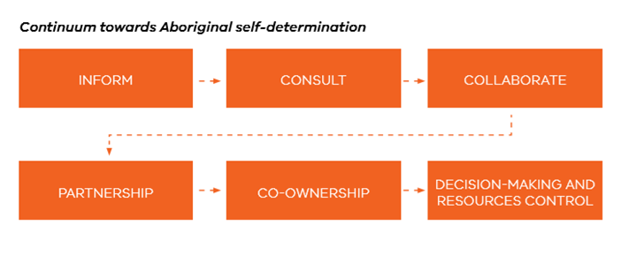
^{[1]}Victorian Aboriginal Affairs Framework 2018 p.23

The VEC commits to working within the following guiding principles, as laid out in the VAAF:
- Human rights
- Cultural integrity
- Commitment
- Aboriginal expertise
- Partnership
- Decision-making
- Empowerment
- Cultural safety
- Investment
- Equity
- Accountability

Public Sector Reform Domains

The VEC commits to advancing self-determination within the public sector reform domains of:
- People
- Systems
- Outcomes
- Accountability
In line with the VAAF and the SDRF, we will work within these domains as follows.

People
The VEC recognises that its workforce must be equipped to drive the development and implementation of culturally safe policies and programs that promote and enable self-determination. To achieve this the VEC will:
- Ensure the workforce has a common understanding of self-determination
- Build the skills of the workforce to effectively engage with Victorian Aboriginal communities
- Build the skills of the workforce to embed the self-determination enablers and guiding principles in policies and programs and ensure this is part of core business
- Ensure the VEC is a culturally safe employer and a employer of choice for Aboriginal Victorians.

Systems
The VEC recognises that the structures and systems established during colonisation, including the democratic process, had the specific intent of excluding Aboriginal people and their laws, customs and traditions. The VEC recognises the need to transform our systems to address structural racism and unconscious bias and enable Aboriginal self-determination. To achieve this the VEC will:
- Ensure that our engagement model supports a self-determination-based approach to working with Aboriginal Victorians
- Ensure we demonstrate understanding of the ongoing structural impacts of colonisation, racism and unconscious bias
- Address racism, discrimination and unconscious bias in our systems
- Recognise and remove barriers to the Aboriginal community accessing our services and participating fully in their democracy
- Improve procurement processes to make them more inclusive and accessible to Aboriginal Victorians.

Outcomes
The VEC recognises that self-determination produces effective and sustainable outcomes for Aboriginal people. We understand that moving from measuring outputs to outcomes better facilitates self-determination. The VEC aims to adopt an outcomes-focused approach by doing the following:
- Actively supporting Aboriginal-led programs that reflect community aspirations
- Continue to move away from deficit-based approaches, focusing instead on strengths-based approaches
- Implement long-term strategies to build trust and development genuine relationships with Aboriginal Victorians
- Be less focused on tangible outputs.

Accountability
The VEC acknowledges that self-determination means that Aboriginal Victorians have the right to make decisions about issues that affect their lives, and that accountability is key to ensuring our commitment to self-determination is translated into meaningful action. To ensure proper accountability, the VEC will:
- Ensure Aboriginal Victorians are supported to hold us accountable
- Move towards measuring community-defined outcomes – what we are achieving for and with Aboriginal Victorians – and robustly evaluate investment and programs against these outcomes
- In partnership with Aboriginal Victorians, create an Aboriginal Engagement Plan (AEP) that commits us to specific actions
- Create a transparent reporting and accountability framework that allows Aboriginal Victorians to hold us accountable for our AEP.

